University of Wales Trinity Saint David
Wales Institute of Science and Art


Electronic Circuits Testing and Applications

Vehicle Electronics ACHA4031

Dafydd Pughe
2401243
04/26
Contents
1 Task 3 1
1.1 Scope Time Division Calculations (6) 1
1.2 Function Generator output square wave (6) 1
1.3 Capacitor charge and discharge wave marked at correct points. (6) 2
1.4 Basic Capacitor Calculations (6) 3
1.5 Capacitor discharge table (5) 4
1.6 Plot log(V) Gradient (5) 4
1.7 Gradient Calculations and Compare(8) 5
1.7.1 Gradient Calculations 5
1.7.2 Comparison table 5
1.8 Capacitor Uses (5) 6
1.9 Inaccuracies Question (4) 8
1.10 Risk Question (10) 9
2 References 10
3 . List of Figures: 11
3.1 List of Tables : 11

Task 3

Scope Time Division Calculations (6)
$$τ=Resistor \left(R\right)×Capasitor \left(C\right)=100 ×1 ×{10}^{-6}=100μS$$
$$40τ=40 ×1 × {10}^{-4}=4mS$$
$$Function Generator Frequancy= \frac{1}{40τ}= \frac{1}{40 ×{10}^{-3}}=250Hz$$
Time period = 1/40
Frequency = 0.025

Function Generator output square wave (6)
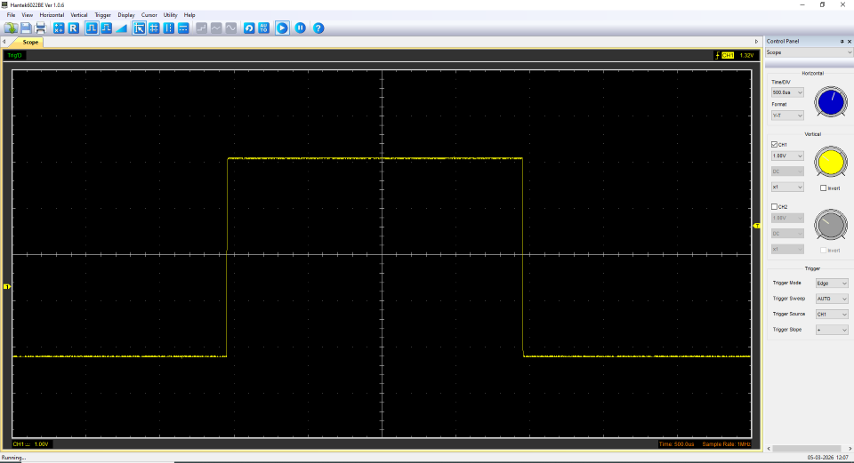
Figure 1 - Square Wave

Capacitor charge and discharge wave marked at correct points. (6)
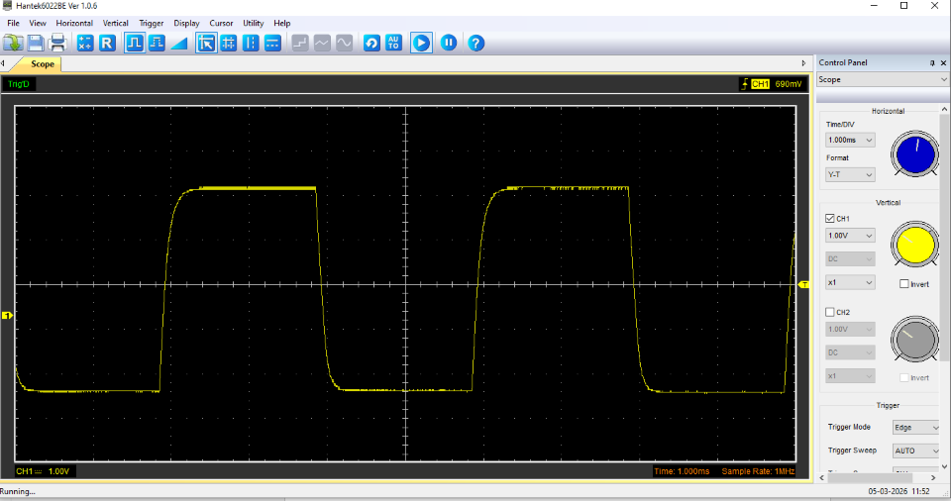
Figure 2 - Cap Wave
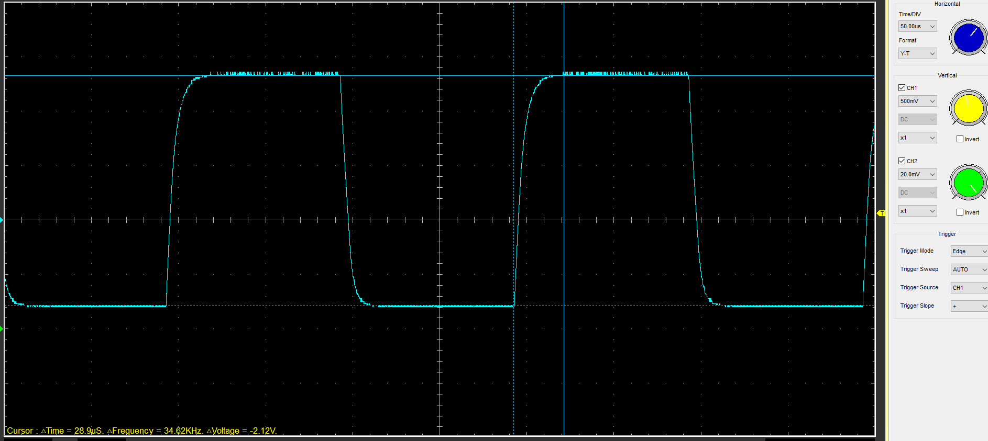
Figure 3 - Cap Wave with Cursors showing Charging
Cursor when Charging:
Voltage = 2.12V
Frequency = 34.62 KHz
Time = 28.9 uS
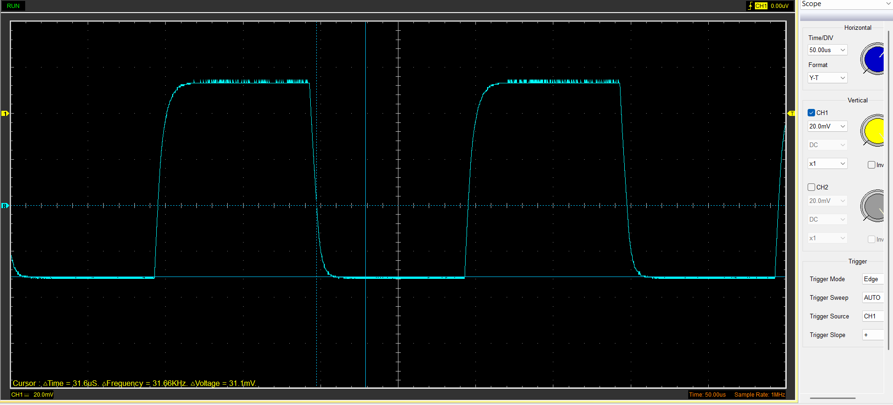
Figure 4 - Cap wave with Cursors showing Discharge
Cursor when discharging :
Time = 31.6uS
Frequency = 31.99KHz
Voltage = 31.1V

Basic Capacitor Calculations (6)

Time Constant (s) = t
Resistance (Ω) = R
Capacitance (F) = C

C = 1 μF
R = 100Ω
(1x10̄⁻⁶) x 100 = 0.0001(s)

Peak = 2.36v
Start = 1.58v
(2.36+1.58)x63.2%-1.58 = 0.91V

Capacitor discharge table (5)
Time (s) | Voltage (V) | ln (V) | dy = y2 – y1 | dx = x2- x1 | dy/dx
 |  |  | dy = ln(V)2-ln(V)1 | dx = Time2 – Time1 | x
0.001218 | 2.5725 | 0.94487819 | x | x | x
0.001227 | 2.2902 | 0.82863915 | -0.11623904 | 9E-06 | -12915.4487
0.001236 | 1.9765 | 0.6813276 | -0.14731155 | 9E-06 | -16367.9496
0.001245 | 1.6941 | 0.52715163 | -0.15417598 | 9E-06 | -17130.6642
0.001254 | 1.4431 | 0.36679358 | -0.16035805 | 9E-06 | -17817.561
0.001263 | 1.1922 | 0.17580034 | -0.19099324 | 9E-06 | -21221.4709
0.001272 | 0.9412 | -0.06059962 | -0.23639996 | 9E-06 | -26266.6624
0.001281 | 0.7216 | -0.32628431 | -0.26568469 | 9E-06 | -29520.5209
0.00129 | 0.4392 | -0.82280039 | -0.49651608 | 9E-06 | -55168.4532
Table 1 - Table displaying capacitor discharge

Plot log(V) Gradient (5)

Figure 5 - Graph showing Time against ln(V)

Gradient Calculations and Compare(8)

Gradient Calculations
Tau = 1/gradient = -1/-26597 = 37.598x10⁻⁶
Capacitor = Tau/Resistor = 37.598x10⁻⁶/100 = 0.37598x10⁻⁶

Comparison table
 | Capacitance | Delta | Percentage difference
Actual | 1 µF | x | X
Marker Calculation | 0.37598 μF | 0.62402 μF | 65.96
Gradient Calculation | 0.37598 μF | 0.62402 μF | 65.96
Table 2 - Comparison Table

Capacitor Uses (5)
There are many different ways a capacitor can be used, some examples of usage are listed below:
- Coupling Capacitor – A coupling Capacitor is when the electronic components only allows the AC signals to pass through one section while the other section allows the DC signals to pass through. The coupling application only works when the connecting 2 amplifier stages together. (Poole, n.d.)
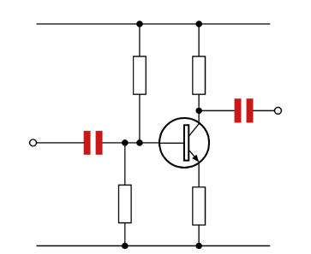
Figure 6 - Input and output coupling capacitors.
https://www.electronics-notes.com/articles/electronic_components/capacitors/capacitor-uses.php
- Filtering – The usage of filtering is when the electronic circuit filters out the unwanted signals that are being recorded. (Electical Voice, 2023)
- Motor Start and Run Capacitors – Capacitors are used in motors such as fridges, washing machines etc. The capacitor keeps a constant voltage to supply a smooth running of the machines. (GeeksforGeeks, 2025)
- Decoupling – Capacitors in the decoupling circuit stabilises the voltage charge that is being discharged. (LearningAboutElectonics, n.d.)
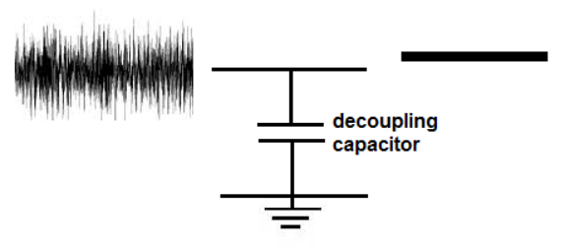
Figure 7 - Decoupling Capactior Diagram
https://learningaboutelectronics.com/Articles/Decoupling-capacitor.php
- ABS capacitor – Using the motion of the wheel speed and braking pressure, the capacitor is putting the sensor through a set of solenoid values which helps to keep the car under control when braking heavily. (SinSpeed, 2025)
- Electrical Power Steering – A capacitor is used for the electrical power steering which helps the weight of the steering and aids the driver.
- Energy Boost (Hybrid and ERS) – This feature is concentrated in motorsport, typically in Formula 1. The ERS in Formula 1 gives a boost in power to help the car accelerate and gain extra speed during the lap. The capacitor helps charge and release power during the lap.
- Ignition systems – The capacitor in the ignition system is essential as it stores high voltage to power the car and realises the energy rapid to ignite the cars engine. Having the energy realised rapidly, it helps to not damage the engine components while starting it.
- Noise Filtering – The capacitors in the system filters out the electrical noise and also ensures the readings for the sensors are accurate.
- Turbo anti lag boost – In the process of anti lag, the turbo swirl continues to spin while the car is not accelerating and keeps the boost, meaning when the driver starts to accelerate again, the power comes immediately instead of a slow and steady rise. (Cope, 2025)

Inaccuracies Question (4)
Inaccuracies could have occurred during the test and measuring that was done. There are many different reasons why the results that was collected and measured could be different to others. One factor of inaccuracy is the equipment that was used, there are many different companies and software used to measure and calculate the results. By using a cheap item from Amazon (Amazon, n.d.), the accuracy compared to a higher specification from TestMeter (Test-Meter, n.d.) could read the reading in a much accurate factor. Which means that other software and devices could be much more accurate than others. The tolerance of the reader could be different to what was measured in the specified value which will affect the readings.
Another inaccurate factor could be human error while processing the test. Human error can change the results of the reading by not setting up the circuit and reader correctly by having a different setting applied. A mistake that could happen is reading the data incorrectly or not following the equations correctly which can produce incorrect data.

Risk Question (10)
To safeguard the security of a vehicle`s CANBUS, there must be a layered defence for the lifecycle. The ISO/SAE 21434:2021 helps preventing the system from being cyberattacked while having important security barriers. (ISO, 2021)
The ISO/SAE 21434:2021 are requirements that is made for road vehicles to manage the cybersecurity risk. These requirements are applied to the lifecycle of the electrical and electronic systems of the vehicles which are easy to hack in cyberattacks. ISO/SAE 2143 benefits the security of the vehicles by reducing the risks by identifying the cyberattacks risks when its developing. It also covers the whole lifecycle of the vehicles preventing the risk for a very long time. The requirements also facilitates better communications between the suppliers and the OEM helping a chain alignment. Also the regulations help meet international and legal requirements which means that the security will work world wide. (ISO, 2021)
Threat Analysis and Risk Assessment (TARA) is carried out in the early stages of development to track the cyber risks at an early stage which will result in ways to obtain the most appropriate measures to protect the risks. The analysis of the threats involves the identification of potential threats connected to cyber security of the vehicles and analysing the possible attacks that can happen with potential scenarios and vulnerability of the vehicles. This process priorities on identifying the risks and the impact that could happen on the security of the vehicle. (NewTec, 2021).
The safeguarding of ISO/SAE 21434 provides a structured framework for a cybersecurity management system (CSMS) which is now a requirement for automotive vehicles that came into force in 2024. This system examinates the risk assessment and the process documentation.
ISO/SAE 12434 is crucial in the current day due to the protection that the restrictions are given to modern cars as safety towards cybersecurity risks. Cyberattacks are a common risks on modern cars due to the amount of technology and electronic components in the car. Also, the ISO/SAE concentrates on safety in modern vehicles by operating the airbag, steering assist and ABS to keep the driver safe when operating the vehicle.

References
Amazon, n.d. [Online]
Available at: https://www.amazon.co.uk/Digital-Multimeter-Continuity-Resistance-Transistor/dp/B0F9TSVBNW/ref=sr_1_4_sspa?adgrpid=1178677364565622&dib=eyJ2IjoiMSJ9.dGMdjjMLGaeTy3bk7fnJdc9kcE0IOm-N5laM5ZmZ1CnmXobceWNuwMEeRqWRLQZZ-i245IGVdMZdHdUCC7tnNo-HJ4i8ouC2QioWDtuMNF
Cope, L., 2025. [Online]
Available at: https://engineerfix.com/what-is-an-anti-lag-turbo-system-and-how-does-it-work/
Electical Voice, 2023. [Online]
Available at: https://electricalvoice.com/applications-of-capacitors-uses/
GeeksforGeeks, 2025. [Online]
Available at: https://www.geeksforgeeks.org/physics/applications-of-capacitor/
ISO, 2021. [Online]
Available at: https://www.iso.org/standard/70918.html
LearningAboutElectonics, n.d. [Online]
Available at: https://learningaboutelectronics.com/Articles/Decoupling-capacitor.php
NewTec, 2021. [Online]
Available at: https://www.newtec.de/en/knowledge/iso-sae-21434-cyber-security-in-motor-vehicles/
Poole, I., n.d. [Online]
Available at: https://www.electronics-notes.com/articles/electronic_components/capacitors/capacitor-uses.php
SinSpeed, 2025. [Online]
Available at: https://www.sinspeed.co.uk/blog/what-is-an-abs-pump-how-does-it-work/
Test-Meter, n.d. [Online]
Available at: https://www.test-meter.co.uk/tenmars-yf-150-digital-capacitance-meter?msclkid=fad40b079de214654e2962e46d70050d&utm_source=bing&utm_medium=cpc&utm_campaign=Bing%20PMAX&utm_term=2324642459721339&utm_content=Ad%20group%20%231

. List of Figures:
Figure 1 - Square Wave 1
Figure 2 - Cap Wave 2
Figure 3 - Cap Wave with Cursors showing Charging 2
Figure 4 - Cap wave with Cursors showing Discharge 3
Figure 5 - Graph showing Time against ln(V) 4
Figure 6 - Input and output coupling capacitors. 6
Figure 7 - Decoupling Capactior Diagram 6

List of Tables :
Table 1 - Table displaying capacitor discharge 4
Table 2 - Comparison Table 5

