Name: Viswanand Venkatasami
Student ID: 1715881
Module No: BMPF 4008
Word Count: 3200Words
4/1/2019

Table of contents
Content Page Number
Section 1
Project Proposal
- The Topic 3
  - Rationale 3
  - Intended Impact 3
  - The Proposed Methodology 3
  - Ethics and Insider Researcher 3

Section 2
Project Report
2.0 Introduction 5
2.1 Literature Review 5
2.2 Methodology 6
2.3 Findings 8
2.4 Conclusions and Recommendations 11
2.5 References 12
2.6 Appendix 13

Section 3
Ethics
3.0 Ethical Approval Form 15

Section 1- Project Proposal

1.0 The Topic
Retention strategies for millenials in the Food & Beverage Department at SALT of Palmar.
1.1 Rationale
SALT of Palmar is a new resort in The Lux Collective which opened in November 2018. Employees spent four months in training so that they could be aligned to the purpose,values and brand concept. As many of our employees are millenials we are concerned that we may fail to retain them as there is a large interest in opportunities on cruise ships.It has thus been decided that we need to understand the needs of our employees so that we can retain them. In the last 3 months, over 35% of team members in the Food & Beverage department resigned from their respective jobs. This is of particular interest to the researcher who leads the team in the Food and Beverage department. To this end the aim of this research project is to find out how we can retain our trained and skilled personnel for the Food & Beverage department at SALT of Palmar.
1.2 Intended Impact
This research aimed at:
- Understanding the needs of millennials at the workplace
- Analysing the satisfaction level of team members over the past few months.
- Determining suitable retention strategies based on the outcome of the study
- Finding ways to enhance the management of team members to better cope with the change in management and new organisational ways.

1.3 The Proposed Methodology
Methods
Survey: From literature, quantitative approaches are preferred when testing cause-effect relations; as a result, structured questionnaire were used.
The questionnaire was relatively short, using 0 – 5 likert scale taking a maximum of 10 minutes to complete. A response rate of 60%, that is, around 30 responses were targeted.
Observation: Participants were observed to monitor their performance and behaviour at work and towards their team members.
Interview: Participants were called for a face to face interview which will not last for more than 10 minutes. During the interview team members could voice out their views if they were not satisfied with the company and their comments were noted with strict confidentiality without affecting their current job position and/or future career prospects.

1.4 Ethics and Insider Researcher
Only professional ethics were considered throughout this survey. Filling of the questionnaire was on a voluntarily basis. All the responses were processed anonymously and the raw data from the survey was kept confidential. All the questionnaires were shredded once analysis was completed.

Section 2- Project Report
2.0 Introduction
This study investigates team members’ needs so that trained and skilled personnel can be retained in the Food & Beverage department at SALT of Palmar. In addition, out of our 30 team members 20 are millennials and to study their performance and behaviour at the workplace and the challenges they faced was helpful for the research. The aims of the research were to know about team members personal and job satisfaction over the past few months at SALT of Palmar. The study prompts a re-thinking of the conditions of work at SALT Of Palmar. The responses from the interviews conducted provide strengths for fundamental arguments against the reasons for high employee turnover in hotels. Following this study suitable retention strategies were determined for the Food & Beverage department and recommendations for improvements to the styles of training conducted were made. Data was collected through secondary research, survey questionnaires, observation and face-to-face interviews.
2.1 Literature Review
Employee turnover is a major challenge faced by companies globally. Employees are the asset of an organisation and organisations cannot afford to lose their key employees. Amy Adkins ,(2016) labeled Millennials as “The Job Hopping Generation,” citing data from their research that 60 percent of Millennials are open to a new job and that 21 percent of Millennials have changed jobs within the past year. Beyond the desire for change, the benefits of “job hopping” can offer a diversity of experience. Millennials are less engaged at work compared to their non-Millennial peers.
UKEssays,(2018). Employee Turnover Rate In Tourism And Hospitality Industry Tourism Essay. The average employee to guest ratio in the hotel industry is 2 staff to 1 guest United Nations, (2007). Consequently, there is a great demand of staff in the hotel industry. Nonetheless, the latter are striving to recruit and retain their current employees. The main reasons is the fierce competition in the local hotel industry. Cruise ships are also recruiting from the same pool of available staff.
Organisations are striving to retain their talent by implementing effective retention strategies. James and Mathew,(2012) pointed out that welfare benefits, personal satisfaction and organisational culture are associated with employee turnover. Researchers such as Amadasu, (2003); Taplin et al, (2003); Gberevbie, (2008) have found that if appropriate employee retention strategies are adopted and implemented by organisations, employees are more likely to remain and work for the successful achievement of organisational goals.
The main factors identified, that could impact on turnover are, orientation and good socialisation procedures Kennedy and Berger (1994), Woods, (1992), ad-hoc recruitment and selection Benn and Farbringer, (1992), Woods and Macaulay, (1989); Wagner, (1991); Wheelhouse, (1989), discrimination at the workplace, Antolik, (1993), lack of training and development opportunities Hogan, (1992); rowden, (1995), organisation culture Woods and Macaulay, (1998) shortage of skills in the labour market Debrah, (1994); Woods, (1992), high levels of work related stress Vallen,(1993);Woods, (1992); Ham and Griffeth, (1995), seasonal nature of the industry Boella, (1998) and job dissatisfaction Bonn and Frbringer, (1992).

2.2 Methodology
The focus of the data gathering was on the opinions of the Food and Beverage team members. The methodology was mostly quantitative.
For this project, 3 methods were used namely:
A 0-5 Likert scale survey questionnaire was used as research instrument to collect primary data from all team members within the Food & Beverage Department at SALT of Palmar. The option of e-mail questionnaire was not chosen as not all team members from the Food & Beverage Department are computer literate and some did not even have an e-mail address. The questionnaire consisted of 10 questions and the table below shows the target of 30 participants. The questionnaire was distributed to the team members and the aim was to gather their views and expectations on employee retention for the Food & Beverage Department.

Outlets | Demi Chef de Rang/ Barista | Chef de Rang/ Supervisor/ Bartender
The Restaurant | 6 | 5
In Room Dining | 3 | 1
Pool Bar | 2 | 3
Beach Bar | 2 | 2
Roof Top Bar | 2 | 2
The SALT Bakery | 2
 | 17 | 13

The questionnaire was filled by the team members mainly after service time in order not to interrupt the smooth running of Food & Beverage operations. They were informed that participation was voluntary and it would take no more than 10 minutes to complete as it will be on a 0-5 Likert scale questionnaire. A pilot test was run with the Executive Assistant/Food & Beverage Manager to check for any corrections.
Responses from the conducted survey were analysed and tabulated on a spreadsheet to have a better overview on the responses from the participants. (See Appendix 1).
- On the job observation was conducted for 3 days whereby team members performance and behaviour was observed. Team Members performance and behavior at the workplace was observed for 3 days. The main objective of this survey was to collect data about employee retention strategies at SALT of Palmar.

- Following the responses collected from the survey, participants were called one by one for a face to face interview to voice out their views about when and why they have been frustrated with the work and unsatisfied with the company. Telephone interview was not chosen as some participants could be reluctant to voice out their views.

As an insider researcher, all team members involved in the project were reassured that all information was treated as confidential and was therefore used for academic purposes only and that they understood it would not affect their jobs or chances of promotion etc if the responses were negative.

2.3 Findings
Survey Questionnaire
A survey using 0-5 Likert scale questionnaire was done with 30 Food & Beverage team members aged between 20 to 42 years old. There were only 25 respondents aged between 24-34 years old from the restaurant, bar and in room dining who responded to the survey. The key findings which are in favour of retaining millennial at SALT of Palmar are as follows:
Question 1 was about Employee Job Satisfaction and the responses showed that 92% team members felt that they were personally accomplished with their work, 100% responded that their jobs make good use of their skills and abilities. 96% were satisfied with their respective jobs and they experienced personal growth such as updating skills, learning different jobs and were rewarded for the quality of their efforts. This response can be supported by the following: daily on-the-job training sessions were conducted, implementation of coffee expert sharing skills and knowledge by conducting theory and practical training sessions of latte art at The SALT Bakery to all Food and Beverage outlets team members irrespective of their job position. 100% respondents liked to go to work and this was a very good sign for SALT of Palmar.96% team members believed that all employees were recognized as individuals and were motivated to see the success of SALT of Palmar. 96% of the participants said they have a clear path for career advancement and this could be justified by the brand concept at SALT of Palmar whereby we are emerging as a whole towards sustainability, freshly sourced local and homemade products to our guests.
Question 2 was about Employee Retention and 92% said the company did an excellent job in keeping employees informed about matters affecting them, 92% answered that their supervisors and manager visibly demonstrated a commitment to quality, encouraged them to be at their best and they are satisfied with the information received from the management on what was going on in all the Food and Beverage outlets namely - The Restaurant, Pool Bar, Beach Bar, The Roof Top Bar and The Salt Bakery. 84% respondents believed that the company is flexible with respect to their family responsibilities. It was a good figure for the respondents working in the hotel sector as there were times when occupancy was high or if there was any special event and they had to work extra hours for which they were remunerated accordingly and as a result they were limited to meet their family responsibilities. Upon being asked if they would advise a friend to apply for a job at SALT of Palmar, 92% responded positively. Also they were briefed about the facilities offered to the team members at SALT which the management believed no other hotels in Mauritius was offering to their team members.
Question 3 was about how long team members were planning to stay in employment at SALT of Palmar and interesting figures were obtained as 48% of the respondents answered they will work with the company for more than 2 years and 28% believed that they will work for more than 1 year. These figures could be justified by the responses collected from questions 1 and 2. However 24% team members stated that they would leave the company as soon as they got an opportunity and this was a major concern for the team and the management. 12% team members did not answer whether the variety of tasks that their positions require was too many, enough or not enough. There might have been some confusion at some point for the respondents as it was not clear to them if the tasks were too many, enough or not enough.
Observation
In terms of team members’ performance and behavior in the Food and Beverage Department at SALT of Palmar it has been noted that most of the team members working in The Restaurant deliver the best of themselves. But because of the low manning, very often they had to work extra hours during which some team members’ energy level was quite low and the weariness could be easily noticed from their facial expression which could create a negative impression ‘vis-à-vis’ guests who stayed over more than a week. Guests could have developed the wrong perception that the employees were being exploited or were wrongly manipulated without knowing that the team members were remunerated or refunded accordingly for the extra hours worked. As discussed with the Human Resources Department during the one to one meeting the option of promotion strategy will be applied to fill in the vacant posts by giving the team members the opportunity to enhance their career within the company and encourage them to apply if they feel they are the right candidate for the post available.
There appeared to be a lack of cooperation between Restaurant & Bar team members and following interview which was done, Restaurant team members said that Bar team members never give them a helping hand when it comes to busy service hours whereby Restaurant team members are encountering difficulties in ensuring prompt service while Bar team members are more relaxed. Also when it comes to replacing a colleague who is on medical or any other special leave, team members are somewhat reluctant and this can cause a negative impact to run the operations smoothly as the brand standards that have been set needs a lot of attention to details and proper supervision. The team member at the SALT Bakery is busy only during breakfast service for the preparation of hot beverages namely coffee, tea and infusions. After breakfast service there are not so many orders for hot beverages and the latter prefers to relax on his work station rather than cooperate with his other team members who badly need some help at the Restaurant and Bar.
Interview
Following a one to one interview which was conducted with 5 team members from different levels of hierarchy per each Food & Beverage outlet, the comments below were noted:
The Restaurant team member believes that he is satisfied with his salary but however he has to do lots of extra hours and this affects his personal life balance as he gets to spend very minimum time with his family and friends. Anotherteam member from the Restaurant said she will leave the company as soon as she will get another opportunity because of the low manning due to which she feels very tired and she said she already went for an interview at another hotel where she had applied for a higher job position and she was awaiting a reply from the interviewer. She also mentioned that she wants to pursue her studies and work towards her career growth in the field of Food & Beverage. Upon considering these facts the Human Resources department enquired if she was interested to apply for the same post at SALT of Palmar and she agreed. The latter was called for a second interview whereby her competences were evaluated and she is actually under probation for a period of 3 months before being promoted as ‘Chef de Rang’ at SALT of Palmar.
The SALT Bakery team member pointed out that the team members from The Restaurant and Bar usually exclude him from the team due to which he is somewhat hesitant and completely ignores the situation when his colleagues need help and support. The Bar team member at the Pool Bar said he does not get any support from his fellow colleagues and they never want to take any responsibility. They rely on him all the time to get the tasks done and most of the time he is challenged by the team members namely the Bartenders who do not always obey to his instructions. Following his comments that were noted by the Human Resources department, it was agreed with the Restaurant Manager and Assistant Restaurant Manager to oversee the Bar operations and extend support to the Bartenders whenever required.
The In Room Dining team member said he is happy with his job and would not hesitate to give a helping hand either in The Restaurant or at The SALT Bakery during busy service hours. He is often scheduled to work overnight and he has no complaints against this. He seized this opportunity to thank the management for all the training and support given for 5 years.

2.4 Conclusions and Recommendations
This study enabled the researcher to identify team members’ needs and to determine suitable retention strategies for trained and skilled team members and create a positive working environment between Generation X and Millenials for the Food & Beverage Department at SALT Of Palmar.
Promotion strategy was adopted for the team member who believed they were capable of shouldering more responsibilities and work towards their personal development and career growth.
After discussion with the Human Resources Department the following recommendations were considered for the project. The option of refunding the team member a day off for the extra hours worked has been considered.
The team members who are likely to leave the company will be briefed about the facilities offered to the team members at SALT which the management believes no other hotels in Mauritius offer to their team members.
It was mentioned in the respective job profiles that the team member could be prone to multitasks whenever required while ensuring flexibility accordingly.
Activity based training sessions will be conducted whereby all Food & Beverage outlets team members will be merged together which will result in them getting to know themselves better and develop the positive working attitude.
Retention measures that could be implemented to fix the above is to have additional manning for the Food and Beverage department so that the team members will not feel exhausted and frustrated while working extra hours. So it has been agreed with the Human Resources Department to recruit additional team members for the Food & Beverage Department.

2.5 References
- Amy Adkins ,(2016) Millennials as “The Job Hopping Generation,”
- UKEssays (2018). Employee Turnover Rate In Tourism And Hospitality Industry Tourism Essay.
- James and Mathew (2012),Organisations are striving to retain their talents by implementing effective retention strategies.
- Kennedy and Berger (1994), Woods, (1992),Orientation and good socialisation procedures
- Benn and Farbringer, (1992), Woods and Macaulay, (1989); Wagner, (1991); Wheelhouse, (1989) Ad-hoc recruitment and selection
- Antolik,(1993), Discrimination at the workplace
- Hogan, (1992); rowden,(1995),Lack of training and development opportunities
- Woods and Macaulay, (1998), Organisation culture
- Debrah, (1994); Woods, (1992), Shortage of skills in the labour market
- Vallen,(1993);Woods, (1992); Ham and Griffeth, (1995), High levels of work related stress
- Boella, (1998),Seasonal nature of the industry
- Bonn and Frbringer, (1992), Job dissatisfaction

Appendix
Survey Questionnaire
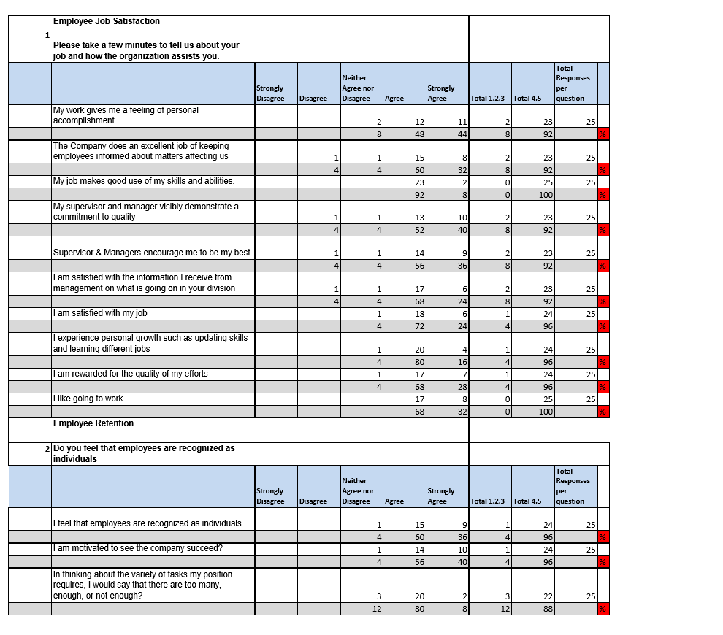
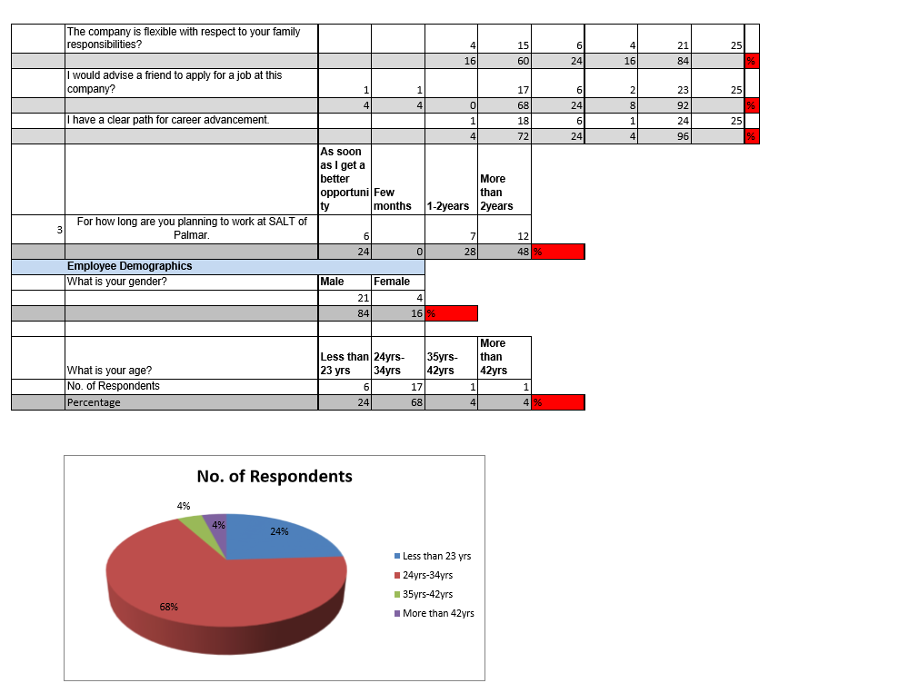

Section 3- Ethics
Ethical Approval Form

