NAME- Gingu Alexandra
ID-2538474

DIGITAL LIFE REFLECTION
Table of Contents
My Screenshots/Photos 3
Screenshot/Photo 1 4
Screenshot/Photo 2 7
Screenshot/Photo 3 9
Screenshot/Photo 4 12
Screenshot/Photo 5 15
Screenshot/Photo 6 18
My Short Reflection 21
Submission Checklist 21
Reference list 23

DS 1 Template

My Screenshots/Photos
- Please add 4–6 screenshots or photos of your digital life.
- You can use your phone or laptop.
- For each screenshot, write one or two sentences explaining what it shows.

Screenshot/Photo 1
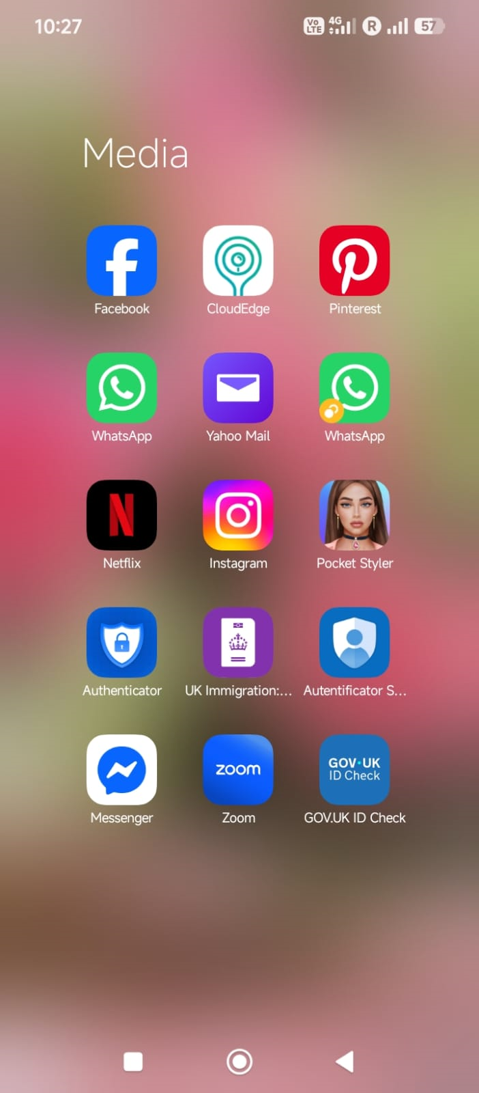
This is a screen shot of many of the social media and communication apps I use frequently in my life (Bentvelzen et al. 2022). It shows the ways of which I communicate with friends, family, and online communities (Facebook, WhatsApp, Instagram, Messenger, and Zoom), using entertainment and digital services.

Screenshot/Photo 2
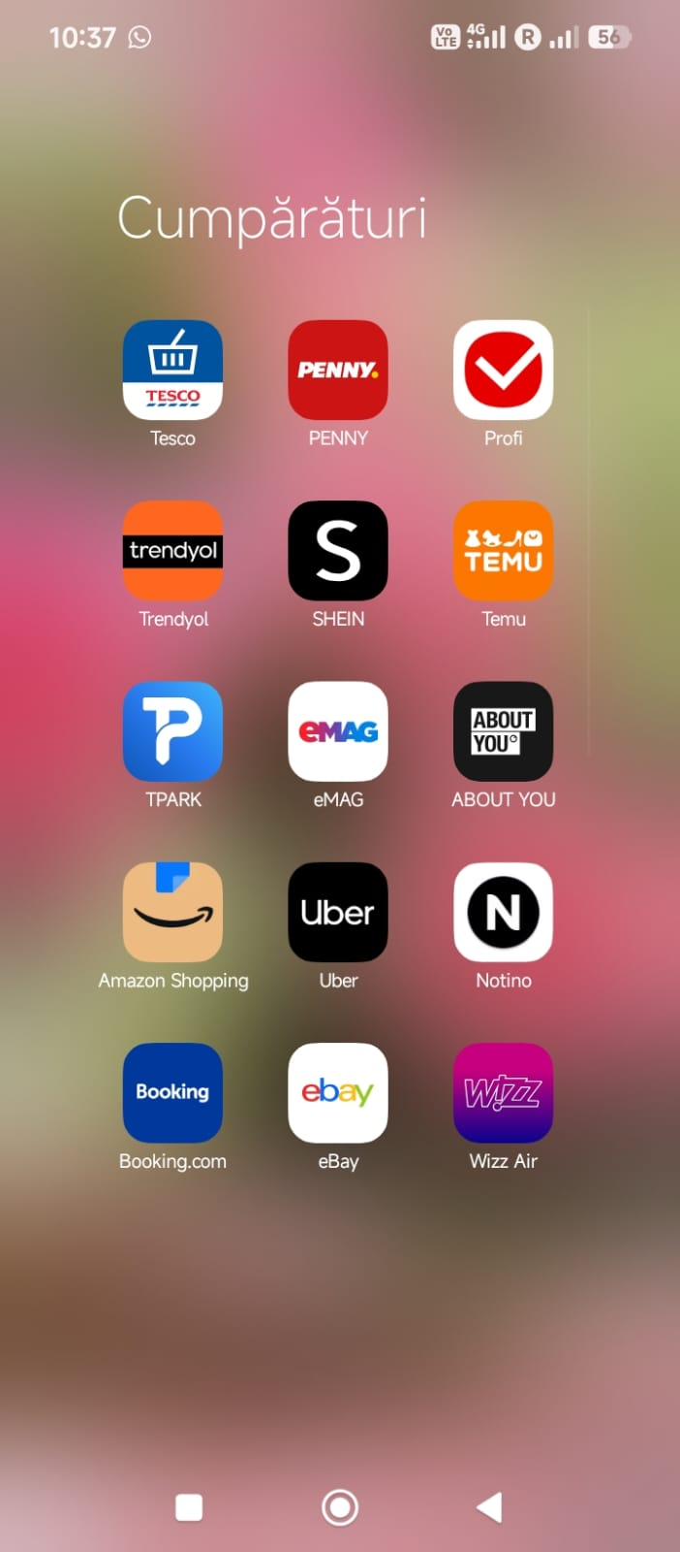
This screen shot is of the shopping and travel applications that I use often to make online purchases and book travel. It makes me realize that I can shop at my fingertips, compare prices, order a product, book transport and accommodation and travel plans on Amazon, eBay, Booking.com, Uber and Wizz Air.

Screenshot/Photo 3
[Insert Photo/Screenshot below]
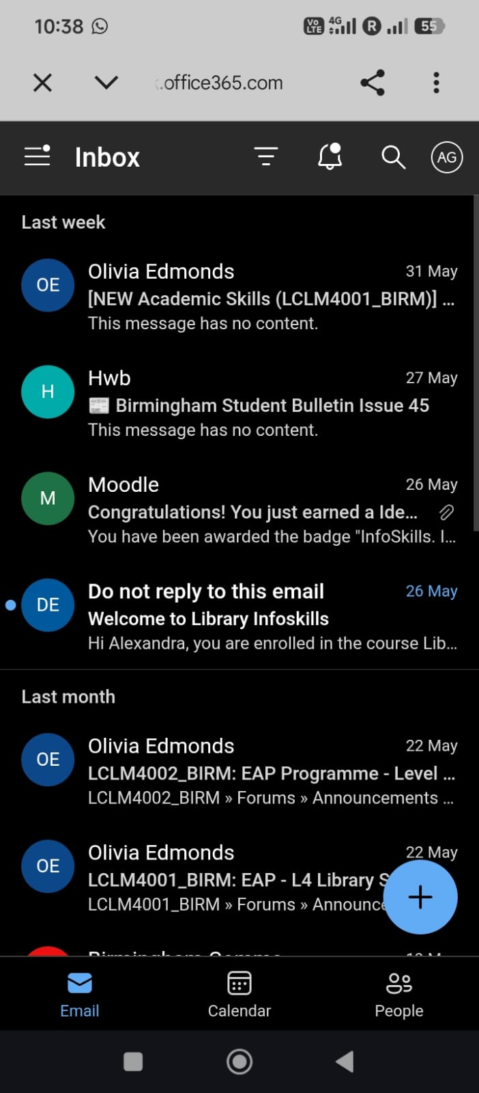
Here is a screen shot of my University email, and learning related communication. Depicts how I am informed on my study, academic duties and the way I am informed of academic information/announcements from the University library, lecture department and school department.

Screenshot/Photo 4

Here are a few screenshots of financial/banking applications that I use to take care of my finances securely. It illustrates how I'm utilizing online banking, digital payments, financial services, and identity verification providers like Lloyds Bank, Revolut, PayPal and EU Login Mobile.

Screenshot/Photo 5
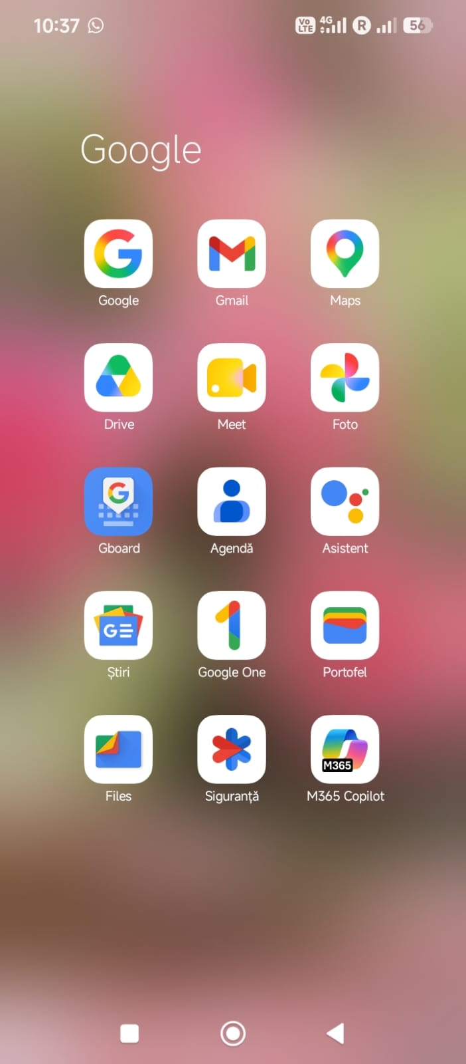
Here is a snapshot of some of the Google applications that are a key component to my digital life. These are employed when communicating, navigating, storing in the cloud, for online meetings, document management, and productivity. I use the Google suite of applications, such as Google Meet, Google Maps, Google Drive, Google One and Google.

Screenshot/Photo 6

Here's a screen grab of my use of the online library and learning resources platform at the University of Wales Trinity Saint David. It demonstrates how I use academic books, journal articles, research and learning support services online to complete academic assignments, undertake research and in my academic development more generally.

My Short Reflection
- Write 5–8 simple sentences about your digital life.
- You can use the sentence starters below if helpful.
My digital life is an integral component of my everyday life, learning experience, communicating experiences and personal organisation. Using digital tools, I communicate with the social media, my family, classmates and lecturers. I frequently use these tools to communicate, to get information, for academic work, and to take care of my personal tasks (van Olmen, 2022). I feel confident in using online learning resources, university systems and productivity applications as they support me to organise my work effectively.
Frequently use the digital platforms for shopping, travelling, financial management, and banking. Many of the technologies have made a lot of everyday activities easier, faster and more convenient. I use Google applications to search for information in academic websites on the Internet and online library catalogues, and to do assignments. These tools help me learn and to develop my knowledge and skills (Jakku et al., 2022). I feel comfortable using a variety of digital technologies, but I have some concerns about security, data privacy and protecting personal information when using online technologies.

Submission Checklist
Before you submit, please check:
​​​ ☒ I added 4–6 screenshots
☒ I wrote short sentences for each screenshot
☒ I wrote my short reflection
☒ My work is my own
☒ My file opens correctly
​​☒ My file opens correctly

Reference list

Bentvelzen, M., Woźniak, P.W., Herbes, P.S., Stefanidi, E. and Niess, J., 2022. Revisiting reflection in hci: Four design resources for technologies that support reflection. Proceedings of the ACM on Interactive, Mobile, Wearable and Ubiquitous Technologies, 6(1), pp.1-27.
Jakku, E., Fielke, S., Fleming, A. and Stitzlein, C., 2022. Reflecting on opportunities and challenges regarding implementation of responsible digital agri‐technology innovation. Sociologia ruralis, 62(2), pp.363-388.
van Olmen, J., 2022. The promise of digital self-management: a reflection about the effects of patient-targeted e-health tools on self-management and wellbeing. International Journal of Environmental Research and Public Health, 19(3), p.1360.

