

Postgraduate/Distance Learning
Assignment coversheet & feedback form
TO BE USED FOR ALL ESSAY SUBMISSIONS FROM APRIL 2026
THIS COVER SHEET REPLACES ALL PREVIOUS VERSIONS.
YOU MUST SIGN THE AI DECLARATION BEFORE YOU SUBMIT THE ESSAY.

THIS SHEET MUST BE THE FIRST PAGE OF THE ASSIGNMENT YOU ARE SUBMITTING (DO NOT SEND AS A SEPARATE FILE)

For completion by the student:
Student Name: FRANCESCA CABRAL

Student University Email: 2317218@student.uwtsd.ac.uk
Module code: HPCA7028  Module title: SACRED SKIES | Student ID number:  2317218 |  |  | Educational support needs:
Assignment title: Image Based Representation of the Sky

Assignment due date: 30/04/2026
This assignment is for the 1st 2nd 3rd 4th 5th 6th module of the degree
Plagiarism declaration
I confirm that this is my original work and that I have adhered to the University policy on plagiarism.

Artificial Intelligence (AI) declaration

I confirm that I have not used any AI tools in the research and creation of this assignment. I confirm that I have not presented any AI generated materials as my own work. I confirm I have copies of my drafts, notes, and other resources I used, which I may be asked to provide in evidence.

Signed: FRANCESCA CABRAL
Date: 29/04/2026

Assignment Mark
1st Marker’s Provisional mark
2nd Marker’s/Moderator’s provisional mark
External Examiner’s mark (if relevant)
Final Mark

NB. All marks are provisional until confirmed by the Final Examination Board.

For completion by Marker 1 :
Comments:

Marker’s signature: |  |  | Date:
For completion by Marker 2/Moderator:

Comments:

Marker’s Signature: |  | Date:
External Examiner’s comments (if relevant)

External Examiner’s Signature: |  | Date:

Introduction
This paper compares my digital photograph “Moon over Geneva,” taken in Geneva on 22 March 2026 at 21:40, with the Metropolitan Museum version of Caspar David Friedrich’s “Two Men Contemplating the Moon” (ca. 1825–30). It compares how each image of the crescent moon is created and how this affects the knowledge is produces. The paper uses selenography in a double sense, as the technical description of the lunar surface and as a wider cultural practice of understanding the moon through sight. From that position, the comparison examines what each image allows the viewer to see, know, and feel about the moon.
The paper proceeds in four stages. The first section sets out the paper’s method, with attention to phenomenological observation, visual analysis, and cultural astronomy. The second, examines how each image positions the viewer in relation to the crescent moon. The third section compares the images of the moon as photograph and painting, focusing on visibility, distance, and lived encounter. The final section places both images within their cultural contexts before ending with some concluding remarks.

Methodological Positioning
This paper is based on two primary images: my photograph of the waning crescent moon over Geneva and the Metropolitan Museum version of Friedrich’s “Two Men Contemplating the Moon.” My photograph is treated as fieldwork evidence, made at a particular hour, from a particular position, under the uncertain visibility of an evening sky in Geneva. Friedrich’s painting is treated as a specific historical work with its own material form, compositional choices, and interpretive history. Other versions of his moonlit motif may enter the discussion only where they clarify dating, repetition, or the claims that can be made about the Metropolitan Museum version. The visual analyses pose the same questions for both images: what is visible, where the moon is placed, how the viewer is positioned, what kind of distance is produced, and how light, scale, framing, and orientation shape the literal act of looking.
It is important to note that the photograph requires a reflexive approach because its evidence was formed through my own act of looking. I stopped at the window, saw the crescent, framed it through the phone, and chose when to press the shutter. That gap between encounter and image be it the photograph or the painting, will be used as part of the evidence, since the paper treats them as both an experience of the sky and a record of that experience.

The Act of Viewing the Moon
Selenography is the description, mapping, and visual study of the Moon’s surface. It treats the Moon as a body whose visible features can be observed, named, measured, compared, and organised into systems of knowledge. Its modes include telescopic observation, hand-drawn lunar maps, engraved lunar atlases, detailed drawings of craters and shadows, photographic plates of the lunar surface, spacecraft imaging, as well as paintings and other such works from the field of the humanities. It is a topic that stretches across disciplines throughout many cultures.
Observation of the moon, forms part of a larger study of astronomy. Human beings have long studied the sky’s visible patterns and developed ways of orienting their place within the cosmos. Brady gives several examples of said orientation through repeated celestial behaviour: the Sun and Moon change light and meet the horizon in rhythms through which time and season can be read, while the stars hold recognisable patterns that can be used for direction, calendar-making, story, and ideas of permanence. Her examples show how practical and symbolic orientation often belong together. Star-lines can work as a mental compass for movement across a landscape, while the Egyptian “Imperishable Stars” gave a visible form to continuity beyond death. Selenography belongs within this wider human practice of reading the sky, because it takes the Moon’s recurring visibility and cycles and turn them into a surface that can be observed, named, mapped, and returned to as knowledge, in this case, the lunar cycle's crescent moon.
The two works compared in this paper approach selenography through different instruments of seeing. “Moon over Geneva” was made with a smartphone (Fig.1.), while Friedrich’s “Two Men Contemplating the Moon” was made in oil on canvas, measuring 34.9 × 43.8 cm (Fig. 2.). The smartphone image first began with an upward look at the crescent. I saw the moon directly with my naked eye, before I tried to photograph it, then had to find it again on the phone screen. That second act of looking changed the encounter because the crescent now appeared inside a small frame, adjusted by the phone’s sensor, exposure settings, and processing. By the time it became a photograph, the moon had passed through both my act of seeing and the device’s way of registering light. My control over that image was partial, because I could choose where to stand, when to press the shutter, and how to frame the crescent, but ultimately, the phone’s sensor, exposure, and processing determined much of what the sky finally looked like (Fig.1.) Meanwhile, Friedrich’s painting passed through a slower process of looking and image-making, seemingly moving through three acts of viewing. First came the sight itself: whatever scene he remembered or studied. Then came the inward act of interpretation of that viewing once the scene was no longer visible. Finally, the scene was viewed again through oil paint, as brush, pigment, and canvas required him to return to the image first viewed then interpreted.
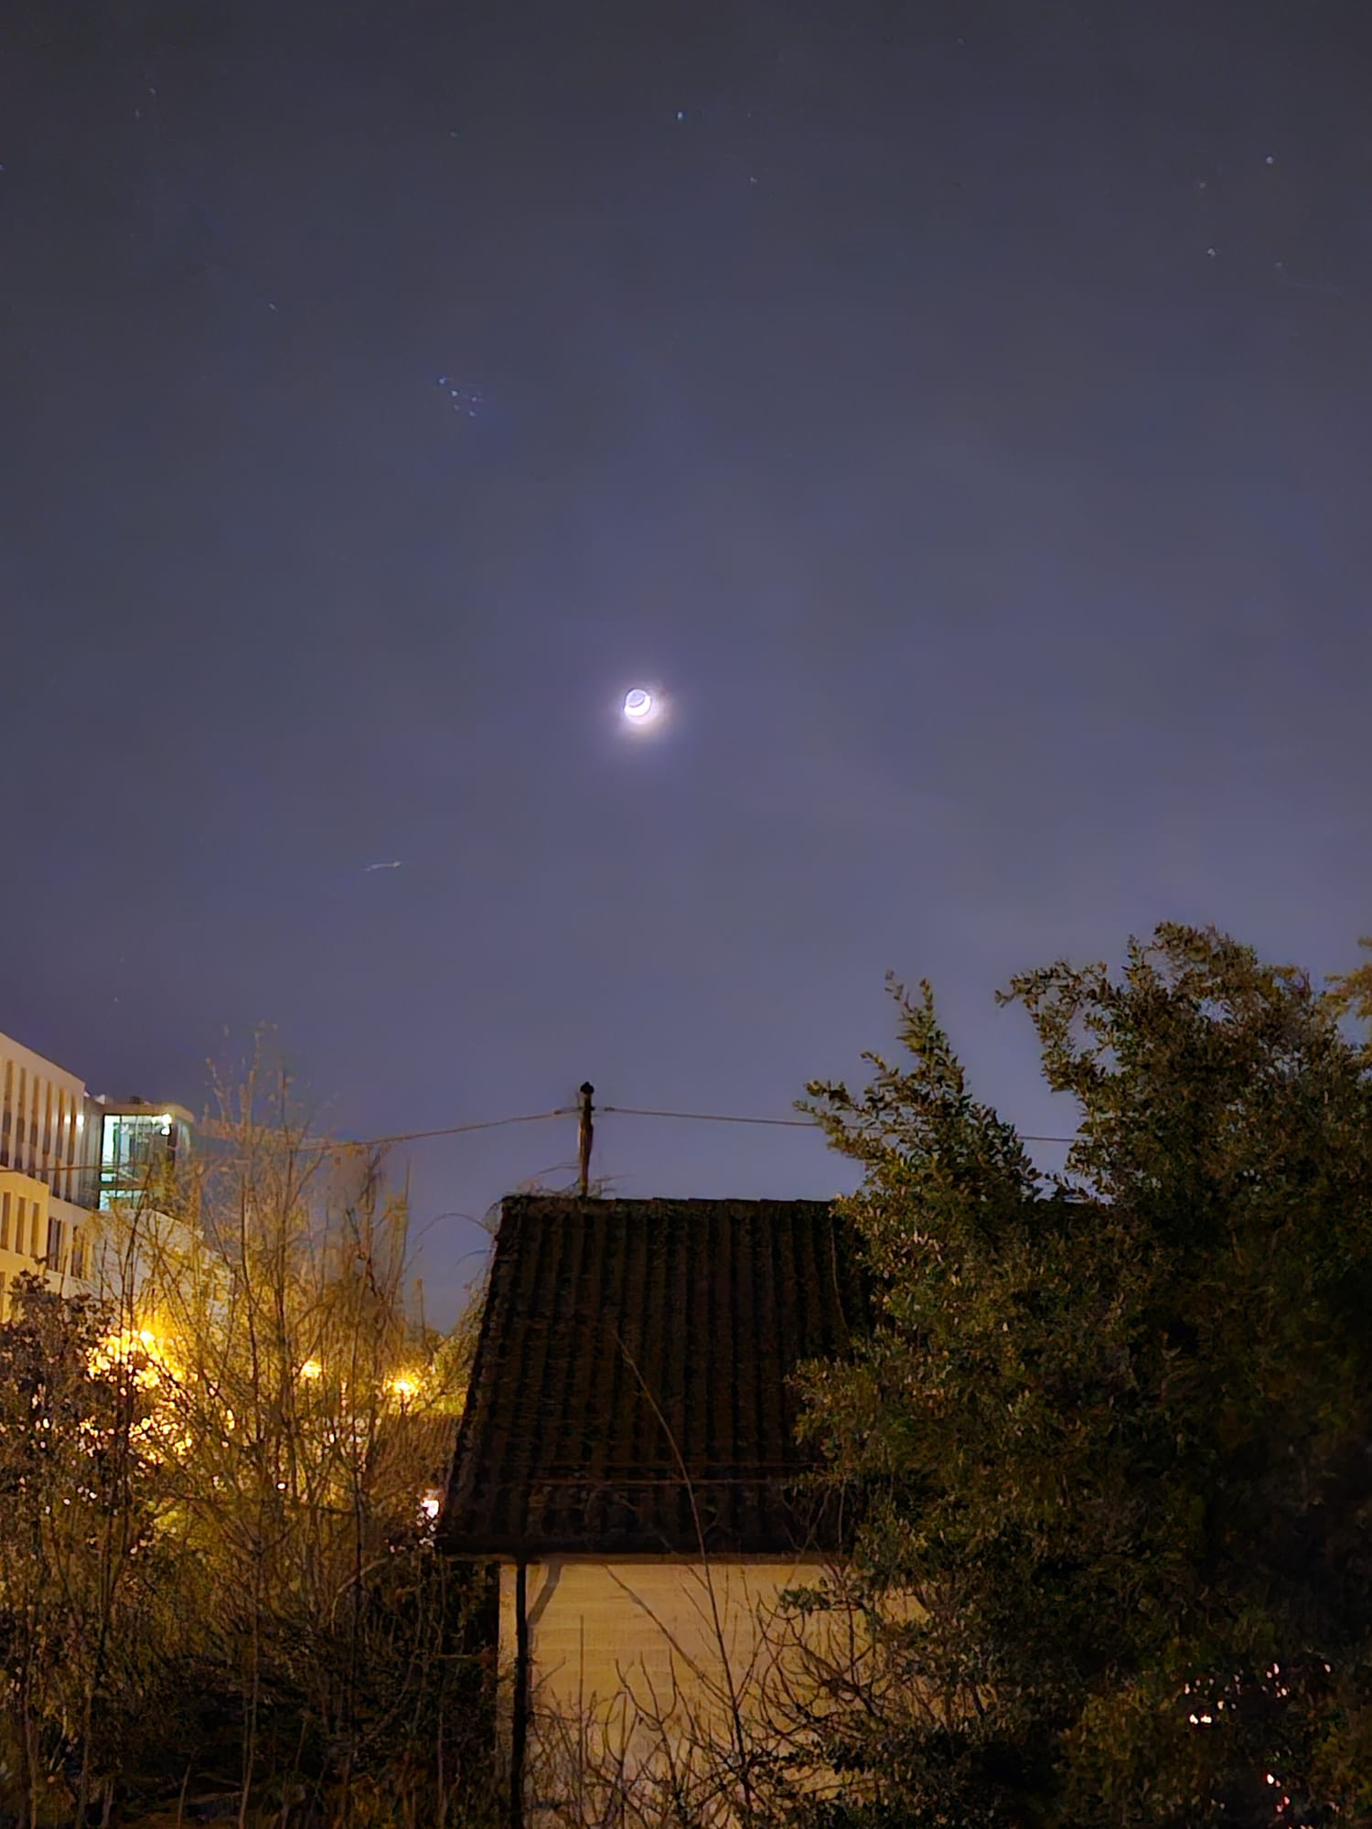
Figure 1. Francesca Cabral, "Waning Crescent Moon over Geneva," digital photograph, 22 March 2026, 21:40, Geneva.
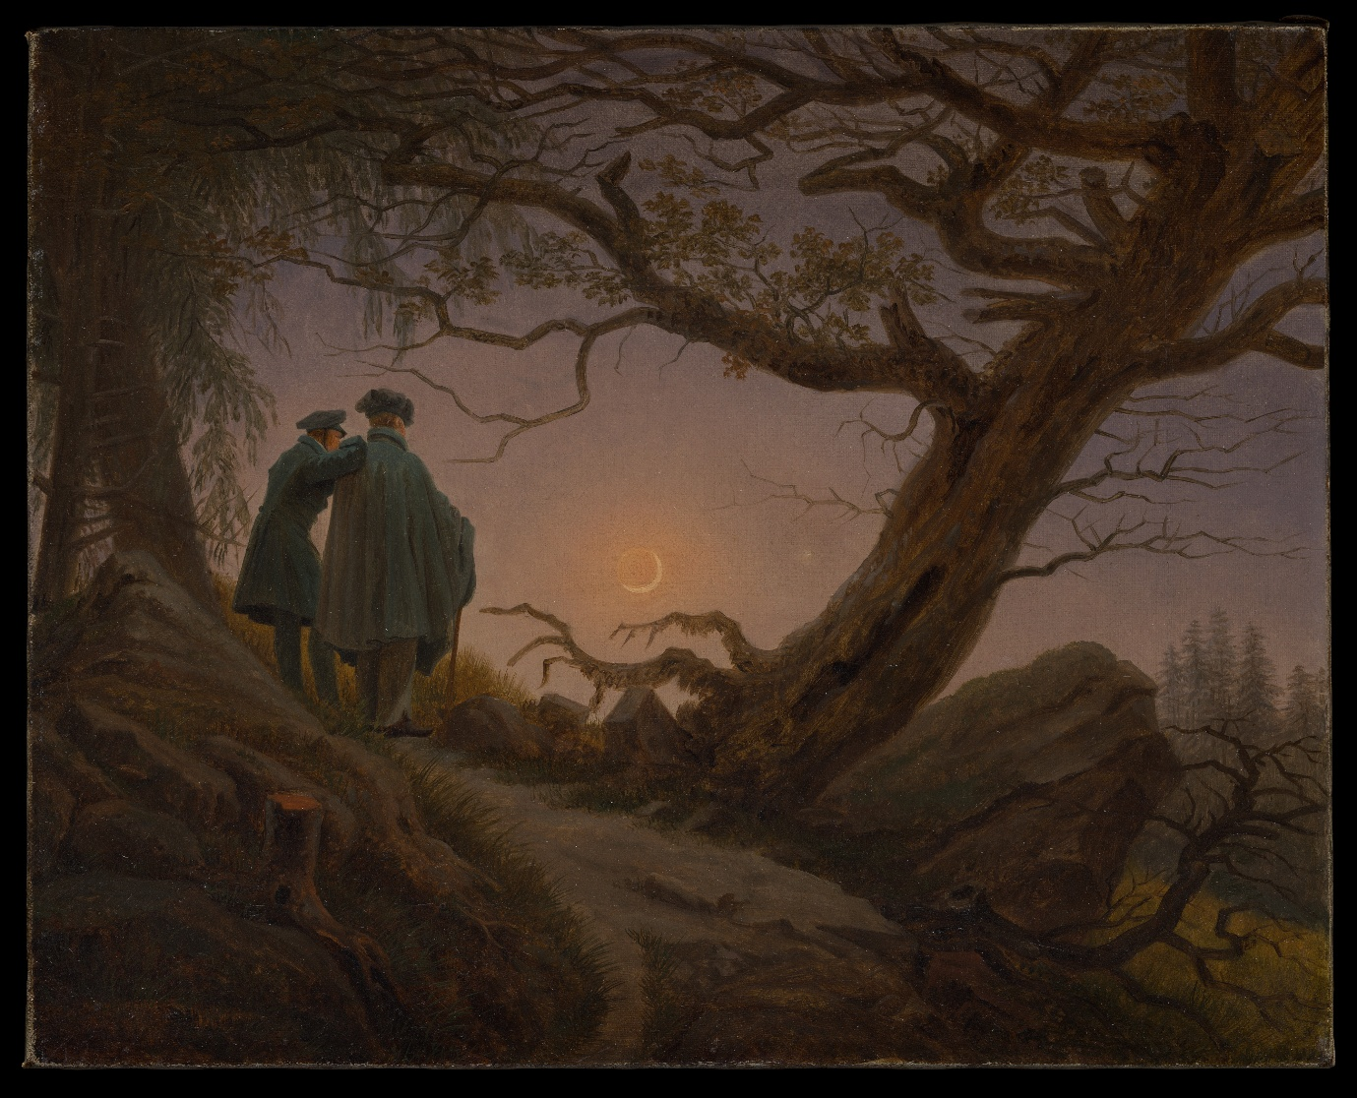
Figure 2 . Casper David Friedrich, "Two Men Contemplating the Moon," c.1825-30, oil on canvas, Metropolitan Museum of Art, New York.
Both images observe the same recurring crescent moon. The crescent seen from Geneva in 2026 and the crescent painted by Friedrich nearly two centuries earlier belong to the same lunar cycle, even though they appear through different places, histories, and conditions of looking. That shared moment in the cycle lets the comparison of this paper ask what changes regarding the knowledge that is produced, happens when the moon passes through different mediums of selenography. In my photograph, the crescent moves from direct sight to the phone screen and then into a digital image shaped by the device’s handling of faint light. In Friedrich’s painting, the crescent moves through observation, memory and compositional judgement, and the slow work of oil on canvas. The paper’s later sections unpack these questions in further detail. What becomes clear at this point however is that selenography is indeed wider than the realm of Western science it is often relegated to. If this lunar phase has occurred since time infinite, and its image created through an immeasurable number of mediums across the globe, then one can only wonder how vast the body of knowledge created from this one single astronomical phenomenon is.

Phenomenology and the Moon as Photograph and Painting

Encountering The Image
The image-making process of my photograph began several days before I took it, during several evenings when the crescent remained too faint to see with the naked eye. Forecasts kept suggesting poor visibility, and each evening of looking without finding it made the search feel more uncertain. When I finally saw it, I was closing the shutters during an ordinary evening. The sight stopped me frozen because the moon seemed to arrive out of the very uncertainty that had preceded it. It hung low in the sky and looked nearer than the moon usually does (Fig.1.), partly because of its position and partly because it had stayed just beyond sight for days before appearing plainly before me. I felt the relief in my body before I began to think about what I was seeing: my shoulders dropped, my face lifted, and I let out a loud breath I had not realised I was holding. I then raced for my phone. Even though I was aware that the moon would remain in the sky for a while longer, there was a feeling of haste that the much-anticipated moment could pass before I had fixed its image. The act of photographing began thereafter, in the shift from looking directly at the crescent to trying to hold that sight through a device.
When I reached for the phone, the encounter between the moon and I changed because it now had to pass from direct sight into the device’s way of handling light. The phone fixed one angle, one exposure, and one instant; in doing so, it held the moon together with the roofs, wires, branches, and streetlight from which I had seen it (Fig. 1.). What came back on the screen was recognisably the same sight, although it felt thinner than the live sky before me. However many angles or settings I tried, the final image did not match the intensity of the moon as I had just seen it. The glowing relation between the bright crescent and its shadowed body weakened, the purple tones of the evening lost depth, and the bodily reaction I felt was altogether absent from the photograph. When the viewing experience was transformed into the photograph what remained is as Barthes states, a physical record of what had been, and evidence that one had to stand before the lens at a particular moment. His ordinary examples, “this is my brother” and “this is me as a child,” demonstrate his point, the photographs points back to a specific person, object, or moment and asks the viewer to recognise that it had been there. The photograph therefore changes the viewing encounter by “arresting” it. What had been a moving relation between my body, the window, the sky, and the sudden appearance of the moon become a fixed image whose strongest claim is that the sighting took place. What remained in the photograph of that Geneva evening, was a record of where the crescent appeared and under what visible conditions I saw it, from one place and at one time. It also keeps me close to the kind of relation to the moon that belongs to my own present life: urban, hurried, device-mediated, and shaped by the pressure to seize the sight before it passes.
Meanwhile, in Friedrich’s “Two Men Contemplating the Moon,” my eye first rests on the purple sky, then on the crescent, then on the dark tree, and only after that settles on the two men below (Fig. 2.). The surface area of the canvas allocated to each element of the painting sets a sequence for viewing the painting in which the large sky sets the scene first, before the figures below become fully present within it. The crescent moon appears as a small brightness shaped by the purple dusk around it. To the right of the painting, the dark tree presses into the same purple field of colour and interrupts its openness with its heavy dark outline. This intentional viewing sequence created through Friedrichs painting is described by Crowther in “Pictorial Space and the Possibility of Art.” In his presentation of painting as a medium of image making, he insists that a painting does not give the viewer a neutral copy of a world already standing complete before the canvas, instead, it organises relations of depth, distance, colour, scale, and direction so that the eye moves through the painting in a particular order before taking the entire image in. The viewer comes to the scene following that arrangement, because the eye is held, delayed, redirected, or drawn onward by the way forms occupy the painted space. As the act of viewing is placed onto a canvas, the scene originally viewed is staged to create an order of seeing through the artist’s brush.

The Image and Knowledge
Whilst the smartphone lost in its production of the moon, the bodily relief of finally seeing it, the urgency that sent me reaching for the phone, the purple depth of the evening, or the feeling that I was at the moon’s mercy rather than in control of the sight, these are elements that resonated strongly in my viewing of Friedrich’s painting. It is within these elements that painting as a medium, in comparison with photography, seems able to hold something the photograph could not. The answer to this seems to partly lay in the reality of the live image of the moon, being translated first through human interpretation, before the image is made, as opposed to being viewed and the image created by a device. Merleau-Ponty’s account of painting helps to shed more light on this difference. In “Eye and Mind,” he says the painter “lends his body to the world,” meaning that painting does not begin from a detached eye that records an object from outside. It begins from embodied vision, from a way of seeing already bound up with movement, position, and feeling. That is why he also says, through Cézanne, that “Nature is on the inside”: light, colour, and depth are not just properties sitting out there in front of us, but things that awaken an echo in the body. Painting can then render that felt relation between the body and the view visible again. In Friedrich’s painting, the purple sky, the dark tree, and the two figures keep hold of what my photograph lost: the complex colour of the evening light, the bodily pull of wonder, the sense of how small we are under the moon, and the feeling that others are there beneath the same sky.
Jerndal builds on this notion of the painter lending himself to the image by arguing that Merleau-Ponty himself, turns to painting because painting can hold closer to perception as it is first lived, without forcing it so quickly into that fixed and settled form. In her reading of Cézanne, she states that he paints in ways that look “wrong” if you judge them by ordinary standards of accurate depiction, but those so-called mistakes are exactly what matter. A table edge may be broken, a jug may seem to be seen from too high while a pot beside it is seen from lower down, or fruit may blur into one another instead of sitting neatly in fixed places. Jerndal says these distortions are important aspects of image-making because they get closer to how the world comes to us in experience before reflection tidies it up into stable objects with fixed properties. When we look at something in life, we do not receive it as a neat set of finished facts. We do not see a table as if it had already been flattened into a diagram with every edge fixed, or fruit as if each piece sat in its own clear slot, or the moon as if it were a settled object with all its relations already measured. One sees while their gaze moves as one thing takes their attention, then another in the same way we do not take in Friedrich’s painting all at once. In my own viewing, my eye went first to the purple sky, then to the crescent, then to the dark tree, and only after that to the two figures below. While I was fixed on the moon, the tree was still pressing in from the side of the painting: its darkness, its height, and its stark outline kept interrupting the sky without fully becoming the centre of attention (Fig. 2.). That same tree functions as what Jerndal calls the margins of vision, where other things continue to solicit the gaze even when we are not fully looking at them. And this is where the brush of the painter, in this case Friedrich is able to produce a depth beyond the poetic sense, but depth to mean the density of a scene in which things do not sit side by side on one flat plane. The moon, the tree, and the two men are held in different relations of nearness and distance, and those relations are experienced in an order. The moon feels far away and yet strongly present, the tree feels near and heavy, and the figures below give that distance a human scale.
The painting for me kept the moon within both a remembered and felt world. It also answered a question my photograph leaves outside itself. When I viewed the moon in Geneva, I found myself wondering who else might be looking at it at that same moment, or who before me had stood under it with the same astonishment. The photograph could not hold those others with me; they remained absent from the frame and present only as thoughts in my mind. In Friedrichs painting, they were already there, in the two figures viewing the moon (Fig. 2.). There is an absence of solitude within the painting, created by showing the viewer the backs of the two figures in such a way that the viewer is invited to watch silently from a position behind them. Amstutz’s account of Friedrich picks up on this notion of a shared viewing experience through her reading of “Two Men by the Sea,” she presents the idea that their [Friedrich’s landscapes] open structure can sustain a community of feeling, meaning, the way his paintings are composed so that they do not lock the viewer into one fixed meaning or one fully scripted response. The paintings are “open” because they give the viewer room to enter them inwardly, but they are not empty. The process, as Amstutz explains it, works through entry, inward reflection, and communicable feeling. First, the painting gives the viewer a point of entry — this is why she spends so much time on the Rückenfigur, the figure seen from behind (insert figs). That figure does not present a specific face or fixed identity to interpret; instead, it draws the viewer in and lets the viewer reflect with him inwardly. Second, this inward response does not remain private in the shallow sense of “anything goes.” Amstutz argues, through Kant’s sensus communis, and Schiller’s theory of landscape, that the painting invites a personal experience that is nevertheless communicable in principle — not because everyone will literally feel the exact same thing, but because the work is structured to awaken a mode of feeling others could also enter. Friedrich’s landscapes are built to move viewers inwardly in such a way that their responses can still meet on shared ground. The work leaves room for subjective engagement, but it also guides that engagement toward wonder, spiritual reflection, and a felt relation to something larger than the self.

Images of the Moon Within Cultural Context
The previous section discussed the way the two images translate the viewing of the crescent moon through different processes. These processes kept my photograph within the fact that the crescent appeared above Geneva, yet it lost much of the bodily response that occurred upon viewing the moon with the naked eye, it lost the richness and depth of the purple sky, and sense of being at the moon’s timing. Meanwhile, Friedrich’s painting removed the element of objectivity in regard to the image he originally viewed. The image making process first had to pass through his phenomenological interpretation before being put onto the canvas. The process of creating the image was greatly slowed in comparison to the photograph. These differences in processes and mediums also carry with them, echoes of the cultural environments in which they were created, as discussed further below.
Friedrich’s “Two Men Contemplating the Moon” belongs to the late eighteenth- and early nineteenth-century world of German Romanticism, when empirical science, classificatory method, and improved instruments were changing how nature could be known. Astronomy had already widened the visible heavens through Herschel’s discovery of Uranus in 1781 and through telescopic work on nebulae, double stars, and stellar structure. The Moon was drawn into the same movement through increasingly exact selenographic drawings and maps, including Johann Hieronymus Schröter’s lunar studies, which presented the lunar surface as something to be described, measured, and named. Wetzels places early Romantic thought within the intellectual world of Jena in the 1790s, where writers, philosophers, and scientists were questioning whether a mechanical account of nature could explain human experience, spiritual feeling, and the sense of belonging within the natural world. For the Romantics such as Friedrich, the problem was not necessarily scientific observation itself, since Romanticism also depended on close attention to natural form, it was the possibility that nature might come to appear chiefly as separate parts of life, governed by external laws and available only to measurement. They feared a moon mapped through coordinates, craters, and visible markings could be known with greater precision while losing its place within a felt relation of distance, dependence, and wonder of something greater than. One can see this concern directly addressed in “Two Men Contemplating the Moon,” and the viewing order Friedrich sets up, where he takes the viewer on journey on which the crescent visible through relation between bodies, trees, path, darkness, and a narrowed sky as previously discussed. (Fig. 2.).
Amstutz further explores the theme of relationality, by exploring how across a variety of his works, Friedrich binds nature with humanity. She reads Friedrich’s landscapes through the Romantic use of analogy, where close observation of natural form could reveal correspondences between plant, body, and inner life. For example, in her reading of “Chalk Cliffs on Rügen” she makes note of a precise change between two versions of the image: when the figures are removed from the later watercolour, their postures remain in exposed roots, an angled stump, and a winding shrub. Similarly, In “Trees and Shrubs in the Snow,” she follows the same logic through branching twigs, snow-rounded lines, and small red marks that depict the shrub as vessels, nerves, and blood within the human body. Friedrich used his landscapes to show the human form within ecology, and thus respond to the loss of connection which science threatened for the Romantics. Friedrich’s landscapes carry human presence through mirroring human form, without needing the body to remain literally visible. In “Two Men Contemplating the Moon,” the leaning oak, lifted roots, and bare branches extend that relation into the moonlit scene (Fig. 2.). They make the landscape seem to bend, strain, and look with the two men beneath it, contributing to the viewing process of the painting feeling embodied and shared.
Centuries after Friedrich’s painted crescent, my photograph enters a contemporary world in which the Moon is seen through phones, orbital cameras, digital simulations, mission archives, and endless scientific planning tools. The distance between viewer and Moon has been altered by this image culture. The Moon remains far above in the sky, yet it is also repeatedly brought nearer than ever before through high-resolution mapping, spacecraft imagery, and the memory of Apollo 11´s human landing. Even those outside the field of astronomy can within a few clicks for example, view NASA’s recent lunar work showing LROC and ShadowCam imagery of Shackleton Crater, who’s technologies combine cameras suited to different lighting conditions, allowing sunlit and permanently shadowed regions near the lunar South Pole to be seen together in astonishing detail. Perhaps even more astonishing, Artemis now uses the South Pole as a site where images, terrain data, illumination, communication, and resource questions are brought together to assess possible human activity on the lunar surface. Although my photograph belongs to the less technologically advanced side of this visual climate and was not made for scientific measurement or mission planning, it nonetheless shares a culture in which the Moon is expected to become an image that can be stored, checked, enlarged, and returned to at one’s convenience. The phone let me keep the crescent after several failed evenings of looking, while also changing the encounter into what the device could produce: a fixed arrangement of bright curve, dark sky, roofs, wires, branches, and electric light (Fig. 1.).
Exciting as these developments may seem, they raise questions around the purpose of contemporary image making. While Friedrich and the romantics responded to fears around a world being divided into measurable parts, classified, and lacking in spiritual meaning, current lunar image-making carries that fear into a harder political field. By the time of Apollo, the Moon had already become a Cold War frontier for the pursuit of imperial pre-eminence in space. Moon imagery centres around access, landing sites, mapping, resource use, and strategic presence. For example, although The Outer Space Treaty states that the Moon and other celestial bodies cannot be claimed through national appropriation, ongoing debates around Artemis, resource extraction, and lunar “safety zones” are highlighting how easily a formal ban on ownership can sit alongside practices that begin to look like said ownership, or even colonization. For some, these concerns regarding lunar colonization are not far fetched, especially for people of the global majority who have witnessed a similar history in which science has served as a handbook to direct missions’ extraction and exploitation. In a capitalist world, Western science has often claimed neutrality on the one hand, whilst on the other, informing policy around the plundering of countless ecologies for profit, often not without violence and destruction of those who have stewarded said ecologies for centuries. If one were to apply Friedrich’s ideas of relationality to the skies today, or perhaps see them as part of the same living system as would be the case through a decolonial knowledge paradigm, then there is perhaps space to view less technologically advanced images of the moon like my photograph through a lens in which a dialogue between the cosmos and human unfolds, similar to that between the watchers and the moon in Friedrich’s work. The Crescent’s refusal to appear and be photographed for several evenings becomes Her voice. Her absence placed a limit on my looking, made me wait, kept me dependent on Her timing. That insistence by the moon unsettles a visual culture in which seeing can so quickly become reaching, and reaching can begin to look like a loss of relationality, and a step towards conquer.

Concluding Remarks
What this paper has shown is that the crescent moon does not become knowledge simply because it is seen. It becomes knowledge through the medium that receives it, the body that looks, and the cultural world that decides what sight is for. In “Moon over Geneva,” the phone secured the fact that the crescent appeared above Geneva at a particular time and under particular conditions of visibility. Yet the sight that first stopped me at the window was never fully carried into the photograph. The image kept the bright curve, the roofs, the wires, the branches, and the electric light, while the relief in my body, the purple depth of the sky, and the feeling of waiting on the Moon’s own timing remained partly outside the frame. Friedrich’s “Two Men Contemplating the Moon” produced a different kind of lunar knowledge. The painting could not necessarily ask the viewer to verify a sighting in the same way. However, it could ask the viewer to enter a relation, through the backs of the two men, the leaning tree, the narrowed sky, and the small crescent held at a distance.
For that reason, selenography cannot be treated here as a purely technical practice of describing the lunar surface. The comparison has shown it as a wider practice of relation, where the Moon may be mapped, stored, painted, remembered, approached, or waited for. In the contemporary moment, that question carries political weight because lunar visibility is increasingly tied to extraction and future occupation. The crescent’s delayed appearance above Geneva leaves the paper with its final take away: that in the same way Friedrich created relationality in his work many years ago, even today with technological advances, I had to relate to the Moon’s own timing, before I could view the full image.

Bibliography
Amstutz, Nina, "Caspar David Friedrich and the Aesthetics of Community," Studies in Romanticism, 54.4 (2015), pp. 447–75
——, "Caspar David Friedrich and the Anatomy of Nature," Art History, 37.3 (2014), pp. 454–81
Barthes, Roland, "Camera Lucida: Reflections on Photography," trans. by Richard Howard (Hill and Wang, 1981)
Brady, Bernadette, "Stars and Cultural Astronomy," Journal of Skyscape Archaeology, 4.1 (2018), pp. 129–33
Crowther, Paul, "Pictorial Space and the Possibility of Art," British Journal of Aesthetics, 48.2 (2008), pp. 175–92
Friedrich, Casper David, "Two Men Contemplating the Moon," ca 1825, Oil on canvas, 34.9 × 43.8 cm, The Metropolitan Museum of Art, Object no. 2000.51 <https://www.metmuseum.org/art/collection/search/438417>
Jerndal, Emma C., "Merleau-Ponty on Painting and the Problem of Reflection," European Journal of Philosophy, 29.1 (2021), pp. 74–89
LROC and ShadowCam teams, "A New Mosaic of the Shackleton Crater," 2023, Digital mosaic, NASA, “NASA Moon Camera Mosaic Sheds Light on Lunar South Pole,” 19 September 2023 <https://www.nasa.gov/missions/lro/nasa-moon-camera-mosaic-sheds-light-on-lunar-south-pole/>
Merleau-Ponty, Maurice, "Eye and Mind," in "The Primacy of Perception," ed. by James M. Edie, trans. by Carlton Dallery (Northwestern University Press, 1964), pp. 159–90
Schröter, Johann Hieronymus, "The Face of the Moon: Galileo to Apollo," 1816 1745, Public Domain <https://www.lindahall.org/experience/digital-exhibitions/the-face-of-the-moon/c-1700-1800/10-schroter-johann-hieronymus/>
Wetzels, Walter D., "Aspects of Natural Science in German Romanticism," Studies in Romanticism, 10.1 (1971), pp. 44–59

Casper David Friedrich, "Two Men Contemplating the Moon," ca 1825, Oil on canvas, 34.9 × 43.8 cm, The Metropolitan Museum of Art, Object no. 2000.51 <https://www.metmuseum.org/art/collection/search/438417>.
Ibid.
Bernadette Brady, "Stars and Cultural Astronomy,” Journal of Skyscape Archaeology, 4.1 (2018), pp. 129–131.
Ibid.
Roland Barthes, "Camera Lucida: Reflections on Photography," trans. by Richard Howard (Hill and Wang, 1981), pp. 79., pp. 80–81.
Ibid., pp. 4-5.
Paul Crowther, "Pictorial Space and the Possibility of Art," British Journal of Aesthetics, 48.2 (2008), pp. 175–192.
Ibid., pp. 183-184.
Maurice Merleau-Ponty, "Eye and Mind," in "The Primacy of Perception," ed. by James M. Edie, trans. by Carlton Dallery (Northwestern University Press, 1964), pp. 159–90 (p. 162).
Merleau-Ponty, ‘Eye and Mind’, pp. 162.
Ibid., pp. 164.
Emma C. Jerndal, "Merleau-Ponty on Painting and the Problem of Reflection," European Journal of Philosophy, 29.1 (2021), pp. 74–89 (pp. 75, 78, 83-86).
Ibid., pp. 83–84.
Ibid.
Ibid., pp. 78.
Ibid., pp. 85.
Nina Amstutz, "Caspar David Friedrich and the Aesthetics of Community," Studies in Romanticism, 54.4 (2015), pp. 447–75 (pp. 449–451).
Ibid.
Ibid.
In Kant’s aesthetic theory, sensus communis refers to a shared capacity for judgement through which a feeling of beauty can be presented as communicable to others, even though it is grounded in subjective experience.
Schiller’s theory of landscape treats landscape painting as capable of awakening feeling in the viewer while leaving room for inward freedom; in this sense, the landscape can guide a personal response that remains communicable to others.
Amstutz, "Caspar David Friedrich and the Aesthetics of Community," pp. 459–460.
Johann Hieronymus Schröter, "The Face of the Moon: Galileo to Apollo," 1816 1745, Public Domain <https://www.lindahall.org/experience/digital-exhibitions/the-face-of-the-moon/c-1700-1800/10-schroter-johann-hieronymus/>.
Walter D. Wetzels, "Aspects of Natural Science in German Romanticism," Studies in Romanticism, 10.1 (1971), pp. 44–59 (pp. 44–46).
Nina Amstutz, "Caspar David Friedrich and the Anatomy of Nature," Art History, 37.3 (2014), pp. 454–481 (pp. 456–59).
Ibid., pp. 459-460.
Ibid., pp. 455-456.
LROC and ShadowCam teams, "A New Mosaic of the Shackleton Crater," 2023, Digital mosaic, NASA, “NASA Moon Camera Mosaic Sheds Light on Lunar South Pole,” 19 September 2023 <https://www.nasa.gov/missions/lro/nasa-moon-camera-mosaic-sheds-light-on-lunar-south-pole/>.

