 | Student No: | 2128501
 | Module Title: | Operating Hotel Facilities
 | Module Code: | BMH4006
 | Lecturer: | Ffion Cumberpatch

Component Three:
Contribution to Overall Module Assessment: 50%
Your task is to create and prepare a presentation following the detailed scenario provided below.

As the floor housekeeping manager and given the recent guest complaints you need to put together a basic training presentation for your colleagues within the housekeeping team to get the best out of them, ensure that brand standard is being achieved, and that Health and Safety procedures are also being followed.

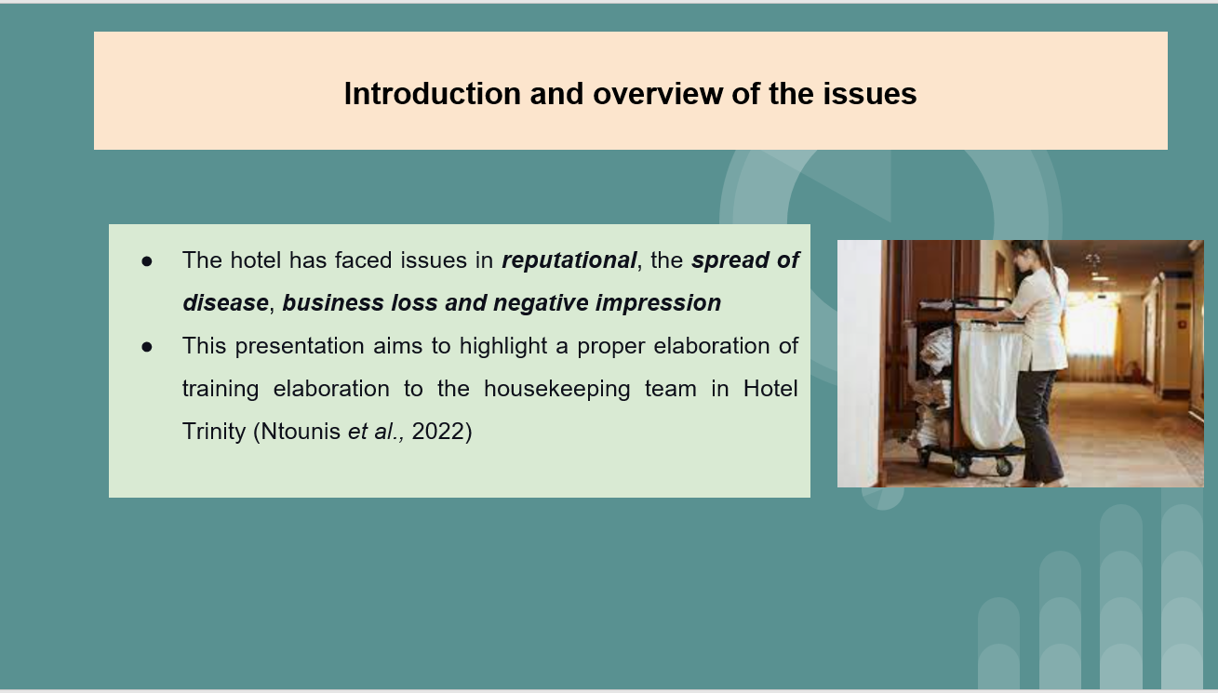
Training Notes: Housekeeping is a necessary element that is crucial for the hotel and the related industry not only in the UK but in any other part of the world. This is related to providing proper satisfaction to the clients who visit the facility for optimum benefit. This study aims to create a proper training presentation to make sure that the previously illustrated complaints are mitigated and a proper team is brought forward while ensuring the achievement of brand standards and health and safety procedures.
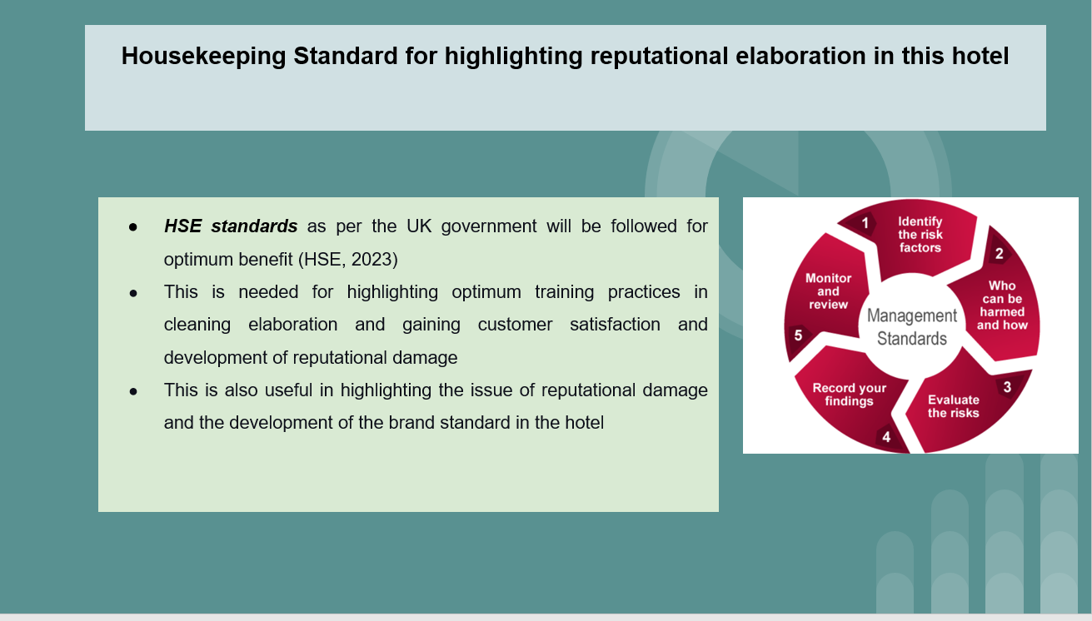
Training Notes:
The presentation is crucial to shed light on the HSE standard of the UK Government and how it is crucial for the team to bring forward optimum cleaning elaboration. This is not only effective for developing brand recognition of the hotel but also for creating optimum customer satisfaction and retaining them for a longer period.
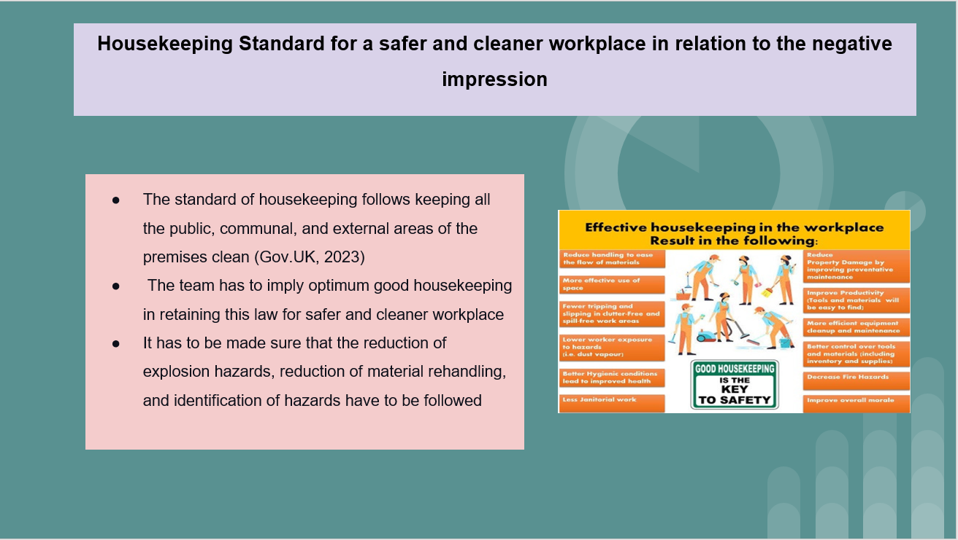
Training Notes: All the members of the team have to make sure that the standard of housekeeping based in the UK has to be followed. The team has to bring forward good housekeeping standards and strive for correlating with this law for a cleaner and safer workplace. It has to be made sure that the team is correlated to identify explosive hazards, material rehandling, and identify unwanted elements for improving the standard of the brand and also improve guest satisfaction.

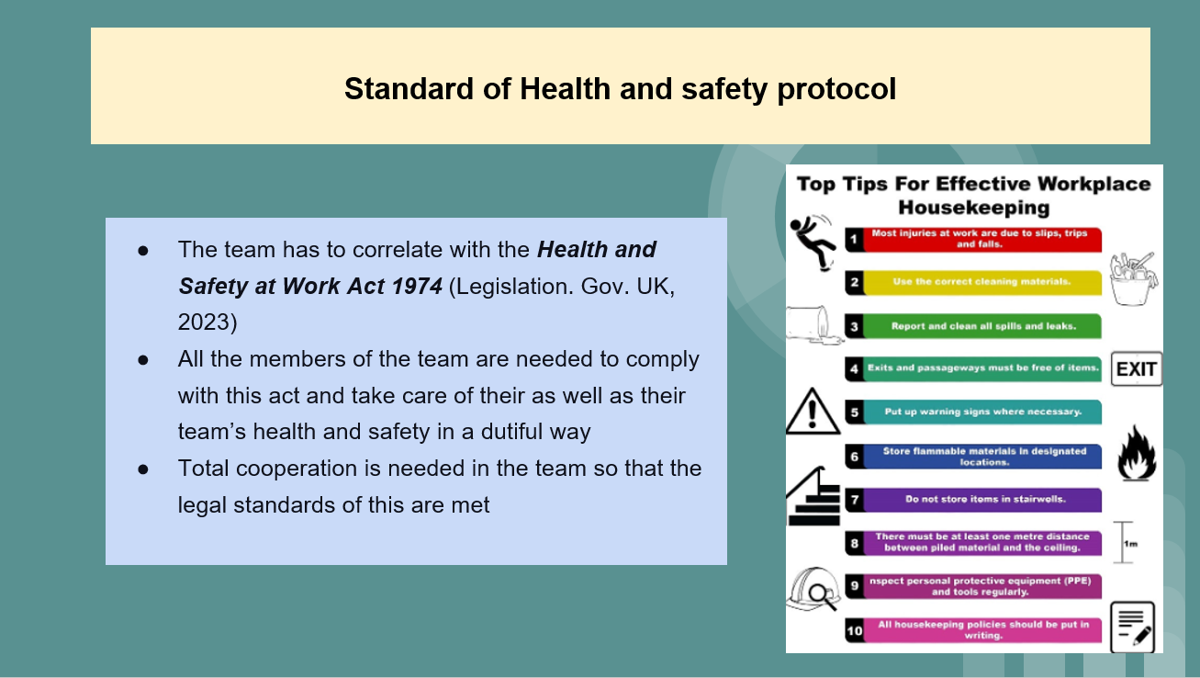
Training Notes: This particular act is mandatory to be correlated in the team for optimum benefit. All the employees and team members must take care of their own and their teammates’ health and also make sure that no one is affected by the actions of individual members at work. They also have to cooperate with the management as well as coworkers while helping them meet the duty to take reasonable care of the health and safety in the hotel premise.
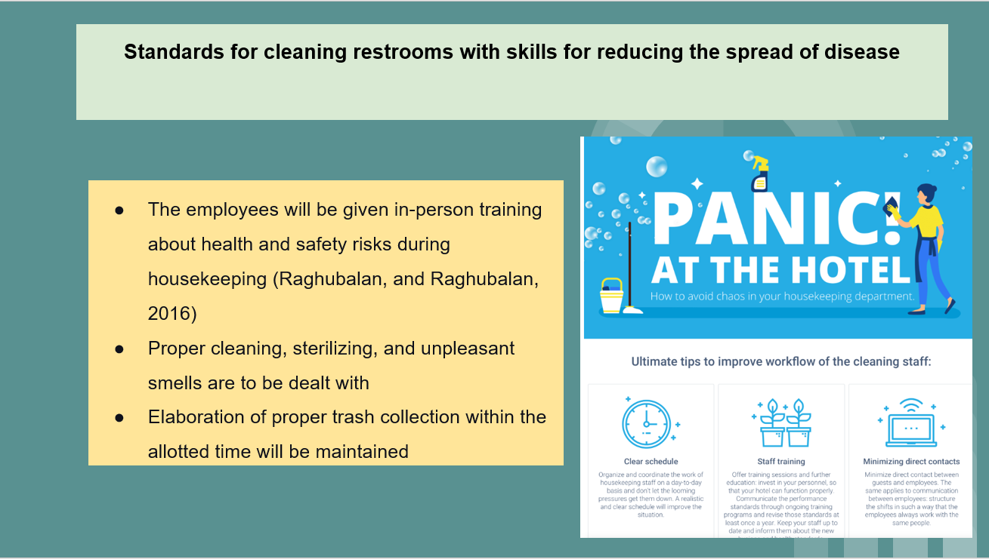
Training Notes: It has to be made sure that all the employees are given in-person training for health and safety elaboration. they have to properly clean, sterilise, and deal with unpleasant smells concerning the restroom. The employees also have to collect and dispose of trash within the allotted period.

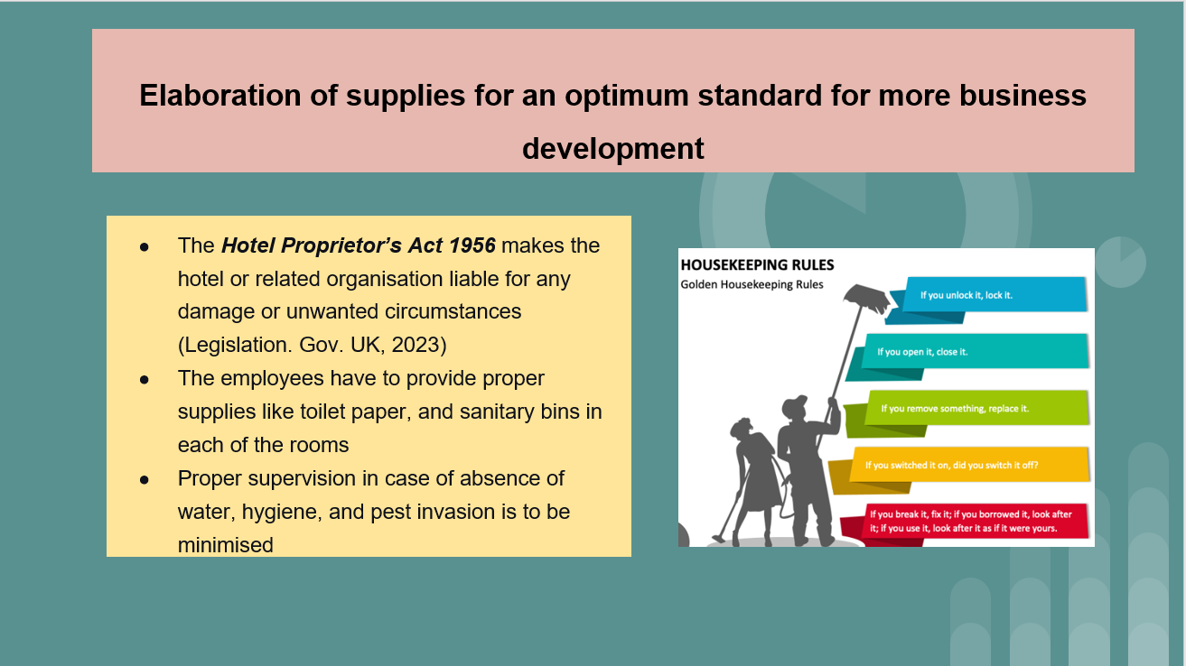
Training Notes: There has to be optimum support in providing all the needed amenities to each of the rooms. The act as mentioned is to be correlated for highlighting proper supplies and optimum standards while side-checking any damage. The employees have to provide a supply like toilet paper, sanitary bins other necessities individually. Proper supervision is also needed in the case of drinking water, hygiene elaboration, and pest control.
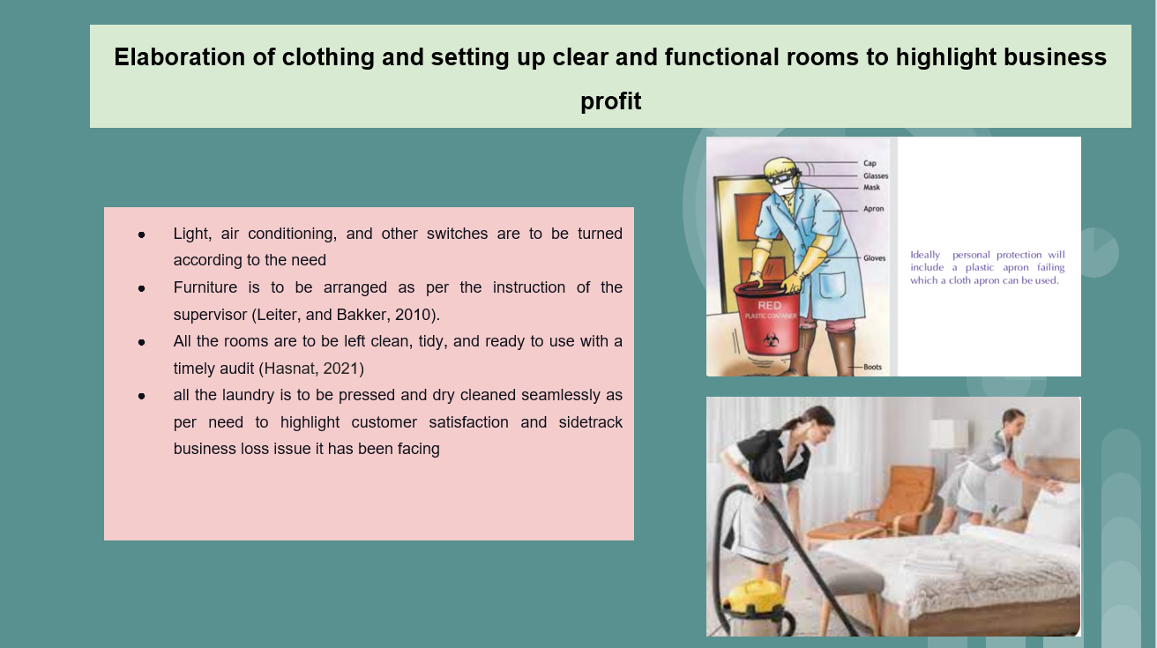
Training Notes:
One of the most crucial complaints is related to cleaning. This is why it has to be made sure that proper light air conditioning and other switches are to be maintained as per need. It also has to be made sure that proper furniture arrangement is done for a cleaner and more functional room setup. All the rooms have to be left clean, tidy, and ready to use. Timely audit is to be done to make sure that everything is clean and tidy and as per need. Most importantly all the laundry is to be cleaned and pressed as per the guest's needs.
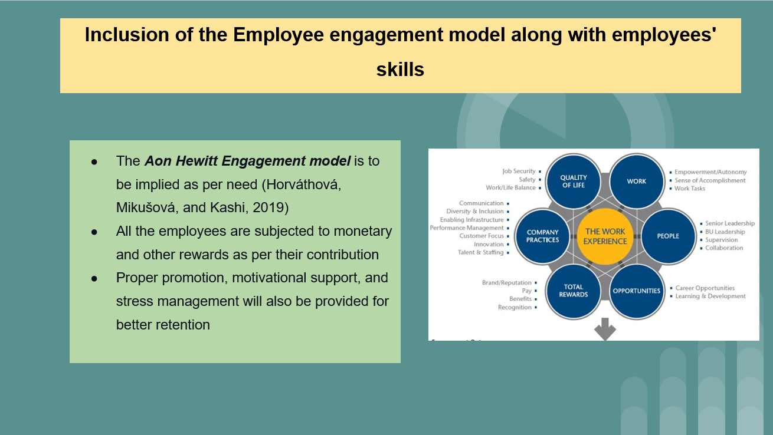
Training Notes:
The Aon Hewitt Engagement model is very much effective in retaining employees and engaging them for a longer period. This is one of the main reasons why proper monitory, as well as other benefits, will be provided to the employees as per their contribution to the hotel. Most importantly motivational support, stress management programs along with promotional illustrations will also be employed for best practices and customer satisfaction.
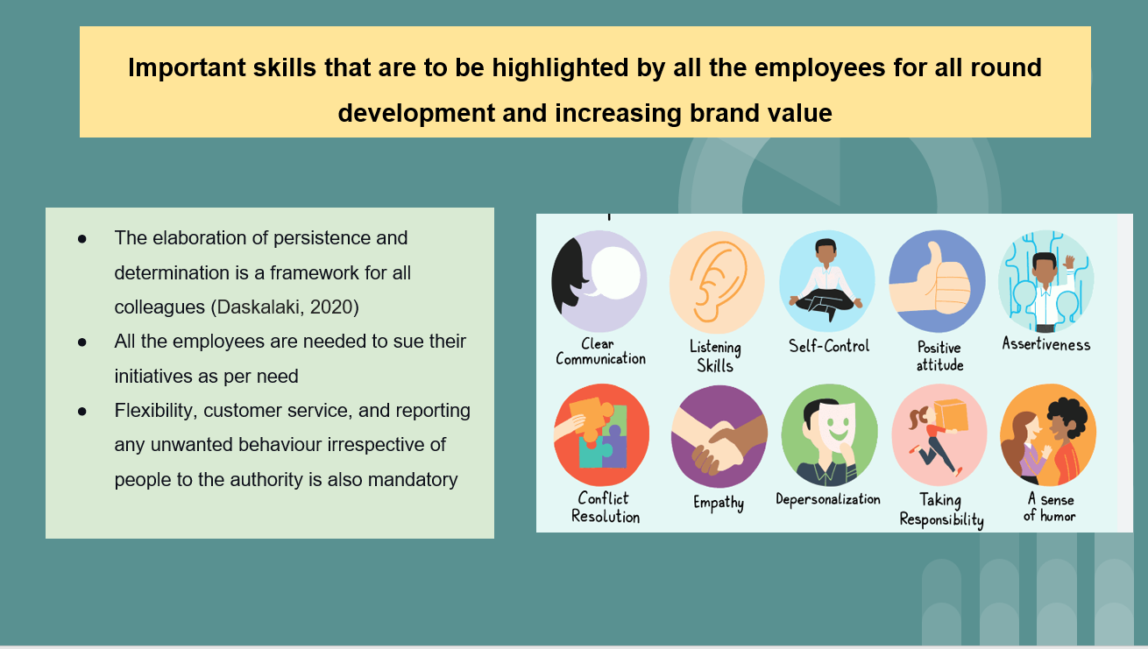
Training Notes: In addition to the practices mentioned previously, the employees are needed to highlight some subjective skills which are related to persistence, determination, and use of initiations as per need. The employees are also needed to be flexible, customers oriented, and report any unlawful behaviour irrespective of the personality to the authority for the best maintenance of the industry as well as Hotel standard.
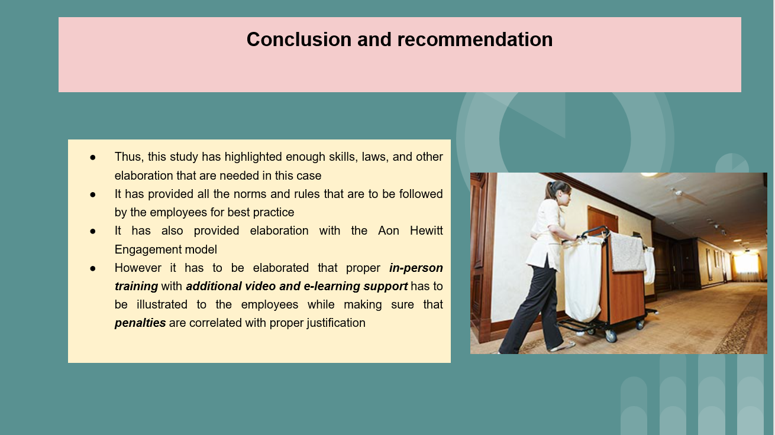

Training Notes: This study has included proper training presentation with which the management can create seamless employee management for the hotel and side-track client’s complaints in the future. In addition, it can be stated that the employees are to be trained with in-person justification with a timely audit to check their developments and mistakes which can pave the way to side-track all the four issues it has been facing.
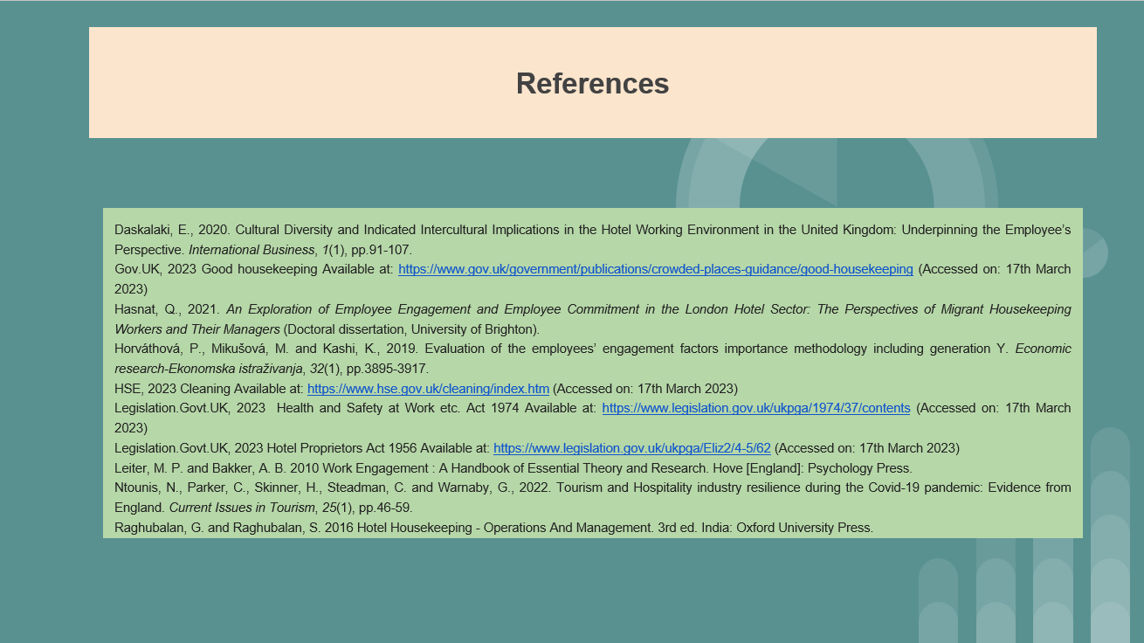

References
Alexakis, G. and Jiang, L., 2019. Industry competencies and the optimal hospitality management curriculum: An empirical study. Journal of Hospitality & Tourism Education, 31(4), pp.210-220.
Carlisle, S., Ivanov, S., Dijkmans, C. and Marco-Lajara, B.M.L., 2022. Environmental Skills Gaps in Tourism and Hospitality Organisations: Evidence from Europe. Tourism: An International Interdisciplinary Journal, 70(3), pp.411-431.
Casado, M. (2012) Housekeeping Management. London: Wiley.
Daskalaki, E., 2020. Cultural Diversity and Indicated Intercultural Implications in the Hotel Working Environment in the United Kingdom: Underpinning the Employee’s Perspective. International Business, 1(1), pp.91-107.
Dimbleby, R. and Burton, G., 2020. More than words: An introduction to communication. Routledge.
Fung, C., Tsui, B. and Hon, A.H., 2020. Crisis management: A case study of disease outbreak in the Metropark Hotel group. Asia Pacific Journal of Tourism Research, 25(10), pp.1062-1070.
Gibson, J.D. ed., 2018. The communications handbook. CRC press.
Goes, P.B., Ilk, N., Lin, M. and Zhao, J.L., (2018). When more is less: Field evidence on unintended consequences of multitasking. Management Science, 64(7), pp.3033-3054.
Gov.UK, 2023 Good housekeeping Available at: https://www.gov.uk/government/publications/crowded-places-guidance/good-housekeeping (Accessed on: 17th March 2023)
Hasnat, Q., 2021. An Exploration of Employee Engagement and Employee Commitment in the London Hotel Sector: The Perspectives of Migrant Housekeeping Workers and Their Managers (Doctoral dissertation, University of Brighton).
Horváthová, P., Mikušová, M. and Kashi, K., 2019. Evaluation of the employees’ engagement factors importance methodology including generation Y. Economic research-Ekonomska istraživanja, 32(1), pp.3895-3917.
HSE, 2023 Cleaning Available at: https://www.hse.gov.uk/cleaning/index.htm (Accessed on: 17th March 2023)
Jacobs, L. and Van Wyk, B., 2019. Engendering twenty-first century workplace literacy for the hospitality industry: exploring the role of the academic library. South African Journal of Libraries and Information Science, 85(1), pp.31-39.
Legislation.Govt.UK, 2023 Health and Safety at Work etc. Act 1974 Available at: https://www.legislation.gov.uk/ukpga/1974/37/contents (Accessed on: 17th March 2023)
Legislation.Govt.UK, 2023 Hotel Proprietors Act 1956 Available at: https://www.legislation.gov.uk/ukpga/Eliz2/4-5/62 (Accessed on: 17th March 2023)
Leiter, M. P. and Bakker, A. B. 2010 Work Engagement : A Handbook of Essential Theory and Research. Hove [England]: Psychology Press.
Losekoot, E., Lasten, E., Lawson, A. and Chen, B., 2018. The development of soft skills during internships: The hospitality student’s voice. Research in Hospitality Management, 8(2), pp.155-159.
Marneros, S., Papageorgiou, G. and Efstathiades, A., 2020. Identifying key success competencies for the hospitality industry: The perspectives of professionals. Journal of Teaching in Travel & Tourism, 20(4), pp.237-261.
Ntounis, N., Parker, C., Skinner, H., Steadman, C. and Warnaby, G., 2022. Tourism and Hospitality industry resilience during the Covid-19 pandemic: Evidence from England. Current Issues in Tourism, 25(1), pp.46-59.
Raghubalan, G. and Raghubalan, S. 2016 Hotel Housekeeping - Operations And Management. 3rd ed. India: Oxford University Press.
Sharma, N., Chaudhary, N. and Singh, V. 2019. Management Techniques For Employee Engagement In Contemporary Organizations. Hershey, Pennsylvania: IGI Global.
Wen, J., Huang, S.S. and Teo, S., 2023. Effect of empowering leadership on work engagement via psychological empowerment: Moderation of cultural orientation. Journal of Hospitality and Tourism Management, 54, pp.88-97.
Wood, R. 2013. Key Concepts in Hospitality Management. London: Sage.

