  Business plan:  Assignment 1 | Program Of Study: BA (Hons) Business Management  Module: Entrepreneurship (LCBB5001)  Title: Component 1: Written Report  Lecturer: Amer Kareem  Name: Adelina-Gabriela Stanciu (2245080)  Word No: 2259

Table of Contents
Overview of Romanian Nights 2
Product and Services 2
Target Customers 3
Legal Format Of The Company 3
Management of the company 4
SWOT Analysis 5
Strengths 5
Weaknesses 6
Opportunities 6
Threats 6
4Ps of Marketing Analysis 7
Product 7
Price 7
Place 7
Promotion 8
Cash flow forecast 8
Revenue and Expenses Breakdown per Event 8
Monthly Cash Flow Forecast 9
Annual Cash Flow Forecast 10
Conclusion 10
References 11

Overview of Romanian Nights
Romanian Nights is not just an event, it is a rich celebration of Romanian culture, traditions, and warm hospitality. Our goal is to transport guests right into the heart of Romania through a thoughtfully designed experience that excites all the senses. By combining tasty food, delightful drinks, vibrant music, and cultural engagement, Romanian Nights offers an unforgettable experience for all who attend.

Product and Services
We will hold lively parties every two weeks to celebrate Romanian culture. These events are well-planned to give a real taste of Romania, from the scenery to the flavours. Guests can enjoy traditional Romanian foods, from savoury dishes like stuffed cabbage and grilled sausages to sweets like special bread and doughnuts, all made by expert chefs. We also serve authentic Romanian drinks, including plum brandy and various local wines, plus non-alcoholic options. Music is essential at our parties, with live performances of both traditional folk music and modern tunes. We make the experience more fun by inviting everyone to learn and join in traditional Romanian dances. Our events are more than just fun; they're about bringing people together and making friends. With different activities, games, and special theme nights, guests can hang out, share their experiences, and make memories that last. We want to create a friendly place where everyone feels part of the group. By hosting these events every two weeks, we not only aim to entertain but also to keep Romanian culture alive in the UK. It's a way to celebrate our heritage and enjoy the good things in life with everyone, no matter where they come from.

Target Customers
The target market for our Romanian parties is primarily the vibrant and sizable Romanian community residing in the UK, with a specific focus on the Southampton area. The number of Romanians living in UK was 539,000 in 2021 (ONS, 2022). This community is bound to appreciate and revel in the authentic cultural experiences reminiscent of their homeland. In addition, our events are designed to appeal to anyone with a keen interest in experiencing the richness of Romanian culture. This includes individuals who enjoy exploring diverse traditions, savouring unique cuisines, and immersing themselves in lively and traditional Romanian music and dances. Whether they are Romanians longing for a taste of home, enthusiasts of multicultural events, or anyone curious to delve into Romanian customs, our parties promise an engaging and inclusive celebration for all attendees.

Legal Format of The Company
We propose incorporating our business as a Private Limited Company (PLC) due to its benefits in legal protection and financial stability for owners. This structure keeps personal assets safe from business risks and enhances the company's credibility with all stakeholders, making it more appealing to customers, suppliers, and investors. It opens doors to capital through share issuance, supports growth, and might offer tax benefits, with corporate profits taxed potentially lower than individual rates. Additionally, it simplifies ownership changes without affecting business continuity (Hargrave, 2024).

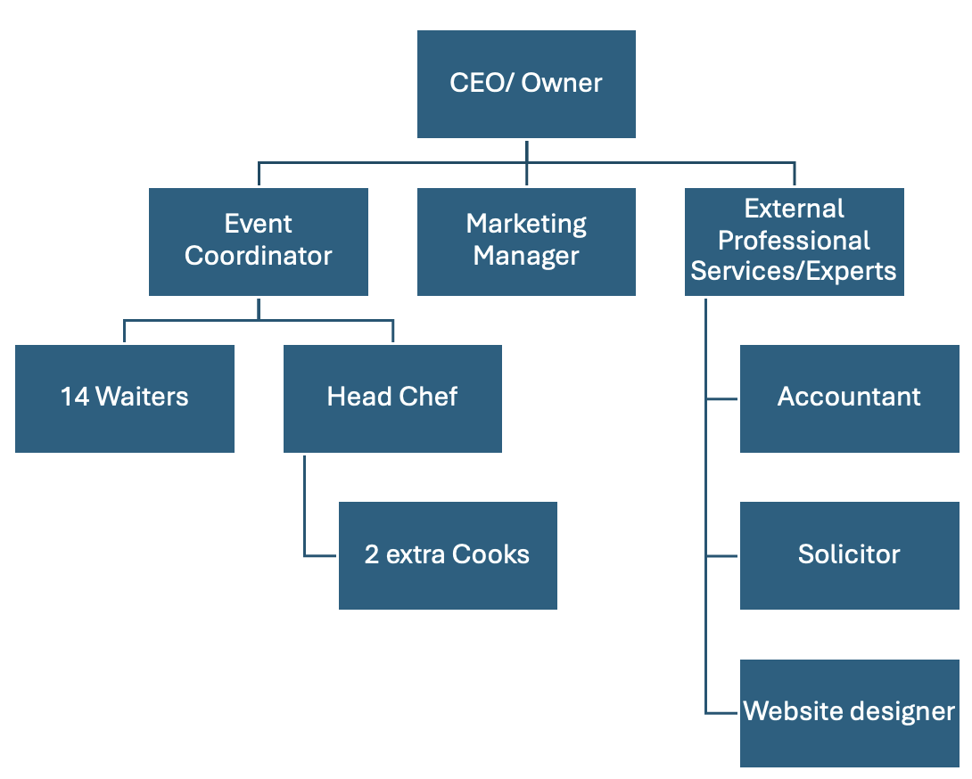
Management of the company

Our business's management structure, complemented by the involvement of external professional services and experts, is strategically designed to ensure efficient operations and exceptional service delivery. At the forefront is the CEO/Owner, who oversees all aspects of the business to foster departmental collaboration toward shared goals. This role includes managing daily operations, making strategic growth decisions, formulating and implementing marketing strategies to boost brand visibility and customer engagement, and handling financial matters such as budgets and forecasts to maintain financial stability aligned with the company’s objectives. The Head Chef is pivotal in creating an authentic culinary experience, responsible for developing traditional Romanian menus that appeal to both the Romanian community and newcomers to the culture, sourcing high-quality ingredients—ideally authentic Romanian products—to preserve dish authenticity and supervising the kitchen team to ensure efficient operation and safety compliance. Additionally, the Event Coordinator ensures the smooth execution of events by meticulously managing bookings, coordinating event staff—like waitstaff and entertainers—to ensure adequate coverage, and overseeing all event logistics to address any issues promptly. Simultaneously, the Marketing Manager focuses on establishing a strong online and offline presence by developing marketing campaigns to promote events and services, creating engaging content, managing advertising budgets, evaluating campaign effectiveness, and maintaining active social media profiles to engage with followers and foster an online community, while forming partnerships with local businesses and organizations to enhance the visibility and reach of our events.
External professional services and experts are essential for supporting our business operations. The accountant ensures accurate financial management and compliance with regulations, handling tasks such as maintaining financial records, tracking income and expenses, preparing statements, and conducting audits for financial integrity. The solicitor provides crucial legal support by offering guidance on compliance, drafting and negotiating contracts to protect the business, and assisting with intellectual property issues. Lastly, the website designer plays a key role in establishing our online presence by creating an appealing and user-friendly website that showcases our offerings, including event details and menus, and implementing an efficient online booking system for customer convenience.

SWOT Analysis

Strengths
The significant Romanian community in Southampton results in high demand for authentic cultural experiences. This event features genuine Romanian food, drinks, and music that cater to this need. Held at the centrally located Southampton Football Club, the venue can accommodate 420 guests and provides ample parking. Collaborations with Romanian producers for ingredients and drinks enhance the event's authenticity while fostering cross-country business relations. The comprehensive package, including a three-course meal, traditional drinks, and live music, ensures an immersive and appealing cultural experience.

Weaknesses
The event faces several weaknesses, including high operational costs due to the venue rental (£2000 per event), band fees (£3000), and staff wages. The ticket price of £100 per guest may be seen as steep, potentially restricting the customer base to wealthier individuals or those very interested in Romanian culture. Profits are also limited by dependence on the venue's bar, as bar revenues do not benefit your venture. Additionally, managing logistics for 420 guests, such as food preparation and service, demands significant coordination and efficient staffing.

Opportunities
Promoting Romanian culture in the UK, particularly in Southampton, poses a considerable chance not only for cultural preservation among the Romanian community but also for attracting cultural aficionados broadly. Success in this initial location could serve as a blueprint for expanding into other UK cities with significant Romanian demographics. Furthermore, there lies potential for valuable partnerships and sponsorships with Romanian cultural entities, businesses, and governmental bodies. Additionally, organizing cultural events opens avenues for extra revenue through merchandise sales, photo opportunities, and the provision of cultural workshops or exhibitions.

Threats
Economic downturns pose a threat to spending on cultural events, as fluctuations in the economy can reduce disposable income and, in turn, affect attendance. Additionally, the presence of competing events or entertainment alternatives may attract potential attendees away from Romanian cultural events. The business’s reliance on importing ingredients and drinks from Romania also leaves it vulnerable to disruptions in the supply chain. Furthermore, compliance with UK and EU import regulations and food safety standards could pose significant challenges due to potential regulatory changes.

4Ps of Marketing Analysis

Product
Offering an authentic Romanian dining experience, this product features a carefully selected three-course meal enriched with traditional Romanian flavors, utilizing genuine ingredients imported from Romanian suppliers. Guests can kick off their meal with appetizers such as "Salata de vinete" or "Mititei", followed by hearty main courses like "Sarmale" or "Mamaliga", and conclude with Romanian desserts such as "Cozonac" or "Papanasi". To complement the meal, approximately 1 liter of Romanian wine is provided per guest, along with non-alcoholic beverage options and access to a full bar for additional purchases. The experience is heightened by live performances of traditional Romanian music, inviting guests to immerse themselves fully through dance and cultural festivities.

Price
The pricing strategy is set at £100 per guest, which encompasses a sumptuous three-course Romanian meal valued at £30 per person, alongside the enjoyment of wine, soft drinks, and an immersive cultural experience with live band entertainment. The cost structure breaks down as follows: venue rental is priced at £2000 for each event, food costs are estimated at £30 per guest, and the expenditure for wine is roughly £3.50 per guest taking into account both procurement and transport. Staffing includes 3 cooks at a total of £400 and 14 waiters at £200 for the event, with entertainment by a live band costing £3000. Additional expenses involve a one-time outlay for decorations, plus ongoing costs for soft drinks, water, and miscellaneous operational logistics.

Place
Choosing Southampton Football Club's Saint Mary Stadium as the event venue offers numerous advantages due to its status as the largest local venue, capable of hosting 420 guests. Its strategic location near the city centre, alongside close proximity to train and coach stations, emphasizes its accessibility. Additionally, the venue provides extensive parking, further enhancing convenience for attendees. This central positioning facilitates effortless arrival via public transport and ensures ample parking, accommodating guests from across the city and nearby regions seamlessly.

Promotion
The targeted promotional efforts aim at the sizable Romanian expatriate community in the UK, especially those in Southampton and nearby regions, as well as individuals keen on immersing themselves in Romanian cultural practices, cuisine, music, and festivities. A multi-faceted approach will be employed, utilizing social media marketing on platforms such as Facebook, Instagram, and Twitter to connect with the Romanian diaspora and a broader audience by sharing updates, exclusive content, and testimonials. Partnerships with Romanian local businesses, cultural organizations, and community groups will further amplify event exposure. Additionally, email campaigns will disseminate information and possible early bird discounts to prior guests and prospective attendees. Encouraging word-of-mouth recommendations is another strategy, alongside advertising on local event listings, community noticeboards, and specific cultural websites that the target audience frequents. Efforts to gain media coverage through local print and broadcast channels will also be vital to increase event visibility.

Cash flow forecast
This detailed 12-month cash flow projection encompasses all pertinent data, assuming the organization of bi-weekly traditional Romanian parties, aiming for a total of 26 events within the year. The business model is built on these gatherings attracting a full house of 420 guests each time, thereby guaranteeing optimal revenue generation. The forecast considers both fixed costs, such as venue rental and other consistent expenses unaffected by attendee numbers, as well as variable costs, which fluctuate depending on guest attendance. The main assumption for this financial outlook is the complete sell-out of each event, maximizing income potential and laying the groundwork for calculating the expected annual profit.

Revenue and Expenses Breakdown per Event
Revenue
Ticket sales are priced at £100 per guest.
420 guests * £100 = £42,000 Total Revenue

Expenses
- Venue hire is estimated to be: £2,000
- Provision of a 3-course meal is calculated at: £30 per guest * 420 guests = £12,600
- Romanian wine, which is imported, costs: £2.50 per litre + £1 per kilo for transport * 420 guests, totalling £3.50 per guest * 420 guests = £1,470
- For soft drinks, including popular beverages like Fanta and Cola: Assuming £1.50 per litre and consumption of 1.5 litres per guest = £2.25 per guest * 420 guests = £945
- The cost for chefs is: 3 cooks * £400 each = £1,200
- The expense for waiters, who number fourteen, is: 14 waiters * £200 each = £2,800
- A live band, which is a crowd-attracting feature, costs: £3,000
Total Expenses per Event
£2,000 (venue hire) + £12,600 (meals) + £1,470 (wine) + £945 (soft drinks) + £1,200 (chefs) + £2,800 (waiters) + £3,000 (band) = £24,015
Net Profit per Event
£42,000 - £24,015 = £17,985

Monthly Cash Flow Forecast
As each month will have approximately 2 events (considering the parties are held every other week), the breakdown the forecast as
The monthly revenue can be determined by taking the revenue per event and multiplying by 2 events (considering the parties are held every other week).
£42,000 per event * 2 events per month = £84,000
The monthly expenses are calculated likewise, by multiplying the expenses per event by 2 events.
£24,015 per event * 2 events per month = £48,030
The monthly Net Profit is then determined by subtracting the monthly expenses from monthly revenue.
£84,000 - £48,030 = £35,970

Annual Cash Flow Forecast
The calculations will be executed by summarizing for the entire year, based on 26 events.
Annual revenue - £42,000 per event * 26 events per year = £1,092,000
Annual Expenses - £24,015 per event * 26 events per year = £624,390
Annual Net Profit - £1,092,000 - £624,390 = £467,610

Conclusion
Wolf (2021) suggests that any enterprise bringing in less than $50,000 annually fits more into the category of a hobby rather than a bona fide business. He argues that a venture doesn’t achieve genuine business status until it reaches or surpasses monthly sales of $8,000, equating to an annual income of $100,000. Wolf describes enterprises falling below this benchmark as "Seedlings," implying they possess promising potential yet are still in the nascent stages of development and have not fully come into fruition.
Given the high interest we expect and our plans to fill every event, the traditional Romanian parties we're planning could make a lot of money. If we manage to sell out all our events and keep our costs under control, we're looking at making an annual net profit of £467,610. This number points to a strong and positive financial future for our business, showing great promise for making good money and growing steadily over time.

References
Hargrave, M. (2024) What Public Limited Company (PLC) Means in the U.K. Available at: https://www.investopedia.com/terms/p/plc.asp. (Accessed: 20 November 2024)
ONS (2022) International Migration, England and Wales. Available at: https://www.ons.gov.uk/peoplepopulationandcommunity/populationandmigration/internationalmigration/bulletins/internationalmigrationenglandandwales/census2021#:~:text=The%20number%20of%20people%20who,%25%20of%20all%20usual%20residents. (Accessed: 20 November 2024)
Wolf, M. (2021) Business Recovery in Difficult Times. 1st edn. BookTrail Publishing. Available at: https://www.perlego.com/book/2939973 (Accessed: 13 November 2024).

