Celebrating Language and Culture

Contents

Rationale 3-5

Overview of activities 5-7

Evaluation 8-9

Appendices 10-11

References 12

This Portfolio will discuss the different interventions used to encourage the Welsh language in education and also the welsh culture, this will include looking at theorists, learning styles and different Government documents including the National curriculum and Curriculum Cymraeg. Schools in Wales have had a different curriculum to England since 1988.The aim of this change was to develop a curriculum with Welsh language and culture to be at the focus of all subjects being taught in Wales, also encouraging cross curricular activities to take place which was included in the 1995 Curriculum Cymraeg. According to (Owens, 1996)
“The 1988 Education Reform Act offered remarkable curricular and institutional potential to Wales. It established a separate Curriculum Council for Wales to advise the Secretary of State and this resulted in the development of a distinctly Welsh curriculum for schools. Separate Orders were developed in history, geography, art and music in addition to the Welsh First and Second language Order and a Welsh dimension to the remaining subjects. In 1995 the Curriculum Cymreig (Welsh Curriculum) was given statutory status in every subject.”

The Siarter Iaith is a framework that offers schools guidance to help ensure that the pupils are confident within and have positive attitudes towards the Welsh language skills that they have. According to the (Welsh Government, no date) “We want to inspire children and young people to use Welsh in all aspects of their lives. The Siarter Iaith is for everyone; all parts of the school community have a part to play-the school council, learners, workforce, parents, carers, governors and the wider community. This will ensure every school has full ownership.”
Schools in Wales are responsible for their part of sustaining the welsh language, (Welsh Government, 2017) highlights this in “The purpose of the Welsh in education action plan 2017-2021 Is to set out our direction for the development of compulsory welsh- medium and welsh language education over the next four years, in line with the vision of Cymraeg 2050: A million Welsh speakers in Wales. Our national mission” The Welsh Government has implemented these into the plan for a million Welsh speakers by 2050 and also has steps to be followed for the new curriculum in 2022. “There are challenges ahead but over the next four years our main aim is to ensure that the required leadership, capacity and infrastructure to deliver the changes are embossed in order to move forward with this important work for our future generations.”(Welsh Government, 2015) Within this framework many strategies are highlighted and discussed with the aim to promote and develop the welsh language and welsh culture further. This plan highlights that staff at all levels will be provided and supported with training they may need to reach this target. According to (Welsh Government, 2017), “Developing the Welsh language skills of our practitioners and capacity to teach through the medium of Welsh is essential to enable the continued growth of the Welsh medium sector, and to improve the teaching and learning of welsh as a subject.”
The new curriculum in 2022 has four purposes; it aims to ensure that all young people will be ethically informed citizens, healthy confident individuals, enterprising, creative, contributors and ambitious capable learners. Welsh Government says that “The new professional standards for teaching and leadership published in September 2017, acknowledge that all practitioners need to continually develop their welsh language skills and that all education leaders consistently emphasise the promotion of welsh culture and language within the ethos of the school and develop the school as an organisation.”
According to (Welsh Government, 2017) “Must ensure that the Welsh language is considered at the forefront of planning and delivery of services to support our learners with additional learning needs and ensure that practitioners and the wider education workforce have access to Welsh language support and resources to help both our most vulnerable and our most talented to reach their potential.” The first part of the action plan has been the government has proposed in the additional learning needs tribunal for the Welsh language support to become stronger, to further support learners with ALN.”
Setting A is a special school that supports pupils with additional needs in primary and secondary classes. The pupils are taught from the national curriculum but within the classroom setting they are also set individual education plans, these provide targets for the young people to be working towards. Setting A celebrates Welsh week each year ,within this the young people experience a variety of activities which celebrate and educate them on welsh culture and recap on welsh key words that the pupils are taught throughout the school year. For the activities discussed in this portfolio the groups were split into three groups of two based on their ability. Each group had three activities to complete, which are similar but altered slightly to support them individually. Firstly the whole class sits for a greeting session, during which incidental welsh is used for feelings, weather and also ‘welsh word’ which is a welsh word of the term that the young people learn to say or become familiar hearing the word. After each term passes another is added so each day in greeting the welsh words are all recapped. After this the students move into their work areas and the first session is cookery.(See Appendix 1) The staff member shows the group pictures of welsh cakes, talks about them and why they are important to Wales etc and encourages interaction and the use of incidental welsh words and reflecting on the welsh culture as much as possible. To encourage literacy skills the instructions are provided step by step supported with symbols. These are on a task board for the higher ability group; the lower ability group has the symbolised instructions with less content. Also included are the ingredients and equipment needed, again this is differentiated. Throughout the instructions contains numeracy with the amount of ingredients needed, also following the order of the instructions. The pupils are encouraged to work as independently as possible and take turns of using the welsh words modelled to them within the activity. During this session humanities and health and wellbeing are also included for a cross curricular link.
The next session, is finding numbers in sand. During this the pupils have to roll a dice, count the spots in welsh and then find the same number in the sand. Before this the staff member practices the numbers in welsh with the students and models the activity. Throughout this activity the young people are using communication, turn taking, numeracy, welsh and fine and gross motor skills.
According to (Welsh Government, 2020)
“The Common Requirements of the School Curriculum in Wales provide that: ‘Pupils should be given opportunities, where appropriate, to develop and apply knowledge and understanding of the cultural, economic, environmental, historical and linguistic characteristics of Wales.’ This statement is deliberately inclusive and aims to reflect the plurality and diversity of Wales in the twenty-first century. Its requirements will help pupils to understand what is distinctive about life in Wales, to celebrate diversity and to acquire a real sense of belonging.”
The third activity was to taste traditional Welsh foods (See Appendix 2 ), staff taught the pupils the name of the food, encouraging them to repeat it back they then explain that these foods are all from Wales as each food is shown one at a time. Then the children are encouraged to use their senses to explore the food and communicate about them. Some pupils may not want to touch, smell or taste the different foods but are encouraged to recognise the name of the food and say or sign it back to the staff member. Once the group has been given the opportunity to taste the food they cut out the picture of that food and stick it under like or dislike. This is a fun way for the pupils to experience and explore the welsh culture. Throughout this activity the young people are encouraged to recognise the name of each food using incidental welsh where possible, staff also model this throughout. After each food the children are asked to choose if they like it or not which is linked to health and wellbeing. During this session the pupils are working on literacy and communication, to talk about what they can see/taste/smell. Science as they are using their senses to explore the different foods and Humanities as they learn about the welsh culture.
Throughout these activities the approaches are all different to provide a motivating, exciting session and motivate the pupils and encourage them to stay on task and focused. When working with students it is essential to be aware of different learning styles and having flexibility to change the approach of the activity to whichever way will support the individual best. There are many learning styles such as, verbal, visual, musical, kinaesthetic, logical, social, and solitary and combination.
Many different theorists have different ideas about the best learning styles and focuses, The Montessori theory is from Maria Montessori a theorist who believes that independence is the main focus and what we should be striving for. This is highlighted in (Montessori, 2020) “It is always a goal of Montessori education in the classrooms to make the child independent and be able to do things for himself. This is achieved by giving children opportunities. Opportunities to move, to choose what they want to do, and to help the adults with tasks. When the children are able to do things for themselves there is an increase in their self belief, self confidence and esteem that they may carry on throughout their life.” This theory encourages children’s confidence and believes that it can have a positive impact of the individuals, another theorist Vygotsky also focuses on young people learning to problem solve but with guidance, “The distance between the actual developmental level as determined by independent problem solving and the level of potential development as determined through problem solving under adult guidance or in collaboration with more capable peers.” (Mcloed, 2019)This is where Vygotsky backed his idea that when a student is provided with the appropriate assistance they will feel supported enough to complete the task. Vygotsky believed that supportive activities would enable the learner to feel more confident. Throughout the tasks above the learners are supported by the staff and appropriate actions are modelled and encouraged for the young people to complete the activities. According to (Mcloed, 2019) “Much important learning by the child occurs through social interaction with a skillful tutor. The tutor may model behaviours and/or provide verbal instructions for the child. Vygostky refers to this as co-operative or collaborative dialogue.”This again supports the activities above where the young people follow the actions and instructions from the staff member and constantly be working towards as much independence as possible. Bruner’s theory of scaffolding highlighted that “It is important for teachers to provide opportunities for children to constantly learn new things. Some of those maybe highly complex and will require support of a very focused kind.”(Wheeler, 2014) This encourages staff to focus on the individual child’s ability and progression and work alongside that rather than generalising the aim of the activity. (Mcloed, 2019) suggests that “Scaffolding is most effective when the support is matched to the needs of the learner. This puts them in a position to achieve success in an activity that they would previously not have been able to do.”
Within the three activities, many aspects were considered whilst planning them. Firstly the differentiation between the groups to individualise the activity for each individual’s ability even within the groups, this was done by different questions being asked, different level of prompts some pupils may have needed verbal prompting whilst others may have needed gestural prompting and modelling. Throughout staff adjust depending on the support the pupils needed. However the worksheets and activity learning objectives stayed the same for each group. To differentiate further the activities could have been made longer or in more detail for the higher ability groups. Each of the activities discussed were prepared to meet each of the individual pupils needs, things such as sym writer (a computer programme which adds symbols to the words), Makaton, verbal instructions, repeated verbal instructions were also included to support throughout the sessions. The desired behaviour was modelled by the leader of the task and praise and tokens were given immediately as reinforces for this behaviour. Within the activities the pupils were encouraged to repeat incidental welsh and learn key words related to the welsh culture. Firstly the cookery session, which included literacy, numeracy ,humantities and health and wellbeing . Throughout this activity the pupils had a bowl each, perhaps the groups could have worked together to encourage peer motivation, sharing and turn taking. These are targets some of the individuals are working on and this would have supported those targets well. Secondly the tasting of the welsh foods, this activity was supported by pictures and two columns where the pupils separated them into likes and dislikes. To improve this activity in the future the higher ability group could have verbally answered more questions about the food such as the colour, food category etc. The lower ability group could have matched pictures of the food to the object to emphasise their understanding of the object recognition.

As a society Wales is very diverse and there isn’t a specific definition or expectation of what it means to be Welsh. Depending on people’s linguistic, cultural and economic background people have different perceptions of this however pupils that are living and learning in Wales should experience the same in the curriculum. (Welsh Government, 2003) supports this in “A Curriculum Cymreig can be used as a unifying principle, fostering a sense of belonging for all pupils and increasing their understanding of the country in which they live. What is important, in all cases, is that work is planned to meet the needs of individual pupils and schools, and that there is a strong focus on developing pupils’ knowledge, skills and understanding within a Welsh context.”

Appendix 1
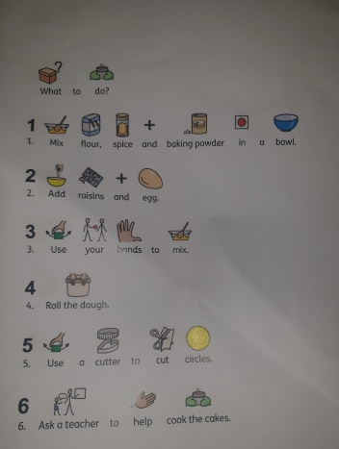
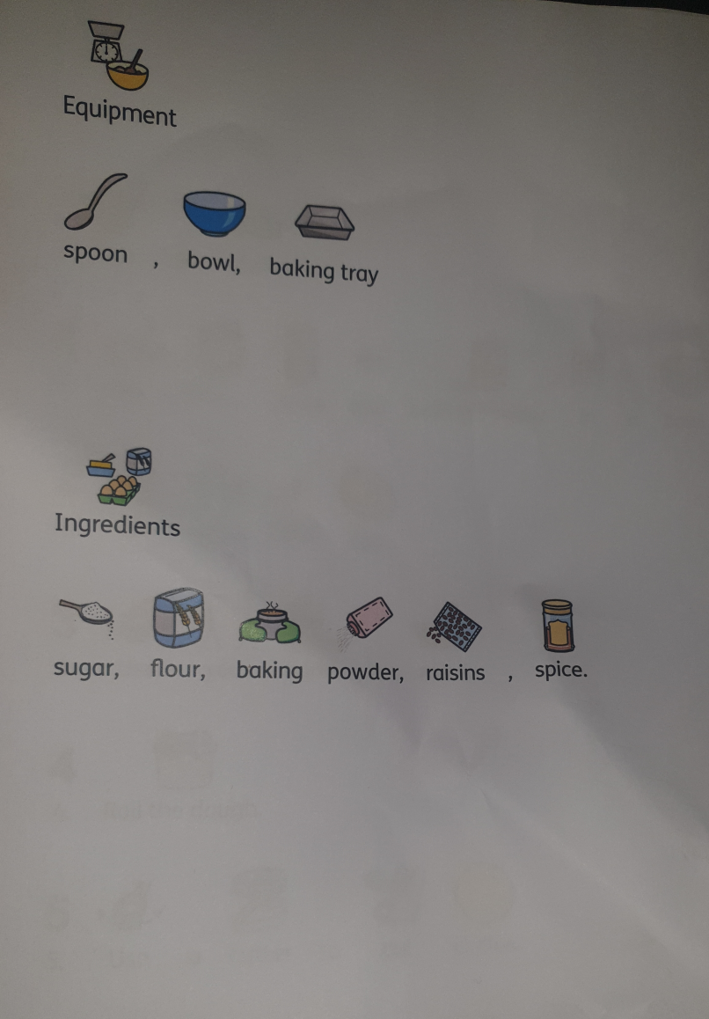

Appendix 2
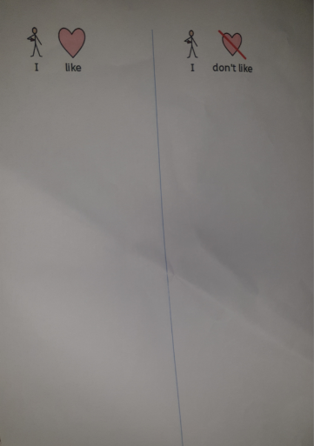
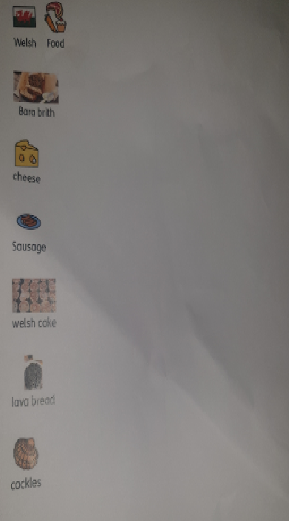

References

Donaldson.G. (2014). Successful Futures . Available: https://gov.wales/sites/default/files/publications/2018-03/succesful-futures-a-summary-of-professor-graham-donaldsons-report.pdf. Last accessed 12/11/20.
Mcloed.S. (2019). The Zone of Proximal Development and Scaffolding. Available: https://www.simplypsychology.org/Zone-of-Proximal-Development.html. Last accessed 12/11/20.
Montessori. (2020). Montessori Theory. Available: http://www.dailymontessori.com/montessori-theory/. Last accessed 12/11/20.
Owens.P. (1996). Working towards the establishment of the National Curriculum in Wales. The Implementation of the National Curriculum in Wales . 1 (1), 15.
Welsh Government . (2003). Developing the Curriculum Cymreig. Available: http://www.wasacre.org.uk/publications/wag/E-developingthecurriculumcymreig.pdf. Last accessed 12/11/20.
Welsh Government . (2017 ). Education in Wales: Our national mission . Available: https://gov.wales/sites/default/files/publications/2018-03/education-in-wales-our-national-mission.pdf. Last accessed 12/11/20.
Welsh Government . (2017). Welsh in Education . Available: https://gov.wales/sites/default/files/publications/2018-02/welsh-in-education-action-plan-2017%E2%80%9321.pdf. Last accessed 12/11/20.
Welsh Government . (2020). Curriculum for Wales guidance . Available: https://hwb.gov.wales/curriculum-for-wales/introduction. Last accessed 12/11/20.
Welsh Government . (no date ). Siarter Iaith. Available: https://hwb.gov.wales/curriculum-for-wales/siarter-iaith. Last accessed 12/11/20.
Wheeler.S. (2014). Learning Theories: Jerome Bruner On The Scaffolding Of Learning. Available: https://www.teachthought.com/learning/learning-theories-jerome-bruner-scaffolding-learning/. Last accessed 12/11/20.

