Gethin Cardy
2105599

Fieldwork Portfolio

Commuinty Profile
In this piece of work, a community profile will be written about Dr Mz, based in Carmarthen. We will first look at the work of the said organisation and how this was founded, which will lead us to the services they provide for young people. We will also look at the structure of Dr Mz, which quality skills the workers have and alternatively get feedback from the young people themselves about Dr Mz.
There are many benefits to a community profile, as it helps the researcher look at the whole picture. It also helps map out future projects intended and what resources the organisation has at their disposal. This gives a clear indication of the strengths and weaknesses of the organisation and therefore can be utilised as a tool to develop the framework and other areas. Community Profile can help by Provide information, Delivering services and activities in a way that is best for people and the priorities and make best use of limited resources Stated by (ARVAC, 2001) Community Research: Getting Started.
Dr Mz was founded twenty-six years ago with the aim to educate and assist young people through activities that enhance their physical, mental and social development (CLD Standards Council Scotland, 2019). Relating to the core objectives of youth work, the organisation became a registered charity in 2008 and in 2019 bought their very own building with the Welsh government community facilities grant and support from the Garfield Weston Foundation.
In the annual year of 2024 and 2025, Dr Mz have delivered over seven hundred sessions and connected with over five hundred young people within the community, working in partnership with the University of Wales Trinity St. David's, Carmarthenshire County Council Youth Service, local schools, local businesses for example Simon J Pizzeria, Incredible Edible Carmarthenshire, Local Motion, Abergwilli Museum and Oriel Myrddin Gallery to name a few.
The structure of the organisation is simple, with-it being Trustees, Manager, lead youth workers, youth support workers and volunteers. All staff members have unique skills that are utilised effectively, ranging from digital skills, ASIST training to interpersonal skills. Currently, there are five lead youth workers who come from different backgrounds however they hold and know the youth work values which aligns with the Youth Work Strategy for Wales. Before looking at what Dr Mz provides as a service, it is necessary to bring attention to some of the funders who keep the origination afloat, including CAVS Carmarthenshire Food Network, Carmarthenshire Town Council, Carmarthen Museum, Hywel Dda Health Board, Carmarthen Food Bank, College Sir Gar and the Carmarthenshire young adult carers and young carers.
Dr Mz open door access is available five days a week, there is no charge for young people to access the provisions. Some of the sessions are the Youth Drop Ins, Juniors and the LGBTQ+ group. Young people can take part in a variety of projects such as cooking, gardening, digital projects and volunteering making this a voluntary participant ensuring empowerment to the young people and empowerment being one of the five pillars of youth work (Youth Work in Wales Review Group, 2022). At the center of Dr Mz is the subsides café offering food supported by a full kitchen for cooking workshops, including products from their own garden for sustainability. Dr Mz also has a quiet room that provides a relaxing environment, a digilab for the computer wizards and a performances hall for the theatrical proformas. All of these falsities are in importance because it creates inclusivity to the young people, also one of the five pillars of youth work by in the Principles and Purposes document (Youth Work in Wales Review Group, 2022).
Recreation is important within the origination providing free pool, football, ping pong, art station, board games and wifi. “Recreational activities in a youth work setting offer a range of benefits that contribute to the overall development and well-being of young people” (Witt and Caldwell, 2010). There is a free bike use service and bike lock loans for young people to access to travel across Carmarthen and feel safe doing so, showing Dr Mz believes in addressing all barriers, with none being too small. They are also part of the Carmarthenshire County Council Period Poverty Scheme offering free hygiene products, reflecting one of their core aims, being young people deserve space to honour their worth and nurture their potential. To help ensure young people are able to thrive, we need to ensure we are creating safe spaces. (Welsh Government, 2025.)
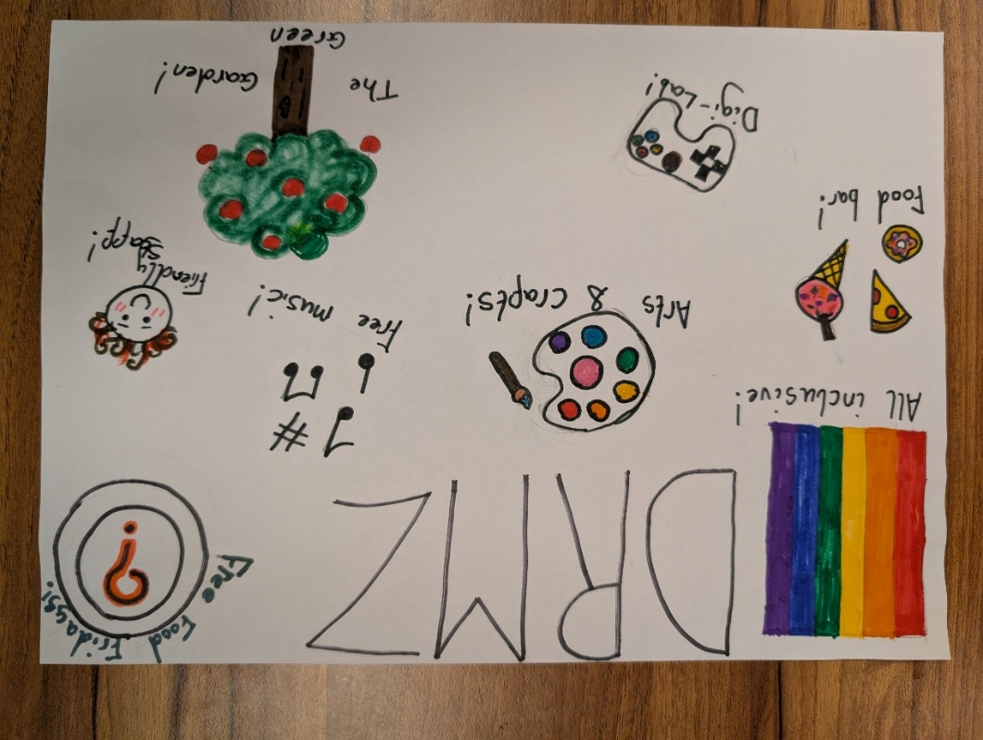
The young people are essential to the project and aged eleven to twenty-five although, there is a junior saturday group where the staff members are transitioning joining the other sessions of the organisation as they are aged ten and eleven. There is a wide range of geographical areas as the organisation welcomes young people with diverse backgrounds from Carmarthenshire and surrounding areas making it a more accessed provision. Due to the rural towns not having secondary schools or colleges, many young people have to take transport into Carmarthen to attend Dr Mz. Having had many discussions with the young people, they all enjoy Dr Mz for different reasons. Some like the space and staff members, whilst others find it a save place. Below are posters designed by the young people expressing their thoughts and enjoyment of the organisation.

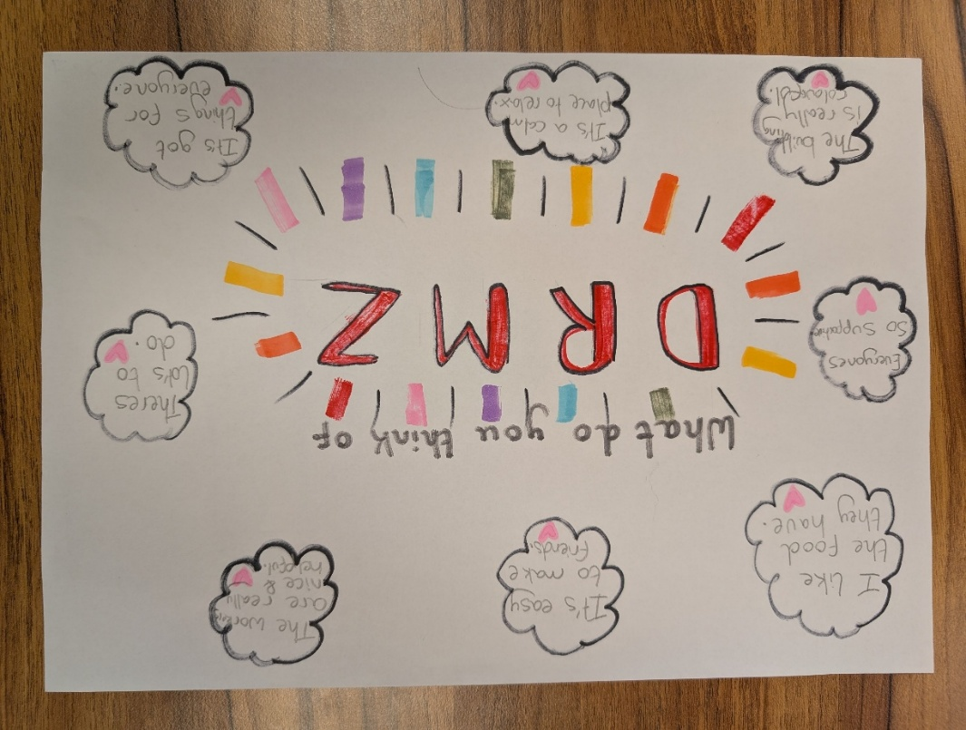
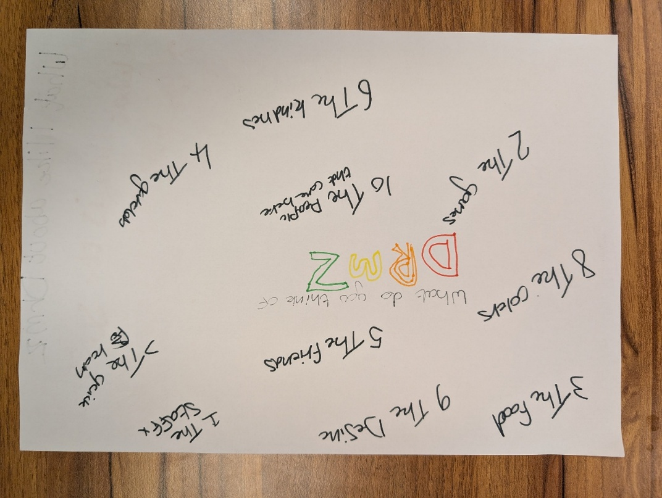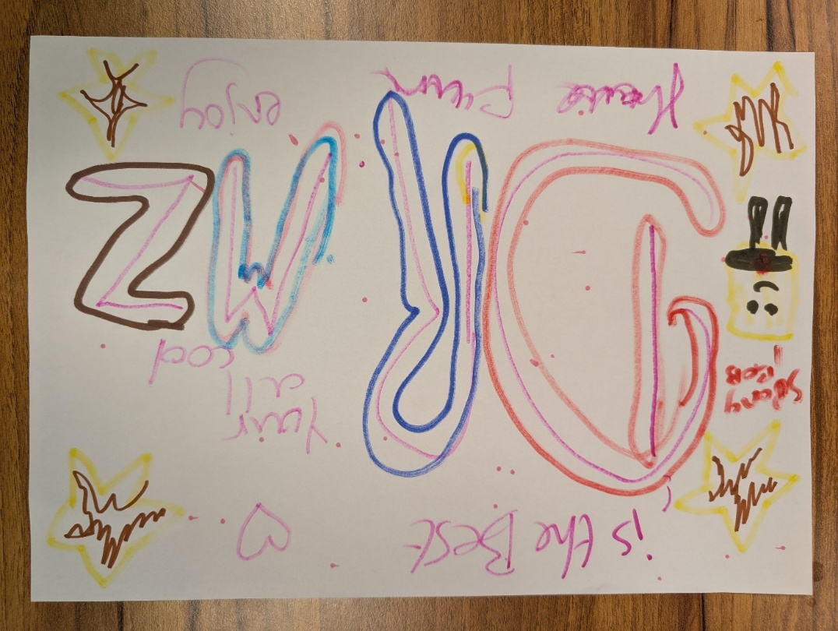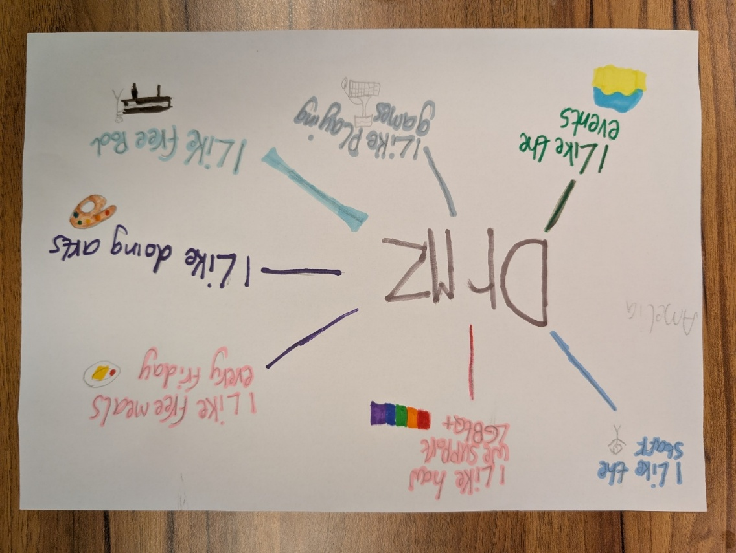

The following paragraphs will go into more detail of the projects offered at Dr Mz. The digital literacy project provided gaming sessions for young people whereby Dr Mz was recreated in Minecraft. The staff provided podcasting for the young people to take part in that developed their skills with the microphone, voice modulation and audacity editing. Digital design projects in Canva developed the young people’s workplace skills through real-word projects creating such documents as a code of conduct, Price lists for such occasions as Christmas fayre’s, social media posts etc. There were also film making sessions and online safety sessions addressing online gambling within video games, social media presents and the Online Safety Act (Gov.Uk, 2023) was also addressed to create a safer environment when using online platform. The Online Safety Act of 2023 states that it
puts a range of new duties on social media companies and search services, making them more responsible for their users’ safety on their platforms. The Act will give providers new duties to implement systems and processes to reduce risks their services are used for illegal activity, and to take down illegal content when it does appear.
(Gov.Uk, 2023)
The Financial Literacy Project brought focused cooking sessions to the project providing young people with the skills to budget when shopping for ingredients. One session saw the young people making bread and comparing the costs to shop bought bread from varies supermarkets. Cooking on a budget course was a youth access course for independent living covering shopping skills, meal prepping and teaching the young people to use the most of their ingredients. Also, with this project saw the Christmas and Easter markets that gave the young people a sense of retail experience teaching them customer services, money management, profits and pricing. The young people also set up a Vinted charity shop supporting their own business skills and learned about online selling, customer service and inventory management.
The Garden Project saw the allotment being put to positive use renting a space for young people to grow their own vegetable and learn valuable skills such as group work, aquaculture, interpersonal skills and the importance of sustainable living. The young people successfully grew a wide range of produce and worked together to create a pollinator garden supporting local biodiversity learning about the environment and the importance of taking action towards the climate. The project was partnered with Local Motion where the young people had access to materials and compost donations from Cwm Environmental.
Other projects such as the Juniors, Home Ed hangout, Free meals, Positive Pathways and the LGBTQ+ sessions, saw that Dr Mz was meeting the need of a wide variety of young people and with the skills of the youth workers and open access, young people had a place of contact where they would feel valued, safe and mostly the education that they deserved. This showed that Dr Mz was touching points with the five pillars of youth work and the rights of the young people stated by the UNCRC.
Why is it important that originations such as Dr.Mz fulfil the achievement of providing young people with the opportunity of projects as such as these listed? There are many factors that influence these kinds of projects to take place. Young people today are not confined to mainstream education and therefor do not get the education or could have the opportunity to participate in projects such as the Garden project, LGBTQ+ project and the financial literacy project. The reason behind this is that some young people may be NEET meaning they are not in education, emplotment or training so these projects ensure that they gain the skills needed for further development. It is also apparent that more young people are being home educated as stated by Welsh Government (2025) in 2024/25, there were 3,014 pupils receiving some type of EOTAS provision, whether their main or subsidiary provision and may have missed out on their social needs and development, making projects like these so important. Also depending on the circumstances of a young person life they may not have the family environment, the social circle or the opportunity to develop their knowledge or skills. Thus need for an intervention as such giving these opportunities. You could argue that that these types of informal education projects could go amiss if there was no interventions from a youth worker, as the criteria to obtain such training or skills do not ensure that every young person is a possible target for such intervention.
In conclusion, Dr Mz is an organisation with great potential. The building itself has the space for young people to develop their skills and enhance themselves. The staff members have developed their skills to give the young people the best of their knowledge. The young people have many opportunities to develop the different projects that are continuously offered by the organisation. The community also benefits from this, due to the fayre’s and others projects that are set out in the community which highlight the good work the young people are involved in.

S.W.O.T Analysis
There are many benefits to writing a S.W.O.T analysis as stated by Spain (2013) “ a “SWOT analysis can provide a useful framework for getting to know and organisation an where change may be necessary”. As the name suggests, it finds the strengths of an organisation, the weaknesses, the opportunities and the threats. From this the organisation can then implement policies, procedures and structures to help improve the services that they deliver as this is good practice outlined by the National Occupation Standards (CLD Standards Council Scotland, 2019). It can also help with funding, as this is an ongoing issue within the field of youth work. As we go through this analysis there will be links between Dr.Mz organisation, and theory within Youth Work. Firstly, there will be a table and secondly there will be key points that will be developed further in this assignment.
Here below you will see a table of a S.W.O.T analysis that will then be broken down and discussed further.
Strength  - Updated training.  - All staff members are trained or being trained as youth support workers or youth workers.  - Good management and staffing structure. Simple but effective.  - Good relationships with the community.  - Networking with other organisation. | Weaknesses  - No in-house teaching for young people.  - Open access kichen  - Small building for a growing organisation.  - Location of building means less foot traffic to engage with.  - Does not do group session for some group minorities apart from the LGBTQ+.
Threats  - Funding  - Staff shortage if any are taking absence. As a small organisation.  - Rely on public transport to engage young people in a further field.  - If there were external building works in the close area, it could cause pathways to be closed. | Opportunity  - Provide education opportunities for young people (for example Princes Trust).  - Gate of the kitchen area. Provide locked storage for knives etc.  - Take to council/other organisation for extension or other possible sites.  - Fund-raising events to make the public more aware of the organisation.  - Further training to enhance discussion points for example womens rights, racism etc.

There are many examples of strengths in the organisation. Two strengths to mention are that all staff members are either trained or having training in the field of youth work as stated by National Youth Agency in the Raising the bar, Youth Work Practice Standards document (National Youth Agency (NYA), 2023) and the second strength is that the organisation has a good relationship with the community. Both are excellent qualities when it comes to a growing organisation. Having staff members trained in youth work means that they understand the work needed in order to perform high quality work and the values of youth work as seen in the Values of Youth Work Functional Map. This aligns with both The Principle and Purposes of Youth Work (Youth Work in Wales Review Group, 2022) and the National Occupational Standards (CLD Standards Council Scotland, 2019).
Another positive quality is that the staff members would know the lines of safeguarding when dealing with young people, as stated within Article 19 The Untied Convention on the Right of the Child Unicef (n.d.).
The second strength to look at will be the good relationship that the origination has with the community. This has many positive benefits from a networking perspective to funding. These points are critical to an organisation in the third sector as they help to run projects and give young people the space, equipment and knowledge to develop themselves as this is pinnacle of youth work as stated in the Youth Work in Wales: Principles and Purposes document (Youth Work in Wales Review Group, 2022).
The second aspect of a S.W.O.T analysis is weakness. The two that will be looked at in detail are the no-in-house education and the groups for different minorities. If the organisation was to have in-house education for young people, this would give the young people a vital tool with the information needed for everyday life including first aid training opportunities and money management, again stated by the UNCRC (Unicef, n.d.) and the educative pillar within the Principles and Purpose of Youth Work, including the values of youth work Funchal map in the National Occupational Standard document (CLD Standards Council Scotland, 2019). The Second weakness would be that the organisation themselves only has group sessions for those of the LGBTQ+ community. Opening sessions for other minorities will increase the number of young people who access the services of the organization as well as giving a better understanding of the different social groups/communities or young people there for improving practice of participation being one of the five pillars mentioned again in the Principles and Purposes of Youth Work document (Youth Work in Wales Review Group, 2022). This will also have an impact on funding for better resources and equipment.
Moving on to threats of the organisation. The two that will be looked at are funding and the element of public transport needed for young people to access the provision. Funding has always been a threat for youth work as sated by the National Youth Agency “Youth services are in crisis. Seen as an essential service in the pandemic, fears of up to 1 in 4 youth centers folding are very real” (NYA, 2021). This will dramatically impact any organisation or project to the extent of closure or scraping of the project. Accessing such funding also requires the time or knowledge that not many organisations have creating a barrier when providing for young people in rural and well occupied areas. The second threat would be mode of transport restricting opportunities for young people to access the provision. Not only that but for educational trips, empowering experiences and overall fun experiences, the organisation relies on public transport making trips out more expensive and limited due to being in a town in a rural area of South/West Wales.
Young people in Wales suffer a disproportionate impact from the cost of public transport. If we could find a way to remove those financial constraints, we could give our youth easier access to education, employment, and other opportunities.
(Welsh Parliament, 2024)
The last section to be discussed in depth is opportunities. Funding and training can be opportunities for the organisation to expand their resources and programmes. Starting with funding as this is a threat, making opportunities for fund-raising such as a sponsored bike ride, not only raises money but also links with health and wellbeing (Unicef, n.d.) and also encourages people to take part in the sport and help in the sales of bikes and bike accessories. Fundraising events will also draw attention to the organisation and in return may gain more young people joining for their drop-in service and projects.
Training or workshops on certain topics such as racism, women’s rights and disabilities will give the organisation the insight it needs to develop further projects for young people of minority groups to engage in as this promotes inclusion and diversity this being fundamental in youth work (Youth Work in Wales Review Group, 2022). Training and workshops can also give youth workers a better understanding, improving their practice and knowledge to give correct information to the young people. Overall leading to better informed practice and more of a educative experience for young people, again bringing attention to one of the five pillars of youth work.

To conclude, this essay shows an opportunity to proform a S.W.O.T analysis on an organisation to give insight into the potential opportunities for the organisation. Looking at many aspects from the strengths to the in-depth opportunities to get a better understanding of what is happening within this organisation that needs developing.

Summary of own Learning
In this part of the essay, we will be looking at the placement students own learning. The first discussion point is what they have learned and developed, leading on to how they have developed this. There are many reasons why this is good for practice and why youth workers develop the need for continuous professional development.
This standard is about reflecting on your own effectiveness as a youth work practitioner, identifying ways in which you can improve your practice and accessing sources of support and opportunities to maintain your continuous professional development.
((CLD Standards Council Scotland, 2019)
This helps to enhance the knowledge of the youth worker, and that provides a better service that the young people are entitled to as seen throughout the articles by UNICEF titled Rights Of The Child 1946 (Unicef, n.d.). There will be points that will have links to theory, especially the National Occupational Standards document (CLD Standards Council Scotland, 2019), The Principles and Purposes of Youth Work (Youth Work in Wales Review Group, 2022) updated document and a professional development plan designed by the placement student.
Firstly, we will look at working with young people in line with the five pillars of youth work, Stated in the Principle and Purposes of Youth Work in Wales document (Youth Work in Wales Review Group, 2022). Two major discussion points that came about in my professional development plan are to learn to be more educative within the third sector and how the third sector operates. The second point would be to develop my skills when it comes to participative exercises, This falls under one of the five pliers within youth work as stated in the Youth Work in Wales: Principles and Purposes document (Youth Work in Wales Review Group, 2022). Whilst having little knowledge of third sector, it was apparent that I was outdated on how the sector worked when involving young people and the procedures they took to effectively manage this. To develop this further one suggestion would be to read more about what is happening within the third sector in Wales. This can include different policies and government documents of recent events and changes. Alongside this, another good practice would be to observe other youth workers when they involve young people in thier projects and which theories they use behind this like the Tuckman group theory (1965, cited in Sapin, 2013). The last suggestion could be to widen my knowledge of projects and exercises that will develop young people’s knowledge of what changes are happening around them and how to use their voices appropriately when making decisions such as their rights linked with the UNCRD Rights of the child (Unicef, n.d.).
Another area to develop would be to facilitate the learning and development of young people through planning and implementing learning activities. One point to consider, would be to develop sessions based around a topic to bring knowledge to young people and another would be to develop interpersonal skills to capture an audience listed in Essential Skills For Youth Work (Sapin, 2013) and The Study Skills Handbook (Cottrell, 2019) to help deliver sessions or discussion points to enhance the knowledge meant of young people.
Three suggestions to coincide would be to plan and lead sessions within the origination. To date, I have delivered E-safety sessions which young people asked for and could also plan focus groups to engage young people and develop my skills also. Two more suggestions would be to ask young people and staff members for feedback when delivering sessions and to use wider reading to gain knowledge on interpersonal skills to help facilitate these sessions.
The third column within the DPD is to actively demonstrate commitment to inclusion, equity and young people’s interests and health and wellbeing. Two major suggestions here would be to learn other ways to bring young people together to express inclusion and to implement the five ways of wellbeing adapted by the NHS (NHS, 2022) to my youth work practice as stated. In order to develop these, I could read on current trends and activities that young people are taking part in to gain an insight into the lives of young people in this modern society as some factors that impact young people are unemployment, long term illness and others peoples ergative attitude to them as stated by Ingram and Harris (2001) and help enforce the rights of the young people stated by the UNCRC (Unicef, n.d.). Also, another suggestion would be to plan sessions around the five ways of wellbeing to be more educative, and support young people’s need when it comes to equity and their health and wellbeing.
Another area of development would be to plan and implement strategy and youth work activities for young people. This could include learning strategies for developing sessions in order to make them more fluid and empowering for young people another pillar of the five pillars in youth work stated within the Principles and Purpose document (Youth Work in Wales Review Group, 2022). To also learn to adapt certain skills when planning activities such as, physical and physiological needs to consider the young people’s ability when developing activities. In order to complete this, I will gather feedback from young people and staff members to assess the effectiveness of the sessions and activities I have planned and what can be improved. I could plan sessions for a wide community of young people to enhance my knowledge of different abilities and needs and with that can also gather my knowledge of young people before planning sessions.
Another area of development would be to develop, lead and manage self and others. Ways to improve this would be to learn how to lead sessions and use Tuckman’s Group Theory (1965) (BiteSize Learning, n.d.) when managing groups of young people in different environments such as, youth project drop-ins. To coincide with this, I could co-polite other sessions with youth workers to educate myself on how they lead sessions with young people and also ask for advice and guidance’s from staff members on how they handle different environments with groups of young people such as drop-ins.
The last area of development would be to work with communities. Encouraging young people to actively engage in their communities and work to promote the voice and needs of young people. Two areas of development would be to read the laws and policies around young people which may affect them to better inform my practice like documents such as National occupational standards (CLD Standards Council Scotland, 2019) and the Social Services and Well-being (Wales) Act 2014 for safegaurding. Also, I would need to learn encouraging skills to promote young people to participate in activities within their communities. For this I read current policies, laws and practices regarding youth work including young people’s voices such as The Future Generation Act (2015) (Welsh Government, 2025).Furthermore, I could plan activities around the community to encourage young people to take part in the community they live in and lastly educate young people on the importances of maintaining a good outlook when in public.
To conclude, over the course of my time on placement I have developed more as a professional youth worker with a good quality of standards to make my work more informed, participated, valued and included to coincide with policies. Such policies being the National Occupational Standards, The Principles and Purposes of Youth Work and The Future Generation of Wales Act and more.

References List
ARVAC (2001) Community Research: Getting Started. Available at: https://arvac.org.uk/community-research-toolkit/why-do-community-research/ (Accessed: 7 December 2025).
BiteSize Learning (n.d.) Forming, storming, norming & performing: Tuckman’s stages of team development. Available at: https://www.bitesizelearning.co.uk/resources/tuckman-stages-team-development-forming-norming-storming-performing (Accessed: 8 January 2026).
CLD Standards Council Scotland (2019) National Occupational Standards for Youth Work. Glasgow: CLD Standards Council Scotland.
Cottrell, S. (2019) The Study Skills HandBook. 5th edn. London: Red Globe Press
Gov.UK (2023) Online Safety Act. Available at: https://www.gov.uk/government/collections/online-safety-act (Accessed: 14 January 2026).
Ingram, G. Harris, J. (2001) Delivering Good Youth Work. Dorset: Russell House Publishing Ltd.
National Youth Agency (NYA) (2021) Time’s running out. Available at: https://nya.org.uk/wp-content/uploads/2021/09/Times-Running-Out-v6.pdf (Accessed: 2 December 2025).
National Youth Agency (NYA) (2023) Raising the bar. Available at: https://nya.org.uk/wp-content/uploads/2024/02/NYA_Publications-2023_Youth-Work-Standards_DOWNLOAD_AW-FINAL-050623-1.pdf (Accessed: 2 December 2025).
NHS (2022) Five steps to mental wellbeing. Available at: https://www.nhs.uk/mental-health/self-help/guides-tools-and-activities/five-steps-to-mental-wellbeing/ (Accessed: 8 January 2026).
Sapin, K. (2013) Essential Skills for Youth Work Practice. 2nd edn. London: SAGE Publications Ltd.
Social Services and Well-being (Wales) Act 2014. (anaw 4). Available at: https://www.legislation.gov.uk/anaw/2014/4/contents (Accessed: 8 January 2026).
Unicef (n.d.) Convention on the Rights of the Child text. Available at: https://www.unicef.org/child-rights-convention/convention-text (Accessed: 2 December 2025).

Welsh Government (2025) Guidance document Well-being of Future Generations (Wales) Act 2015: the essentials. Available at: https://www.gov.wales/sites/default/files/pdf-versions/2025/2/2/1740501518/well-being-future-generations-act-essentials.pdf (Accessed: 8 January 2026).
Welsh Government (2025) National Youth Strategy for Wales. Cardiff: Welsh Local Government Association.
Welsh Government (2025) Pupils educated other than at school: September 2024 to August 2025. Available at: https://www.gov.wales/pupils-educated-other-school-september-2024-august-2025-html (Accessed: 8 January 2026).
Welsh Parliament (2024) Freedom to thrive. Available at: https://senedd.wales/media/eibb1gqt/cr-ld16506-e.pdf (Accessed: 12 December 2025).
Witt, P.A. and Caldwell, L.L. (2010) The Rationale for Recreation Services for Youth: An Evidenced Based Approach. Available at: https://www.nrpa.org/uploadedFiles/nrpa.org/Publications_and_Research/Research/Papers/Witt-Caldwell-Full-Research-Paper.pdf (Accessed: 7 December 2025).
Youth Work in Wales Review Group (2022) Youth Work in Wales: Principles and Purposes. Wales: CWVYS.

