University of Wales Trinity Saint David
Wales Institute of Science and Art


Vehicle Performance Optimisation using Simulation Software
Introduction to Vehicle Engineering (ACHA4035)

Nicole Crofts
2501478
October 2025
1052 Words

Contents
1 Introduction 3
2 Main Body 4
2.1 Gear Ratios 4
2.2 Silverstone Circuit 5
3 Results 7
4 Conclusion 8
5 References 9

Figure 1: Engine RPM graph 7

Introduction
In this assignment, the task was to distribute credits across different components in a vehicle to try to optimise lap times across different circuits. The vehicle and circuit maps were uploaded into Optimum Lap software to run different simulations and test out each choice. There was a limit of 150 credits of which could be used however I wanted to make the most effective vehicle on the track. Gear ratios also had to be chosen from a range of different ones.

I decided to focus on one track in particular: Silverstone Circuit. Each of these credits were distributed throughout the different options to try to optimise the vehicle and adapt it to Silverstone Circuit.

Main Body

Gear Ratios
Gear Ratios Chosen:
1st Gear | 3.1
2nd Gear | 2.6
3rd Gear | 2.2
4th Gear | 1.8
5th Gear | 1.5
6th Gear | 1.2

Across very different tracks, from Monaco’s short straights and sharp corners to the long straights of le mans, and the very different track lengths, it is important that the gear ratios provide consistent but still effective lap times across all types of circuits. This is why it is crucial that even spacing between each gear is a factor when choosing gear ratios.

Aiming for close to even jumps between each gear ratio is important as it means there is a less of a drop in RPM when shifting gears. A smaller drop in RPM means that there is less time lost shifting up gears since there isn’t as much power to build up whereas a bigger drop would waste more time while having to increase its power from the drop to reach the same number. An even spacing of gear ratios calls for a consistent jump in RPM between all gears, ensuring there is not a substantial loss of time gaining power in any of the gears. A graph comparing these engine RPMs throughout each circuit of the season can be seen in figure 1. These consistent, balanced changes all lead to effective lap times across all types of circuits, as well as better control and driveability for the driver. (TrueGeometry, 2025)

Silverstone Circuit
Measurements Chosen:
Mass | 945 | 30
Aerodynamics | Map D | 30
Tyres | Type C | 30
Engine | Map E | 60
Drive Efficiency | 0.9 | 0
Total Credits Left |  | 0

Silverstone Circuit is a track which demonstrates a mix of different types is straights and corners, but it is a very high-speed track. Unlike Monaco, it has a lot longer length and wider, quicker corners. It is not quite as long as Le Mans though, with less turns and high-speed corners in it. It is quite diverse as it is not on one end of the extreme like Monaco or Le Mans. I factored this into my decision for each measurement and watched trends that happened as I ran each simulation, but each one made it clear that Silverstone is not like any other circuit.

Firstly, I focused on the aerodynamics and tyres of the car as I believed these were more specific and tailored to each track, whereas the rest of the components were more general to a lot of track types.

In Silverstone, a lot of the lap is spent at high speed, so it is important to have a high downforce coefficient so the car has high grip to keep up speed, and also a higher drag coefficient to maintain the cars stability. Although these higher numbers tend to slow cars down on some tracks, it is essential that they are high in Silverstone as there needs to be grip and stability when at such a fast pace. My simulations also showed that this was the case as Map D in aerodynamics showed the quickest pace.

The tyre figures that I chose also happened to be the same one that came out quickest in my simulations. The lateral and longitudinal friction in the Type C tyres prove to be the quickest.

Evidently, the lighter the mass of a vehicle, the quicker it will go. It was obvious that mass would play a big factor in reducing lap times. Since none of the masses were too small, I did not need to worry about making the vehicle too light that it would lose too much grip. Before I decided my mass factor, I ran simulations on each factor which effected credits to see if any of the others would make more drastic changes in lap times which would be worth adding more credits to.

I noticed in my simulations that the engine power scalar made a more significant change is lap time, so I dedicated more credits towards that and reduced my cost budget for mass by a little. I also noted that the drive efficiency made a lot less difference to the time than the mass. These simulations made me realise that I should dedicate more credits towards the engine power scalar, but substitute more of my credits from drive efficiency to the mass. These changes and decisions helped me to distribute my credits across the different components to make the most effective lap times.

Results

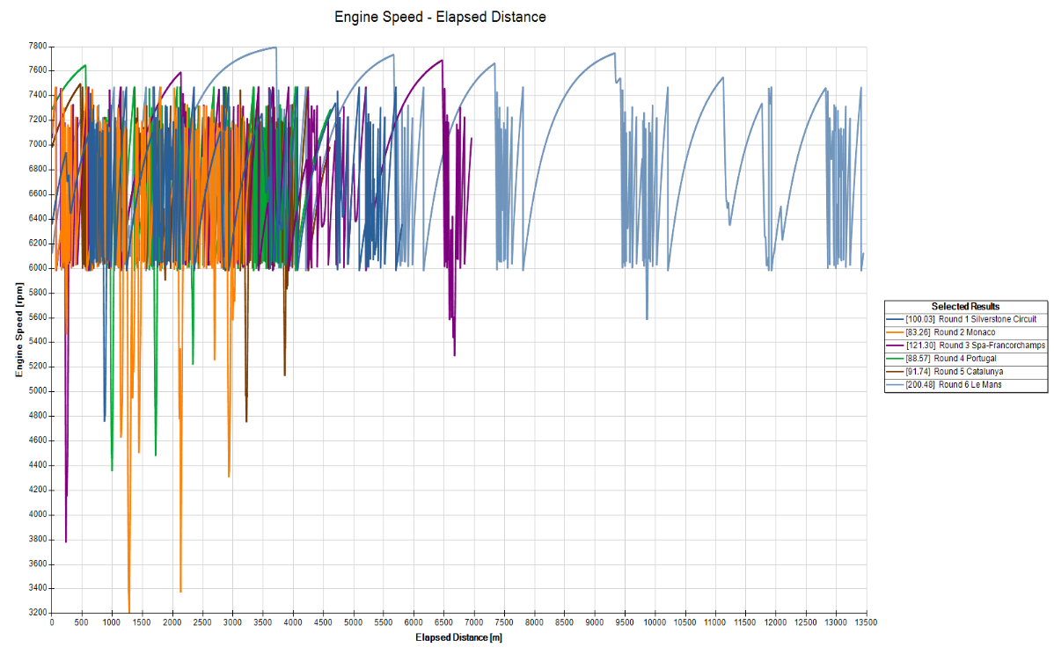
Figure 1: Engine RPM graph
Graph showing engine RPM on each circuit.

Conclusion
In conclusion, it has been proved that Silverstone is quite high-speed track as the simulations that were ran, especially on the aerodynamics and tyres proved that. From the simulations, it proved that which such a high speed track like Silverstone, higher grip and drag is essential in car setup.

The rest of the components were distributed to wherever was best to improve lap times. It has been proved in my simulations that drive efficiency was the least effective on lap times, with mass being a bigger factor but overall the engine power scalar had the most impact, creating a lot faster lap times.

References
TrueGeometry. (2025, March). "Why are close-ratio gearboxes preferred in high-performance racing applications?". Retrieved December 13th, 2025, from blog.truegeometry.com: https://blog.truegeometry.com/api/exploreHTML/07974db38667d596b5b9486dd02eb1f1.exploreHTML

