Component 1
Blogs: AI Chatbots and Student Mental Health

Student: Ivana Konjevod Novosel
Student ID: 2217492
Module: Population Health and Digital Health Promotion
Module Code: LCHS7009
Lecturer: Dr Raheela Shaikh

Blog 1: Can a Chatbot Support Student Mental Health? A Look at Wysa

Hook and problem
Staying healthy at university can be difficult. A survey of 12,796 students and graduates in the UK found that 29% of those at school at the time had difficulty with mental health. However, 64% of those who had experienced difficulties had not attended support offered by the University or Students' Union (Cibyl, 2023). Many avoid it because they lack the words, fear being a bother, or cannot get an appointment. AI chatbots can help at any hour, without an appointment and without an audience.
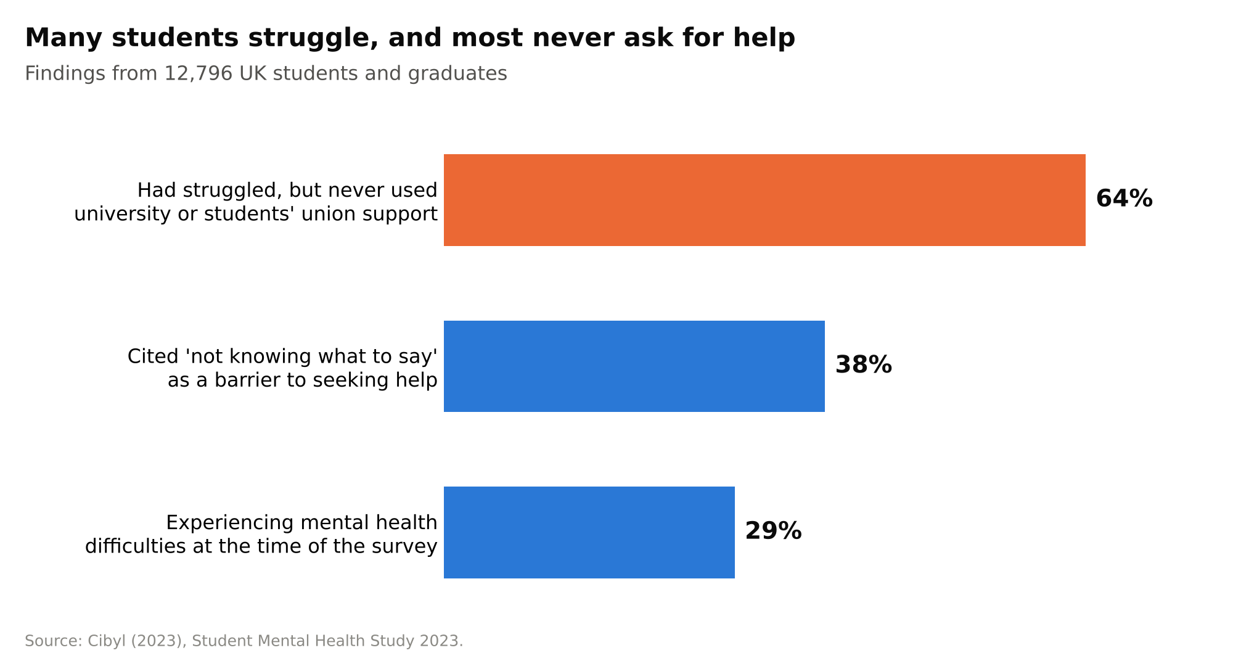
Figure 1. The mental health problems and help-seeking of UK students. Data from Cibyl (2023); figure by the author.

How it works
Wysa helps people reduce low mood, worry, and stress through cognitive behavioural therapy (CBT) techniques using an AI chatbot. It has over 200 self-care tools, an SOS button that connects to help resources, and optional text sessions with human wellbeing coaches (Wysa, n.d.).
Imagine that Priya, a second-year student, wakes up before a deadline. She writes that she is overwhelmed. Wysa asks what it is because of, then guides her through a thought-reframing exercise and a breathing exercise. Some NHS Talking Therapies services in the UK also use a version of Wysa to triage referrals (NICE, 2025).
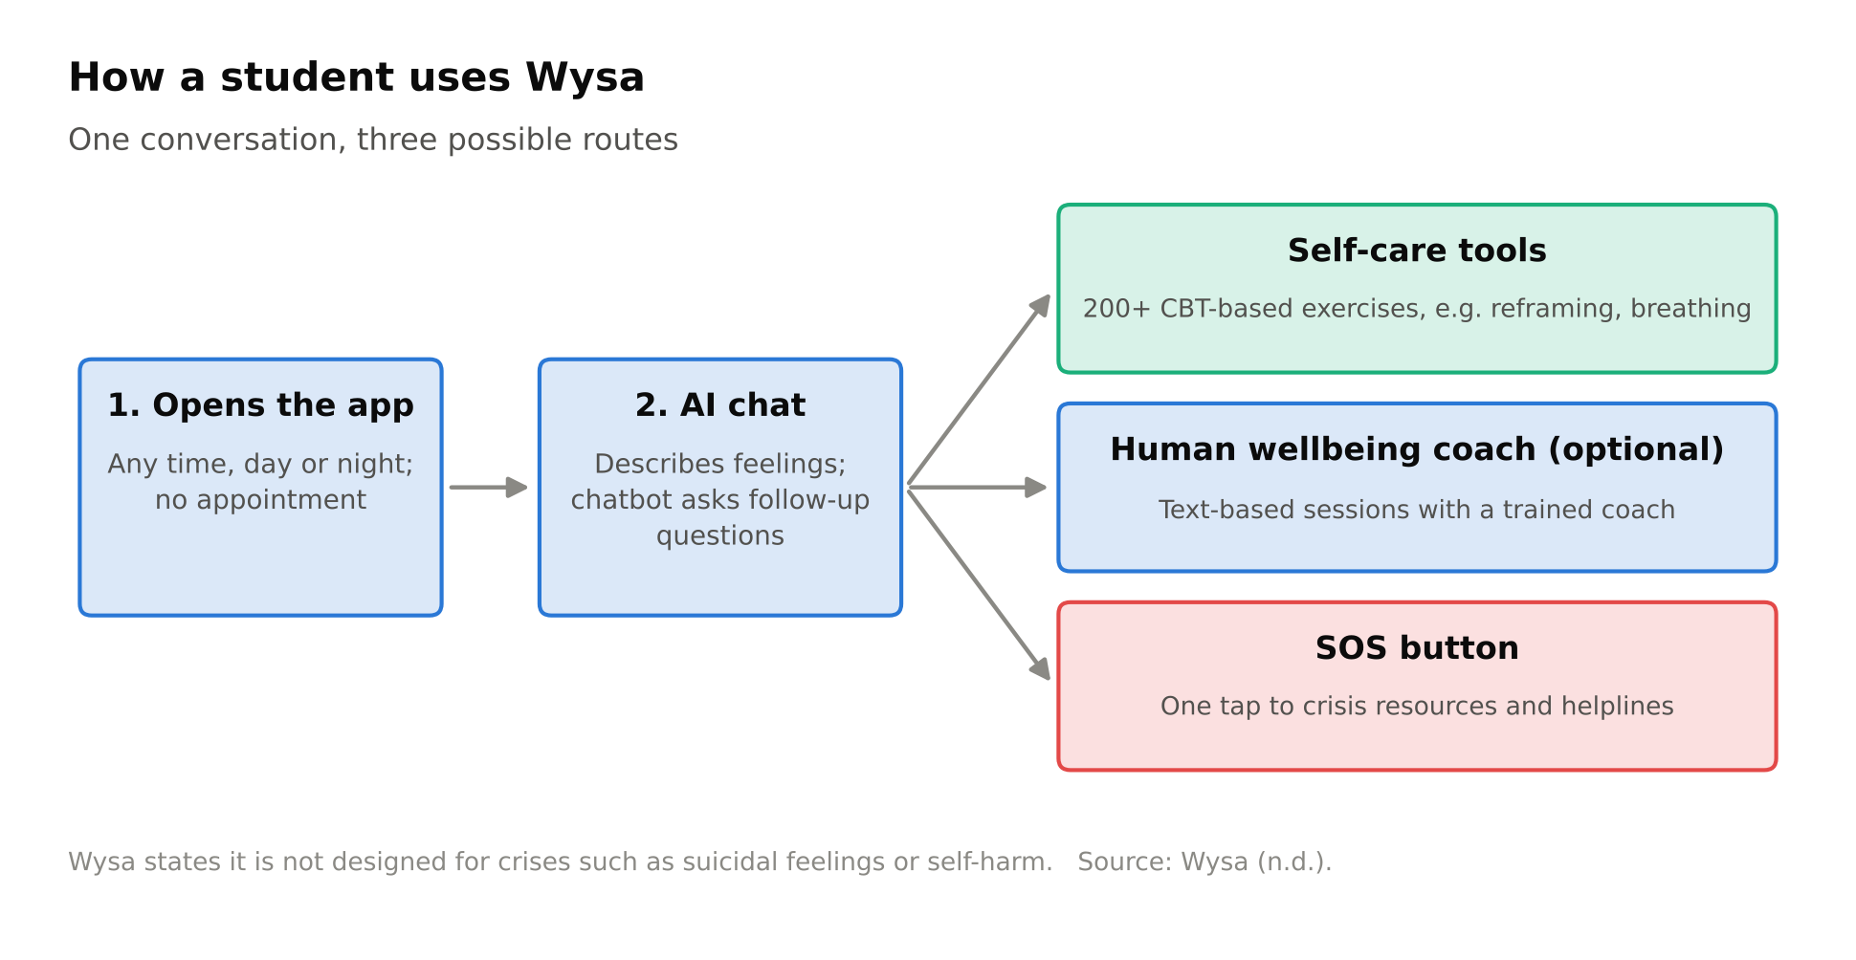
Figure 2. How a student interacts with Wysa, starting when they open the app through tools for self-care, coaching, and crisis. Data from Wysa (n.d.) and author's figures.

Evidence it promotes health
A real-world study found 129 users with depressive symptoms had a reduction in their depression score on the PHQ-9 over at least two weeks after using Wysa. Frequent users showed a moderate improvement compared with infrequent users (5.8 points versus 3.5 points) (Inkster, Sarda and Subramanian, 2018). However, there was no control group, and several authors were affiliated with the company.
The overall situation is more complicated. A study published in the Journal of Medical Internet Research reported that a meta-analysis of 15 randomized trials showed that AI chatbots decreased depression and distress. However, they did not show a clear benefit in overall psychological wellbeing, and long-term effects were also not established (Li et al., 2023).

Critical discussion
The benefits are scale and cost. Wysa is waitlist-free and available 24 hours a day. Because it is anonymous, it may be suitable for students who are being held back by shame. It is inexpensive and, after construction, can support a large number of pupils for relatively little additional cost: according to NICE (2025), a licence fee of £1.39 – £3.90 per referral is required for the triage version.
The shortfalls are significant. Independent use is limited to adults and requires a Smartphone. Students also disclose highly personal information to a private company, which requires trust to be established by being transparent about data handling. Mental health app retention is fragile: median retention after 15 days is 3.9% (93 apps) (Baumel et al., 2019). Wysa claims it is not intended for crises like suicidal feelings or self-harm (n.d.), but 41% of the survey respondents in Cibyl (2023) had suffered from suicidal thoughts. The last risk is sustainability: When the competitor Woebot ceased operations of its consumer bot in June 2025 (Hagen, 2025), it lost its consumer application.

Addressing the shortfall
The most critical is a warm handover to humans. Universities with Wysa should have a direct link between the SOS route and their own wellbeing service. The student who flagged the risk would then be called by a named practitioner within 1 working day and will be given details of 24-hour helplines. This ensures that the chatbot remains helpful, but also prevents a student in trouble from conversing with just the machine.

References (Blog 1)
Baumel, A., Muench, F., Edan, S. and Kane, J.M. (2019) 'Objective user engagement with mental health apps: systematic search and panel-based usage analysis', Journal of Medical Internet Research, 21(9), e14567. doi:10.2196/14567.
Cibyl (2023) Student Mental Health Study 2023. Available at: https://cibyl.groupgti.com/hubfs/Cibyl%20Student%20Mental%20Health%20Study%202023.pdf (Accessed: 20 October 2026).
Hagen, J. (2025) 'Woebot Health shutting down its app', MobiHealthNews, 25 April. Available at: https://www.mobihealthnews.com/news/woebot-health-shutting-down-its-app (Accessed: 20 October 2026).
Inkster, B., Sarda, S. and Subramanian, V. (2018) 'An empathy-driven, conversational artificial intelligence agent (Wysa) for digital mental well-being: real-world data evaluation mixed-methods study', JMIR mHealth and uHealth, 6(11), e12106. doi:10.2196/12106.
Li, H., Zhang, R., Lee, Y.-C., Kraut, R.E. and Mohr, D.C. (2023) 'Systematic review and meta-analysis of AI-based conversational agents for promoting mental health and well-being', npj Digital Medicine, 6, 236. doi:10.1038/s41746-023-00979-5.
NICE (2025) Digital front door technologies to gather service user information for NHS Talking Therapies for anxiety and depression assessments: early value assessment (HTE30). London: National Institute for Health and Care Excellence.
Wysa (n.d.) Wysa for individuals. Available at: https://www.wysa.com/for-individuals (Accessed: 20 October 2026).

Blog 2: PeerPath: An AI Peer-Support Chatbot With a Route to Real Clinicians

Hook and problem
A lot of students who have difficulty learning do not seek help. 64 per cent of current students who had some mental health issue did not access any support from the university or students' union. Not knowing what to say (38%) was the most prevalent barrier (Cibyl, 2023). That barrier is reduced by the use of chatbots like Wysa, but they don't create crises (Wysa, n.d.). PeerPath maintains the simplicity of access to the chatbot and introduces people: other students and, if necessary, a clinician.

How it works
PeerPath is an app that combines an AI chatbot, peer chats and video calls with clinicians, all at the university. Imagine that it's the end of a rough week, and Tom, a first-year student, is messaging PeerPath at midnight. The chatbot answers first, performs a brief check-in and provides a grounding exercise. Since Tom says that he feels isolated, it invites him to join the chatted evening with other first-years. If his check-in score exceeds a particular level, the system arranges a video session with the University counsellor for the following day.
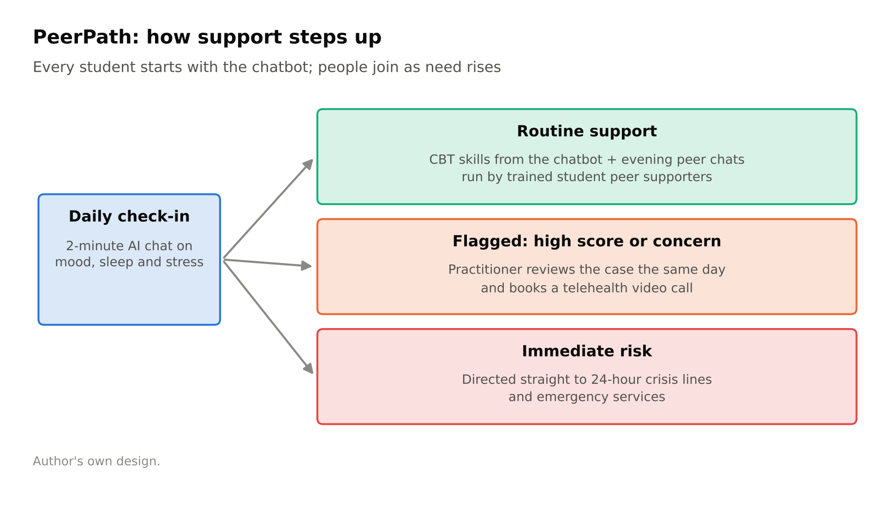
Figure 1. The PeerPath escalation pathway, from the chatbot to peers, to clinicians. Author's own design.

Design: Who joins, what is a week like, who is in charge of the week?
Who joins: 18+ university students who choose to join via the student portal, through the wellbeing service or Freshers' Week. Peer groups consist of 10-12 students in the same year of study.
What a week will consist of:
- Daily: Two-minute ‘check-in’ with the Chatbot on mood, sleep and stress, every day.
- Monday to Thursday evenings – a 60-minute moderated peer group discussion about the theme of the week, e.g. Exam stress, loneliness, sleep or money worries.
- Wednesday: a CBT skill using a chatbot, e.g., challenging an unhelpful thought.
- Sunday: Weekly summary; student may share with clinician.
Who leads: Trained, paid and supervised student peer supporters run the group chats. Flagged cases are reviewed by a University mental health practitioner daily. Self-harm and/or suicide comments and/or scores of 10+ elicit a same-day telehealth call. All those at immediate risk are referred to 24-hour crisis lines and emergency services.
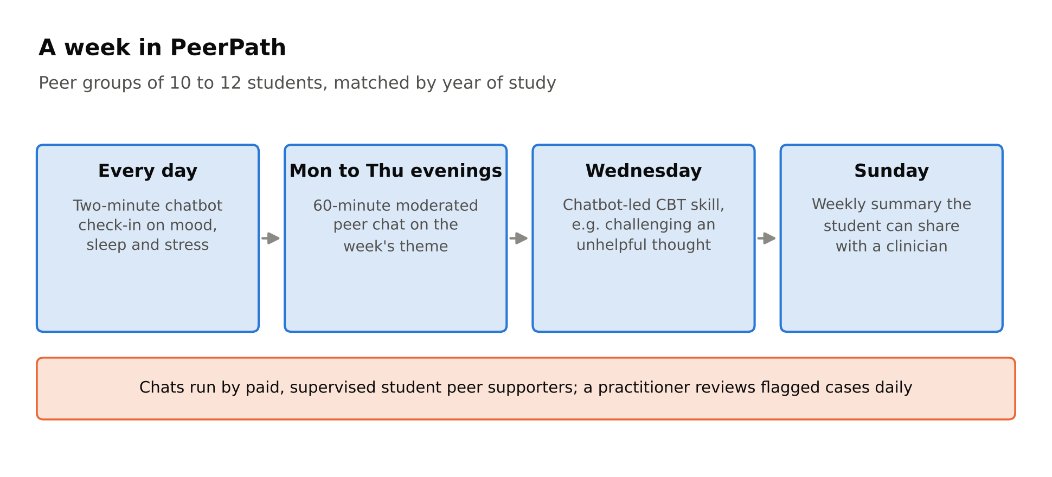
Figure 2. A typical week in PeerPath. Author's own design.

The outcomes and results of the discussion are expected.
PeerPath is based on two theories. The buffering hypothesis suggests that social support protects the body against the negative effects of stress on mental health (Cohen and Wills, 1985). The COM-B model also posits that behaviour change occurs when there is a combination of changes in capability, opportunity, and motivation (Michie, van Stralen and West, 2011). Skills learned in chat, social opportunity through peer chats, and peers seeking help reduce shame and increase motivation. Based on this, it is hypothesized that there will be less distress and more help-seeking over one term.
These effects are estimated, and the evidence for each component is mixed. Only six studies of limited quality and ambiguous results were identified in peer support for children and youth online (Ali et al., 2015). The effects of the chatbots on depression and distress reduction were seen without a significant impact on wellbeing, though the effect was larger when chatbots were integrated within messaging apps (Li et al., 2023). To test PeerPath, a pilot measuring scores on the PHQ-9 and the GAD-7 would be required.

Addressing the shortfall
The most consistent failing is drop-off, as median drop-off rates after 15 days in mental health apps are 3.9% (mean = 4.5%) (Baumel et al., 2019). A concrete solution is called a peer buddy. One peer supporter is matched with each new user. The buddy sends a personal message and gives the student a short call (not through the app) if the student hasn't checked in for 5 days.

References (Blog 2)
Ali, K., Farrer, L., Gulliver, A. and Griffiths, K.M. (2015) 'Online peer-to-peer support for young people with mental health problems: a systematic review', JMIR Mental Health, 2(2), e19. doi:10.2196/mental.4418.
Baumel, A., Muench, F., Edan, S. and Kane, J.M. (2019) 'Objective user engagement with mental health apps: systematic search and panel-based usage analysis', Journal of Medical Internet Research, 21(9), e14567. doi:10.2196/14567.
Cibyl (2023) Student Mental Health Study 2023. Available at: https://cibyl.groupgti.com/hubfs/Cibyl%20Student%20Mental%20Health%20Study%202023.pdf (Accessed: 20 October 2026).
Cohen, S. and Wills, T.A. (1985) 'Stress, social support, and the buffering hypothesis', Psychological Bulletin, 98(2), pp. 310–357.
Li, H., Zhang, R., Lee, Y.-C., Kraut, R.E. and Mohr, D.C. (2023) 'Systematic review and meta-analysis of AI-based conversational agents for promoting mental health and well-being', npj Digital Medicine, 6, 236. doi:10.1038/s41746-023-00979-5.
Michie, S., van Stralen, M.M. and West, R. (2011) 'The behaviour change wheel: a new method for characterising and designing behaviour change interventions', Implementation Science, 6, 42.
Wysa (n.d.) Wysa for individuals. Available at: https://www.wysa.com/for-individuals (Accessed: 20 October 2026).

