Assignment 2: Menu Engineering
Food & Beverage Operations (BMIH4002)
Catalin Viorel Ciobanu (2216877)
Ffion Cumberpatch

Word Count:407
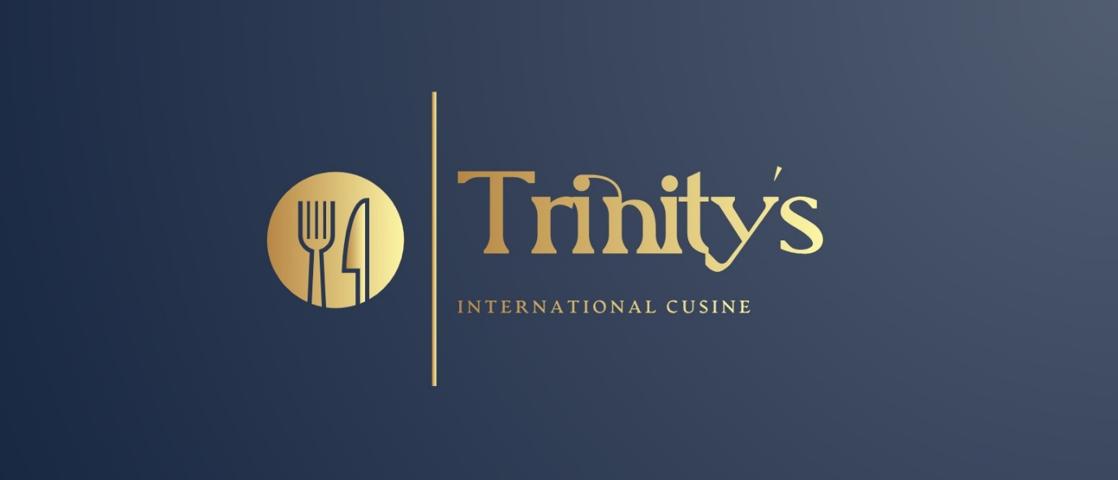

The chosen concept that I’m proposing for the new restaurant that will be opened inside Hotel Trinity will be an international food concept with a menu that will include dishes from the most iconic places all over the world (Looka, 2023).
The name of the restaurant is very simple and will give all the information that the customers need but also at the same time is quite intriguing because it will make them curious about the menu. Considering that the hotel customers will be from different nationalities the idea is to please all of them and also to give them the opportunity to try different dishes (Namesnack, 2023).
The purpose of this menu is to offer worldwide flavours in dishes executed with original ingredients while keeping the dietary requirements simultaneously. For example, as a starter, the menu offers one of the iconic French starters, the Lyonnaise Quenells in cream sauce, a traditional mixture of dough, cream, egg yolk and pike fish. This recipe comes from the gastronomical capital of France, Lyon (Angadi, 2022). The main dishes from the menu will include a variety of meat recipes cooked in different styles but with ingredients coming from the same country as the dish. For example, we offer ‘Bistecca Alla Fiorentina’, served rare and seasoned with local spices cooked over red-hot coals, this Florentine steak is simple and luxurious at the same time (Italyfoodies, 2022). For dessert, the menu will be based on international tastes for example ‘La Dame Blanche’ a Belgian hot fudge sundae with vanilla Ice Cream (Saunders, 2022). Finally, we will end with a collection of wines, beers, soft drinks and hot drinks all coming from different parts of the world.
In conclusion, Trinity’s international cuisine Restaurant will be a friendly restaurant in which families, couples and also single people can enjoy quality time. Everything from the menu will have a story behind and this is what will give us the chance to create a strong relationship with the customers and provide them with a unique experience which will make them come and visit us again. Inside the restaurant, we will create a very nice ambience using a worm pallet of colours on the walls with pictures of places where the food is coming from and the history behind our menu. On the other hand, we will do our best to offer our customers a really nice gastronomical experience and some really nice memories regarding our restaurant.
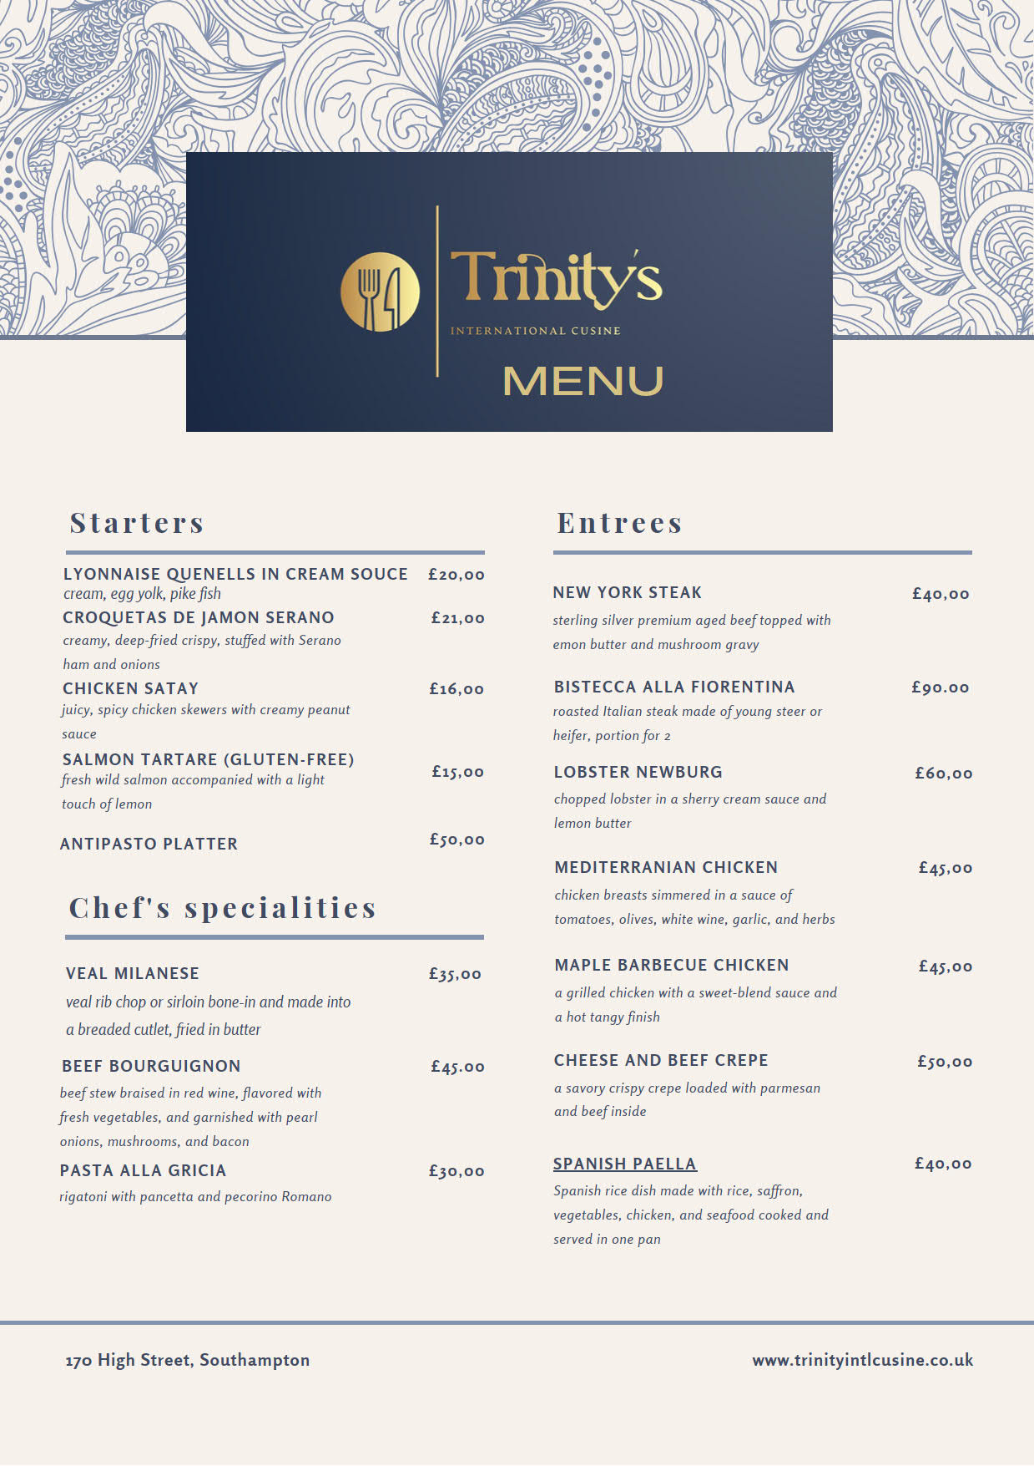

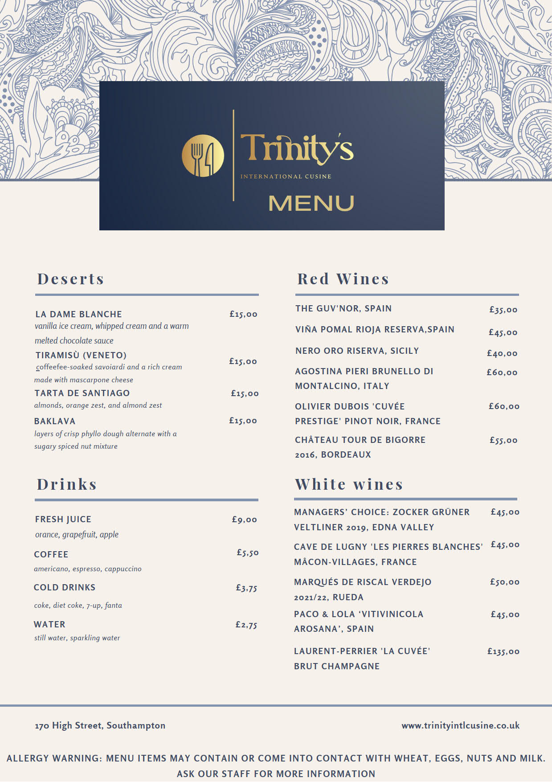

References list:
Angadi N. (2022) 13 Classic French starters to love. Available at: https://snippetsofparis.com/french-starters/ (Accessed: 08 June 2023).
Italyfoodies (2022) Tuscan Food Guide: 28 Traditional Foods of Tuscany. Available at: https://www.italyfoodies.com/blog/tuscan-food-guide-foods-of-tuscany/ (Accessed: 08 June 2023).
Looka (2021) Free Logo Creator. Available at: https://looka.com/editor/130114271 (Accessed: 07 June 2023).
Namesnack (2023) International Restaurant Business Names. Available at: https://www.namesnack.com/guides/international-restaurant-business-names/ (Accessed: 07 June 2023).
Sounders K. (2022) ‘11 Authentic Belgian Desserts’ [blog]. 9 June. Available at: https://insanelygoodrecipes.com/belgian-desserts/ (Accessed: 08 June 2023).

