Assignment 2
Internet Technology & Security
1805357, Jordan Soroko, BSc Computing
Table of Contents
- Abstract
- Introduction
- Guidelines
- Questions to answer with BYOD solutions
- Mobile Device Management
- Recommending an MDM for staff to use
- Advantages & Disadvantages of BYOD
- Framework
- Conclusion
- Bibliography

- Abstract
This report aims to outline the appropriate documentation, recommendations and visualisation of securing their preferred flexible use of a simulated company’s network features and accessibility.

- Introduction
As an I.T security consultant, one is responsible for keeping our client/organisation safe so that people do not misuse the technology and harm anyone involved with the company.

Producing protocol guidelines on all use of CoffeeCapulus’ network(s) online and offline allows clients, customers and employees to appropriately use their device without crossing any clearly outlined boundaries, understand what they can and cannot do so they may not cause trouble and lastly ensure the least amount of damage is done to any of the network(s) by people unknowingly causing harm to them and therefore the company.

3. Guidelines
Here are a set of example policy guidelines to help CoffeeCapulus’ network stay secure (most apply specifically to staff as they are the ones responsible for sensitive company data):

1. Any device in use should have the latest operating system version running whether it be windows, IOS etcetera as new patches come out to fix recent or old security threats including essential protection against evolving malware. [1] This helps to achieve the best possible security at that given time to defend against any vulnerabilities.

2. Staff must; take extra care to prevent the loss of any private company data, be liable if any software or application used harms the company as well as maintaining the confidentiality and integrity of data passing through the company’s network. [2]

3. Staff ensure their devices are as secure as possible and any information inside that device is also safe, examples for these would be setting fingerprint scans to unlock their device as well as encrypting documents and files on the device. [2]

4. Business and personal data should be kept apart and should not interfere with each other in any way.

5. Offline access is not permitted because allowing files and data to be stored/downloaded is an obvious red flag for security they should only be accessed when connected to the network. [1]

There is a major difference between customers and staff members using their own devices, customers will not be transmitting private company data and therefore it is necessary for the employees of the company to abide by new and differing procedures more intensely than that of the consumer.
Questions to answer with BYOD Solutions
As an I.T security consultant, one would need to come up with strategies and hypothesise solutions to keep the company afloat during times such as data leak disasters and have workers and also the network running at optimal potential.

Firstly, to deal with the many uncontrolled, differing devices being used one could come to a conclusion that using the popular MDM platform Cisco Meraki would be suitable because it can handle dealing with multiple different brands of devices, operating systems and applications on user devices. Choosing industry standards such as Addigy or Jamf Pro would not be acceptable as they only cover apple products including just Mac, iPhones etcetera.

Addressing the use personal devices in office is very important and should clearly be firstly outlined in guidelines specifically towards staff members, communicated to them personally so that they understand not to misuse their devices personally during business times.

When a participating device owner in employment leaves the company, their device should become unregistered for authentication with administrators involved with the mobile device management platform, they will have the access level of a customer. In a somewhat similar situation, when a device is stolen or lost the same principle will be applied and it is up to the I.T department to investigate and assess the damage that could be administered to the company or network, finding out who is responsible, what data has been lost and how it is patchable. This should be already thought of in a risk analysis report to preconceive the strategy of recovering possible data leakage as a result of BYOD.

Data leakage is inevitable in a large organisation utilising BYOT, when participating devices leave the business premises they are taking with them information that can be stored and or accessed on that device for others to see/intercept, staff particularly will need to understand this concept adapt appropriately.

Mobile device management
MDM is the use of software put in place to assist a corporate environment in keeping control of their network while people bring in their own devices. They “secure and enforce policies on smartphones, tablets and other endpoints”. [3]
Recommending an MDM for staff to use
For all of CoffeeCapulus’ staff and customers a safe solution to use for mobile device management platform would be Cisco Meraki. Cisco Meraki is a great solution for I.T Administrators to use in their business’ network(s) in order to effectively control the environment. [4]It is widely used and is applicable to the client CoffeeCapulus as this MDM platform can monitor and manage all different kinds of devices from Linux machines to android. Cisco Meraki allows the management of a whole network remotely from a dashboard to enforce security policies, deploy software, apps and troubleshoot any managed devices. [5]
Pricing will be a rather expensive initial investment for CoffeeCapulus but a typical I.T security consultant would advise the use of this MDM to anyone looking to inject BYOT into their enterprise.
Administrators can apply network segmentation on an MDM for example to limit the corporate network so that only the rightly authorised people can access certain information. This can be done by creating groups/departments and adding personnel to those groups on the network, escalating user privileges not letting anyone who doesn’t need that information gain access.
Advantages and disadvantages of BYOD
There has been recent talks on whether or not companies should use BYOD, a number of factors are necessary to consider when implementing BYOD for a business like for example the number employees etc, obviously there are downsides and upsides to any implementation such as this, here are some to consider.
Advantages
Companies do not have to invest in buying extra, personal end devices for their employees which would otherwise affect all different sizes of business’.
The flexibility of bringing one’s own device can ensure employees are comfortable and at least somewhat knowledgeable with the technology they are using. It also allows employees to remotely continue their work via said device at any point in time. The flexibility options can increase both employee happiness and productivity. [6]

Disadvantages
Security is one of the main talking points when it comes to BYOD and can often be point of decision on whether a company decides to adopt this or not. BYOD can be a less strict approach to employer controlled bought and used devices and can lead toward network vulnerabilities.? Employees and customers will access all kinds of sensitive information, without strict security and guidelines BYOD can result in coordinated malicious attacks on a network or people unintentionally attracting malware. [6]
With customers and staff bringing in their own devices and there being a vast range of technology to cover, added pressure is applied to an organisation’s I.T department as they may not be specialists with some pieces of technology and it will be more difficult to effectively maintain and update software such as multiple operating systems and applications. [6]
Lastly comes scalability; with lots of devices being in use a network can struggle to handle all of this traffic especially if a single person is using multiple devices such as a laptop, tablet and phone. [6]
With CoffeeCapulus having a large staff and customer base it will be very costly to implement BYOD securely due to the pricing of networking equipment and software as well as the various different roles of I.T staff who may consult, monitor and implement all aspects of the network.
With persons having company data on their devices, it is probable that at some point a few pieces of technology gets lost or stolen. This can inevitably result in data being completely lost and unrecoverable or even worse resulting in a network breach because of this, a frightening statistic is that “46.5% of enterprises that allow employee-owned devices to access their network have experienced data breach”. [7]
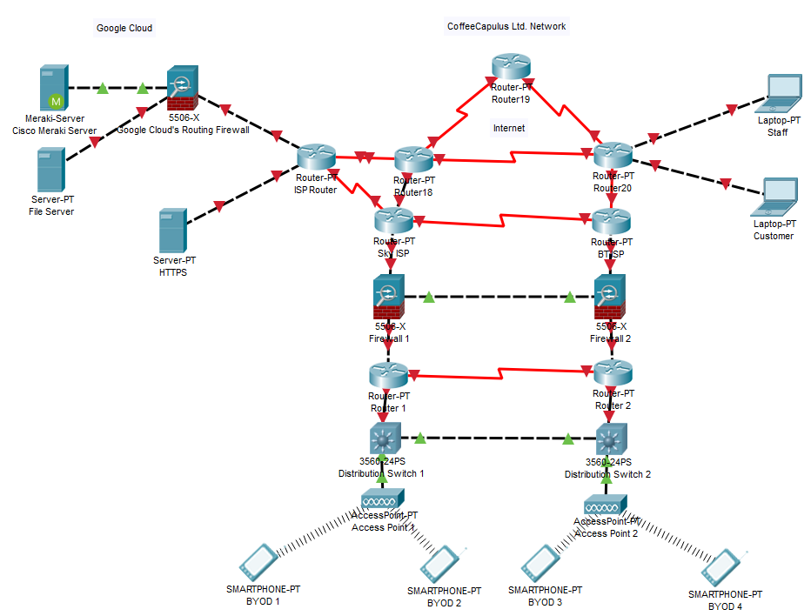
Framework

Here is an example network architecture from packet tracer to demonstrate a solution towards CoffeeCapulus requirements.
To explain the construction, we begin with any personal device brought in and used by anyone (in this case a set of smartphones) in a small radius or building. These phones will be wirelessly connecting to an access point put in place to be facilitated into the network. Moving up according to the OSI model from the access layer, we have the distribution layer in which there are distribution switches where all packets and information from our end devices are sent through. From here, we move to the centre of the network to the routers for CoffeeCapulus which are facing toward our public internet WAN. Forms of hardware firewalls are used to protect against unauthorised access from users in the network. Then, a strong recommendation would be to use two different internet service providers to for the purpose of redundancy (if one were to go down for any reason the network would still be running off our second ISP), example acceptable ISP’s would be Sky and BT. At the very top we of course have our public wide area network allowing us connection across to our cloud datacentre which in this case we have chosen to go with Google Cloud. Separated into different spokes we have our public and also private accessible information; the firewall denies unauthorised users from entering where in our example would mean any customers or staff who may not need access to certain parts of data. We have our file server and MDM server (Cisco Meraki) only to be utilised by authorised staff via the companies’ I.T department or network administrator, this is where our MDM server is needed as authorisation for staff members will be configured here. The HTTPS server is open to staff as well as customers so that they may use the internet freely. The cloud allows us to access these features that are fundamental for our organisation’s needs in today’s world and would otherwise be far to expensive to obtain this hardware which is why we need to sign with a cloud service provider such as Google Cloud. Lastly there is the difference between customers and staff connecting to the network remotely, a customer would connect to the internet through the network with hypertext transfer protocol secure (HTTPS) enforcing a common, secure connection to use openly. Staff could link up to the network from wherever they want using a virtual private network (VPN) for the purpose of preventing any sensitive company related data from being intercepted by potential threats as appose to using HTTPS which won’t “secure all online communications coming from your device”. [8]
Conclusion
Bring Your Own Technology is still a developing aspect of today’s modern workforce, on the one hand It is seen as a positive addition to an organisation because it is a flexible measure that both employers and employees would benefit from but on the other the nature of this flexibility grants additional pathways to breaching a network with lots of potential security vulnerabilities without cautioned implementation, monitoring and updates.
There are certainly tools out there right now to assist with mobile device management and the security and scalability issues, it is a matter of how steps are executed to introduce BYOD on whether it is a viable option for a business that also wants to prioritise the safety of everyone’s information involved like for example how well security policies are first created but also followed strictly and how security measures on the network are more than adequate.

Bibliography

[1] | Tech Talk, “10 BYOD Policy Guidelines For A Secure Work Environment,” GFI Software, 20 May 2014. [Online]. Available: https://techtalk.gfi.com/10-byod-policy-guidelines-for-a-secure-work-environment/.
[2] | University of Strathclyde Glasgow, “Bring Your Own Device Policy,” [Online]. Available: https://www.strath.ac.uk/media/ps/its/its-software/BYOD.pdf.
[3] | M. Rouse, “Mobile Device Management (MDM),” TechTarget, [Online]. Available: https://searchmobilecomputing.techtarget.com/definition/mobile-device-management.
[4] | IT Pro Team, “Best MDM Solutions 2020: Take The Hassle Out of BYOD,” 11 September 2019. [Online]. Available: https://www.itpro.co.uk/mobile/29775/best-mdm-solutions.
[5] | Cisco Meraki, “Solutions: Mobile device management,” [Online]. Available: https://meraki.cisco.com/solutions/mobile-device-management.
[6] | Riverside Technologies inc., “The Advantages & Disadvantages of BYOD,” 26 July 2018. [Online]. Available: https://www.1rti.com/the-advantages-disadvantages-of-byod/.
[7] | TrendMicro, “Implementing BYOD: How Lost or Stolen Devices Endanger Companies,” 2 March 2015. [Online]. Available: https://www.trendmicro.com/vinfo/es/security/news/mobile-safety/how-lost-or-stolen-devices-endanger-companies.
[8] | A. Rasmussen, “HTTPS vs. VPN: Why you need both,” NordVPN, 19 April 2019. [Online]. Available: https://nordvpn.com/blog/https-vs-vpn/.

marking criteria and Student FEEDBACK

This section details the assessment criteria. The extent to which these are demonstrated by you determines your mark. The marks available for each criterion are shown. Lecturers will use the space provided to comment on the achievement of the task(s), including those areas in which you have performed well and areas that would benefit from development/improvement.

Common Assessment Criteria Applied (Assignment 1) | Marks available | Marks  awarded
1. Engagement with Literature Skills
Extent of research and/or own reading, selection of credible sources, application of appropriate referencing conventions.
You have used only websites/online sources for your referencing and did not engaged with any academic peer review article to make your work credible. Websites require careful consideration. Some key concept considered. (Grade mark: 45.33%) | 15 | 6.8
2. Knowledge and Understanding Skills
Extent of knowledge and understanding of concepts and underlying principles associated with the discipline.
Need to demonstrate more depth of the research, see comment above which can help in this area. Did not use IEEE report format. (Grade mark: 45.33%) | 15 | 6.8
3. Cognitive and Intellectual Skills
Analysis, evaluation and synthesis; logic, argument and judgement; analytical reflection; organisation of ideas and evidence
Your report explain relevant areas for this assignment; policy, MDM, etc. No DFD done. See comment in your report to improve your abstract, conclusion and other areas. (Grade mark: 47.50%) | 40 | 19
4. Practical Application Skills
Deployment of methods, materials, tools and techniques; application of concepts; formulation of innovative and creative solutions to solve problems.
No practical work uploaded. A design diagram discuss in report. (Grade mark: 25.00%) | 20 | 5
5. Transferable Skills for Life and Professional Practice
Attributes in professional practice: individual and collaborative working; deployment of appropriate media; presentation and organisation.
Your work need to be formatted and be consistent to make it look professional. Some grammatical errors and some areas the sentences could be clearer. . (Grade mark: 48.00%) | 10 | 4.8

Assignment Mark (Assessment marks are subject to ratification at the Exam Board. These comments and marks are to give feedback on module work and are for guidance only until they are confirmed. ) | Late Submission Penalties (tick if appropriate) |  | 42%
 | Up to four weeks late |  | 42%
 | First Attempt? |  | 42%

