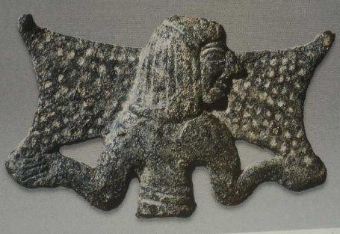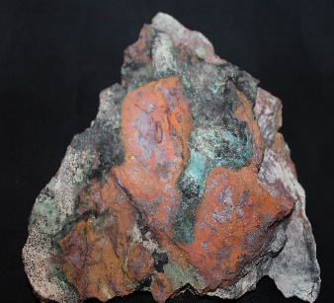
Trader with copper ingot Copper ore Copper slag (Arediou)

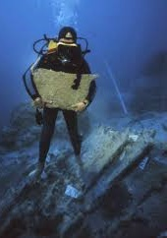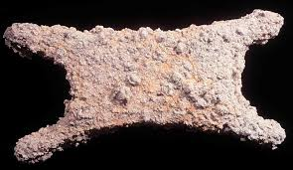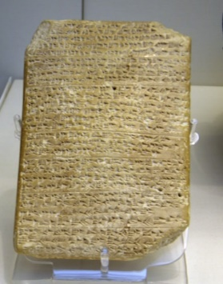
Copper ingots, Ulu Burun Iron ingot, Ulu Burun Amarna letter, Alashiya

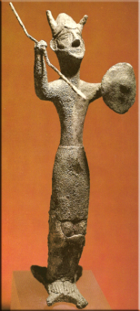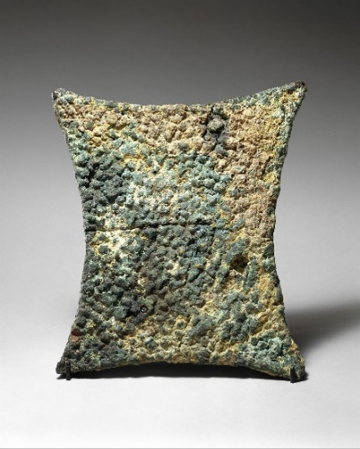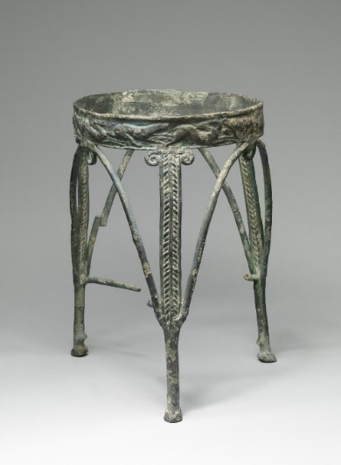
Ingot God, Enkomi Copper ingots & copper tripod
(Sardinia, Sicily, Greece, Ugarit) (Cyprus, Sardinia, Crete)
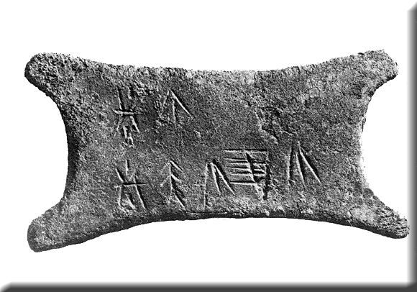 Inscribed miniature ingot, Enkomi

