Module Name: Academic skills
Module Code: LCM4001
Student’s Name: Violetta Lendiel
Student’s ID: 2329128
Group: 1

Lecturer’s Name: Timothy Hopkins

Date 20/08/2024

University of Wales Trinity Saint David (London Campus)

Table of Contents
Introduction 1 4
2 Reflection Topics 5
2.1 Note taking 6
2.2 Paraphrasing 6
2.3 Academic Writing 7
3 Conclusion 8
4 List of Reference 9
Appendix 1 10
Appendix 2 12
Appendix 3 13
Appendix 4 14
14

Introduction 1
I am writing to you today with a sense of excitement and determination as I embark on the journey of for the learning about my great but mean time honestly difficult experience. Reflecting on my past experiences, I realize that every role I played was a stepping stone that shaped me into the person I am today. My journey began in the hectic world of learning and developing my skills in the business world, where I learned the importance of attention to detail and teamwork. When I became a student at Trinity St David's University of Wales, my responsibilities expanded and I was given chance of learning and developing my skills. I am drawn to the opportunity to learn from esteemed faculty members and engage with fellow students who share my passion for making a positive impact in the world. I am excited about the prospect of exploring new ideas, challenging my assumptions, and ultimately emerging as a more knowledgeable and empowered.

2 Reflection Topics
I have use Gibbs' reflective cycle in my work. Using this method to process an experience is a smart idea. This is a one-time event or something that happens to you often. Though Gibbs first recommended using it for recurring events, the stages and concepts also hold true for one-time encounters. If you use a standalone experience, your action plan can be more broad and consider how you might use the findings in the future. There are a number of useful questions that will assist you complete the task.

2.1 Note taking
One of those modules that I enjoyed to exploring its note taking method, most interesting for me was tabular notes (see appendices 1,2) We was learn about that in week 2. This module including Linier, Diagraming, and Cornell notes. We was listening an audio practice to speed notes taking .( BBC 2019).
On my not the best ability to write and spell correctly this is experience was a bit annoying. That was also challenging as my wadable not enough full to describe. I couldn’t do as fast and best I can.
But on mean time I found it very useful for any future journey on study and occupations. Whatever, I need keep doing to react mean point of this module.
By using Cornell note method, I was able to comprehend the relationships between various concepts more easily and my notes were lot more engaging to read again. Rather than writing my notes in the typical linear style, I was able to organise the ideas I had and the information we covered in class. I was able to bring together the ideas of the cornel note by using this technique to centre the main subject and explore the minor objects. I think using notes taking in class forces me to think more in English even if this headache. I may use this method to my future studies next term.

2.2 Paraphrasing
The second module was a pleasant trip, to put it mildly it is paraphrasing. When writing someone else's ideas in your own words, paraphrasing is a useful tool. Paraphrasing is helpful when utilising other people's writing to bolster your own arguments. It's an intriguing possibility to alter the language and structure of a paraphrase while maintaining its meaning. Paraphrasing puts quotations and paraphrases from other authors into context, shows the idea, avoids plagiarism, and helps to contextualise the information. We get to know about paraphrasing on week 4 academic writing/ paraphrasing. (See appendix 3,4)
Week 4 was so interesting for me because one of my favourite thinks to do to explore myself on my on world. Since school age I really liked use synonyms in my sentience’s or storis. This was helped me fully reveral the text or any news or story. On time now it great tool for those people who English vocabulary not enough full. The paraphrase help us present any king of material in correct way.
Using alternative words and wording to convey the same concepts is known as paraphrasing. When writing brief passages of text, such phrases or sentences, paraphrasing is helpful. A paraphrase is a useful instrument for combining evidence and source material into assignments as an alternative for direct quotations. Awesome tool for any career or position in life if you know how to paraphrase it.
I noticed it easier to understand the connections between different ideas by adopting the paraphrasing approach, and my notes were much more interesting to read again. I was able to arrange my thoughts and the material we covered in class, as opposed to recording my notes in the conventional linear approach. By focusing on the primary topic and examining the supporting information, I was able to integrate the ideas of the paraphrase. Even although English is not my first language, I believe that paraphrasing helps me grow as a speaker of the language. Without a doubt, I'll employ this strategy.

2.3 Academic Writing
The most important learning experience we got during my term 1 studying was academic writing. We got to talk about academic writing which took place during week 4. We had lots of opportunities to practice getting it right. I thought I was pretty confident, and I was spent a lot of time preparing it as I've seen others do it (see apendics,5)
I really wanted to perform well throughout practice. Perhaps I was expecting too much of myself? My attempts at composure failed, and I felt confused, so I kept practicing even though I was anxious and dissatisfied with my output. I talked about it with my teacher afterward, and we decided where and how I could do better. Though I felt it was the greatest approach to learn how to get better, I was a little ashamed that I had to talk to my teacher.
Writing academically in a professional setting is far more challenging than it is in a university. Speaking with the teacher was really beneficial, and I've come to the realisation that I need to improve the structure of my presentations for me to communicate information more effectively. I learnt from this experience that this is in fact the case. Asking for assistance when you need it is crucial, and even while receiving criticism might be hard at times, it is occasionally useful if it helps you to develop yourself.
All on all, the experience improved both my grammar and writing. I've had the chance to exercise my English, I feel able writing academically in a professional setting, my communication skills have improved, and I believe that going through a challenging circumstance has strengthened my resilience and given me the ability to pick myself over when things don't go as planned.

3 Conclusion

In the ends any of student journey and knowing are very helpful for the future studying and carrier. The any experience are great. One famous person said “ the bad experience is also experience” even if may struggling now for any reason this struggle build you self. My reflective report and topics I have chosen are on my opinion will effect on me the good way. As a student, I have had the opportunity to refine my methods of learning and social interaction. that has additionally aided in my personal development. I've come to assume that this maturity will also aid in my development as a better thinker—one who has the patience to hear what others have to say and give it some thought. I see learning as a two-way process that requires careful consideration As a student, gaining all the knowledge my teachers have put in front of me and becoming a conscientious been and will remain my top priority.

4 List of Reference
Bailey, S. (2020). Academic Writing for International Students of Business and Economics. Routledge.
Kissner, E. (2006). Summarizing, Paraphrasing, and Retelling. Heinemann Educational Books.
Macdonald, V. and Note Taking (2014). Note Taking Skills for Everyone : Learn the Strategies of Effective Note Taking in Order to Earn Maximum Grades Today!. Createspace.
Scribbr. (n.d.). Academic style. [online] Available at: https://www.scribbr.co.uk/category/academic-style/.
Stuckler, D. (2022). How To Improve Your Academic Writing IMMEDIATELY | 3 Tips For PHD Students. YouTube. Available at: https://www.youtube.com/watch?v=7FrYXvJOO44.

Appendix 1
Note taking1
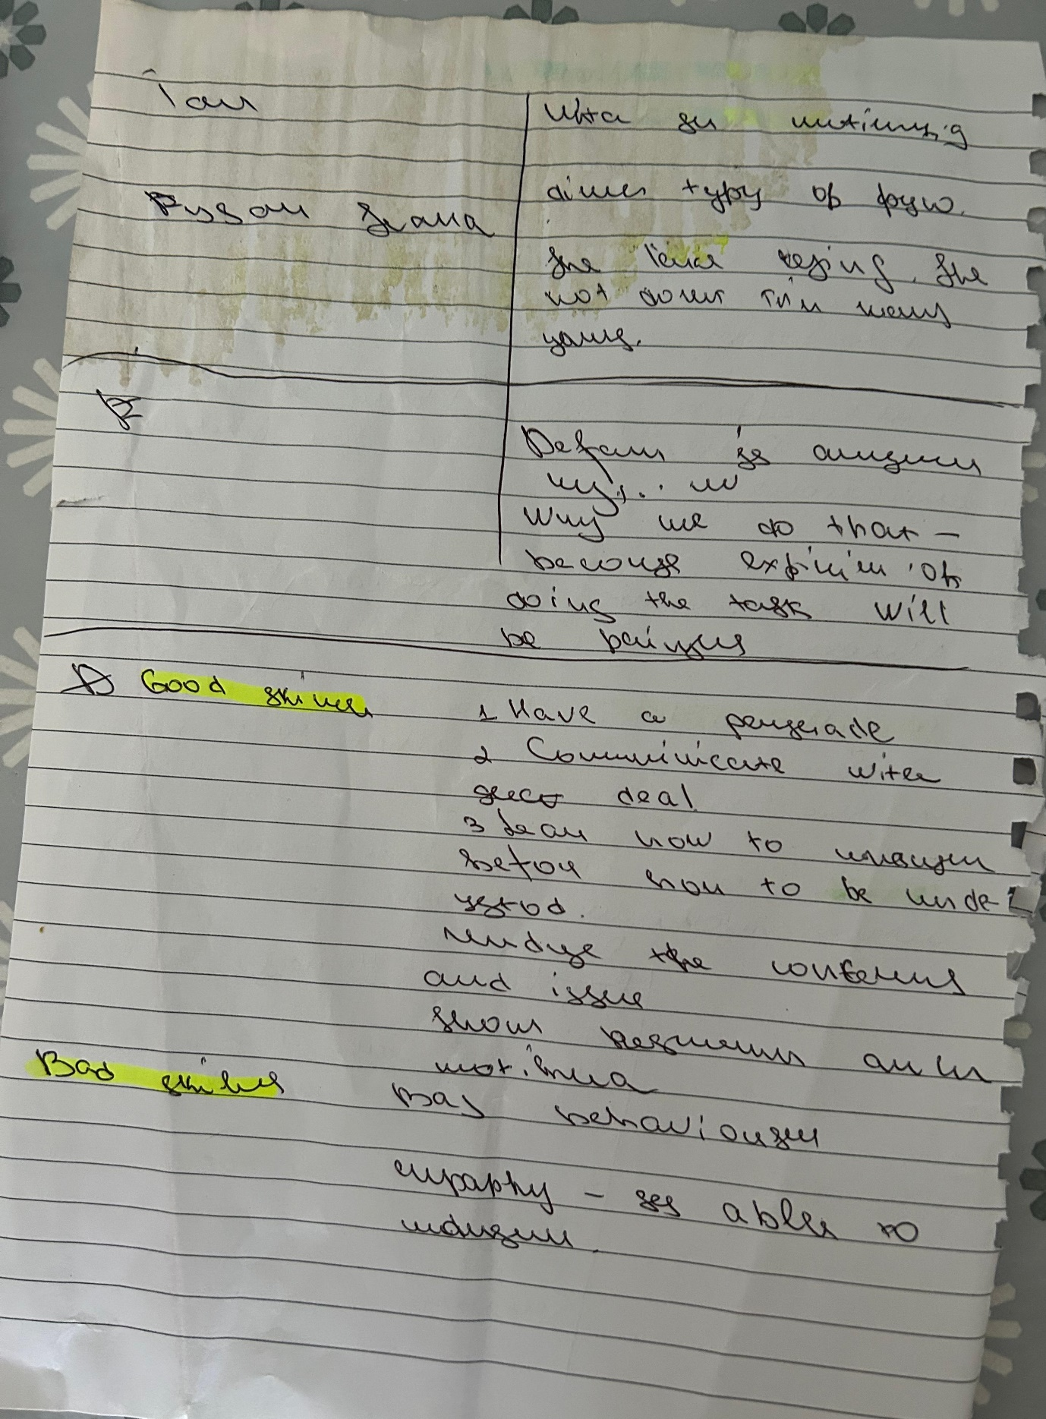

Appendix 2
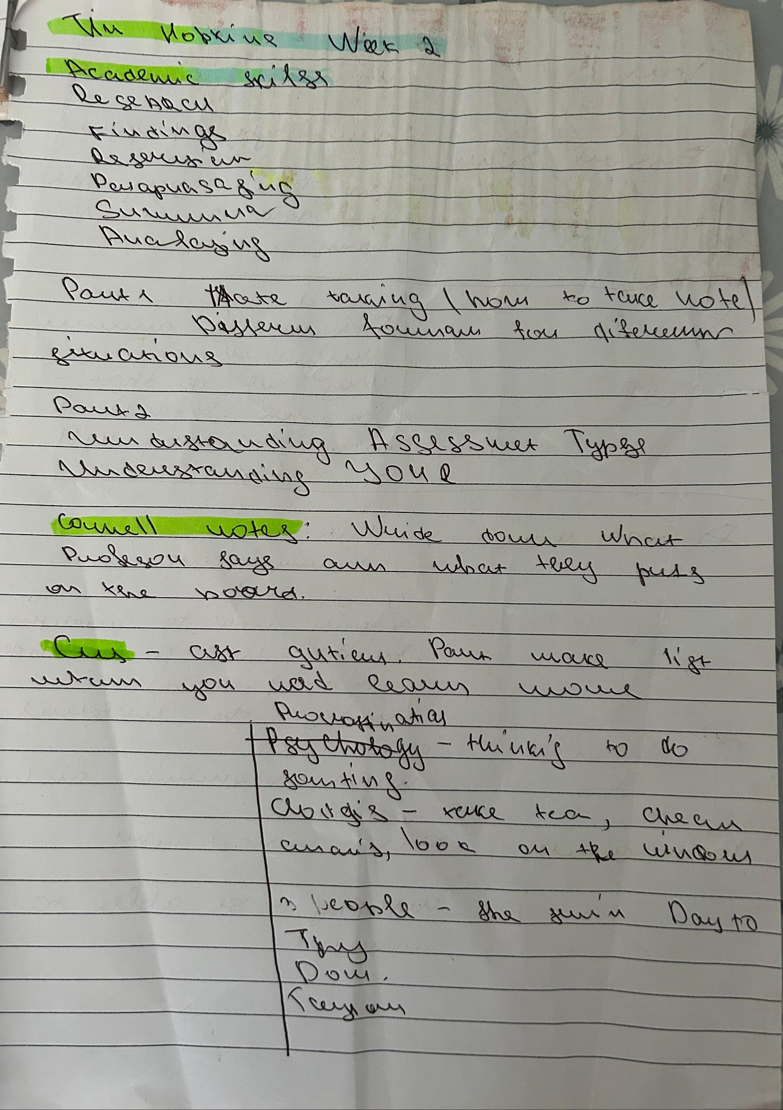

Appendix 3
Paraphrasing
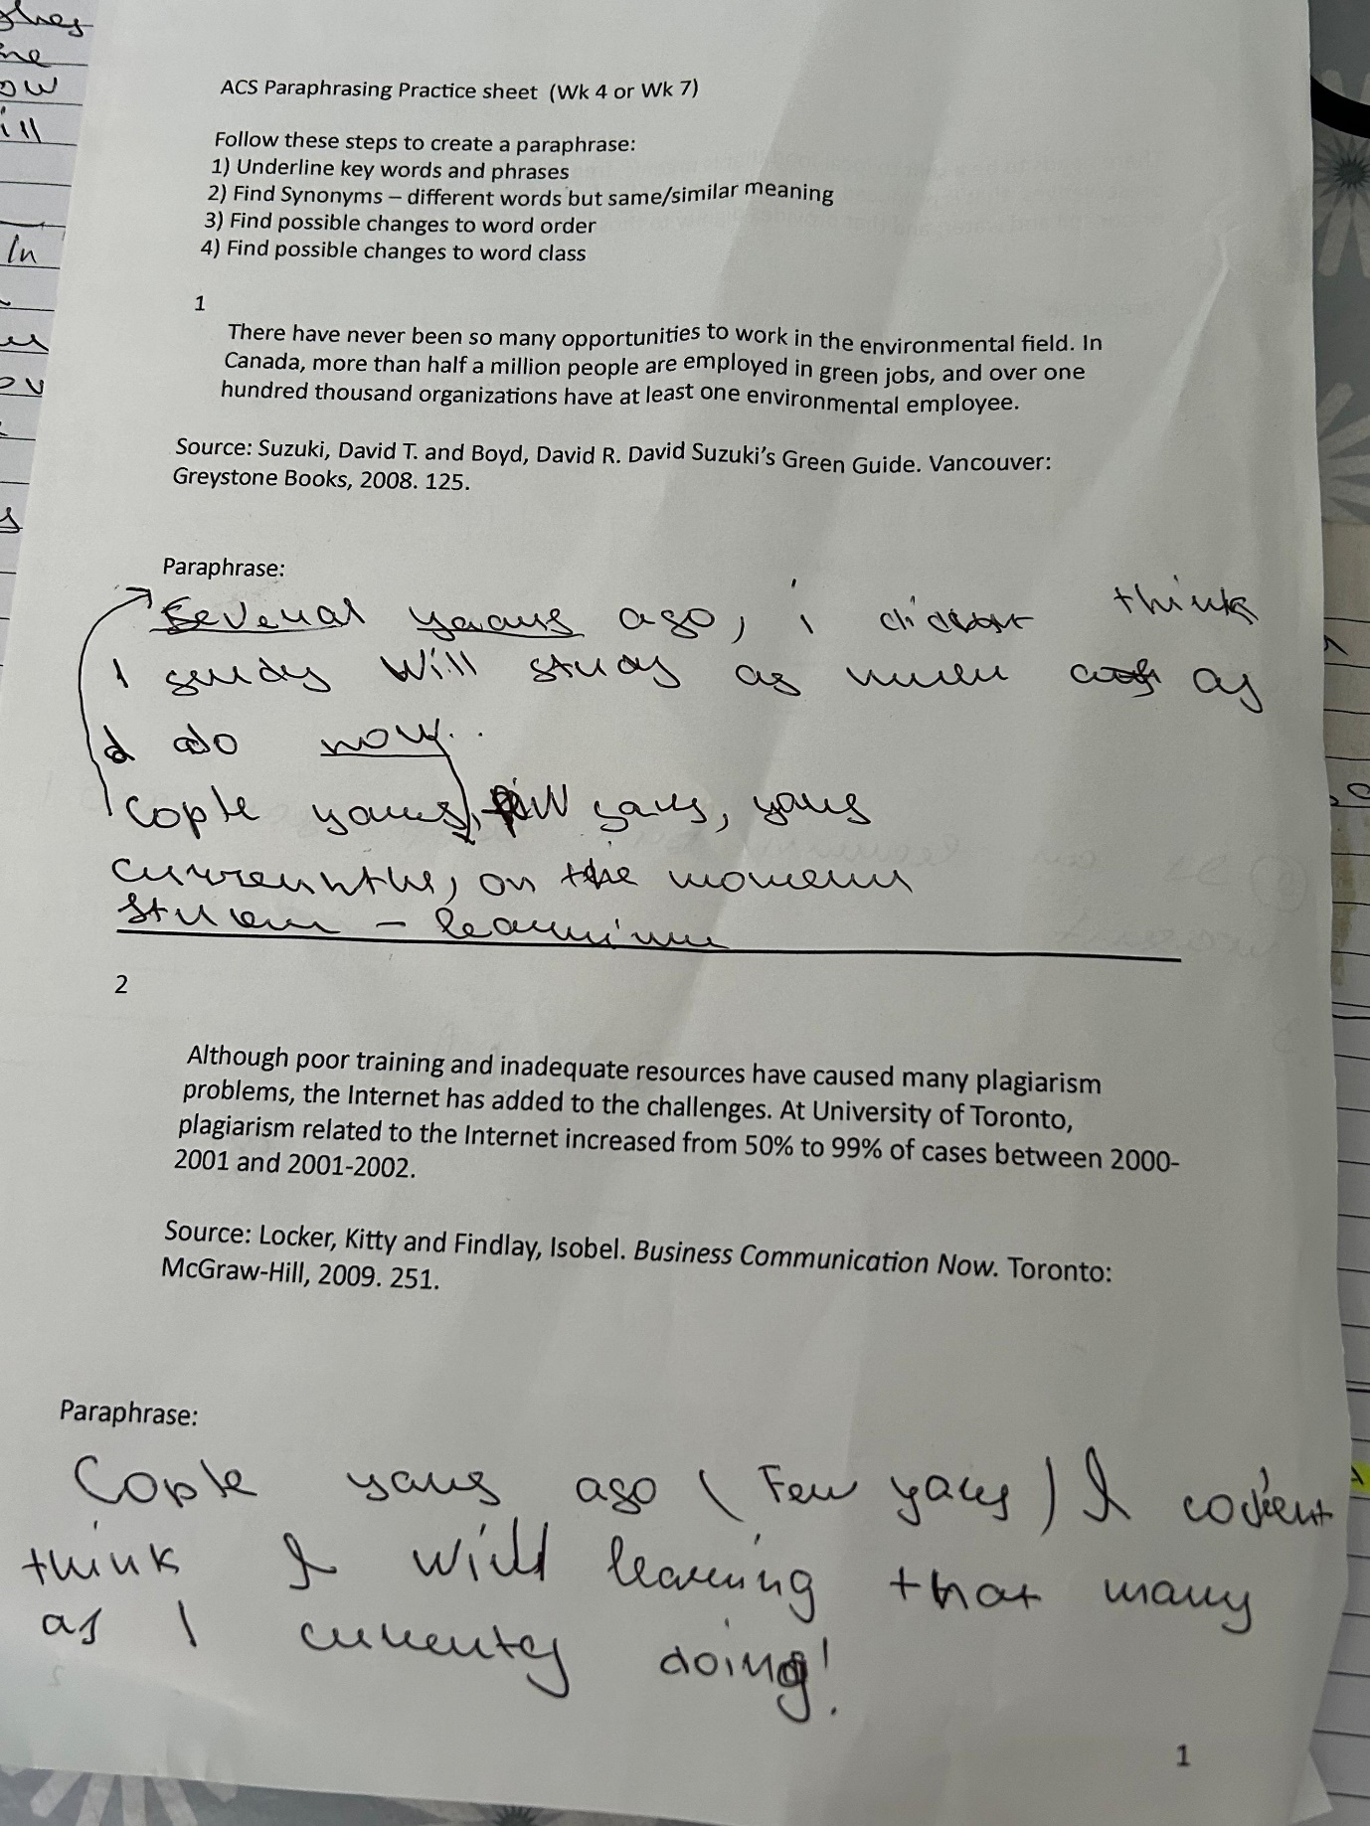

Appendix 4



