Management Ethics Assignment 1 2018 – Critical Discussion of Corporate Social Responsibility



19th November 2018

MODULE NAME: Management ethics: m5x00803
Name: Amy Collins
Student Number: 1703573
Table of Contents
Executive Summary 3
Introduction 3
What is Child Labour? 4
Corporate Social Responsibility 4
Stakeholders 5
Stakeholder Mapping 5
Gibbs Model of Reflection 6
Conclusion 7
Recommendations 7
References 7
Appendix A- Poster 9
Appendix B- Questions and Answers 10

Executive Summary

Introduction
This report will be focussing on how H&M have used child labour, and how they have reacted to the negative publicity as a result. It will also look at how companies have corporate social responsibility for themselves as well as how they are affecting their stakeholders. A reflective summary, using Gibbs’ reflective model will also take place as a summary of the report, discussing what might have been difficult throughout, as well as future enhancements for a similar situation.

What is Child Labour?
“Child labour involves very young people in full-time, often dangerous work. It is thought to affect one in six children around the world. Areas of work include farms, factories, building sites, dumps and mines.” (Gifford, 2009:6)

Corporate Social Responsibility
“The concept of corporate social responsibility is understood as companies caring for the wellbeing of their workers, for the natural environment, or for society in general by adhering to international standards.” (Thauer, 2014:2)
Milton Friedman (1970:173) suggests that ‘only people can have responsibilities’ and that a business should focus only on generating profits. Applying this to H&M, their use of child labour would suggest that they are willing to risk the negative publicity in order to maximise their profits. On the other hand, Freeman, Wicks and Parmar (2004:365) argue that ‘values are necessarily and explicitly a part of doing business’. In saying this, it is suggested that the success of a business comes down to more than just their profits and that relationships with stakeholders are also valued.
Figure 1 Carroll’s Corporate Social Responsibility Pyramid (Carroll, 2016)
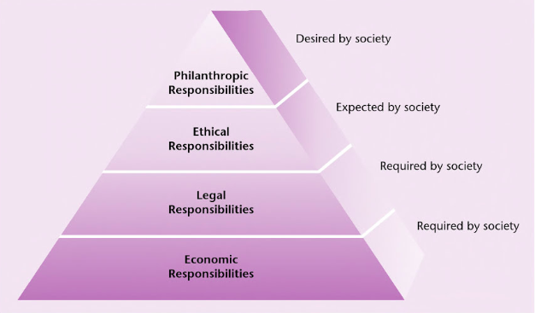
This image (left) shows Carroll’s corporate social responsibility pyramid. It demonstrates the responsibilities that are required and expected by society based on the organisations. Both economic responsibilities and legal responsibilities are required by society, meaning that business have little choice but to meet these requirements. Archie Carroll (2016:3) suggests that economic responsibilities are ‘a baseline requirement that must be met in a competitive business world.’ H&M’s code of conduct suggest that they comply to these requirements by ensuring that wages are ‘paid regularly, on time, and must reflect experience, qualifications and performance of the employee’ (H&M, 2018).
They also go as far as describing themselves as ‘a good corporate citizen’ in their tax policy (H&M 1, 2018), insisting that ‘all taxes and charges are paid according to local laws and regulations in the countries where H&M operates’.
Looking at their code of conduct, H&M (2018) specify that ‘no person shall be employed at an age younger than 15 (or 14 where the national law so allows)’ should be employed by the company. Despite 14 being the legal age to work in some countries, it is debatable whether allowing children this young to work, particularly in conditions discovered in Mynymar (Butler, 2016).
Part of H&M’s vison is to ‘create a truly sustainable fashion industry that is good for people, communities and the planet’ (H&M 2, 2018). This falls under Carroll’s idea of a philanthropic responsibility, on top of their aim to ‘lead the change towards a circular and renewable fashion industry’ (H&M 2, 2018).

Stakeholders
 |  |  | INTEREST
 |  |  | LOW |  | HIGH
 |  |  | Minimal Effort |  | Keep Informed
 |  |  |  |  | Competitors
 | LOW |  |  |  | Employees
 |  |  |  |  | Media
POWER
 |  |  | Keep Satisfied |  | Key Players
 |  |  | Government |  | Customers
 | HIGH |  |  |  | Investors
 |  |  |  |  | Directors
Figure 2 Mendelow’s Stakeholder Matrix (Knowledge Grab, 2018)

There are a variety of aspects that can affect the way in which a business operates, but their stakeholders are the most important. A stakeholder can be defined as ‘any group or individual who can affect or is affected by the achievement of an organization’s purpose’ (Freeman 2010:53) The influence that stakeholders have on a business is immensely powerful, a business can fail to make a profit if it does not have the support of its stakeholders. Stakeholder mapping is another way demonstrating the influence of stakeholders.

Stakeholder Mapping
The model demonstrated above, Mendelow’s stakeholder matrix (Knowledge Grab, 2018) contains a number of examples that show which stakeholders have the most power and interest in a business. Looking at the minimal effort section, these stakeholders hold a low amount of power while also having a low interest. It is important for a business such as H&M to not bombard its stakeholders with unnecessary information, but to keep an eye out to monitor if their influence changes. (Oxford College of Marketing, 2018)
The next section is the high interest but low power, also known as the keep informed section. H&M would need to ensure they are communicating with these stakeholders to maintain their interest in the business. Next is the keep satisfied section, meaning that stakeholders have a high power over the organisation but having low interest. H&M need to ensure they are satisfying these group of stakeholders without providing them with too much information that may cause them to lose interest. The final section of Mendelow’s stakeholder matrix is the stakeholders that have the most power and the most interest. These are known as key players and H&M would need to ensure that they are fully cooperating with these stakeholders to maintain a high level of interest in the business (Oxford College of Marketing, 2018).

Gibbs Model of Reflection
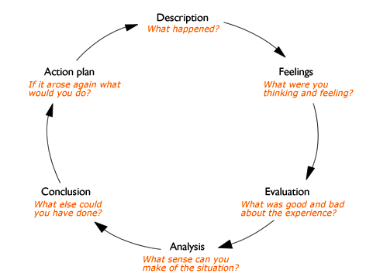
Figure 3 Gibb’s Model of Reflection (Oxford Brookes University, 2018)
The topic which I chose to research was child labour in relation to fashion retail store, H&M. I was first tasked with creating a poster based on the issue along with a poster defence, where I defended my use of imagery, wording and presentation. I then had to discuss corporate social responsibility, linking the issue to numerous theoretical models and making reference to various stakeholders that would be affected by this issue.
I feel like the research conducted allowed me to successfully assess H&M’s stance towards child labour, while also teaching me more about the issues faced by large retailers across the world.
When producing this report, I particularly enjoyed designing and creating the poster, while researching an issue as important as child labour gave me great insight into the issues faced by both large companies and exploited workers. As there was so much information available, I sometimes struggled to stick to the permitted word count.
Throughout my research, I have learnt that there are arguments both for and against corporate social responsibility from a business perspective, relationships with stakeholders should be valued as they have a very high influence on the company, and I have also learned that there are different levels of expectation from society when it comes to CSR as discussed in Carroll’s CSR pyramid.
During this report, I could have researched other companies that carry out child labour and use them as comparison against H&M. I could have also attempted to research the history of the issue to establish if there has been an improvement. If the opportunity arose, with a larger word count, I can implement this in the future.

Conclusion
Even though H&M carry out child labour, they still have a strong backing from most customers as it is still one of the popular shops in retail parks and city centres. Despite their code of conduct stating that they are against child labour, they continue to use workers aged as young as 14 in countries where it is legal. They need to ensure they are satisfying the needs of every one of their stakeholders to ensure they are maintaining their interest in the company as well as meeting the criteria required and expected by society.

Recommendations
As part of the recommendations to improve the controversy of child labour, large companies such as H&M could provide under privileged children working in their factories with education. This means that they would be getting good publicity from the press, improving their reputation and the children will be getting access to education that they could not previously afford themselves. If H&M can not do this, they could begin by setting a global age limit for employees at 16 and working closer with suppliers to improve working conditions.

References
Freeman, R. E., Wicks, A. C. and Parmar, B. (2004) ‘Stakeholder Theory and "The Corporate Objective Revisited " ‘in Organization Science, 15(3), pp. 364–369.
Friedman, M. (1970) “The Social Responsibility of Business Is to Increase Its Profits in The New York Times Magazine. pp. 173
Gifford, C. (2009) “Child Labour” London: Evans Brothers.
Butler, S. (2016) “H&M factories in Myanmar employed 14-year-old workers” (Online) Available at: https://www.theguardian.com/business/2016/aug/21/hm-factories-myanmar-employed-14-year-old-workers (Accessed: 9 Nov. 2018)
International Labour Organization. (2018) “ILO Conventions and Recommendations on child labour” (Online) Available at: https://www.ilo.org/ipec/facts/ILOconventionsonchildlabour/lang--en/index.htm (Accessed: 9 Nov. 2018)
Thauer, C. (2014) “The Managerial Sources of Corporate Social Responsibility” Cambridge: Cambridge University Press.
Crane, A. & Matten, D. (2016) “Business Ethics: Managing Corporate Citizenship and Sustainability in the Age of Globalization” Oxford: Oxford University Press.
Oxford Brookes University (2018) “Reflective Writing: About Gibbs reflective cycle” (Online) Available at: https://www.brookes.ac.uk/students/upgrade/study-skills/reflective-writing-gibbs/ (Accessed: 13 Nov. 2018)
H&M. (2018) “Code of Conduct” (Online) Available at: http://sustainability.hm.com/content/dam/hm/about/documents/en/CSR/codeofconduct/Code%20of%20Conduct_en.pdf (Accessed: 15 Nov. 2018)
H&M 1. (2018) “Tax Policy” (Online) Available at: http://sustainability.hm.com/en/sustainability/downloads-resources/policies/policies/tax-policy.html (Accessed: 15 Nov. 2018)
H&M 2. (2018) “Vision and Strategy” (Online) Available at: https://about.hm.com/en/sustainability/vision-and-strategy.html (Accessed: 15 Nov. 2018)
Carroll, A. (2016) “Carroll’s pyramid of CSR: taking another look” in International Journal of Corporate Social Responsibility. pp. 1-8.
Freeman. R (2010) “Strategic Management: A Stakeholder Approach” Cambridge: Cambridge University Press.
Oxford College of Marketing. (2018) “What Is Mendelow’s Matrix and How Is It Useful?” (Online) Available at: https://blog.oxfordcollegeofmarketing.com/2018/04/23/what-is-mendelows-matrix-and-how-is-it-useful/ (Accessed: 18 Nov. 2018)
Knowledge Grab. (2018) “Mendelow’s Matrix” (Online) Available at: http://knowledgegrab.com/glossary/mendelows-matrix/ (Accessed: 18 Nov. 2018)

Appendix A- Poster
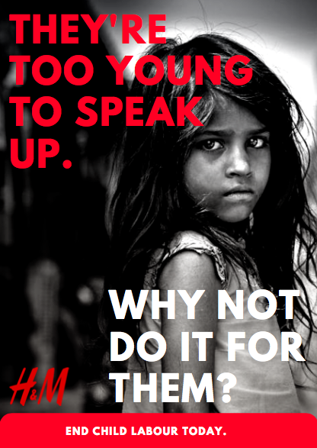

Appendix B- Questions and Answers
Which organisation or issue are you investigating?
H&M is the chosen organisation to base the report on. They are a clothing retailer which are highly popular around the world. H&M are one of the major retailers that are still using child labour to this day.
What unethical business practice(s) are you investigating?
In 2016, Sarah Butler (2016) of the Guardian exposed H&M after it was revealed that “children as young as 14 toiled for more than 12 hours a day” in Myanmar, and had been doing so since 2013. The business practise that will be evaluated will be child labour within H&M.

What are the main issues and debates involved?
An issue for H&M is that some of their factories employ children under the age of 15. This is not illegal in all countries, however it is considered unethical practice as they could potentially be ‘involved in hazardous activities that may compromise their physical, mental, social or educational development’ (UNICEF, 2017).

What are the main stakeholder groups that are impacted by the issues you are examining and how are they impacted in your opinion?
The stakeholder groups that would be impacted by any action taken include the exploited workers themselves, who could see improved working conditions or better pay. Shareholders of companies which exploit child labour could also see reduced sales, while any action taken on their behalf would cost them money. The company’s competitors could also take advantage of the increased awareness in the issue, potentially improving sales.
What is the response by the organisation to your argument?
In response to the revelations, the company said that it was “of utmost importance” that their products were made under “good working conditions and with consideration to safety, health and the environment” (Butler, 2016).

Why have you used the images and words you have selected?
I used rhetorical language as I thought it would encourage the reader to consider the issue that I am promoting, while the emotive text is also easy to understand. The background image of an upset, young child adds to the emotion of the poster which will hopefully further encourage the reader to consider the issue themselves and potentially take action when it comes to the products that they purchase.

What research have you done to underpin your argument?
When researching the issue, I found that children’s charity UNICEF suggested that “around one in four children” engage in work that could potentially have a damaging to their health in lesser developed countries such as Myanmar (UNICEF, 2017).
How strong do you think the evidence is to back up your argument?
Looking at the previous question, it is a shocking statistic from a reliable source as UNICEF is an organisation that’s purpose is to protect children’s rights and is known worldwide, making it a strong piece of research to back up my argument.

What would you hope would happen after the audience has understood your message?
It would prove very difficult to deter people from purchasing goods from their favourite stores because of child labour as it is something which we are unable to witness ourselves. Exploiting child labour also decreases prices, which is attractive to customers (Brewer, 2015).

What models and theories will you be referring to in your reflective report?
Gibb’s reflective cycle will be evaluated within the reflective aspect of the report as it is easily segmented into stages to reflect on more easily.

Why did you decide on this particular research question?
The topic of child labour was chosen as it is a topic where the surrounding circumstances allowed me to express my views through a powerful poster.
What are the practical implications of the unethical business practice you have investigated? You may consider implications for a number of stakeholder groups.

By continuing to carry out child labour, there are a variety of implications that can affect H&M. One being that many customers will boycott purchasing from H&M if they know they use child labour. This could see H&M’s profits fall and give them negative publicity. While customers are avoiding shopping with H&M, competing organisations will be gaining customers and investors will be more reluctant to invest in H&M.

References
Brewer, J. (2015) “Be honest: you don't care if your pretty dress was made by child slaves” (Online) Available at: https://www.telegraph.co.uk/news/worldnews/asia/vietnam/11770335/Be-honest-you-dont-care-if-your-pretty-dress-was-made-by-child-slaves.html (Accessed: 9 Nov. 2018)
Butler, S. (2016) “H&M factories in Myanmar employed 14-year-old workers” (Online) Available at: https://www.theguardian.com/business/2016/aug/21/hm-factories-myanmar-employed-14-year-old-workers (Accessed: 9 Nov. 2018)
UNICEF. (2017) “Child labour” (Online) Available at: https://data.unicef.org/topic/child-protection/child-labour/ (Accessed: 9 Nov. 2018)

