
Student Name: Svetlana Dimitrova
Student Number: 1714890
Module Number: BMSW5104
Module Title: Managing Projects in the Organisation
Name: Dr Kenny Tang

Content
Introduction 1
Project Risk Management 2
Project Time Management 4
Project Implementation 7
Kotter’s 8 Steps 7
Greiner’s Life Cycle Model 12
Stakeholders 13
Stakeholders Mapping (Mendelow) 14
Personal Development Plan 15
Reference 20



Introduction

Project management is a research and an art. It is a method, since it focuses on tried-and-tested methods and procedures for the implementation of programmes. It is an art as it often includes organising and communicating with others and allows administrators to show strategic ability in circumstances that are special to each project. Effective project management approach lays out structures, procedures, protocols and strategies for handling staff and jobs. Effective approach improves the likelihood of completion and thereby supports the organisation, the team and the project manager. In today's globalised environment, with the rapid development of technology, projects in general are becoming not only more complex but also resource consuming. That is why, in order to succeed in a project, knowledge and use of project management methods and techniques is required. The experience of developed market economies would be valuable to us and to our economy, even more so that project management is an essential part of the businesses of these countries. Project management is the most dynamically developing modern profession (Briggs, 2012).
According to the most prominent thinkers in management, there are two major disciplines that will dominate: project management and multifunctional team building. Businesses looking towards the future are special about how much they plan their programmes. Good project management capabilities should be the sole indicator of potential company owners and executives. "There are two important skills for successful modern management ... one of them is the ability to manage projects." (Kanter, 1989).
BBC Worldwide is the BBC's main commercial division and a directly managed BBC corporation. BBC Worldwide is dedicated to establishing the BBC brand globally, advancing the BBC public service mission and maximising revenues, while ensuring that all activities are carried out in a way compatible with the ideals and values of the BBC. BBC Worldwide has given itself the goal of substantially rising the income of the BBC public service over a span of five years (cipd.co.uk, 2015).

Project Risk Management

Risk management is a structured method for defining, assessing and responding to project threats. This includes increasing the likelihood and effects of successful outcomes and reducing the possibility and consequences of adverse events for project purposes. The risk reduction strategy describes how the project manager can address the challenges of achieving this goal. Modern understanding of risk reduction as a mechanism that complements and interacts with certain systems within the enterprise, constantly and systematically, may be an effective solution to the realities confronted by subjects. In this way, the risk assessment mechanism is not only a method for mitigating and controlling the effects of negative outcomes on the company, but also the ability to find prospects. (Pavodani and Tugnoli, 2005).
Risk management needs to build a detailed action plan on how to deal with the challenges and opportunities during the project development process. The risk management approach is split into many phases:
- Development of the risk management programme and opportunities;
- Taking action to define and mitigate the possibility of project risks;
- Communication with the project manager and stakeholders to collect and interpret details on the risk management initiative;
- Use of software initiative risk assessment, analysis of the knowledge obtained;
- Production and monitoring of project concern through daily meetings with the project manager and other stakeholders.
Risk assessment is the analysis of the condition in order to understand what may be problematic with the product design and production process at some period during the process. Sources of threats and possible effects need to be established before they can be mitigated. Experts in their own fields provide innate ways to identify a threatening condition. As such, the recognition methods discussed in this segment are more common in nature and involve a team methodology such that certain facets of the project are investigated for danger circumstances (PMBOK Guide, 2013).
Tim Davie took over as Chief Executive Officer of BBC Worldwide in April 2013. One of the first things he did was to explain the goal of BBC Worldwide: first, to develop the prestige of BBC and its name, second, to achieve a successful financial gain and a third world-class media business. Getting a consistent plan based on the three main themes meant that everyone in the sector could appreciate the direction of the organisation (cipd.co.uk, 2015).
Many papers and books have been written identifying risk in the project management approach as a mixture of incentives and challenges for risk reduction activities. In this respect, a well-structured project risk management approach, composed of two parts, such as an incentive management framework and a hazard management plan, may be regarded. (McNeil, Frey, Embrechts, 2005).
Risk management strategy shall be established and accepted through risk assessment and shall be necessary for the progress of the project, enabling the team to mitigate accidents and escape adverse effects, and to resolve risks as required by priority. The report is typically produced by the project manager in conjunction with a team of specialists (analysts, technical managers, etc.) to define challenges for evaluating their effect, reflecting on the approach and taking advantage of the appropriate solution opportunities (PMBOK, 2013).
The risk management procedures of the BBC have been in force for many years and have been improved since the beginning of 2006 after an internal and external review on good practise. The purpose of these structures is to guarantee that relevant threats and opportunities are detected and shared and ensure that the BBC manages to achieve its goals and key priorities: (Nao.org.uk. 2020).

Project Time Management

According to Max Wideman Time Management is the role needed to sustain an adequate allocation of time to the overall conduct of the project across the successive stages of its natural life cycle (i.e., design, growth, execution and completion) through means of time preparation, time forecasting, time scheduling and time management processes (Wideman, 1990).
The plans for the next step of BBC Worldwide growth would drive progress over the next three years and beyond. The CEO incorporated an expanded contribution to creative innovation with new BBC service products, coupled with a more efficient and cohesive streaming platform. Taken together, all three strategic goals would help to expand the BBC's reach around the globe, both through our own offerings and through our substantial third-party revenues, resulting in stronger audience exposure to BBC and British material and positive cash flows back to the BBC (BBC - BBC Worldwide CEO, 2013). In addition, monthly trainings for the employee to promote transition has been initiated and the CEO has taken a new course in organisational culture. Some of the big institutional shifts that took place in April 2014 affected the working community organisation as a whole. This is because WEx has agreed to implement and enforce a culture plan. In addition, director Kirstin Furber wanted to ensure that WEx participants expressed a culture of interest and development in such a manner that all of them would be encouraged to express and sustain a culture of development. In fact, inspiring and attracting workers helps to work and interact together instead of becoming separated. Good organisation needs behaving in order to show that the relationship within the company operating together in particular was respectful to society (cipd.co.uk, 2015).
Milestones or project goal is the scheduling method used to identify a particular stage of project preparation. This determines, of essence, the start and the completion of the job and represents the conclusion of a significant step in the task. Milestones may be used to symbolise both tasks begun and done. If a marker reflects on the key points of success of the initiative, it can be helpful as a planning method. Even as the assignments split down the overall project into manageable pieces, the milestones separate the project into milestones (Andersen, 1996).
The most important milestones of the project stages, which are easily visible and mapped by the project team and have additional significance to the tasks in the plan are:
- The start of the project - balanced reorganisation in 2012
- Change of clarity in strategy in April 2013 by Tim Davie
- BBC Worldwide focus on the communications - 2014
- The HR has planned a workshop for the employee
- The system & technologies change in 2015 (cipd.co.uk, 2015).
According to the Project Management Body of knowledge (PMBOK), the Monitoring and Control Process Group forms among all procedures carried out to track the execution of the project such that possible issues can be detected in a timely manner and corrective steps can be taken as necessary to govern the execution of the project (PMBOK, 2013).
This is the active phase of the project. In this phase, the key and most active role is played by the contractor. This is the real implementation of the project. In this phase, management consists of managing, coordinating different team members in performing individual tasks and ongoing control. It is carried out in the form of regular meetings with project participants and regular reports to the contracting company's teams. Weekly schedules are drawn up and progress is monitored.
In this critical step, the GLTs were charged with coordinating seminars for their colleagues. The goal of the "Working Together" seminars was to involve people in a dialogue to learn what BBC Worldwide workers want in their company if they aligned with the vision of culture and listened to their thoughts. In order to reach 1,800 workplaces in 18 countries across the nation, HR needed to be safe in providing senior leaders for all the members having their meetings. The seminars are deemed to be a big success. For certain workers, this provided them an opportunity to be part of a larger discussion regarding the society in which they wished to function for the first time (cipd.co.uk, 2015).
Gantt's Bar Chart started as a modest but successful method for tracking employees' advancement towards the mission goal. A diary was kept every day for each worker in black if he followed the norm, in red if he did not. It has been expanded to include more graphs on machine workload, staff workload, cost management and other topics. It was when he addressed the issue of monitoring all the various projects and actions of government departments during the 1917 military effort that Gant realised that this would be based on time, not quantity. His approach was a bar chart that displayed how work was expected to be done over time. This helped the management to see, in graphic form, how far the research went and showed where and when steps would be required to maintain it on time. (Chandler, 1962).
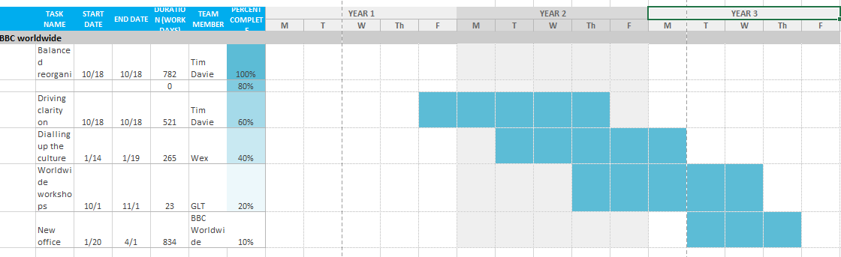
Figure 1. Gantt chart (1917).
Source: sample of Gantt chart, student’s work - S. Dimitrova ID 1714890.

Project Implementation

This is the active phase of the project. In this phase, the key and most active role is played by the contractor. This is the real implementation of the project. In this phase, management consists of managing, coordinating different team members in performing individual tasks and ongoing control. It is carried out in the form of regular meetings with project participants and regular reports to the contracting company's teams. Weekly schedules are drawn up and progress is monitored.

Kotter’s 8 Steps
Kotter’s (1996) 8 Steps of Creating a Major Change has been identified as the best-known methods of corporate transition, the conventional wisdom for driving development, and the most convincing framework for success in handling development. (Mento et al., 2002).
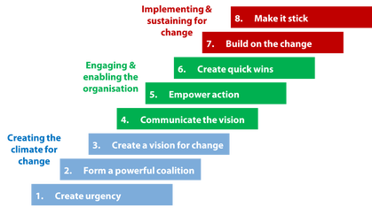
Figure 2: Kotter’s 8-Step Change Model
Source: https://frontlinemanagementexperts.wordpress.com/2015/07/02/kotters-8-step-change-model/

Stage 1: establishing a sense of urgency
The first step of Kotter's eight-stage cycle is to build a sense of urgency; recognition of the need for an organisation to improve. Kotter argues that the inability to build a sense of urgency is the single greatest error made in attempting to reform organisations and has written an entire novel, A Sentence of Urgency, which focuses exclusively on this point (Kotter, 1996).
In October 2012, BBC Worldwide announced a strategic reorganisation that turned the business from a divisional to a national control line. In addition, there are global digital transformation platforms and quality management around the business. The goal was to increase competition from international markets and to get accessible to customers. Since the change, there was still a sense that GLT had to improve its leadership skills; nevertheless, WEx seems to have become more business oriented. In, BBC Internationally has worked to attract expertise in a dynamic climate. WEx wanted to give workers something distinctive: an atmosphere and a philosophy that would make it easier for workers to be the best on a global stage. The entire company needed to adjust to the modern market paradigm. The transition was painful for workers which involved several layoffs. (cipd.co.uk, 2015).
Stage 2: creating the guiding coalition
The second stage of the Kotter Cycle requires the creation of a group with adequate strength to drive the transition. Guiding coalitions for the Knowledge Management Program have been developed at several rates. Most significantly, the Executive Management Group has been supported by the CEO and direct reporting and has given clear policy guidance for the initiative (Kotter, 1996).
The BBC Worldwide Executive Board is known as the WEx (Worldwide Executive Committee) and, together with members of the Global Leadership Team (GLT), is responsible for the overall management of BBC Worldwide. The two sections of the company are strongly linked, with an emphasis on becoming one BBC. HR has planned a workshop for cascade The CEO was eager to see a real convergence within WEx and meant that meetings would have to be mandatory to ensure that all staff were involved (cipd.co.uk, 2015).
Stage 3: develop a vision and strategy
When the idea of reform first arises, other brilliant concepts and strategies are brought around. Such principles must be connected to an overall vision that people can clearly comprehend and recall. A clear vision makes everyone realise why you are asking them to do something. Once people see the "big picture" themselves, what you are attempting to achieve, the instructions issued to them make better sense.
The CEO's opinion was that day-to-day problems and lack of visibility, rather than industry obstacles for companies, may contribute to unhappiness. Workers needed to tell a straightforward storey; believe that their problems had been understood and worked upon; and that they should have been handled equally and included in correspondence. He concentrated on sharing a consistent roadmap to invest in content, create national brands and deliver digital innovation. The CEO took every chance to repeat that message. “Pulse” personnel polls have been used every few months to assess internal awareness and compliance with the policy. Creating a straightforward plan based on three main themes meant that all in the sector could appreciate the company's focus (cipd.co.uk, 2015).
Stage 4: communicating the change vision
The fourth stage of the Kotter Process is to express a dream of transition. However, Kotter points out that managers ignore the amount of teamwork required to create a cohesive vision, an effort that may be compromised by inconsistent interactions and lead to a delayed change. (Kotter, 1996).
At this point, the Executive Director was invaluable, not just in putting out a message that the dialogue about culture was significant, but also in trying to make the plan "very good and genuinely powerful." Instead of dictating how seminars will be held, the HR has specified the requirements to be met. A facilitation kit was issued, including a video of the director interviewing the BBC Worldwide Culture Executive, with some guidance and a deadline. Managers have a way to configure the workspace for their fields, clearly focussed on tasks, placed several notices on the wall for all the feedback, and then checked them to find different samples of participants (cipd.co.uk, 2015).
Stage 5: empowering broad-based change
The fifth stage of the Kotter Cycle includes overcoming obstacles to progress, reforming processes or frameworks that hinder the dream, and promoting new ideas (Kotter, 1996).
WEx hosted the "virtual" GLT World Conference, where the international staff can participate and take them through a workshop. The approach was to explain what the business was looking to accomplish and suggest resource leaders could use to make this happen because some people don't engage in culture ... it is for the HR department. The debate was on what to do with BBC Worldwide society and what needs to be improved. We told storeys in which a leader of the WEx clarified what was relevant to him. WEx is concerned about their love for the BBC, their worries and what they needed me to do by getting GLT into the discussion (cipd.co.uk, 2015).
Stage 6: generating short-term wins
Short-term improvements tend to illustrate the effectiveness and energy of transition, recognises that short-term changes must be visible; clearly successful; and clearly related to the course of transition (Kotter, 1996).
Workshops are deemed to be a big achievement. Any workers were granted an opportunity to be part of a larger discussion regarding the society in which they wished to function for the first time. WEx had expected the results of the meetings and places where improvements could be created, but merely asking staff about the plan may not have had the same effect (cipd.co.uk, 2015).

Stage 7: consolidating gains and producing more change and Stage 8: anchoring new approaches in the culture
Stage seven, improved reputation is used to reform procedures, frameworks, and practises that do not suit the mission, recruit, encourage, and cultivate staff who can achieve mission, enhance strategies with new initiatives, issues, and agents for progress.
The system has achieved substantial traction by short-term improvements, the participation of the program's leading coalitions with senior personnel, and the continuous usage of all available contact platforms to enhance the exposure of the initiative. A leader of WEx spoke about using the HR business associate in his area to add some identity and creativity to the structures coming from central HR. For starters, to help develop good connexions with employees, anyone trying to reach “Better Call Paul” ideas, relating to the Better Call Saul spinoff from Breaking Bad. Now that the Pledge has been disseminated, GLT leaders realise that their constituents will be waiting for them to satisfy their responsibilities (cipd.co.uk, 2015).

new
behaviours and ways of working
Workshops- big wins
Involving leaders in identifying the changes required
The GLT: behaviour change and
divisional action plans
clear plan of investing in content
New CEO
strategic reorganisation

Greiner’s Life Cycle Model

Organizational researchers have established frameworks that aim to clarify the stages of organisational development. L. Greiner's essay called “Evolution and Revolution as Organizations Grow” is the most important and recognised as a classic (Bedeian and Zammuto, 1991). In addition, Kaplan and Johnston described corporate development in developmental and innovative ways (Kaplan and Johnston, 1998).
Greiner proposes that the breakdown of each revolution time period defines whether or not the company can arrive at the next development point. At the same time, the completion of the development processes triggers the appearance of crisis management in each process (Tang, Jones and Forrester, 1997).
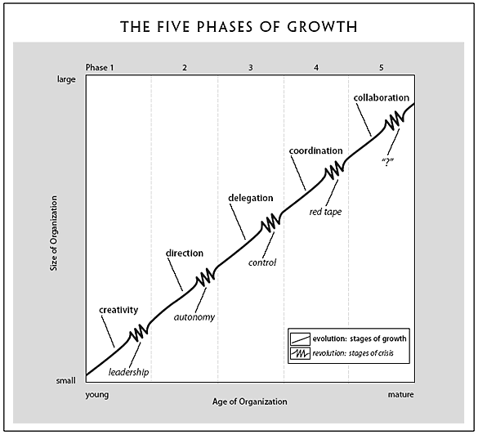
Source: Greiner, 1998

Table 1: Greiner’s Life Cycle Model for BBCW Source: Greiner, 1998
Phase | Crisis ending stage
creativity | The founders must restructure  organisation and invite professional  manager
direction | Start developing precise goals  and areas of development
delegation | The staff motivation system is based on work results. Workshops are perceived to be a big achievement.
coordination | The role of the formal planning and reporting procedure is increasing, and the formalisation of communications is increasing.
collaboration | Teamwork predominates, flexibly redistributes and combines functions. For example, to help develop good connexions with employees, anyone trying to reach 'Better Call Paul' concepts, relating to the Better Call Saul spinoff from Breaking Bad.

Stakeholders

In 1984, R. Edward Freeman defines and outlines communities that are the stakeholders in an organisation, also explains which proposes strategies by which management should take proper consideration of the needs of such communities (Freeman, 1984).
It is good practice to analyse the stakeholders in each endeavour. People involved in one project and the roles they perform within the project can usually also be classified; it is possible for one person to fulfil several of the roles indicated:
- The project manager is the one with the power and accountability for the project. The role of the project manager is to plan, support and educate project stakeholders;
- The sponsor of the project is an individual with a higher degree of authority than someone personally involved in the project who promotes the execution of the project. The project supporter is the person that intervenes because, for example, the upper management of the organisation fails to support the project manager; the clients and users;
- Core project team;
- Additional staff - is reallocated, subcontracted or otherwise supported by another entity of the company;
- Suppliers and creditors - in the case of a contract transaction, they overflow;
- External stakeholders - the media, environmental organisations, many organisations with an involvement in the field;
- Trade unions or industry organisations; state and municipal administration; regulations and legislation, etc.
Internal stakeholders are entities inside a company-e.g. shareholders and staff. External stakeholders are non-business organisations. For BBC Worldwide internal stakeholders are owner and employee. BBS works with audiences and other stakeholders to explore what impartiality means to them in the social media era and to win diversity in the creative community and work with key industry stakeholders to achieve their ambitions on the diversity screen. (bbc.co.uk, annual plan, 2019-20).

Stakeholders Mapping (Mendelow)

Power is an essential aspect of the stakeholder and stakeholder matrix model. In 1981 Mendelow proposed the first stakeholder power / dynamics matrix. Johnson and Scholes (1999) modify it by providing a power / interest matrix under which the axis of importance substitutes the axis of dynamism. By classifying stakeholders in a power / interest hierarchy, project managers develop a clearer understanding of how coordination and stakeholder interactions influence the project and its behaviour (Olander and Landin, 2005).
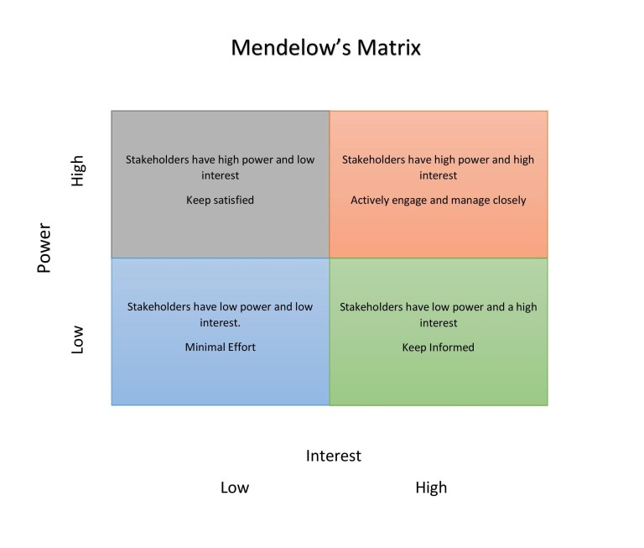
Government, suppliers, | Owner, CEO, project managers,
Audience, | Employee, shareholders, competitors
Table 2: Mendelow matrix for BBCW

Personal Development Plan

Reflecting on an academic process is not just about being mindful of my aptitude and capacity. Moving past this, it allows me to consider my strengths and weaknesses, to acknowledge how I can treat those situations better, and to remember what I have experienced. In order to have a detailed perspective on my understanding, I have followed Gibbs model.
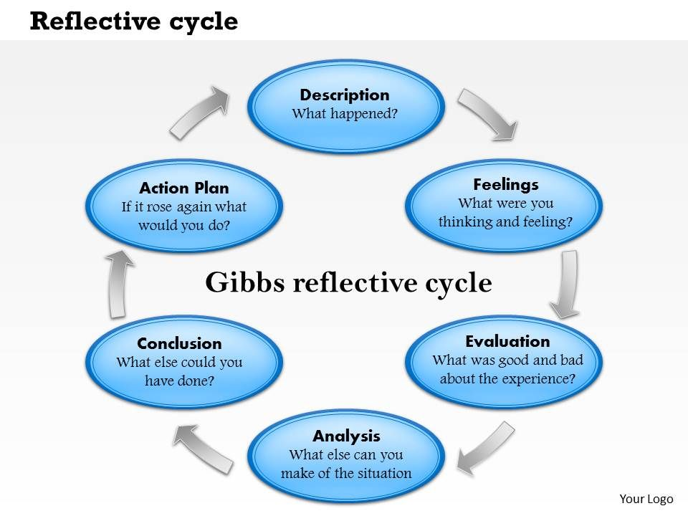
Source: https://www.slideteam.net/business_powerpoint_diagrams/0514-reflective-cycle-powerpoint-presentation.html

Description: During the two years of my university studies, I was obliged to produce fourteen coursework to demonstrate to my lecturers and my fellow students’ what knowledge I had gained during the academic years. These two years of training provided me with the knowledge to pursue professional projects through the application of business management theories, techniques and tools.
Feelings: Working with my lecturers, some of them, people from the actual business world, and my classmates was a different experience for me. The business plan had to be implemented as a requirement for the completion of Managing Enterprise in the 21st Century. This initiative has become a big challenge. The first one being the language barrier. Being a non-native English speaker has had a significant effect on my self-esteem and confidence. Several times I was ashamed and upset at my own failure to express my opinion directly to the group.
Evaluation: Since the first project was a different experience for me, I found myself trying to bring the most out of it. As I work best on my own, I find that team work eventually influenced my participation. However, I did everything I could to make the best of this initiative. For example, I read articles and other references to improve my awareness of the essence of the business plan. I have wanted to use my research and design expertise to help the project.
Analysis: The goal of the course was to improve management skills in students so that they can deal with the modern market climate. Personally, I agree that non-practical philosophy learned in lectures could not help students grasp business life in the real world, creating a business plan in the first year has changed my approach as a student.
Conclusion: I had the ability to improve my management abilities, as well as my knowledge of how to work effectively with customers. In turn, I have learned how to prepare, improve the fundamentals of practise, create a business strategy, construct an efficient team, and enhance management and other abilities, outlined in most of the philosophy of the course. In addition, I found that learning more about the subject allowed me to make a stronger contribution to the project.
Action plan: As a potential entrepreneur, I know the value of working on creating and controlling a business strategy. It is important for me to thrive with the project right though it has begun. In addition to the long-term market goals, it is also necessary to establish an action plan for me personally. The self-improvement plan is going to help me develop new abilities and improve existing ones. So, I need to concentrate on setting goals and learning more about myself in order to have a positive influence on my career. By maintaining good personal behaviours such as exercise and rising tension or job behaviours such as time management or continuing education, I expect that my company can also expand in tangible ways.
Dr Meredith Belbin and his colleagues also found that there are nine activity groups, called “Belbin Group Roles”. Growing team needs the presentation of one of the nine tasks of the Belbin Team Role to become a high-performing squad. But that doesn't imply that every team needs nine people! Most individuals would have more than one Belbin Team positions that they are most familiar with, although that's going to change over time. The Belbin Team Position has positives and weaknesses, and the-Team Function is of equal importance. (Belbin teams, 2020)
Individuals have a greater understanding of their skills by utilising Belbin, which leads to more productive communication between staff and supervisors. Strong ventures can be put together, existing workers should be respected and improved, and everybody should learn how to make an effect on the business.

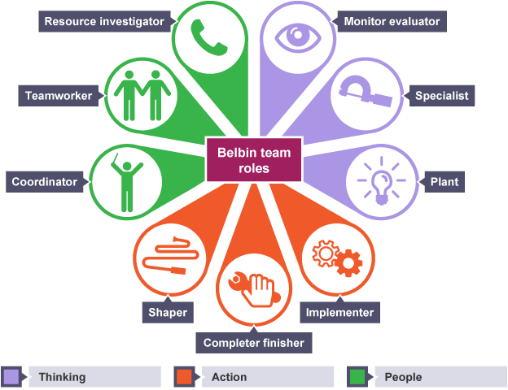
Source: https://dotnetsharing.wordpress.com/2017/09/19/learn-belbin-team-roles-through-reflection/

Me in 2025
Me in 2023
Me in 2020
Source: https://dotnetsharing.wordpress.com/2017/09/19/learn-belbin-team-roles-through-reflection/ and student’s work

What do I need to learn? | What do I have to do? | What resources will I need | Time Schedule
better time management and improved employee relationships | Complete BA (Hons) Leadership and Management | University programme, lectures | June 2021
increase focus, productivity, and patience. | Regular report for analysis and evaluation of actions and decisions. | Keep a diary | August 2025
gain knowledge, make better decisions, | Read books | Business books | Five per year

Reference

A Guide to the Project Management Body of Knowledge (PMBOK), Fifth edition, Project Management Institute, Pennsylvania, USA, 2013, p. 488-489
A Guide to the Project Management Body of Knowledge (PMBOK), Fifth edition, Project Management Institute, Pennsylvania, USA, 2013, p. 453-454
Andersen, E., 1996. Warning: activity planning is hazardous to your project's health! International Journal of Project Management, 14(2), pp.89-94.
Bedeian, A. and Zammuto, R., 1991. Organizations. Chicago: Dryden Press.
Belbin teams, 2020. The Nine Belbin Team Roles. [online] Belbin.com. Available at: https://www.belbin.com/about/belbin-team-roles/[Accessed 7 May 2020].
Bbc.co.uk. 2020. BBC - BBC Worldwide CEO, Tim Davie, Shares Future Vision For BBC Worldwide - Media Centre. [online] Available at: https://www.bbc.co.uk/mediacentre/worldwide/worldwide-future-vision.html [Accessed 4 May 2020].
bbc.co.uk, annual plan, 2019-20.
http://downloads.bbc.co.uk/aboutthebbc/reports/annualplan/annualplan_2019-20.pdf
Briggs, D. G., 2012. REASSESSING PROJECT MANAGEMENT: A SCIENCE OR AN ART? International Journal of engineering and management science, 4(3), pp. 507-512.
Cipd.co.uk. 2015. [online] Available at: https://www.cipd.co.uk/Images/landing-transformation-change_2015-case-study-bbc-worldwide_tcm18-9055.pdf [Accessed 2 May 2020].
Chandler, A., 1962. Gantt on Management: Guidelines for Today's Executives. Edited by Alex W. Rathe. New York, American Management Association and the American Association of Mechanical Engineers, 1961. Pp. 288.
Freeman, R. E., 1984. Strategic Management: A Stakeholder Approach. Boston: Pitman.
Kanter, R., 1989. When Giants Learn To Dance: Mastering the Challenges of Strategy Management and Careers. London: Routledge.
Kaplan, S. and Johnston, R., 1998. Dislocations—drivers of industry evolution, innovation and corporate growth. Strategic Change, 7(1), pp.13-18.
Kotter, J., 1996. Leading change. Harvard Business School Press, Boston.
Mento, A.; Jones, R.; Dirndorfer, W., 2002. A change management process: Grounded in both theory and practice. Journal of Change Management 3:45-59.
McNeil, A. J.; Frey,R.; Embrechts, P. , 2005. Risk Management, Concepts Techniques Tools, Princeton University Press, New Jersey, p. 144
Nao.org.uk. 2020. [online] Available at: https://www.nao.org.uk/wp-content/uploads/2014/07/nao_report_bbbc_management_of_risk.pdf [Accessed 4 May 2020].
Olander, S. and Landin, A., 2005. Evaluation of stakeholder influence in the implementation of construction projects. International Journal of Project Management 23(4): 321-328.
Padovani, R. and Tugnoli, A. (2005). The entertainment risk management in non-financial enterprises 21 (2) pp. 89 / 126
Tang, N., Jones, O. and Forrester, P., 1997. Organizational growth demands concurrent engineering. Integrated Manufacturing Systems, 8(1), pp.29-34
Wideman, M. (1990). Total Project Management of Complex Projects – Improving Performance with Modern Techniques. A Presentation to the Construction Industry in the cities of Bangalore, Bombay, Calcutta, Madrasand New Delhi on behalf of the Consultancy Development Centre, New Delhi, India - January 1990. Available at: http://www.maxwideman.com/papers/performance/appendixc.htm [Accessed 4 May 2020].

