
Design, Development, and Evaluation of a Virtual Reality Codebase Visualisation Tool
Research Proposal

William Foot (2405192)
Word Count: 1,466
Contents
2 Introduction 2
3 Background to the Proposed Research 2
4 Research Problem Statement 4
5 Research Aim & Objectives 4
6 Methodology 5
6.1 Methods 5
6.2 Materials 5
7 Project Plan 6
8 References 9

Introduction
Learning a new codebase can be daunting as a new developer; repositories and file structures can change all the time, and code complexity increases as the project evolves [1]. A single function can have ties to other files all over the codebase, and this can quickly become overwhelming when trying to understand what the different methods do by only viewing one file after another [2]. Being able to understand a new codebase quickly is crucial.
As most integrated development environments (IDEs) rely on file-based editing, it can become difficult to visualise how each file interacts with each other and viewing multiple fragments of code all at the same time [3]. This text-based method of viewing a codebase is the most common way a developer will interact with a codebase. However, there are other methods that a developer could use to aid in their understanding and engagement of a codebase [4], [5].
Various new applications and techniques have been developed to visualise codebases and address the limitations of text-based IDEs. 3D visualisations of codebases are still struggling to gain acceptance in many developer workflows. Issues such as navigation and interaction are holding this immersive experience back [6]. Virtual Reality (VR) could be used to overcome this interaction barrier, and some tools have even started using VR to aid in viewing and refactoring large codebases [1], [2]. VR would allow you to step into and view large codebases, as it offers a more natural interactive experience than 2D screens controlled by a mouse and keyboard [7].

Background to the Proposed Research
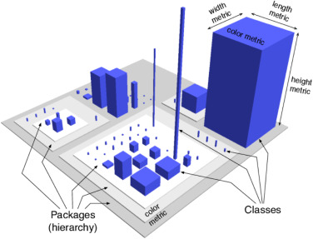
The city metaphor is widely used in software visualisation: classes are represented as buildings, which are contained within districts representing packages. The number of attributes and methods can represent the buildings' width and height, respectively. Various visualisation tools have used this approach [8]. Moreno-Lumbreras et al. examined the influence of this metaphor. They found an increasing number of publications since 2001 in which researchers used this method to create software visualisation tools. They also identified the use of extended reality as an opportunity for exploration [8].
Figure 1. An example of the City Metaphor [8]
Wettel and Lanza used the city metaphor across a number of papers to help identify areas of design disharmony, such as classes that have too much responsibility, exploration of large systems, and program comprehension [6], [9], [10], [11]. Panas et al. created a tool to visualise large codebases, as well as present an overview to stakeholders and users from different areas of the business [12]. They have used an existing visualisation tool, Vizz3D, to produce their application. The program also collects and displays run-time analysis for visualisation [12]. EvoSpaces is another 3D visualisation tool for exploring software architecture [13], [14]. The software focuses on providing the user with a global view of the system through navigation and interaction with the world. Users can navigate the world by flying over the city or walking through the streets. The buildings can also be entered to view the functions and methods contained within. There is also a relationship view that highlights which classes are connected and how data flows between them [13], [14].
Code Park is a tool that aims to help novice users, such as students, understand codebases in an engaging and intuitive way [4], [15]. Code Park represents each class in the codebase as rooms that the user can enter to view all the code it contains. It also allows the user to click on functions in the code and be taken to the class that defines them [4]. HeapKeep attempts to gamify exploring a codebase by creating a 3D world where the user can navigate it like a game's dungeon. The user is followed by a Large Language Model (LLM) powered non-playable character (NPC) that can answer questions about the code [5]. However, the paper concluded that users found the navigation of the 3D environment frustrating and slow, and preferred using the 2D map representation to visualise and navigate the codebase [5].
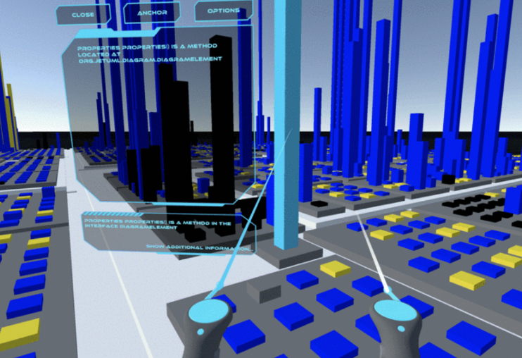
The city metaphor has also been used when creating software visualisation tools for VR. CityVR aims to provide users with a more interactive experience when viewing a codebase. It uses a 3D virtual environment and gamification to boost engagement, curiosity, and interest in exploring a codebase [16]. Users were presented with tasks to gauge their comprehension. VR City allows users to view source code and visualise method invocations [17]. It also proposes a new layout algorithm that differs from the traditional nested, street, and graph-based layouts. The new layout algorithm focuses on positioning the buildings with respect to the method coupling [17]. Giannaccari et al. proposed a tool that could not only view codebases but also aid in refactoring within a VR environment [1]. The software aims to improve perception and simplify refactoring by making it feel more organic and engaging. One limitation of the software was that it took too long to build scenes, hindering real-time interaction. Furthermore, a user study was not completed as part of the development process [1].
Figure 2. Visualisation of a codebase in VR [1]
Other VR tools took a different approach to visualising codebases. CodeHouse is a tool that visualises a codebase's structure in VR to aid understanding and debugging [2]. Rooms represent modules, and within each room, some objects represent functions connected with lines that represent the relationships between these functions. Objects can be selected to view more detailed information, such as the source code, and debugging is supported by linking a debugger tool [2]. IslandViz is another tool for exploring codebases in VR. It represents each module as a distinct island. These islands are then shown on a virtual table, allowing the user to explore through the use of navigational tasks [18]. Various building types represent different kinds of classes and functions, and the overall layout of the islands can reflect the number of packages the modules need, with minimal requirements resulting in many smaller islands that are spread out [18].
Using VR also has some limitations compared to traditional 3D applications. Fittkau et al. explore the use of gesture-based interaction with a VR environment and evaluate the practicality and use of VR [7]. The gesture interaction was well received; however, some participants in the study experienced motion sickness and were unable to complete all tasks. As well as this, the resolution of the headset made some labels difficult to read [7].

Research Problem Statement
I propose creating a VR application to overcome the drawbacks of 2D displays and input devices for viewing large, complex codebases in 3D. This application will take advantage of a VR headset’s ability to display 3D information to a user in a way they naturally perceive. Using a VR headset will also provide a more immersive experience for the user, allowing them to walk around to view data and to impose a sense of scale among the different objects and relationships within the codebase.

Research Aim & Objectives
Aim: To design, develop, and evaluate an interactive virtual reality tool to aid comprehension of software codebases.
Objectives:
- Create a tool that can scan through a codebase and highlight and record information that can be used to create the interactive VR environment.
- Design and create a VR environment using the Unity game engine that can be navigated using a VR headset.
- Use the data from objective one to build the interactive environment and visualise the scanned codebase.
- Obtain user feedback via a questionnaire to evaluate the impact and practicality of this tool.

Methodology

Methods
An interactive software application will be created first and used to display a codebase. Similar to Fittkau et al. [7] and Bisset et al. [5] a group will be selected to interact with the application and perform basic tasks, such as finding classes and navigating. Afterwards, they will be given an online survey to gather qualitative data about their experience. In-person interviews may also be conducted. This will assess whether the application will effectively improve user engagement when learning new codebases and highlight any issues users may have encountered.

Materials
Unity will be the game engine used to create the application, which uses the C# coding language [19]. Unity is the most widely used engine for creating VR applications, and it also provides support for creating them [20]. JetBrains Rider will also be the preferred IDE used, and it offers a free license for student use [21]. A Meta Quest 3S will be the Virtual Reality Headset used to test and display this project [22].
Microsoft Forms is a free tool to create surveys to collect user feedback [23]. Any data collected from users will be anonymised, and personal data will not be collected. It also provides basic metrics and lets you export the response data to Excel.

Project Plan
The Gantt chart was created using a website called Tom’s Planner [24]. The figures below show some of the key dates and milestones throughout the project.
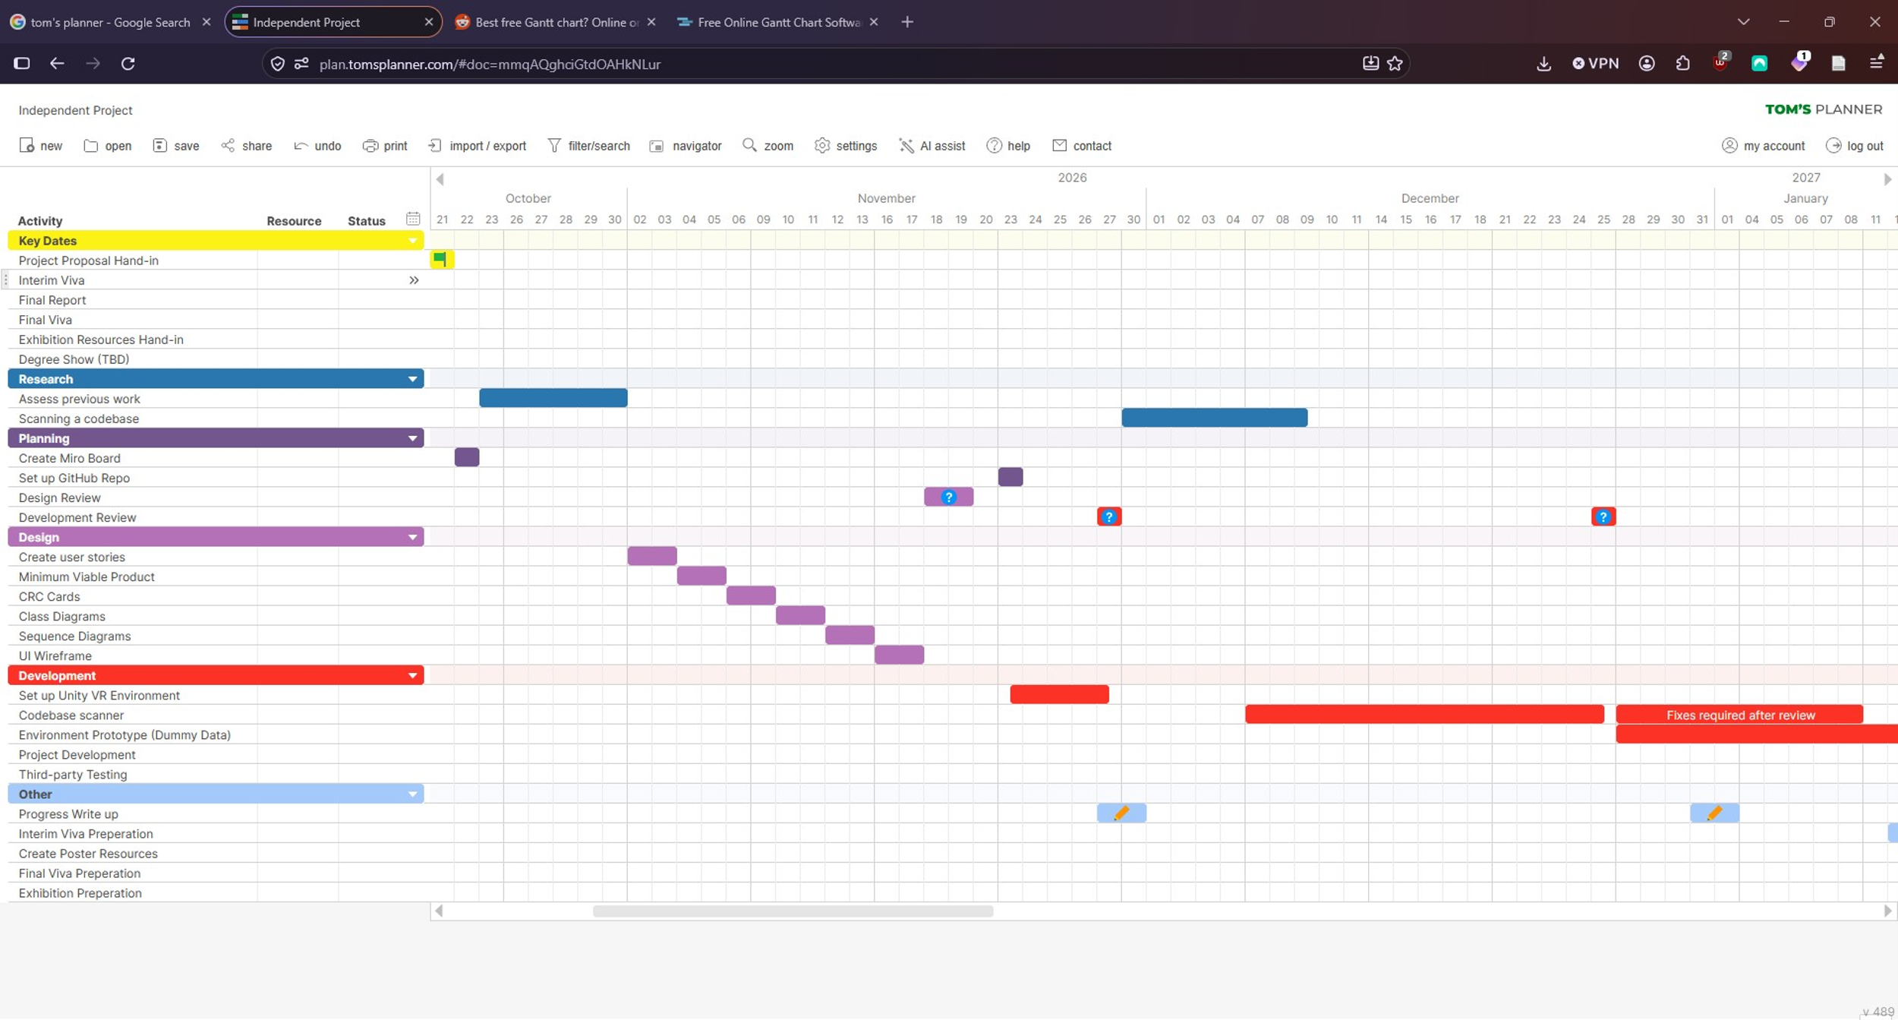
Figure 3. Project Timeline (1/3)

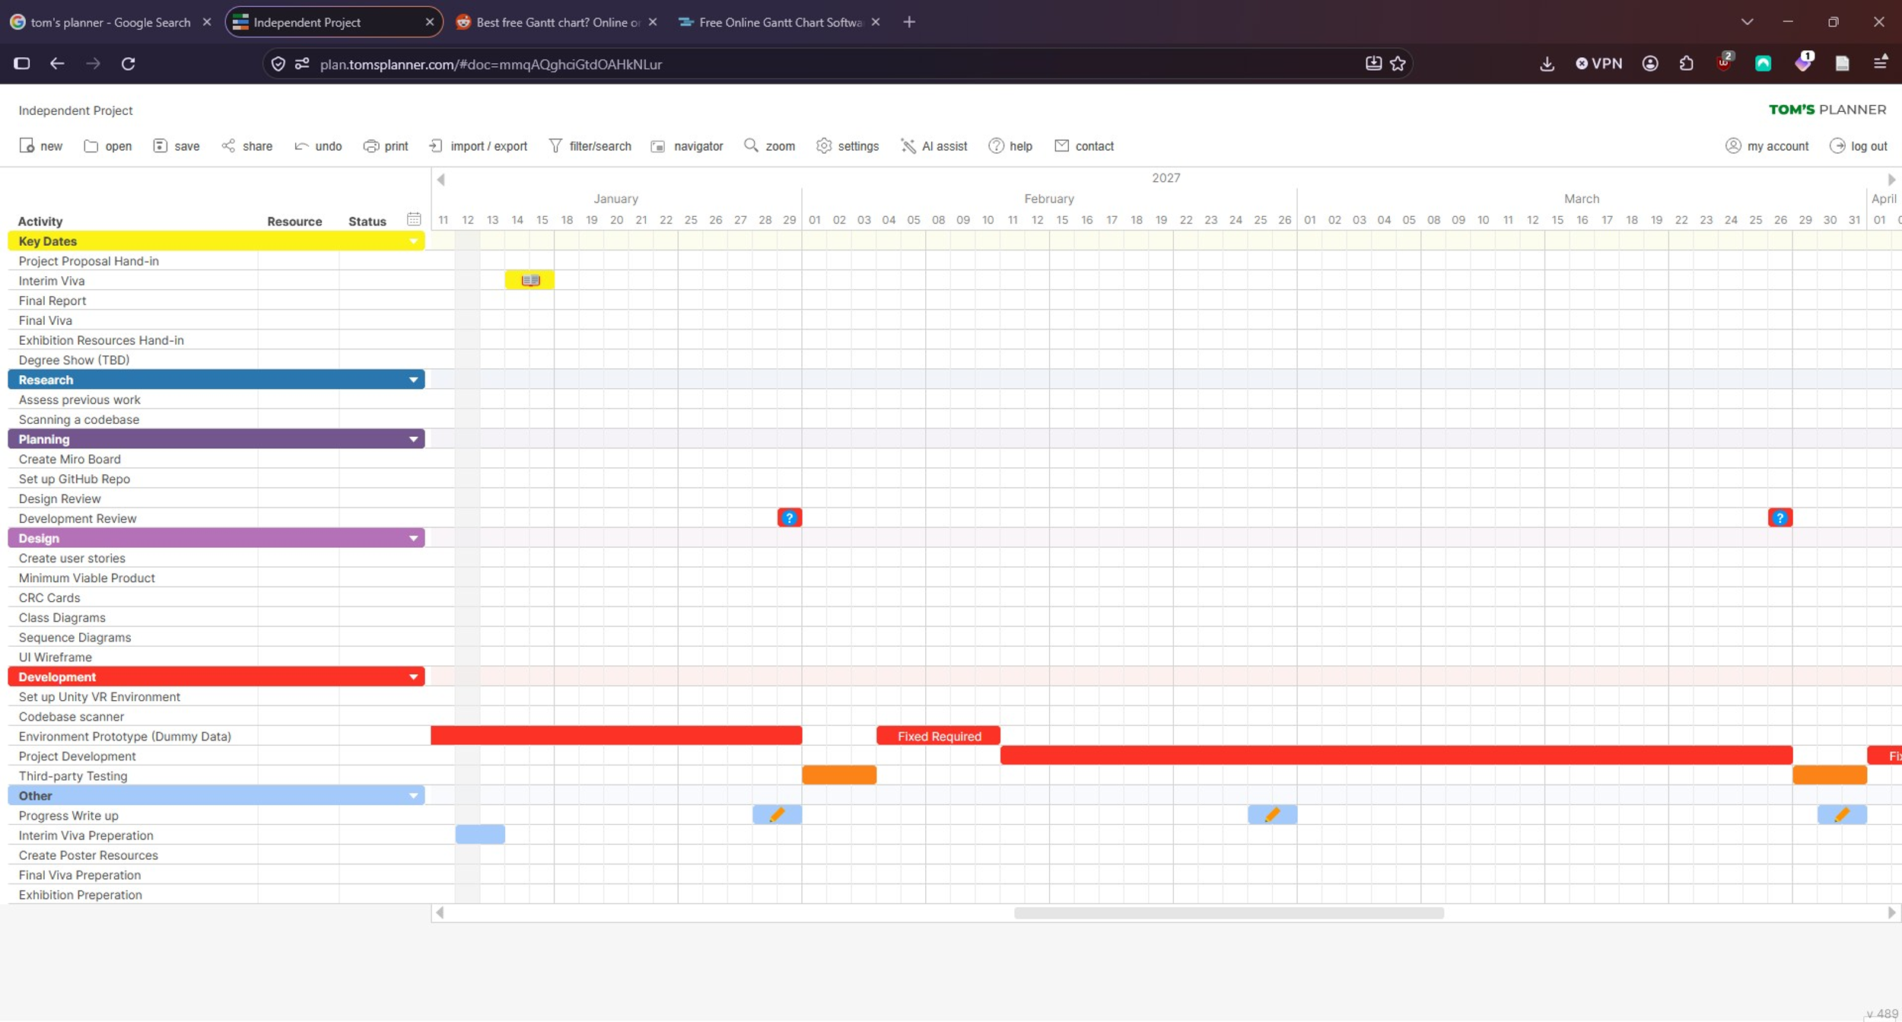
Figure 4. Project Timeline (2/3)

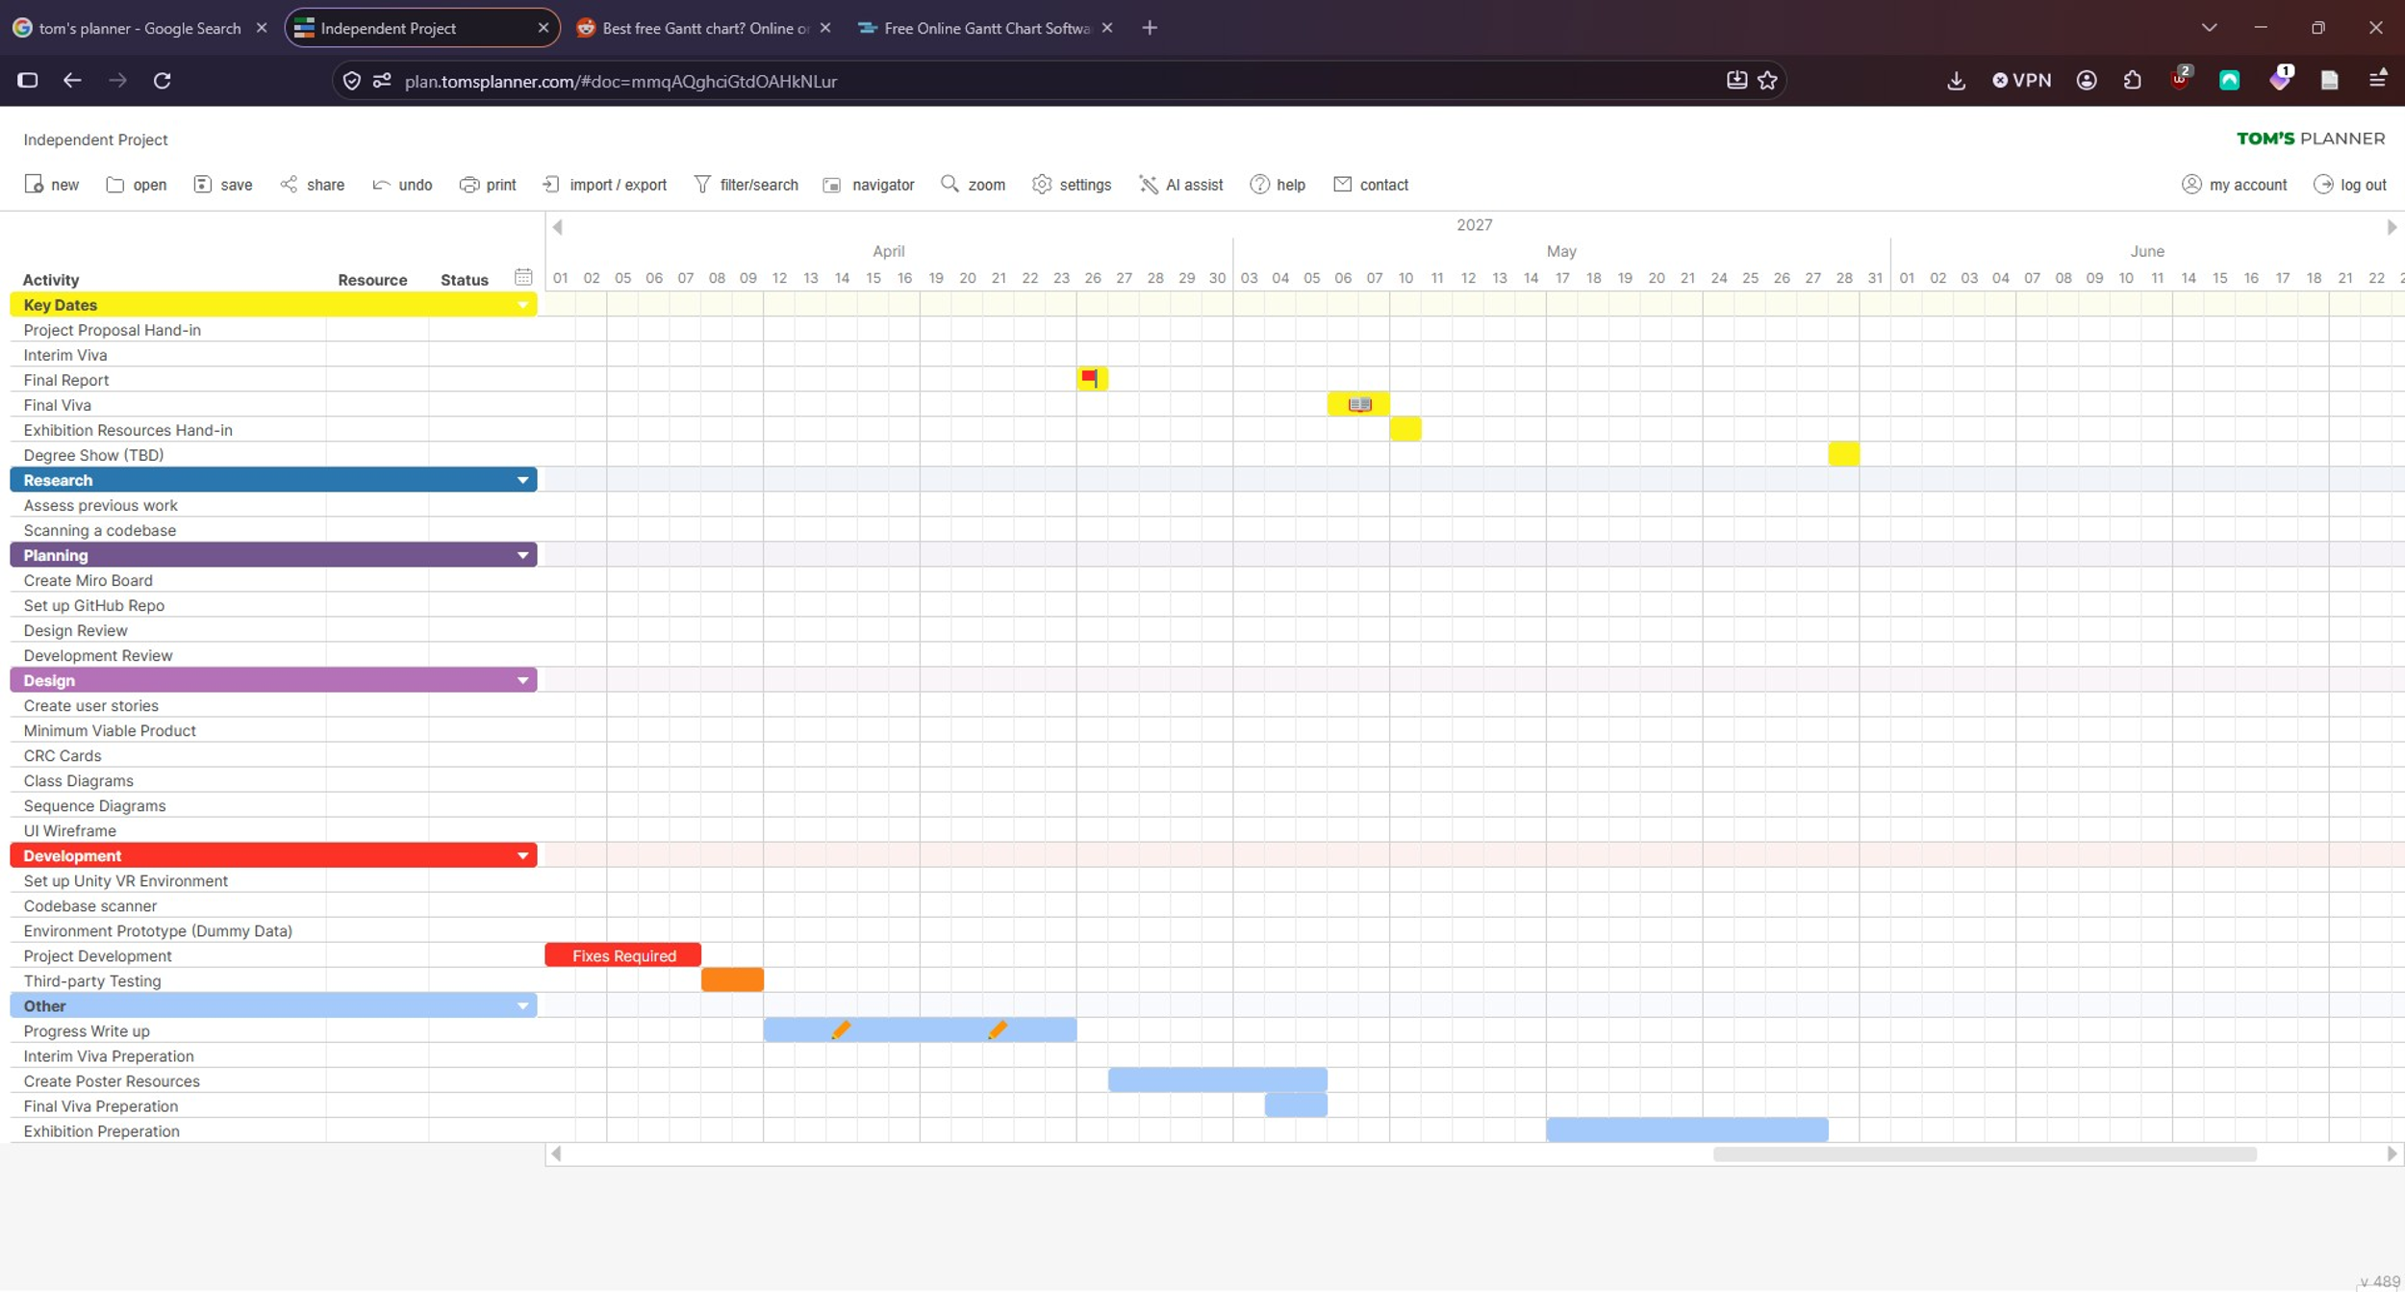
Figure 5. Project Timeline (3/3)

References
[1] M. Giannaccari, M. Raglianti, and M. Lanza, ‘Code Refactoring in Virtual Reality’, in 2025 IEEE/ACM Second IDE Workshop (IDE), May 2025, pp. 7–12. doi: 10.1109/IDE66625.2025.00006.
[2] A. Hori, M. Kawakami, and M. Ichii, ‘CodeHouse: VR Code Visualization Tool’, in 2019 Working Conference on Software Visualization (VISSOFT), Sep. 2019, pp. 83–87. doi: 10.1109/VISSOFT.2019.00018.
[3] A. Bragdon et al., ‘Code bubbles: rethinking the user interface paradigm of integrated development environments’, in 2010 ACM/IEEE 32nd International Conference on Software Engineering, May 2010, pp. 455–464. doi: 10.1145/1806799.1806866.
[4] P. Khaloo, M. Maghoumi, E. Taranta, D. Bettner, and J. Laviola, ‘Code Park: A New 3D Code Visualization Tool’, in 2017 IEEE Working Conference on Software Visualization (VISSOFT), Sep. 2017, pp. 43–53. doi: 10.1109/VISSOFT.2017.10.
[5] R. Bissett, J. Loane, and P. Morris, ‘HeapKeep: Exploring Novel Codebases Through an RPG Interface’, in 2025 IEEE Working Conference on Software Visualization (VISSOFT), Sep. 2025, pp. 149–153. doi: 10.1109/VISSOFT67405.2025.00032.
[6] R. Wettel and M. Lanza, ‘Visualizing Software Systems as Cities’, in 2007 4th IEEE International Workshop on Visualizing Software for Understanding and Analysis, Jun. 2007, pp. 92–99. doi: 10.1109/VISSOF.2007.4290706.
[7] F. Fittkau, A. Krause, and W. Hasselbring, ‘Exploring software cities in virtual reality’, in 2015 IEEE 3rd Working Conference on Software Visualization (VISSOFT), Sep. 2015, pp. 130–134. doi: 10.1109/VISSOFT.2015.7332423.
[8] D. Moreno-Lumbreras, J. M. Gonzalez-Barahona, G. Robles, and V. Cosentino, ‘The influence of the city metaphor and its derivates in software visualization’, J. Syst. Softw., vol. 210, p. 111985, Apr. 2024, doi: 10.1016/j.jss.2024.111985.
[9] R. Wettel and M. Lanza, ‘Visually localizing design problems with disharmony maps’, in Proceedings of the 4th ACM symposium on Software visualization, in SoftVis ’08. New York, NY, USA: Association for Computing Machinery, Sep. 2008, pp. 155–164. doi: 10.1145/1409720.1409745.
[10] R. Wettel and M. Lanza, ‘Visual Exploration of Large-Scale System Evolution’, in 2008 15th Working Conference on Reverse Engineering, Oct. 2008, pp. 219–228. doi: 10.1109/WCRE.2008.55.
[11] R. Wettel and M. Lanza, ‘Program Comprehension through Software Habitability’, in 15th IEEE International Conference on Program Comprehension (ICPC ’07), Jun. 2007, pp. 231–240. doi: 10.1109/ICPC.2007.30.
[12] T. Panas, T. Epperly, D. Quinlan, A. Saebjornsen, and R. Vuduc, ‘Communicating Software Architecture using a Unified Single-View Visualization’, in 12th IEEE International Conference on Engineering Complex Computer Systems (ICECCS 2007), Jul. 2007, pp. 217–228. doi: 10.1109/ICECCS.2007.20.
[13] S. Alam and P. Dugerdil, ‘EvoSpaces Visualization Tool: Exploring Software Architecture in 3D’, in 14th Working Conference on Reverse Engineering (WCRE 2007), Oct. 2007, pp. 269–270. doi: 10.1109/WCRE.2007.26.
[14] P. Dugerdil and S. Alam, ‘Execution Trace Visualization in a 3D Space’, in Fifth International Conference on Information Technology: New Generations (itng 2008), Apr. 2008, pp. 38–43. doi: 10.1109/ITNG.2008.137.
[15] ISUE Lab, Code Park: A New 3D Code Visualization Tool, (May 03, 2017). Accessed: Oct. 09, 2026. [Online Video]. Available: https://www.youtube.com/watch?v=LUiy1M9hUKU
[16] L. Merino, M. Ghafari, C. Anslow, and O. Nierstrasz, ‘CityVR: Gameful Software Visualization’, in 2017 IEEE International Conference on Software Maintenance and Evolution (ICSME), Sep. 2017, pp. 633–637. doi: 10.1109/ICSME.2017.70.
[17] J. Vincur, P. Navrat, and I. Polasek, ‘VR City: Software Analysis in Virtual Reality Environment’, in 2017 IEEE International Conference on Software Quality, Reliability and Security Companion (QRS-C), Jul. 2017, pp. 509–516. doi: 10.1109/QRS-C.2017.88.
[18] M. Misiak, A. Schreiber, A. Fuhrmann, S. Zur, D. Seider, and L. Nafeie, ‘IslandViz: A Tool for Visualizing Modular Software Systems in Virtual Reality’, in 2018 IEEE Working Conference on Software Visualization (VISSOFT), Sep. 2018, pp. 112–116. doi: 10.1109/VISSOFT.2018.00020.
[19] ‘Unity: Develop, Deploy, and Grow | The World’s Leading Game Engine’, Unity. Accessed: Oct. 18, 2026. [Online]. Available: https://unity.com
[20] S. Jangra, G. Singh, A. Mantri, S. Angra, and B. Sharma, ‘Interactivity Development Using Unity 3D Software and C # Programming’, in 2023 14th International Conference on Computing Communication and Networking Technologies (ICCCNT), Jul. 2023, pp. 1–6. doi: 10.1109/ICCCNT56998.2023.10308030.
[21] ‘Rider – the ultimate IDE for Unity’, JetBrains: Developer Tools for Professionals and Teams. Accessed: Oct. 18, 2026. [Online]. Available: https://www.jetbrains.com/lp/dotnet-unity
[22] ‘Meta Quest 3S: Next-gen virtual reality headset’, Meta. Accessed: Oct. 19, 2026. [Online]. Available: https://www.meta.com/gb/quest/quest-3s/
[23] ‘Surveys, Polls, and Quizzes | Microsoft Forms’. Accessed: Oct. 18, 2026. [Online]. Available: https://www.microsoft.com/en-us/microsoft-365/online-surveys-polls-quizzes
[24] ‘Tom’s Planner - Gantt charts for the rest of us.’, TomsPlanner. Accessed: Oct. 18, 2026. [Online]. Available: https://www.tomsplanner.com

