
Programme: Master of Business Administration
Module: Marketing Management
Module code: LCMB7024
Assessment Component 2: Marketing Strategies Poster
Assignment Title: A Strategic Brand Extension and Marketing Plan for Future Workspace Innovation - Apple HoloSphere
Lecturer: DR Laila Maazouz
Student Name: Abhishekkumar Vinubhai Pethani
Student ID: 2525424
Total Words: 2399 (excluding element 1)
Table of Contents
Element 2: Segmentation, Targeting, Differentiation and Positioning (STDP) Analysis 3
2.1 Segmentation 3
2.2 Targeting 5
2.3 Differentiation 6
2.4 Positioning 6
Element 3: Marketing Mix (4Ps) Strategy 7
3.1 Product Strategy 7
3.2 Pricing Strategy 8
3.3 Place (Distribution) Strategy 10
3.4 Promotion Strategy 11
3.5 Integration with Brand Extension Strategy 12
Element 4: Reflection 12
Reference List 14
Appendices 18
Appendix 1: Element 1 – Brand Extension Poster Presentation 18

Element 2: Segmentation, Targeting, Differentiation and Positioning (STDP) Analysis

2.1 Segmentation
Apple HoloSphere market can be segmented based on geographic, demographic, psychographic as well as behavioural variables. The major markets are developed markets in North America, Europe, and Asia-Pacific where the purchasing power and technological adoption is high. All these regions dominate the upcoming immersive technology markets that are emerging, with North America alone representing more than 36% of the holographic display market (Persistence Market Research, 2026).
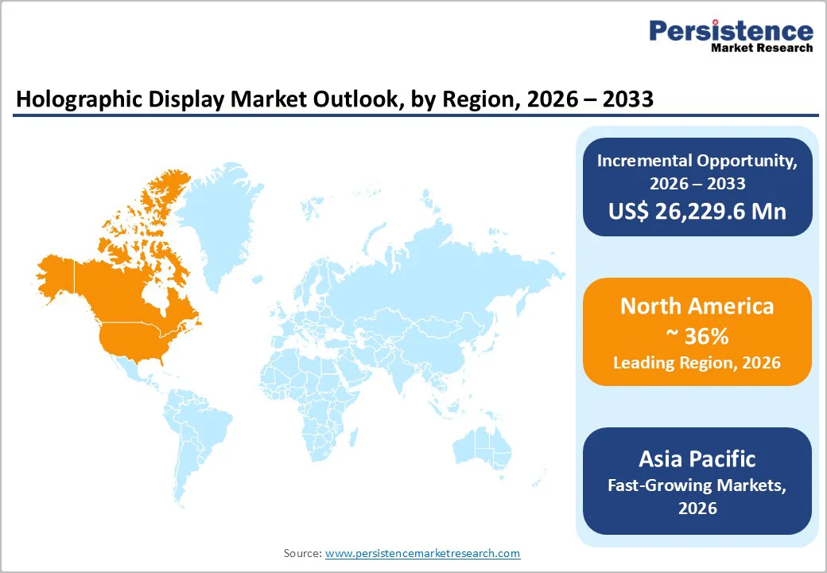
Figure 1: Market Outlook of Holographic by Region
(Source: Persistence Market Research, 2026)
Demographically, the product will be aimed at middle to high-income people aged 25 to 45, who are often professionals, creatives, and entrepreneurs. The group is more attached to remote work with higher engagement, and about 25% of individuals who are aged 25 to 54 years are involved and participated in telework (HIGH5, 2025).
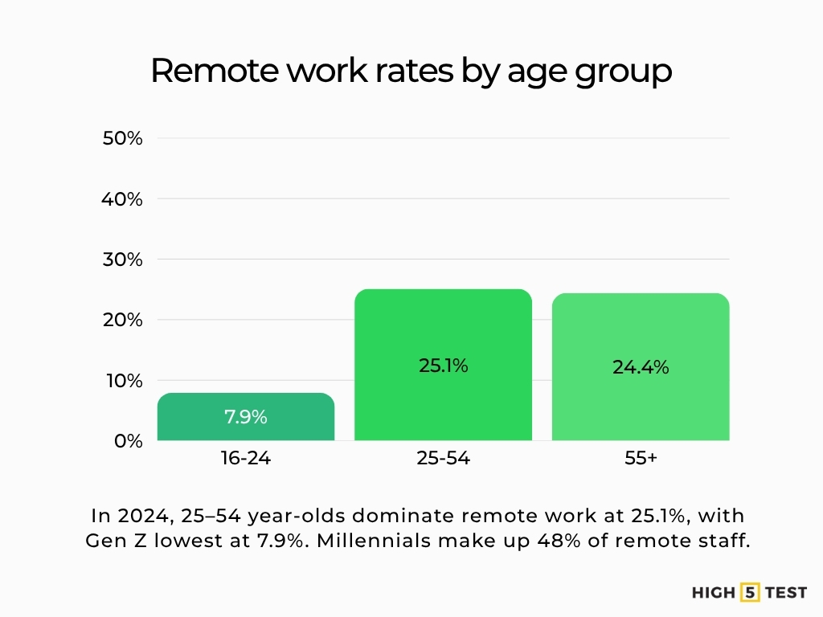
Figure 2: Rates of Remote Work by Age Group
(Source: HIGH5, 2025)
Psychographically, the segment encompasses innovation-oriented, flexible, and tech-savvy consumers who experience and enjoy premium experiences that are more flexible and productive. Such individuals often tend to be the first to adopt the new high-tech devices such as AR and holographical displays, which is projected to have a CAGR of more than 25.2% (Futuremarketinsights, 2025).
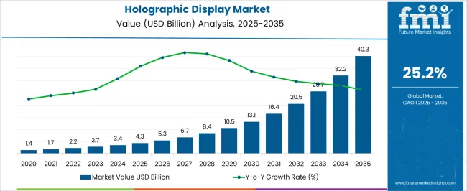
Figure 3: Market Forecast of Holographic Display
(Source: Futuremarketinsights, 2025)
The most applicable users in behavioural terms will be regular consumers of Apple ecosystems and remote or hybrid employees, where 83% of employees worldwide would rather work in hybrid systems (EasyStaff, 2025).

2.2 Targeting
The Apple HoloSphere is mostly aimed at urban professionals, creators, and digital nomads working in flexible and knowledge-intensive jobs. Such individuals usually work in technology, marketing, design, and consulting areas where remote and hybrid work is highly widespread (TOUSARVANDANI, 2024). This group is also strategically significant because about 52% of remote-enabled workers are currently operating in a hybrid setting, which helps in highlighting the high and continued need of flexible work solutions (Gable, 2026).
The secondary target audience will consist of corporate leaders or tech enthusiasts, who seek to have high-quality innovative tools to become more productive and preserve their status in the setting of work (Bashiru, 2023). These customers usually have high disposable income and are usually early adopters, which focuses on suiting well with the strategy based on premium pricing of Apple.
The profitability of these segments is very high because they have high purchasing power and are ready to invest in high technology. Moreover, remote working has become a permanent trend worldwide, as approximately 22% of employees are currently working remotely, and 83% are inclined toward hybrid working (Spooner, 2025). On the whole, this segment is highly consistent with Apple brand identity, and it helps in ensuring its high adoption, and focuses on well integration into the ecosystem, and growth perspective based on long-term aspects.

2.3 Differentiation
Apple HoloSphere stands out in terms of innovative technology in the form of holographs instead of a conventional two-dimensional screen, which is completely transformed into a three-dimensional workspace. The holographic systems are also capable of producing immersive holograms, unlike traditional displays, which need extra devices such as headsets for the purpose of providing a more natural experience of user (Shvetsov and Alsamhi, 2024). This is in line with the fact that the holographic display market is fast expanding with the market projected to grow to well over $40 billion by the year 2035 having a CAGR of 25%+ and thus there is high demand of the immersive solutions (Futuremarketinsights, 2025).
The integration of an ecosystem is a major strength that allows Apple to have a seamless connectivity among Mac, iPad, and other devices, which focuses on strengthening the customer lock-in and makes it more usable (Al-Sakaf, 2025). HoloSphere is more comfortable than VR/AR headsets, as its interaction does not require wearing of any devices and may result in fatigue. Unlike multi-monitor configurations that are common to enhance productivity, HoloSphere has no physical hardware limitations and provides comparable or even more multitasking features, however a multi-screen setup is already viewed as productivity-enhancing by people working in the field (Childs et al., 2023).

2.4 Positioning
Aspect | Details | Competitors | Positioning Insight
Positioning Statement | For urban professionals, creatives, and digital nomads, Apple HoloSphere is a premium holographic workspace device that enables seamless, immersive productivity anywhere. | Meta (Quest VR), Microsoft (HoloLens), Samsung (multi-device setups) | Clearly defines HoloSphere as a next-generation workspace, not just another device
Core Positioning Elements | Premium, futuristic, productivity-focused; supports “work anywhere” concept; acts as both a productivity tool and a status symbol for professionals | VR/AR headsets and high-end monitor brands | Combines innovation + lifestyle appeal, aligning with aspirational users
Perceptual Positioning | Positioned as high price, high innovation, targeting premium segment with cutting-edge features and seamless ecosystem integration | High-end VR devices, multi-monitor workstations | Occupies top-right quadrant (luxury + innovation), reinforcing exclusivity
Brand Alignment | Reflects Apple’s brand values: innovation, simplicity, and premium user experience through intuitive design and ecosystem connectivity | Competitors often lack full ecosystem integration or simplicity | Strengthens Apple’s brand consistency and differentiation in future workspace tech
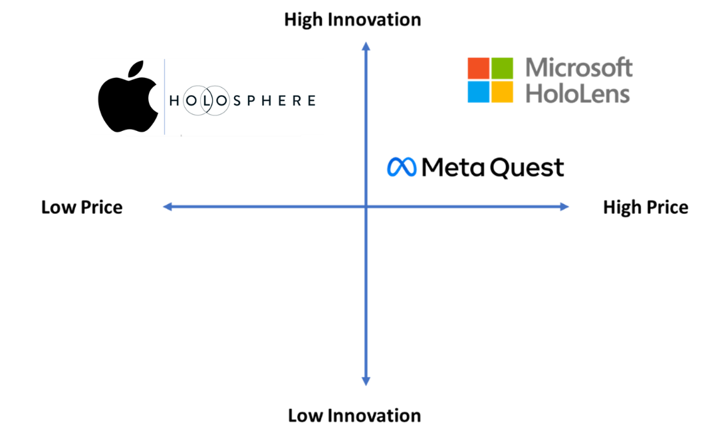
Figure 4: Perceptual Mapping
(Source: Self-Created)

Element 3: Marketing Mix (4Ps) Strategy

3.1 Product Strategy
Apple HoloSphere is a solution to the contemporary workspace dilemmas, being a holographic workspace that aims to make the workspace environment more mobile and productive. This is in line with the increased requirement of immersive technologies as the market of holographic displays was estimated to be about $4.3 billion dollars in 2025 and is set to rise above $40 billion by 2035 with a CAGR of about 25% (Futuremarketinsights, 2025).
The real product will have the following advanced features such as 3D holographic display, gesture and voice control, and complete integration into the Apple ecosystem (Shvetsov and Alsamhi, 2024). The holographic technology provides 3D realistic visualization without the use of physical screens, which helps in improving the interaction and engagement with user (Dimensionmarketresearch, 2026). The minimalist and portable design of the product supported by a strong brand name of Apple and usability.
Apple services such as iCloud, AppleCare, and continuous software updates are added to the augmented product, which improve and increase the loyalty of customer and value based on long-term aspects (Akhonzada, 2025). As an innovative product, HoloSphere is at the introduction phase of the product life cycle, and it is aimed at the early adopters of a growing market.

3.2 Pricing Strategy
Apple HoloSphere will implement a luxury pricing approach that involves a market-skimming strategy that will initially charge a high price for the purpose of capturing the first mover and achieving maximum profitability. This is supported by the fact that Apple has invested heavily in innovation, with more than 34.5 billion dollars in the methods of research and development in the year of 2025 and has been able to develop sophisticated technologies that have the ability to justify high prices (Statista and Apple, 2026).
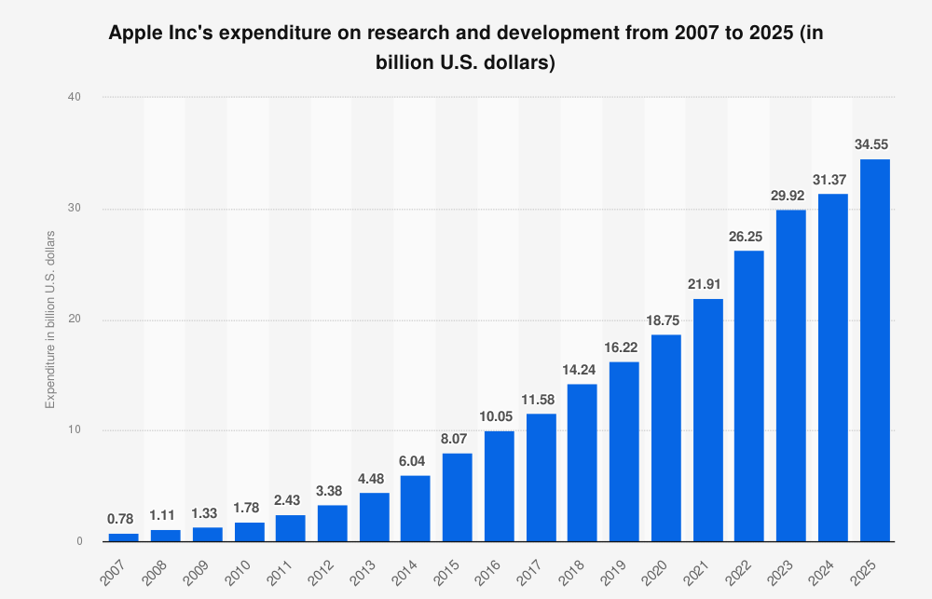
Figure 5: Apple’s Expenditure on Research and Development
(Source: Statista and Apple, 2026)
The prestige pricing is also a part of the strategy; the prices are high, which contributes to the perceived quality and exclusiveness. Brand positioning is supported by the fact that higher prices are associated with high value and status by the consumers (Minh and Hue, 2025). Apple has a good brand equity and therefore its demand is rather inelastic such that customers are ready to pay high and premium prices despites it increases, as evidenced by its high revenue performance.
Competitively, HoloSphere will be sold at a higher price compared to VR headsets and high-end workstations, as it will possess a unique value proposition. Value-based pricing strategy will be used, which means that the prices will be based on perceived advantages of productivity, innovation, and integration of ecosystems (Arumsari et al., 2026). Perceived value is greater than cost, however consumers are ready to pay, which is why the perceived value and willing to pay matter in the markets of high-tech products (Bushara et al., 2023).

3.3 Place (Distribution) Strategy
The distribution of Apple HoloSphere will be based on selective and controlled distribution strategy that will guarantee accessibility and exclusive brands. The major mediums will also involve the direct platforms of Apple, specifically the Apple store chain and the official online stores of Apple Inc. It has more than 500 retail outlets across the world offering immersive experiences with products, which create greater customer interaction and help in premium positioning (Apple, 2026).
Digital accessibility is important because the online channel has a global presence, and e-commerce is a growing proportion of consumer electronics sales, as estimated to rise to more than $819.32 billion in 2025 to over $959.92 billion in 2026 at a compound annual growth rate (CAGR) of 17.2% worldwide (thebusinessresearchcompany, 2026). Moreover, premium retail distribution will help in enabling the company such as Apple to have limited control of the brand image and increase its availability.
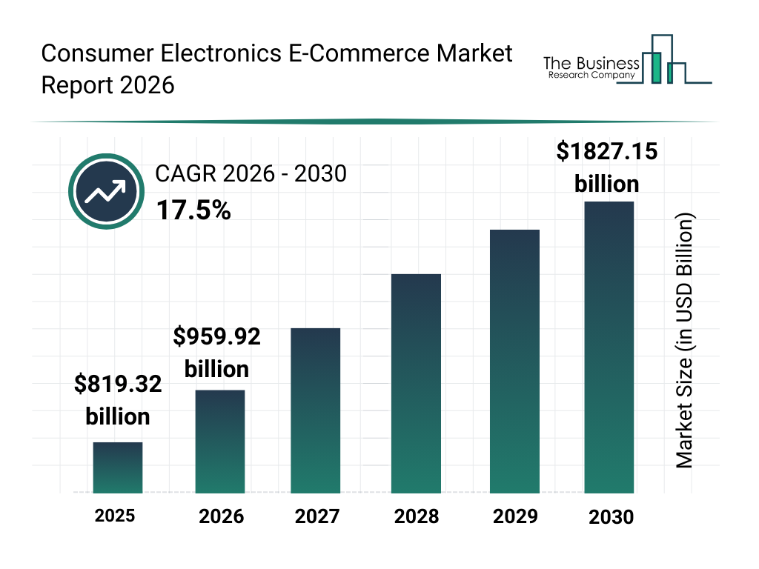
Figure 6: Market Overview of Consumer Electronics E-commerce
(Source: thebusinessresearchcompany, 2026)
Geographically, the first launch will be done in the developed markets like North America, Europe, and Asia-Pacific where demand of advanced technologies is the greatest. Apple has adopted the omnichannel approach, which combines online and offline points of contact, which results in allowing the customers to purchase their products through online ordering or visiting the stores to test and demonstrate the products (Mehta and Verma, 2026).

3.4 Promotion Strategy
Element | Strategy Application | Tools & Channels | Marketing Insight (AIDA & Branding)
Integrated Marketing Communications (IMC) | Apple HoloSphere will use a fully integrated communication strategy to ensure consistent messaging across all platforms, reinforcing brand identity and innovation positioning | Apple ecosystem, website, retail stores, digital platforms of Apple Inc. | Ensures unified messaging, strengthening brand recall and supporting all stages of AIDA
Digital Marketing | Focus on high-impact social media campaigns and influencer collaborations with tech creators to demonstrate product capabilities and real-life use cases | YouTube, Instagram, X (Twitter), tech reviewers, content creators | Captures Attention and Interest through visually engaging and informative content
Product Launch Events | Apple-style keynote events will introduce HoloSphere as a revolutionary product, generating global buzz and media coverage | Live-streamed events, press releases, global media | Drives Attention and Desire through exclusivity, storytelling, and innovation appeal
Experiential Marketing | Interactive in-store demonstrations allow customers to experience holographic technology firsthand, increasing engagement and understanding | Apple Stores, pop-up demo zones, tech exhibitions | Encourages Desire and Action by providing tangible product experience
Message & Brand Storytelling | Core message: “The future of work-anywhere.” Focus on innovation, productivity, and lifestyle transformation | Advertising campaigns, storytelling videos, user scenarios | Enhances emotional connection and supports full AIDA journey, reinforcing Apple’s premium and innovative brand image

3.5 Integration with Brand Extension Strategy
The Apple HoloSphere marketing mix is directly in line with the overall brand extension and is therefore consistent with the fundamental identity of the Apple Inc. The product approach focuses on technology as a high-end holographic product, which will strengthen the position of Apple as a leader in the high-end solutions in the market (Fernandez, 2024). The pricing policy is in favour of the premium position which is attributed to high perceived value and exclusiveness of the brand.
The place strategy helps in ensuring that there is strong brand control by the integrated ecosystem and selective distribution of Apple, ensuring that there is a consistent and high-quality customer experience (Bryła and Abdusattarov, 2025). The promotional plan is based on aspirational branding, where storytelling and immersive experiences are applied to communicate and convey the future of work (Umoren et al., 2022).

Element 4: Reflection
My experience with Apple HoloSphere growth of brand extension taught me essential lessons regarding strategic marketing brand development which is driven by innovation. The process has showed me how Apple utilise its strong equity of brand for entering markets of new product. The three core elements of innovation, simplicity, and premium positioning of market highlights on establishing the critical importance for establishing product ties with existing identity of brand. The exercise allowed me to practice theoretical frameworks through practical application of STDP and principles of marketing mix which I could focus on the process of implementing in structured environments.
My poster presentation work helped me learn how to present complex concepts through direct visual communication. The 3 to 5-minute presentation required me to choose main points which I had to express through descriptions in an exact manner. The practice helped me to develop my presentation skills at the same time I established specific content which combined the requirements of both investors and customers. The creative process of poster design helped me to improve my ability for the purpose of presenting ideas through more effective and professional methods.
I developed important skills through this project which I used for the purpose of developing the abilities of critical thinking, skills of creative thinking, and strategic analysis competencies and proficiencies. I have gained understanding of new trends in a better manner which include remote work and immersive technologies, and their influence on the behaviour of consumer and opportunities based on market. The training program helped me in developing my professional skills through teaching me how to approach the situations of marketing with strategic thinking methods. Furthermore, I focused on developing the stronger skills based on research and analytical aspects by the process of interpreting market data along with aligning it with strategic decisions. This experience also helped me in improving my ability for the purpose of connecting the theory with practice, along with improving my problem-solving capabilities and preparing me for handling the complex challenges of marketing in both dynamic and competitive environments of business.
My current approach focuses on requiring implementation through further improvements in a better manner. My future projects will require me to use academic sources together with real-world data; however, I have the ability to create more credible arguments. I will spend my efforts on the better practices of time management in which will help me complete my ideas and focuses on creating improved presentations. The experience helped me develop my academic skills together with my professional skills which I required for a marketing career and business profession. The project has helped me in the process of developing the skills for evaluating the trends of market as I learned to apply knowledge of market during the process of developing new products. The project made me more confident regarding making strategic decisions and choices while I learned how the strategies of marketing contributing to the growth of business based on long-term aspects and competitive advantages for companies.

Reference List
Akhonzada, Z., (2025). Managing Quality in Apple’s Products and Services: A Comparative Analysis of Excellence and Ongoing Challenges. Journal Home Page, 4(2), pp.01-15. https://www.researchgate.net/profile/Zahidullah-Akhonzada/publication/400048313_Managing_Quality_in_Apple's_Products_and_Services_A_Comparative_Analysis_of_Excellence_and_Ongoing_Challenges/links/6974785a58b9985baa8a9cd8/Managing-Quality-in-Apples-Products-and-Services-A-Comparative-Analysis-of-Excellence-and-Ongoing-Challenges.pdf
Al-Sakaf, H.F.T.A., (2025). International marketing strategy of the enterprise (based on the materials company «Apple Inc.». http://dspace.puet.edu.ua/bitstream/123456789/15206/1/Hind_diploma2.pdf
Apple (2026). Apple at Work - Success Stories - Retail. Apple. Available at: https://www.apple.com/in/business/enterprise/success-stories/retail/ (Accessed: 3 April 2026).
Arumsari, O.P.D., Damayanti, V., Utami, R.A. and Dewi, T.S., (2026). Pricing Strategy in Digital Marketing: A Systematic Review of the Value-Based Approach. East Asian Journal of Multidisciplinary Research, 5(3), pp.823-838. https://journaleajmr.my.id/index.php/eajmr/article/download/46/146
Bashiru, A.O., (2023). The Role of Leadership in Technology and Innovation in Creating a Competitive Work Environment and Improving Company Performance. https://www.theseus.fi/bitstream/handle/10024/814555/Bashiru_Akeem.pdf?sequence=2
Bryła, P. and Abdusattarov, S., (2025). Apple’s Strategy Success Factors and Challenges in Europe: A Case Study of Apple’s Business Model and International Marketing. Annales Universitatis Mariae Curie-Skłodowska, sectio H–Oeconomia, 59(5), pp.7-30. https://journals.umcs.pl/h/article/download/19001/13386
Bushara, M.A., Abdou, A.H., Hassan, T.H., Sobaih, A.E.E., Albohnayh, A.S.M., Alshammari, W.G., Aldoreeb, M., Elsaed, A.A. and Elsaied, M.A., (2023). Power of social media marketing: how perceived value mediates the impact on restaurant followers’ purchase intention, willingness to pay a premium price, and E-WoM?. Sustainability, 15(6), p.5331. https://www.mdpi.com/2071-1050/15/6/5331
Childs, E., Mohammad, F., Stevens, L., Burbelo, H., Awoke, A., Rewkowski, N. and Manocha, D., (2023). An overview of enhancing distance learning through emerging augmented and virtual reality technologies. IEEE transactions on visualization and computer graphics, 30(8), pp.4480-4496. https://arxiv.org/pdf/2101.11000
Dimensionmarketresearch (2026). Holographic Display Market. Dimensionmarketresearch.com. Available at: https://dimensionmarketresearch.com/report/holographic-display-market/ (Accessed: 3 April 2026).
EasyStaff (2025). Rising Remote Work: Statistics and Projections for 2025 - EasyStaff. EasyStaff. Available at: https://easystaff.io/rising-remote-work-statistics-and-projections-for-2025 (Accessed: 3 April 2026).
Fernandez, C., (2024). Revolutionizing Tomorrow: Embracing the Cutting-Edge of Holographic Technology. In Holography and Its Applications. IntechOpen. https://www.intechopen.com/chapters/1195242
Futuremarketinsights (2025). Holographic Display Market | Global Market Analysis Report - 2035. Futuremarketinsights.com. Available at: https://www.futuremarketinsights.com/reports/holographic-display-market (Accessed: 3 April 2026).
Gable (2026). Work From Home Stats: 30+ Key Remote Work Statistics For 2026. Gable.to. Available at: https://www.gable.to/blog/post/work-from-home-statistics (Accessed: 3 April 2026).
HIGH5 (2025). Remote Work Statistics (2025). HIGH5 Strengths Test. Available at: https://high5test.com/remote-work-statistics/ (Accessed: 3 April 2026).
Mehta, R. and Verma, A., (2026). Omnichannel Retailing Strategies and Their Impact on Consumer Purchase Intention and Customer Experience in The Digital Era. Journal of Marketing and Sales Management ISSN: 2457-0095 (Online), 9(2). https://admin.mantechpublications.com/index.php/JoMSM/article/viewFile/2637/1154
Minh, H.V. and Hue, N.T.T., (2025, October). Branding Strategies in the Luxury Goods Market: Managing Brand Identity, Customer Perception, and Competitive Positioning in a Saturated Market. In Proceedings of the International Conference on Contemporary Studies in Social Sciences (ICSSSS 2025) (p. 97). Springer Nature. https://www.atlantis-press.com/article/126016589.pdf
Persistence Market Research (2026). Revolutionizing Visual Communication: Exploring the Evolving Market for Holographic Displays and their Impact on Modern Consumers! Persistence Market Research. Available at: https://www.persistencemarketresearch.com/market-research/holographic-display-market.asp (Accessed: 3 April 2026).
Shvetsov, A.V. and Alsamhi, S.H., (2024). When holographic communication meets metaverse: Applications, challenges, and future trends. IEEE Access, 12, pp.197488-197515. https://ieeexplore.ieee.org/iel8/6287639/6514899/10788695.pdf
Shvetsov, A.V. and Alsamhi, S.H., (2024). When holographic communication meets metaverse: Applications, challenges, and future trends. IEEE Access, 12, pp.197488-197515. https://ieeexplore.ieee.org/iel8/6287639/6514899/10788695.pdf
Spooner, H. (2025). The State of Remote Work: 2025 Statistics - Neat. Neat. Available at: https://neat.no/resources/the-state-of-remote-work-2025-statistics/ (Accessed: 3 April 2026).
Statista, and Apple. (2026). Apple Inc's expenditure on research and development from 2007 to 2025 (in billion U.S. dollars). Statista. Available at: https://www.statista.com/statistics/273006/apple-expenses-for-research-and-development/?srsltid=AfmBOooYprUVnT7oxc_1a0U76ihHcLG5pVBTv56--en9AvQpybKing7C (Accessed: 3 April 2026).
thebusinessresearchcompany (2026). Consumer Electronics E-Commerce Market Analysis, Size And Trends Global Forecast To 2022-2030. www.thebusinessresearchcompany.com. Available at: https://www.thebusinessresearchcompany.com/report/consumer-electronics-ecommerce-global-market-report (Accessed: 3 April 2026).
TOUSARVANDANI, K., (2024). Destination Decision-Making: A Study of Digital Nomads’ Preferences and Motivations. https://thesis.unipd.it/bitstream/20.500.12608/83193/1/KhodabandehTousarvandani_Maryam.pdf
Umoren, O., Didi, P.U., Balogun, O., Abass, O.S. and Akinrinoye, O.V., (2022). Strategic digital storytelling techniques for building authentic brand narratives and driving cross-generational consumer trust online. International Scientific Refereed Research Journal, 5(3), pp.238-261. https://gisrrj.com/paper/GISRRJ225325.pdf

Appendices

Appendix 1: Element 1 – Brand Extension Poster Presentation


