

Assessment 1
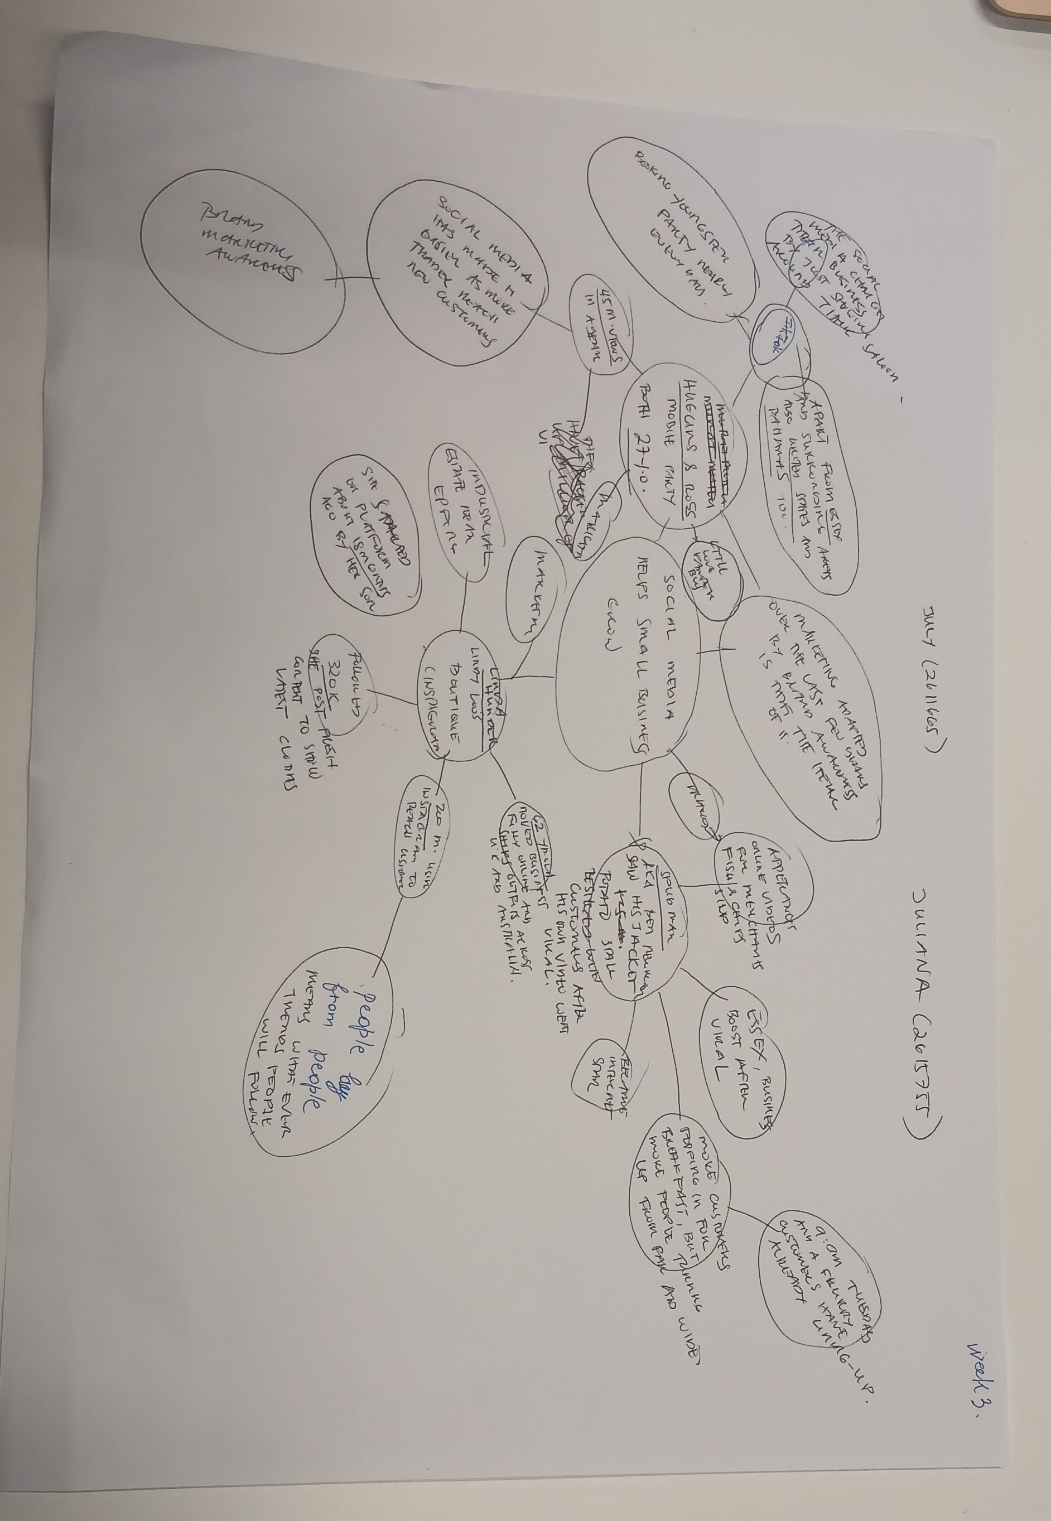

- What is the main idea of the whole text?

The main points is that social media help small brands become successful. It makes businesses popular and helps them get new customers very fast.

- What is one key point that supports the main idea, and which specific example from the text shows this?

Key point: Making viral video is the fastest way to become popular online.
Example: From the text I will take Huggins and Ross Bliss, they got 45 million views in under a year for their business.

- What is a different key point that supports the main idea, and which specific example from the text shows this?
Key point: Social media helps small local businesses find customers in other countries and grow globally. It allows them to become popular.
Example: Linda Lou's Boutique uses Instagram and sells clothes across the UK and Australia.

- Which part of the text do you think is most important, and why?
Most important part: Personally, I really liked that the text highlighted the phrase "People buy from people".
Why: This is very important today. From my own experience, when I look for products on social media, I always prefer to see real creators and authentic stories. Friendly faces build trust, which works much better than simple ads.

Reflection:
- What did you find difficult in this task (including in-class components), and why was it difficult?
It was a bit difficult to understand some sentences and some words in the text and select the most important facts from the large text. Discussing the article with my team and looking for keywords helped me with this difficulty and found the main ideas much faster. I focused on the main words.
- What helped you with this difficulty, and how did it help you?
I learned that buyers want to see real faces on social media. It attracts them, makes them watch videos and motivates people to buy from new businesses. This is because the principle "People buy from people" is very important.

