25/08/2020
ACADEMIC AND EMPLOYABILITY SKILLS
LECTURER : SYLVIA HOFFMANN
MODULE NUMBER: BMSW4001
REFLECTIVE WRITING
Yazmin Vega rodriguez (1917100)
Contents

INTRODUCTION 2
REFLECTIVE WRITING 2
COVER LETTER 3
PUBLIC SPEAKING PRACTICAL EXERCISE 4
TIME MANAGEMENT 5
CONCLUSION 5
Bibliography 6
APPENDIX 1 7
APPENDIX 2 8
APENDIX 3 9

ACADEMIC AND EMPLOYABILITY SKILLS
REFLECTIVE WRITING

INTRODUCTION

The objective of this writing is to identify which model of reflection I will use to express my perspective and conclusion about four different topics, It based on my personal experience, that I will explain on detail below, helping me to developed my skills and identify my weakness and strengths to structure my writing, that will be reflected on my capacity of analysis.
In this case, I will use Gibbs reflective cycle. This theory involve our thoughts and feelings in a specific situation to overcoming it, positively and negatively permitting evaluate ourselves and conclude with a futures solutions that will allow having better results.

REFLECTIVE WRITING

Related to the employability skills module, I did an exercise in class, which consisted of improvising with reflective writing.
I had to write, put into practice and analyse what I had learned regarding the material provided in class with a respective video to reinforce the exercise further.
Once I finished it, we had the option to share the task with the rest of the group, having a constructive criticism was optional, I decided to participate and interact with the rest of the class using digital sources through the platform that the university offers, called a class notebook, which was new to me, and consisted of uploading my exercise to a specific folder and then waiting for my feedback. The text-only the teacher had direct access. Stop then make the respective correction in class in front of everyone at the same time is very confidential about written text.
Sylvia methodology is very dynamic and participatory, which has a positive impact on my commitment to the subject, and especially receiving feedback at the time. I was very anxious to receive observation about my piece of writing.
As I expected, my writing did not have logic, I did not follow instructions of the structure that I had to follow, and wrote five different topics, my teacher told me that it was a swimming pool, that I had everything. I had to focus on only one topic and develop it.
I have to admit that I do not have enough tools to structure a reflective writing, my lack of concentration significantly affects my academic performance, my lack of time makes my procrastination increase, and I do not prioritize have to highlight how just a simple class exercise demonstrates the weaknesses and strengths that I have, and that I don't pause in terms of expressing my ideas, and how external factors directly affect my concentration and focus.
Once I identify my disadvantages, I have to direct and structure my writing in an easy way to follow; that is why looking for the necessary tools is crucial for me. For developing myself, to be more specific, I made a reservation of how to improve my reflective writing and de concept.
Reflecting writing is based on a personal experience that involves situations, feelings and emotions that identifies what happens and why according to the past and how to perform better in the future, the evidence of your experiences are going to help you to constructively criticize yourself. (Mulder, 2018)

On balance my research shows me how to structure my work and the method that I am going to use in the future which is Gipps reflective cycle writing using six steps, in this way, I will focus on being clear about the concept and having enough time to adapt it to me. Workstyle, having an orderly sequence and with logic to advance, will give me the right tools to avoid wasting time and be able to progress in a more effective way.

I will put my knowledge from now in actions plan to progress and improve on my mistakes.
I am aware of my procrastination and how it affects me when writing, and that I need to follow a sequence so as not to deviate from the main idea in this way I will be concise and clear.
Thanks to this module with Silvia in the second term, she has been of great support for me, her professionalism and her dexterity to correct and individually contribute exercises on lase and reviewing what we have written gives me a broad perspective of the faults I have and what I can do to change it in the future
The exercises in class, being Spontaneous, increases my ability to reflect and expand my ideas in real-time.

COVER LETTER

In the employability skills module in the second quarter in week number 3, we had a cover letter as content, after analysing and clarifying the concepts, purpose and relevance in the professional market and how it is directly related to the selection process. What is the first impression that the employer has of the candidate together with the CV, once we identified the role, we had to write our presentation letter, which I developed adapting more to my work experience,
we carried out in class an experimental case about the job description for cover letter writing activity which presented several options which had to be adapted and developed throughout the exercise such as: administrative office manager, project manager, a recruitment consultant for events, restaurant manager, and sales assistant.
Sylvia guided us through Microsoft team, how to upload it to the platform that the university offers, called class notebook, which expedited the online correction that Sylvia would do later for students who wanted to participate and have their respective feedback.
Honestly, I was very concern, especially because I did not have sufficient time to work on it. And as it was a class exercise, I did not take it with the seriousness it deserved.

Firstly, my cover letter had many errors. Initially, I did not worry about looking for more information about the company, the name of the description of the role I thought was the person to whom it had to be addressed, and it was the name of the recruitment retail, then the header was poorly structured, Sylvia commented about the simple and easy to understand language focused on the vocabulary I used, she mention some words that were not the right one.
As it was an exercise in class, do not take it as seriously as I should have, from my point of view, doing this type of correction in class is very productive and easy to incorporate into future exercises and practical in our daily life. As it is a cover letter, I have done the research, and it is fascinating what I have found these are some of the essential tips that I will use when preparing my presentation letter to be more competitive such as:
write a very clear and positive introduction, include my full name, date, my date, greeting if I do not know the person name I can replace with Dear. Mr/Ms. Last name. Why I am interested in that position, where did I saw the advertisement, use formal writing, friendly vocabulary and persuade them, I will emphasis about my experience but not copy the C.V. Why I am the right candidate, focus on my skills adapted to the role, show my disposition to have the opportunity to have an interview and finally formal farewell and attachments. (Green, 2020)
From my perspective, the best way to learn is to accept the suggestion and progressively do changes, even if you are not just to it, especially in front of your classmates, and for my benefit indirectly all the constructive criticisms that are made We can learn in a group and improve by adapting them to our work, and this requires the commitment of extra time to focus more and be able to use the available resources.
The new online methodology allows simulating a presential class in terms of clarification on real-time. Trying to maintain the dynamics between teacher-student. Personally, the module of employability has been constructive for me. I will participate more to improve my weaknesses, and I will be more conscious of using more the blade, it is a vital resource, to improve in the process of my future studies.

PUBLIC SPEAKING PRACTICAL EXERCISE

During the week eight, we had a subject called public speaking in our module; we had to prepare a short presentation about 2-3 minutes, introducing the most significant achievements in an any of this these topics: professional, educational or personal life. As we were expecting with feedback at the end. The most exciting part.

I was a bit nervous at the beginning because just one person was participating, and I was not sure if my exercise was the right one, mainly I was terrified of a bad review, afterwards was my own initiative took part of the practical exercise, I spoke for about 3 minutes, about my personal goals and how the story began since I left my country.

From my own experience, it was exciting to express myself in front of all class and communicate all my emotions through my short speaking. I enjoy it because I could see the rest of my classmate how they were emotionally involved in the class.
Unfortunately, I am not a confident person, I had to read my exercise because of my procrastination, my natural tendency is to mix topics, so it was helpful for me to read it. And organise my goals chronologically.

Related about my practical speaking, I had a good review in general from my lecture and classmates; we were giving an overview about the content of my topic and vice versa, make more straightforward to make improvements. I will implement tips to practise such as Talk naturally, be confident, practice in front of the mirror it is a good point, and body language to don’t look over-emotional. (Shandrow, 2019)

For the future presentations I will emphasise more on the audience being more energetic, Also is relevant to take in considerations that presentations online is something new for me so I will research more about it, at the moment this will be part of study dynamics with the current situation that we have to adapt on these days.

TIME MANAGEMENT

On the first term, I had the opportunity to introduce myself with this topic which is Time management, I had too many inconvenient in general with my first experience in this course at university, my first trimester I was completely lost, and I face to do my assignment without any support; obviously, the pandemic started, so it was even more complex for me.

I am not a self-motivated person in terms of learning, so I was always avoiding online classes, because of my lack of concentration, on the first trimester I had clear the concept and prioritisation, about how to manage my time, but in the practise I am not able to improve.
Evaluations
from my perspective, I am conscious that I don’t have enough time to dedicate to my studies with this current situation the rota has been changed in my company, so the option that I had before it is not available now, the late shift is going to affect in the future my course and my health.

From the last term, I will use more module to support my performance at university and career adviser from the university. And I will reconsider all the critical points of the time management to revaluate in which areas I am doing wrong, that I could take more advantage in my benefit.
As a new strategy, I will incorporate a diary to improve my time been more proactive and organised better my hours per night to study,
Without over stress. (Morgan, 2017)

CONCLUSION
As part of my reflective writing, I have been able to identify more clearly my failures when structuring my ideas thanks to this course that gave us the tools to choose the model that best suits our way of thinking and to be able to conceptualize the content for later apply it individually; the gibs model has helped me explore new concepts and methodology that I can implement for my benefit and that in the future I will be able to apply them in any field, whether professional or personal, I have managed to refine my style based on thoughts and feelings. that I identify myself with Gipps theory , in terms of recognizing a situation or a problem and think about and then take actions in how will face if the situation happened again I will put on practice what I have learned and overcome in a future scenarios

Bibliography
Green, A., 2020. The cut. [Online]
Available at: https://www.thecut.com/article/how-to-write-a-cover-letter.html
[Accessed 20 August 2020].
Morgan, P., 2017. The Business student guide to study and employability. London: Sage .
Mulder, P., 2018. Toolshero. [Online]
Available at: https://www.toolshero.com/management/gibbs-reflective-cycle-graham-gibbs/
[Accessed 10 August 2020].
Shandrow, K. L., 2019. Entrepreneur Europe. [Online]
Available at: https://www.entrepreneur.com/slideshow/299610
[Accessed 19 August 2020].

APPENDIX 1

Reflective writing

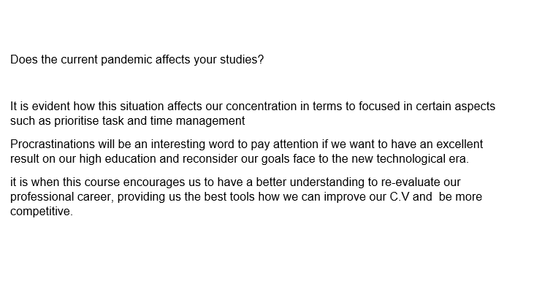

APPENDIX 2

Cover letter

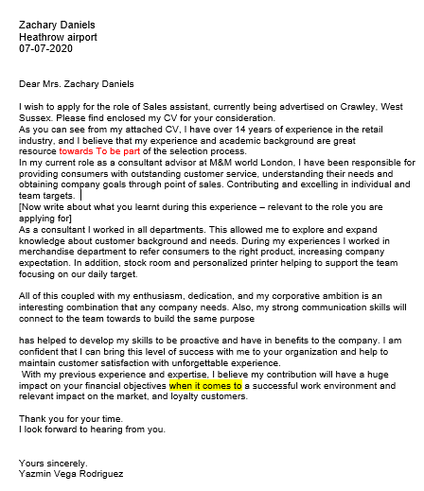

APPENDIX 3

Public speaking practical exercise


