As media consumers in the 21st century we are so easily transported to worlds beyond belief. From when we are children, and we imagine a world completely build up in our heads to growing older and sinking our minds into video games, music and movies we are constantly living in a world that isn’t like our own. Our escape can sometimes be an artificial world... that being transported back into the world of cowboys or transported forward into the world of a post-apocalyptic land. These artificial worlds become our escape from the real world but sometimes the feeling can be a little too real. I will be covering a few terms such as Lonliness, Artifical and Quiet and how these all these terms interlock with my thinking moving forward.

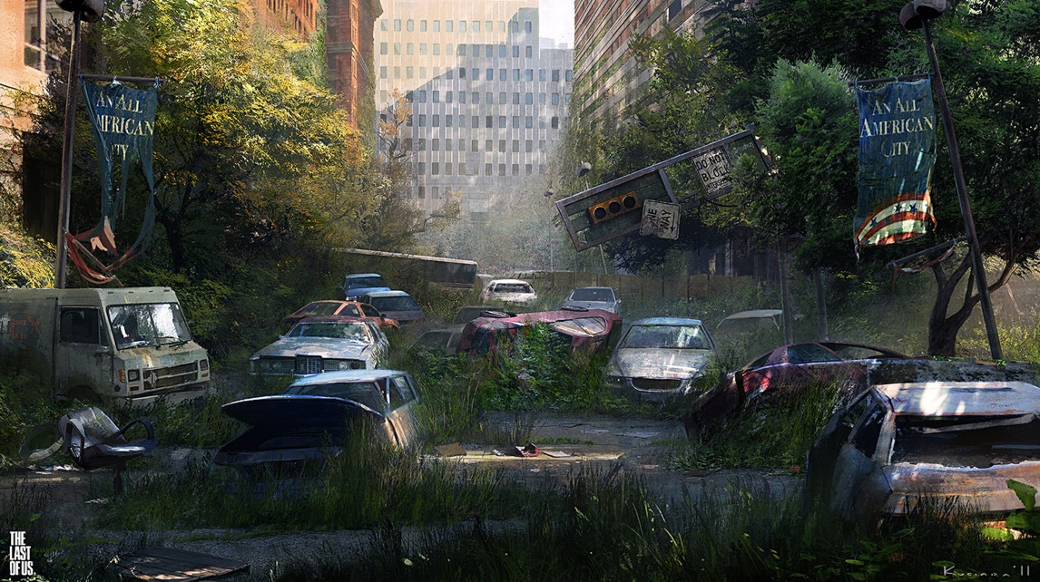
Maciej Kuciara – concept art

Loneliness is a term that is so easy shined into a negative light, but sometimes it can be used to great artistic effect to make something feel real. The essence of video games is to make you get lost in a world that is artificially built and you spend so much time in these worlds it’s a given that the goal is to get you hooked in ways other medias doesn’t have too. It is so easy to escape into the world of a video game, so easy in-fact that in 2022 we live in a world where video games and virtual reality are the new normal. Video games have evolved into a brand-new sense of the word ‘Social Media’. People don’t just play with strangers over the internet anymore. People form genuine relationships. (Lufkin, 2020) Not only are they the new normal, just like movies, TV and Books; they create an artificial world we can get lost in. Sometimes these video games can create a real feeling. Video games such as The Last of Us; Naughty Dog (2013), Red Dead Redemption 2; Rockstar (2018) or Death Stranding; Kojima Productions (2019) achieve this in a standard that has barely been reached before in video games. These three video games create an incredible feeling of loneliness within an artificial world in their own way. When in a creative mindset “Letting go means stepping away from the world we have built for ourselves and see what else is out there. See what is happening in the here and now, away from our own story.” (Reid, 2020). Concept art is such an important piece of the puzzle when it comes to designing the world we see within video games, as seen in Maciej Kuciara’s work, who helps clients to realize their unique vision through illustration and design and has worked with the likes of Google, Sony, Universal, Naughty Dog and Dreamworks. (Maciej Kuciara, 2019) Kuciara creates a vision through their concept art, especially when looking towards the last of us where Kuciara created a world that feels so forgotten and lost through time but at the same time feels as this is a real image frozen in time, it feels real and that’s the key to getting lost in a world, a sense of grounded life. This work also went on to be some key concept art used within the game design and can be seen represented within the final product. Concept art is used to convey the ideas within somebody’s mind before reaching the final project, concept art is the first stage of design when creating a world. It is almost like a more developed sketch. The saying, “a picture paints a thousand words,” should be the mantra of every Concept Artist. (Fitzgerald, 2019) This level of design pushes forward a sense of realism to the game, without concept art, you wouldn’t be able to get lost in these worlds. And a lot of thought needs to go into them, such as stated in the last of us art book, “The simple appearance of a natural environment can convey a great deal of emotion.” (p. 99) Which show the idea that artists help create these artificial worlds you so easily get lost in the magic of. When researching this topic, I came across a website article by Jacob Geller who brought up the idea that ‘Red Dead Redemption 2’s biggest success is loneliness’ which I agree so much to, because the world of that video game is so vast and wide, you could spend hours and hours exploring and still find elements you have never seen with your own eyes before. As seen in fig 2 the map of Red Dead Redemption is a highly in-depth developed piece of which stretches the realm of imagination when you really break it down. Twinfinite recorded themselves riding from one corner of the map to other and it took us 16 minutes at full sprint on our horse. (Gibson, 2018) Which is impressive when you remember every part of this world has been crafted top to bottom to act as if it is real, living and breathing city you could get lost in.

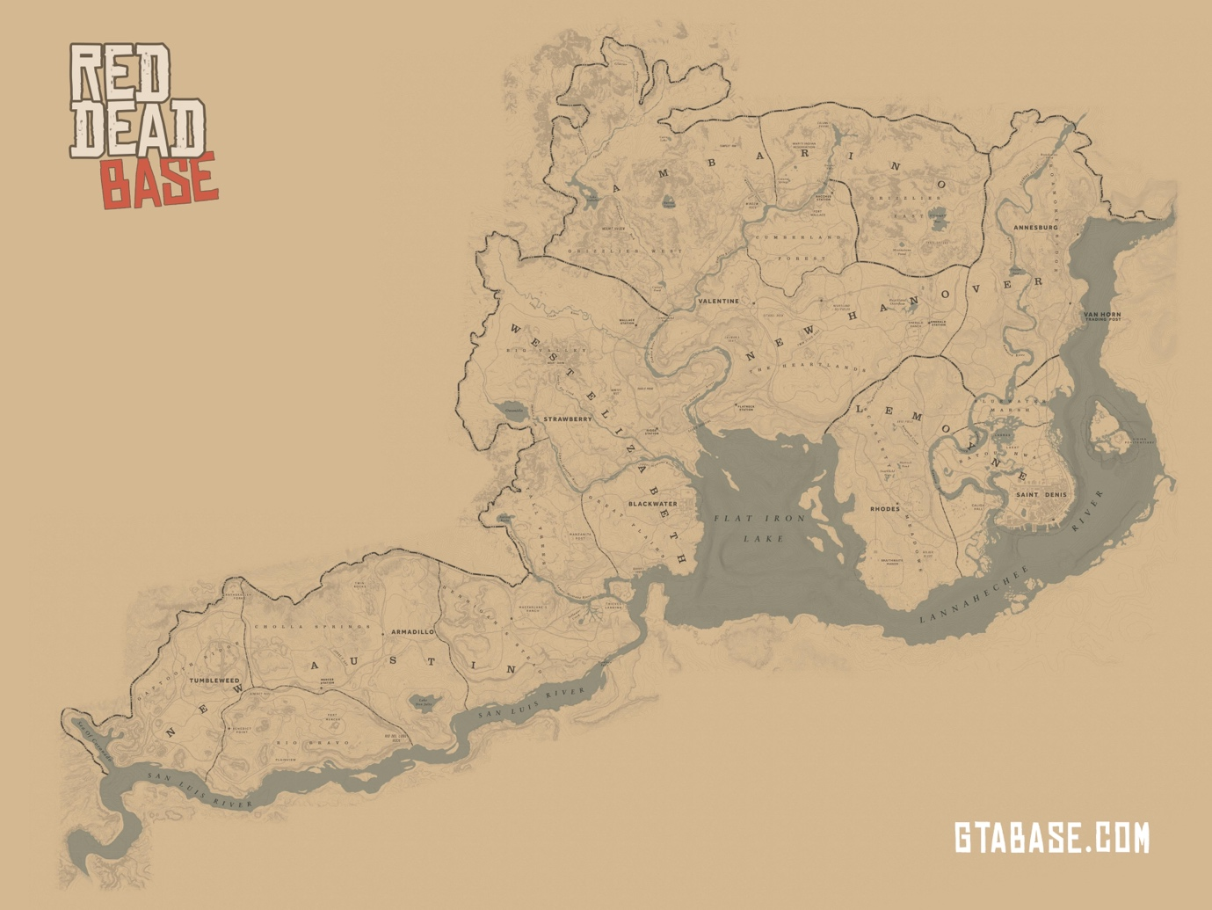
Fig 2. Red dead redemption 2 map

When searching the term “Artificial” I found a lot of results which explored the sense of forced perspective creating the biggest sense of loneliness but the best example of this I came across in my research would have to be Aristotle Roufanis. His work, titled Alone Together called out to me from the moment I first saw it and I was drawn to it instantly because of how unique it was in comparison to other works I came across. Roufanis work is so unique due to the methods used to create these stunning photography pieces which draw the viewers eye instantly and makes them want to look closer to discover what is so off about it. It creates an almost uncanny valley impression on the viewer because it seems so odd at first.

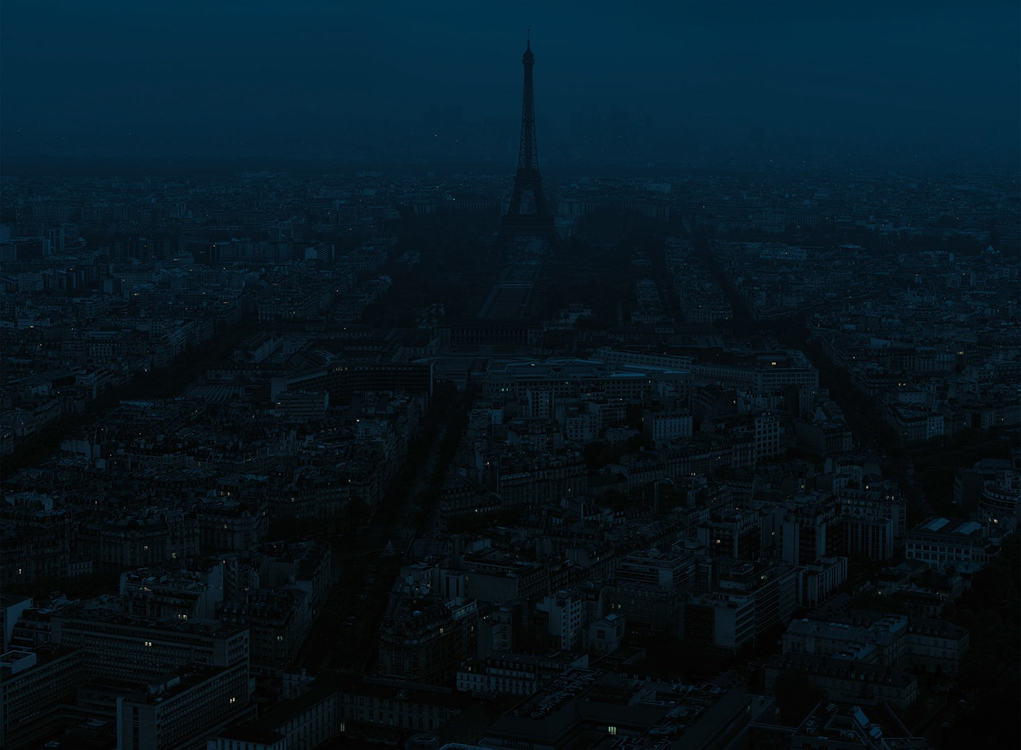
Fig 3. Alone Together; Paris

Take his Paris piece, for example. Roufanis can create a sense of quietness, darkness and lonliness in a city that is never either of those things. Paris has never stood THAT still before. However due to his methods, Roufanis can make Paris stand still and isolate people. Roufanis takes away the big flashing lights, headlights from cars and even the many lights on in the background and can make a city feel lifeless in an artifial way, because we know for a fact Paris never sleeps. The way the photographer isolates people in an artificial way is incredible. From their own words, “The bigger the city, the lonelier we feel. It is important for people to understand that although lonely, they are not alone. Individuality does not equal to alienation.” (Spirou, 2018) The idea of isolating a huge city by only seeing a few illuminated city seems outlandish, but when you actually see it in practice it makes you think. Roufanis does this to raise awareness in a sense to show that even in the big cities, there is an epidemic of loneliness it’s just so hard to see it; but they do it in such a way that it shines a positive light upon it. (Spirou, 2018) Roufanis’ alone together is not just a sad person sitting in a room alone, it really makes you think about what you are looking at. The way isolation and loneliness is conveyed here is almost hidden in plain sight, but it is there. Making Paris dark, paused in a moment in an artificial way really highlights the ‘smaller’ people in a bigger city. It’s easy to feel lonely in a big city. Life moves so fast, and people rarely talk to strangers, so the project highlights this phenomenon of “social alienation” (Nicholls, 2017) I’m a huge fan of how this works. As seen in fig ___, it shows a much more zoomed in image. This time looking at an apartment building and it really shows the ideas previously talked about. Roufanis own style shines through in a way to make the person viewing piece think about the isolated person. We see no faces and not even a good look inside of said apartment, but it leaves enough intrigue where you want to know more, and it drives you mind into making its own conclusions of how this person lives their life. The way these images are created is a topic to discuss all itself. It takes so long to develop an image like this. The images of Alone Together are a “result of dedicated observation, as he photographs the cities he visits from dusk till dawn: after setting up his equipment on a high-rise or hill, the artist proceeds to patiently capture the city below click-by-click, in a process that can take several hours. This is followed by meticulous post-processing that can take up to six months for each work.” (Spirou, 2018) It is a long process to make something like this, but I think it pays off and shows thinking outside the box can really help convey an idea such as ‘Artificial loneliness.

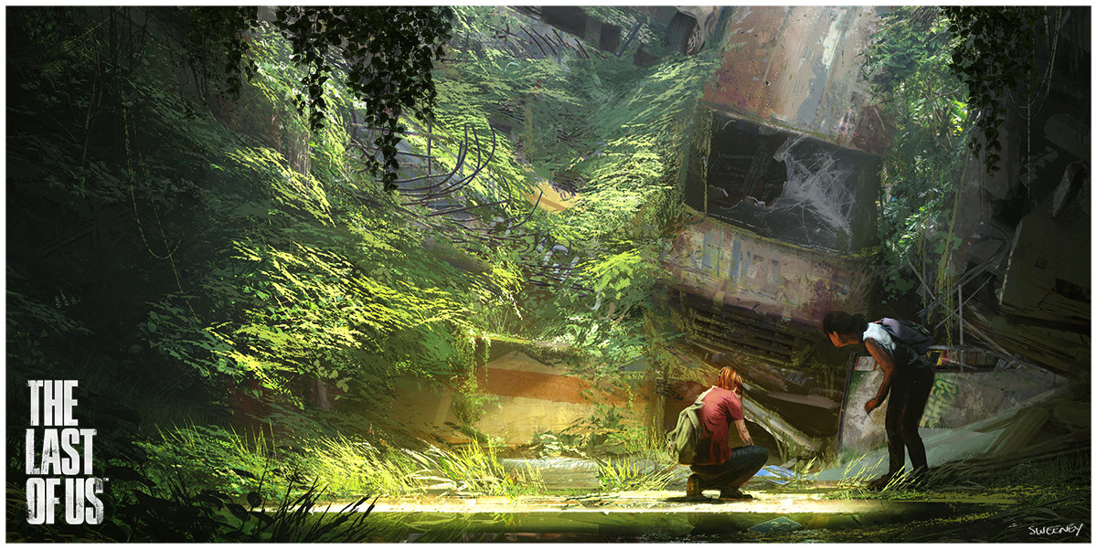
Fig 4. Last of Us John Sweeney – Concept Art

Quietness is how you would imagine loneliness would sound because when you think of ‘shutting yourself out’ from the outside world, a person could look for quiet or silence from the louder noises being projected. But when creating an artificial world within media such as video games it is much better to create silence in different forms. Just like when you’re reading a book and a writer would convey a sense of quiet. Creating atmosphere is such an important piece to getting lost in a world because if you don’t create the atmosphere, you could get pulled out of that world and almost become uninterested. Unlike movies you are not spending two hours in a game before you move onto the next movie or move on entirely, most games in 2022 have runtimes which near thirty hours and most people would play up to six hours on average. It is important to make sure the user gets completely lost in this world. Some ways this have been achieved in the past is sound design. “Much of The Last of Us is played in a silence punctuated with gun shots, head crunching and flesh slicing. Listen closer though and this gives way to the noise of the city. Devoid of traffic and industry the spaces you enter bristle with trickling water, creaking girders and the unseen wildlife reclaiming this now uninhabited world.” (Robertson, 2013) The Last of Us and other video games such as red dead redemption 2’s magic doesn’t come from the world which you see on the surface, the magic comes from the parts of the world you would miss if you were not paying attention to it. Just like the real world. If we as people zoom out of the narrow view which is our own and try to project our mind like a photograph from Aristotle Roufanis’ alone together project you can be lost in the magic of the world. Stopping and listening to the quiet tussling of animals you can’t see, or the wind blowing and hitting leaves against a wall. It is things like this which could be an afterthought to many but are always there, Loneliness isn’t quiet, and the first point of understanding the term ‘Artificial and forced loneliness’ is that a creator doesn’t have to make it dark, gloomy, quiet and empty. The last of us was compared to the Covid-19 breakout a lot, especially after the UK went into lockdown “and the background noise of the world fell to silence. The traffic noise, the drunken revellers, the music, the chatter, all of it gone, and now looking out the window fills me with the same tension, and dread.” (Cooper, 2020) Crating a world that is empty, while at the same time filled with life can be such a hard job, but games make the world feel so real. It is so easy just to stop and admire the view of something many people would had just walked past. Admiring a small piece of work a creative mind behind the scenes had spent months working on. It is nice to admire work many people would just brush past. As quoted from a video essay called, artificial loneliness by Jacob Geller, When I sat and watched a sunrise in the mountains of The Legend of Zelda: Breath of the Wild, it was because I was truly taken aback by the beauty of the moment, not because the game told me to. When I grappled with the staggering emptiness of Shadow of the Colossus’ world, I felt absolutely connected to Wander and his lonely quest. And in Red Dead Redemption 2, my cowboy daydreams were best fulfilled by nights spent alone, with only the stars for company. (Geller, 2019)

When exploring all my 3 words, which were Artificial, Loneliness and Quiet I have reached a main idea of what question I would like to ask and answer moving forward with for my year three studies. With assistance from thinkers and creatives such as Aristotle Roufanis, Maciej Kuciara and _____ my question would come from the term artificial loneliness and how people create that world through a sense of art, sounds and photo manipulation. I loved the work Aristotle Roufanis created to convey a sense of loneliness in a big open city that never sleeps and it has brought me closer to the topic and questions I would like to discuss going forward. I would love to explore a sense of artificial lonliness which pushes a creative mind into making others think differently about the topic they are looking at, as described by Roufanis himself “In a big city, we are all close to each other but we are still alone somehow” (Lachowskyj, 2017) Which I personally find so true, because I honestly feel the most lonely in the places that have loads of people in one place. It is a crazy thought, but I reason with his words so much and is something I would like to explore deeper with my own writing and research, finding a creative solution to the term artificial loneliness and forcing a perspective on loneliness without having it be directly in the viewers face.
Bibliography
Wells, N & Meyer, A & Monacelli, E (2013) The Art Of The Last Of Us. Page 99. Milwaukie, Dark Horse Books
Lufkin, B (2020) How online gaming has become a social lifeline.
Available from; https://www.bbc.com/worklife/article/20201215-how-online-gaming-has-become-a-social-lifeline [Accessed on 15th April 2022]
Reid, A (2020) Ethical Worldbuilding In Games
Available From; https://www.massive.se/blog/games-technology/ethical-worldbuilding-in-games/ [Accessed on 15th April 2022]
Kuciara, M (2019) Maciej Kuciara
Available From; https://kuciara.com/about [Accessed on 16th April 2022]
Fitzgerald, R (2019) What is concept art?
Available From; https://www.cgspectrum.com/blog/what-is-concept-art [Accessed on 16th April 2022]
Gibson, A (2018) Here’s How Long it Takes to Cross Red Dead Redemption 2’s Map
Available From; https://twinfinite.net/2018/10/heres-long-takes-cross-red-dead-redemption-2s-map/ [Accessed on 16th April 2022]
Spirou, K (2018) Aristotle Roufanis Studio; Alone Together.
Available From; https://aristotle.photography [Accessed on 15th April 2022]
Nicholls, W (2017) Alone Together: Photos That Show the Loneliness of Cities During Blue Hour
Avaiable From; https://petapixel.com/2017/09/16/alone-together-photos-show-loneliness-cities-blue-hour/ [Accessed on 16th April 2022]
Robertson, A (2013) How 'The Last Of Us' Sound Design Outshines Gameplay
Available From; https://www.forbes.com/sites/andyrobertson/2013/07/04/the-last-of-us-in-depth-review-sound-design/?sh=5730b5325271 [ Accessed on 16th April 2022]
Cooper, D (2020) Maybe don't start playing 'The Last of Us' during a pandemic
Available From; https://www.engadget.com/last-of-us-irl-pandemic-130050966.html?guccounter=1&guce_referrer=aHR0cHM6Ly93d3cuZ29vZ2xlLmNvbS8&guce_referrer_sig=AQAAABU7BkxQjxKIR6ckRxLSRhE68K0eRWdLZxsc837fm06l25N7sOG2mxAC6dNRFpZPZGqMvLBcKR4smPYb6IMDYrgNVUzrqqooi7o2zaVw1O5mCZJqqz0eb76rSVSkE8CDyw9RxzP5Z-DQlYJmLLjHagbvEsXJ41vLcIxen8pE-CHD [Accessed on 17th April 2022]
Geller, J (2019) Artificial Loneliness. Nov 19, 2019.
Available From; https://www.youtube.com/watch?v=hUwTh4uSILg&t=16s [Accessed on April 2nd 2022]
Lachowskyj, C (2017) Alone Together with Aristotle Roufanis
Available From; https://www.1854.photography/2017/11/alone-together-with-aristotle-roufanis/
[Accessed on April 16th 2022]

List of Figures:
Figure 1. The last of us concept art – ConceptArtWorldUK.com. Accessed from: https://conceptartworld.com/wp-content/uploads/2013/06/The_Last_of_Us_Concept_Art_MK-06.jpg [Accessed on 15th April 2022]
Figure 2. Red Dead Redemption 2 Map – GTABASE.com. Accessed from https://www.gtabase.com/images/red-dead-redemption-2/locations/Red-Dead-Redemption-2-Full-World-Map.jpg [Accessed on 15th April 2022]
Figure 3. Alone Together; Paris – Plain Magazine. Accessed From https://i0.wp.com/plainmagazine.com/wp-content/uploads/2017/08/content_plain-magazine-alone-together-07.jpg?ssl=1 [Accessed on April 2nd 2022]
Figure 4. Last of Us John Sweeney – Concept Art – Art Station. Accessed From https://cdnb.artstation.com/p/assets/images/images/000/133/695/large/john-sweeney-boston-car-small.jpg?1443928383 [Accessed on April 15th 2022]

