MSc Public Health and Social Care in Practice
Module: Practice-Based Research
Module code: LCHS7008
Component 2: Written Research Proposal
Research Title
“Sex-Specific Cardiovascular, Lifestyle and Hormonal Risk Factors Associated with Dementia Among Adults Aged 65 Years and Older in the UK: A Systematic Literature Review”
Student Name: Norin Mohamadmunafkhan Qureshi
Student ID: 2528087

Table of Contents
1. Introduction and Background 4
1.1 The Issue 4
1.2 Explaining the Scale 5
1.3 Explaining the Consequences 5
1.4 Narrowing the Focus 5
2. Research Problem, Rationale and Evidence Gap 6
2.1 Research Problem 6
2.2 Research Rationale 6
2.3 Evidence Gap 6
3. Literature Review 7
3.1 Cardiovascular Risk Factors and Dementia 7
3.2 Lifestyle Risk Factors 7
3.3 Hormonal Risk Factors 8
3.4 Literature Gap 8
4. Research Aim, Objectives and Question 8
4.1 Research Question 8
4.2 Aim 8
4.3 Objectives 9
5. Methodology 9
5.1 Research Design 9
5.2 Question Framework: PICO 9
5.3 Search Strategy 10
5.4 Databases to be Used 10
5.5 Keywords 10
5.6 Inclusion and Exclusion Criteria 10
5.7 Study Screening and Selection 11
5.8 Number of Articles to be Selected 11
5.9 Data Extraction 11
5.10 Data Synthesis and Analysis 11
5.11 Critical Appraisal and Risk of Bias 11
6. Ethical Considerations 11
7. Limitations 12
8. Timeline and Expected Contribution 13
9. References 14

Research Title
Sex-Specific Cardiovascular, Lifestyle and Hormonal Risk Factors Associated with Dementia Among Adults Aged 65 Years and Older in the UK: A Systematic Literature Review.

Introduction and Background

The Issue
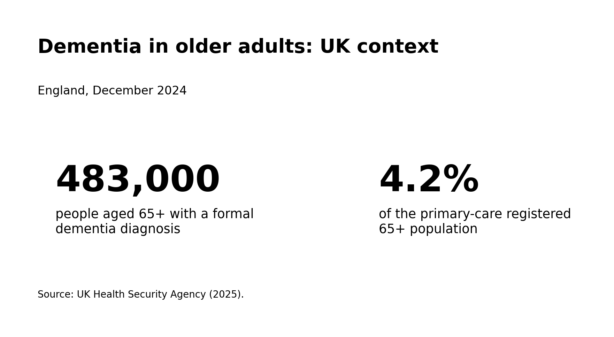
Dementia is a significant public health problem in the older population. It may have an impact on memory, thinking, communication, behaviour and the ability to carry out activities of daily living but it is not regarded as a normal process of ageing. Alzheimer’s disease and vascular dementia are among the most prevalent. The syndrome of dementia results from a range of biological, cardiovascular, social, lifestyle and genetic factors rather than any one factor (Hogervorst, Temple and O’Donnell, 2023; Livingston et al., 2024).
Figure 1: diagnosed dementia among adults aged 65 years old or over in England December 2024 (UK Health Security Agency, 2025)

Explaining the Scale

Dementia poses a substantial strain on health and social care services in the UK. In England, there were 483,000 individuals aged 65 years and over with a clinical diagnosis of dementia by December 2024, accounting for 4.2% of the primary-care registered population within this age group (UK Health Security Agency, 2025). This highlights the ongoing extent of dementia among this demographic group and underlines the importance of prevention and risk reduction (Livingston et al, 2024).

Explaining the Consequences

The impact of dementia on independence and quality of life may be gradual. Person can become more dependent on others to support with medicines, money, mobility, communication and activities of daily living. This may add to the emotional, practical and financial stress on families and unpaid carers and result in greater demand for health and social care services (Livingston et al., 2024; NICE, 2015).

Vascular disease seems particularly relevant to vascular dementia and may be implicated in Alzheimer’s disease. There are sex differences in the associations between Cardiovascular Disease and Dementia subtypes, with some evidence of a stronger relationship in women (Dong et al., 2022). Lifestyle factors such as obesity, metabolic disease and vascular damage may also be involved (Brain et al.,2023; NICE, 2015).

Narrowing the Focus

Dementia occurs in both sexes but numerous studies often list risk factors without testing whether strength or direction of association differs by sex. This is relevant as the exposure may not have an equal relation to dementia in women versus men (Hogervorst, Temple and O’Donnell, 2023; Berezuk et al., 2023).

Gong et al. (2021), have also used the UK Biobank and identified that smoking, diabetes, high adiposity and previous stroke were all associated with dementia in men and women. However, they also found the association between blood pressure and dementia to show a different pattern in women to men. These results show that combining results can miss different related factor between the genders (Gong et al., 2021).

An additional place of difference is with hormones. Women usually see a large decrease in oestrogen at menopause whilst for men testosterone tends more slowly with age. Studies within the UK Biobank showed relation of menopause, lifetime oestrogen exposure and men’s testosterone with dementia but the outcomes are inconsistent (Hogervorst, Temple and O’Donnell, 2023; Hao et al., 2023; Park, Marston and Mukadam, 2024; Marriott et al., 2022)

Research Problem, Rationale and Evidence Gap

Research Problem

This primary research issue is that cardiovascular, lifestyle and hormonal risk factors are generally examined in isolation. As a result, it is not easy to discern the overall trend of sex-specific dementia risk among older populations in the UK. Differences in the magnitude of associations between women and men have also been reported in the current literature Gong et al., 2021; Dong et al., 2022; Chen et al., 2023;

Research Rationale
This proposed review is warranted as many of these risk factors are potentially modifiable, for example by better management of blood pressure, diabetes and weight, and cessation of smoking and increased physical activity, which could all reduce risk of dementia. The Lancet Commission discusses several potentially modifiable dementia risk factors and highlights the importance of preventive strategies throughout the lifespan (Livingston et al., 2024; Stephan et al., 2024).

Evidence Gap

A systematic review of the UK evidence can thus offer a comprehensive summary of these risk factors, highlighting comparison of the reported associations between women and men, identifying commonality, contradiction, and gaps in the research (Livingston et al., 2024; Bransby et al., 2024).

Literature Review

Cardiovascular Risk Factors and Dementia

Vascular function can be impacted by factors such as hypertension, diabetes, obesity, dyslipidaemia, stroke and cardiovascular disease and all may be linked to dementia (Brain et al., 2023; Jia et al., 2023; Kuate Defo et al., 2024). A number of these associations have been identified in an umbrella review (Brain et al., 2023; Jia et al., 2023; Kuate Defo et al., 2024).

Sex-specific evidence is especially pertinent. Gong et al. (2021) observed that smoking, diabetes, adiposity and prior stroke were related to increased dementia risk in both sexes, whilst the relation with blood pressure varied between males and females. Dong et al. (2022) further identified sex differences in relationships between cardiovascular diseases and various dementia subtypes.

Lifestyle Risk Factors
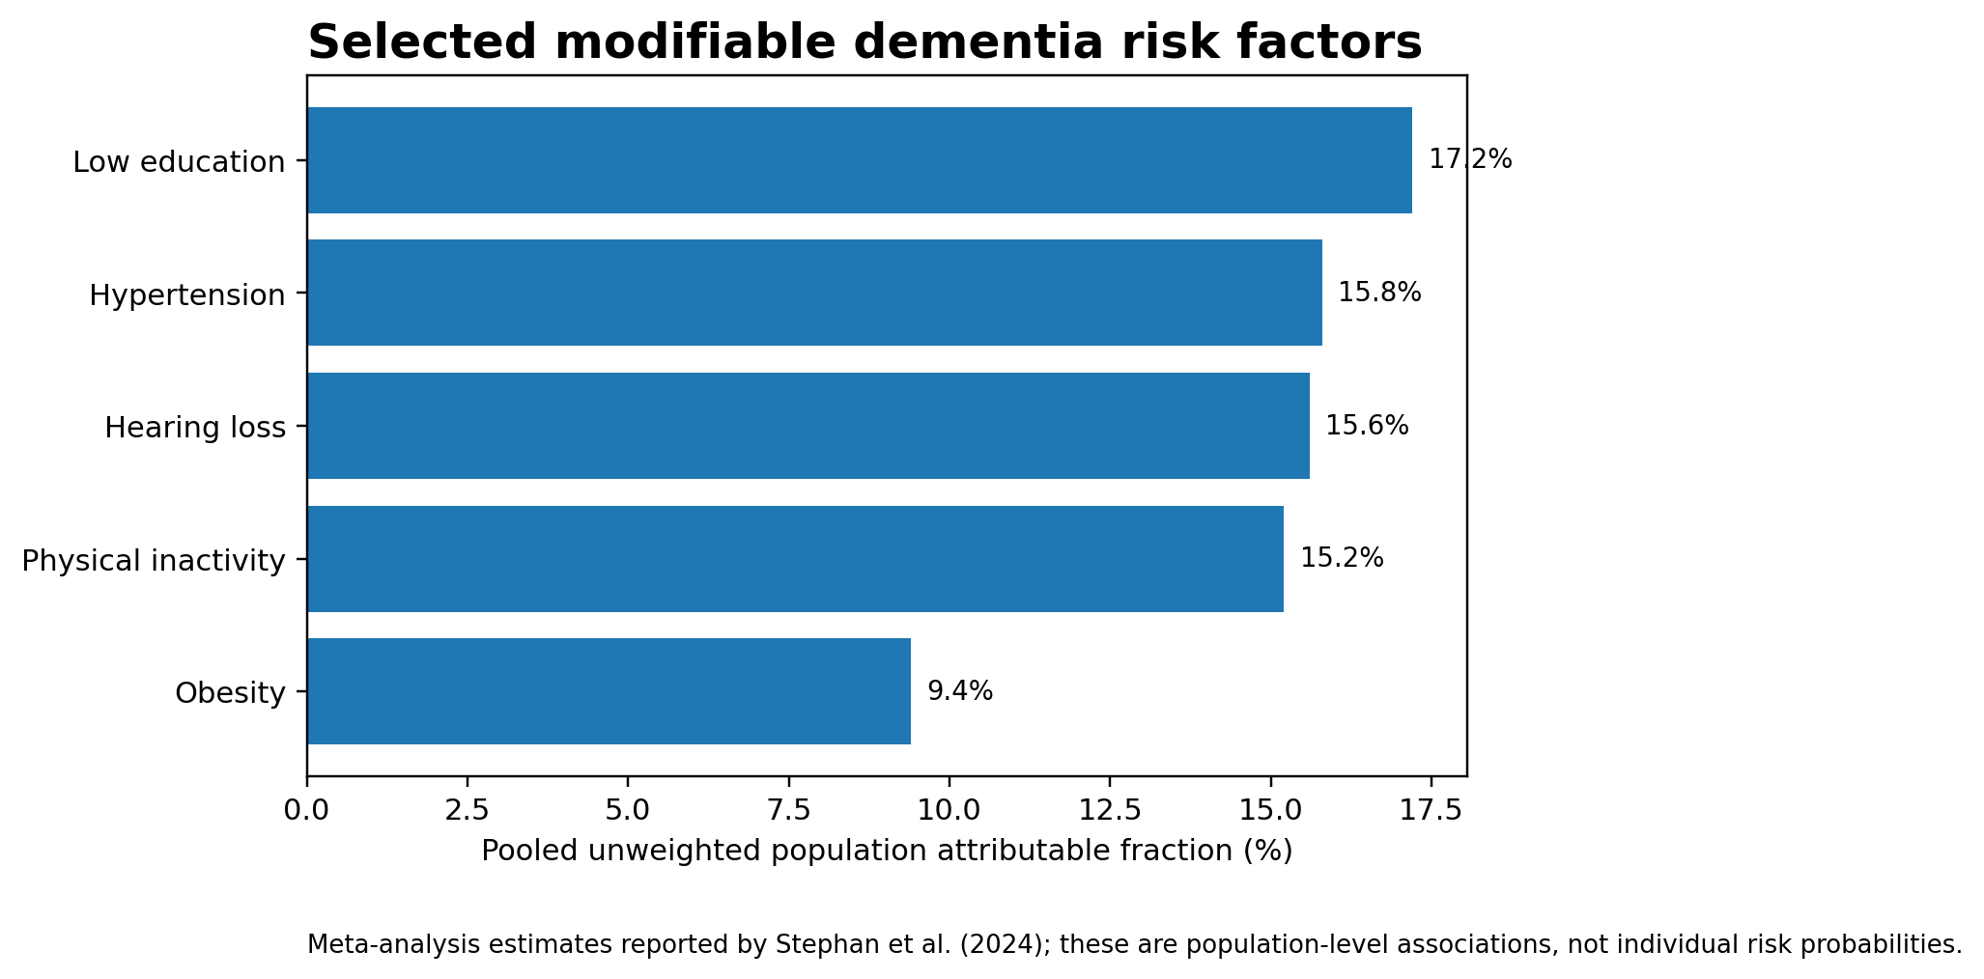
Modifiable risk factors for dementia investigated include Smoking, physical inactivity, diet, obesity, alcohol use and sleep. Chen et al. (2023) studied age- and sex-specific modifiable risk factor profiles in United Kingdom-based population using UK biobank data and also put forth the findings of associations between dementia and various health and lifestyle related factors. In addition NICE (2015) recommends population interventions that promote not smoking, exercise, healthier foods, limited alcohol consumption and maintain healthy weight.
Figure 2: The pooled unweighted population attributable fractions for the modifiable risk factors for dementia (Stephan et al., 2024).

Lifestyle factors may also have different interactions with socioeconomic factors, such as education and access to health-related resources. These factors are highly significant in considering the gender differences, given that patterns of exposure and the social circumstances may vary (Chen et al., 2023; NICE, 2015).

Hormonal Risk Factors

Hormonal factors are important to consider when discussing sex differences in dementia. Menopause causes a sharp decline in endogenous oestrogen exposure in women. In men, free testosterone tends to decline with age rather than abruptly. Hogervorst, Temple and O‘Donnell (2023) outline the sex differences in dementia and suggest how sex steroid hormones may influence brain aging, with the evidence from hormone treatment studies being inconclusive.

UK Biobank research has investigated associations between earlier menopause and dementia risk (Hao et al., 2023) and associations between lifetime oestrogen exposure and dementia (Park, Marston and Mukadam, 2024). Other UK Biobank research has looked at associations between lower concentrations of testosterone in men and higher dementia incidence (Marriott et al., 2022). These are important findings but observational evidence such as this must be interpreted with caution as there may be an influence from reproductive history, comorbidities, treatment decisions etc.

Literature Gap

Overall, there is literature to support links between dementia and hormone, cardiovascular and lifestyle factors, however the evidence is not as equally developed across both sexes. This review will draw together UK evidence, and compare whether associations are different between women and men (Hogervorst, Temple and O‘Donnell, 2023;Chen et al., 2023).

Research Aim, Objectives and Question

Research Question
What cardiovascular, lifestyle and hormonal factors may increase the risk of dementia among adults aged 65 years and older in the UK, and how might these risk factors differ between men and women?

Aim
To explore and bring together existing evidence on cardiovascular, lifestyle and hormonal risk factors linked to dementia among adults aged 65 years and older in the UK, with a focus on understanding how these factors may differ between men and women.

Objectives
- To identify the main cardiovascular, lifestyle and hormonal risk factors associated with dementia in UK adults aged 65 years and over.
- To examine the evidence regarding the associations between these risk factors and dementia in older adults in the UK.
- To compare the reported associations between these risk factors and dementia in men and women, including differences in the strength or pattern of associations where evidence permits.
- To consider the implications of sex-specific dementia risk factors for individual-level risk reduction and public health and social care practice in the UK.

Methodology

Research Design

This study will use the secondary research design of a systematic literature review. It will gather and appraise published evidence on cardiovascular, lifestyle and hormonal risk factors for dementia in UK adult aged 65 years and older, considering the impact of sex differences. The review will consist of systematic search, screening, selection of relevant articles, appraisal of study quality and synthesis (Page et al., 2021).

PRISMA 2020 will ensure transparent and complete reporting of the review. The guideline offers direction on the reporting of the identification, selection, appraisal and synthesis of the studies and offers a new flow diagram and checklist of 27 items (Page et al., 2021).

Question Framework: PICO
The ‘PICO’ framework will be applied to develop the research question. As this review will be exploring risk-factor prevalence rather than a clinical treatment, the ‘Intervention’ will be defined as exposure to the cardiovascular, lifestyle and hormonal risk factors being investigated. The ‘Comparison’ will be described as lower or absent levels of exposure. This allows for a well-defined comparison group while maintaining consistency with the research question and approved ethics form.
PICO element | Description
Population (P) | Adults aged 65 years and older in the UK.
Intervention/Exposure (I) | Exposure to cardiovascular, lifestyle and hormonal risk factors.
Comparison (C) | Lower or absent exposure to the identified risk factors.
Outcome (O) | Dementia or related cognitive outcomes, including all-cause dementia, Alzheimer’s disease and vascular dementia.
Table 1: PICO Framework (Source: Self-created)

Search Strategy

Search strategy. A search strategy will be devised prior to the commencement of the search. Key words will include: dementia, aging, sex differences, cardiovascular risk factors, lifestyle factors and hormonal factors. These key words will be used in conjunction with each other with the use of Boolean operators such as and and or. Database specific subject headings will also be utilized where available. The search strategy will be recorded allowing reporting the number of records identified, screened, rejected and included (Rethlefsen et al., 2021).

Databases to be Used
A scoping literature search will be carried out using PubMed/MEDLINE, CINAHL and Google Scholar/Scopus as outlined in the approved ethics proposal, and by reference list checking of identified relevant papers. The four latter sources should encompass medical, nursing, public health and social care research as well as multi-disciplinary studies.
Keywords

Main words used will be ‘dementia’, ‘Alzheimer‘s disease’, ‘older people’ and ‘aged 65 years and over’. Other words used will be men, women, ‘sex differences’, ‘sex-specific’, ‘cardiovascular risk factors’, ‘hypertension’, ‘diabetes’, ’ cholesterol’, lifestyle, ‘smoking’, ‘alcohol’, ‘physical activity’, ‘diet’, ‘hormonal factors’, ‘menopause’, ‘oestrogen’, ‘testosterone’ and ‘hormone replacement therapy’.

Inclusion and Exclusion Criteria
Criteria | Inclusion | Exclusion
Population | UK adults aged 65 years and older. | Studies not focused on the UK or without relevant older-adult data.
Exposure | At least one cardiovascular, lifestyle or hormonal risk factor. | Studies unrelated to the three risk-factor areas.
Outcome | Dementia or related cognitive outcome. | Studies focused only on treatment or management.
Publication | Peer-reviewed research studies, in English. | Conference abstracts without sufficient data, editorials, opinion articles and dissertations.
Date | Studies within the final protocol search period. | Studies outside the final protocol period.
Table 2: Inclusion and Exclusion Criteria (Source: Self-created)

Study Screening and Selection

Records will be imported into reference-management software and eliminated duplicates. Titles and abstracts will then be screened to determine if they meet inclusion criteria. Full-text articles will then be evaluated for inclusion. The search strategy will be presented using a PRISMA 2020 flow diagram showing the number of records identified, screened, excluded and included (Page et al., 2021).

Number of Articles to be Selected

The number of studies inthe reviewwill include around 20–30 that fit the inclusion criteria and contain relevant evidence to address the question. This is not a random choice but the final number will be determined by outcomes of the search and screening.

Data Extraction
For all of the studies included in the review, a typical data-extraction table will be completed. Details will include author and year, design of study, subject characteristics of the UK study population, sample size, age range, sex, cardiovascular/lifestyle/hormonal risk factor, dementia outcome, main results, association measures where available, major limitations and risk of bias. Employing the same approach will facilitate comparison across studies (Page et al., 2021).

Data Synthesis and Analysis
Narrative synthesis will be used as the main method of evidence synthesis as the anticipated heterogeneity of included studies across population, risk factors, study design and dementia outcome. The results will be subsumed into categories of cardiovascular risk factors, lifestyle and hormonal factors. Within these categories comparisons between men and women will be described. Any quantitative data including odds ratios, risk ratios and hazard ratios will also be described. Meta-analyses may be used if allowed by study homogeneity (Page et al., 2021).Critical Appraisal and Risk of Bias
The quality and risk of bias of the included studies will be appraised with the JBI critical appraisal tools suitable to each study design. Cohort and analytical cross-sectional study designs will then be the assessed with the appropriate checklists. Where assessment is performed, this will be taken into account when synthesis and interpreting evidence, so not all studies are assumed to be equally methodologically sound (Barker et al., 2025).

Ethical Considerations
This systematic review will be based on existing published secondary evidence and as such will not require participant recruitment, interviews, questionnaires or collection of individually identifiable personal information. The conduct of research and data management will adhere to the UWTSD Research Ethics and Integrity Code of Practice and the appropriate Data Management Policy and Procedures. All sources will be referenced and the findings will be published truthfully with no fabrication, falsification or data dredging.
.

Limitations
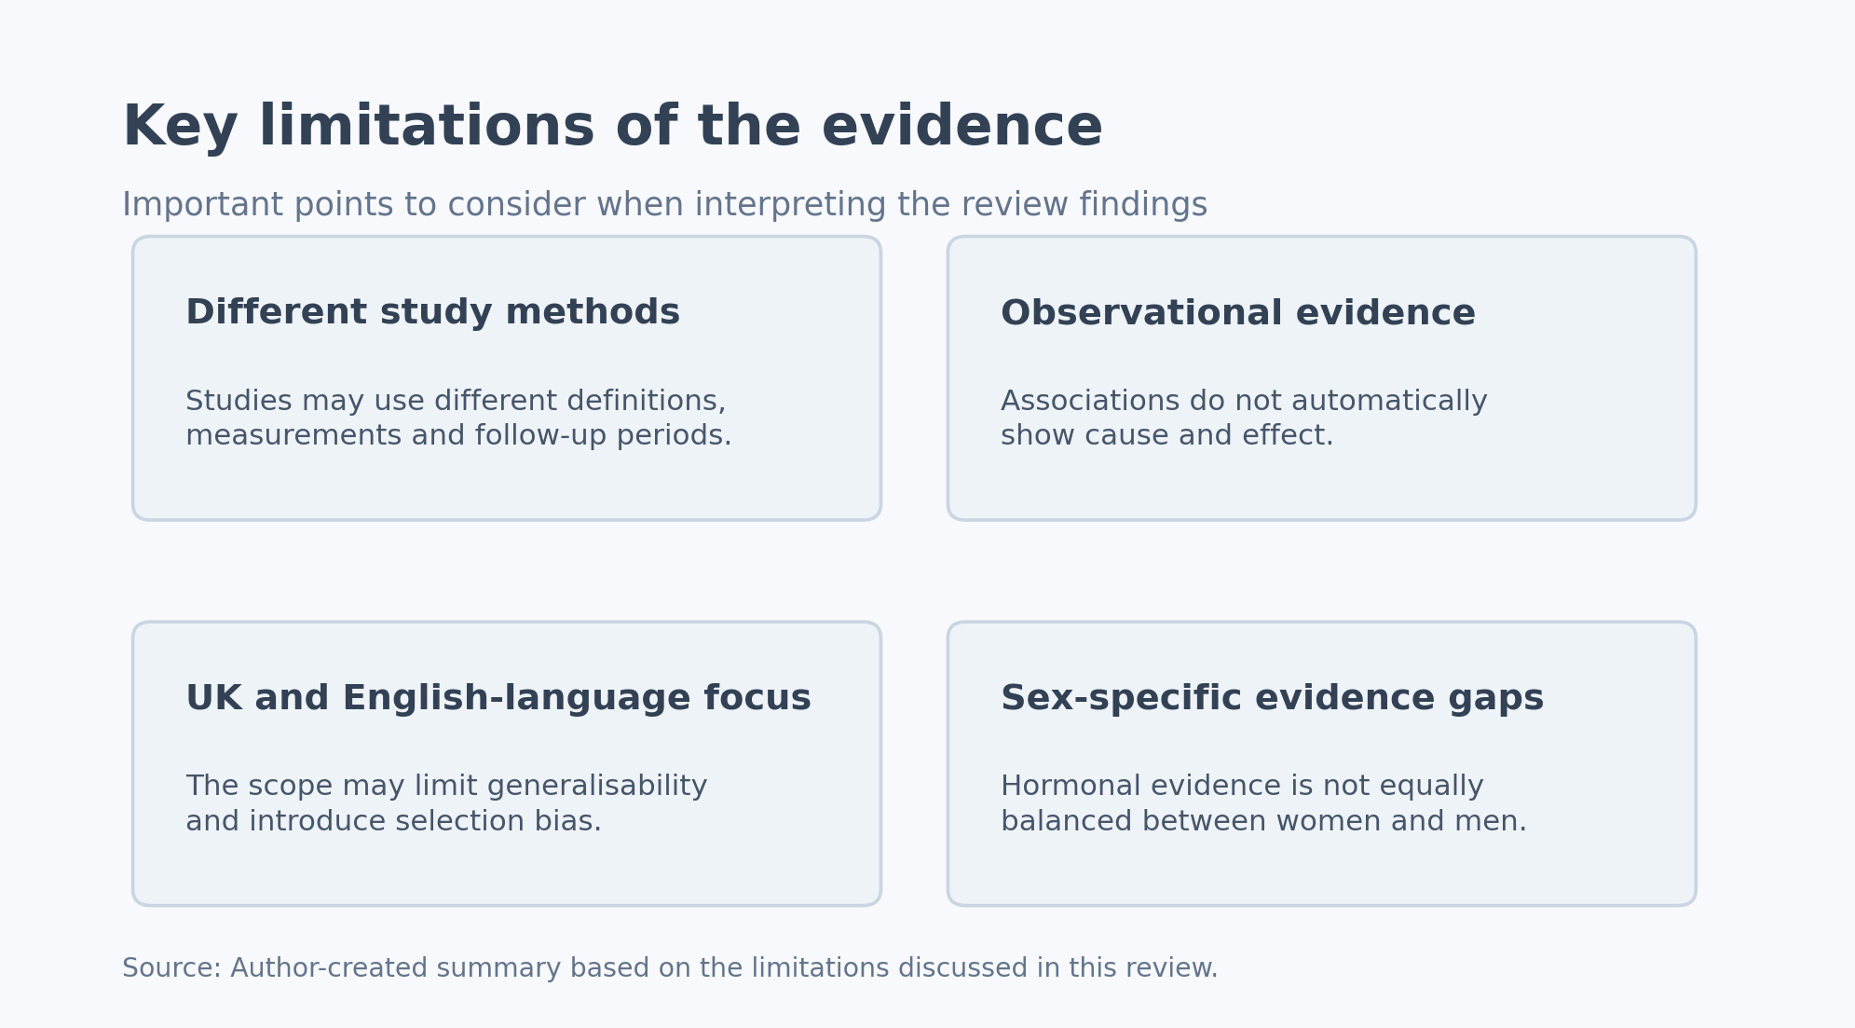
Figure 3: Critical limitations that inhibit the interpretation of the evidence (adapted from Bransby et al., 2024; Hogervorst, Temple and O’Donnell, 2023).

Variations across studies in the definition of dementia, risk factors, measures of exposures and duration of follow-up can pose challenges in drawing comparisons. The preponderance of evidence is likely to be observational and any associations found do not establish causal effects. Confounding variables like socioeconomic status, education level, comorbidities or healthcare utilization could bias the results. The evidence on hormones may be less equitable across women and men (Bransby et al., 2024; Hogervorst, Temple and O’Donnell, 2023). These constraints will be addressed when evaluating the end synthesis.

Timeline and Expected Contribution

It is estimated that the review will take around 8 weeks to complete. In week 1, the research question, PICO statement and search strategy and eligibility criteria will be finalised. Weeks 2–3 will involve database searching, duplication removal and screening of titles/abstracts. Weeks 4–5 will involve full text screening and critical appraisal. Week 6 will be used to extract data. Week 7 will be used to prepare a narrative (descriptive) and thematic synthesis of the findings, as well as to compare the results identified in men and women. Week 8 will be used for the final writing, editing and submission.

The review should synthesize evidence on cardiovascular, lifestyle and hormonal risk factors for dementia in the older UK population and identify sex differences. The results might contribute to causal explanations and contextualise the applicability to the UK of excess risk identified elsewhere. An update publication may be a useful platform to highlight topical areas for future UK public health and social care research (Livingston et al., 2024; NICE, 2015).

References
- Alzheimer’s Society (2026) ‘Risk factors for dementia’. Available at: https://www.alzheimers.org.uk/about-dementia/managing-the-risk-of-dementia/risk-factors-for-dementia (Accessed: 18 August 2026).

- Barker, T.H., Hasanoff, S., Aromataris, E., Stone, J.C., Leonardi-Bee, J., Sears, K. et al. (2025) ‘The revised JBI critical appraisal tool for the assessment of risk of bias for cohort studies’, JBI Evidence Synthesis, 23(3), pp. 441–453. doi:10.11124/JBIES-24-00103. Available at: https://doi.org/10.11124/JBIES-24-00103 (Accessed: 18 August 2026).

- Berezuk, C., Khan, M., Callahan, B.L., Ramirez, J., Black, S.E. and Zakzanis, K.K. (2023) ‘Sex differences in risk factors that predict progression from mild cognitive impairment to Alzheimer’s dementia’, Journal of the International Neuropsychological Society, 29(4), pp. 360–368. doi:10.1017/S1355617722000297. Available at: https://doi.org/10.1017/S1355617722000297 (Accessed: 18 August 2026).

- Brain, J., Greene, L., Tang, E.Y.H., Louise, J., Salter, A., Beach, S. et al. (2023) ‘Cardiovascular disease, associated risk factors, and risk of dementia: an umbrella review of meta-analyses’, Frontiers in Epidemiology, 3, 1095236. doi:10.3389/fepid.2023.1095236. Available at: https://doi.org/10.3389/fepid.2023.1095236 (Accessed: 18 August 2026).

- Bransby, L., Rosenich, E., Maruff, P. and Lim, Y.Y. (2024) ‘How Modifiable Are Modifiable Dementia Risk Factors? A Framework for Considering the Modifiability of Dementia Risk Factors’, Journal of Prevention of Alzheimer’s Disease, 11(1), pp. 22–37. doi:10.14283/jpad.2023.119. Available at: https://doi.org/10.14283/jpad.2023.119 (Accessed: 18 August 2026).

- Chen, H., Cao, Y., Ma, Y., Xu, W., Zong, G. and Yuan, C. (2023) ‘Age- and sex-specific modifiable risk factor profiles of dementia: evidence from the UK Biobank’, European Journal of Epidemiology. doi:10.1007/s10654-022-00952-8. Available at: https://doi.org/10.1007/s10654-022-00952-8 (Accessed: 18 August 2026).

- Dong, C., Zhou, C., Fu, C., Hao, W., Ozaki, A., Shrestha, N. et al. (2022) ‘Sex differences in the association between cardiovascular diseases and dementia subtypes: a prospective analysis of 464,616 UK Biobank participants’, Biology of Sex Differences, 13, 21. doi:10.1186/s13293-022-00431-5. Available at: https://doi.org/10.1186/s13293-022-00431-5 (Accessed: 18 August 2026).

- Filler, J., Georgakis, M.K. and Dichgans, M. (2024) ‘Risk factors for cognitive impairment and dementia after stroke: a systematic review and meta-analysis’, The Lancet Healthy Longevity, 5(1), pp. e31–e44. doi:10.1016/S2666-7568(23)00217-9. Available at: https://doi.org/10.1016/S2666-7568(23)00217-9 (Accessed: 18 August 2026).

- Gong, J., Harris, K., Peters, S.A.E. and Woodward, M. (2021) ‘Sex differences in the association between major cardiovascular risk factors in midlife and dementia: a cohort study using data from the UK Biobank’, BMC Medicine, 19, 110. doi:10.1186/s12916-021-01980-z. Available at: https://doi.org/10.1186/s12916-021-01980-z (Accessed: 18 August 2026).

- Hao, W., Fu, C., Dong, C., Zhou, C., Sun, H., Xie, Z. et al. (2023) ‘Age at menopause and all-cause and cause-specific dementia: a prospective analysis of the UK Biobank cohort’, Human Reproduction, 38(9), pp. 1746–1754. doi:10.1093/humrep/dead130. Available at: https://doi.org/10.1093/humrep/dead130 (Accessed: 18 August 2026).

- Hogervorst, E., Temple, S. and O’Donnell, E. (2023) ‘Sex Differences in Dementia’, Current Topics in Behavioral Neurosciences, 62, pp. 309–331. doi:10.1007/7854_2022_408. Available at: https://doi.org/10.1007/7854_2022_408 (Accessed: 18 August 2026).

- Jia, R., Wang, Q., Huang, H., Yang, Y., Chung, Y.F. and Liang, T. (2023) ‘Cardiovascular disease risk models and dementia or cognitive decline: a systematic review’, Frontiers in Aging Neuroscience, 15, 1257367. doi:10.3389/fnagi.2023.1257367. Available at: https://doi.org/10.3389/fnagi.2023.1257367 (Accessed: 18 August 2026).

- Jones, A., Ali, M.U., Kenny, M., Mayhew, A., Mokashi, V., He, H. et al. (2024) ‘Potentially Modifiable Risk Factors for Dementia and Mild Cognitive Impairment: An Umbrella Review and Meta-Analysis’, Dementia and Geriatric Cognitive Disorders, 53(2), pp. 91–106. doi:10.1159/000536643. Available at: https://doi.org/10.1159/000536643 (Accessed: 18 August 2026).

- Kuate Defo, A., Bakula, V., Pisaturo, A., Labos, C., Wing, S.S. and Daskalopoulou, S.S. (2024) ‘Diabetes, antidiabetic medications and risk of dementia: A systematic umbrella review and meta-analysis’, Diabetes, Obesity and Metabolism, 26(2), pp. 441–462. doi:10.1111/dom.15331. Available at: https://doi.org/10.1111/dom.15331 (Accessed: 18 August 2026).

- Livingston, G., Huntley, J., Liu, K.Y., Costafreda, S.G., Selbæk, G., Alladi, S. et al. (2024) ‘Dementia prevention, intervention, and care: 2024 report of the Lancet standing Commission’, The Lancet, 404(10452), pp. 572–628. doi:10.1016/S0140-6736(24)01296-0. Available at: https://doi.org/10.1016/S0140-6736(24)01296-0 (Accessed: 18 August 2026).

- Marriott, R.J., Murray, K., Flicker, L., Hankey, G.J., Matsumoto, A.M., Dwivedi, G. et al. (2022) ‘Lower serum testosterone concentrations are associated with a higher incidence of dementia in men: The UK Biobank prospective cohort study’, Alzheimer’s & Dementia, 18(10), pp. 1907–1918. doi:10.1002/alz.12529. Available at: https://doi.org/10.1002/alz.12529 (Accessed: 18 August 2026).

- NICE (2015) Dementia, disability and frailty in later life – mid-life approaches to delay or prevent onset (NG16). Available at: https://www.nice.org.uk/guidance/ng16. Available at: https://www.nice.org.uk/guidance/ng16 (Accessed: 18 August 2026).

- Page, M.J., McKenzie, J.E., Bossuyt, P.M., Boutron, I., Hoffmann, T.C., Mulrow, C.D. et al. (2021) ‘The PRISMA 2020 statement: an updated guideline for reporting systematic reviews’, BMJ, 372, n71. doi:10.1136/bmj.n71. Available at: https://doi.org/10.1136/bmj.n71 (Accessed: 18 August 2026).

- Park, H.K., Marston, L. and Mukadam, N. (2024) ‘The Effects of Estrogen on the Risk of Developing Dementia: A Cohort Study Using the UK Biobank Data’, The American Journal of Geriatric Psychiatry, 32(7), pp. 792–805. doi:10.1016/j.jagp.2024.01.025. Available at: https://doi.org/10.1016/j.jagp.2024.01.025 (Accessed: 18 August 2026).

- Rethlefsen, M.L., Kirtley, S., Waffenschmidt, S., Ayala, A.P., Moher, D., Page, M.J. et al. (2021) ‘PRISMA-S: an extension to the PRISMA statement for reporting literature searches in systematic reviews’, Journal of the Medical Library Association, 109(2), pp. 174–200. doi:10.5195/jmla.2021.962. Available at: https://doi.org/10.5195/jmla.2021.962 (Accessed: 18 August 2026).

- Stephan, B.C.M., Cochrane, L., Kafadar, A.H., Brain, J., Burton, E., Myers, B. et al. (2024) ‘Population attributable fractions of modifiable risk factors for dementia: a systematic review and meta-analysis’, The Lancet Healthy Longevity, 5(6), pp. e406–e421. doi:10.1016/S2666-7568(24)00061-8. Available at: https://doi.org/10.1016/S2666-7568(24)00061-8 (Accessed: 18 August 2026).

- UK Health Security Agency (2025) ‘Dementia profile: prevalence and supporting well topics statistical commentary, March 2025’. Available at: https://www.gov.uk/government/statistics/dementia-profile-march-2025-update/dementia-profile-prevalence-and-supporting-well-topics-statistical-commentary-march-2025. Available at: https://www.gov.uk/government/statistics/dementia-profile-march-2025-update/dementia-profile-prevalence-and-supporting-well-topics-statistical-commentary-march-2025 (Accessed: 18 August 2026).

- Zhang, X., Li, Q., Cong, W., Mu, S., Zhan, R., Zhong, S. et al. (2023) ‘Effect of physical activity on risk of Alzheimer’s disease: a systematic review and meta-analysis of twenty-nine prospective cohort studies’, Ageing Research Reviews, 92, 102127. doi:10.1016/j.arr.2023.102127. Available at: https://doi.org/10.1016/j.arr.2023.102127 (Accessed: 18 August 2026).

