
APPENDIX GA36b

LEVEL 5 ASSESSMENT SPECIFICATION

Student name: | Alex Gregory | Student ID number: | 1910666
Programme: | PCDA
Module: | Operational Policing Practice 2
Module code: | BMPP5002D | Contribution to Overall Module Assessment (%): | 50%
 |  | Internal Verifier:
Assignment Title: | Assignment 2 | Word count (or equivalent): | 4000 Words
Submission deadline: | 11th January 2021 | Return date of provisional marks & written feedback: | 20 working days
Submission method: | All written assessments, where practical and possible, must be submitted via Turnitin unless otherwise instructed by the Lecturer. (Please DO NOT put this assessment specification into Turnitin or it will match many similarities with other students’ submissions.)  Late submission of the assessment will result in a late penalty mark. Penalties for late submission: Up to one week late, maximum mark of 40%. Over one week late, 0%. Only the Extenuating Circumstances Panel may approve a change to submission dates.
Academic honesty / referencing: | Academic honesty is required. In the main body of your submission you must give credit to authors on whose research and ideas your work is based. Append to your submission a reference list that indicates the books, articles, etc. that you have used, cited or quoted in order to complete this assessment.
Module Learning Outcomes
(from module syllabus)
Criminology
- Critically review the constitutional role of the police in contemporary society and the wider criminal justice system
- Assess the strengths and weakness of different policing models in relation to crime/victimisation and the public and explore crime prevention theories initiates and strategies
- Evaluate the benefits that a greater understanding of sociology and criminology can have on operational policing and decision making
Counter Terrorism
- Explain the organisational structures and inter-relationships that exist in counter-terrorism policing and the current threats faced by the UK CT network
- Analyse the potential links between terrorism and other forms of criminality
Response Policing
- Illustrate how theories and principles of psychology and human behaviour can be applied in various response contexts
- Critically review key issues relating to the complexity and challenges of operational policing
- Undertake the role and responsibilities of a first responder to a critical incident
- Review examples of high-profile critical and major incidents and analyse the role of the police within a joint emergency services operation to establish ‘best practice’

Policing Communities
- Analyse why key incidents/events have had a damaging effect on the willingness of communities to engage with the police
- Engage with the community to examine/critique how current policing practice can impact upon the community
- Evaluate the role of community policing in fostering and maintaining community cohesion and understand and apply key principles of effective community engagement
Policing the Roads
- Apply police powers in relation to commercial vehicle enforcement
- Explain how to police the strategic road network effectively and safely
- Explain roles and responsibilities of personnel involved in police pursuits, and the types of vehicle
Information & Intel
- Explain and employ analytical products provided by intelligence specialists during the course of an investigation
Conducting Investigations
- Understand the difference between 'volume and priority' crime
- Understand the importance of the concept of memory upon interview methods and process

TASK DESCRIPTION

Students are required to complete a 1000-word essay under each of the following titles:
Title 1: Analyse why key incidents/events have had a damaging effect on the willingness of communities to engage with the police. Evaluate the role of community policing in fostering and maintaining community cohesion and understand and apply key principles of effective community engagement

What is community engagement?
Community engagement is based on the idea that everyone affected by an issue impacting their community, should have a say into the decisions making around it. Public participation can influence decisions that affect the provision of policing services and their aspirations for the future and in relation to local community policing issues, it is critical that the community feels they have an understanding as to the reasons why policing decisions are made, as well as the power to have an influence over strategy. (Hussey, 2021)
It has been observed that without the support of the communities that it serves, the police service would not function. This can be seen as linking directly into the core principles of policing in this country of “Policing by consent”
Benefits of effective community engagement include the following:
- Increased public confidence in the police.
- Fair decision making and positive public interaction develops trust in the police service.
- Improved public perceptions of safety
- Reductions in disorder and anti-social behaviour
- Police officer job satisfaction
Community engagement can come in many forms outside of policing, and can include organized groups, agencies, institutions, or individuals working with a community. There are a number of models that can be applied to community engagement but all involve collaboration, engagement and a shared approach to decision making and understanding.
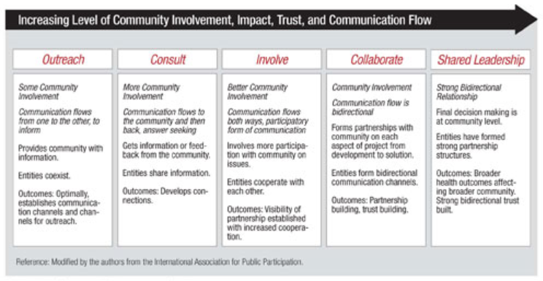
(ATSDR, 2021)

Essential elements for effective community policing:

(Adapted from College of policing, 2021)
Events that have had a damaging effect on community engagement with police?
Throughout the history of modern policing there have been numerous events which can be seen to have had a detrimental or damaging effect on community engagement. From the historical underpinnings of the police from local “Watchmen” which operated up to the 1830’s, through to local visible “Police Beat” foot patrols, communities were essentially more closely policing themselves with a visible presence of local officers on the streets. With the advent of the motorisation of beat policing in 1960’s, this took the police away from their neighbourhoods and with less neighbourhood visibility a reactive crime control approach was developed in the 1980’s and 1990’s where police would predominantly only respond to calls from service from the public, for crime that had already been committed or was in progress, rather than proactively helping to prevent crime and disorder. In this model, the public were expected to be the eyes and ears of policing but beyond that there was no actual engagement with the public as to what could be done to tackle the root cause of issues. This lack of engagement became particularly prevalent within ethnic minority groups
One of the most damaging events on community engagement within policing in the 20th century was of course the Brixton riots. The specific targeting of young black males for stop and search activity as part of “Operation Swamp” in early April 1981, was an attempt to cut street crime in Brixton utilizing more that 1000 stop searches in six days and this resulted in a backlash from the 25% ethnic minority community and led to subsequent attacks on the police. This incident led to an increased divide between the community and the police, with tensions in the area still visible today with a general lack of trust towards the police from people of black, Asian and minority ethnic backgrounds.
Wherever the community is excluded or is without a voice, they will naturally feel naturally excluded from the discussions around the issues within their locality. Inclusivity, openness, fair representation and collaboration are all key to bringing the community into the fray to understand their needs, their issues and their expectations.
How to engage with communities?
There are a number of community engagement models and strategies. Arnstein’s model shows that the lower rungs of the ladder (shown below) do not deliver genuine community engagement and participation. An example of this is where a public meeting is held, to ‘manipulate’ community opinion perhaps by disseminating false information or false promises. Alternatively, the perspective might be that the community will agree with this if only they can see the benefits. In this example, the purpose of the meeting is ‘manipulation’ rather than engagement. The further you move up the ladder the more engaging the approaches become. (regenwales.org, 2021)
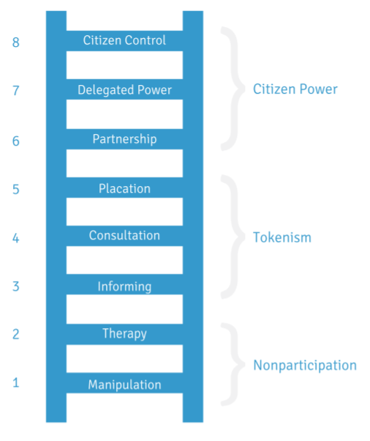
Arnstein (1969)
Impacts of poor engagement?
There are a number of negative impacts from poor community engagement, including a loss of public confidence in the police, loss of legitimacy, strategic difficulties whereby the police cannot adapt to changing needs through lack of understanding of community specific issues, increased vulnerability, further dissent and disorder from disenfranchised members of the public and an unrealistic expectation of what the police service can deliver.
What is Community Cohesion?
Community Cohesion is what needs to happen in communities to enable diverse groups of people to get on with each-other. A level of Integration is needed, to enable new residents and existing residents to adapt to one another. This is key to successful Community Cohesion. It enables a sense of belonging, to a place, to a group, to a community. It helps people get on together in their local area, which in turn helps people feel safer and more secure in their neighbourhoods. This makes people feel better about the circumstances in which they live, increases their positive feelings towards other people and the statutory services which serve them, and, above all, their general feelings of happiness and well-being. A cohesive community can also help to tackle violent extremism. A community where people have increased contact, relationships and understanding with others is less likely to have extremist views. (NPIA, 2021).
For Community Cohesion to work, It is vital that police teams and other agencies win the trust of the public. As discussed above, certain communities may inherently mistrust the police and it is important that this is recognised and openly addressed in the community response. Neighbourhood policing teams are central to this strategy and visible and active engagement between these teams and community leaders and organisations will drive understanding and expel myths and negative beliefs if done correctly. This in turn would bring trust and a more effective relationship.
Benefits of Community Cohesion:

Key principles of community cohesion?
The Centre for Trust, Peace and Social Relations (CTPSR) identifies that there are six key facets of community cohesion:

A community can be seen as having cohesion if all of the above conditions are met.

(1064 Words)
Title 2: Assess the strengths and weakness of different policing models in relation to crime/victimisation and the public and explore crime prevention theories initiates and strategies. Explain and employ analytical products provided by intelligence specialists during an investigation
Policing in England and Wales:
The term “British model of policing” is sometimes used to describe policing culture in England and Wales. There is no formal definition of the model, but it is the foundation by which they function and it consists of three core concepts:
- The Office of Constable:
Police officers (no matter their rank) each individually hold the Office of Constable. The Office of Constable grants them powers to detect, prevent and investigate crime.
- Operational independence:
Those who work in police forces are under the “direction and control” of their chief constable. 7 Chief constables across England and Wales are independently responsible for all operational matters concerning their force.
- Policing by consent:
The concept of ‘policing by consent’ is derived from the nine ‘general instructions’ given to the first officers of the Metropolitan Police Service (MPS) in 1829. These instructions, known more commonly as the “Peelian Principles of Policing”, named after Sir Robert Peel, assert that police lose their authority when they lose the consent of the public. The public’s consent is maintained “not by pandering to public opinion” but by applying the law fairly, impartially and through as minimal force as is practicable.
(Commonslibrary.parliment.uk, 2021)
Policing is one of the most critical functions undertaken by government, with the police ensuring the maintenance of law and order and acting as the first link in the criminal justice system (Varghese, 2010). Below are some examples of policing models that are adopted by police forces around the world. These individual models can be used in conjunction with each other, in order to achieve a specific policing purpose or goal. They are all models and as such will not always definitively resolve a problem but rather provide a mechanism to help inform a strategic direction for decision makers with each having its own strengths and weaknesses.

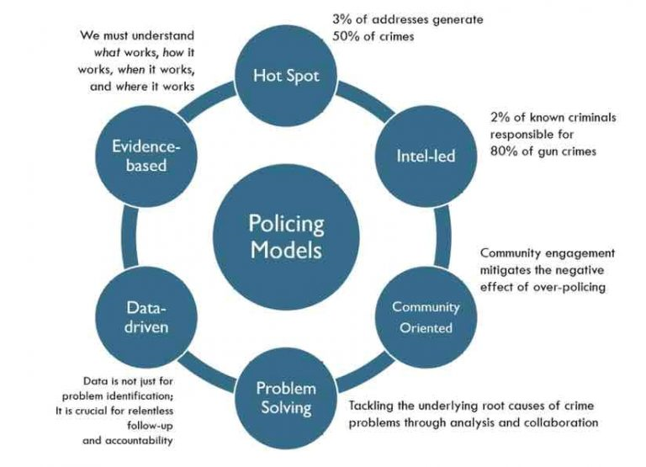
Modern policing models (Beck, 2019).
Criminology and Policing theory:
Criminology is more than just looking at criminal behaviour. It analyses how crime affects victims and wider society. Criminology considers various theories and ideas around how and why crimes occur and looks at ways to control and prevent criminal behaviour, in addition to the way law enforcement operates, and the mechanism of the criminal justice system. It is considered a branch of sociology and draws on aspects of psychology and social anthropology, taking a scientific approach to understanding crime and criminal behaviour. (Oxbridge, 2021)
Below I will look at some other policing theories and discuss the strengths and weaknesses of each.
Problem-oriented policing (POP)
POP is an approach to tackling crime and disorder involving the identification of a specific problem, thorough analysis to understand it, the development of a tailored response and assessment of the effects of the response. The approach is to develop targeted interventions, rather than an intervention itself and therefore it can be applied to any crime and disorder problem. This can be described in the context of the SARA model of problem solving. The model assumes that by identifying and understanding the root causes of a problem or conditions that enable it to persist, the solution developed to tackle it will be effective. The SARA model employs four stages:

(College of policing, 2020)
Problem Analysis Triangle
The problem analysis triangle (sometimes referred to as the crime triangle) provides a way of thinking about recurring problems of crime and disorder. This idea assumes that crime or disorder results when (1) likely offenders and (2) suitable targets come together in (3) time and space, in the absence of capable guardians for that target. The model can be seen below:
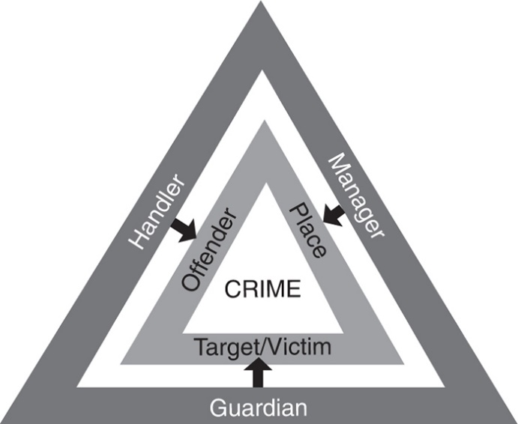
Center for Problem Oriented Policing. (2013)
The PAT triangle (above) is a relatively simplistic theory that was derived from the routine activity approach to explaining how and why crime occurs. In essence it observes that by removing any one of the three variables, that you can prevent crime from occurring, however what it does not do is look at the root causes as to why crime is occurring in the first place such as socio-economic factors or the offender profile behaviours.

Broken Windows Theory
The broken windows theory states that visible signs of disorder and misbehaviour in an environment encourage further disorder and misbehaviour, leading to serious crimes. In essence, a broken window becomes a physical symbol that the residents of a particular neighbourhood do not especially care about their environment and that low-level deviance is tolerated. The principle was developed to explain the decay of neighbourhoods (psychologytoday, 2021). Again, this is a simple theory designed to highlight the links between how an area looks to the likelihood of crime and disorder occurring, it does not look at the root cause of issues.
CPTED
Crime Prevention Through Environmental Design (CPTED), also known as Design Out Crime, is based on the fundamental idea that the proper design and management of the physical environment can deter crime in a specific area. It is based on 5 core CPTED principles:
Adapted from Crimeprevention.com, 2021
CPTED is a pro-active model where a physical environment is designed to utilise target hardening, making criminality more difficult, less rewarding or higher risk for an offender. It can reduce crime in areas where the environment is suitably designed used but does not prevent crime from happening elsewhere. This can be seen as simply moving a problem, for instance, into a neighbouring community and actually increase offending there. As discussed above, this does not address the root cause as to why people are choosing to offend.
Intelligence Products (NIM – National Intelligence Model)
NIM brakes Intelligence Products down into 5 core categories:
- Strategic Assessments
- Tactical Assessments
- Target Profiles
- Problem Profiles
- Proportionality
The data generated is used by analysts to inform strategic police decisions at command level
Conclusion:
All of the models and theories discussed above, tackle one or more different elements of why criminality may occur in a given environment but it can be observed that for each model, the deficiency lies in the understanding of the root cause as to why people are offending in the first place. The SARA model can be seen to get closest to the root cause of an issue through the intelligence and information led approach but in order for an intervention to be effective, these models would need to be supported by community engagement and with a collaborative community policing team. It is vital that best practice is shared both locally and nationally to establish the effectiveness of any intervention and this is provided by the College of Policing but it is also recognised that what works well in one area, may not in another.
(1095 Words)
Title 3: Critically review key issues relating to the complexity and challenges of operational policing, review examples of critical and major incidents and analyse the role of the police within a joint emergency services operation to establish ‘best practice’.

Operational policing in England and Wales is facing ever increasing challenges from the public and although 20,000 extra officers were promised by the UK government back in 2019, given the natural attrition over the 3-year recruitment period, this can be seen to fall well short of what is required, given this was roughly the number of officers cut by the conservative government around 2010. There is a growing fear of a return to a targeted metric-based approach with the government said to be expecting for a 20% reduction in serious and violent crime, in payback for this increased investment (Guardian, 2021)
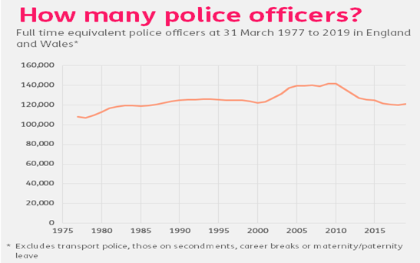
Adapted from fullfact.org, 2021
Despite a recorded 12% reduction in overall crime due to the pandemic, the trends are already showing this heading back towards pre-pandemic levels, where demand will likely increase further. (NPCC, 2021). Significant increases in online cybercrime are challenging, demanding additional resources and upskilling, all off the background of 10 years of austerity where the criminal justice system is creaking and expected to do more with less and in the shadow of the worldwide coronavirus pandemic.
Politics
Political ill-will towards the police continues to grow around the world. This was seen recently in the UK through the Sarah Everard vigil in London which was widely seen to have been politicised and fingers pointed at the police by the media and government without evidence, only for their actions to have been deemed appropriate through a later investigation (BBC, 2021), through to the George Floyd protests in America, fuelling the Black Lives Matter movement and creating further resentment from the public towards the police. This is not only damaging to the reputation of the police but results in difficult working conditions and affects legitimacy and wider compliance, resulting in further disorder.
Domestic violence
Domestic violence has been on the rise significantly during the pandemic, with The Crime Survey for England and Wales showing that 1.6 million women and 757,000 men had experienced domestic abuse between March 2019 and March 2020, with a 7% increase in recorded domestic abuse related crimes overall. Although there is limited official data so far on the impact of lockdown on domestic abuse, the Office for National Statistics (ONS) reports that in mid-May 2020, there was a 12% increase in DV related referrals to victim support and between April and June 2020, there was a 65% increase in calls to the National Domestic Abuse Helpline, when compared to the first three months of that year. (ONS, 2021). DV can often be associated with unemployment and alcohol use, both of which have seen increases due to the pandemic.
Online threats
Cybercrime is a growing threat that continues to rise in scale and complexity, affecting essential services, businesses and private individuals alike. Cyber crime costs the UK billions of pounds, threatens national security and increases the demands in policing the issues. Criminals seek to exploit human or security vulnerabilities in order to steal passwords, data or money directly. The most common cyber threats include:
The scale and complexity of cyber-attacks is wide ranging and 'Off the shelf' tools mean that less technically proficient criminals are now able to commit cyber-crime, and do so as awareness of the potential profits becomes more widespread. Evolving technical capabilities of malware means evolving harm as well as facilitating new crimes, such as the crypto-mining malware which attacks digital currencies like Bitcoin. (NCA, 2021)
Youth offending
Youth crime is a significant problem and some countries, including the US, take a negative view on high rates of youth incarceration. (Travis, 2014). It could be argued that custodial sentences act as an effective deterrent from engaging in criminal activity but recent research into the development of the juvenile brain, explains how criminal behaviour may naturally cease with age. This counter-productive dynamic of criminalisation at a young age is therefore a difficult issue to solve (mgh.harvard.edu). The UK for example has the growing issue with county lines drugs gangs and the utilisation of vulnerable people as a means for exporting narcotics around the country. This poses the question if they should be treated as criminals or victims.
Repeat offending
The UK suffers from high rates of reoffending vs other developed countries. Figures from the world population review, show that around 60% of released prisoners, go on to reoffend within a two-year period. This can be affected by numerous factors, such as the person’s circumstances before imprisonment, their social environment and community, events during their incarceration, and the difficulty adjusting back into everyday life. Many individuals released from prison may have difficulty finding jobs to support themselves and reconnecting with family members and this affects everyone: the offender, their family, the victim of the crime, the community and the Police who need to expend more resource in dealing with further offences (worldpopulationreview.com, 2021)
JESIP
The Joint Emergency Services Interoperability Programme was established in 2012 following a report by the Association of Chief Police Officers, Chief Fire Officers Association (National Resilience) and Association of Ambulance Chief Executives (AACE) submitted to the Home Secretary in April 2012.
It sets out 5 principles of joint working whereby incidents are managed collaboratively, and best practice is shared amongst the emergency services:
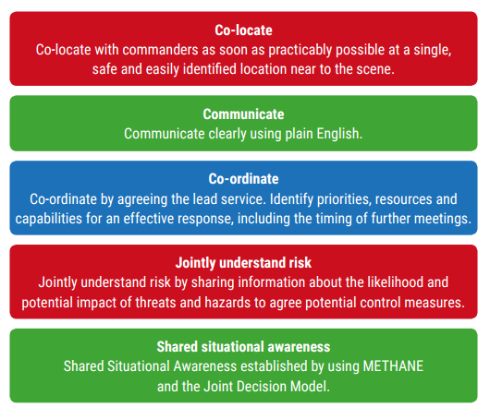
(ukfrs.com, 2021)

The mnemonic ‘METHANE’ is used to ensure accuracy of information is passed to command. This also provides the structure for first responders to share information with control room ensuring situational awareness

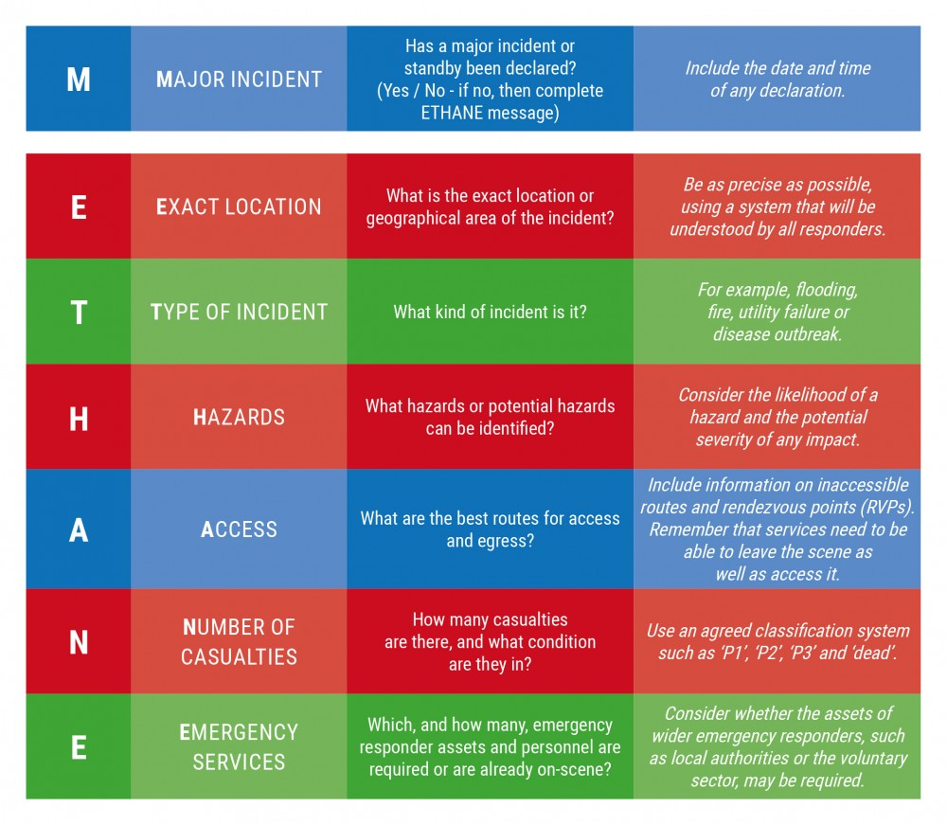
Methane (JESIP, 2021)

Major and Critical incidents
JESIP defines a major incident as, an event or situation with a range of serious consequences which requires special arrangements to be implemented by one or more emergency responder agency. The college of policing, defines a critical incident, as any incident where the effectiveness of the police response is likely to have a significant impact on the confidence of the victim, their family and/or the community (College of Policing, 2013).
As discussed earlier, one of the most recent critical incidents which had a negative impact on police and the public involved the vigil of Sarah Everard. The visuals of young women being dragged away by police led to a media frenzy and condemnation of the police by some politicians, however a subsequent review of actions by police by the HMICFRS, vindicated police and concluded that appropriate actions and force was taken. This highlights the importance of maintaining public confidence in policing and highlights the issues caused by the media in their negative attitudes towards policing.
An example of a Major incident would include the 7/7 bombings or the Manchester arena attack, involving high numbers of casualties and demanding a multi-agency attendance.
(1093 Words)
Title 4: Analyse the potential links between terrorism and other forms of criminality and discuss how policing the roads assist in counter terrorism investigation

The CPS defines terrorism as the use or threat of action, both in and outside of the UK, designed to influence a government organisation or to intimidate the public. It must also be for the purpose of advancing a political, religious, racial or ideological cause.
Examples include:

To commit a terrorism offence, a person does not need to commit, what could be a terrorist attack. The planning, assisting and collecting information on how to commit these acts are all considered crimes according to the CPS (CPS, 2021)
Organised crime and terrorism
Over the past 25 years, organized crime and terrorist organizations have developed closer working relationships, recognizing that they may accomplish more and achieve more success using the expertise and specializations of each other’s networks. Despite their often-dissimilar goals and/or cultural differences, varied criminal and terror groups are working together. Like corporate outsourcing, Transnational Organised Crime groups (TOCs) operate on an international scale, forging partnerships with other OCGs to leverage expertise. Involvement in the drug trade by the Taliban and the Revolutionary Armed Forces of Colombia (FARC) for example, is critical to the ability of these groups to fund terrorist activity.
There is evidence that there is a link between petty crime and terrorism, where individuals on the margins of society or in prison are most vulnerable to radicalisation. In other areas of the world, the relationship between organised crime and terrorism has evolved, to where it has become increasingly difficult to draw a distinction between the two. Activities of terrorists and organised criminals frequently reinforce each other, where terrorists engage either directly or indirectly in organised crime activities such as trafficking, smuggling, extortion, kidnapping for ransom and the illicit trade of natural resources, for financial and/or material benefits. Such benefits contribute to undermining state security, stability and social and economic development, which in turn may create or maintain the conditions for organised criminal groups to flourish. On the other side, organised crime groups may employ terrorist tactics, including the strategic use of violence, to enable their objectives. In designing an appropriate policy response, there is value to recognising that there is a strategic distinction to be made between those situations where causal and enabling conditions for organised crime and/or violent extremism converge and where monitoring and preventive action is possible, versus those situations where the relationship is already in place, and where situation specific approaches are required. (ICCT.NL)
Strategic Roads Network (SRN)
Securing roads and keeping them free from the threat of serious crime and terrorism, is the heart of the 2018-2021 NCC Roads Policing Strategy, alongside keeping roads safe, free from harm and running efficiently. (NPCC, 2018)
In England and Wales the Strategic Roads Network (SRN) is made up of motorways ‘trunk roads’ and a number of A roads. This network, covers approximately 25000 miles and is a conduit for the majority of road travel for 40 million+ vehicles. Amongst road users, there a minority utilising the network to commit organised and serious criminality, including OCG’s, County line gangs as well as human trafficking and child sexual exploitation, some of which can have links to funding international terrorism.
Roads Policing Units (RPU)
The RPU (Roads Policing Units) core role is to respond to traffic incidents, whilst also helping to detect and disrupt terrorism and serious criminality using the range of tools available. With roads policing accounting for only 4% of all officers, they must rely on technology, utilising it effectively and efficiently. There are approximately 1800 deaths per year with another 25,000 injuries on roads in England and Wales and with the added pressure of disrupting serious and organised crime, along PACTS recommendations an increase in numbers, it’s also recommended that Intelligence be enhanced and more widely shared with greater use of technology (pacts.co.uk, 2020)
Intelligence
The National Intelligence Model (NIM), acts as a framework from which to manage the roads policing priorities and it is an Intelligence-led policing approach (ILP). Utilizing this model, intelligence is gathered around a wide range of criminality including domestic incidents, arrests, criminal records, traffic stops, and OCG activity data, allowing the UK's law enforcement agencies, such as the Police and National Crime Agency (NCA) to collate and analysis this data and can assist in strategically targeting this groups or individuals involved.
Intelligence gathering is covered by a range of legislation including the following: Security Service Act 1989, the Intelligence Services Act 1994 (ISA), the Regulation of Investigatory Powers Act 2000 (RIPA) and the Investigatory Powers Act 2016 (College of policing, 2021) and the Intelligence

Sources that feed into NIM include:

The NCA (National Crime Agency) puts the number of organised crime groups operating in the UK at around 6,000 and by the end of 2015, the number of offenders had topped 50,000. The Organised Crime Group Map (OCGM), is a system used by local police forces and other agencies, to track and manage the response to known groups that are considered to be OCGs. This approach is possible through the intelligence led policing (NCA, 2021). When this intelligence is shared between agencies, it must always be proportionate and carried out in accordance with the principles of the Human Rights Act 1998 (Legistlation.co.uk, N.D)
Automatic Number Plate Recognition (ANPR)
ANPR is one of the most powerful tools in the technological arsenal of the police. ANPR (Automatic Number Plate Recognition), is a camera technology backed by sophisticated software, used for a very powerful policing purpose. ANPR automatically reads vehicle registration marks (VRMs) using a UK network of approximately 11,000 cameras placed across the SRN (police.uk, N.D) and compares it against a database. Once a vehicle has been identified through intelligence or other means as being suspicious is “pinged” on one of these cameras, Police and other crime agencies can then use this as a tactical option to disrupt, prevent and detect criminal activity by tracking the movements of the offending or suspicious vehicle.
As well as being accessed at centralised locations, ANPR terminals can provide real time data to roads policing vehicles, allowing them to proactively monitor the road as they drive. This information can inform the officer of any flagged offences and instigate a stop of the vehicle under Section 163 the Road Traffic Act 1988 (legistlation.gov.uk, N.D) again potentially disrupting potential criminal activity.

Benefits of ANPR (Adapted from College of Policing, 2020)

Conclusion
The tools, technology and systems discussed above, combine to make for a powerful weapon against criminality and terrorism. They help inform the strategic decisions made, where and how to deploy resource (including multi agency) and form the evidential backbone for a successful investigation into combatting this type of activity.
(1100 Words)

Bibliography

- ASU. 2021. [online] Available at: <http://www.popcenter.org/learning/60steps/index.cfm?stepNum=8> [Accessed 12 July 2021].
- Atsdr.cdc.gov. 2021. Chapter 1: What Is Community Engagement? | Principles of Community Engagement | ATSDR. [online] Available at: <https://www.atsdr.cdc.gov/communityengagement/pce_what.html> [Accessed 12 July 2021].
- Bang the Table. 2021. What is Community Engagement? - Bang The Table. [online] Available at: <https://www.bangthetable.com/what-is-community-engagement/> [Accessed 12 July 2021].
- BBC News. 2021. Police 'acted appropriately' at Sarah Everard vigil. [online] Available at: <https://www.bbc.co.uk/news/uk-56574557> [Accessed 12 July 2021].
- Brown, J., 2021. Policing in the UK. [online] House of Commons Library. Available at: <https://commonslibrary.parliament.uk/research-briefings/cbp-8582/#:~:text=The%20term%20British%20model%20of,independence%20and%20policing%20by%20consent.> [Accessed 12 July 2021].
- Center for Law, Brain & Behavior. 2021. Juvenile & Emerging Adult Justice. [online] Available at: <https://clbb.mgh.harvard.edu/juvenilejustice/> [Accessed 12 July 2021].
- Cps.gov.uk. 2021. Terrorism | The Crown Prosecution Service. [online] Available at: <https://www.cps.gov.uk/crime-info/terrorism> [Accessed 12 July 2021].
- Cps.gov.uk. 2021. Terrorism | The Crown Prosecution Service. [online] Available at: <https://www.cps.gov.uk/crime-info/terrorism> [Accessed 12 July 2021].
- Crime Prevention HQ. 2021. CPTED - Crime Prevention Through Environmental Design - Crime Prevention HQ. [online] Available at: <https://crimepreventionhq.com/cpted> [Accessed 12 July 2021].
- Icct.nl. 2021. [online] Available at: <https://www.icct.nl/app/uploads/2017/04/OC-Terror-Nexus-Final.pdf> [Accessed 12 July 2021].
- Icct.nl. 2021. [online] Available at: <https://www.icct.nl/app/uploads/2017/04/OC-Terror-Nexus-Final.pdf> [Accessed 12 July 2021].
- Jesip.org.uk. 2021. JESIP - Working together, Saving Lives. [online] Available at: <https://www.jesip.org.uk/early-stages-methane> [Accessed 12 July 2021].
- Johnjay.jjay.cuny.edu. 2021. [online] Available at: <http://johnjay.jjay.cuny.edu/nrc/NAS_report_on_incarceration.pdf> [Accessed 12 July 2021].
- Justiceinspectorates.gov.uk. 2021. [online] Available at: <https://www.justiceinspectorates.gov.uk/hmicfrs/wp-content/uploads/inspection-of-mps-policing-vigil-commemoration-sarah-everard-clapham-common.pdf> [Accessed 12 July 2021].
- Library.college.police.uk. 2021. [online] Available at: <https://library.college.police.uk/docs/npia/CohesionGuide.pdf> [Accessed 12 July 2021].
- Library.college.police.uk. 2021. [online] Available at: <https://library.college.police.uk/docs/npia/NIM-Code-of-Practice.pdf> [Accessed 12 July 2021].
- Library.college.police.uk. 2021. [online] Available at: <https://library.college.police.uk/docs/appref/Policing-our-Roads-Together-partners-copy.pdf?_gl=1*16z9jxr*_ga*MTk0MTM0OTg3Mi4xNjI1NzY5MjA3*_ga_CVJJFNCBCC*MTYyNTc2OTIwNi4xLjEuMTYyNTc2OTc3OS4w> [Accessed 12 July 2021].
- Library.college.police.uk. 2021. [online] Available at: <https://library.college.police.uk/docs/appref/Policing-our-Roads-Together-partners-copy.pdf?_gl=1*16z9jxr*_ga*MTk0MTM0OTg3Mi4xNjI1NzY5MjA3*_ga_CVJJFNCBCC*MTYyNTc2OTIwNi4xLjEuMTYyNTc2OTc3OS4w> [Accessed 12 July 2021].
- Nasuwt.org.uk. 2021. Community Cohesion. [online] Available at: <https://www.nasuwt.org.uk/advice/in-the-classroom/children-and-young-people/community-cohesion.html> [Accessed 12 July 2021].
- National Police Chiefs' Council (NPCC). 2021. Update on crime trends - March 2021. [online] Available at: <https://news.npcc.police.uk/releases/update-on-crime-trends-march-2021> [Accessed 12 July 2021].
- Nationalcrimeagency.gov.uk. 2021. Cyber crime. [online] Available at: <https://www.nationalcrimeagency.gov.uk/what-we-do/crime-threats/cyber-crime> [Accessed 12 July 2021].
- Ons.gov.uk. 2021. Domestic abuse in England and Wales overview - Office for National Statistics. [online] Available at: <https://www.ons.gov.uk/peoplepopulationandcommunity/crimeandjustice/bulletins/domesticabuseinenglandandwalesoverview/november2020> [Accessed 12 July 2021].
- Oxbridge. 2021. What is criminology? Learn and explore with us! | Oxbridge. [online] Available at: <https://oxbridgehomelearning.uk/blog/what-is-criminology/> [Accessed 12 July 2021].
- police, T., 2021. Police officer numbers in England and Wales - Full Fact. [online] Full Fact. Available at: <https://fullfact.org/crime/police-numbers/> [Accessed 12 July 2021].
- Psychology Today. 2021. Broken Windows Theory. [online] Available at: <https://www.psychologytoday.com/gb/basics/broken-windows-theory> [Accessed 12 July 2021].
- Regenwales.org. 2021. [online] Available at: <http://www.regenwales.org/upload/pdf/071415111717A%20Guide%20to%20Effective%20Community%20Engagement.pdf> [Accessed 12 July 2021].
- Researchbriefings.files.parliament.uk. 2021. [online] Available at: <https://researchbriefings.files.parliament.uk/documents/CBP-8582/CBP-8582.pdf> [Accessed 12 July 2021].
- the Guardian. 2021. Police in England and Wales face crime targets in return for 20,000 new officers. [online] Available at: <https://www.theguardian.com/uk-news/2021/jan/11/police-in-england-and-wales-face-targets-in-return-for-20000-new-officers> [Accessed 12 July 2021].
- The White House. 2021. Transnational Organized Crime: A Growing Threat to National and International Security. [online] Available at: <https://obamawhitehouse.archives.gov/administration/eop/nsc/transnational-crime/threat> [Accessed 12 July 2021].
- Ukfrs.com. 2021. Guidance | NFCC CPO. [online] Available at: <https://www.ukfrs.com/guidance/search/jesip-joint-doctrine-interoperability-framework> [Accessed 12 July 2021].
- Varghese, J., 2010. Police Structure: A Comparative Study of Policing Models. SSRN Electronic Journal,.
- Whatworks.college.police.uk. 2021. Problem-orientated policing. [online] Available at: <https://whatworks.college.police.uk/toolkit/Pages/Intervention.aspx?InterventionID=47> [Accessed 12 July 2021].
- Worldpopulationreview.com. 2021. Recidivism Rates By Country 2021. [online] Available at: <https://worldpopulationreview.com/country-rankings/recidivism-rates-by-country> [Accessed 12 July 2021].

GUIDANCE FOR Students IN THE COMPLETION OF TASKS

NOTE: The guidance offered below is linked to the five generic assessment criteria overleaf.

- Engagement with Literature Skills

Your work must be informed and supported by scholarly material that is relevant to and focused on the task(s) set. You should provide evidence that you have accessed an appropriate range of sources, which may be academic, governmental and industrial; these sources may include academic journal articles, textbooks, current news articles, organisational documents, and websites. You should consider the credibility of your sources; academic journals are normally highly credible sources while websites require careful consideration/selection and should be used sparingly. Any sources you use should be current and up-to-date, mostly published within the last five years or so, though seminal/important works in the field may be older. You must provide evidence of your research/own reading throughout your work, using a suitable referencing system, including in-text citations in the main body of your work and a reference list at the end of your work.

Guidance specific to this assessment:

Refer to reading list to help you find relevant sources. Do not use Wikipedia or ‘red top’ newspapers’ these sources are not reliable, try to use governmental sources and reliable journal articles and books.

- Knowledge and Understanding Skills

At level 5, you should be able to demonstrate: sound knowledge and critical understanding of the well-established concepts and principles of the subject area and the way in which those principles have developed; knowledge of the main methods of enquiry in the discipline. Knowledge relates to the facts, information and skills you have acquired through your learning. You demonstrate your understanding by interpreting the meaning of the facts and information (knowledge). This means that you need to select and include in your work the concepts, techniques, models, theories, etc. appropriate to the task(s) set. You should be able to explain the theories, concepts, etc. meaningfully to show your understanding. Your mark/grade will also depend upon the extent to which you demonstrate your knowledge and understanding.

Guidance specific to this assessment: You should demonstrate that you have understood what we have discussed in lectures and tutorials. Do not simply reproduce power point slides, show understanding and expand your knowledge by reading.

- Cognitive and Intellectual Skills

You should be able to critically analyse information, and propose solutions to problems arising from that analysis, including the critical evaluation of the appropriateness of different approaches to solving problems. Your work must contain evidence of logical, analytical thinking, evaluation and synthesis. For example, to examine and break information down into parts, make inferences, compile, compare and contrast information. This means not just describing what! But also justifying: Why? How? When? Who? Where? At what cost? At all times, you must provide justification/evidence for your arguments and judgements. Evidence that you have reflected upon the ideas of others within the subject area is crucial to you providing a reasoned and informed debate within your work. Furthermore, you should provide evidence that you are able to make sound judgements and convincing arguments using data and concepts, with an understanding of the limits of knowledge, and how this influences analyses and interpretations. Sound, valid conclusions are necessary and must be derived from the content of your work. Where relevant, alternative solutions and recommendations may be proposed.

Guidance specific to this assessment:
Do not show bias in your assignment you should present a balanced argument putting forward different perspectives.

- Practical Skills

At level 5, you should be able to use/deploy a range of established techniques within the discipline, and apply underlying concepts and principles outside the context in which they were first studied, including, where appropriate, the application of those principles in an employment context. You should be able to demonstrate how the subject-related concepts and ideas relate to real world situations and/or a particular context. How do they work in practice? You will deploy models, methods, techniques, and/or theories, in that context, to assess current situations, perhaps to formulate plans or solutions to solve problems, or to create artefacts, some of which may be creative. This is likely to involve, for instance, the use of real world artefacts, examples and cases, the application of a model within an organisation and/or benchmarking one theory or organisation against others based on stated criteria. You should show awareness of the limitations of concepts and theories when applied in particular contexts.

Guidance specific to this assessment: You might use ‘real world’ examples to highlight your arguments.

- Transferable Skills for Life and Professional Practice

Your work must provide evidence of the qualities and transferable skills necessary for employment requiring the exercise of personal responsibility and decision-making. This includes demonstrating: professional development to advance existing skills and acquire new competences that will enable you to assume significant responsibility within organisations; that you can initiate and complete tasks and procedures, whether individually and/or collaboratively; that you can use appropriate media to effectively communicate information, arguments and analysis in a variety of forms to specialist and non-specialist audiences; fluency of expression; clarity and effectiveness in presentation and organisation. Work should be coherent and well-structured in presentation and organisation.

Guidance specific to this assessment: Put into practice what you have learned in Academic skills to structure your work so that it flows from one logical argument to the next using ‘linking’ words and sentences. Demonstrate you effective referencing skills.

Student FEEDBACK FORM

This section details the extent to which the assessment criteria are demonstrated by you, which in turn determines your mark. The marks available for each category of skill are shown. Lecturers will use the space provided to comment on the achievement of the task(s), including those areas in which you have performed well and areas that would benefit from development/improvement.

Generic Assessment Criteria | Marks available | Marks  awarded
1. Engagement with Literature Skills  . | 15
2. Knowledge and Understanding Skills | 25
3. Cognitive and Intellectual Skills | 25
4. Practical Application Skills | 25
5. Transferable Skills for Life and Professional Practice | 10

Assessment Mark (Assessment marks are subject to ratification at the Exam Board. These comments and marks are to give feedback on module work and are for guidance only until they are confirmed. ) | Late Submission Penalties (tick if appropriate) |  | %
 | Up to 1 week late (40% Max) |  | %
 | Over 1 week late (0%) |  | %

GENERIC ASSESSMENT CRITERIA

Level 5
In accordance with the Framework for Higher Education Qualifications, at the end of Level 5 students will be expected to have developed sound knowledge and critical understanding of the well-established concepts and principles in their field of study, and of the way in which those principles have developed. They will have learned to apply those concepts and principles more widely outside the context in which they were first studied, including, where appropriate, the application of those principles in an employment context. They will have knowledge of the main methods of enquiry in the subject area, and ability to evaluate critically different approaches to problem solving. They will possess an understanding of the limits of their knowledge, and how this influences their analyses and interpretations. They will be able to use a range of established techniques to initiate and undertake critical analysis of information, and to propose solutions to problems arising from that analysis. They will be able to effectively communicate information, arguments and analysis in a variety of forms to specialist and non-specialist audiences, and deploy key techniques of the discipline effectively. They will be able to undertake further training, develop existing skills and acquire new competences that will enable them to assume significant responsibility within organisations. They will have the qualities and transferable skills necessary for employment requiring the exercise of personal responsibility and decision-making.

Level 5 | FAIL | MARGINAL FAIL | SATISFACTORY  (3rd / Pass) | GOOD  (2.2 / Pass) | VERY GOOD  (2.1 / Merit) | EXCELLENT  (1st / Distinction) | EXCEPTIONAL  (1st / Distinction)
Category | 0-29% | 30-39% | 40-49% | 50-59% | 60-69% | 70-84% | 85-100%
Engagement with literature (including reading, referencing,  academic conventions and  academic honesty) | Little or no evidence of reading and/or reliance on inappropriate sources.  Views and findings mostly unsupported and non-authoritative.  Referencing conventions used incoherently or largely absent. | Poor engagement with essential reading. No evidence of wider reading. Reliance on inappropriate sources, and/or indiscriminate use of sources. Heavily reliant on information gained through class contact. Inconsistent and weak use of referencing. | Engagement with a limited range of mostly relevant and credible sources. Some omissions and minor errors.  Referencing conventions evident though not always applied accurately or consistently. | Engagement with an appropriate range of literature, including sources retrieved independently. Some over-reliance on texts. Referencing may show minor inaccuracies or inconsistencies. | Engagement with a wide range of literature, including sources retrieved independently.  Selection of relevant and credible sources. Very good use of referencing, with no/very few inaccuracies or inconsistencies. | Engagement with an extensive range of relevant and credible literature. Consistently accurate application of referencing. | Exceptional engagement with an extensive range of relevant and credible literature. High-level referencing skills consistently applied.
Knowledge and understanding (Sound knowledge and critical understanding of the well-established concepts and principles in their field of study; knowledge of the main methods of enquiry in the discipline.) | Major gaps in knowledge with unsatisfactory, uncritical understanding of the subject matter. Much irrelevant material. Substantial inaccuracies. Significantly flawed understanding of the main methods of enquiry in the discipline. | Fragmentary knowledge, with only superficial critical understanding. Some significant inaccuracies and/or irrelevant material. Incomplete or partially flawed understanding of the main methods of enquiry in the discipline. | Limited but adequate knowledge and critical understanding of the well-established concepts and principles within the subject area, with a few gaps in the selection of material. A narrow critical understanding of the main methods of enquiry. | Knowledge is reasonably detailed and accurate. A good critical understanding of the well-established concepts and principles and the main methods of enquiry, with minor gaps in the selection of material. | Knowledge is reasonably extensive. Exhibits very competent critical understanding of the well-established concepts and principles of the subject and the main methods of enquiry. Breadth and depth of knowledge. | Excellent, detailed knowledge and highly critical understanding of the well-established concepts and principles of the subject and the main methods of enquiry. | Exceptionally detailed knowledge and outstanding critical understanding of the well-established concepts and principles of the subject and the main methods of enquiry. May go beyond established theories.
Cognitive and intellectual skills  (Critical evaluation and analysis of concepts and principles; argument and judgement; the limits of their knowledge, and how this influences their analyses and interpretations.) | Wholly or almost wholly descriptive work. Little or no critical evaluation and analysis of concepts and principles.  Failure to develop arguments, leading to illogical or invalid judgements. Unsubstantiated generalisations or opinion, made without use of any credible evidence. | Largely descriptive work, with superficial use of critical evaluation and analysis of concepts and principles. Weak development of arguments and judgements. Information accepted uncritically, uses generalised statements made with scant evidence and unsubstantiated opinions. Ideas sometimes illogical and contradictory. | Limited attempt at critical evaluation and analysis of concepts and principles, tending towards description.  Some evidence to support arguments and judgements but these may be underdeveloped, with a little inconsistency / mis-interpretation or failure to fully recognise limits of knowledge. | Some critical evaluation and analysis of concepts and principles, though descriptive in parts.  An emerging awareness the limits of their knowledge and ability to use evidence to support the argument though with some tendency to assert/state opinion rather than argue on the basis of reason and evidence.  Mostly valid arguments and logical judgements. | Sound critical evaluation and analysis of concepts. Is selective in the range of evidence used and synthesises rather than describes. Ability to devise arguments that show awareness of different stances, and use evidence convincingly, to support appropriate and valid judgements. | Excellent critical evaluation and analysis of concepts and principles leading to logical, evidence-based, reasoned arguments and judgements. Explicit recognition of other stances and a strong awareness of the limits of their knowledge.  A capacity for independent thought and ability to ‘see beyond the question’, suggesting some grasp of the broader field and wider concepts. | Outstanding critical evaluation and analysis of concepts and principles. Uses evidence exceptionally well to connect ideas, and support highly logical and persuasive, arguments and judgements. Evidence of independent thought and ability to ‘see beyond the question’, suggesting a clear grasp of the broader field and wider concepts. Perceptive recognition of the limits of their knowledge, and how this influences their analyses and interpretations.
Practical skills  (Apply underlying concepts and principles more widely outside the context in which they were first studied; use a range of established techniques; propose solutions to problems arising from analysis.) | Limited or no use of established methods, materials, tools and/or techniques.  Little or no appreciation of the context of the application.  Limited understanding of the application of theory to practice or making appropriate links between the two.  Very weak problem-solving skills outside the context in which they were first studied. | Rudimentary application of established methods, materials, tools and/or techniques but without consideration and competence. Flawed appreciation of the context of the application.  Weak understanding of the application of theory to practice, with only occasional evidence of making appropriate links between the two. Weak problem-solving skills outside the context in which they were first studied. | An adequate awareness and mostly appropriate application of established methods, materials, tools and/or techniques.  Basic appreciation of the context of the application. Theoretical knowledge and understanding applied in practice, but not always making logical links between the two.  Can identify problems and propose basic solutions outside the context in which they were first studied. | A good and appropriate application of established methods, materials, tools and/or techniques.  Clear appreciation of the context of the application. Mainly consistent, accurate and logical application of theory to practice, making appropriate links between the two.  Can identify problems and propose mostly appropriate solutions outside the context in which they were first studied. | A very good application of a range of established methods, materials, tools and/or techniques.  Very good consideration of the context of the application, with perceptive insights. Consistent, accurate and logical application of theory to practice, making appropriate links between the two. Can identify problems and propose appropriate solutions outside the context in which they were first studied.  Evidence of some creativity. | An advanced application of a range of established methods, materials, tools and/or techniques.  The context of the application is well considered, and insightful.  Consistent, accurate and logical application of theory to practice, making well-developed links between the two. Can identify problems and propose excellent, creative solutions outside the context in which they were first studied. | Exceptional levels of application and deployment skills using established methods, materials, tools and/or techniques. Consistent, accurate and logical application of theory to practice, making highly developed links between the two. Can identify routine and non-routine problems and propose quite sophisticated, creative solutions outside the context in which they were first studied.
Transferable skills for life and professional practice  (Effectively communicate in a variety of forms  to specialist and non-specialist audiences; the qualities and transferable skills necessary for employment requiring the exercise of personal responsibility and decision-making.) | Communication medium is inappropriate or misapplied.  Work is poorly structured, disorganised and/or confusingly expressed. Very weak use of language and/or very inappropriate style. Failure to work effectively as part of a group. Little or no evidence of the skills for employment requiring the exercise of personal responsibility and decision-making. | Communication medium is poorly designed and/or not suitable for the audience.  Work is poorly presented in a disjointed manner. It is loosely, and at times incoherently, structured, with information and ideas often poorly expressed. Weak use of language and/or inappropriate style. Flawed approach to group work, meeting only partial obligations to others. Limited evidence of the skills for employment requiring the exercise of personal responsibility and decision-making. | Can communicate in a suitable medium for the audience but with some room for improvement.  Mostly ordered presentation and structure in which relevant ideas / concepts are reasonably expressed. Work may lack coherence in places. Can work as part of a group, meeting most obligations to others but perhaps with limited involvement in group activities.  Demonstrates the basic skills for employment requiring the exercise of personal responsibility and decision-making, with some areas of minor weakness. | Can communicate effectively in a suitable medium for the audience, but may have minor errors.  Mostly coherent, organised work, in a suitable structure and is for the most part clearly expressed. Can work effectively independently and/or as part of a team, with clear contribution to group activities.  Demonstrates the skills for employment requiring the exercise of personal responsibility and decision-making, with some areas of strength and some of minor weakness. | Can communicate well, confidently and consistently in a suitable medium for the audience.  Work is coherent, fluent, well-structured and organised. Can work very well autonomously and/or as part of a team, with very good contribution to group activities.  Demonstrates very good skills for employment requiring the exercise of personal responsibility and decision-making, with just occasional minor weakness. | Can communicate professionally confidently and consistently in a suitable medium for the audience.  Work is coherent, very fluent and is presented proficiently. Can work autonomously with initiative. Where relevant can work professionally within a team, showing leadership skills as appropriate, and meeting obligations. Demonstrates excellent skills for employment requiring the exercise of personal responsibility and decision-making and an appetite for further development. | Can communicate with an exceptionally high level of professionalism, highly suitable for the audience.  Work is exceptionally coherent, very fluent and is presented professionally. Can work exceptionally well within a team, showing leadership skills. Demonstrates exceptional skills for employment requiring the exercise of personal responsibility and decision-making and an appetite for further development.

THIS DOCUMENT IS ALSO AVAILABLE IN WELSH

