Welsh Assignment Lucy Badham - 1800114

Written Reflection.
The Welsh Government (2017) implies that it is essential for pupils to learn the language of Welsh as it can provide multiple opportunities to develop their skills not only in Welsh, but in English. The Welsh Government additionally suggests that learning the Welsh language can provide pupils with confidence which they can use in a wide range of contexts. Chucas (2017) would agree that the Welsh language provides multiple benefits to learners as he suggests that from learning the Welsh language, allow career opportunities open up. It is clear that learning the Welsh language provides benefits for learners, therefore, that is why there is a great need to develop learners Welsh language skills throughout their school life. For this assignment, I intended to develop pupils Welsh language skills further by providing an opportunity for the learners to develop their skills in all three strands. Furthermore, the lesson focused specifically on the pupils learning ‘Past Tense’ sentence starters and the pupils then expanded on the sentence starters learnt. The lesson involved pupils being able to use the Welsh sentence starters verbally by being involved in a ‘Splat’ game in order to encouraged pupils to use Welsh orally and practice speaking the key vocabulary. Additionally, pupils were given the opportunity to not only listen to their peers but listen to Welsh ‘Past Tense’ sentence starters being spoken on a website called ‘DuoLingo’. The last part of the lesson focused on the pupils using their Welsh language skills to write a paragraph focusing on the events of their Christmas Day. Pupils had to use their prior knowledge regarding the ‘Past Tense’ sentence starters and use word banks and Welsh language dictionaries to assist them.

Throughout the Welsh lesson that I taught to the pupils, I intended to introduce a new sentence pattern to the pupils in order to develop their Welsh language skills. I intended to give the pupils the opportunity to develop all three strands of the Welsh curriculum; Oracy, Reading and Writing (Welsh Government, 2016). Upon reflecting on the lesson taught, there were aspects that worked well and aspects that could be improved.
Griggs (2010) implies that in order to become an outstanding teacher, you need to be reflective. After the lesson was taught, I began to reflect upon my practice. My mentor and myself identified that there were many aspects that were successful such as the use of the correct pronunciations throughout the lesson. My mentor identified that the majority of the Welsh vocabulary used by myself was pronounced correctly. However, I had to work on my pronunciations prior to myself teaching the Welsh lesson, as I was not fully confident teaching the ‘Past Tense’ phrases. It was identified prior to the lesson that my pronunciation needed to be focused on, as pronouncing some Welsh phrases proved difficult to myself. Furthermore, I identified that the use of constant questioning worked greatly throughout the lesson. The pupils were asked questions about ‘Past Tense’ phrases that they were taught. My mentor agreed that this was a successful part of the lesson as all pupils stayed engaged throughout due to the constant use of questions about the learning. It is clear that use of the questioning worked well and is identified as being good pedagogy as Black and Wiliam (1998) suggests that the use of questioning can produce significant learning gains. I believe that the use of questioning was successful as I could identify the knowledge and understanding of each of the learners throughout the lesson. Furthermore, my mentor and myself focused on the use of repetition throughout the introduction and identified the aspect as being beneficial for myself and the pupils. Due to myself providing pupils with multiple opportunities to play the game of ‘Splat’ it allowed pupils to keep engaged and it enabled the pupils to remember the information easier. Bruner (2000) suggests that teachers should use repetition within the classroom as deepens the engagement process. The use of repetition therefore deepened the engagement of all of the pupils. Lastly, my mentor and myself agreed that the activities that were planned for the pupils worked well and was a successful way to develop their Welsh language skills. The activities focused on further developing the learners use of the Welsh language, specifically focusing on the ‘Past Tense’. The activities worked successfully as all pupils were given the opportunity to develop their Welsh speaking, reading and writing skills and the progression shown from the beginning of the session was clear when questioning pupils during the plenary. Additionally, the activities were exciting for the pupils and were creative, which was therefore easier for the pupils to stay engaged. Esytn (2018) would agree that Welsh language activities and lessons should be creative as they suggest that teachers should provide pupils with imaginative experiences, so pupils stay engaged and interested. Although many aspects of the Welsh language lesson that I taught were successful, some aspects did not work as well.

Throughout the Welsh language lesson that was taught my myself, upon reflecting, I recognised that my practice could be improved while teaching Welsh. Once I had reflected on my lesson individually and discussed the aspects that I could improve on with my mentor, we identified some aspects that could be improved together. An aspect of the lesson that I could have improved is the amount of incidental Welsh throughout the lesson. The amount of incidental Welsh could have been used to a larger extent, in order to show pupils that the Welsh language should be used constantly. For example, I could have asked more questions in Welsh and then asked the pupils in English, for the pupils to hear more Welsh phrases and sentences. If the lesson was to be conducted again, I would aim to ask more questions in Welsh, so the language is used throughout. It is essential that learners hear the Welsh language constantly in order for them to be immersed in the language. Additionally, another aspect that could be improved by myself is my confidence when teaching the Welsh language. Estyn (2013) suggests that if practitioners are not confident in speaking the language, pupils will not progress as much as if practitioners are confident teaching the language. Myself and my mentor discussed that I should feel more confident while teaching Welsh as I occasionally doubt my ability to teach this subject and therefore, I do not teach to the best of my ability. Therefore, from reflecting on my practice it is clear that I should feel more confident as it will have a negative effect on the pupils that I am teaching. Furthermore, if the lesson was to be taught again, I would aim to be more confident in front of the pupils, as there is evidence available that supports that it would affect pupils learning.

From reflecting on my practice, by watching the video clip of myself teaching the Welsh language, I believe that it provided me with the opportunity to reflect greatly. Schon (1987) suggests that the use of video for specifically video practice enhances reflective practice. Reflecting on your teaching and practice is vital as it can allow you to develop aspects of your teaching or practice that could improve. Brookfield (1995) and Merrifield (1993) as discussed in Shandomo (2010) would agree that reflection is vital as they suggest that it can improve professional development. Not only did I reflect upon my teaching, my professional tutor reflected on my practice also. By my professional tutor and I reflecting on my teaching, it provided multiple benefits such as the gaining the perspectives of others. It was beneficial that my tutor reflected on my practice as it allowed me to delve into perspectives that I might not have thought about. It further allowed me to then work on the actions that my tutor suggested for myself. The suggestions that my tutor suggested for myself allowed me to develop my practice and personal development. For example, my personal tutor suggested that the use of questioning in the Welsh language needed to improve and become more natural while teaching. From reflecting on my practice, it allows many benefits to professional practice as it can allow teachers to move from just experience, to understanding and then developing practice.

By reflecting on this specific Welsh language lesson, it provided the chance to develop not only my Welsh language skills, but the pupils that I was teaching. The Welsh language is considered to be an extremely integral part of the Welsh Curriculum 2022 (2020) and it is clear that the Welsh language needs to not only be developed by educators, but to the pupils also and that is why it is essential that we reflect on our practice in order to provide children the best opportunity to develop Welsh language skills and to develop our language skills, so we become more confident to teach the Welsh language.

References

Black, P and Wiliam, D. King’s College, London. Department of Education and Professional Studies (1998) Inside the black box: Raising standards through classroom assessment. GL Assessment, London.

Bruner, R (2000) Repetition is the First Principle of All Learning, vol. 1, pp. 1-4.

Chucas, J (2017) Four reasons why you should support the Welsh language. (Online). (Accessed: 26th March 2020). Available from: https://nation.cymru/opinion/four-reasons-why-you-should-support-the-welsh-language/

Estyn (2013) Welsh Language Development in the Foundation Phase. (Online). (Accessed: 28th March 2020). Available from: https://www.estyn.gov.wales/sites/www.estyn.gov.wales/files/documents/Welsh%20Language%20Development%20in%20the%20Foundation%20Phase%20-%20January%202013.pdf

Estyn (2018) Welsh in key stage 2 and key stage 3 in Welsh-medium or bilingual schools. (Online). (Accessed: 1st April 2020). Available from: https://www.estyn.gov.wales/sites/www.estyn.gov.wales/files/documents/Welsh%20in%20key%20stage%202%20and%20key%20stage%203%20in%20Welsh-medium%20or%20bilingual%20schools%20En.pdf

Griggs (2010) Becoming an outstanding primary school teacher. Routledge, Abingdon.
Schön, D. (1987). Educating the reflective practitioner: Toward a new design for teaching and learning in the professions. San Francisco, California: Jossey-Bass.
Shandomo, H.M (2010) The Role of Critical Reflection in Teacher Education. (Online). (Accessed: 4th April 2020). Available from: https://files.eric.ed.gov/fulltext/EJ915885.pdf

Welsh Government (2016) Curriculum for Wales - Programme of Study for Welsh. (Online). (Accessed: 24th March 2020). Available from: https://hwb.gov.wales/storage/959e1dcd-7b16-4df6-afb5-d7ff95b8772d/welsh-programme-of-study.pdf

Welsh Government (2017) Welsh in Education - Action Plan 2017-21. (Online). (Accessed: 18th March 2020). Available from: https://gov.wales/sites/default/files/publications/2018-02/welsh-in-education-action-plan-2017–21.pdf

Welsh Government (2020) Curriculum for Wales Guidance - 2022. (Online). (Accessed: 11th April 2020). Available from: https://hwb.gov.wales/storage/afca43eb-5c50-4846-9c2d-0d56fbffba09/curriculum-for-wales-guidance-120320.pdf

Video Link.

https://youtu.be/N3MefUM3QC0

Welsh Language – Lesson Plan.

Lesson Plan Phase 1

Lesson Plan – Step 1 Cynllun Gwers – Cam 1

Student-teacher | Lucy Badham | Class: | Year 5/6
AoLE or Subject | Welsh (Cymraeg) | Date: | 30/1/20
Lesson Focus: | Past Tense
Meaningful links to Curriculum | Welsh Programme of Study  Oracy  Year 5  - ‘Develop their ability to use language that is appropriate for formal and informal situations’  - ‘Contribute to group discussion, takimg some responsibility for completing the task well’  - ‘Express opinions about topics and written texts and include some supporting reasons’  Year 6  - ‘Contribute purposefully to group discussion to achieve agreed outcomes’  - ‘Express opinions clearly about topics and written texts and include supporting reason’  - ‘Use and demonstrate a grasp of a wide range of natural Welsh syntax structures and vocabulary (including terminology) correctly when speaking’  Writing  Year 5 and 6  - ‘Use language appropriate to writing, including standard forms of Welsh’  - ‘Use the standard form of a variety of verbs, e.g. present, past and negative forms’
Meaningful links to:  Cross Curricular Responsibilities | Welsh Curriculum 2022  Langauge, Literacy and Communication.  Progression Step 3- I can communicate in a growing range of languages (Welsh, English, an international language and, where applicable, home/community languages).  I can use translanguaging skills in Welsh, English and an international language, and, where applicable, home/community languages.

Learning Objectives (focus on Learning- use accessible vocabulary):
The pupils will learn to:
- Develop their Welsh Language regarding the ‘Past Tense’ using key vocabulary and sentence structues.
- Write a short paragraph, focusing on the ‘Past Tense’, using word mats to assist.

Success Criteria (clearly linked to each Learning Objective and related to the process and/or product of learning) | Assessment of Pupils’ Learning  Evidence  (What have the learners to say/write/do/produce – to demonstrate learning)
- Create a paragraph focusing on what happened at Christmas, using the ‘Past Tense’ sentence starters.  - Practice using key Welsh vocabulary such as ‘Ces i’, Es i’ and ‘Chwaraeais i’.  - Practice listening to key Welsh vocabulary. | - Questionning – Pupils will be asked constant questions regarding the work to test their knowledge and understanding.  - Think, pair, share – Pupils will be discussing idea’s with their partners and then feeding their idea’s back to the class.

Time | Activities/Methodology/Key Concepts  (Teacher’s Role – including key teaching points, differentiation strategies and key questions) | Pupil Tasks  (Pupils’ role –including differentiation, engagement in formative assessment and homework) | Resources  (Including Health and Safety requirement)
Opening phase (with links to prior learning) | - KEY QUESTION – ‘Can you remember any ‘Past Tense’ sentence starters in Welsh?’  - Pupils will be asked to recap on key Welsh vocabulary regarding ‘Past Tense’ as it was briefly discussed during previous session – Ask pupils to think, pair, share or discuss in their groups any ‘Past Tense’ sentence starters that they can remember.  - Give pupils around 1 or 2 minutes.  - QUESTION – ‘So what ‘Past Tense’ sentence starters can you remember?’ – Ask a range of pupils from all abilities.  - Ask pupils to translate the sentence starters into English, so I can see their understanding.  - Once sentence starters are discussed, discuss any that have not been mentioned.  - Explain to pupils that they will take part in a ‘Splat’ game to focus on key Welsh vocabulary regarding the ‘Past Tense’ – This will drill the Welsh sentence starters.  - Explain that the pupils will be focusing on the sentence starters of ‘Ces i’, ‘Es i’, ‘Chwaraeais i’, ‘Roedd’ and ‘Roeddwn i’n’ – Welsh Key Phrases.  - I will say the Welsh or English and the pupils will then have to find the Welsh or English to the sentence starter that is said.  - Ask pupils from a range of abilities and repeat the game x4. | - Pupils will discuss key Welsh sentence starters regarding the ‘Past Tense’.  - Pupils will be given around 1 minute to discuss any ‘Past Tense’ sentence starters that they can remember.  - Pupils from a range of abilities will be asked, so I can see the knowledge and understanding of all pupils – Pupils will be asked to translate the sentence starter to English ‘Yn Saesneg’.  - Pupils will be taking part in a game of ‘Splat’ which will drill the Welsh vocabulary to the pupils.  - Pupils will be asked from a range of abilities to come up and practice finding Welsh sentence starters.  - Pupils will be focusing on the sentence starters of ‘Ces i’, ‘Es i’, ‘Chwaraeais i’, ‘Roedd’ and ‘Roeddwn i’n’. | - Interactive WhiteBoard  - Pointers – For game.  - Laptops.  - Jenga Blocks.  - Pencils.
Teaching & Core Learning | - Once pupils have had an opportunity to practice using the Welsh sentence starters regarding the ‘Past Tense’, explain activities.  - Pupils will be split into 3 groups, higher ability, middle ability and a lower ability.  - Pupils will be completing a rotation – 20/25 minutes each.  - Group 1 – Writing a paragraph describing their Christmas. Pupils will be assisted by myself in order to complete the entry. Pupils will be able to use word mats which involves many sentence starters and key vocabulary to help them. Pupils will have to write about what they did in the morning ‘Bore’, afternoon ‘Prynhawn’ and the night ‘Nos’. They will be encouraged to use Welsh dictionary’s to help them.  - Group 2 – Pupils will be going onto ‘DuoLingo’ and practicing listening and writing ‘Past Tense’ sentences.  - Group 3 – Pupils will be given jenga blocks which have Welsh past tense sentence starters on them. Pupils will work in groups of 2/3 and have to build a jenga tower. One at a time, pupils will take one jenga block at a time and complete the sentence e.g. ‘Es i nans ty’. Pupils from lower ability will be able to use the word banks to help them.  - Ask constant questions to all of the pupils to test their knowledge and understanding of the Welsh. | - Pupils will be split into 3 groups; Higher Ability, Middle Ability, Lower Ability.  - Pupils will be given 3 activties to complete and given 20/25 minutes to complete tasks.  - Group 1 – Pupils will write a paragraph to describe what they did in the morning ‘Bore’, the afternoon ‘Prynhawn’ and the night ‘Nos’ on Christmas Day. Pupils will have to compose sentences using word mats, dictionary’s and my support to help them.  - Group 2 – Pupils will be going onto ‘DuoLingo’ to help them practice their listening Welsh skills and their writing skills.  - Group 3 – Pupils will have a game of Jenga, pupils will work in groups to help practice their Welsh skills. They will have to pick one jenga block at a time and then complete the sentence. The jenga block will start the sentence such as ‘Ces i’ and then the pupils will complete the sentence.
Plenary | - Ask pupils to pack all of the equiptment away that they have used.  - QUESTION – ‘Can you remember one sentence starter or can you tell me once sentence that can tell me what you did on Christmas Day? Yn Cymraeg?’  - Ask pupils to use hands up ‘Dwylo i fyny’ – Choose a range of pupils at random.  - Once pupils have relayed their sentence, ask the rest of the class to relay it in English? ‘Yn Saesneg’  - Asks around 4/5 pupils. | - Pupils will pack all equiptment away.  - Pupils will be asked to use their Welsh language skills to tell us what they did on Christmas day ‘yn cymraeg’.  - Around 4/5 pupils will be asked.  - The rest of the class will be asked to translate the sentence, ‘yn saesneg’.

Lesson Plan – Phase 1
Evaluation of the Learning Experience
(include references to QTS)

Evaluation of Pupil Learning

Evidence of Learning (including attitude to learning over time)) | - Majority of pupils completed all of the tasks provided to ensure that they developed in the Welsh Language.  - All pupils were able to provide myself with one sentence starter/sentence ‘Yn Cymraeg’ to show that their language skills were consolidated.  - Majority of the pupils developed their oracy and written language skills as they completed the tasks provided.
Next Steps for Progress | - Pupils will be tested on what they learnt and what they can remember about the about the information and language skills that were taught previously.  - Pupils will be concentrating more on the ‘Past Tense’ to consolidate knowledge. They will be practicing their oracy and writing Welsh language skills again.  - Pupils who struggled with this specific lesson, or one one specific task such as the writing task will be supported more by myself or the class teacher in the following Welsh session.

Reflective Analysis of Teaching and Strategies For Development – including justification/rationale for pedagogical choices

Evidence of my Effective Practice | - Constant Questionning – The use of constant questionniong worked well as it allowed me to see the development of each pupil and see what they have learnt throughout the lesson. It also kept the pupils on track as they were being reminded of what they should be doing.  - Repetition – The use of repeption worked well as pupils were consantly reminded of the key vocabulary – My class teacher/mentor identified that this worked well also.  - Activities – The activities planned worked well and was identified as being a postive regarding the lesson from my mentor. The activities provided pupils with the opportunity to focus on a range of area’s such as oracy to develop their skills.
Areas for my Development | - Incidental Welsh – The use of incidental Welsh could have been improved throughout this specific Welsh lesson, as there could have been a lot more used, such as praising the pupils constantly in Welsh.  - Confident – My mentor recgonised that my confidence when teaching the language could be improved, as I was aprehensive when teaching. This is due to the fact that I do not speak fluent Welsh and was not taught a great deal during school.

Resources for Welsh Language Lesson.

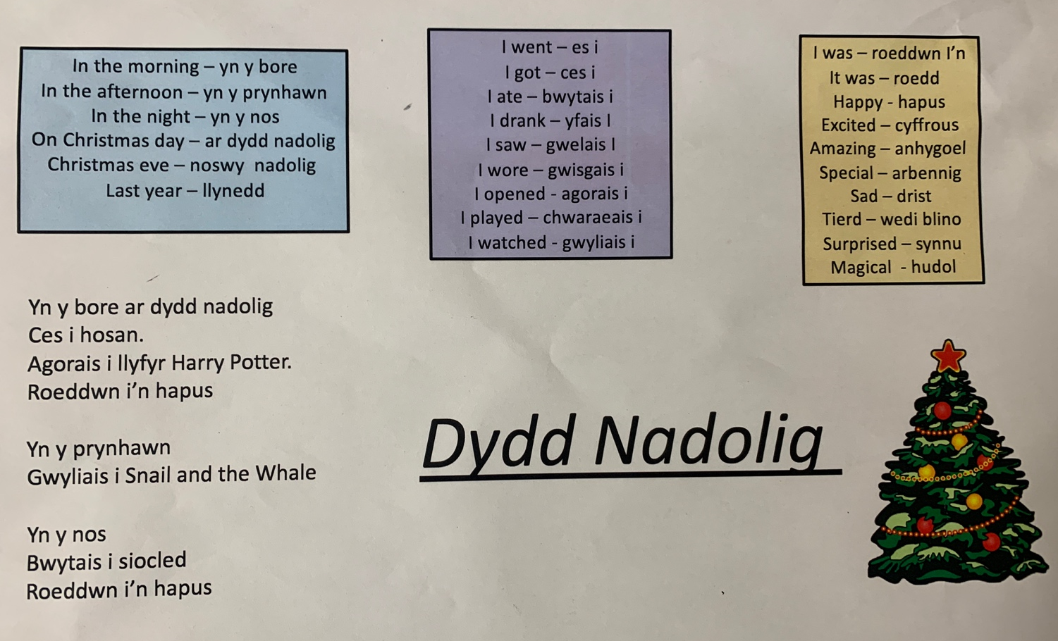
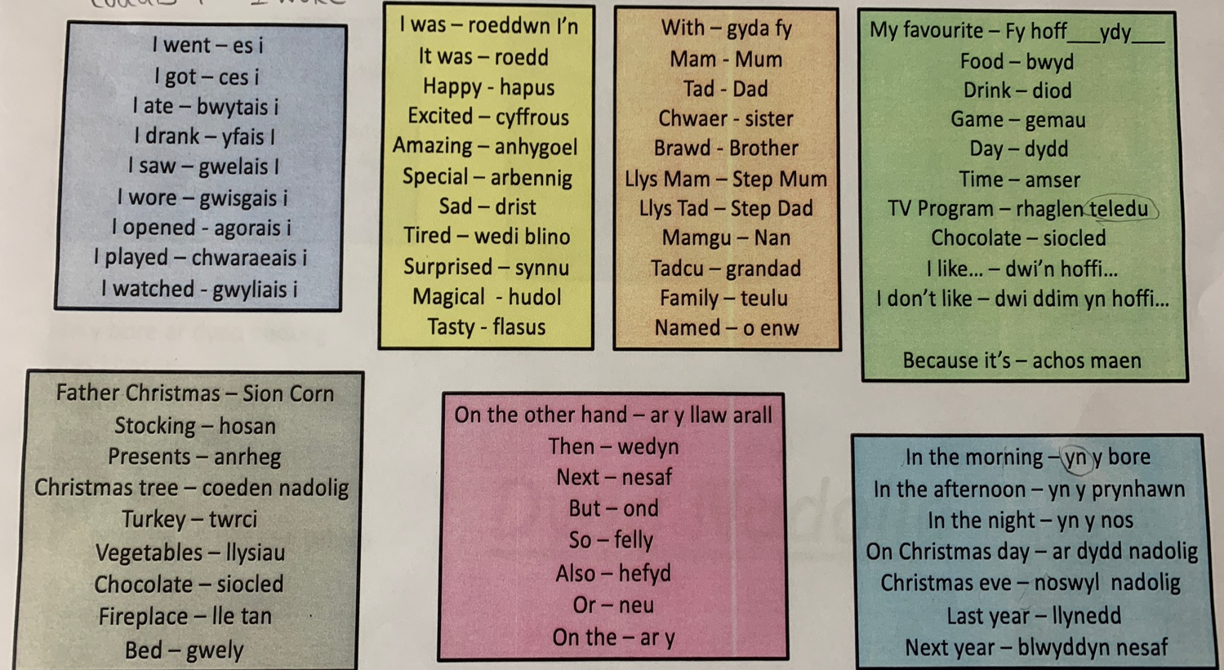
Word Mats – Assist pupils to write their paragraphs about Christmas.

Jenga Blocks – Task to provide pupils with the opportunity to develop their oracy and communication skills in the Welsh language.


