“If ever one art movement consumed the entire illustration genre, it was Surrealism” (Heller and Chwast, 2008, p.70). Discuss with reference to contemporary illustration.
Evan Elias (2100463)

In order to assess the modern place of surrealism, it is important to understand the application of the movement in a contemporary context. Thus, there is a need to assess the relevance of the media analysed under the label of surreal. Matthew Gale’s presentation of surrealism as the “undiscriminating fantasy of childhood” (Gale, 1997, pg. 219) is indicative of the application of the movement to children’s picture books. Integrated into bizarre acts of self-exploration, the advancement of the movement was integral to an understanding that “There are other relations besides reality, which the mind is capable of grasping and which also are primary, like chance, illusion, the fantastic, the dream.” (Aragon, 1924, pg. 3). This idea is present in the abstraction of traditional storytelling, using visual metaphor and metonym to create new perceptions and deconstruct preconceived notions. However, surrealism does not stand alone in its influence on the genre. A desire for whimsicality in children’s picture books may require influence drawn from a variety of art movements, such as dada, surrealism, futurism, and cubism (Kuiper K., 2022) - all of which function individually but can be grouped under modernism. This essay will focus on the correlation between contemporary illustration in picture books and surrealist pioneer artworks, honing in on integral compositional elements that form motifs. Alongside the surreal, other influences are present, and exploring the impact of these varying influences on the narrative structure will contribute to the discussion.
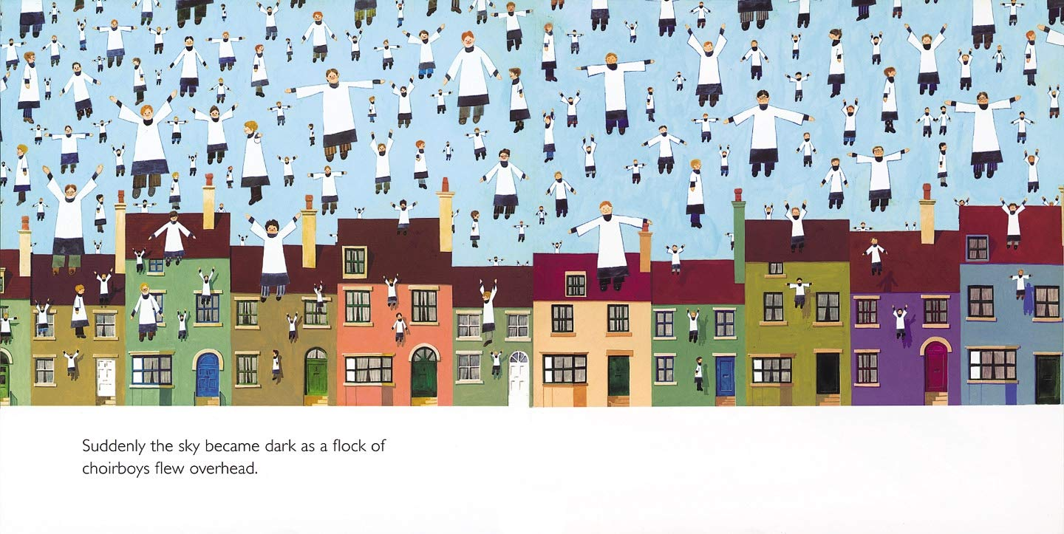
Fig 1, Through the Magic Mirror, Anthony Browne, 1976
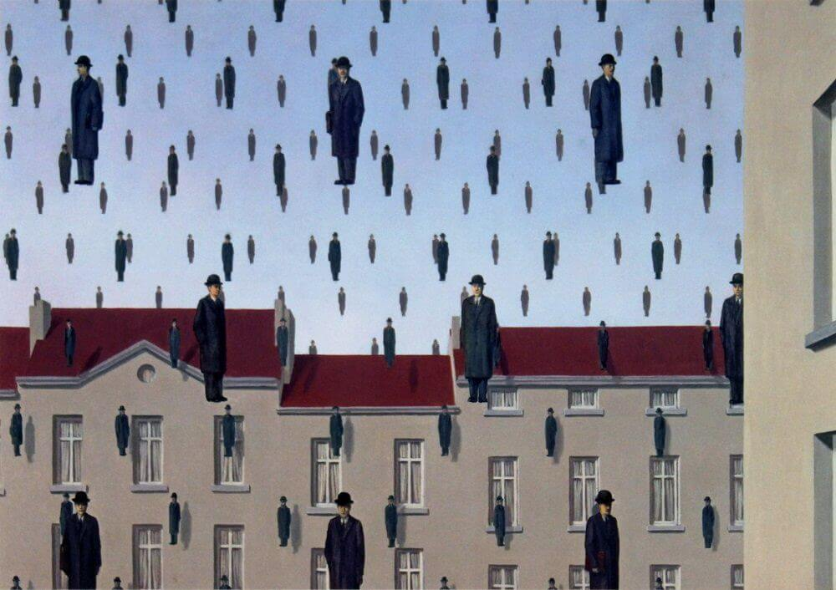
Fig 2, Golconda, Rene Magritte, 1953
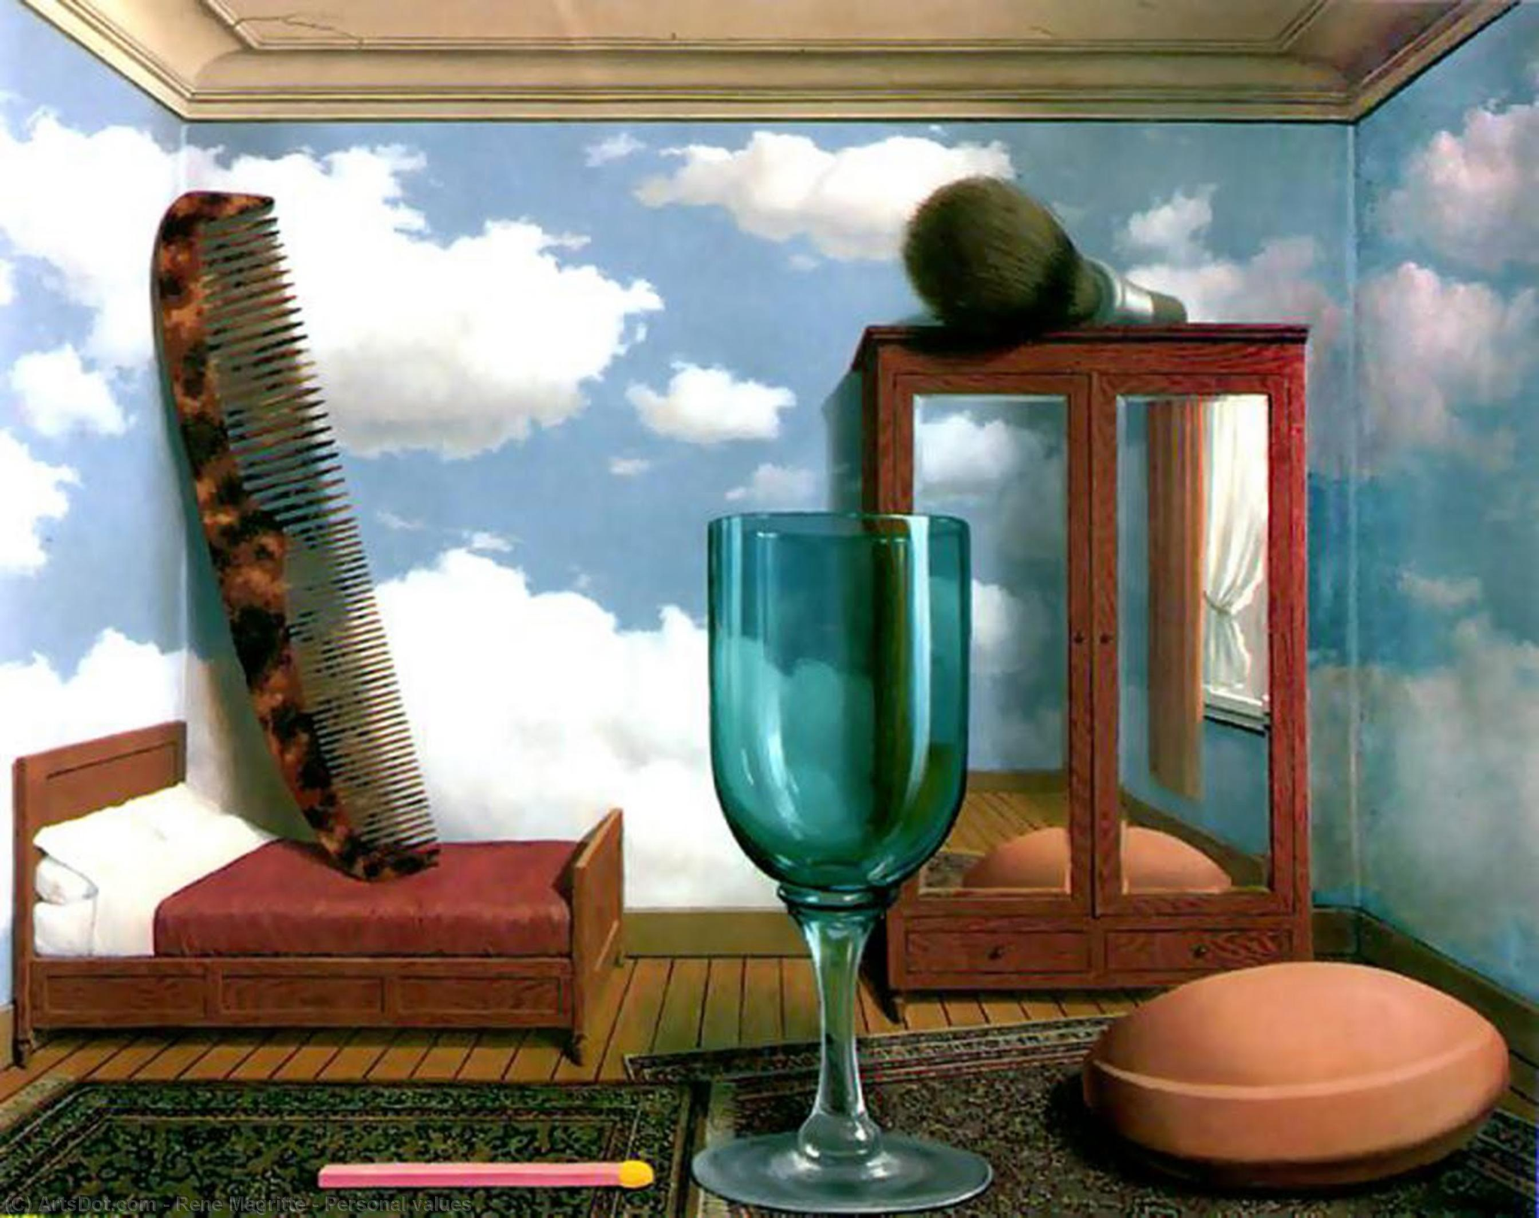
Fig. 3, Les Valeurs Personnelles, Rene Magritte, 1952
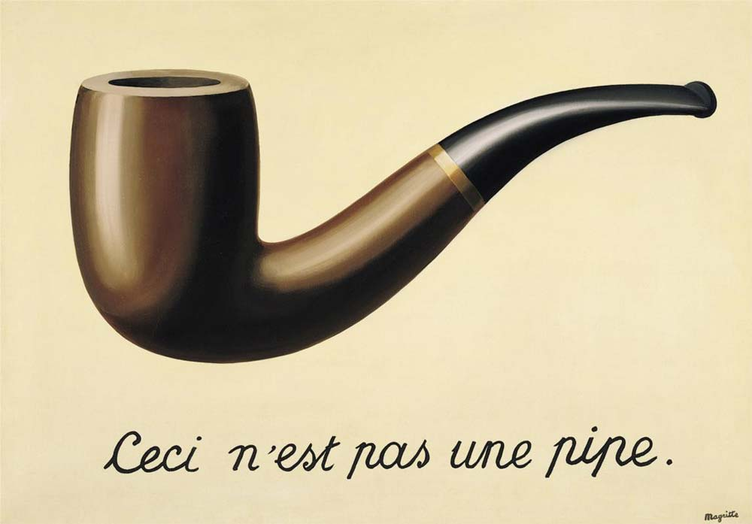
Fig. 4, The Treachery of Images, Rene Magritte, 1929
Author-illustrator Anthony Browne’s picture book Through the Magic Mirror (1976) integrates surreal imagery as a presentation of childlike exploration. The use of imagery from surrealist Rene Magritte can be seen through the recurring choirboys in the sky (fig 1). The composition resembles Golconda (1953), a Magritte painting (fig 2), created 24 years before the publishing of Through the Magic Mirror, inferring the influence of the movement in contemporary illustration. Surrealism as a tool of the presentation of dreamlike-images relates to that of Anthony Browne’s work, intrinsic in its portrayal of childhood and imagination. The surrealist movement itself made reference to the “shattering and regrouping” (Adorno, 2019, pg. 103) of dreams to formulate a similar feeling to the structure and pacing of a dream. These ideas are perpetually woven into Browne’s imagery, indicating the impact of the surrealist movement in contemporary illustration. Browne’s desire to link the movement to children’s illustration in this way may somewhat be evidence of its relevance in the contemporary. Magritte’s influence can be identified throughout the illustrations of Through the Magic Mirror. Les valeurs personnelles (1952), another Magritte painting (fig 3), exemplifies surrealist projection into children’s media, playing with scale as a means of disorientating the viewer. Adorno argues “what Surrealism adds to illustrations of the world of objects is the element of childhood we lost” (Adorno, 2019, pg.104), and this is indicated through this indulgence in disproportion. By accessing a childlike perspective, surrealism lends itself to children’s illustration; the ease of the transition of surrealist ideas into children’s media may suggest a reason for the surrealist consumption of contemporary illustration. Figure 3 demonstrates this imbalance of size, and hints at references to Magritte’s bowler-hatted men, present in works such as Golconda (1953). Alongside this, the figure is seen smoking a pipe, and under the referential context of surrealism, this may point to Magritte’s The Treachery of Images (1929) (fig 4). Intrigue in the “omnipresence of “mystery” behind ordinary appearances” (Baas, 2007, pg. 256) as a more generalised Magritte synopsis or overarching statement, may contextualise the connection between the artist and Browne. The application of surrealist technique to that of a contemporary illustrator can be condensed to the necessity of pragmatism to story tell in a coherent manner, even if events are dreamlike. In contrast, the argument could be made that the reason surrealist influence is prevalent in this picture book is because of the intentions of the author/illustrator to create surrealist-inspired books. An example of this would be Browne’s picture book Willy the Dreamer (1997), which is woven with referential material which parallels famous surrealist artworks.
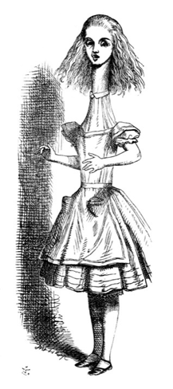
Fig 5, Alice’s Adventures in Wonderland, John Tenniel, 1865
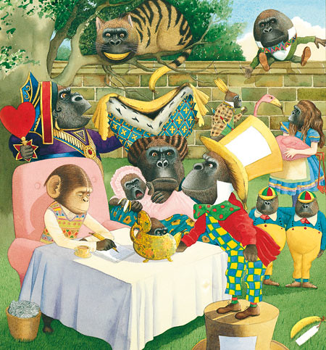
Fig 6, Willy the Dreamer, Anthony Browne, 1997
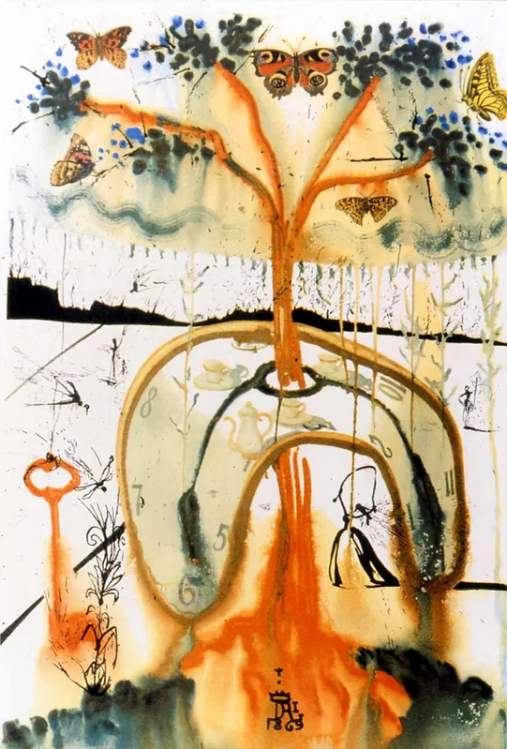
Fig 7, A Mad Tea Party, Salvador Dali, 1969
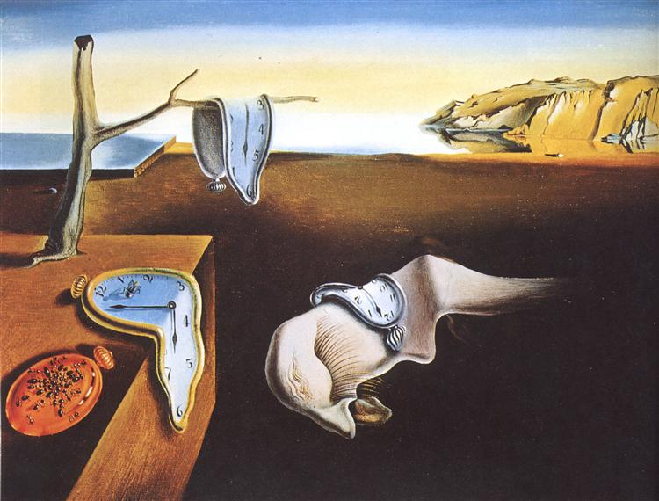
Fig 8, The Persistence of Memory, Salvador Dali, 1931
In a chronological context, Lewis Carroll’s Alice’s Adventures in Wonderland (1865), was a pioneer of the integration of the surreal into children’s storytelling, beloved for its “pervasive sense of inverted logic” and “ingenious absurdity” (Stoffel, 1997, pg.68). The imagery is recognised as a surreal milestone, emerging itself in a dreamlike narrative structure, despite being written, published, and illustrated before the surrealist era. The importance of illustration is highlighted in the first chapter of the novel, stating “’and what is the use of a book,’ thought Alice, ‘without pictures or conversations?’” (Carroll L., 1865, pg. 67). The importance of surreal in illustration is immediately highlighted as Alice yearns for the visual, highlighting her youthful perspective. David Hopkins argues the goal of the surrealist artist is to “move beyond aesthetic pleasure” and to make people “see and experience things differently” (Hopkins, pg. 3, 2004), and both of these ideas are present throughout the illustrations. Figure 5 is demonstrative of the almost grotesque nature of the illustrative series by John Tenniel. Having focused on the influence of the surreal on contemporary children’s illustration, Carroll’s work is an example of the opposite – children’s illustration influencing the surreal. Anthony Browne demonstrates the influence of Carroll in his picture book Willy the Dreamer (1997). There is recognition of Carroll as a surreal author inherent to the nature of the picture book, as it pays homage to the surrealist movement. The image (fig 6), inspired by the Mad Hatter’s Tea Party, is a figment of a dream from the protagonist Willy. This may be indicative of the surrealist intrigue in the dream. Contrasting to the genre of children’s picture books, surrealism is present in contemporary illustration in variety. Salvador Dali’s commissioned heliogravures, directly inspired by the events of Alice’s Adventures in Wonderland, are examples of children’s books influencing the surrealists. Figure 7, A Mad Tea Party (1969), has an illustrative quality in its priority of composition, but abstract in its use of inks/watercolours. Its self-referential nature can be seen in direct parallel to Dali’s own work The Persistence of Memory (1931) (Fig 8). From this alone, the inference could be made that the artist is self-aware of his own influence, and uses this influence as an opportunity to call back to prominent moments of the surrealist movement. In the correlation being made between Dali and Carroll, there could be a further acknowledgement of Carroll as a surrealist writer. The cyclical nature of inspiration is demonstrated through the persistence of Alice’s narrative throughout contemporary illustration, and the deduction that perhaps art movements are not influential in the linear way proposed by Heller and Chwast.
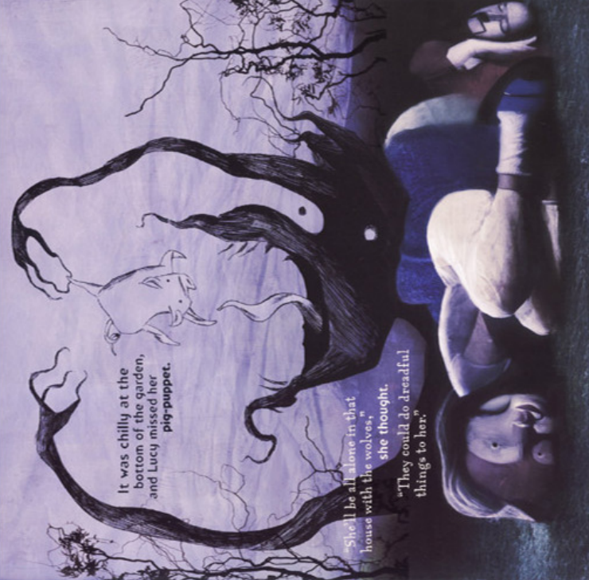
Fig 9, The Wolves in the Walls, Neil Gaiman and Dave McKean, 2003
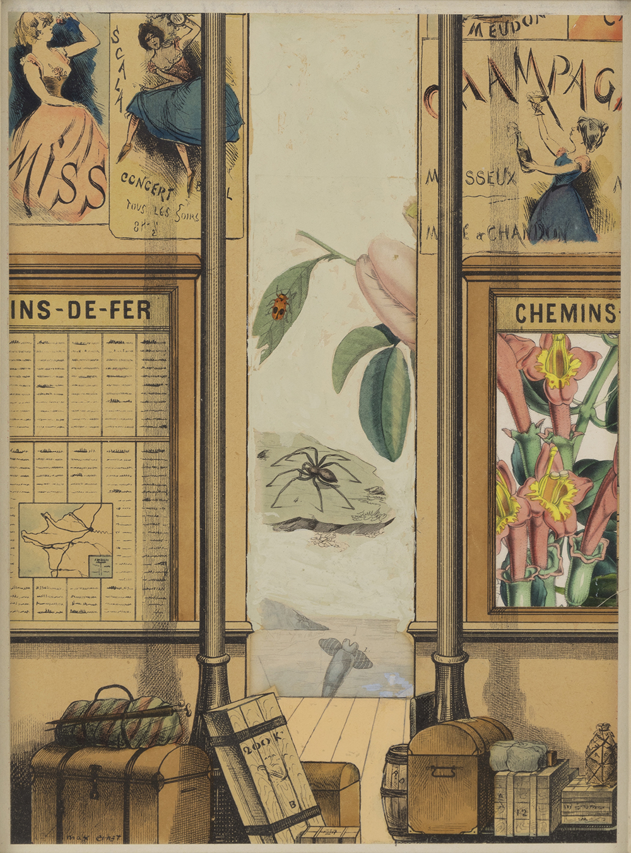
Fig 10, Les Filles, Le Mort, Le Diable, Max Ernst, 1970
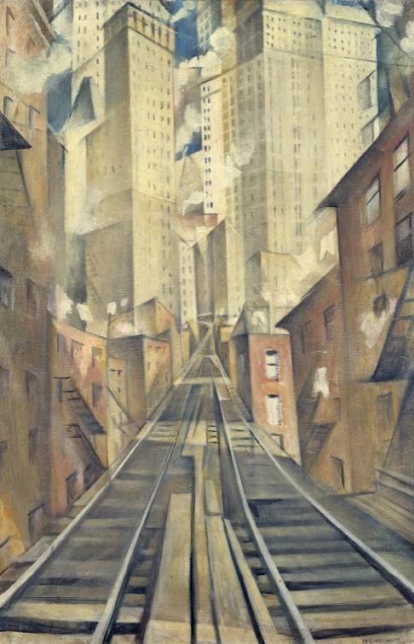
Fig 11, The Soul of the Soulless City, Christopher Richard Wynne Nevinson, 1920
In contrast to the prior books, Neil Gaiman’s The Wolves in the Walls (2003) draws from a myriad of 20th century art movements to illustrate the events of the book. Firstly exploring the surreal influence, Dave McKean’s work is not only surreal in its narrative content, but uses a multitude of visual techniques to conjure dreamlike pacing. McKean exercises his creative liberty through unconventional technique, and by doing so creates emphasis on the dreamlike attributes of the picture book. It seems to relish in its collage of events, playing with format and structure to interrupt a traditional way of storytelling. McKean noted one of his inspirations to be “Surrealists and the illustrators who were inspired by surrealism” (McKean, 2015), and so the impact of the movement on contemporary illustration can be seen through the stylistic choices he makes. The implication of a “style” of illustration is to “evoke a pre existing meaning” (Nodelman, 1988, pg. 79); from this definition, the assumption can be made that illustration for children’s picture books is derivative of its content, inferring that a surreal text must have surreal imagery. The narrative itself follows a dreamlike structure, further enhanced by its visual language. The dream is indispensable to the surreal, and finds its place as an act of innovation with the surrealists “recording and publishing” (Spector J., 1989, pg. 289) their dreams.
The juxtaposition of images in the illustrations have the intent of creating “disruption and chaos” (Nodelman P., 1988, pg. 1), but this may also be a characteristic innate to children’s picture books. The images of the book “rarely possess the harmonious balance” of other artworks outside of the genre, presumably because of the desire to demonstrate the disarray in the story. The analytic conclusion cycles around again: the narrative in a contemporary children’s picture book may be better suited for the surreal artist/illustrator. “Discovery and inventiveness through metaphor exemplify the mind-body interconnection - an interconnection strongly realised through art.” (Serig, D., 2006, pg. 230). This idea is presented through the metaphorical nature of the book. The wolves, perhaps being representative of some unwanted truth hidden within a house, allow the reader to discover the lives and attitudes of family members. Thus initiating the characters to display their identity through the situations they are presented with. This may allude to surrealism presenting itself in contemporary illustration as a tool of narrative depiction. Figure 9 demonstrates the amalgamation of the clashing style, dreamlike narration, and key personality elements of each character through a collaging of visual ideas. The technique of collage is present in the work of surrealist Max Ernst, and his connection to Mckean is represented in figure 10, demonstrating the clashing of images to form abstraction between the once rational. Image layering is formulaic in its creation of a fluctuating narrative; Ernst himself implies a “permanent metamorphosis” (Giedion-Welcker C., 1964, pg.105) through the disregard of scale and compositional structure through his collaging. Applying this to the illustrations could indicate the development of the plot, and create a discernible dissonance to signify a conflict. While there is crossover between the surrealist and Dave McKean’s use of collage, this is not conclusive evidence of the movement consuming “the entire illustration genre” (Heller and Chwast, 2008, p.70).
To contrast, the influence of cubism can be seen throughout the book. McKean cited Pablo Picasso as another influence of his, and this may contrast the surreal through a cubist lens. The intrinsic intentions of cubism can be identified in McKean’s work. Traditional rules of “modelling, foreshortening, and especially perspective” (Kissane S., 2002, pg. 62) were abandoned as a core motivation behind cubism. While examples of foreshortening and perspective can be identified in the book illustrations, there is a clear embrace of the “two-dimensional space of the surface”. The abstraction of the human form mirrors that of Picasso, especially during his Rose Period, in which features are exaggerated and simplified to place desired emphasis on particular elements. Both artists utilise the intensity of the shadow to create a harsh contrast which forms a distinctive silhouette. From analysis and the words of McKean, the deduction can be made that cubist influence is present in the illustrations. The conclusion on whether it outweighs the surrealist influence is unanswered, however surrealism was not all-consuming of the contemporary illustration genre. Furthermore, the influence of the futurist movement can be identified in McKean’s portrayal of the dynamic character. Having sprouted from prior art movements “neo-impressionism and cubism” (Tate, 2017), futurism aimed to portray “the dynamism, the energy and movement, of modern life.” ‘The Wolves in the Walls’ is a story centred around action and so features scenes saturated with erratic movement. The visual correlation between the work of McKean and futurist Christopher Richard Wynne Nevinson is representative of the shared motivations between both artists - the desire to demonstrate action through still images. ‘The Soul of the Soulless City’ (1920) (fig 11) utilises architectural structures to form perspective, while Mckean translates similar visual technique to convey a panicked emotion through the figures.
In order to further explore the argument, the book must have a wider consideration to allow for the perceiving of elements such as character, narrative arc, composition, and colour structure in relation to surrealism. This argument is presented in ignorance to the interconnection of cubism to the surrealist movement. When acknowledging these movements as a collective, the separation of influence falls indistinguishable as a multitude of 20th century art movements have their place among the landscape of contemporary illustration. Conducting a semiotic analysis (Barthes, p. 113, 1957) on particular elements of figure 9 will allow for a greater understanding of the application of different art movements throughout the 20th century. These elements work as a conjunction, using content saturated in chaos to extract a superlative presentation of each character. John Berger’s Ways of Seeing (Berger J., 1972) states that “The relationship between what we see and what we know is never settled.” (pg.7) This idea can be attached to a variety of visual motifs seen in figure 9, by creating threat and fear around recurring symbols such as darkness and the wolves. The arrangement and curation of images in relation to the nature of a symbol is an “interplay of directed tensions” (Arnheim, 1954, pg. 11). Intention can be created through placement, in which the hierarchical position of the wolf is indicative of its power. In assuming that “squares are rigid and that rounded shapes are accommodating” (Nodelman P., 1988, pg. 127), the character of Lucy and her dad exist in contrast to the wolf, in both core shape and medium used. This illustration exemplifies the synthesis of surrealism and contemporary illustration by demonstrating key plot points through abstract presentations, while still retaining a rationality that allows for the portrayal of the story.
The influence of surrealism on contemporary illustration can be seen especially through the lens of children’s picture books. The origins and developments of the movement itself coincide with common topics presented through the medium, such as dreams, fear, the subconscious, the imagination, and the importance of childhood. Due to the parallel relevance of the content shown between surrealism and picture books, the argument could be made that one influences the other out of convenience. The use of metaphor accords itself to the narratives in picture books, due to the need to simplify complex topics. A key characteristic of the surrealist movement is symbolic metaphor, thus making the two compatible, and interchangeable with theme and structure. Highlighted by Through the Magic Mirror, a more literal sense of influence can be seen, with literal visual motifs copied from the surrealists into the work. This in itself displays the consumption of contemporary illustration by surrealism; however, the book acts as a surrealist introduction and so could be discredited through the analysis of intention. However, Lewis Carroll’s Alice in Wonderland was an introduction of surrealist thought before the 20th century origin of the movement, and because of that the inference can be made that the surreal is inherent to children’s media. Neil Gaiman’s The Wolves in the Walls is a presentation of a surrealist text in conjunction with surrealist contemporary illustration, and so is demonstrative of the complete embrace of an absurdist narrative.
List of Figures
Figure 1: Through the Magic Mirror, Anthony Browne, 1976
Figure 2: Golconda, Rene Magritte, 1953
Figure 3: Les Valeurs Personnelles, Rene Magritte, 1952
Figure 4: The Treachery of Images, Rene Magritte, 1929
Figure 5: Alice’s Adventures in Wonderland, John Tenniel, 1865
Figure 6: Willy the Dreamer, Anthony Browne, 1997
Figure 7: A Mad Tea Party, Salvador Dali, 1969
Figure 8: The Persistence of Memory, Salvador Dali, 1931
Figure 9: The Wolves in the Walls, Neil Gaiman and Dave McKean, 2003
Figure 10: Les Filles, Le Mort, Le Diable, Max Ernst, 1970
Figure 11: The Soul of the Soulless City, Christopher Richard Wynne Nevinson, 1920
Bibliography
Adorno, T. W., Nicholsen, S. W., & Kottman, P. A. (2019). Looking Back On Surrealism. In R. Tiedemann (Ed.), Notes to Literature (pp. 102–105). Columbia University Press. http://www.jstor.org/stable/10.7312/ador17964.12
Aragon and Susan De Muth (2010). A wave of dreams. London: Thin Man Press.

Arnheim, R. (1974). Art and visual perception : a psychology of the creative eye. Berkeley: University Of California Press.
Baas, J., 2007. Magritte and Contemporary Art: The Treachery of Images. New York: College Art Association, Inc.
Barthes, R. (1957). Mythologies. France: Les Lettres nouvelles.
Berger, J. (1972). Ways Of Seeing. New York: Penguin Books.

Browne, A. (2008). Willy the dreamer. London: Walker Books.
‌Browne, A. (2010). Through the magic mirror. London: Walker.
Carroll, L. (2019). Alice’s adventures in Wonderland. Tulsa, Oklahoma: Edc Publishing.
‌‌Gaiman, N. and Mckean, D. (2008). The Wolves in the Walls. Paw Prints.
Gale, M. (1997). Dada [and] surrealism. London: Phaidon.

Giedion-Welckler, Carola, and Scheyer E. (1964) Max Ernst: Irony—Myth—Structure. Criticism, vol. 6, no. 2, (pp. 105–113) JSTOR, http://www.jstor.org/stable/23094202. Accessed 3 Dec. 2022.

Hopkins, D. (2004). A very short introduction. Oxford University Press.

Heller, S. and Chwast, S. (2008). Illustration : a visual history. New York: Abrams.
Kissane, S. (2002-) Analysing Cubism. Irish Arts Review, vol. 30, no. 1, (2013) (pp. 62–65). JSTOR, http://www.jstor.org/stable/23610326.
Kuiper, K. (2019). Modernism | Definition, History, & Examples. In: Encyclopædia Britannica. [online] Available at: https://www.britannica.com/art/Modernism-art. [Accessed 24th November 2022]

Magritte, Barron, S., Draguet, M., Cochran, S., Armstrong, R., Zelevansky, L., Papanikolas, T., RousselN., County, A. and Fondation Magritte (2006). Magritte and contemporary art : the treachery of images. Los Angeles: Los Angeles County Museum Of Art; Ghent.

Mary Ann Caws (1995). Surrealism and women. Cambridge, Mass: Mit Press.

McKean, D. (2015). FAQ – Dave Mckean. [online] Available at: https://www.davemckean.com/personal/faq/#:~:text=Who%20are%20your%20main%20influences [Accessed 22nd November. 2022].

Nodelman, P. (1988). Words About Pictures. Athens, Georgia: The University of Georgia Press.

‌Spector, Jack J. (1989) André Breton and the Politics of Dream: Surrealism in Paris, ca. 1918–1924. American Imago, vol. 46, no. 4, (pp. 287–317). JSTOR, http://www.jstor.org/stable/26303837. [Accessed 28 November 2022]
Serig, Daniel. “A Conceptual Structure of Visual Metaphor.” Studies in Art Education, vol. 47, no. 3, 2006, pp. 229–47. JSTOR, http://www.jstor.org/stable/25475783. [Accessed 28 November 2022.]
Stoffel, S. (1997). Lewis Carroll and Alice. New York: The Wonderland Press.
‌ Tate (2017). Avant-garde. [online] Tate. Available at: https://www.tate.org.uk/art/art-terms/a/avant-garde#:~:text=As%20applied%20to%20art%2C%20avant. [Accessed November 29th, 2022]

‌

‌

