Learning in the Digital era

Task 1 Activity

Hello . Welcome to my project . I hope you will enjoy it !

Data analyst
Because I enjoy gathering and analysing various types of data to track business or solve problems, I would like to work as a data analyst after I graduate.In every industry, including banking, consulting, manufacturing, etc., data analysts are highly sought after. It is imperative for data analysts to possess the qualities of meticulousness, effective communication, and exceptional organisation. [1] Although the majority of businesses constantly gather vast amounts of data, this information is meaningless in its unprocessed state. Data analytics can help in this situation. Data analytics is the process of examining unprocessed data to extract valuable, actionable insights that can be utilised to guide and inform astute business decisions. As a result, you can make well-informed decisions and plans based on the data rather than winging it.
In order to be successful in this job, you need a set of skills like : [2]
- Communication skills
Data analysts collaborate closely with key business stakeholders and may be accountable for sharing and presenting their insights to the entire firm.
- Familiarity with programming languages
To do their work, data analysts use several different programming languages. Although at first seeming difficult, this is nothing that cannot be learnt with patience.
- Aptitude in statistics and mathematics

You'll obviously need a mathematical mind because data analysts work with numbers for a significant amount of their workdays!
- The ability to adapt

This implies it's critical to have an open mind and stay up to date on new methods and technologies. [3]
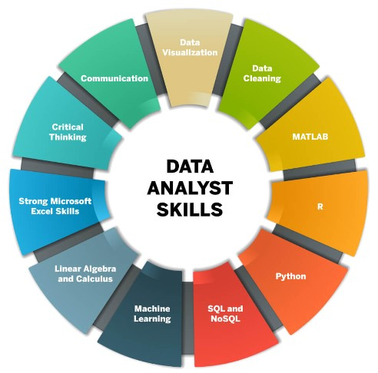

[1] | E. STEVENS, “Data analytics ? Complete guide for begginers,” 17 November 2023. [Online]. Available: https://shorturl.at/ewCFR.
[2] | G. Koop, “Analysis of Financial Data,” in Analysis of Financial Data, 2010, p. 256.
[3] | E. DNA, “The Evolving Skill Requirements For Data Analysts In 2024,” 01 2024.

