Name : Renu Miah
Student number : 2025335
E-portfolio report
Learning in the Digital Era – BMPL4007/BMPS4009

Table of Contents

Task 1 – Written summary 2
Task 2 – Mind map 3
Task 3 – Presentation 4
Task 4 – Reflection 5
Reference list 6

Task 1 – Written summary

Higher education requires you to take charge of your own learning, therefore you are ultimately responsible for being well prepared. When preparing for higher education, there are numerous elements that must be considered and managed.
The first step in ensuring that concentration levels are maintained, and that productivity is maximised is creating a conductive learning environment. The Study Skills Handbook by Stella Cottrell (2019) gives several examples of how to do this, including minimising distraction, putting your phone on silent, selecting a set location to preserve consistency, and creating an acceptable arrangement for the room or study space. In addition to creating a conductive environment, it’s critical to decide on study time that works with your schedule. Planning study periods and creating a schedule will help you maximise your learning potential. Planning time to take regular, brief breaks from studying is also crucial if you want to prevent losing focus and being less productive.
In order to complete your course in its entirety and to maintain a healthy balance between your study life and other responsibilities, effective time management is essential. You can attend classes on time and efficiently fulfil deadlines if you keep track of where and when session is held as well as when assignments are due.
Setting priorities for job management is a crucial skill to maintain optimal productivity and planning ahead is a crucial step in achieving this. But a poorly thought-out scheme will ultimately fail. Utilizing an evidence-based guideline like Eisenhower’s Principle will help you efficiently priorities your responsibilities.

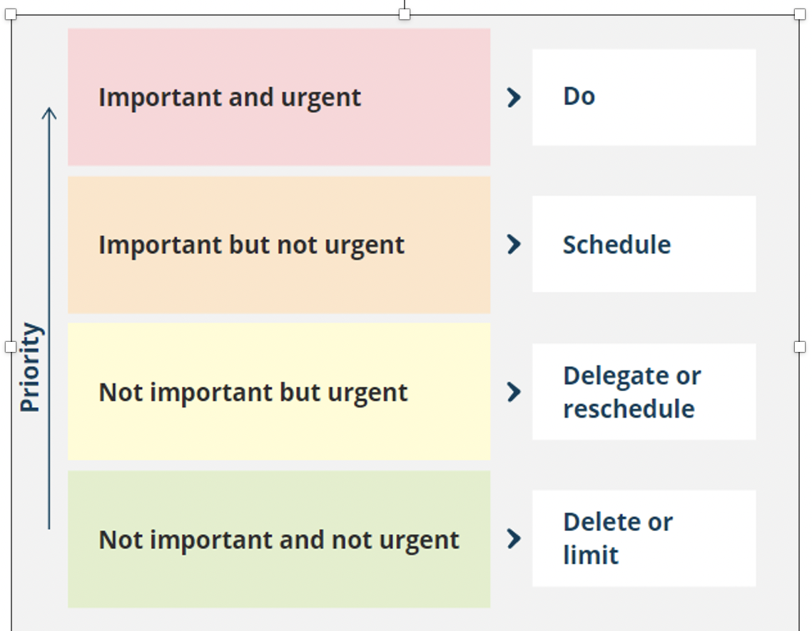

Another crucial ability is knowing how to produce content using appropriate digital channels. Four essential software programs-Microsoft Word, Microsoft PowerPoints, Microsoft Teams, and Microsoft Outlook—are needed to generate and distribute coursework and assignment.
It is crucial to make sure that all of the information you acquire for assignments and presentation is supported by evidence and comes from reliable sources. Information needs to be properly cited and should be based on research that has been acquired from reputable source such books, articles, and journals.

Task 2 – Mind map
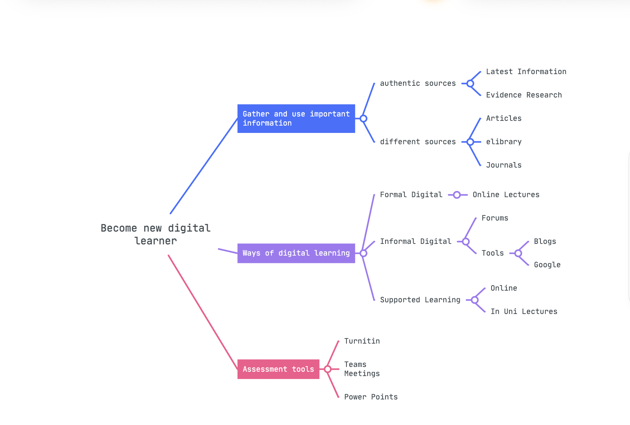
www.mindmeister.com

Task 3 – Presentation
Please follow this link to view my presentation:
https://youtu.be/SyTzCcHoQU0

Task 4 – Reflection

Beginning university has been a great adventure filled with both difficulties and successes that has already taught me a tremendous amount. It has been a significant learning process, and in order to truly understand the entire voyage, it is vital to effectively reflect on it.
Use of an efficient and well-made tool or guide is essential while reflecting on any experience or piece of work. One such illustration is Borton’s reflection tool, a straightforward but very helpful manual that enables the user to quickly reflect on and analyse their experience.

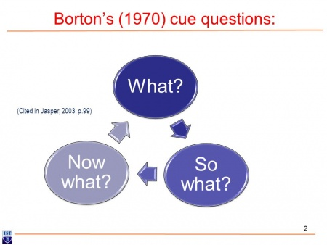

What? Is the first query that this tool poses to the reflector, highlighting the description of the event’s nature. Starting university and figuring out how to use online resources and studying has been a bit of a challenge. The basics of accessing the programme content were not too difficult to learn. However, it took some time to learn how to use the university’s online library to conduct relevant information searches. I first had trouble finding reliable, fact-based information on my topic, which made it difficult for me to compose my first projects.
The following section of the tool focuses on the phrase “So What?” Due to this challenge, I had to give myself time to become comfortable with the proper search phrases and practise effective information entry in order to get the best search results. I discovered how to divide the task into portion and concentrate on each section separately using my time management skills. To ensure that I was productive, it was crucial for me to collect my thoughts and make notes along the way.
What Now? Is the last question posed to the reflector in the reflecting tool. Through productive study sessions with my tutor, I was able to change my data collection methods as a result of this difficult experience. I was able to learn how to use web resource effectively and receive advice on how to compose my tasks. In the future, I’ll be sure to ask for advice from reliable sources and give myself time to study fresh essay-writing strategies.

Reference list

1. Business management daily (2021) ‘Try the Eisenhower Matrix for workflow’ vol.47 (10). P. 1
2. Burns, Tom (2016) The complete guide to success at university. 4th ed. London sage press
3. Cottrell, Stella (2019) The study skills handbook. 5th ed. London Red globe press
4. Rolfe, Gary (2014) ‘Reach, touch and teach: Terry Burton’ vol.34(4), p. 488-489
5. www.Mindmeister.com

