Student name: | NAVEEDA FATIMA | Student ID number: | 2406614
Programme: | BSc Health and Social Care
Module: | Protecting and Supporting Families in Health and Care
Module code: | BMHP5021 | Contribution to Overall Module Assessment (%): | 50%
Lecturer: | GILLIAN WEAVER
Assignment Title: | Component 2 Written Report | Word count (or equivalent): | 2000 Words (+/- 10%)

Table of Contents
1. Introduction 2
2. The Early Help System 2
3. Multi-Agency Working 4
4. Evaluation of Local Authority Websites 5
4.1 Leeds City Council 5
4.2 Norfolk County Council 6
4.3 Tower Hamlets Council 7
5. Comparative Analysis 7
6. Conclusion and Recommendations 8
7. References 10

An Examination and Analysis of How the ‘Early Help’ System is Signposted to UK Families by Local Authority Websites

Introduction
The safeguarding and care of children, youths and families is one of the key focus areas in the health and social care provision system in the UK. There is a growing focus in policy frameworks on preventative strategies that tackle problems before they develop into safeguarding issues. Among these methods, the Early Help system is intended to offer families in trouble timely and coordinated assistance (Department for Education, 2020).
The provision of Early Help services and the ability of families to receive relevant support is the task of local authorities. Local authority websites are one of the main portals to information in the digital era and therefore design, ease of use, and simplicity are critical in enabling prompt intervention. Ineffective communication can postpone the provision of assistance, and the risk of injury or crisis can grow.
This report explores the effectiveness with which Early Help is signposted using three local authority websites: Leeds City Council, Norfolk County Council and Tower Hamlets Council. It starts with an explanation of the Early Help system and why multi-agency working is essential and then the assessment of each site. A comparative analysis is then made to analyse the strengths and weaknesses, which result in a justified conclusion and recommendations to improve.

The Early Help System
Early Help is defined as the support of children, young people and families in the earliest stage of identified need, with the intention of avoiding the development of the problems into more serious issues that would have to be addressed through statutory intervention (Department for Education, 2020). It is a preventive, strengths-based method that emphasizes on bettering long-term outcomes within the family.
According to the Early Help System Guide (2020), successful Early Help is about early identification of need, early intervention, and service coordination. This can involve parenting, mental health, education, housing, and financial issues. Notably, Early Help is voluntary, and this aspect encourages participation and empowerment (Department of Education, 2022).
In addition, Early Help is integrated into larger safeguarding structures. Working Together to Safeguard Children (2023) notes that early support lowers the risk of harm to children and minimizes the necessity of more intrusive interventions that might include child protection plans (Department of Education, 2023). This emphasizes the cost-efficiency and the significance of early intervention in terms of ethics.
Early Help is also effective in changing family outcomes as supported by research. Indicatively, early intervention programmes have been found to lower social and economic expenses in the long-term related to neglect, poor education achievement, and mental health problems (Allen, 2011). But accessibility and awareness, which parts of the information are relayed to families will determine the success of Early Help.
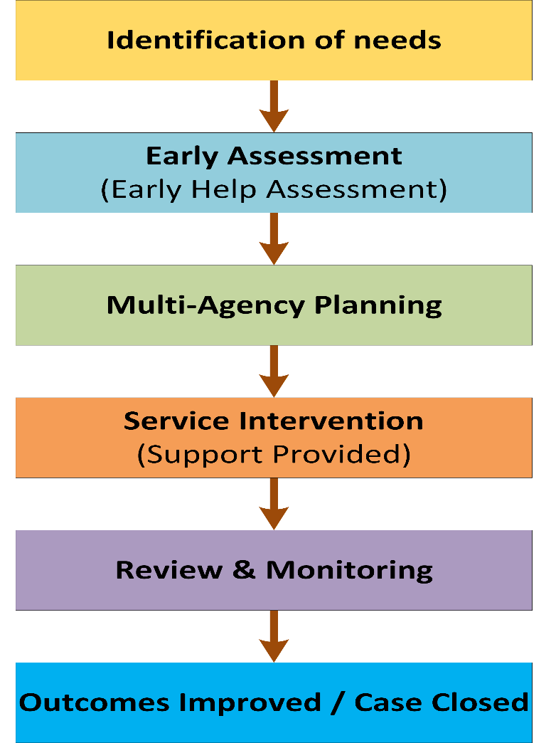
Figure 1: The Early Help process illustrating stages from identification to intervention and review (adapted from Department for Education, 2020).

Multi-Agency Working
Another key aspect of the Early Help system is multi-agency working, which means working with professionals of various fields: health, education, social care, and voluntary organisations. The methodology will provide an integrated approach to support that is responsive to the multi-dimensional needs of families (Department of Education, 2023).
The Working Together to Safeguard Children (2023) guidance stipulates that effective multi-agency working necessitates effective communication, responsibility, and coordinating service delivery. It allows professionals to exchange information, reveal risks in a more efficient manner and offer combined support plans (Department of Education, 2023). In the absence of this cooperation families can get disjointed or duplicate services leading to diminished effectiveness of interventions.
Inter-disciplinary working also improves professional decision-making as there are varied points of view. An example is teachers can spot educational issues and healthcare providers may spot developmental or mental health problems. These insights together can be used to understand family needs comprehensively (Parton, 2005).
But there are no challenges to multi-agency working. Various obstacles to collaboration may include data-sharing limitations, organisational obstacles, and disparate professional priorities (Featherstone, 2014). Hence, there must be effective communication channels and systems.
The local authority websites contribute to the multi-agency working process through the provision of information about the referral process, coordination, and partnering. Consequently, the measurement of the communicated elements on the web is important when gauging the success of Early Help provision.
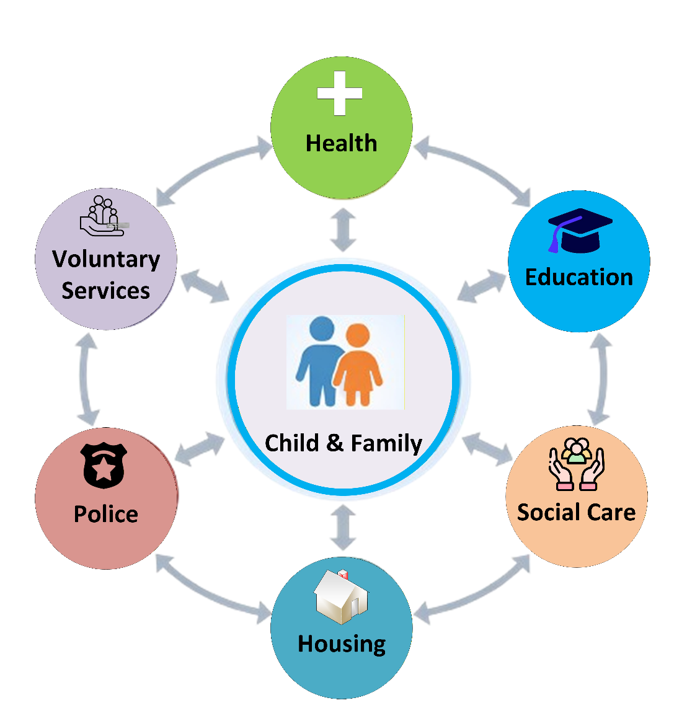
Figure 2: Multi-Agency Working

Evaluation of Local Authority Websites

4.1 Leeds City Council
Leeds City Council offers a clear and detailed outline of the Early Help services. The purpose, target audience, and benefits of Early Help are clearly defined on the site. This is in line with government recommendations, which stress the role of effective communication when encouraging early intervention (Department of Education, 2022).
The ease of use in the structure of the Leeds site is one of its main strengths. Data is classified under clear headings and navigation is easy, so that a user can find the services easily. This is presented in a non-technical and simple language that can be understood by families that do not have a professional background. This is good practice in communicating in a public-service where there must be clarity and inclusivity (Local Government Association, 2021).
The site also includes comprehensive details of services available such as children centres, youth support, and family intervention programmes. Further, there are clearer ways to refer to routes and contact details for easier access and increased interactions.
An additional strength is the emphasis on working collaboratively with other agencies; the site illustrates how all services rely on one another to support families according to statutory guidance (Department of Education, 2023). This openness will serve to create trust and familiarity between users.
Nevertheless, the site can be enhanced with the use of additional graphics, like diagrams or flowcharts, to show the process of the Early Help. It has been proposed that visual communication may help users to grasp and interact with a system, especially in the cases of complex systems (Knaflic, 2015). Also, one might add case studies to illustrate a real-life application of Early Help.

4.2 Norfolk County Council
The Norfolk County Council has an extensive and detailed information on Early Help services. The site also contains detailed descriptions of how assessments are done, the referral routes, and the role of the professionals involved. This is mirrored by the close fit to policy frameworks and represents an advanced system (Department of Education, 2022).
One of the strongest aspects of the Norfolk site is that it has rich information, especially to the professionals. It provides downloadable resources, guidance documents, and referral forms, which would facilitate multi-agency working and provide consistency of practice. This degree of elaboration is helpful to practitioners who need to be guided to procedures considered.
Nevertheless, the site is less efficient in the communication with families. The language is usually technical and presupposes the background knowledge of the processes of social care. This can also pose an obstacle to users who do not understand professional terminology and make it less accessible (LGA, 2021).
The other limitation is navigation. The site layout may be complicated, as the users have to browse through several pages to get information that is of interest to them. This can deter participation especially when it has to do with families in need of urgent assistance.
In addition, the site does not have easily summarized synopses or illustrations, which restrict its usability. Although the information is detailed, it is not presented in a friendly format always. This brings out one of the most common problems of communicating in the public service: the need to be detailed and at the same time accessible.

4.3 Tower Hamlets Council
Tower Hamlets Council is the one where Early Help information is rendered in a clear and accessible way, and the user engagement is prioritized. The language and navigation are not complex, and the families can easily understand the site and get services.
The crucial asset of the Tower Hamlets website is the focus on inclusiveness. It also emphasises the services customized to the various communities and the significance of cultural sensitivity in service provision. This is the best practice in ensuring that the needs of various populations are met (Featherstone et al., 2014).
The site is also self-referral and offers sufficient contact details, which helps in the early intervention whereby the families will seek help on their own. This is in line with the ideals of empowerment and accessibility as part of the Early Help (Department of Education, 2022).
The site is however not a deep site as compared to Leeds and Norfolk. Although it gives a review of services, it never goes into details of the processes or the multi-agencies cooperation. It can restrict its usefulness by users who want to have comprehensive information.
Also, little is known about the coordination of services or collaboration between professionals. This will lead to less transparency, and this can have an impact on the user confidence in the system.

Comparative Analysis
The study of the three websites of local authorities demonstrates that there are major variations in communicating the services of Early Help.
The most even-handed approach is shown by Leeds City Council, which allocates accessibility and enough detail. It is well organized, easy to understand and incorporates information about the services, which makes it useful among both families and professionals. This corresponds to the best practice in communicating to the public, which focuses on clarity, usability, and inclusivity (LGA, 2021).
On the contrary, Norfolk County Council is detailed but in an inaccessible manner. The language and complicated navigation might become obstacles to families and restrict the efficiency of the Early Help communication. Although the site helps the professionals, it does not satisfy the requirements of non-specialists’ users to the full extent.
Accessibility and inclusivity are the priority of Tower Hamlets Council that facilitates the involvement of the families with the service. Nevertheless, the inadequate description of multi-agency working and the insufficient explanation of its functioning decreases its general efficiency. It gives a point of entry to assistance, but it is not complete to notify users about the system.
The best communicator of Early Help services is the Leeds City Council in general. It has an appropriate balance of clarity and detail with the information being accessible and informative. This helps in early intervention since the families will be in a position to learn and receive services with ease.
Table 1: Comparison of Local Authority Early Help Website Effectiveness
Criteria | Leeds City Council | Norfolk County Council | Tower Hamlets Council
Clarity of Information | High simple, user-friendly language | Moderate technical terminology used | Clear and easy to understand
Depth of Information | High balanced detail | Extensive professional detail | limited depth
Ease of Navigation | Well-structured layout | Complex navigation | Simple navigation
Accessibility for Families | Inclusive and clear | User-friendly for non-professionals | Very strong focus on accessibility
Multi-agency Explanation | Clear and well-explained | Detailed but technical | Limited explanation
Use of Visual Aids | Limited | Very limited | Limited
Overall Effectiveness | Most effective | Moderate | Good but lacks depth

Conclusion and Recommendations
In conclusion, the Early Help system is important because it helps to assist families and avoid the development of the issues. Nonetheless, it is not only as effective as its ability to provide service but also the way information is conveyed.
This report has shown that the local authority sites are quite dissimilar in terms of their communication on Early Help approach. Leeds City Council offers the best form of model, with Norfolk and Tower Hamlets both having strengths and significant weaknesses.
To enhance the Early Help services communication, the following recommendations are suggested:
- Enhance the accessibility: apply a plain language and do not use technical terms so that the information is comprehensible to every user (LGA, 2021).
- Use visual materials: Diagrams, flow charts, and infographics can improve the perception of the complicated processes (Knaflic, 2015).
- Detail and simplicity: Be able to give detailed information, but in simplified form to families as well as detailed information to professionals.
- Add real life examples: Case studies could show how Early Help is applied in real life and make users more active.
- Improve navigation: Streamline the web layouts to allow the user to have access to information fast and easy.
- Enhance transparency: Transparency should be enhanced by clarifying the collaboration between the multi-agencies to foster trust and comprehension.
Through these improvements, local authorities will be able to make the Early Help services more accessible and effective, which would eventually lead to the improvement of the outcomes of children, young people, and families.

References
Allen, G. (2011) Early Intervention: The Next Steps. London: HM Government.
Department for Education (2022) Early Help System Guide.
Department for Education (2023) Working Together to Safeguard Children. London: HMSO.
Featherstone, B., White, S. and Morris, K. (2014) Re-imagining Child Protection. Bristol: Policy Press.
Knaflic, C. N. (2015) Storytelling with Data. Hoboken: Wiley.
Local Government Association (2021) Effective Communication in Local Government. London: LGA.
Parton, N. (2005) Safeguarding Childhood: Early Intervention and Surveillance in a Late Modern Society. Red Globe Press.
Leeds City Council (2026). One minute guide: Early help.
Norfolk County Council (2026). Early help for children and families
Tower Hamlets Council (2026) MAST Early Help & Children and Families Service.

