Student Name: Eleisha Katherine Price

Student Number: 2005610

BA Course Title: Surface Pattern Design

Module: ADAD4018

Ways of Thinking Lecturer’s Name: Julia Lockheart

Tasks in the order I received them:

Task 1: Manifesto Writing = 471

Task 2: Observational Writing =

Task 3: Practise-based Writing =

Task 1: Manifesto Writing

- Focusing on the industry of the mind; understanding and accepting oneself to partner with the processes of our artistic practice.
- Being aware that the greatest knowledge is in knowing that we know nothing. There is always something to learn, to understand and to easily forget.
- In literature there is stillness and silence, in imagery there are explosions and tears of both colours.
- Courage and rebellion will be the essential elements to a successful practice.
- Do not worry, overanalyse, discuss or compare; remain quiet, have respect and be calm.
- We all must return to craftsmanship, there is no soul in mass production.
- Traditional mediums are those of self-discovery.
- Striving for artistic fame is a selfish man’s game.

3 Areas of Exploration:

Focusing on the industry of the mind; understanding and accepting oneself to partner with the processes of our artistic practice.
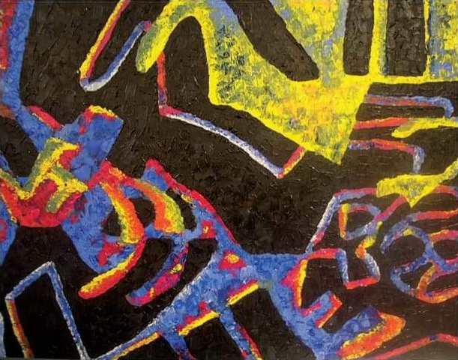
Fig 1. Olivia’s finished piece. 2013.

Thought processes are difficult to explain; Olivia justifies from this piece that making assumptions are easy and the ‘gut feeling’ of knowing if something will work or not is common through practice. A case study (Hickman, R; Kiss, L. 2013) through a phenomenological approach features the cognitive processes of creative students during a five-hour art session. The reflective nature of the observations ensued would provide the students the benefit of developing their abilities in their art making processes through their personal cognitive understanding rather than the processes that can be learned in other areas. Through many theoretically based literatures, it is widely believed that art activities can be classified as being cognitive processes (Dorn, C. 1999). Making decisions through recognition and exploration transforms perception into an important consideration: a fundamental concern for those working in the arts is to create satisfying and expressive relationships with their work.
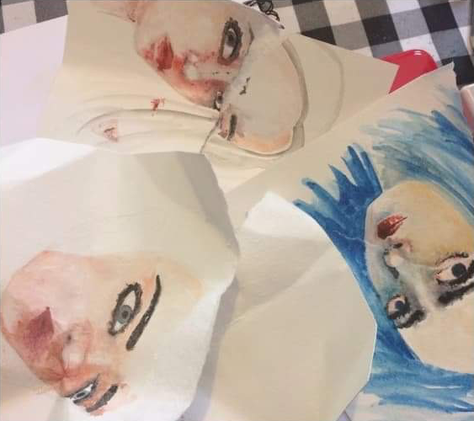
Courage and rebellion will be the essential elements to a successful practice.
Fig 2. Failed attempts at watercolour portraits. 2016. Erika Lancaster.
Rebellion, or otherwise known as ruthlessness can be a disregard of others opinions, walking over the normalities of society or hurting fellow artists in pursuit of creating artwork that is successful. The discussion of whether artists need some of this to make art (Smith, J.M. 2012), is determined by the right amount of appropriate aggression, and syncing this with justice, fondness, and remorse against religious and moral pondering. Sometimes, being rebellious in the artistic world can help us understand what is important to us; to be unique. To be ruthless as a dedicated and ambitious artist is to lack guilt about one’s own callous behaviour regarding their practice. Having courage is a prior step to enabling our rebellious nature. It is courage that helps us push through our psychological conundrums – to show or tell what others may not want to know, to challenge, or to simply reveal bold indifference. Artistic practice requires courage to overcome guaranteed failure (Lancaster, E. 2016) – to see above and beyond.

We all must return to craftsmanship, there is no soul in mass production.
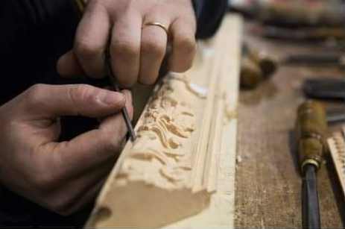
Fig 3. Wood carving wonders. Photo: ©️fuorisalone. 2019.

Production through modernity often refers to the use of technology, which mediates most of our interaction with the world (Openshaw, J. 2015). Technology has its own aesthetic framework that deceives and makes us ignorant to what is already around us. It changes our expectations of the realistic. There are things that technology can not satisfy in artistic practices that traditional methods can – this is true across all subjects, for example: fine art and textiles, where we are asked to observe everything around us for inspiration and influence. Digital media will undoubtedly dominate our future, but there will always be waves of resistance from traditional artists. The term for this is a post-digital mindset, a use of tactile materials often in metal, glass or wood practices. Hand-crafted items retain the spirit and compassion of the artist. Machines take away this feeling from the end product, making it common, temporary, or unoriginal; something easy to buy and something easily replaceable.

Bibliography
Baker, H., 2015. 10 Game-Changing Art Manifestos | Blog | Royal Academy of Arts. [online] Royalacademy.org.uk. Available at: https://www.royalacademy.org.uk/article/ten-game-changing-manifestos [Accessed 5 November 2020].

Hickman, R. and Kiss, L., 2013. Investigating Cognitive Processes within a Practical Art Context: A Phenomenological Case Study Focusing on Three Adolescents. The international journal of art & design education.

Homedecorideas.eu. 2019. The Wonders of The Italian Craftsmanship: Behind the Scenes | Home Decor Ideas. [online] Available at: https://www.homedecorideas.eu/inspirations/wonders-italian-craftsmanship-scenes/ [Accessed 7 November 2020].

Lancaster, E., 2017. Self-Doubt an Artist: How to Stay Confident and Keep Going. [online] Erika Lancaster-Artist, Content Creator & Online Art Tutor. Available at: https://www.erikalancaster.com/art-blog/self-doubt-as-an-artist-how-to-stay-confident-and-keep-going [Accessed 6 November 2020].
Openshaw, J., 2015. Postdigital artisans: craftsmanship with a new aesthetic in fashion, art, design and architecture.

SMITH, J.M., 2012. Ruthlessness and Art-Making. The Virginia Quarterly Review.

List of Figures:

Figure 1. Olivia’s finished piece. (2013) Accessed from: Hickman, R. and Kiss, L., 2013. Investigating Cognitive Processes within a Practical Art Context: A Phenomenological Case Study Focusing on Three Adolescents. The international journal of art & design education.

Figure 2. Failed attempts at watercolour portraits. 2016. Erika Lancaster. Accessed from: https://www.erikalancaster.com/art-blog/self-doubt-as-an-artist-how-to-stay-confident-and-keep-going [Accessed 6 November 2020].

Figure 3. Wood carving wonders. Photo: ©️fuorisalone. 2019. Accessed from: https://www.homedecorideas.eu/inspirations/wonders-italian-craftsmanship-scenes/ [Accessed 7 November 2020].

