Jordan Gibbs

Student Number - 1603358

6007 Assignment

‘A critical evaluation and the identification of next teaching and learning steps focusing on a case study of an individual learner or a group of learners, based on an observed critical incident.’

Word Count – 3870 words

Table of Contents
Introduction 3
Observations 4
Methodology 5
Four Purposes 7
Literature Review 9
Reflection/Evaluation & Next Steps 13
Conclusion 15
References 16
Appendices 17

Introduction

I am going to undertake 4 lesson observations of different year groups and teachers in order to identify techniques used to benefit myself during my teaching career in the future. Whilst undertaking my observation I will fill in the ‘steer document’ to ensure I pick up on relevant points and that my observation is worthwhile with the points I am looking for. I am also going to identify a critical incident in each of my observations. “Critical incidents are not ‘things’ which exist independently of an observer and are waiting for discovery like golden nuggets, or desert islands, but like all data, critical incidents are created” (Tripp, 1993). Critical incidents are important as they allow us to focus on a certain incident/aspect of a lesson and then analyse how they have affected the lesson/learning or how they could’ve affected the lesson/learning if they did not occur. “These incidents appear to be ‘typical’ rather than ‘critical’ at first sight, but are rendered critical through analysis” (Tripp, 2011). This highlights the fact that a critical incident doesn’t have to be anything major, it could be the use of a technique effectively for example and becomes critical in the analysis of how it was implemented.

Critical incidents can be positive or negative. An example of a positive critical incident could be where the teacher did something well, such as using effective questioning to get a pupil to further explain their answer. A negative example could be if a teacher missed out on the chance to use effective questioning, therefore a recommendation could be made for the future to ensure the use of effective questioning and highlight the importance and benefits of doing so.

Observations

An observation is “the action or process of carefully watching someone or something” (Collins Dictionary, 2020). For my observations as previously stated I will carefully be observing the teacher and the teaching thy are undertaking and how they try to develop their pupils with tasks and through their methods of teaching.

When undertaking my observations, I will follow BERA’s 2018 guidelines in relation to anonymity. “The confidential and anonymous treatment of participants’ data is considered the norm for the conduct of research.” (British Educational Research Association (BERA), 2018). This is especially important as when working with children there is a requirement to safeguard them at all times and by keeping them anonymous this will allow for the safeguarding to take place. Not only will I keep children and teachers names anonymous, I will also keep the school anonymous and will not name them at any time.

The school I observed the lessons in is based near the centre of Swansea. As stated in the previous paragraph, I will not be naming the school so I will refer to them as ‘school x’. ‘School x’ is a highly regarded school in Swansea and has strong links with their local community as it is at the heart of what they are aiming to achieve. The critical incident I am focusing on occurred a lesson I observed in the year 6 class of ‘school x’. The year 6 class were being taught a literacy lesson that was being tied into their term topic of pirates. The lesson was still at the start of the new academic year, so even though they would have previously done literacy work in years prior to their start year 6, the aspects they were focusing on might’ve been new to them. The lesson was being taught in the classroom and the teacher was using the whiteboard as a key resource in the lesson. The children as a group seemed very engaged in the lesson and the topic and I think this was aided by the fact it was linked to their topic of Pirates.

Methodology

There are many different observation models, however it is important that the right models are selected for the task. I will be using the non-participant observation method as I will be watching video recordings of lessons in ‘School x’ as I will not being able to attend the school due to the current COVID-19 pandemic and therefore, will not be participating in the lesson in any way and the children will not be aware of the fact I would have observed their lesson.

The type of data I will be looking to collect is qualitative data, as a pose to the other alternative, quantitative data. “Qualitative data can be observed and recorded. This data type is non-numerical in nature.” (QuestionPro, 2020). The data I will be collecting is non-numerical and I will be analysing the teaching and the class behaviours during my observations to identify critical incidents and one key factor of qualitative data is that it is: “exploratory; it involves in-depth analysis and research.” (QuestionPro, 2020), this highlights its importance and relevance to me. The other option of data that I am not going to be collecting is quantitative, this is due to the fact quantitative data is collects numerical data and is defined as: “Data that can be quantified and verified, and is amenable to statistical manipulation.” (Business Dictionary, 2020).

“Case studies are important sources of research data” (Cohen, Manion & Morrison, 2011). There are many strengths to case studies, one of these found again by Cohen, Manion and Morrison is that “They can be undertaken by a single researcher without needing a full research team” (Cohen, Manion & Morrison, 2011). This is a benefit and is one of the reasons I used the case study as a method as it allowed me to complete my tasks fully enough alone without needing to work with a fellow student/partner. It allows me to collect all the data and information I find alone and without the assistance of a team, this is particularly important when identifying critical incidents and what I may consider as a critical incident, another person may not, so this shows the importance of doing it alone as it is specific to my views and teaching for the future.

However, Cohen, Manion and Morrison also found weaknesses in the method of case studies where they stated “They are prone to problems of observer bias” (Cohen, Manion & Morrison, 2011). This shows that by working alone which was one of the strengths, it also allows me to apply a bias that I may not realise I’m doing and therefore can affect the findings of the case study, for example I could go into an observation looking to focus on behaviour management techniques the teacher uses, this could then affect me picking up on anything else such as questioning used by the teacher as I was only focused on behaviour management techniques. Whereas if I was working as part of a team there would be less chance of missing things as more people would be observing.

Four Purposes

When designing the new curriculum for Wales, the four purposes were identified as being important. “The four purposes should be the starting point and aspiration for schools’ curriculum design.” (Hwb Wales, 2020). As shown in (appendix A) the four purposes of the new curriculum are that children and young people develop as:
- Ambitious, capable learners.
- Enterprising, creative contributors.
- Healthy, confident individuals.
- Ethical, informed citizens.

The critical incident I identified was the year 6 teacher in ‘school x’ using effective questioning to get the children to infer as to what an image meant/was for and then justify their answers as to why they thought that. I identified this as a critical incident as rather than just settling for the children’s answers he wanted them to justify their answers and explain it themselves, allowing them to get a deeper understanding through explaining what they thought, along with benefitting the rest of the class as it could change the way they saw the picture. The teacher could have also easily assumed why they thought it and just taken their first answer, but by getting the children to explain their answers it can also develop other things such as their communication skills through explanation but also their confidence of speaking in front of the class too. When I am qualified as a teacher this is something I would look to do myself as I thought it was very effective and helped the children get a deeper understanding.

This critical incident links to the four purposes in many ways. It links to the ambitious capable learners as the children were faced with an image and they were capable of inferring what the image represented and what the image was trying to tell them and then they justified why they thought this and what in the image affected what they thought.

The critical incident also links to enterprising creative contributors as the children are thinking creatively about what the image could be portraying and they are also contributing their thoughts to the class so that others will benefit as they may identify something from the image that no one else has and it can broaden the minds of their peers.

The critical incident links to ethical informed citizens too. It does so as when the children are explaining and justifying their ideas, the rest of the class listen carefully and patiently and respect the views of everyone within the classroom as not once did a child interrupt a peer when they were talking. I liked this and it is something I would want my future classes to do as too often you can see in classrooms children shouting out or talking over others or not listening, you could tell it was something they had been taught throughout school.

Healthy confident individuals were also linked to the critical incident as the children were confident in telling the class their views and what they thought the image meant. This is important as too often children as scared to give their answers in front of the class in case they are branded as being ‘wrong’.

Literature Review

One theory that supports involvement in lessons is by Laevers in 1994. Involvement can come in many ways and one of which if through questioning which is what I have focused on. Laevers (1994) stated that high levels of both well-being and involvement allow children to experience deep learning. This links to my critical incident, the effective use of questioning by the teacher as all the children were involved in the lesson as they all had to infer what they thought from the image that was displayed on the whiteboard. This got them all involved as it was a fun engaging task and they knew they could’ve been the one chosen at random using class dojo to give their justification to the class. This shows the use of effective questioning was beneficial as it allowed the children to gain a deeper learning experience as the questions kept them thinking ‘why’ and kept them involved and engaged in the lesson. However, linking back to Laevers point of well-being and involvement, this could be out of the teachers control as if a child is having issues at home with their family life, it could affect their well-being and concentration in class which could then affect their involvement in the lesson, but if a child has high levels of well-being, it is down to the teacher to ensure their involvement levels are high and one way of doing so is by using questioning as it captures the ideas and views of the children within the class, meaning the child has to stay involved with the tasks as the could be the one who is asked.

The Welsh Assembly Government designed the ‘Developing Thinking and Assessment for Learning Tools and Strategies’ for teachers to be aware of the different ways they can further the learning of their pupil. One of the strategies from the Welsh Assembly Governments’ document was ‘Question Bubbles’. This is where the teacher asks learners high order questions, such as asking them to justify their answers, by asking “But why do you think that?” (Welsh Assembly Government, 2010). Asking ‘Why’ like the teacher did in my critical incident, makes the children think about their answers and gain a deeper understanding, which links to my previous point by Laevers in (1994). The children can get a deeper understanding by explaining as they really have to think about what they know and recall their thoughts, to give a clear explanation to their peers of what they believe. Another benefit to this is that when children justify their answer and explain why they thought this, if they are correct it will give them a confidence boost when it comes to sharing their ideas with the class in future tasks. One way the teacher can help with this is if they agree with what the children are saying and the ideas there are coming up with they can use positive reinforcement and praise such as ‘well done’ or ‘great answer’, as it will stick with the child and they will remember the feeling they had when they were praised in front of the class and they will want to feel this again.

Another one of the strategies from the Welsh Assembly Governments document was ‘Big Questions’. The big questions were designed to help “lead to a greater depth of understanding and therefore a higher level response”. (Welsh Assembly Government, 2010). This can be done by asking open and problem-solving questions, just like the teacher did in the lesson I observed. This shows the teachers effective open questions helped the children get a better understanding as they were explaining their answers aloud to the class, reinforcing it to themselves at the same time, this approach is similar to the ‘Big Questions’ approach as it shows how different types of questions can aid the children’s understanding. With high level responses being developed through a greater depth of understanding, brings benefits to the whole class due to the fact if more pupils are giving a higher-level response then pupils within the class can learn from each other’s responses and develop new ways of thinking if they had come up with an alternative idea originally.

The lesson I observed mirrored Blooms Taxonomy (1956) referring to the six cognitive stages a child will pass through when learning something new (see appendix ‘B’). These are:
- Remember.
- Understand.
- Apply.
- Analyse.
- Evaluate.
- Create.

Throughout the lesson I identified the use of effective questioning and the reinforcement of the importance of the children justifying their answers. When critically analysing the use of effective questioning I realised this had allowed the children to ‘analyse’ and ‘evaluate’ their understanding that they had just improved. As seen above the analysing and evaluating ties into the six stages in Blooms Taxonomy. This gave me an insight of the children passing through the six stages and how they started at stages number one and two, understand and apply, as they inferred what they believed the image was for and then passed through to the ending four and five, analyse and evaluate, as they justified their answers and shared their reasons with the class as to why they thought this. The use of effective questioning allowed for the children to reach the six processes.

As previously stated the Welsh Assembly Government devised the ‘How to develop thinking and assessment for learning in the classroom’ document. Within this document, they also discuss Vygotsky and his theories for learning. They go on to state that more recent research has added to Vygotsky’s theories. One example of this is “Nearly 80% of what children learn, they learn from each other.” (Welsh Assembly Government, 2010). This relates to Vygotsky’s theory of learning as he believed children learned best through their peers. This is relevant in relation to my critical incident of the use of effective questioning, as when the teacher was asking the children to justify their answers and why they thought that way about the images he displayed on the board, when the children explained their ideas aloud to him and the class, it allowed the whole class to learn and develop their thoughts based on what their peers saw and inferred from the image. This could also link to my point made earlier about Laevers (1994) as he discussed involvement. The fact children are allowed to talk and share their views within the classroom will make them more involved in the activities compared to if they were given the image on a piece of paper and were told to just write their views on a piece of paper. By talking aloud, it allows the children to interact with their peers which is more fun and enjoyable for them which will lead to an increase in the involvement in the lesson.

Bronfenbrenner’s Ecological System Theory (1979) refers to the way in which children learn. It is broken down into systems (see appendix ‘C’). Bronfenbrenner referred to the microsystem as “the inner most level is the immediate setting containing the developing person. This can be the home or the classroom” (Bronfenbrenner, 1979). The microsystem impacts the individual through school and home life. This is similar to the previous point of Vygotsky’s theory of learning as he believed children learned best from their peers. My critical incident mirrors this theory as the children were inferring and explaining their answers to the class and their peers as to why they thought that way. By getting the children to do this the teacher has opened up new perspectives for children by making them curious and question their own beliefs as they may not have seen the image in this way and it can lead to them broadening their views and the children can take these inferable skills to other areas of their learning whether that is at home or at school as they may question why something may occur and develop into an inquisitive child/young adult. If the children start to question why something is occurring it is good as it shows they want to further their understanding on the topic/issue.

Reflection/Evaluation & Next Steps

When reflecting on my critical incident I did so through Brookfield’s lens. Brookfield states “Critically reflective practitioners constantly research these assumptions by seeing practice through four complementary lenses: the lens of their own autobiographies as learners of reflective practice, the lens of learners’ eyes, the lens of colleagues’ perceptions, and the lens of theoretical, philosophical, and research literature.” (Brookfield, 1998). By reflecting through the four lenses it has allowed me to understand and consider how the critical incident influenced and effected each individual in the room (the children and the teacher).

On reflection of the critical incident I identified, the use of effective questioning, I believe that the focus on this was worthwhile as it allowed the children to develop their knowledge on the topic as they were able to share ideas and pick up points from what their peers had inferred. This is good as it will broaden the mind of the children when they use their inference skills in the future. Communication skills were also developed, as well as potential for the children’s confidence levels to be boosted, as they were sharing their ideas aloud with the class when chosen at random, linking to the four purposes (healthy confident individuals) and it was incorporated well by the teacher.

One thing that could be done to develop the use of effective questioning could be by getting the children to do the questioning. The children could be put into small groups, where one child becomes the questioner and the rest of the group look at an image and infer what it could be about. The questioner would need to ensure they were using effective questioning when asking the rest of the group what they thought the image was about and asking them to justify and explain why they thought that. This would allow the children to develop their thinking and communication skills rather than the teacher be the questioner. However, one disadvantage of this would be that the children may not understand what an effective question, such as the importance of asking for justification and the use of ‘why’ in the case of my critical incident, so would need to be questioned by the teacher prior to the undertaking of the task so they understood what an effective question is and the information it should gain from the individual/group being questioned.

If I was to do this observation process again I would focus on a weakness in my own teaching skills. Even though effective questioning is something I have become more aware of and I will look to use regularly as a teacher, if I was to repeat the process I would focus on behaviour management techniques used by the teacher so that I my own personal behaviour management could improve as a result as this is an area I feel I need to improve on. However, if I was to focus on this, it could lead to a bias in what I found as I may have been looking for something that wasn’t there or wasn’t relevant if the children were well behaved and adhered to the classroom rules correctly, therefore meaning I may have missed the opportunity to identify other critical incidents.

What I have learnt through this process is that questioning can be used to not only test and understand the knowledge of the individual/group being questioned, but it can also allow other people in the room (peers/teaching staff) to understand things in a different way. This is good as by questioning one individual it doesn’t only help that one child to gain a deeper understanding of their thoughts through their explanations but it will also help the other children as they can listen and process the thoughts of others to influence their own views and their outlook on things in the future.

Conclusion
This assignment falls under the module of ‘Who am I teaching’ and the ways in which I can develop the learning and understanding of the children that step into my classroom when I become a teacher. While looking into the use of effective questioning, my critical incident, I have gained a deeper understanding of the roles of the teacher and the ways in which they can develop the learning of their pupils through different approaches. The use of effective questioning allowed the children to improve their communication skills along with their confidence and their thinking skills. This was good as it allowed children to develop many cross-curricular skills during one task.

By observing the lesson and identifying the critical incident I have linked to the role of an effective practitioner and the new standards set by the Welsh Government for teachers in Wales. It will also help me when I start my first academic placement and prepare me for my first teaching role when I have qualified as I will understand that what I teach needs to be linked to Donaldson’s new curriculum for Wales and the four purposes of the curriculum that were devised as well as taking the opportunity to link tasks to cross-curricular activities so the children can develop in more than one area at once.

References
British Educational Research Association (BERA), 2018. Ethical Guidlines For Educational Research. Fourth ed. London: British Educational Research Association.
Bronfenbrenner, U., 1979. The Ecology of Human Development. Cambridge: Havard University Press.
Brookfield, S., 1998. Critically Reflective Practice. The Journal of Continuing Education in the Health Professions, Volume 18, pp. 197-205.
Business Dictionary, 2020. Quantatitve Data. [Online]
Available at: http://www.businessdictionary.com/definition/quantitative-data.html
[Accessed 01 10 2020].
Cohen, Manion & Morrison, 2011. Research Methods in Education. Seventh Edition ed. London: Routledge.
Collins Dictionary, 2020. Definiton of Observation. [Online]
Available at: https://www.collinsdictionary.com/dictionary/english/observation
[Accessed 30 09 2020].
Hwb Wales, 2020. Developing a vision for curriculum design. [Online]
Available at: https://hwb.gov.wales/curriculum-for-wales/designing-your-curriculum/developing-a-vision-for-curriculum-design/#curriculum-design-and-the-four-purposes
[Accessed 05 10 2020].
Laevers, F., 1994. The Leuven Involvement Scale for Young Children. s.l.:Centre for Experiential Education.
QuestionPro, 2020. Qualitative Data- Definition, Types, Analysis and Examples. [Online]
Available at: https://www.questionpro.com/blog/qualitative-data/
[Accessed 01 10 2020].
Tripp, D., 1993. Critical Incidents in Teaching. First ed. Oxon: Routledge.
Tripp, D., 2011. Critical Incidents in Teaching. Classic Edition ed. London: Taylor & Francis Group.
Welsh Assembly Government, 2010. How to develop thinking and assessment for learning in the classroom, s.l.: Crown.

Appendices

A – Four Purposes

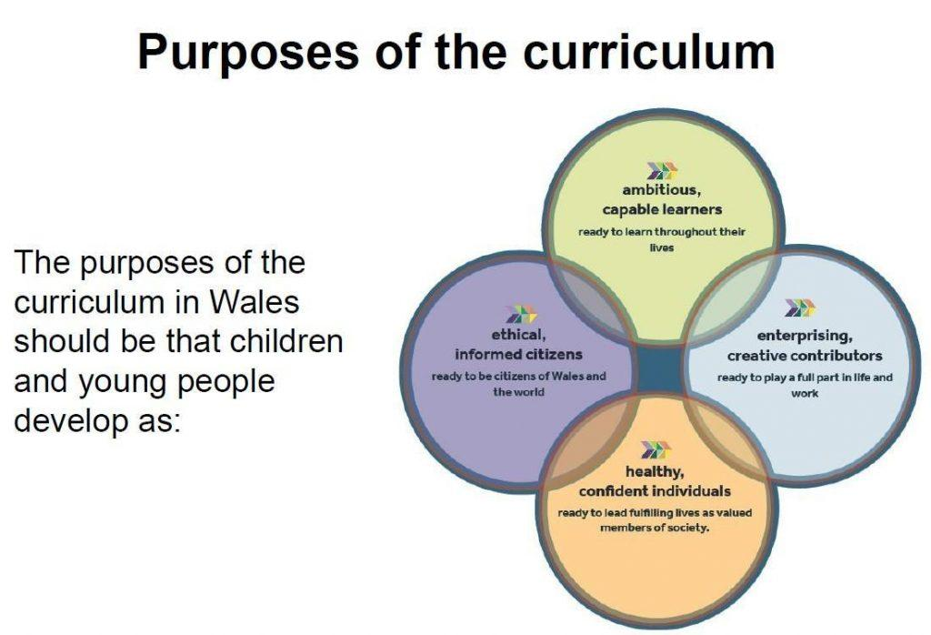

B – Blooms Taxonomy
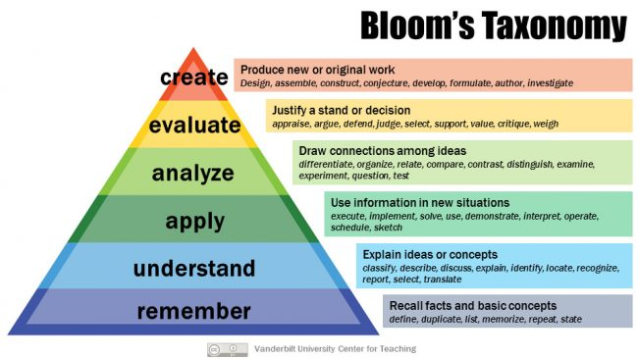

C - Bronfenbrenner’s Ecological System Theory
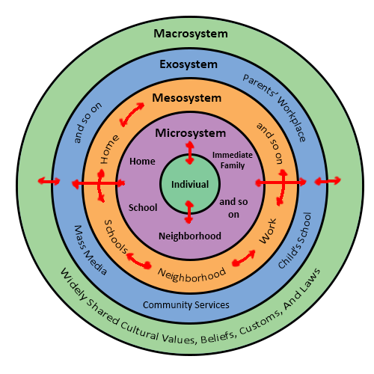

D – Observation/Field Notes Year 5
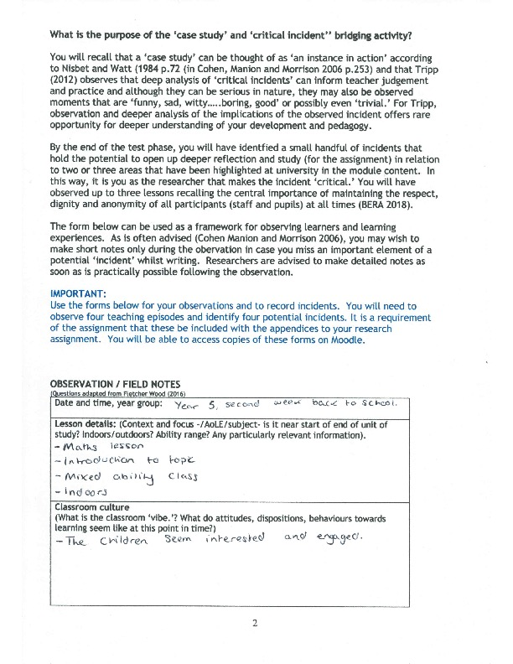

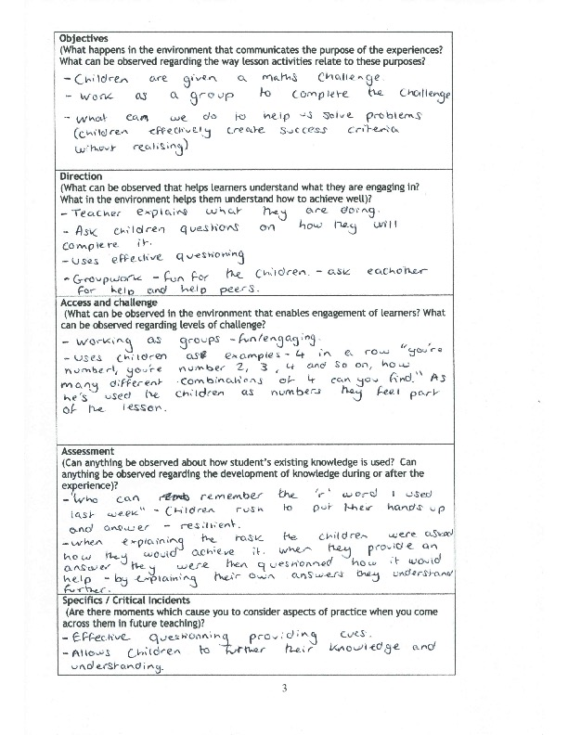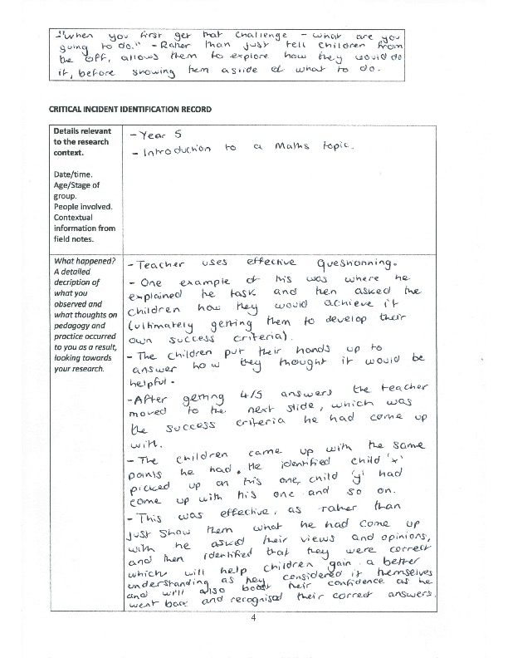

E – Observation/Field Notes Year 6
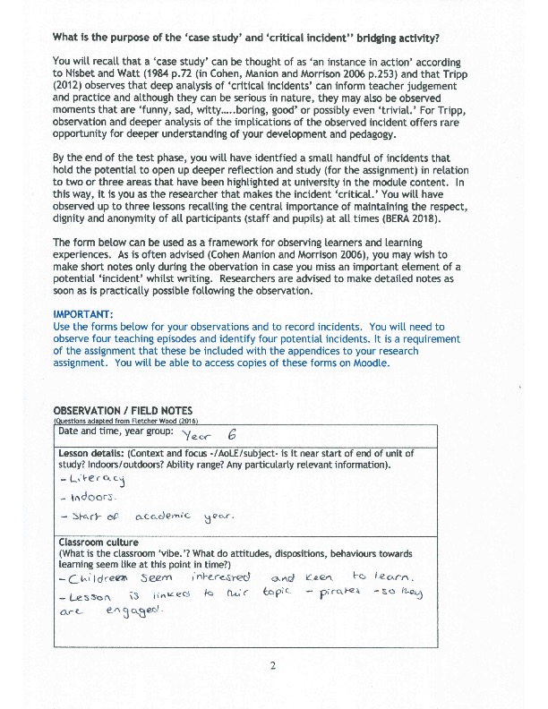
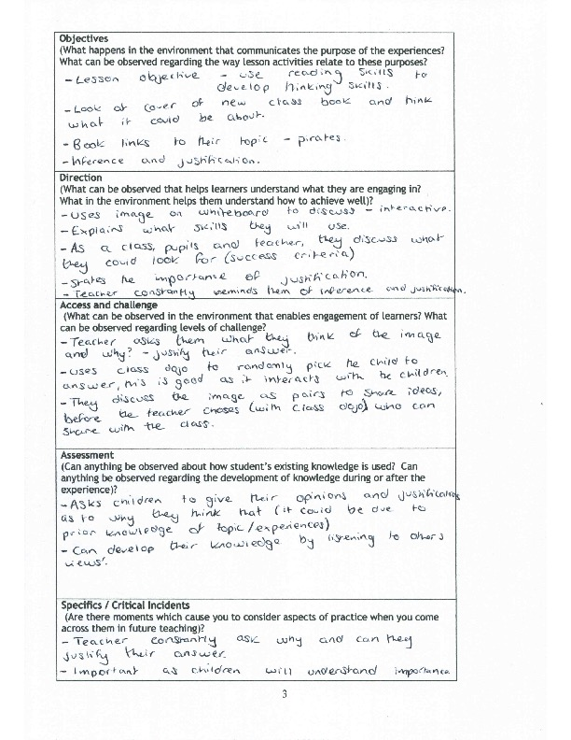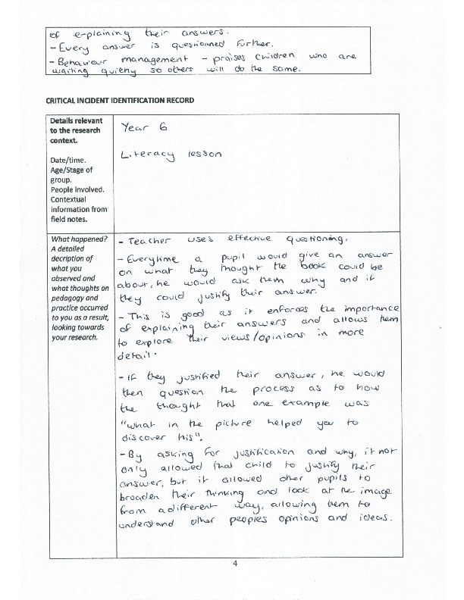

F – Observation/Field Notes Nursery
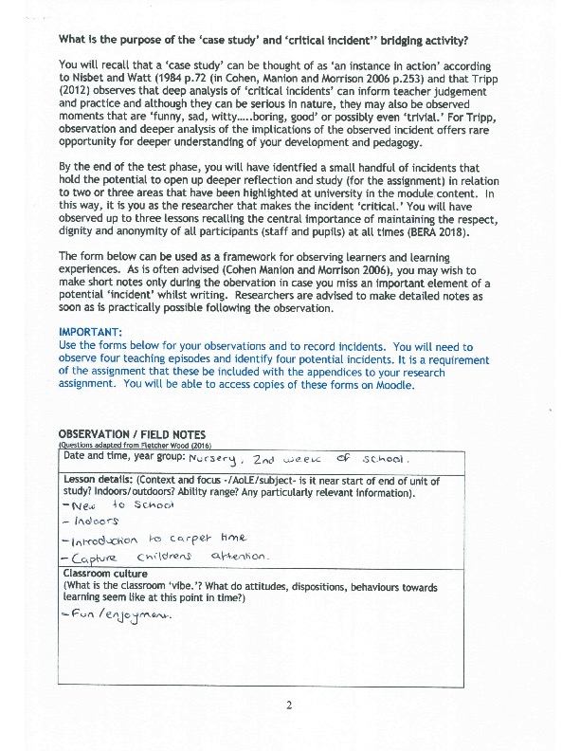
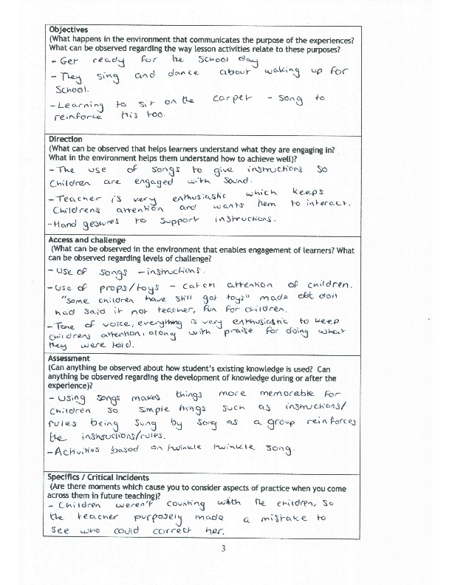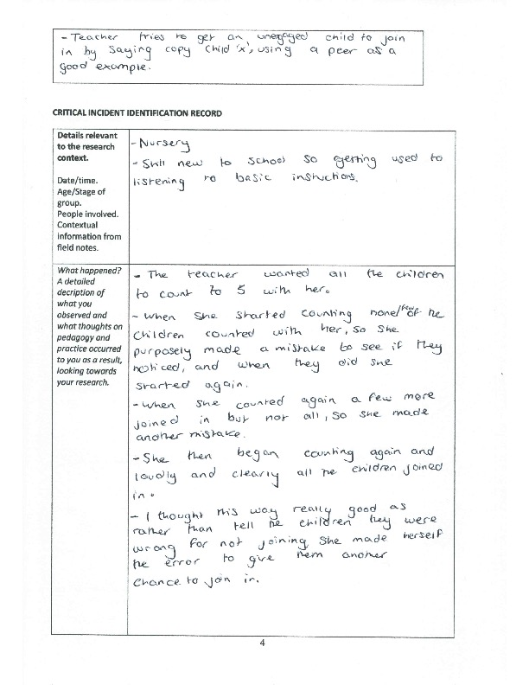

G – Observation/Field Notes Year 1


