University of Wales Trinity Saint David
Wales Institute of Science & Art



Analyse and simulate a mechanical energy recovery system
Stress Analysis and Dynamics ACMA5010

Rhys O’Shea
2415783
November 2025
Word count - 2740

Table of Contents
Table of Contents 2
Table of Figures 4
Table of tables 5
1 Task A 6
1.1 Introduction 6
1.2 Energy Storage in Flywheels 6
1.3 Historical Development of Flywheels 7
1.4 Modern Applications of Flywheels 8
1.4.1 Power grid and renewable integration 8
1.4.2 Industrial applications 9
1.4.3 Transportation 9
1.4.4 Safety and engineering challenges 10
1.5 KERS (Kinetic Energy Recovery Systems) in Road Vehicles 10
1.5.1 Operating Principles in KERS 11
1.5.2 Design Considerations 12
1.5.3 Automotive Adoption 12
1.6 Mechanical Batteries 13
1.6.1 Fundamentals of Mechanical Batteries 13
1.6.2 Mechanical vs Chemical Batteries 13
1.7 Conclusion 14
2 Task B 16
2.1 Question 1 16
2.2 Question 2 16
2.3 Question 3 16
2.4 Question 4 17
2.5 Question 5 18
2.6 Question 6 20
2.7 Question 7 20
2.8 Question 8 23
3 Bibliography 25
4 Appendices 29
4.1 Appendix A – Question 5 Calculations 29
4.1.1 Braking Speed 29
4.1.2 Vehicle KE 30
4.1.3 Energy Requested/Stored in KERS 30
4.1.4 Final Speed in m/s 31
4.1.5 Final Speed in mph 31
4.2 Appendix B – Question 7 Calculations 32
4.2.1 Moment of Inertia 32
4.2.2 Flywheel Angular Speed 32
4.2.3 Flywheel Speed (RPM) 33

Table of Figures

Figure 1 – Potter’s Wheel (Lesley, 2021) 7
Figure 2 - James Watt's Steam Engine (Davies, 2011) 7
Figure 3 - Flywheel Energy Storage System (LaMonica, 2011) 8
Figure 4 - British Rail Class 139 (Network Rail, 2021) 9
Figure 5 - Flywheel KERS Module (Vijayenthran, 2013) 10
Figure 6 - Flywheel KERS System Layout (Vijayenthran, 2013) 11
Figure 7 - Final vehicle speed achieved after re-acceleration vs braking speed. Values computed for a 2080 kg vehicle with a 6.5 kg flywheel and 80% combined efficiency: braking speeds 20–60 mph in 5 mph steps. 19
Figure 8 - Required rotational speed (rpm) of a 4.5 kg thin-ring flywheel vs external diameter (mm) for a 1510 kg vehicle braking at 60 mph. Energy required = 80% of vehicle kinetic energy. 22
Figure 9 – Scatter plot of Moment of Inertia (I)(kg·m²) vs Diameter (mm) vs Rotational Speed of the Flywheel (RPM) (4.5kg flywheel, 60mph braking) 23
Figure 10 - Excel Formula for calculations of Braking Speed 30
Figure 11 - Excel Formula for calculations of Vehicle KE 30
Figure 12 - Excel Formula for calculations of Energy Requested/Stored in KERS 31
Figure 13 - Excel Formula for calculations of Final Speed in m/s 31
Figure 14 - Excel Formula for calculations of Final Speed in Mph 32
Figure 15 - Excel Formula for calculations of Moment of Inertia 32
Figure 16 - Excel Formula for calculations of Flywheel Angular Speed 33
Figure 17 - Excel Formula for calculations of Flywheel Speed in RPM 33

Table of tables
Table 1 – Mechanical vs Chemical Batteries (Ufine, 2025) (The Engineering ToolBox, 2005) (Schaper, 2021) (Epectec, n.d.) (Kesgin, n.d.) (Muelaner, 2022) (Etpa, n.d.) 13
Table 2 – Constants from Previous Questions used (Question 5) 18
Table 3 – Question 5 Calculations 18
Table 4 - Constants from Question used (Question 7) 20
Table 5 – Question 7 Calculations 21

Task A

Introduction
Mechanical energy storage has been instrumental across the development of engineering systems for many centuries. One type of mechanical storage device is the flywheel, which stores kinetic energy using a mass that is in motion and releases that energy when needed (Hagler, 2019). Over time, the concept has evolved from its early use in potter’s wheels to its modern use in compact devices such as in kinetic energy recovery systems (KERS) (Etpa, n.d.). Flywheels serve as a mechanical buffer, absorbing energy changes while supplying short bursts of power, and enabling system efficiency and effectiveness (Etpa, n.d.). In this assignment, the history of flywheels and their transition from potter’s wheels to current applications in regenerative braking and storage of energy on the grid, will be analysed. Additionally, the assignment will discuss KERS as an application in road vehicles, while considering engineering challenges such as rotor balance, materials selection, and containment with high rotational speeds. Finally, a critical comparison will be conducted between chemical batteries versus mechanical batteries (flywheels), analysing their relative advantages and limitations.

Energy Storage in Flywheels
A flywheel stores energy in the form of rotational kinetic energy, and this is expressed by $E=\frac{1}{2}Iω^{2}$, where I is the moment of inertia and ω is the angular velocity of the flywheel (The Engineering ToolBox, 2005). The amount of energy stored increases with both mass and the rotational speed; however, this is limited by the centrifugal stresses present in the flywheel's material, given by $σ=pr^{2}ω^{2}$ , (Nagali, 2024). Modern carbon-fibre composites can be run at higher rotational speeds than traditional steel flywheels due to their superior ratio of strength (tensile strength) to density (Nagali, 2024). When torque is applied to the flywheel, it accelerates and stores energy, and when the torque is reversed, the flywheel releases that energy back through a generator or drivetrain (Schaper, 2021).

Historical Development of Flywheels
The flywheel, one of the earliest mechanical energy storage devices known, has ancient roots. Early civilisations in ancient China, adopted mechanical energy storage forms in potter's wheels (Bender, 2016) illustrated in Figure 1 below. They were highly effect for potters, as they maintained consistent rotational motion (Hagler, 2019), which meant their hands were free to shape clay.

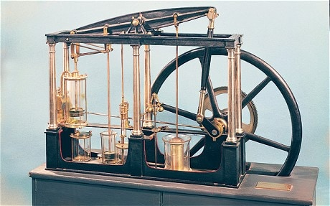
As mechanical systems progressed, flywheels became an important part of engines and machinery during the Industrial Revolution, where their ability to stabilise rotational speed and store excess energy was valuable for steam engines in minimising torque fluctuation and ensuring smooth, consistent motion (Sousa, 2011). James Watt's Steam Engine (shown in Figure 2) was one of the first to incorporate this design.
Figure 1 – Potter’s Wheel (Lesley, 2021)
Figure 2 - James Watt's Steam Engine (Davies, 2011)
By the 19th and early 20th centuries, the flywheel design had evolved right along with increased capabilities of materials and manufacturing. The addition of steel rims and later formed laminated composites allowed for higher rotational speeds and greater storage density while also being substantially lighter in overall weight (Etpa, n.d.). This was a shift from a principal reliance on mass-based energy storage to systems based on engineered structures with several advantages in performance and reliability.
By the mid-20th century, flywheels were surrounded by high precision device engineering with specific usages in power smoothing, energy buffering, and later, high-speed storage systems (Etpa, n.d.). These early stages of development demonstrated the transition into the present form of flywheels now used in hybrid vehicles, renewable energy systems, and kinetic energy recovery systems.

Modern Applications of Flywheels
Originally, flywheels were primarily designed for stabilisation of rotational motion. Whereas modern applications include high-efficiency energy storage and recovery.


Power grid and renewable integration
Figure 3 - Flywheel Energy Storage System (LaMonica, 2011)
Flywheels are now being used as grid-stabilisation devices, especially in systems that depend on intermittent renewable energy sources which rely on short-duration storage. For example, modern flywheel energy storage systems (FESS) such as Beacon Power's installations in the United States, illustrated in figure 3, provide short-duration energy storage to match supply and demand (Beacon Power, n.d.). They can deliver megawatts of power in seconds and serve as a perfect solution for frequency regulation (Beacon Power, n.d.).

Industrial applications
In manufacturing settings, flywheels can provide back-up power and regulate spikes in voltage. For example, uninterruptible power supply (UPS) systems with flywheels allow for instantaneous power while the diesel generator starts and eventually takes over (Active Power, 2024). Unlike chemical batteries, these flywheels will charge and discharge thousands of times without degradation (Active Power, 2024).

Transportation
Flywheel energy storage system technology is also applied to modern rail and road transport. The British Rail Class 139, shown in Figure 4, incorporates a compact steel flywheel to recuperate kinetic energy from braking and enhance fuel efficiency on short-distance routes (WDB Group, n.d.). In a similar manner, the Volvo Flybrid system used in their S60 model, employs a carbon-composite flywheel that provides instantaneous power during accelerations and leads to reduced fuel consumption and emissions during stop/start driving (Vittala, 2014). These examples show how flywheels can provide efficient and high-power energy recovery systems in transport systems.

Figure 4 - British Rail Class 139 (Network Rail, 2021)

Safety and engineering challenges
As modern flywheels frequently operate at very high speeds (20,000–50,000 rpm) to increase energy density (Christian.M, n.d.), advanced containment systems must be built and rigorously tested in the event of mechanical failure due to fractures of the rotor (Etpa, n.d.). These advanced containment structures typically use steel or a carbon-fibre composite for housing (Pichot, 1997) (Green Car Guide, 2019). Therefore, precision balancing, along with minimal friction bearings are crucial to reduce energy losses and increase lifespan (Olabi, 2021).

KERS (Kinetic Energy Recovery Systems) in Road Vehicles
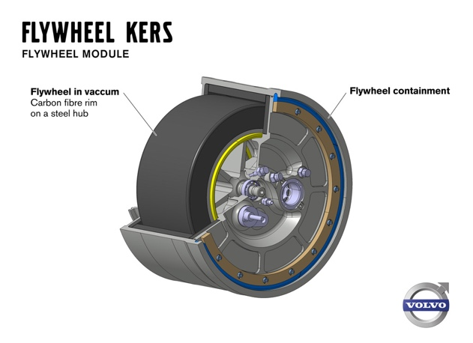
A common use for flywheels is in Kinetic Energy Recovery Systems (KERS). KERS systems capture energy generated when a vehicle decelerates (brakes), store that energy in a flywheel, and release it back into the vehicle's drivetrain when the vehicle accelerates (Bai, 2021). An example of a flywheel KERS module used in Volvo vehicles can be seen in Figure 5 below.
Figure 5 - Flywheel KERS Module (Vijayenthran, 2013)

Operating Principles in KERS
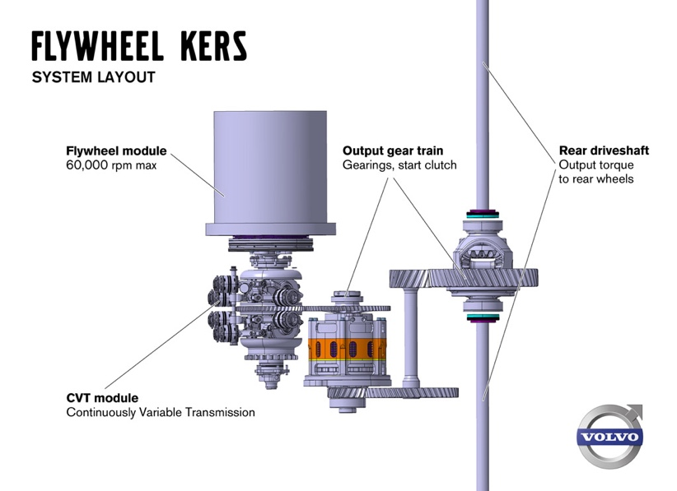
KERS systems capture kinetic energy that would otherwise be lost as heat via braking (Bai, 2021). They do this via a continuously variable transmission (CVT) that connects the flywheel to the vehicle's drivetrain, allowing energy to flow in both directions (Collins, 2011), this is demonstrated in Figure 6. When a vehicle brakes, the torque produced by the vehicle's wheel accelerates the flywheel, and when the vehicle re-accelerates, the process is reversed (Bai, 2021) (Ingram, 2013). A typical flywheel- based KERS will store approximately 150Wh which allows you to accelerate the vehicle at 60 kW for about 6 seconds (Green Car Guide, 2019). KERS theoretically can recover about 80% of the energy, but this recovery is limited by drivetrain and bearing losses (Etpa, n.d.).
Figure 6 - Flywheel KERS System Layout (Vijayenthran, 2013)

Design Considerations

Precision balancing
Flywheels for KERS typically rotate in excess of 50,000 rpm (Christian.M, n.d.). At those speeds, even a minor degree of imbalance will result in significant centrifugal forces, and therefore it is necessary to machine tolerances to nanometre level to ensure perfect rotor symmetry, minimise vibration, and prevent failure (Nagali, 2024) (Etpa, n.d.).

Containment
Due to such high rotational speeds, the flywheel should be sufficiently contained in high-strength composite or steel enclosures in order to withstand the potential rotor disintegration, which may release forces to those comparable in explosive devices (Green Car Guide, 2019).

Materials
Traditional steel flywheels are very heavy and therefore have limited maximum speed (Etpa, n.d.). Whereas modern KERS utilise carbon-fibre composites which preserve high tensile strength while reducing density, this therefore allows them to yield more stored energy per unit of mass (Green Car Guide, 2019).

Automotive Adoption

Formula 1
In 2009, FIA permitted the use of KERS, and teams such as Williams began developing flywheel-based systems (BBC, 2024) (Sousa, 2011). Most teams opted for battery-electric storage for KERS, but the flywheel KERS created by Williams went on to be used in hybrid buses and vehicles.

Road Vehicles
The Porsche 911 GT3 Hybrid (2010) was fitted with a flywheel KERS to allow bursts of power to be used during racing (Sousa, 2011). Additionally, both Volvo and Jaguar Land Rover have been trialling these systems in passenger vehicles, which have demonstrated fuel savings of 15–20% (Adcock, 2014).

Public Transport
Buses equipped with flywheel KERS reduce fuel consumption and emissions, especially during stop and go driving cycles in urban environments. According to Epta, (Etpa, n.d.) these are also employed in Subway systems in Rennes, France, which yield the same benefits.

Mechanical Batteries

Fundamentals of Mechanical Batteries
Mechanical batteries (Flywheels) accumulate energy using motion or potential energy as previously described, they do this instead of relying on any kind of chemical reaction, converting mechanical work into kinetic energy before releasing the energy when needed to produce fast, effective energy use and delivery (Ufine, 2025) (Etpa, n.d.).

Mechanical vs Chemical Batteries
Table 1 – Mechanical vs Chemical Batteries (Ufine, 2025) (The Engineering ToolBox, 2005) (Schaper, 2021) (Epectec, n.d.) (Kesgin, n.d.) (Muelaner, 2022) (Etpa, n.d.)
Characteristic | Flywheel (Mechanical) | Lithium-Ion (Chemical)
Energy Density | 5-100 Wh/kg | 150 Wh/kg
Power Density | 400-30,000 W/kg | 200-900 W/kg
Efficiency | 85%-95% | 90%-95%
Cycle Life | 10,000-100,000 cycles | 500 – 3,000 cycles
Response Time | Milliseconds | Seconds
Sustainability | Recyclable | Toxic metals, poor recyclability

As shown in Table 1 above, Mechanical batteries such as flywheels, offer several distinct advantages over chemical batteries. Firstly, mechanical systems demonstrate extreme durability and longevity, achieving often over 20 years and tens of thousands of cycles without loss of performance due to not depending upon any chemical reactions that degrade over time (Active Power, 2024). Mechanical systems are therefore very well suited for long-term reliable applications and require minimal maintaining over long periods. Secondly, mechanical storage devices provide instantaneous energy delivery and recovery. They can rapidly charge and discharge, allowing fast charge-discharge cycles which chemical batteries cannot deliver.
Furthermore, as mechanical batteries have a high-power density, it means they are better suited for applications that need short powerful bursts of energy, such as grid stabilisation or regenerative braking. Mechanical batteries are also environmentally sustainable, in that they would not use any toxic or rare materials, creating no chemical waste, thus reducing lifecycle environmental impacts compared to lithium batteries. Additionally, although energy density is lower, mechanical systems can offset this through high round trip efficiencies (85-95%), quick responses to demand or dispatch, and scalability for large-scale energy storage. Therefore, combining all these features, flywheels and other mechanical batteries can provide a substantial option for environmentally responsible energy systems where rapid response and long lifespan is more critical than size.

Conclusion
The flywheel is among the oldest and most primitive forms of mechanical energy storage, having developed from use in pottery, into hybrid road vehicles, formula 1 racing and renewable energy integration. While the principle has remained the same, storing energy through rotational motion energy, technological development in materials, containment and precision manufacturing has allowed the flywheel to be recognised as a viable option in energy storage. Within the transport sector, flywheel based kinetic energy recovery systems (KERS), have demonstrated an ability to provide a meaningful efficiency increase within motorsport, bus transport, and passenger vehicles. Whereas in larger scale systems, flywheels provide significant support in renewable energy grids by supplying fast-acting power. When comparing to chemical batteries, flywheels have unique characteristics such as extremely long cycle life, high efficiency, fast-acting power and lower environmental implications. Current limitations with flywheels preventing widespread use include the high containment costs associated, with also a relatively low energy density. In time, however, it is likely that the future systems of storage will utilise flywheels, in conjunction with batteries, in a more hybrid approach. The flywheel, therefore, stands as both an ancient invention and a modern engineering solution and is the perfect example of how mechanical principles continue to shape technological advancements.

Task B

Question 1
Vehicle Mass = 2080kg
Initial Braking Speed = 55mph
$$1\text{mph = 0.447m/s ∴ 55×0.447 = 24.587 m/s }$$
$$\text{KE=}\frac{1}{2}×mv^{2}$$
$$\text{∴ KE of the vehicle before braking}=\frac{1}{2}×2080×{(24.587)}^{2}=628,701.392\text{J}$$

Question 2
Combined Efficiency = 80%

$$\text{Efficiency = }\frac{\text{Energy Output}}{\text{Total Energy}} ∴ \text{Energy Output}= \text{Efficiency × Total Energy}$$
$$0.8 ×628701.392=502,961.114\text{J}$$
Therefore, Energy Stored in the flywheel when the vehicle brakes from 55mph to rest = $502,961.114\text{J}$

Question 3
Flywheel mass = 6.5kg
External $∅$ = 300mm $∴ r=150\text{mm } =0.15\text{m}$
$$\text{Flywheel moment of Inertia (Thin Ring) = }I=mr^{2}$$
$$I=6.5 × {0.15}^{2}=0.14625 \text{kg}.{\text{m}}^{2}$$

$$\text{Rotational KE = }\frac{1}{2}Iω^{2} ∴ ω=\sqrt{\frac{2×E}{I}}$$
$$ω=\sqrt{\frac{2×502961.114}{0.14625} }=2622.613 \text{rad/s}$$
$$\text{rpm }= ω× \frac{60}{2π}$$
$$2622.613× \frac{60}{2π}=25044.113\text{ rpm}$$
Therefore, Rotational Speed of the flywheel after braking = $25044.113\text{ rpm}$

Question 4
Assuming stored energy is used to re-accelerate the flywheel, E = 502961.114 J
$$\text{Using} \text{KE =}\frac{1}{2}×mv^{2} ∴ v= \sqrt{\frac{2 × E}{m}}$$
$$v= \sqrt{\frac{2 × 502961.114}{2080}}=21.991\text{m/s}$$
$$\frac{21.991}{0.447}= 49.197 \text{mph}$$
Therefore, final speed of the vehicle using only the KERS flywheel = 21.991 m/s

Question 5
Table 2 – Constants from Previous Questions used (Question 5)
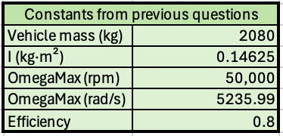
Given the constants from previous questions and the vehicle specification, shown in Table 2 above. These values were used in different equations to find the final speed after re-acceleration using the KERS, these calculations are displayed in Table 3. To streamline calculations, formulas were used in excel. These calculations and formulas were first proved manually using braking speed of 20 mph, before applied through the braking increments, these calculations/formulas can be found in Appendix A.

Table 3 – Question 5 Calculations
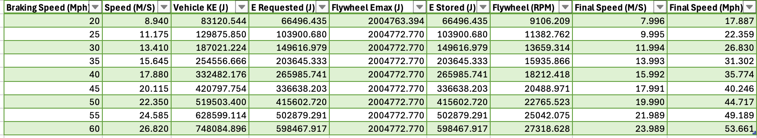
The braking speed was then plotted against final speed after re-acceleration, which can be seen in Figure 7 below.

Figure 7 - Final vehicle speed achieved after re-acceleration vs braking speed. Values computed for a 2080 kg vehicle with a 6.5 kg flywheel and 80% combined efficiency: braking speeds 20–60 mph in 5 mph steps.
On the scatter graph, illustrated in Figure 7, it can be seen that as the braking speed rises, the kinetic energy available for energy recovery also increases proportional to the square of the velocity (KE$\text{=}\frac{1}{2}×mv^{2}$). Therefore, the higher the braking speed, the more energy that can be stored in the flywheel, which in turn allows the vehicle to achieve higher speeds after re-acceleration. However, while this relationship generates greater increases at higher speeds, it is not a linear relationship. This is due to the final velocity being determined by the square root of the stored energy, $v_{f}=v\sqrt{η}$ (derived from energy equation), therefore the rate of increase in re-acceleration diminishes as braking speed rises. An example of this, is that after braking at 20mph, using the stored energy, re-acceleration will be to 17.9mph a 2.1mph difference. Whereas if braking at 60mph, re-acceleration after using stored energy is 53.7mph, a 6.3mph difference. Additionally, there is greater losses in real systems due to factors like drivetrain losses, bearing friction and drag which restricts the efficiency of energy recovery (Etpa, n.d.), therefore the actual increases will be less than the theoretical increases shown in Figure 7.
In summary, by increasing the braking speed, the vehicle's re-acceleration improves, however with diminishing proportional returns due to efficiency and system losses. This effect explains why hybrid cars better fuel economy in city have driving than on the motorway, due to the fact that slow speeds with frequent braking can take advantage of regenerative energy recovery systems to a much greater extent (Ingram, 2013).

Question 6
Using the 60mph case for the 2080kg vehicle:
$$v=53.661\text{mph}=23.989\text{m/s}$$
If final speed is attained in 6.5 seconds:
$$\text{t}=6.5$$
$$∴$$
$$a=\frac{v}{t} ∴ a=\frac{23.989}{6.5}=3.6906 m/s^{2}$$
Therefore, the average acceleration is 3.69 $m/s^{2}$

Question 7
Table 4 - Constants from Question used (Question 7)
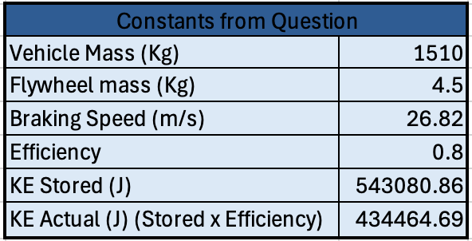
Given the constants/vehicle specification given in the question, shown in Table 4 above. These values were used in different equations to calculate the Moment of Inertia, to then subsequently calculate the flywheels angular speed and the flywheels speed in RPM, for the range of different external diameters. These calculations are shown in Table 5. To streamline calculations, formulas were used in excel. These calculations and formulas were first proved manually using external diameter of 120mm, before applied through the diameter increments, these calculations/formulas can be found in Appendix B.
Table 5 – Question 7 Calculations
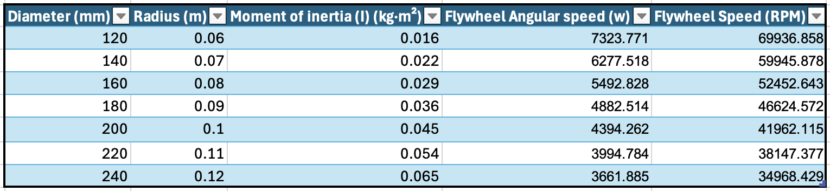
The results were then plotted as a scatter graph, Rotational Speed of the Flywheel against the External Diameter of the Flywheel and can be seen in Figure 8 below.

Figure 8 - Required rotational speed (rpm) of a 4.5 kg thin-ring flywheel vs external diameter (mm) for a 1510 kg vehicle braking at 60 mph. Energy required = 80% of vehicle kinetic energy.
The graph shown in Figure 8 above, demonstrates that as the external diameter of the flywheel varies from 120 mm to 240 mm, the required speed to store the equivalent amount of braking energy becomes significantly less. This is because the moment of inertia increases with the radius squared, as illustrated in Figure 9 below. Therefore, a larger flywheel will store more energy at lower angular velocities. Small flywheels, on the other hand, would need to be spun significantly faster in order to store the same amount of energy as the larger ones. In practice, however, this is limited by the maximum speed of the flywheel, for the larger vehicle (relevant for Questions 1-6), this is 50,000 rpm as stated in the specification. If the flywheel spins beyond its maximum speed, excessive centrifugal stresses develop, and mechanical failure or containment issues would occur (Green Car Guide, 2019) (Bryce, 2024).
The graph shows that diameters of 120 mm to 160 mm exceed the larger vehicle's maximum allowable speed and therefore are not a suitable option (for the larger vehicle), while flywheels of 170 mm or more will operate at reasonable operational speeds so will be suitable, but will require larger, heavier containment systems. Although smaller diameter flywheels are lighter and more compact, they require much higher speeds that may exceed the safe limits, thus larger diameters would be more practical KERS applications in terms of both materials and safety margins (Bryce, 2024).
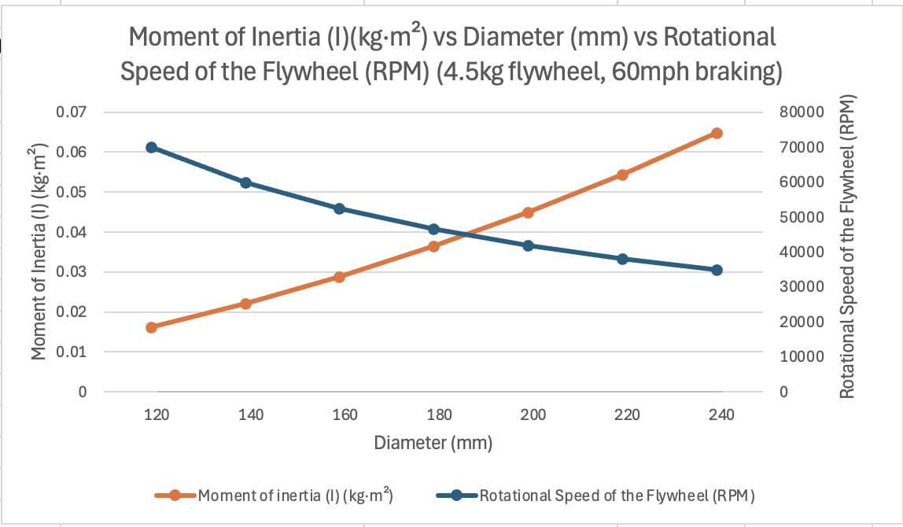
Figure 9 – Scatter plot of Moment of Inertia (I)(kg·m²) vs Diameter (mm) vs Rotational Speed of the Flywheel (RPM) (4.5kg flywheel, 60mph braking)

Question 8
In the analyses presented in Questions 1 to 7, several assumptions were made to allow consistent calculations. Firstly, the motion of the vehicle was assumed to occur on a flat surface, with no aerodynamic drag or rolling resistance considered, as well as drivetrain and tyre slip losses also being neglected (Etpa, n.d.). This ensured that any changes in kinetic energy were entirely due to braking and then re-acceleration using the KERS system. Additionally, the KERS energy transfer between the vehicle and the flywheel was treated as ideal, aside from the combined 80% efficiency (the cumulative mechanical and transmission losses during the braking and acceleration). The flywheel was also considered to be of thin-ring shape as stated in the specification and thus, the moment of inertia could be defined as, $I=mr^{2} ,$ for simplified rotational energy calculations.
Furthermore, Material strength limitations were ignored except where the 50,000-rpm design constraint was applied. As the system was assumed to operate in a vacuum chamber (as stated in the specification), Heat loss due to bearing friction, air drag, and electrical conversion were ignored (Bryce, 2024). Similarly, the re-acceleration phase also assumed 100% traction, so there was no wheel slip or loss in the drivetrain efficiency factor, apart from the combined efficiency factor (Bryce, 2024).
Moreover, in all calculations the vehicle mass was assumed constant and that energy storage or recovery took place instantaneously with no time delay. In addition, energy losses related to auxiliary systems were not considered. These simplifications generate an idealistic system performance, as real-world energy recovery would be reduced due to resistive/thermal losses that are not taken into account with the theoretical model.

Bibliography
Active Power, 2024. Optimizing Energy Storage: Unveiling the Advantages of Flywheel UPS Systems over Chemical Batteries. [Online]
Available at: https://www.activepower.com/wp-content/uploads/2024/04/Optimizing-Energy-Storage.pdf
[Accessed 5 November 2025].
Adcock, I., 2014. Volvo Flybrid KERS technology. [Online]
Available at: https://www.just-auto.com/features/analysis-volvo-flybrid-kers-technology/?cf-view
[Accessed 6 November 2025].
Bai, S., 2021. Science Direct. [Online]
Available at: https://www.sciencedirect.com/topics/engineering/kinetic-energy-recovery-system#:~:text=13.,almost%2033%25%20%5B104%5D.
[Accessed 6 November 2025].
BBC, 2024. 2009 BBC F1 explanation of KERS & look at Williams flywheel system. [Online]
Available at: https://www.youtube.com/watch?v=SswAHQGaUiA&t=84s
[Accessed 6 November 2025].
Beacon Power, n.d. Flywheel Energy Storage Systems. [Online]
Available at: https://beaconpower.com/wp-content/themes/beaconpower/inc/beacon_power_brochure_032514.pdf
[Accessed 5 November 2025].
Bender, D., 2016. Storing Energy. [Online]
Available at: https://www.sciencedirect.com/topics/engineering/engine-flywheel
[Accessed 5 November 2025].
Bryce, E., 2024. Flywheel Energy Storage: A Promising Alternative to Batteries for Balancing Solar Power. [Online]
Available at: https://www.bryceenergyservices.com/2024/10/05/flywheel-energy-storage-a-promising-alternative-to-batteries/
[Accessed 11 November 2025].
Christian.M, n.d. Flywheel Energy Storage. [Online]
Available at: https://www.aquaswitch.co.uk/blog/flywheel-energy-storage/
[Accessed 6 November 2025].
Collins, S., 2011. Flywheel hybrid systems (KERS). [Online]
Available at: https://www.racecar-engineering.com/articles/f1/flywheel-hybrid-systems-kers/
[Accessed 6 November 2025].
Davies, A. H., 2011. James Watt: Britain's head of steam. [Online]
Available at: https://www.telegraph.co.uk/news/science/8367976/James-Watt-Britains-head-of-steam.html
[Accessed 5 November 2025].
Epectec, n.d. Battery Cell Comparison. [Online]
Available at: https://www.epectec.com/batteries/cell-comparison.html
[Accessed 14 October 2025].
Etpa, n.d. Flywheel Energy Storage. [Online]
Available at: https://www.etpa.nl/knowledge-base/technology/flywheel-energy-storage
[Accessed 5 November 2025].
Green Car Guide, 2019. VOLVO’S FLYWHEEL KERS PUTS A NEW SPIN ON HYBRID CARS. [Online]
Available at: https://www.greencarguide.co.uk/features/volvos-flywheel-kers-puts-a-new-spin-on-hybrid-cars/
Hagler, G., 2019. Flywheels. [Online]
Available at: https://www.ebsco.com/research-starters/engineering/flywheel
[Accessed 5 November 2025].
Ingram, A., 2013. Volvo Flywheel Hybrid System (aka KERS) Tests Completed Successfully. [Online]
Available at: https://www.greencarreports.com/news/1083772_volvo-flywheel-hybrid-system-aka-kers-tests-completed-successfully#:~:text=According%20to%20our%20sister%20site,GreenCarReports%20on%20Facebook%20and%20Twitter.
[Accessed 6 November 2025].
Kesgin, M. G., n.d. Overview of Flywheel Systems for Renewable Energy Storage with a Design Study for High-speed Axial-flux Permanent-magnet Machines. [Online]
Available at: https://sparklab.engr.uky.edu/sites/spark/files/2019%20IEEE%20ICRERA%20UKSpark%20Overview%20Flywheel.pdf?utm_source=chatgpt.com
[Accessed 14 October 2025].
LaMonica, M., 2011. Flywheel storage maker Beacon Power declares bankruptcy. [Online]
Available at: https://www.cnet.com/culture/flywheel-storage-maker-beacon-power-declares-bankruptcy/
[Accessed 6 November 2025].
Lesley, 2021. Potter’s Wheel History | How Ancient Pottery Wheels Evolved. [Online]
Available at: https://thepotterywheel.com/potters-wheel-history/
[Accessed 15 October 2025].
Muelaner, J., 2022. What to consider when evaluating battery performance. [Online]
Available at: https://www.batterypowertips.com/what-to-consider-when-evaluating-battery-performance-faq/?utm_source=chatgpt.com
[Accessed 14 October 2025].
Nagali, G. S., 2024. Design of flywheel energy generation system. Intellectual Journal of Energy Harvesting and Storage, 2(2), pp. 96-104.
Network Rail, 2021. The two unique Class 139 Parry People Movers which serve the Stourbridge town branch line. [Online]
Available at: https://www.networkrailmediacentre.co.uk/resources/kisve-renx9-mxv8o-cct24-n15uw
[Accessed 6 November 2025].
Olabi, A. G., 2021. Critical Review of Flywheel Energy Storage System. [Online]
Available at: https://www.researchgate.net/publication/350838094_Critical_Review_of_Flywheel_Energy_Storage_System
[Accessed 6 November 2025].
Pichot, M. A., 1997. The Flywheel Battery Containment Problem. Journal of Passenger Cars, Volume 106, pp. 380-389.
Schaper, A., 2021. Flywheel Energy Storage. [Online]
Available at: https://schaperintl.com/flywheel-energy-storage/
[Accessed 14 October 2025].
Sousa, L. d., 2011. Energy storage – flywheel. [Online]
Available at: https://www.resilience.org/stories/2011-10-05/energy-storage-flywheel/
[Accessed 11 November 2025].
The Engineering ToolBox, 2005. Flywheels - Kinetic Energy. [Online]
Available at: https://www.engineeringtoolbox.com/flywheel-energy-d_945.html
[Accessed 14 October 2025].
Ufine, 2025. Comparing Mechanical Batteries and Lithium Batteries: Which Is Right for Your Application?. [Online]
Available at: https://www.ufinebattery.com/blog/comparing-mechanical-batteries-and-lithium-batteries-which-is-right-for-your-application/
[Accessed 14 October 2025].
Vijayenthran, V., 2013. Volvo Completed tests of KERS, Confirms Fuel Savings of 25 Percent. [Online]
Available at: https://www.motorauthority.com/news/1083745_bmw-to-offer-solar-powered-charging-systems-to-ev-customers
[Accessed 6 November 2025].
Vittala, M., 2014. Volvo: Kers is better than batteries. [Online]
Available at: https://www.businesscar.co.uk/analysis/volvo-kers-is-better-than-batteries/?cf-view
[Accessed 6 November 2025].
WDB Group, n.d. Stourbridge Hybrid Engine Flywheel. [Online]
Available at: https://wdbgroup.co.uk/blog/stourbridge-hybrid-engine-flywheel/
[Accessed 6 November 2025].

Appendices

Appendix A – Question 5 Calculations

Braking Speed
Braking speed = 20mph, therefore converted to m/s =
$$20 × 0.447=8.94 m/s$$
Excel Formula for calculations is shown in Figure 10 below.
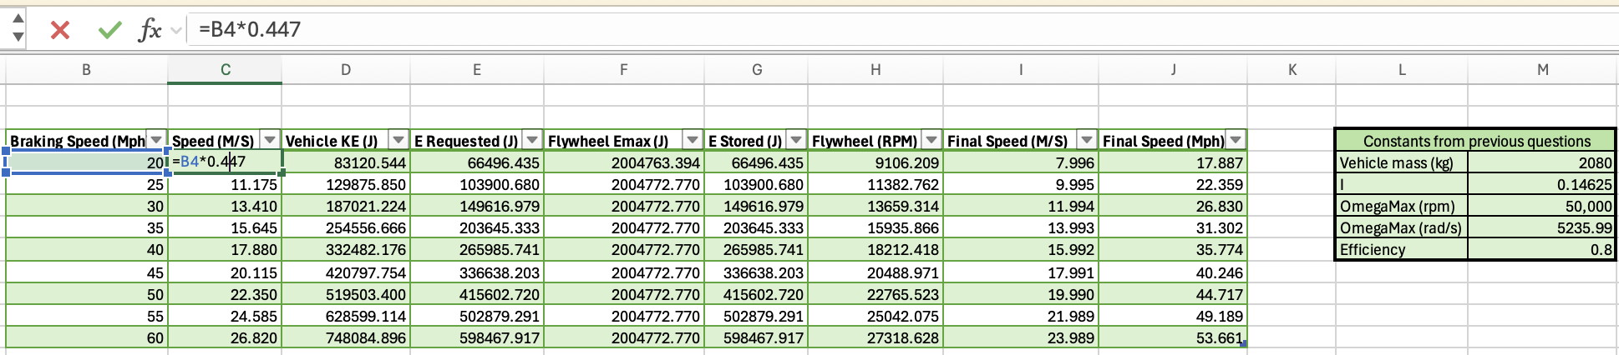
Figure 10 - Excel Formula for calculations of Braking Speed

Vehicle KE
$$\text{KE=}\frac{1}{2}×mv^{2}$$
$$KE=\frac{1}{2}×2080×{(8.94)}^{2}=83120.544\text{J}$$
Excel Formula for calculations is shown in Figure 11 below.
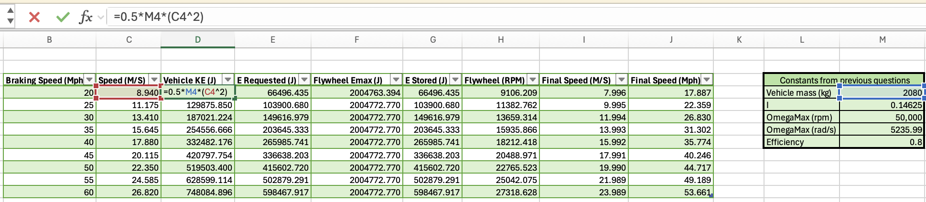
Figure 11 - Excel Formula for calculations of Vehicle KE

Energy Requested/Stored in KERS
$$\text{Energy Output}= \text{Efficiency × Total Energy}$$
$$0.8 ×83120.544 =66496.435\text{J}$$
Excel Formula for calculations is shown in Figure 12 below.
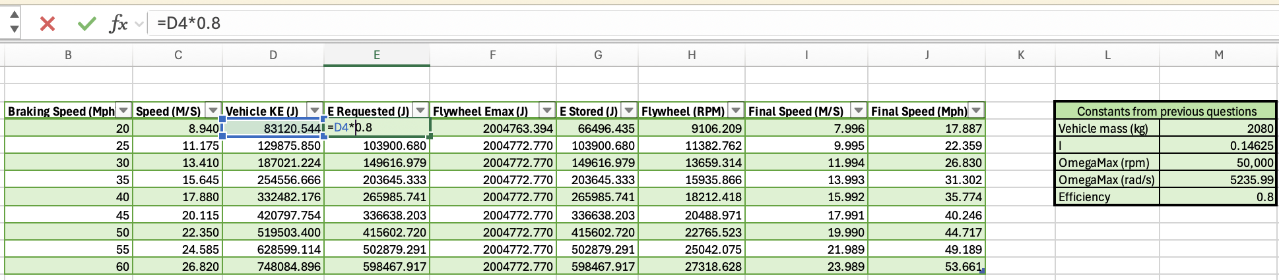
Figure 12 - Excel Formula for calculations of Energy Requested/Stored in KERS

Final Speed in m/s
$$v= \sqrt{\frac{2 × E}{m}}$$
$$v= \sqrt{\frac{2 × 66496.435}{2080}}=7.996\text{m/s}$$
Excel Formula for calculations is shown in Figure 13 below.
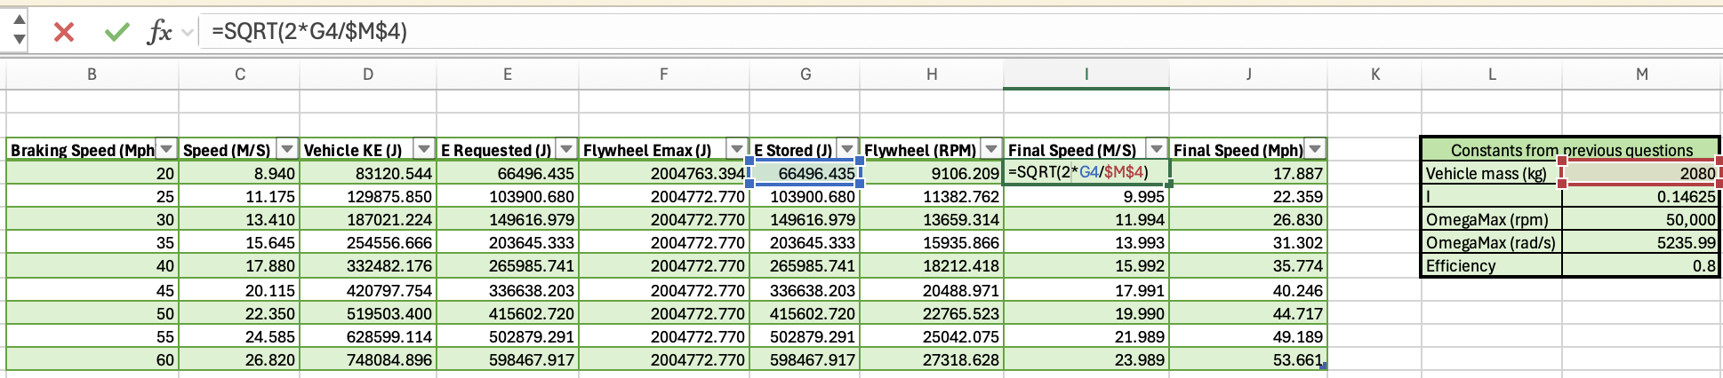
Figure 13 - Excel Formula for calculations of Final Speed in m/s

Final Speed in mph
$$\frac{7.996}{0.447}= 17.887 \text{mph}$$

Excel Formula for calculations is shown in Figure 14 below.
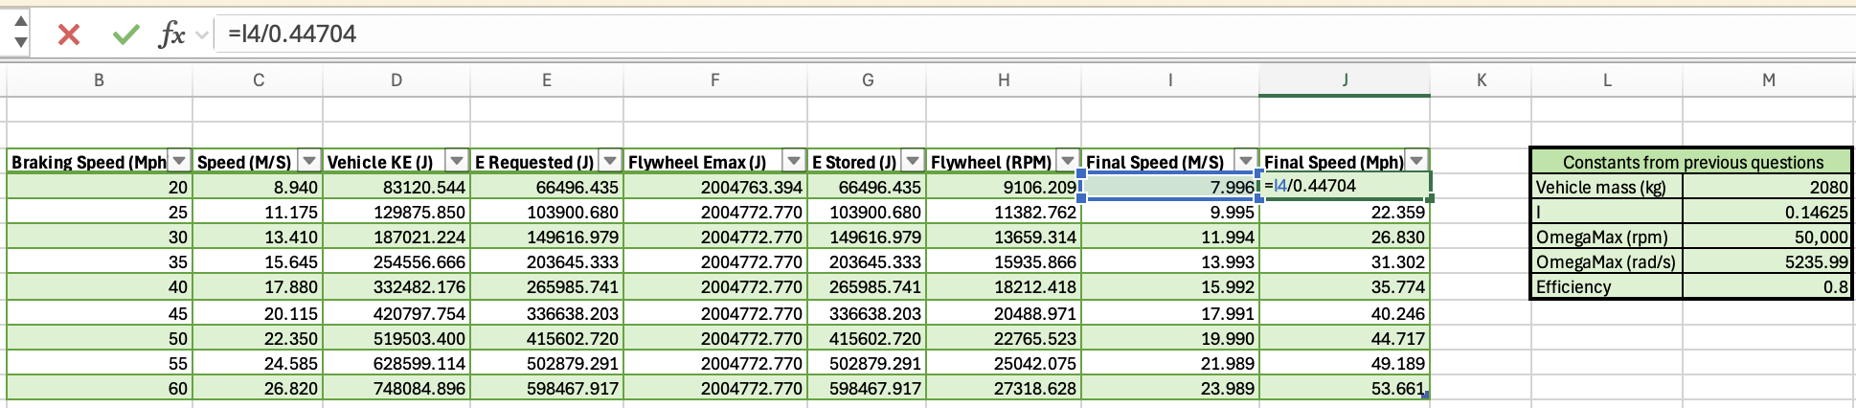
Figure 14 - Excel Formula for calculations of Final Speed in Mph

Appendix B – Question 7 Calculations

Moment of Inertia
$$\text{Flywheel moment of Inertia (Thin Ring) = }I=mr^{2}$$
$$I=4.5 × {0.06}^{2}=0.0162 \text{kg}.{\text{m}}^{2}$$
Excel Formula for calculations is shown in Figure 15 below.
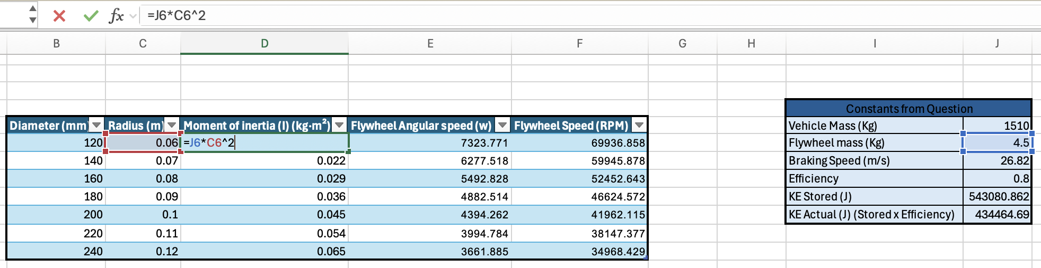
Figure 15 - Excel Formula for calculations of Moment of Inertia

Flywheel Angular Speed
$$\text{Rotational KE = }\frac{1}{2}Iω^{2} ∴ ω=\sqrt{\frac{2×E}{I}}$$
$$ω=\sqrt{\frac{2×4344664.69}{0.0162} }=7323.770 \text{rad/s}$$
Excel Formula for calculations is shown in Figure 16 below.
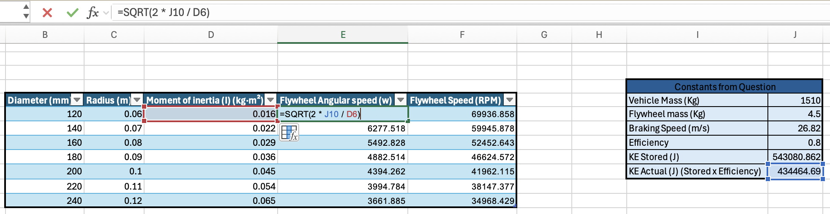
Figure 16 - Excel Formula for calculations of Flywheel Angular Speed

Flywheel Speed (RPM)
$$\text{rpm }= ω× \frac{60}{2π}$$
$$7323.770× \frac{60}{2π}=69936.858\text{ rpm}$$
Excel Formula for calculations is shown in Figure 17 below.
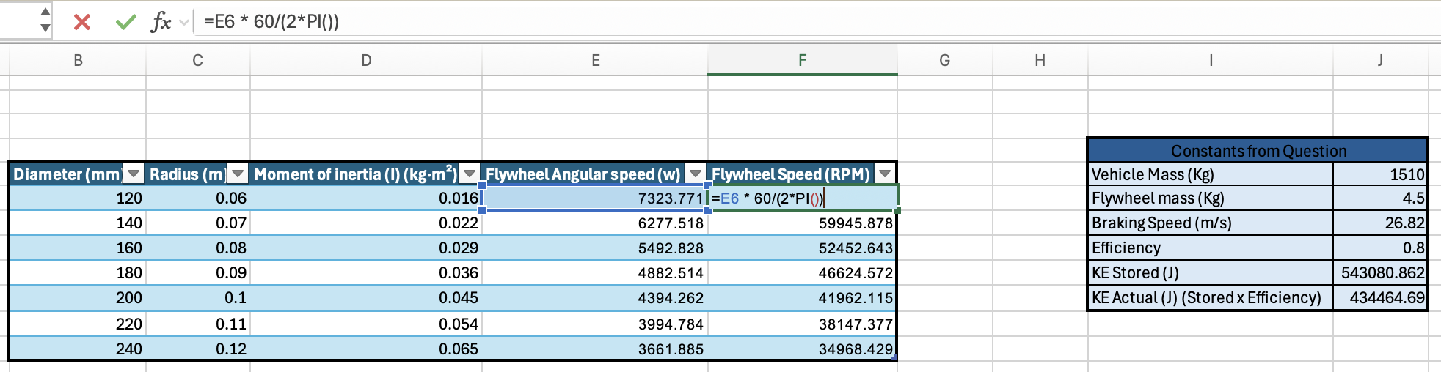
Figure 17 - Excel Formula for calculations of Flywheel Speed in RPM

