DS 1 Template

My Screenshots/Photos
- Please add 4–6 screenshots or photos of your digital life.
- You can use your phone or laptop.
- For each screenshot, write one or two sentences explaining what it shows.

Screenshot/Photo 1
[Insert Photo/Screenshot below] xd
Smartboard
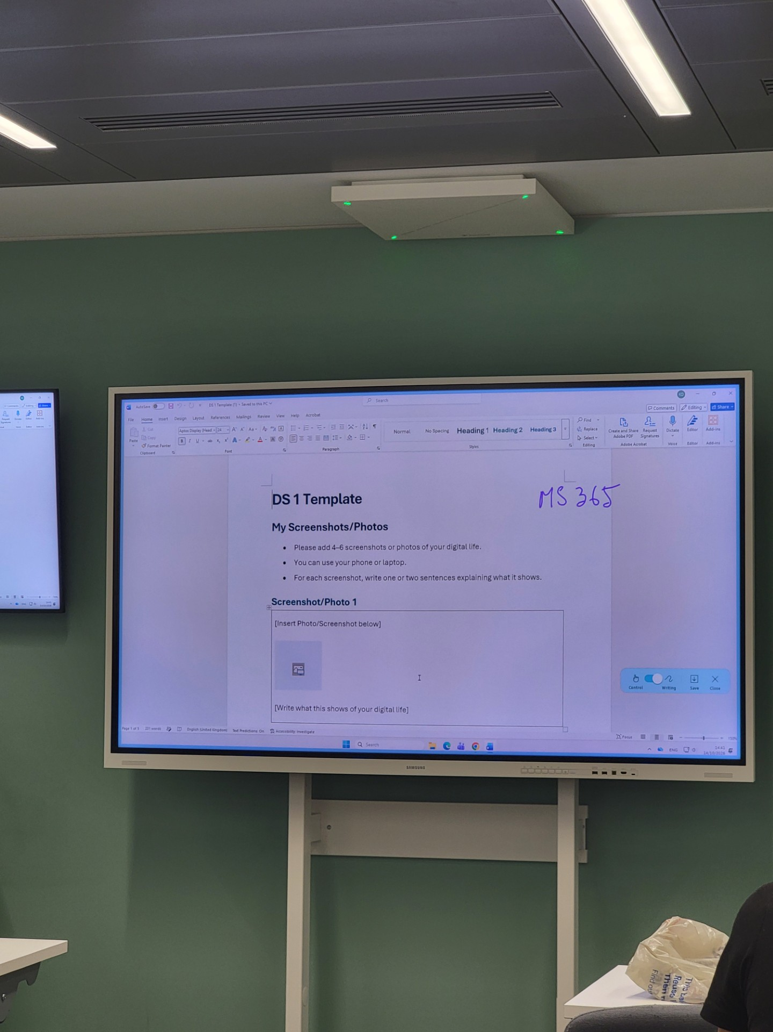
Lesson Interactive -better media connection/content
Recognition Handwriting-Sdoftware built in coverting text ointo to digital format
Multitasking – apps able to run off web browser/internet connection

Screenshot/Photo 2
[Insert Photo/Screenshot below] Charger

Chargeing fast USB -Wattage wire high voltage
Powering Device – current of electricity powering up tech

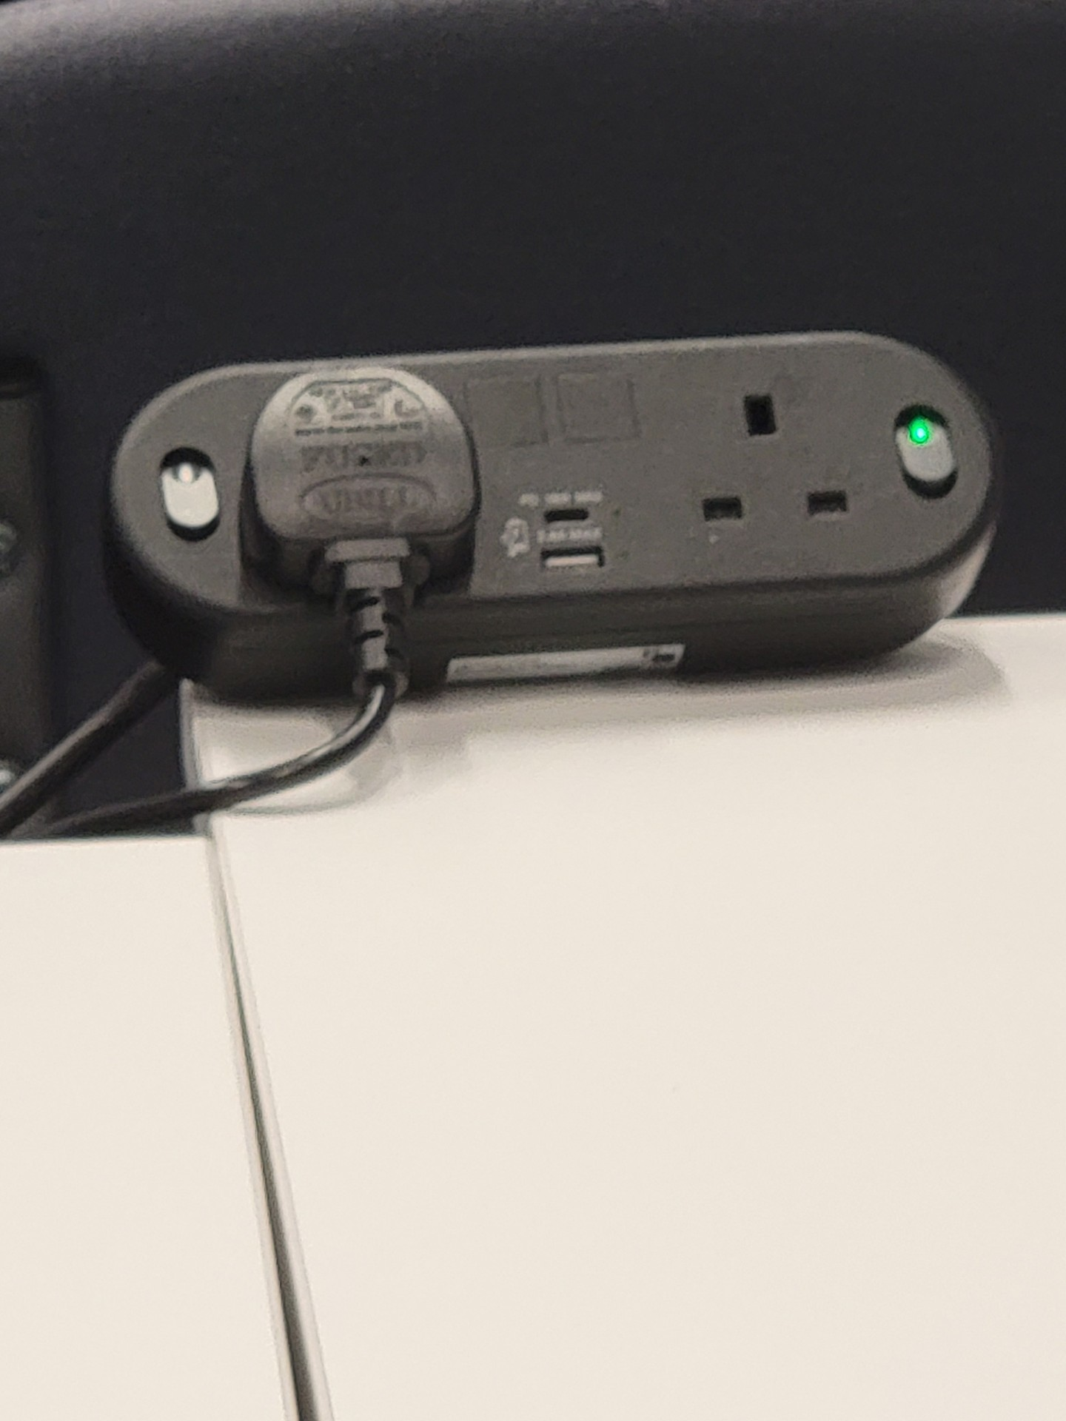
[Write what this shows of your digital life]

Screenshot/Photo 3
[Insert Photo/Screenshot below]
Monitor
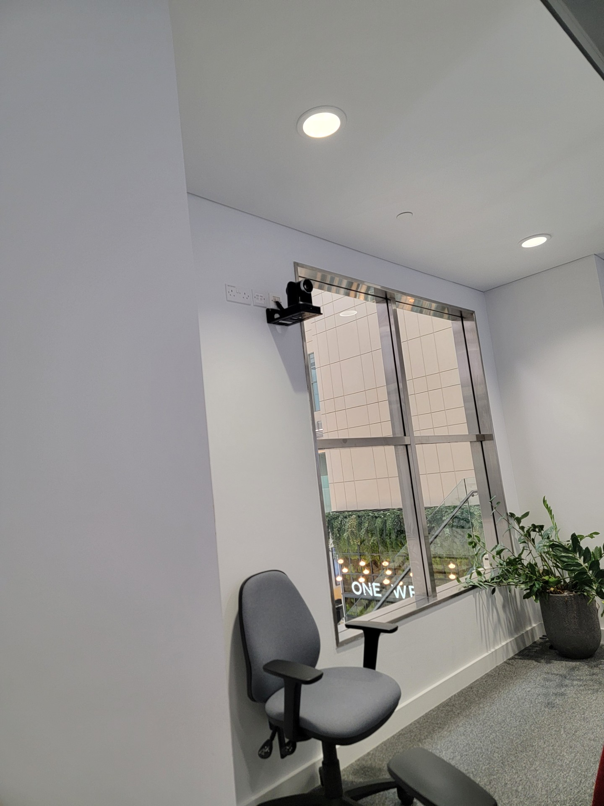 Data – text able top show
Gaming-able to play interactive games
[Write what this shows of your digital life]

Screenshot/Photo 4
[Insert Photo/Screenshot below]
Laptop
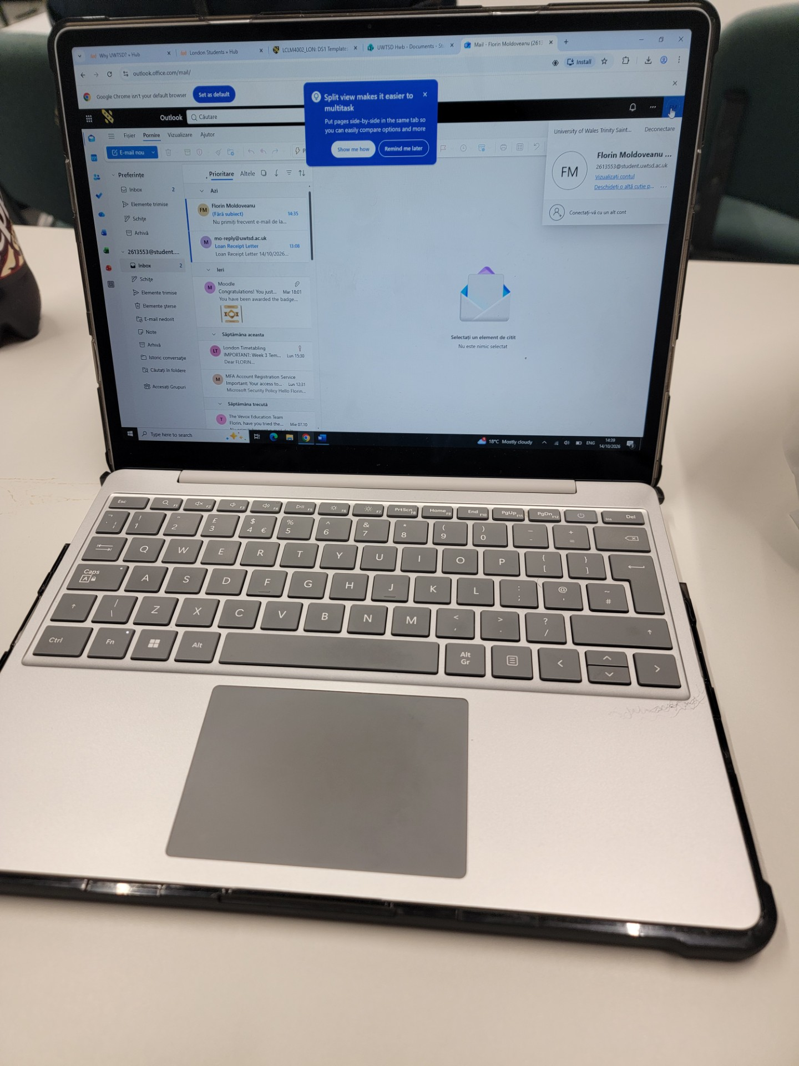
[Write what this shows of your digital life] Internet,word documents and much more

Screenshot/Photo 5
[Insert Photo/Screenshot below]
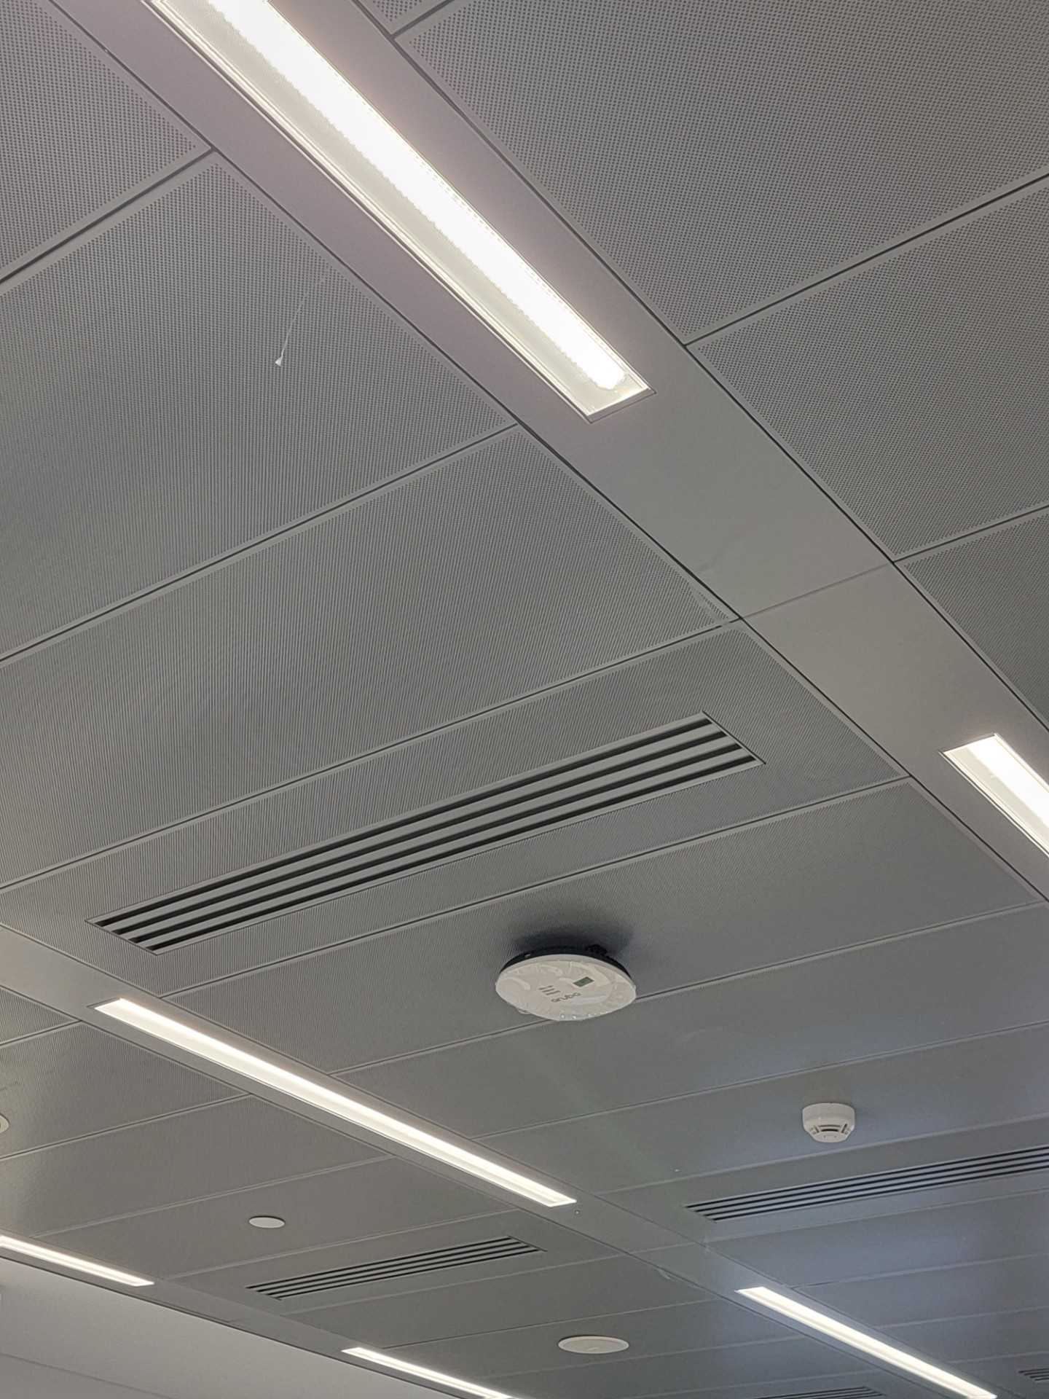
[Write what this shows of your digital life]

Screenshot/Photo 6
[Insert Photo/Screenshot below]
iphone
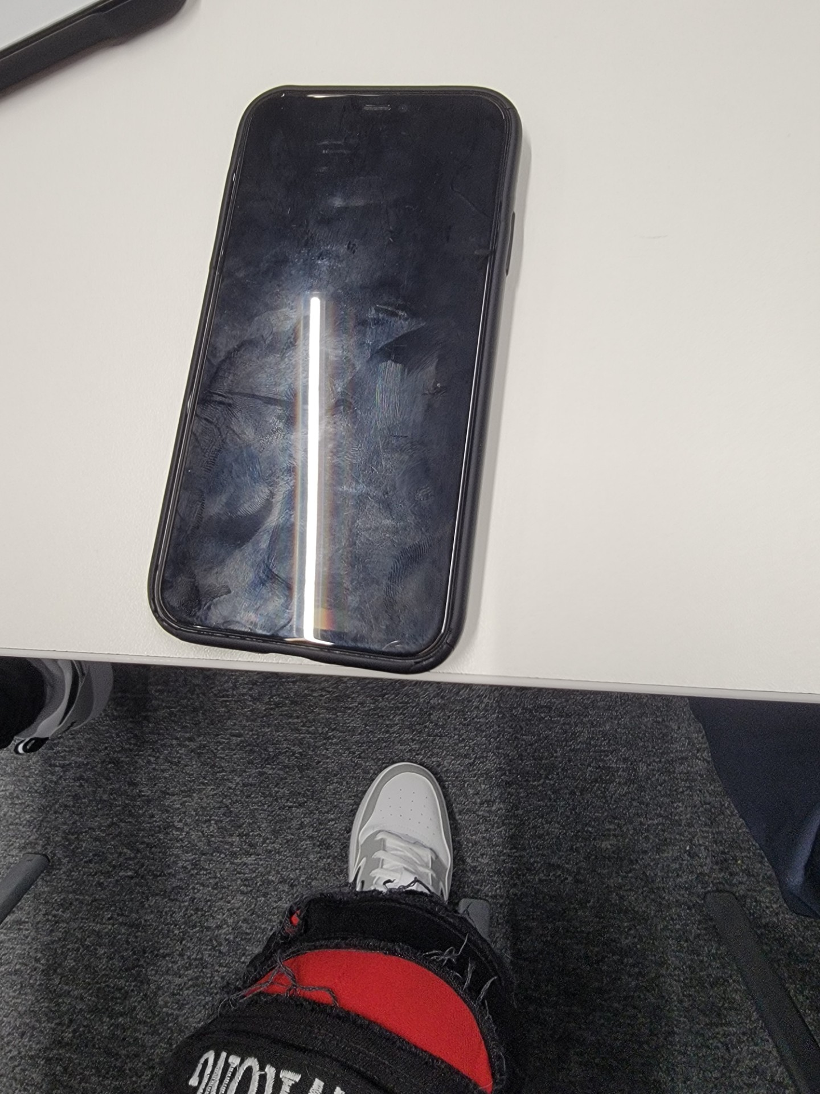 Connection-able to connect around the world
[Write what this shows of your digital life]

My Short Reflection
- Write 5–8 simple sentences about your digital life.
- You can use the sentence starters below if helpful.
I use the phone to call my wife.i use a laptop for homework.i
use charger for mi phone

Sentence starters
- I use digital tools to …
- I feel confident when I …
- I want to improve …
- I often use these tools: …
- I sometimes feel nervous about …
- I hope this module will help me …
- Digital skills are important for me because …
You can write more if you want.

Submission Checklist
Before you submit, please check:
​​​ ☒ I added 4–6 screenshots
☒ I wrote short sentences for each screenshot
☒ I wrote my short reflection
☒ My work is my own
☒ My file opens correctly
​​☒ My file opens correctly

