

MBA – Masters of Business Administration
Marketing Management
LCMB7001
Assessment 1

Student name: AJAY ARAVIND KULAPPURATH
Student ID: 2210730
Executive Summary
Marks & Spencer is one of the leading retailers in the UK with a series of products and services offered by the company on both a local and a global scale. The brand has major issues in terms of appealing to different generations of customers, coping with customer expectations along with ineffective decision-making. The brand needs to invest more in reshuffling its collections in online stores in order to stabilise its market positioning among fierce competition. The interlinking of the marketing strategies and brand awareness-related aspects has revealed its importance to increase the overall brand presence of the particular organisation. The consideration related to the fact and the implication of marketing strategies associated with the aspects is highlighted in the report. The in-depth understanding of the marketing management and initiatives of the organisation are pointed out in the report as well. The determination of brand awareness and its link with consumer satisfaction and competitive advantages are pointed out and linked with the organisation's marketing initiatives.

Table of Contents
Introduction 3
Rationale for choosing the organisation 3
Organisation overview 3
Challenges faced by Marks & Spencer 4
Innovative marketing strategy formation 6
Establishing interlinking of marketing strategy with brand awareness 8
Evaluation of M&S’s marketing management and initiatives 9
Increasing brand awareness and consumer satisfaction 9
Use of brand resonance model 10
Obtaining competitive advantages in new market segments 11
Customer journey across a variety of communication channels 12
Stakeholders’ expectations management 14
Conclusion 14
Recommendation 15
Reference List 16

Introduction
Marketing plays a critical role in structuring the portion of the organisation and due to that approach, the marketing department of the organisation can be considered the face of the organisation. The study discusses the importance of marketing approaches in an organisation in the shades of Marks & Spencer. The study contains brief information about the current condition of Marks and Spencer in the competitive market. The issues faced by the company also have been highlighted in the report. It delivers a concise idea regarding the marketing approaches that need to be taken care of for mitigating the challenges faced by the company.

Rationale for choosing the organisation
There are specific reasons for choosing this company for proceeding with the study. It is one of the most famous companies in the UK that faces specific issues which might be mitigated by bringing changes in their marketing approaches. More specifically it is evident that M&S pays very little attention to the requirements of the consumer base and due to that it faces issues to develop brand awareness (bbc.com, 2022). Based on this approach, it can be mentioned that due to this issue M&S has been chosen for developing the marketing strategy.

Organisation overview
Marks and Spencer (M&S) are one of the leading British retailers headquartered in Paddington, London. The brand is well-known for selling a wide range of retail goods starting from home products, foods and clothes. Founded in 1884 by Michael and Marks and Thomas Spencer, the brand has successfully segmented its own businesses in Asia and Europe (forbes.com, 2022). The variety of product offerings by M&S in the luxury segment has allowed the brand to constitute a global brand value for the organisation on a global scale. In 2022, the organisation obtained a worldwide profit margin of GBP10.9 million, making it one of the highest-grossing brands in the luxury goods segment (statista.com, 2022). Currently, the brand is operating with over 1000 stores in the UK retail market followed by 450 operating stores on a global scale.
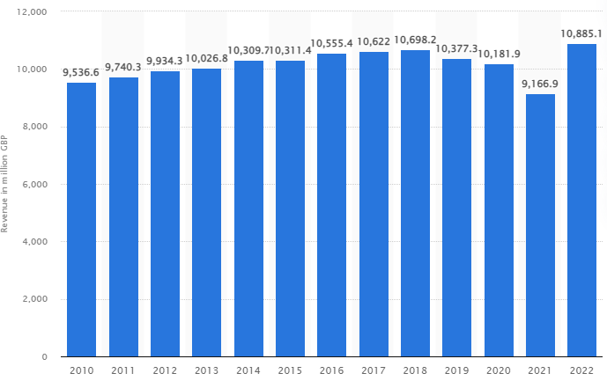
Figure 1: Global revenue of M&S in 2022
(Source: statista.com, 2022)
M&S is currently on the verge of business expansion all over the UK along with its expansion in the digital arena. However, the emergence of competition in the UK has threatened the organisation in both its physical and digital space. Other brands like Riverisland, Newlook, Asos and Next are some of the notable competitors of M&S, especially in the digital space (similarweb.com, 2022). Digitalisation has helped the organisation to grow its bounce rate up to 36.99% in the digital space. Currently, the website of M&Sb is ranked in the 59th position in the UK with over 32.3 million visitors on the page every day (similarweb.com, 2022). Despite the exponential forecasted success, the organisation is vulnerable to issues caused by customer segmentation, competition, globalisation and digitalisation in both its domestic and international markets.

Challenges faced by Marks & Spencer
M&S is exposed to some of the fierce challenges of the current age of globalisation and digitalisation. Due to the shift in customer taste, the brand is currently struggling to appeal to any generation of customers successfully. On one side, the food sales of the brand raised up to GBP 6.6 billion, but on the other side, the fashion sales attained only a 14% increase in recent times (statista.com, 2022). In the fashion segment, M&S is repeatedly failing to deliver their utmost quality and style, eventually losing millennial customers in the digital space. Another major issue within the organisation lies in its inconsistencies and mistakes in decision-making for the market. Recently, M & S cut over 950 jobs to deal with the retail jump issues (bbc.com, 2022). This further affected the brand image of M&S among the wide market space in the UK retail industry.
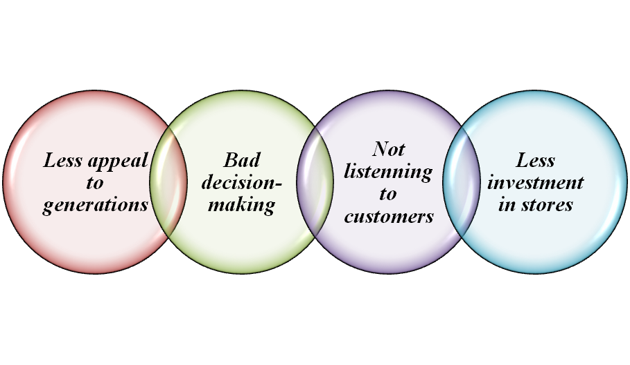
Figure 2: Challenges and issues in M&S
(Source: Created by author)
One of the central challenges for M&S is understanding its customers and offering products according to their tastes. Some market associates have outlined that M&S does not listen to its customers and it creates major issues for them to create a successful trajectory for the customer journey with the brand (bbc.com, 2022). The brand is still negligible regarding its food waste management operations and products like biscuits are available for people whenever they ask. This further appears as one of the notable challenges for the brand, concerning the implication of sustainable business management. Another longstanding challenge within M&S is regarding their too much dependence on the digital space and negligence in investing more in local stores around the UK. M&S stands in the 1,160 positions on a global scale in terms of online customer engagement (similarweb.com, 2022). Digitalisation has made both businesses and customers more inclined towards the online space, eventually boosting competition in the digital space. Further, M&S’ dependence on the online market can cause a major loss for the organisation, concerning competitive marketing on both the domestic and international markets.

Innovative marketing strategy formation
The company needs to increase its market penetration approaches for enjoying a sustained position in the competitive market. It is evident that lowering the cost of everyday essentials is one of the best strategies that has been applied by M&S to attract the attention of consumers (telegraph.co.uk, 2022). It is a general criterion of sustaining the business which has been fulfilled by the company. On the other hand, for penetrating deep into the market the company has to identify the requirements alongside the low prices of the product. Marketing segmentation or STP theory needs to be applied there. Based on the approaches of STP organisations can classify their target market and a better understanding of their requirements can be achieved (Kalam, 2020). Based on the STP analysis, M&S gets the opportunity to know their customers well and that helps in providing justified products as per requirements. It helps them to make the consumers understand the values they share with consumers. Apart from that, a sense of loyalty can also be increased among consumers.
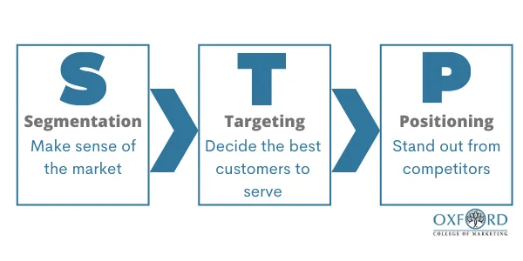
Figure 3: STP marketing method
(Source: oxfordcollegeofmarketing.com, 2022)
One of the main issues that the company faces is related to its clothing sales. Poor performance in sales is evident as the company did not appeal to any specific generation (forbes.com, 2022). Based on this approach, product development strategy needs to be taken into consideration through their marketing approaches. The company needs to categorise their product with eye-catchy names. For instance, the company can specify their Gen Z consumers and make different products for this target market. This factor also helps the company in developing its brand awareness among the different age segments. The product distinctiveness model needs to be taken into consideration. Using this approach, the company can get a precise idea regarding the preference of different consumers (hbr.org, 2022). This strategy helps the company to make products based on the preference of each age group. For instance, it can be seen that the young generation nowadays prefers baggy clothes. Keeping this in view M&S can provide baggy clothes to this specific category and that helps in meeting the consumer's preference approaches. Hence, M&S can also cope with the challenges of changing aspects of the consumers.
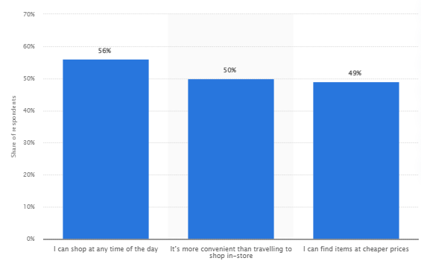
Figure 4: Reasons for online shopping preference
(Source: statista.com, 2022)
Market development strategy is another factor that the company needs to take into consideration while coping with its existing challenges. Apart from that it also needs to be mentioned that a market development strategy helps the company in creating and maintaining a sustained position in the competitive market. Based on the market development strategy organisations can involve the existing product to target a new market for achieving business growth (nibusinessinfo.co.uk, 2022). Changing attributes of the customers can be taken into consideration while practising this method. For instance, the company can develop new channels to better reach consumers. It is evident that the company invests more in in-store inserted online selling. The company needs to shift its business approaches from offline to online as per the preference of the consumer base. It is evident that most consumers prefer online shopping instead of online (statista.com, 2022). M&S needs to take this as an opportunity and invest more online instead of in stores for addressing growth. This factor also helps in resolving the ineffective decision-making attributes of the company.

Establishing interlinking of marketing strategy with brand awareness
Implication of different marketing strategies serves more than one purpose for the particular organisation. The formulation of brand awareness for M&S has a direct link with the established marketing strategies to develop and penetrate a particular region for increased business. The development of products based on diversified needs is comprehended by the organisation to effectively establish its brand awareness in the wider market segment of the UK. As per the opinion of Jasmani and Sunarsi (2020), popular brand recognition is essential for organisations to easily penetrate the desired market segment and establish their business process. Brand awareness is the elementary aspect of the marketing efforts that an organisation is relying on. The implication of social media, email and SEO marketing is vital for the organisation to easily put thoughts of their brand and their services and make the market penetration-related aspects more reliable.
M&S has contrasted its existing business and marketing initiatives on a generic method. M&S brand, data credentials, and cross-marketing initiatives on a digital platform are used for existing marketing initiatives and brand awareness (corporate.marksandspencer.com, 2022). The implication of new marketing initiatives which is linked to the organisation's existing brand awareness is vital to contrast increased consumer engagement and market developments has already cut short their marketing expense by 13% after their profitability slid to 63.9% to £176.4m in the previous year (campaignlive.co.uk, 2018). Therefore, the organisation is recommended to use their brand awareness as a key tool to use in marketing initiatives and contrast an effective reach to their consumers with a short budget.
Concentric diversification along with conservative business development strategies is crucial for the organisation to enter a market and increase its brand awareness or vice versa.
The organisation's initiatives to raise brand awareness to gain trust and influence consumers from the desired market segments are praiseworthy. In such a context, Makrides et al. (2020), highlighted that digital marketing plays a vital role to contrast effective brand awareness for a company or organisation. M&S has existing brand equity and they need to use it to imply in their marketing development strategies and obtain consumer retention. On the other hand, the organisation can also use brand equity to convince their consumers to purchase products and services from M&S’s designated outlet. Furthermore, Świtała et al. (2018), suggested that brand awareness and consumer determination of an organisation's products and services can be used for obtaining competitive advantages. The uses of product development based on the new market considerations are crucial for M&S’s modified marketing strategies to increase their existing brand awareness.
These types of aspects can be contrasted by M&S even before entering the market. On the contrary, Tian, et al. (2020), pointed out that the organisation can promote their diversified products and services along with their brand marketing. M&S can simultaneously interlink the marketing initiatives with their existing brand image to contrast a more persuasive approach.

Evaluation of M&S’s marketing management and initiatives
The orchestration of marketing initiatives has multiple purposes, increasing consumer satisfaction, creating brand equity, and competitive advantages and capture of new markets. M&S and their marketing team have comprehended such aspects and contrasted their marketing initiatives in the digital platform to connect with their consumers. The detailed breakdown of the marketing management and initiatives the pointed out in the following section,

Increasing brand awareness and consumer satisfaction
M&S has contrasted their marketing initiatives to state their marketing message about the organisation and what they do that is for the consumers' determination. The organisation effectively uses consumer satisfaction data from different market segments to imply in their new marketing initiatives and brand awareness campaign. M&S has increased its products and services sales by 21.5% in 2020 and determined effective market growth (statista.com, 2022). These aspects shed light on the consumer satisfaction level and increased brand awareness in the operational market segments for M&S.
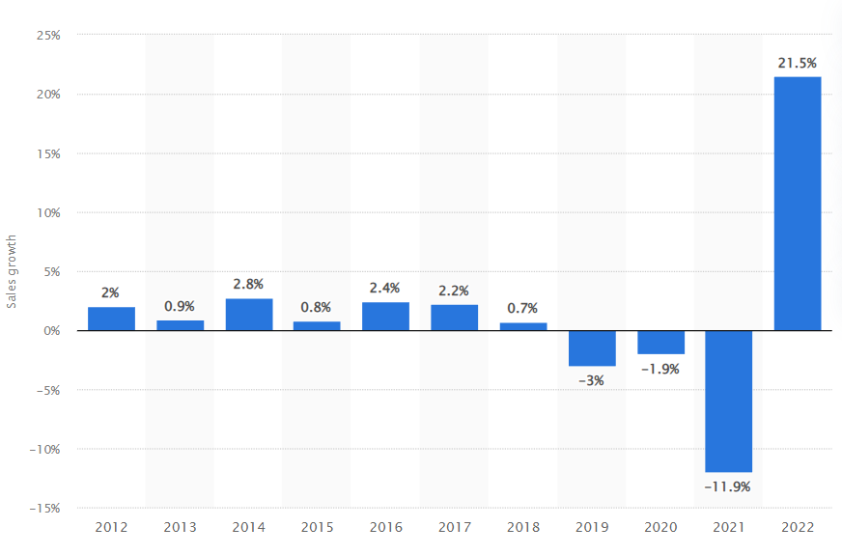
Figure 5: Revenue growth of M&S from 2012-2022
(Source: statista.com, 2022)
Brand recognition and increased value of services and the reputation of the organisation are effective for M&S to connect with their consumers on a crucial basis. Moreover, reassurance to the consumers is vital for obtaining their trust and encouraging them to use the products and services provided by the organisation (Papadas et al., 2019). M&S has contracted such initiatives and the encouraged consumers have obtained their services and provided positive feedback which eventually stronghold the brand positions. The aspects of consumer satisfaction and they provide feedback are featured by M&S to use it and increase their brand awareness among consumers on a crucial basis.

Use of brand resonance model
The formation of a robust brand image can be comprehended by M&S to modify their existing marketing strategies to contrast a different and better outcome. The brand resonance model outlines the aspects of how well the consumer relates to a particular brand. M&S can formulate a conservative path of communication with their targeted consumers and engage in a new level. The brand resonance model consists of six elements which are brand salience, “brand performance”, “brand imagery”, “brand judgement”, “brand feelings' ' and “brand resonance” (ccsenet.org, 2022). These aspects are vital for M&M to create marketing resilience and produce consumer reliability coefficients to increase brand performance in market segments. As proposed by Moura et al. (2019), the development of long-term business initiatives and consumer relations can be comprehended by organisations using the brand resonance model. The collective influence of the six elements can help M&S to contrast a robust brand awareness campaign for the wider market segments.
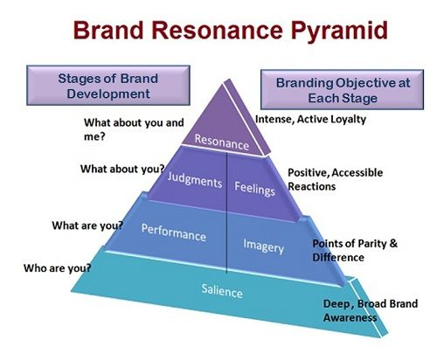
Figure 6: Brand Resonance Pyramid
(Source: businessjargons.com, 2022)
Additionally, consumer relationship means increased sales, consumer satisfaction level and a chance for the organisation to increase its sales and services range. Therefore, achievement of satisfaction, engagement and loyalty are the crucial aspects for M&S to imply in their existing marketing strategies

Obtaining competitive advantages in new market segments
M&S’s ability to select the potentially profitable market and meet the consumer's needs can effectively increase its competitive positioning. These aspects can be obtainable by the organisation using its existing brand image and digital marketing initiatives to connect with consumers on a crucial basis. Diez-Martin et al. (2019) highlighted that the use of different marketing channels is crucial for organisations to contrast their loyal consumer base and obtain increased reviews than their rivals. These aspects are crucial for M&S to use social media and email to obtain consumers' trust and encourage them to choose their services over their competitors in the same market. Competitive advantages are the most prominent beneficial values for the organisation and its effective marketing initiatives (Buswari et al., 2021). Furthermore, the business performance and the use of brand awareness and consumer loyalty are essential for H&M to capture wider market segments than their competitors such as Next PLC and Woolworth Group Ltd.
The successful differentiation strategies and the experiential marketing-oriented aspects have important factors to build and develop the values of a brand. M&S and their existing brand values can be comprehended with such aspects to generate brand loyalty and focus on obtaining competitive advantages.

Customer journey across a variety of communication channels
The product or service of the company has to be consumer-centric because without that business growth cannot be addressed. As opined by Neher et al. (2016), the customer journey can be long across different channels and touchpoints. Based on this approach it can be mentioned that different channels need to be addressed and utilised by M&S to get a precise idea regarding the requirements of the consumers and apply them in communication development.
- Email marketing
Emails can be marked as specified channels that can be used by M&S to enhance customer journey approaches. Email is one of the most cost-effective and commonly used marketing channels for applying better promotion of the product and service (nibusinessinfo.co.uk, 2022). Companies can use these channels in conjunction with STP.
- General Messaging
It is evident that individuals check their notifications at least 5 times a day and that can be addressed as an opportunity for developing market awareness. General messaging can be used by M&S to convey information and attractive offers of their product to the consumers. Online messaging applications like WhatsApp, Discord and normal messages can be used by the company to convey their information to the consumer base.
- Social media channels
Different social media channels need to be used by the companies to bring improvement in customer journey mapping. Social media plays a critical role in creating a satisfying customer experience (forbes.com, 2022). The official Facebook page of the company can be utilised in this context. More specifically, using the official Facebook page M&S can convey about their offers and other approaches to the consumer for developing a sense of loyalty among the consumers.
- Brand endorsement
The formulation of a brand endorsement model is vital for the organisation to use the channels of social media marketing and take it one step further. The assurance of the brand endorsement using known public features and uses their face and fame to promote the services of products in the wider market segment. Moreover, M&S can consider tying up with major influencers and public celebrities and making their marketing initiatives to connect with the consumer.
Implying the customer journey map with diagram
Customer journey mapping showcases the perspective of the consumers regarding the products and services of the company. The five stages of customer mapping are awareness, consideration, purchase, retention and advocacy and using these factor companies gets the opportunity to extend their consumer base effectively (cim.co.uk, 2022). Advertisement approaches has been taken into consideration by the chosen company for boosting the awareness of their brand among the consumer’s base. Search results can be mentioned as the touch points in this context and the company needs to up-rank their position in the general search results.
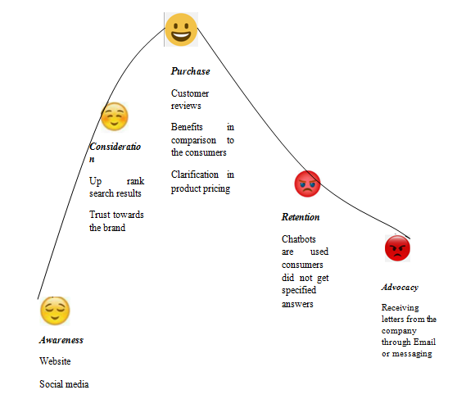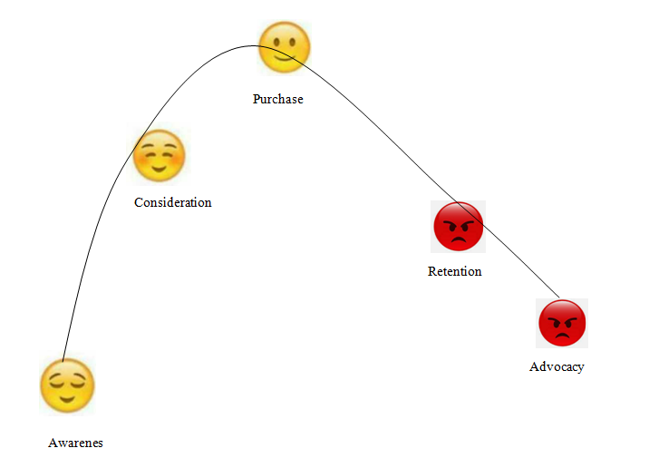
Figure 7: Customer Journey mapping of M&S
(Source: created by Author)
Trust is the main touch point in case of the consideration stage. M&S for marinating the trust factors use the feedback section to showcase reviews of their products to the consumer base. This stage makes the consumer realise that the products of M&S is better than its competitors not per the view of the company but from the views of other consumers. During the Purchase stage M&S maintained clarification regarding cost and other specification. The company uses the Chabot system to maintain the interactive relationship with the consumer that justifies the retention stage. During the advocacy stage the companies positively handle the criticism of their product on the social platforms. For instance, after the delivery if an individual consumer gets a faulty product that person can claim his money back from the company.
The strengths and weakness of the customer journey map of M&S
From the analysis, it can be seen that the promotional approaches of the company is strong enough. On the other hand, the advocacy stage is weak as suing catboats the company failed to provide specific answers to the consumers. Delay in the payment delivery of the faulty product can also be seen that impacted the company reputation negatively.

Stakeholders’ expectations management
The national and local government holds a major impact on the businesses and revenues of Marks and Spencer, eventually appearing as one of the notable stakeholders of the organisation. M&S manages utter transparency within the organisation’s communication system with the transmission of information with a stable flow. The organisation uses an internal network to communicate with internal stakeholders and a B2B and B2C business network for external stakeholders (corporate.marksandspencer.com, 2022). Apart from the government, the employees, customers, investors and shareholders are some of the notable stakeholders of M&S in the current times.
The management of customers’ expectations can be met by M&S by investing more in local stores to cope with customer demands successfully. The customer traffic on the website of M&S can appear as a major issue for the stakeholders of the organisation. In this case, focusing more on local business development can segment the customers for the company successfully by distributing the customers evenly between the online and offline markets (Pedrini and Ferri, 2018). Similarly, compliance with the UK’s environmental guidelines can make the organisation more sustainable with time, eventually demolishing the issue of waste management and coping with the expectations of the government. Further, the expectations of the investors and shareholders can be boosted by focusing more on the expansion of business in different segments and marketplaces.

Conclusion
M&S has always been one of the dominant brands operating in the retail market of the UK with multiple competitive advantages. Despite the exponential company growth, inconsistencies and mistakes in decision-making have impacted the company’s brand reputation and caused challenges for the brand on the market. The use of the digital platform to promote its business has made M&S too much inclined to its digital space, eventually impacting the physical marketplace for the company in both the local and the global markets. The incorporation of the STP model helps M&S to segment its customers successfully and then target and position the brand in the market with utmost agility in marketing and promotion. This has also strengthened the marketing of M&S, especially in terms of dealing with decision-making issues successfully. Due to this, the company needs to focus on the development and assessment of innovative technologies for ensuring quality services to all customers without facing major complexities. Therefore, M&S can promote its business in both the digital and the physical marketplace to deal with the longstanding business issues caused by globalisation, digitalisation, emerging competition and many more.

Recommendation
- Reply limitation is one of the major drawbacks of Chatbots. The consumer several time failed to get the information what they actually wanted to know due to Chatbots (bbntimes.com, 2022). The study suggested that the company needs to introduce a dedicated designation who is responsible for replying the specific questions of the consumers.
- One of the main reasons behind pay back delay is the company take time to revivify whether the damage was happened due to the company or from the consumer side. It can be suggested to the company to increase the employee base of the product re-verification team as this make the entire process faster than before.

Reference List
bbc.com, (2022). “Challenges faced by M&S”. Available at: https://www.bbc.com/news/business-53478403 [Accessed on: 16th November, 2022]
bbc.com, (2022). “M&S: Five reasons the retailer is struggling”. Available at: https://www.bbc.com/news/business-53478403, [Accessed on: 11th November, 2022]
bbntimes.com, (2022). “EVERYTHING YOU NEED TO KNOW ABOUT THE LIMITATIONS OF CHATBOTS”. Available at: https://www.bbntimes.com/technology/everything-you-need-to-know-about-the-limitations-of-chatbots, [Accessed on: 26th December, 2022]
businessjargons.com, (2022). Brand Resonance. Available at: https://businessjargons.com/brand-resonance.html, [Accessed on 11th November, 2022]
Buswari, M., Setiawan, M. and Khusniyah, N., (2021). The Effect between Green Product Innovation and Green Marketing on Competitive Advantage and Business Performance. PalArch's Journal of Archaeology of Egypt/Egyptology, 18(2), pp.47-63.
campaignlive.co.uk, (2018). M&S cuts marketing spend as pretax profit slides 64%. Available at: https://www.campaignlive.co.uk/article/m-s-cuts-marketing-spend-pretax-profit-slides-64/1434500, [Accessed on 11th November, 2022]
ccsenet.org, (2022). Analyzing the Brand Equity and Resonance of Banking Services: Malaysian Consumer Perspective. Available at: https://www.ccsenet.org/journal/index.php/ijms/article/view/8124, [Accessed on 11th November, 2022]
cim.co.uk, (2022). “Five stages of your customers' buying journey”. Available at: https://www.cim.co.uk/content-hub/blog/five-stages-of-your-customers-buying-journey/, [Accessed on: 26th December, 2022]
corporate.marksandspencer.com, (2022). “Stakeholder response in Marks and Spencer”. Available at: https://corporate.marksandspencer.com/sites/marksandspencer/files/marks-spencer/human-rights-and-our-supply/pdf-responding-to-stakeholder-concerns.pdf [Accessed on: 16th November, 2022]
corporate.marksandspencer.com, 2022). FULL YEAR RESULTS FOR 52 WEEKS ENDED 2 APRIL 2022. Available at: https://corporate.marksandspencer.com/media/press-releases/full-year-results-for-52-weeks-ended-2-april-2022, [Accessed on 11th November, 2022]
Diez-Martin, F., Blanco-Gonzalez, A. and Prado-Roman, C., (2019). Research challenges in digital marketing: sustainability. Sustainability, 11(10), p.2839.
forbes.com, (2022). “Company overview of M&S”. Available at: https://www.forbes.com/companies/marks-spencer/?sh=14d10bca7de1 [Accessed on: 16th November, 2022]
forbes.com, (2022). “Marks & Spencer And Primark Are In The Wrong Business, Just Ask Greta Thunberg”. Available at:https://www.forbes.com/sites/andrewbusby/2019/11/06/marks--spencer-and-primark-are-in-the-wrong-business-just-ask-greta-thunberg/, [Accessed on: 11th November, 2022]
forbes.com, (2022). “Social Media’s Important Role In Creating Long-Lasting Digital Connections” Available at:https://www.forbes.com/sites/forbescommunicationscouncil/2021/12/21/social-medias-important-role-in-creating-long-lasting-digital-connections/, [Accessed on: 11th November, 2022]
hbr.org, (2022). “The New Product Development Map” Available at:https://hbr.org/1989/05/the-new-product-development-map, [Accessed on: 11th November, 2022]
Jasmani, J. and Sunarsi, D., (2020). The Influence of Product Mix, Promotion Mix and Brand Image on Consumer Purchasing Decisions of Sari Roti Products in South Tangerang. PINISI Discretion Review, 1(1), pp.165-174.
Kalam, K.K., (2020). Market Segmentation, Targeting and Positioning Strategy Adaptation for the Global Business of Vodafone Telecommunication Company. International Journal of Research and Innovation in Social Science (IJRISS), 4(6), pp.427-30.
Makrides, A., Vrontis, D. and Christofi, M., (2020). The gold rush of digital marketing: assessing prospects of building brand awareness overseas. Business Perspectives and Research, 8(1), pp.4-20.
Moura, L.R.C., Ferreira, P.R., de Oliveira, A.D. and da Silveira Cunha, N.R., (2019). Test and validity of the Brand Resonance Model’s. RevistaGestão&Tecnologia, 19(1), pp.4-24.
Neher, K., Maechler, N., and Park, R., 2016. From touchpoints to journeys: Seeing the world as customers do. Retrieved March, 18, p.2017.
nibusinessinfo.co.uk, (2022). “Benefits of email and the internet” Available at:https://www.nibusinessinfo.co.uk/content/using-email-business-communication-and-marketing, [Accessed on: 11th November, 2022]
nibusinessinfo.co.uk, (2022). “nibusinessinfo.co.uk” Available at:https://www.nibusinessinfo.co.uk/content/market-development-strategy, [Accessed on: 11th November, 2022]
oxfordcollegeofmarketing.com, (2022). “Finding The Right Customers With The STP Model”. Available at:https://blog.oxfordcollegeofmarketing.com/2020/06/24/finding-the-right-customers-with-stp-model/, [Accessed on: 11th November, 2022]
Papadas, K.K., Avlonitis, G.J., Carrigan, M. and Piha, L., (2019). The interplay of strategic and internal green marketing orientation on competitive advantage. Journal of Business Research, 104, pp.632-643.
Pedrini, M. and Ferri, L.M., (2018). Stakeholder management: a systematic literature review. Corporate Governance: The International Journal of Business in Society, 19(1), pp.44-59.
similarweb.com, (2022). “Competitors of M&S”. Available at: https://www.similarweb.com/website/marksandspencer.com/competitors/ [Accessed on: 16th November, 2022]
statista.com, (2022). “Food sales of M&S”. Available at: https://www.statista.com/statistics/413627/food-sales-marks-and-spencer-mands-united-kingdom-uk/ [Accessed on: 16th November, 2022]
statista.com, (2022). “Leading reasons why consumers worldwide chose to shop online in 2021” Available at:https://www.statista.com/statistics/676358/reasons-online-shoppers-prefer-to-shop-online/, [Accessed on: 11th November, 2022]
statista.com, (2022). “Revenue of M&S”. Available at: https://www.statista.com/statistics/413349/group-revenue-marks-and-spencer-mands/ [Accessed on: 16th November, 2022]
statista.com, (2022). Revenue growth of the Marks & Spencer group worldwide from 2012 to 2022. Available at: https://www.statista.com/statistics/872848/marks-and-spencer-sales-growth-worldwide-uk/, [Accessed on 11th November, 2022]
Świtała, M., Gamrot, W., Reformat, B. and Bilińska-Reformat, K., (2018). The influence of brand awareness and brand image on brand equity–an empirical study of logistics service providers. Journal of Economics & Management, 33, pp.96-119.
telegraph.co.uk, (2022). “M&S slashes the price on everyday essentials amid cost-of-living crisis”. Available at: https://www.telegraph.co.uk/business/2022/04/11/ms-slashes-price-everyday-essentials-amid-cost-of-living-crisis/, [Accessed on: 11th November, 2022]
Tian, S., Tao, W., Hong, C. and Tsai, W.H.S., (2022). Meaning transfer in celebrity endorsement and co-branding: meaning valence, association type, and brand awareness. International journal of advertising, 41(6), pp.1017-1037.

