Ellie Phillips – 2503584
Proposal
Gwyn Hall
For my chosen site, I would like to exhibit site specific work in the Gwyn Hall, Neath. I have chosen this place for multiple reasons, with the main being nostalgia, a love for film and musical theatre and because it is rich in history.
Growing up in a small town there was not. A lot to do, but my friends and I would love a visit to the Gwyn Hall to watch films. I also have fond memories of watching plays and shows there with my family in childhood. It is a deeply nostalgic place for most of us who live in Neath, which I feel adds an emotional element, not only for me, but for other people who live in the area. I also feel that due to its rich history, from being a Council Chamber to a Victorian music hall to now, as well as a tragic fire in 2007, there is much to explore and experiment with when it comes to creating work relevant to the location.
The Gwyn Hall first opened back in 1888 and is still open today. Within this period, it has served multiple purposes, with the main being entertainment and show business which is what intrigues me the most. The hall first held its first performance way back in 1888, with “a grand concert organised by the Town Band and Mr J. S. Church” (Celtic Culture 2026). There have also been multiple artists perform there over the years “Throughout its history, the hall has hosted concerts, plays, musicals, and even wrestling matches. Adelina Patti performed there on numerous occasions, and David Lloyd George once delivered a speech. In more recent years, performers have included actor Steven Meyo, opera star Katherine Jenkins, and the Stereophonics.” (Celtic Culture, 2026).
When it comes to theme, I would perhaps explore the theme of show business in my exhibition. I am very drawn to the aesthetic of old fashion theatre, and I feel this could be brought to life well here. Maybe a collection of work that explores and depicts the evolution of show business through artworks, by using a location that has held concerts, film and theatre for over a century. Or if the topic of theatre itself is too narrow for a whole group, perhaps the theme of performance, or simply the evolution of the hall through its history could be an interesting idea in itself.
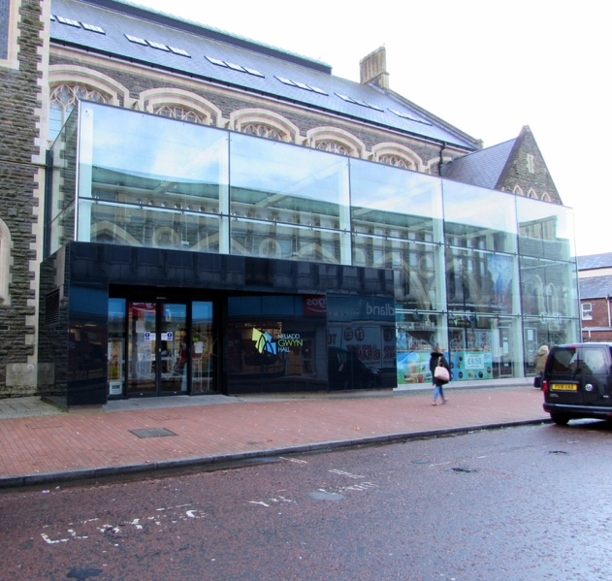
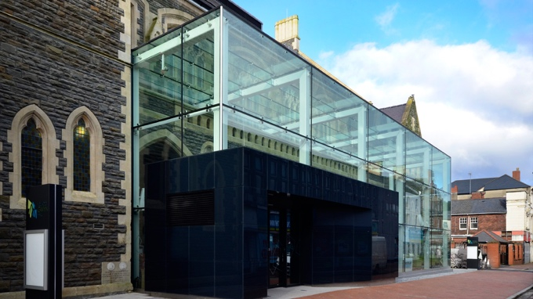
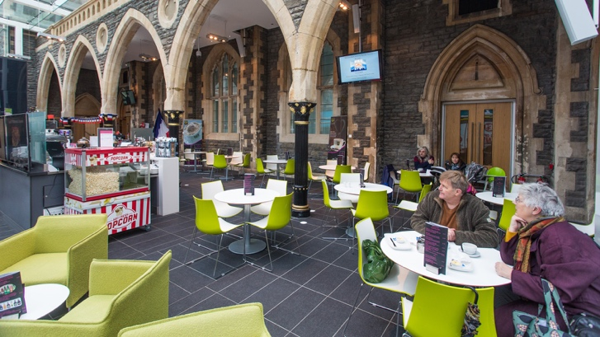
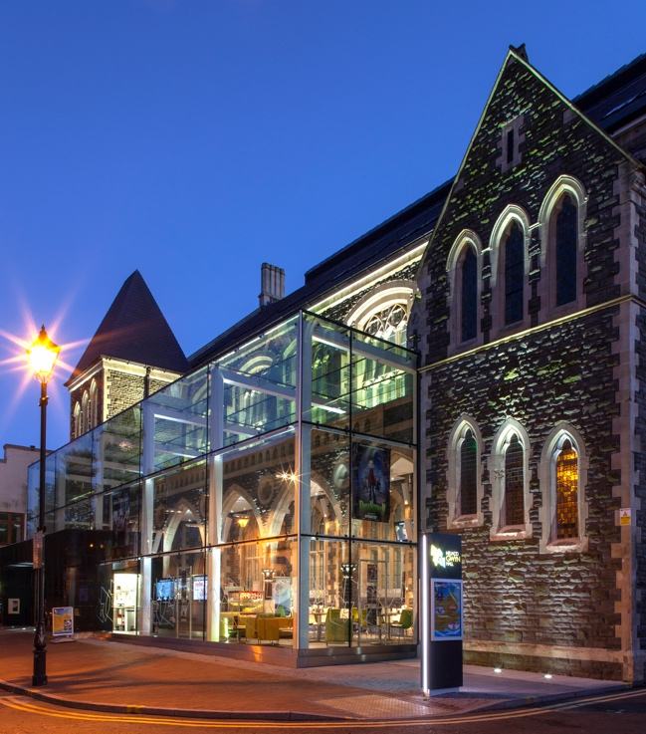

Reference list
Celtic Culture. (2026). History. Celtic Culture. Available: https://gwynhall.com/about-us/history

