Lillian Mary C York (2317170)
UWTSD 2026
salt mummification laboratory report

Contents
Abstract 2
Keywords 2
Introduction: 2
Aims and hypothesis 3
Aim 3
Hypothesis 3
Methodology 3
Design 3
Materials 4
Procedure 4
5
Measurements of samples 5
Results 6
Week one 7
7
Week two 8
Week three 9
Total Mass Loss 11
Discussion of results 11
Mummification in ancient Egypt 12
Interpretation 13
Conclusion 14
Comparing results 15
References 17

Abstract
This study investigates the properties of three different salts, sea salt, Himalayan pink salt, and Epsom salt, using tomato quarters as organic proxies for soft tissue. The experiment aims to evaluate which salt most effectively removes moisture and preserves tissue over a four-week period, drawing on techniques with the use of natron in ancient Egyptian mummification. Results demonstrate varying levels of dehydration and preservation, with Epsom salt showing the greatest structural preservation, while sea salt exhibited the most rapid moisture extraction. These findings suggest that chemical composition plays a crucial role in desiccation efficacy, supporting existing literature on the importance of natron in mummification. The study highlights both the effectiveness and limitations of modern salts instead of natron.

Keywords
Desiccation; Mummification; Natron; Preservation; Salts

Introduction:
Mummification in ancient Egypt had a complex funerary practice which was designed to preserve the human body for the afterlife. Natron was used for this, which was a natural occurring salt mixture composed of mostly sodium carbonate, sodium bicarbonate, sodium chloride, and sodium sulphate. Natron functioned as a powerful desiccant, which removed the moisture from the body and helped with delaying of decay (Abdel-Maksoud and El-Amin, 2011).
The removal of the moisture from the tomato and anything someone wishes to preserve is key in preventing decomposition, as bacteria and enzymes responsible for decay require water to function. Experimental archaeology has demonstrated that desiccation alone can significantly slow tissue degradation (Morozova et al, 2020). Studies replicating mummification techniques have confirmed that natron effectively dries tissues while maintaining the structure of the subject (Zimmerman, Brier and Wade, no date).
Modern salts such as sea salt, Himalayan salt, and Epsom salt differ significantly in their chemical structure and mineral content. Sea salt consists of mostly sodium chloride with traces of minerals (Sea Salt: Uses, Benefits, and Downsides, 2019). While Himalayan salt contains a broader range of minerals including calcium and potassium (Pink Himalayan Salt Benefit and Uses, Holland & Barrett, no date). Epsom salt differs from the other salts and despite its name, it is not a true salt (Epsom Salt: Benefits, Uses, and Side Effects, 2018).
This experiment uses tomatoes as a proxy for human tissue due to the high-water content and soft structure. By comparing the desiccation effects of different salts, this study aims to better understand how salt composition influences preservation and how this relates to the ancient Egyptian embalming practices.

Aims and hypothesis

Aim
To investigate the effectiveness of different salts (sea salt, Himalayan salt, and Epsom salt) in removing moisture from organic material and preserving its structure, to better understand the embalming process in ancient Egyptian mummification.

Hypothesis
It is hypothesised that salts with stronger desiccating properties will result in greater moisture loss and be better at persevering. Based on the chemical composition, it is expected that Epsom salt or Himalayan salt will be better than sea salt due to their mineral content and potential for moisture absorption.

Methodology

Design
This experiment was designed to simulate the desiccation process used in ancient Egyptian mummification. Tomatoes were used to substitute human tissue due to their high moisture content. Different salts were tested to evaluate their ability to replicate the effects of natron.

Materials
- Fresh tomatoes
- Himalayan pink salt
- Sea salt
- Epsom salt
- Digital scales
- Knife
- Chopping board
- Sealable sandwich bags
- Storage bag
- Dark cupboard

Procedure
- Tomatoes were cut into equal quarters using a knife and a chopping board.
- Each tomato potion was weighed using digital scales.
- Salt quantities were measured as follows:
- 250 grams of Himalayan salt with 56 grams of tomato
- 55 grams of sea salt with 39 grams of tomato
- 300 grams of Epsom salt with 29 grams of tomato
- Each tomato sample was placed into their own sandwich bag.
- The corresponding salt was added, ensuring full coverage of the tomato.
- Bags were sealed to create an airtight environment.
- All samples were placed inside a larger bag and stored in a dark cupboard.
- Observations and weights were recorded weekly over three weeks.
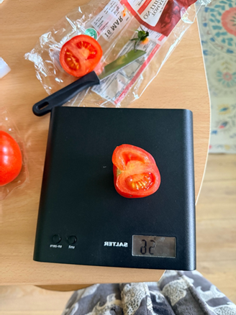
Figure 3: tomato sample for Himalayan salt
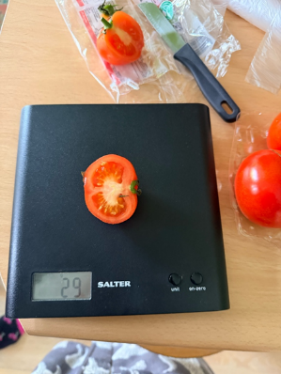
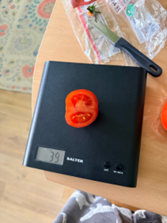
Figure 2: Tomato sample for Epsom salt
Figure 1: Tomato sample for sea salt

Measurements of samples
Sample | Salt Type | Initial Tomato Mass (grams) | Salt Mass (grams)
A | Himalayan Salt | 56g | 250g
B | Sea Salt | 39g | 55g
C | Epsom Salt | 29g | 300g

Results
week | Salt Type | Mass (grams) | Physical Observations
1 | Sea Salt | 35g | Very watery, mushy, salt turned pink
1 | Himalayan Salt | 55g | Slightly mushy, mostly intact
1 | Epsom Salt | 29g | Best preserved, minimal mushiness
2 | Sea Salt | 25g | Extremely watery, clumpy salt
2 | Himalayan Salt | 32g | Some liquid, moderate preservation
2 | Epsom Salt | 29g | Intact, minimal liquid
3 | Sea Salt | 18g | Shrunken, rubbery texture
3 | Himalayan Salt | 26g | Decomposing, skin separating
3 | Epsom Salt | 29g | Maintained shape, slightly rubbery

Week one
- Sea salt: highly watery and mushy; salt turned a pinkish colour; weight of tomato reduced to 35 grams
- Himalayan salt: slightly mushy but structurally intact; weight 55 grams
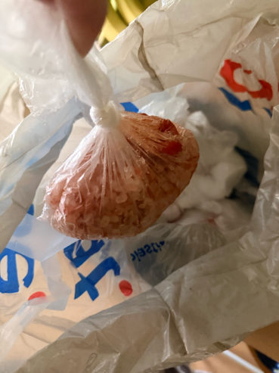
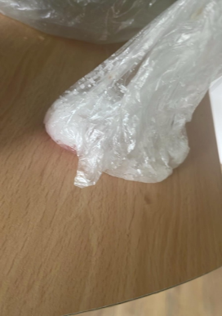
- Epsom salt: best preserved; minimal mushiness; weight remained 29 grams
Figure 4: Week one results of Himalayan salt
Figure 6: Week one results of sea salt 1

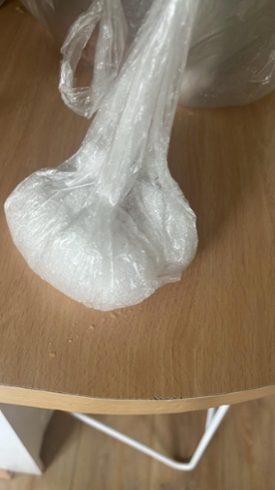
Figure 5: Week one result of Epsom salt

Week two
- Sea salt: Extremely watery, salt clumping; weight 25 grams 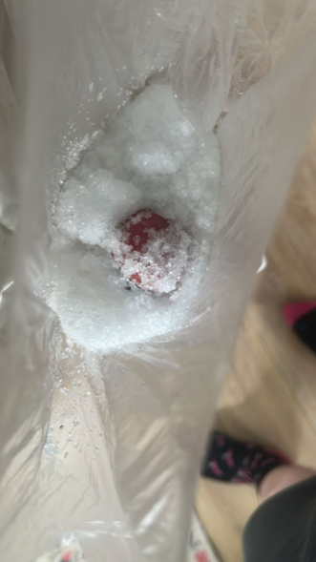
Figure 10: Week two results of sea salt
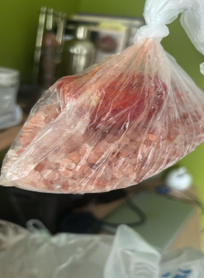
- Himalayan salt: Some water accumulating; moderate preservation; weight 32 grams
Figure 7: Week two results of Himalayan salt
- Epsom salt: Most intact; minimal liquid; weight unchanged at 29 grams

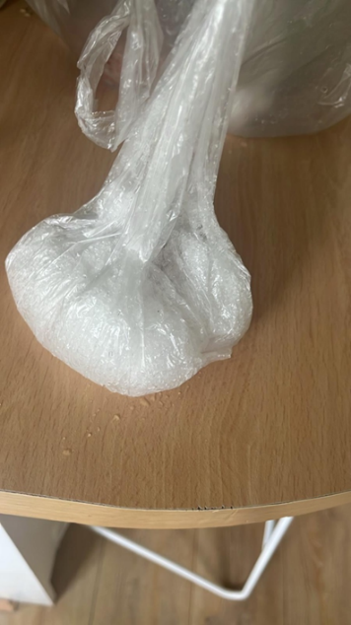
Week three
Figure 8: Week two results of Epsom salt
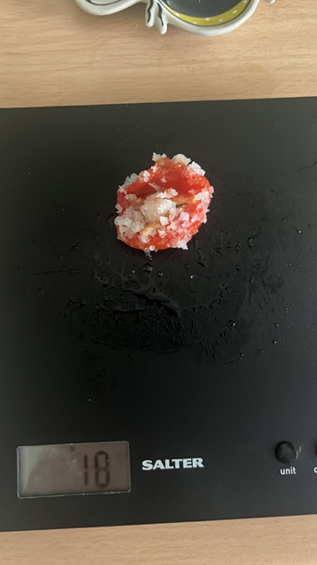
- Sea salt: Shrivelled, rubbery texture; weight 18 grams
Figure 11: Results of week three of Sea salt
- Himalayan salt: Significant decomposition; skin separation; weight 26 grams
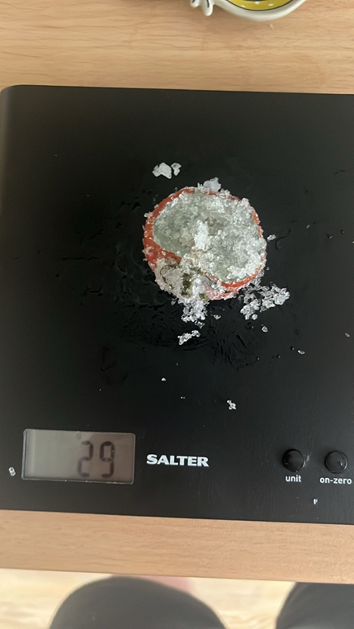
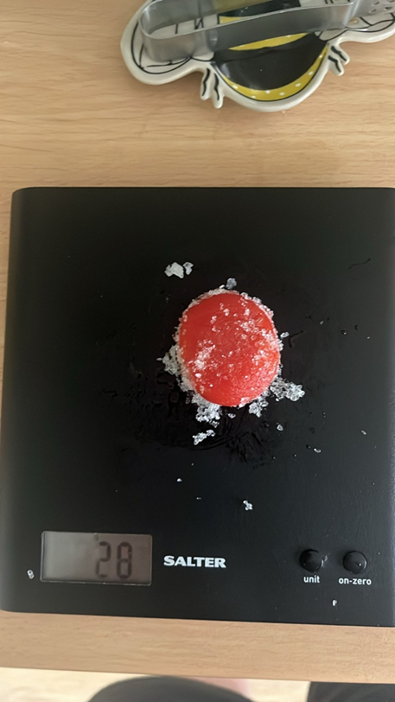
- Epsom salt: Maintained original shape; slight rubberiness; weight at 29 grams
Figure 13: Week three results of Epsom salt
Figure 12: Week three results of Himalayan salt

Total Mass Loss
Salt Type | Initial Mass (g) | Final Mass (g) | Mass Loss (g) | % Mass Loss
Sea Salt | 39g | 18g | 21g | 53.8%
Himalayan Salt | 56g | 26g | 30g | 53.6%
Epsom Salt | 29g | 29g | 0g | 0%

Discussion of results
The results indicate clear differences in the desiccating ability of each salt. Sea salt showed the most rapid moisture extraction, as shown by significant weight loss and the accumulation of liquid at the bottom of the sandwich bag. However, this was accompanied by structural degradation, suggesting that rapid dehydration may damage the tissue.
Himalayan salt showed moderate effectiveness but ultimately resulted in decomposition. Despite having over 80 traces of minerals, these did not appear to enhance the preservation of the tomato (Pink Himalayan Salt, Benefits & Uses, Holland & Barrett, no date).
Epsom salt produced the most stable results, by keeping the tomato’s shape and weight over time. This suggests that magnesium sulphate may stabilise the tissue structure while limiting excessive moisture loss. However, its lack of significant weight reduction shows that it may not function as a strong desiccant.
In contrast, natron used by ancient Egyptians was highly effective due to its chemical structure. It combined multiple sodium-based elements that enchanted the moisture extraction while also preserving the tissue (Lucas, no date; Abdel-Maksoud and El-Amin, 2011). This balance which natron shows, is crucial as excessive dehydration can cause the structure to collapse, while insufficient dehydration leads to decay.
Experimental mummification studies support these findings, demonstrating that controlled desiccation is essential for long-term preservation (Morozova et al, 2010). The results of this experiment suggest that none of the tested salts fully replicate the properties of natron, though each show some similarities.

Mummification in ancient Egypt
Mummification in ancient Egypt was a process to preserve people, to prevent decomposition and to ensure that the person’s body was able to go into the afterlife. The ancient Egyptians believed that the physical body was necessary for the soul to continue to exist. Which made the preservation essential. Over time, the process developed into a complex procedure. Which combined anatomical knowledge, chemical treatment, and ritual practices together. The process began with the removal of the internal organs, which are the first to decay. An incision was made in the abdomen to remove organs such as the liver, lungs, stomachache and intestines (Abdel-Maksoud and El-Amin, 2011).
The most critical stage of mummification was dehydration using natron, which was a natural mixture of sodium carbonate, sodium bicarbonate and sodium sulphate (Lucas, no date). The body was covered in natron for around 40 days, allowing the salt to absorb the moisture from the tissues. This process was essential. As the removal of water stops the enzymatic decay, which is one of the primary causes of decomposition (Morozova et al, 2020).
After the dehydration, the body was cleaned and treated with oils and resins. These substances provided antibacterial properties and helped to further preserve the tissue (Organic chemistry of embalming agents in Pharaonic and Graeco-Roman mummies, no date). The body was then restored to the natural shape, and the entire body was wrapped in line bandages often with protective amulets.
Modern experimental replications have demonstrated the effectiveness of these methods, especially the role of natron in preserving tissue over extended periods of time (Zimmerman, Brier and Wade, no date). Overall, mummification relied on a balance of dehydration and chemical treatment, highlighting the advanced practical knowledge the ancient Egyptians held.

Interpretation
The effectiveness of each salt can be explained by its chemical make up:
- Sea salt: strong desiccant, rapidly extracts moisture but may damage tissue
- Himalayan salt: has multiple minerals but lacks strong dehydration capability
- Epsom salt: stabilises structure but does not effectively remove moisture

Natron’s unique make up allows it to both dry and preserve tissue effectively, making it superior to other salts. Its role in mummification highlights the importance of its chemical makeup and how the collaboration of the components aid each other to preserve what is needed.
The results of the experiment demonstrate clear differences in the desiccation and preservation capabilities of the three salts tested.
Sea salt showed the most rapid and significant moisture extraction, as shown by a mass reduction from 39 grams to 18 grams of the tomato over the three week period. This represents a loss of around 53.8% of the original mass. Which shows strong desiccating properties. Observational data supports this, with the tomato becoming more and more watery in the early stages before eventually shrinking and developing a rubber texture. However, this rapid dehydration appeared to change the structure of the tomato, resulting in a mush consistency. This suggests that while sodium chlorite if effective at removing water, it may not preserve the tissue structure effectively.
Himalayan salt also demonstrated a great moisture loss, with a deduction of the mass of the tomato from 56 grams to 26 grams (53.6%). The tomato showed signs of decomposition, including skin separation and increased softness. Indicating that moisture removal alone was insufficient to prevent tissue breakdown.
In contrast, Epsom salt showed no change in mass, remaining a constant 29 grams throughout the experiment. This indicates that it did not act as a strong desiccant. However, it preserved the structure of the tomato more effectively than the other salts, with minimal shrinkage and a maintained shape.
When compared to natron, none of the salts fully replicated its effectiveness,

Conclusion
This experiment demonstrates that different salts vary in their ability to desiccate and preserve organic material. Sea salt provided to be the most effective at removing moisture, as evidenced by the substantial reduction in mass over the three-week period. However, this rapid dehydration had a negative impact on the stature of the tomato, resulting in a mushy texture before eventually shrinking.
Himalayan salt showed moderate performance, with a similar level of moisture loss but ultimately led to visible decomposition. The tomato showed signs of tissue breakdown, including separation of the skin, indicating that a high mineral count alone is insufficient in preventing decay.
Epsom salt was the most effective at maintaining the original shape of the tomato, with minimal visible decomposition throughout the experiment. However, it showed little to no reduction in mass, suggesting that it lacks strong desiccating properties. This highlights the limitations it has as a preservation agent, as the removal of moisture is a critical factor in preventing decay.
These findings suggest that the success of ancient Egyptian mummification was largely due to the unique makeup of natron, which provides a balance between dehydration and preservation.
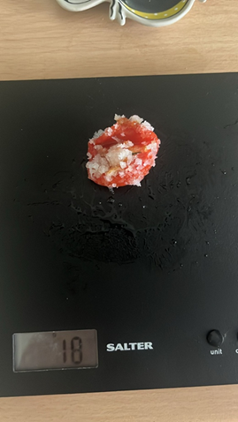
Future research could explore combing different salts to more closely match the composition of natron, as well as extending the duration of the experiment to observe long term preservation effects. Such investigations would provide further insight into the chemical process underlying mummification and improve the accuracy of experimental reconstructions.

Comparing results
Figure 1: Tomato sample for sea salt Figure 11: Results of week three of Sea salt

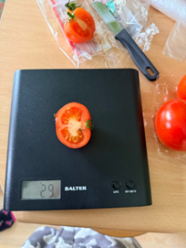
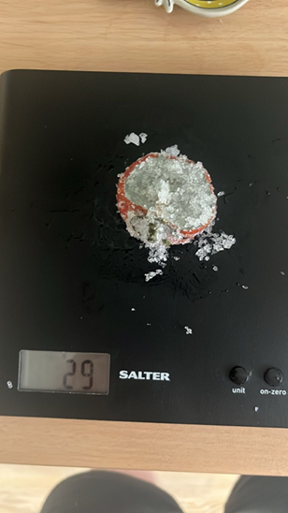
Figure 2: Tomato sample for Epsom salt
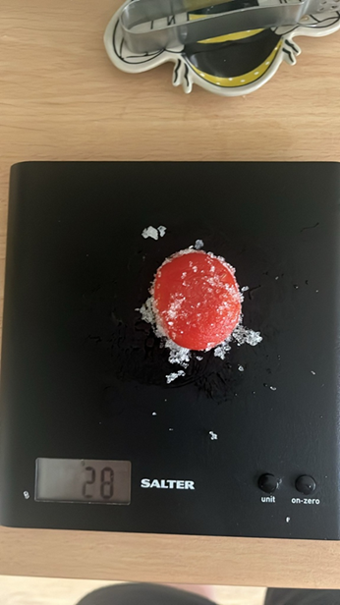
Figure 3: tomato sample for Himalayan salt
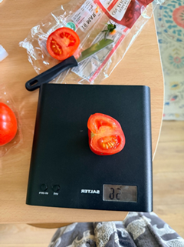
Figure 12: Week three results of Himalayan salt

References

Abdel-Maksoud, G. and El-Amin, A.-R. (2011) ‘A REVIEW ON THE MATERIALS USED DURING THE MUMMIFICATION PROCESSES IN ANCIENT EGYPT’, Mediterranean Archaeology and Archaeometry, 11(2), pp. 129–150. Available at: https://www.maajournal.com/index.php/maa/article/view/437 (Accessed: 27 March 2026).
Epsom Salt: Benefits, Uses, and Side Effects (2018). Available at: https://www.healthline.com/nutrition/epsom-salt-benefits-uses (Accessed: 27 March 2026).
Lucas, A. (no date) ‘The Use of Natron in Mummification’.
Morozova, I. et al. (2020) ‘Ongoing tissue changes in an experimentally mummified human leg’, The Anatomical Record, 303(12), pp. 3085–3095. Available at: https://doi.org/10.1002/ar.24333.
Organic chemistry of embalming agents in Pharaonic and Graeco-Roman mummies - ProQuest (no date). Available at: https://www.proquest.com/docview/204473085/fulltextPDF?pq-origsite=primo_ra&accountid=130472&RAO=true&sourcetype=Scholarly%20Journals (Accessed: 27 March 2026).
Pink Himalayan Salt | Benefit & Uses | Holland & Barrett (no date). Available at: https://www.hollandandbarrett.com/the-health-hub/food-drink/food/pink-himalayan-salt/ (Accessed: 27 March 2026).
Sea Salt: Uses, Benefits, and Downsides (2019). Available at: https://www.healthline.com/nutrition/sea-salt-benefits (Accessed: 27 March 2026).
Zimmerman, M.R., Brier, B. and Wade, R.S. (no date) ‘Brief communication: Twentieth‐century replication of an Egyptian mummy: Implications for paleopathology’. Available at: https://onlinelibrary-wiley-com.uwtsd.idm.oclc.org/doi/10.1002/(SICI)1096-8644(199812)107:4<417::AID-AJPA4>3.0.CO;2-B (Accessed: 27 March 2026).

Figures 1-13: All photos photographed by Lillian York

