BMSW4005

PROFESSIONAL AND CAREER DEVELOPMENT

STUDENT NAME: Crista grigore
STUDENT ID: 2118246

Resume

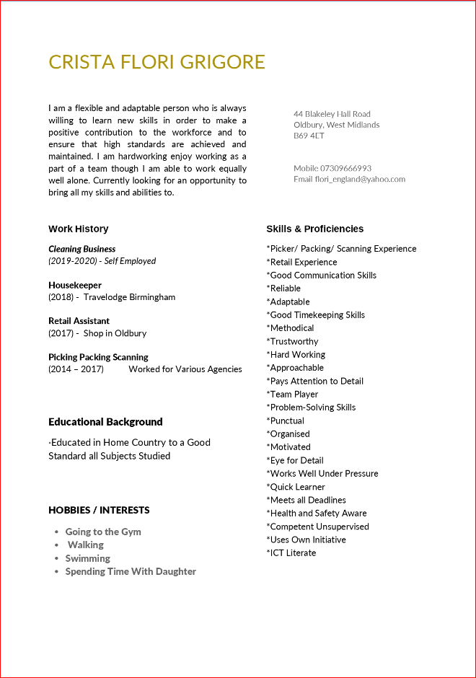

Cover Letter

Aaron Loeb
Head of Human Resources
Gold Lion Business Services, Inc.
123 Miller Street. Westwood,
South Carolina 12345

Dear Mr Loeb:
With 6 years of sales experience and a proven track record of consistently surpassing sales targets, I am excited to express my interest in the Sales Executive position at Gold Lion Business Services, Inc. Through my professional background, I have gained a comprehensive understanding of the sales process, which includes generating leads, prospecting, and finalizing deals. I excel in building client relationships, identifying their unique needs and concerns, and providing tailored solutions that meet their requirements. During my tenure at Gold Lion Business Services, Inc., I delivered remarkable results by surpassing sales targets and boosting the company's revenue.
Additionally, I have built strong relationships with clients, earning their trust and becoming their go-to advisor. I am enthusiastic about the opportunity to leverage my sales skills and expertise to contribute to your team's success at Gold Lion Business Services, Inc. My work ethic, passion for sales, and ability to work collaboratively with colleagues make me an invaluable addition to your organization. Thank you for considering my application, and I am looking forward to discussing my qualifications in more detail and demonstrating my potential to contribute to your team's success.
Sincerely,
CRISTA FLORI GRIGORE

Job Advertisement



