

LOCATION: Swansea | LLEOLIAD: abertawe
LEVEL 6 | LEFEL 6
EXAMINATION PERIOD | CYFNOD ARHOLIADAU
May 2020 | MAI 2020

MODULE CODE: ACCA6018
COD Y MODWL: ACCA6018
WIDE AREA NETWORKS
TIME: 2 HOURS

Name : NICK ALEXANDER

Student ID : P147734

Date & Time : 11/05/2020 10AM START

This is an individual practical lab-test, held under examination conditions. You will be assigned three Switches and two Routers; you should configure these devices based on the given specifications.

This paper is marked out of 100.

Device IPv4 Address Tables;
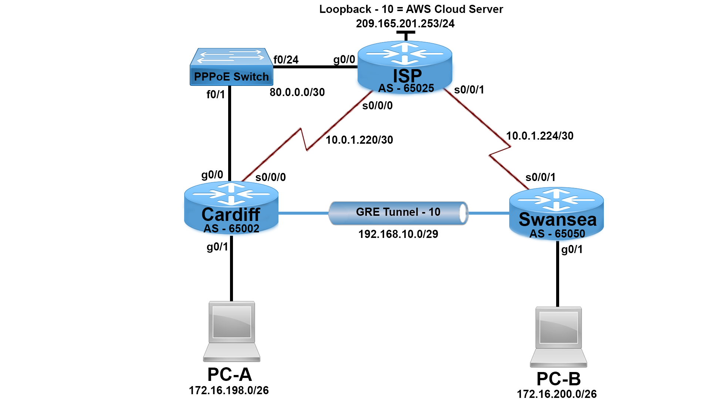

ISP
Interface | IP Address | CIDR
Loopback 10 | 209.165.201.253 | /24
G0/0 | PPPoE Enabled Global Group | -
G0/1 | Last Available Address (Refer to Topology) | /26
Virtual Template 1 | 80.0.0.1 | /30
S0/0/0 | First Available Address (Refer to Topology) | /30
s0/0/1 | First Available Address (Refer to Topology) | /30

Cardiff
Interface | IP Address | CIDR
G0/0 | PPPoE Enabled – Dialer Pool 1 | -
Dialer 1 | IP Address Negotiated – Last Available PPPoE Pool | -
Tunnel 10 | First Available Address (Refer to Topology) | /29
S0/0/0 | Last Available Address (Refer to Topology) | /30

Swansea
Interface | IP Address | CIDR
G0/1 | Last Available Address (Refer to Topology) | /26
Tunnel 10 | Fifth Available Address (Refer to Topology) | /29
S0/0/1 | Last Available Address (Refer to Topology) | /30
PC-A
Interface | IP Address | Default Gateway | DNS Server
NIC | DHCP | DHCP | 8.8.8.8
PC-B
Interface | IP Address | Default Gateway | DNS Server
NIC | DHCP | DHCP | 8.8.8.8

Task 1: - Topology Creation (5 marks)
Using Packet Tracer software create the topology shown above and complete all tasks below.
Task 2: - Basic Device Configuration (10 marks)
- Cable a network as per the topology diagram.
- Configure all devices with IP address shown in the above tables and network topology.
- Configure hostnames on each device.
- Disable DNS lookup on all routers.
- Configure domain name on all routers = wanexam2020.com
- Secure privilege executive login with level 5 encrypted password = class
- Create local database of username and encrypted level 5 password for all routers; Username = admin Password = cisco
- Secure all router console lines with local authentication and enable synchronous logging.
- Secure all router virtual terminal lines with local authentication and disable telnet.
- After enabling SSH; create cryptographic keys with 1024 bit modules.

Task 3: - Cardiff and Swansea DHCP configurations (8 marks)
- Configure a DHCP pool on Cardiff router so PC-A receives its IP Address, Default Gateway and DNS Server configurations from the DHCP server. (4 Marks)
- Configure a DHCP pool on Swansea router so PC-B receives its IP Address, Default Gateway and DNS Server configurations from the DHCP server. (4 Marks)
Note: Refer to Network Topology and IP Address table for IP addressing and DNS address.

Task 4: - Configure Exterior Gateway Routing with BGP (25 Marks)
- Create a BGP instance on all routers utilizing the Autonomous System Numbers (ASN) that has been given within the network topology.
- Configure all routers with the network statements pertaining to each of their interface subnet addresses.
- Configure BGP neighbor addresses for each router where appropriate.

- Configure a default static route on ISP router with Lo10 as outgoing interface.

- Redistribute the default route within BGP process by adding the network statement: network 0.0.0.0 to the ISP BGP process.

- Verify all routes are on routing table.

Task: 5 - Point to Point Protocol (PPP) (7 Marks)

- Configure all serial links to utilize PPP encapsulation

- Configure Challenge Handshake Authentication Protocol (CHAP) on all routers using the password = wanexam2020

Task: 6 - Generic Routing Encapsulation (GRE) Tunnel (10 Marks)

- Configure a GRE tunnel link between Cardiff and Swansea routers using the IP address given within the IP table for the tunnel addresses. Use tunnel 10 as the GRE interface.

- Use the serial interfaces as the source for each tunnel respectively.

- Use the serial link IP address for the destination of the tunnel on Cardiff and Swansea routers.

- Use default tunnel mode for encapsulation.

Task: 7 - Network Address Translation (NAT) (5 Marks)

- Allow PC-A and PC-B subnet to utilize PAT.

- Configure Port Address Translation (PAT) on the ISP router using the Loopback 10 interface as the translated address.

- Configure NAT on the correct interfaces on the ISP router to start the NAT process.
Task: 8 - Test connectivity Pre ACL (15 marks)
From PC-A, ping PC-B and AWS Cloud Server and vice versa. Is it successful? ______YES______

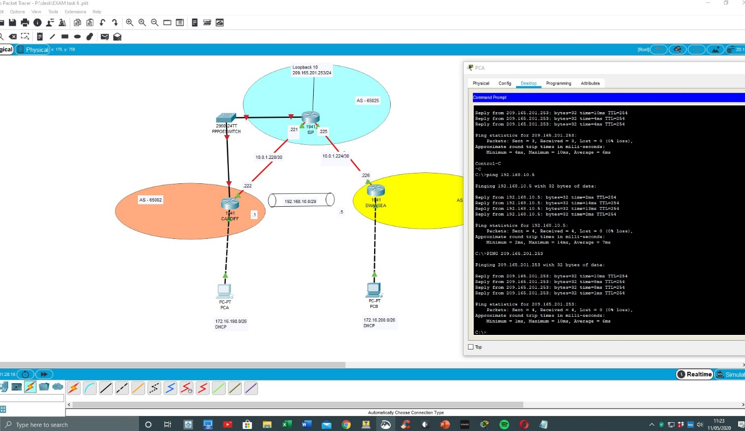
Figure 1Pc A - pinging AWS
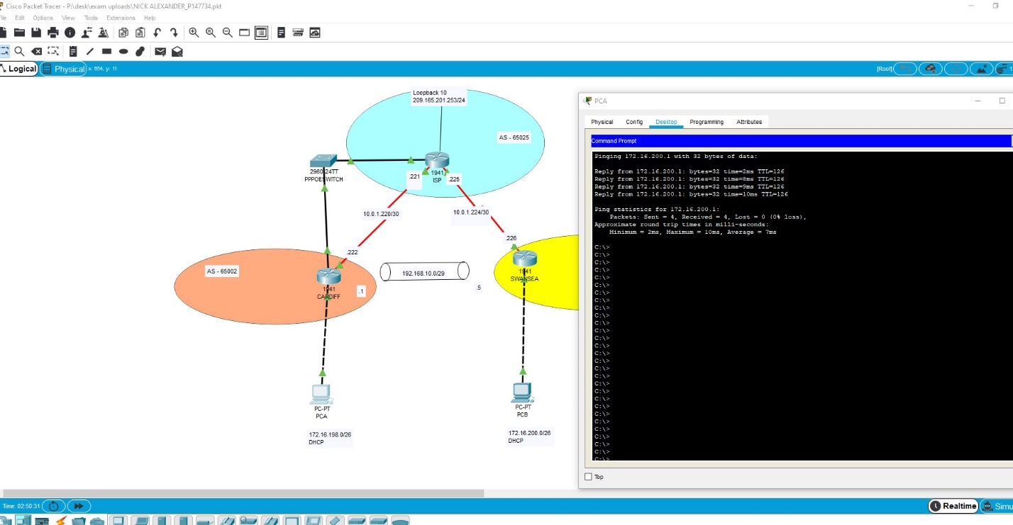
Figure 2 - Pc A Pinging PCB

From any PC - B, ping Cardiff router tunnel 10 IP address. Is it Successful? _______YES_______

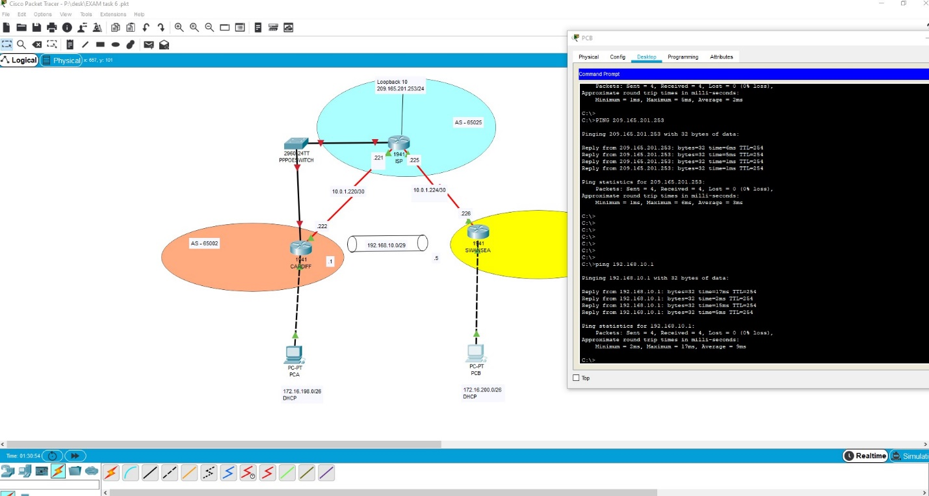
Figure 3- Pc B pinging Cardiff tunnel and AWS

Task: 9 - Access Control Lists (ACL) (15 Marks)
Create an ACL to only allow the PC-B subnet to remote SSH into the Cardiff router. ( 3 Marks)
Create an ACL to prevent PC-B from ‘Pinging’ the AWS server and also prevent PC-B from using HTTP and DNS protocols within the AWS server. (7 Marks)
Verify only PC-B is able to SSH to Cardiff router. Try SSH from PC-B and PC-A, screenshot the output here. (5 Marks)

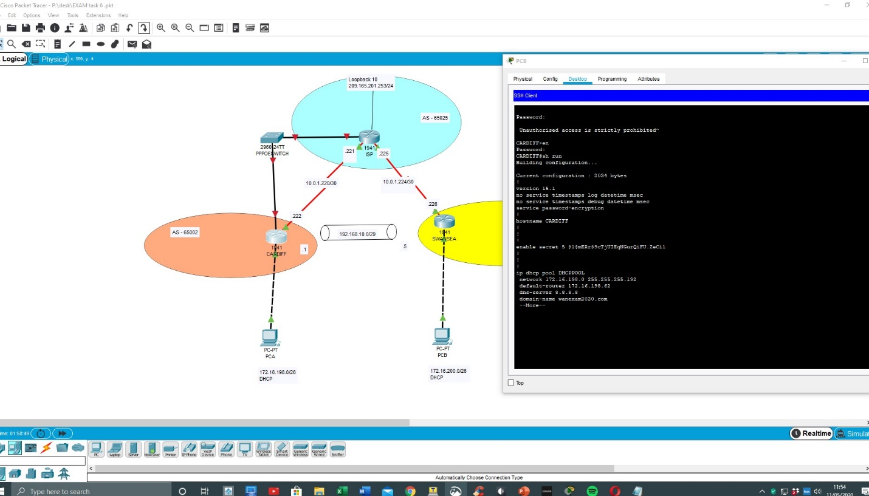
Figure 4- Pc B SSH into cardiff

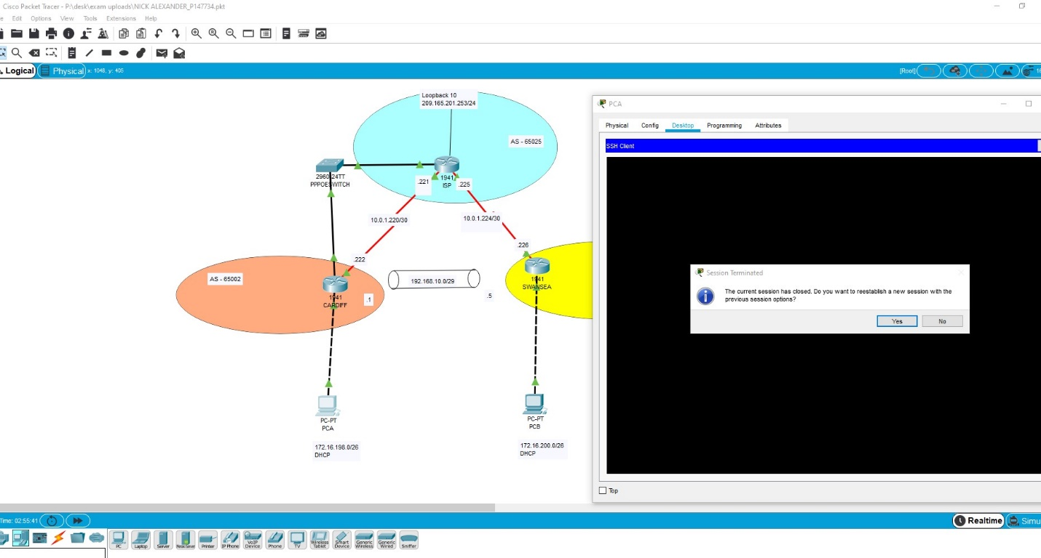
Figure 5 - Pc A Failing to SSH into Cardiff

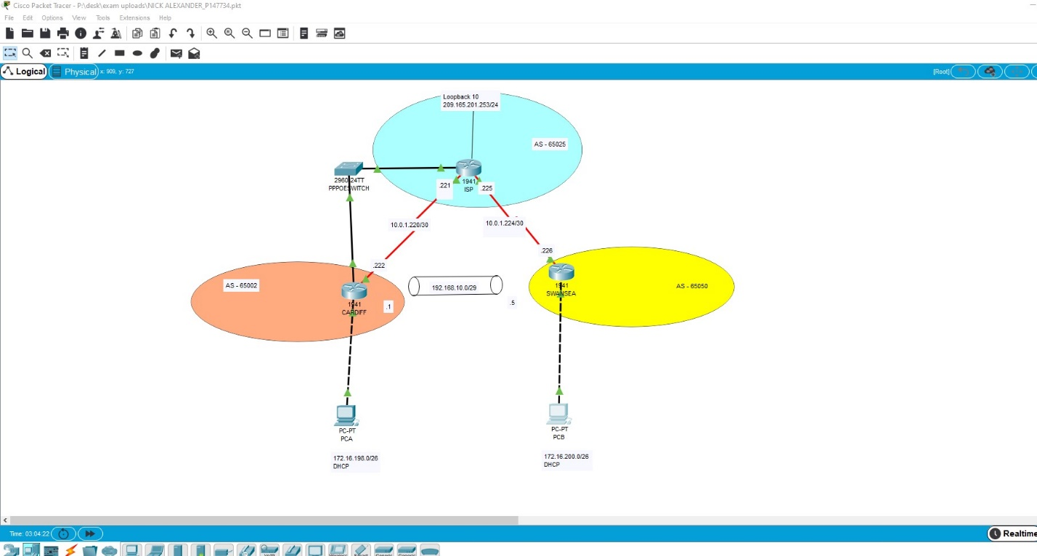
Figure 6- after acl - ping blocked from pc B
Submission Requirement
The packet tracer file should be saved as “studentname_id” and uploaded on Moodle. In addition to packet tracer file, you must also submit

- the output of show running-configuration command in a text file for all devices configured.
- This document with task 8 and task 9 completed

All documentation for your solution should be submitted electronically on Moodle.
It is your responsibility that you submit all the outputs and files correctly.

