UNIVERSITY OF WALES
TRINITY SAINT DAVID

ASSIGMENT TITLE: Structure and Culture of Microsoft

NAME: OANA BALABAN
STUDENT NUMBER :1911819

August 2020

Table of Contents
Introduction 1
Organisational Overview 2
Organisational Structure of Microsoft 3
Role of culture in organisation 5
Relationship between culture, employees and the structure for effective performance 7
Conclusion 8
References 9

Introduction

The following report on the structure and the culture will evaluate the same for Microsoft. The organisational structure for Microsoft will be evaluated, which will further be supported by relevant theories and models. The next part will cover the role and the importance of the culture in Microsoft. Further; the report will establish the relationship between all the core components and how they have a significant impact on the performance and development of the firm will be seen with the support from relevant evidence and models.

Organisational Overview

Microsoft is a multinational technological firm having headquarters in Washington. It manufactures the products and services such as software's, electronic products, sales of computers. One of the trending services of the firm includes cloud computing. The firm was established in 1975 by Bill Gates (Microsoft, 2020). The firm provides its services all over the Globe. The firm has various departments to focus on operations all over the world. The culture of the firm focuses on innovation and related practices to have competitive advantages. The combination of perfect structure and the suitable culture has enlisted Microsoft at 30th Rank in Fortune 500 in the list by largest revenues.

Organisational Structure of Microsoft
Definition
The organisational structure in simple term referred to as; the outline of the activities, processes and systems and their way of working in the organisation. The activities further include the roles, duties, powers and responsibilities and distribution among the firm.
Importance
The structure in any of the businesses is important; as it determines the information flow of the firm and between various hierarchical levels. Further; it distributes the specific roles, responsibilities, powers and task to each of the employees in the hierarchy from top to bottom that makes it easy for the firm to achieve its tasks as the firm knows who is responsible for which works (d'Ippolito, 2014). It brings clarity among the work with a systematic approach. Some of the indirect benefits of it include the elimination of organisational politics and unethical power usage that motivates the employees to work.
Weick's Model of Organising
The theory by Weick’s explains that the employees in the organisation create the environment around them, i.e. the way of looking at the things known as Enactment. The selection stage includes the identification of specific organisational structure with which the firm can effectively communicate the way it’s desired in its hierarchical level (Starbuck, 2015). The retention is using the same structure for future communication and uses. Since; the communication is the major issue in the structure; the model best suits to have an effective organisational structure.
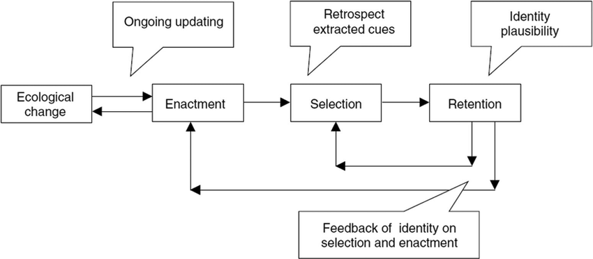
(Source: Maitlis, S. and Christianson)
Microsoft structure
Talking in terms of structure, Microsoft follows the Divisional organisational structure. The CEO of Microsoft has explained the reasons behind the adoption of divisional organisational structure in the form of organisational change made in 2015. The main focus of the firm behind this structure is to concentrate more on three engineering groups with more focus on innovation (Panmore, 2018). The structure combines various functions into single divisions which are further categorised base on the division of the products or the markets. The main reason behind the divisional structure is to easily focus on the mobile and cloud business. The firm has adopted the structure because every unit or division acts as a separate company within the firm as all the other functions are available in each division, making its independent in terms of operations. Making changes or closing of one of the divisions does not affect the others. The specific skills and capabilities of the employees relate to the products, and the markets can be enhanced.
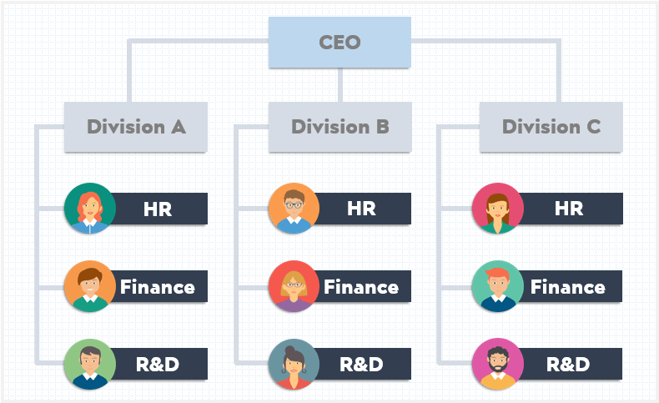
(Source: Someka, 2020)
The structure promotes decentralisation and eliminates internal conflicts as all the functions are different, and there is no competition in terms of seeking more resources or power. Microsoft has adopted the three styles of divisions based in a single structure such as product, global level and geographic segments. The product-based division uses the products of Microsoft for structuring and related resources. Microsoft has a separate division for Clouding related products while; separate for others. Product-based divisions promote innovation (Linked In, 2020). The product-based divisions for Microsoft include; the productivity and business process, Intelligent Cloud, Personal Computing, Corporate and others. The global corporate groups also define the structure of Microsoft. They define the structure based on the essential functions of the business such as CEO office, commercial business, marketing, global sales and operations, corporate strategy, Microsoft cloud, human resources, Business development, applications and services, windows and devices, technology and research, Legal, etc. ().
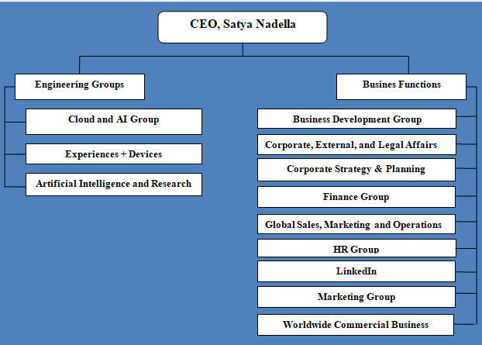
(Source: Business research methodology, 2019)
The last includes the geographic segments, but at least level, the segments described below are used to group operations in the financial reports of the firm. The segments include the United States and international. The divisional organisational structure of Microsoft is based on the above listed three categories.

Role of culture in organisation
Definition
The organisations culture refers to all those deep-seated beliefs, values, way of interaction, languages, assumptions that contribute to the social and the psychological environment of Microsoft. The culture is the basic values that are the key to success.
Importance
The listed reasons show the importance of organisations culture such as; culture promotes the unity through policies, decisions, etc. the unity makes the employees work together, respect each other’s values and skills and leads to competitive advantages and further develops the firm (Carlström and Ekman, 2012). A proper organisational culture aligns the basic values, and the goals of the firm synced and made the employees motivated to achieve them. The good culture focuses on caring the employees, which further with innovative services promotes the brand.
Handy’s organisational culture
The theory by Charles handy has proposed four sorts of organisational culture that can exist in the firm, and Microsoft follows one of them. The four cultures include;
Person culture: This sort of culture has the employees or individual has their field of expertise, and the employees rely on themselves rather than polices and rules of the firm. The employees find their personal goals superior to the objectives of the firm. It may include the institute of medical professionals, lawyers, etc.
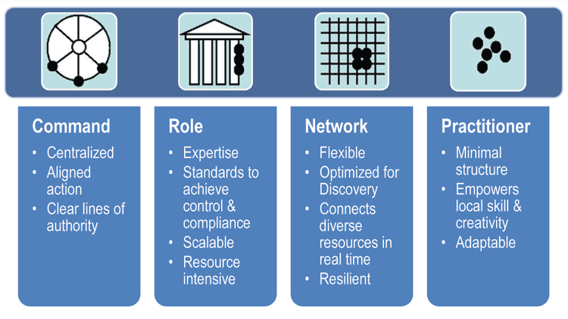
(Source: The Collborationdna, 2020)
Power culture: The power culture allows the central power of decision making in the hands of few in the top management. The person uses the power to make the other's work, and it can be against their wishes. The power which is commonly exercised is the coercive power.
Task culture: The task culture is a sort of matrix form, and it is mainly formed in the IT sector or for the project teams. The teams are formed for problem-solving. The structure in such cultures includes the supervision of two managers (Cacciattolo, 2014).
Role culture: The role culture focuses on the strict follow-up of the policies and the rules as stated during the formation of the firm to distribute the power, roles and duties accordingly. The culture allows the equal distribution of power and responsibilities.
Microsoft’s culture
As per the analysis by Business research and methodology (2019), the organisational structure of the firm has changed many times since; it formation but it has changed in the recent times in 2015 by the new CEO Satya Nadella. The CEO has made the firm to follow the three core concepts as the part of their organisational culture such as; the Learn it all mentality that makes the employees learn the new things from wherever they can. Further; openness, the employees can reach for CEO anytime related to any issues and further; the innovation, and diversity and Inclusion. These are the core concepts incorporated as organisational culture. Looking at the core concepts and features, the organisational couture of Microsoft is the Role culture with the unique approach of innovation and its promotion among the employees. The firm provides the duties and powers and further provides flexibility and open space to make the employees innovate new products.

Relationship between culture, employees and the structure for effective performance
Relationship
The relation between the culture and the structure can be established as the structure is the result of the structure as the culture is the basic value and all the activities from starting are affected by it. While; the structure one's implanted effectively, it has a partial impact on the culture of Microsoft. It is the culture of the firm that impacts the type of the structure, such as whether it would be matrix, divisional, functional or flat organisational chart. The power culture promotes the tall organisational structure to enjoy power over others (Microsoft, 2020). The role culture such as Microsoft uses the decentralisation to have effective results and so on. The employees are the other factors that have an impact on the culture, such as with the entrance of the new employees, comes the new views and cultural differences, and this affects the organisational culture.
Looking at the example of Microsoft, with the change in the leaders the culture of the firm has changed many times such as initially they are being laid by Bill Gates, then by Steve Ballmer between 2000-14, then currently in 2015 by Satya Nadella. Thus; the people are linked to the culture.
Impact on business performance
The divisional organisational structure is very good for the development of the firm as it has less management which improves the speed of decision making needed in competitive advantages. Further with the role culture in Microsoft, all the employees are given with equal responsibilities and power at each level, and this makes the employee motivated and seek in productivity (Pinho et al. 2014). The organisational culture eliminates the politics among the employees as all the roles are distributed equally, and there is no unethical usage of power by others and makes the employee feels safe and confident to work. The innovation approach is the new one as part of effective organisational culture that provides the employees with free space to apply their own ideas and implement in the given task for innovative results and provides the firm with competitive advantages.
The structure of the firm, i.e. divisional approach as per the products matches with the organisational culture of allocation of the roles and duties as per the policies makes the employees comfort in their zone and work effectively (Kafashpoor et al. 2013). The structure makes the management to distribute the works while; the culture provides the specific roles that match the tasks listed as job roles and get it easily done by talented employees.

Conclusion

The report has a focus on the aspects of structure and the culture of Microsoft, along with the influence of the employees in it. The concept of role and the culture are described and briefed and are synced with that of Microsoft. The culture and the structure of Microsoft are supported with relevant evidence from relevant sources and are further supported by appropriate theories and models. At last, the relations between the structure and the culture are established, and its impact on the development of Microsoft was shown.

References
Books and journals
Cacciattolo, K., 2014. Understanding organisational cultures. European scientific journal, 2(1), pp.1-7.
Carlström, E.D. and Ekman, I., 2012. Organisational culture and change: implementing person‐centred care. Journal of health organisation and management.
d'Ippolito, B., 2014. The importance of design for firms' competitiveness: a review of the literature. Technovation, p.forhcoming.
Kafashpoor, A., Shakoori, N. and Sadeghian, S., 2013. Linking organisational culture, structure, Leadership Style, strategy, and organisational effectiveness: Mediating role of knowledge management. Advanced Research in Economic and Management Sciences (AREMS), 10, pp.158-172.
Maitlis, S. and Christianson, M., 2014. Sensemaking in organisations: Taking stock and moving forward. Academy of Management Annals, 8(1), pp.57-125.
Pinho, J.C., Rodrigues, A.P. and Dibb, S., 2014. The role of corporate culture, market orientation and organisational commitment in organisational performance. Journal of Management Development.
Starbuck, W.H., 2015. Karl E. Weick and the dawning awareness of organised cognition. Management Decision.
Online
Business research methodology, 2019 (Online) [Accessed through] < https://research-methodology.net/microsoft-organizational-structure-divisional-structure-with-focus-on-innovation/> [Access on 8th August 2020]
Linked In, 2020 (Online) [Accessed through] < https://www.linkedin.com/pulse/microsoft-power-divisional-structure-eric-viardot> [Access on 8th August 2020]
Microsoft, 2020 (Online) [Accessed through] < https://www.microsoft.com/en-in/microsoft-365/business-insights-ideas/resources/make-org-charts-for-your-business> [Access on 8th August 2020]
Microsoft, 2020 (Online) [Accessed through] <https://www.microsoft.com/en-gb > [Access on 8th August 2020]
Panmore, 2018 (Online) [Accessed through] < http://panmore.com/microsoft-corporation-organizational-structure-characteristics-analysis > [Access on 8th August 2020]
Someka, 2020 (Online) [Accessed through] < https://www.someka.net/business/types-of-organizational-structures/> [Access on 8th August 2020]
The collaborationdna, 2020 (Online) [Accessed through] < https://collaborationdna.com/2016/08/14/culture-change-dilemma-21st-century/> [Access on 8th August 2020]

