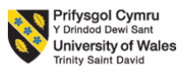

Programme: Master of Business Administration.
Module: Marketing Management Assessment component 2
Module code: LCMB7024
Name: Mohammedaadil Sadikbhai Rana.
Student Id:2530040
Lecturer’s Name: Laila Maazouz & Dian mayasari.

Table of Contents
1.0 Element 1: Brand Extension Poster Presentation 3
2.0 Element 2: Develop a Segmentation, Targeting, Differentiation, and Positioning (STDP) 4
2.1 Key market segments relevant to the brand extension using geographic, demographic, psychographic, and behavioural variables 4
2.2 Detailed explanation of your chosen target audience 6
2.3 Way brand will differentiate itself from competitors in the market 6
2.4 Positioning of the brand extension 7
3.0 Element 3: Marketing Mix (4Ps or 7Ps) 8
3.1 Way each element of the marketing mix will be applied and how it aligns with and supports the overall brand extension strategy 8
4.0 Element 4: Reflection 13
4.1 Reflection on my experience developing the brand extension 13
4.2 Reflection on the experience preparing and delivering the poster presentation 13
4.3 Key skills, knowledge, and insights you have gained throughout this process 13
4.4 Way these have contributed to my personal and professional development 13
4.5 Way I could further enhance my approach and performance in similar projects in the future 14
References 15

1.0 Element 1: Brand Extension Poster Presentation
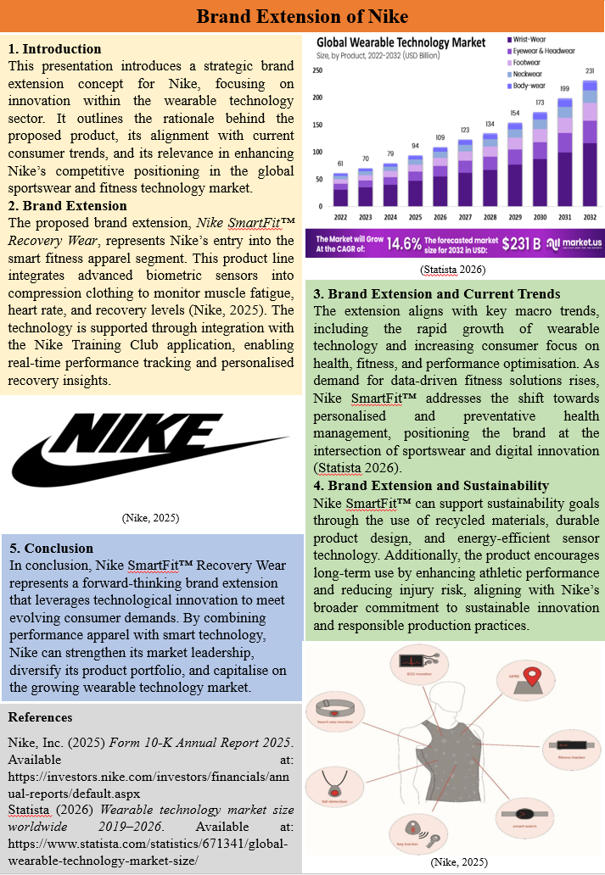

2.0 Element 2: Develop a Segmentation, Targeting, Differentiation, and Positioning (STDP)

2.1 Key market segments relevant to the brand extension using geographic, demographic, psychographic, and behavioural variables
Geographic Segmentation
The geographical location of the Nike SmartFit™ Recovery Wear target market would be in areas that have been shown to embrace wearable technologies, especially North America, Europe and Asia-Pacific cities. It is expected that the wearable market will expand to $86.65 billion in 2025 and reach up to $431.74 billion by 2034, which will support the high demand in such key markets as North America, Europe, and Asia-Pacific (Business Research Insights, 2025). Asia-Pacific, particularly India and China, is a high-growth market, motivated by increased disposable income and digital awareness of fitness. The wearable technology is also expected to reach more than 103 billion around the world in 2026, with geographic demand being highly concentrated in the developed and fast urbanising worlds.
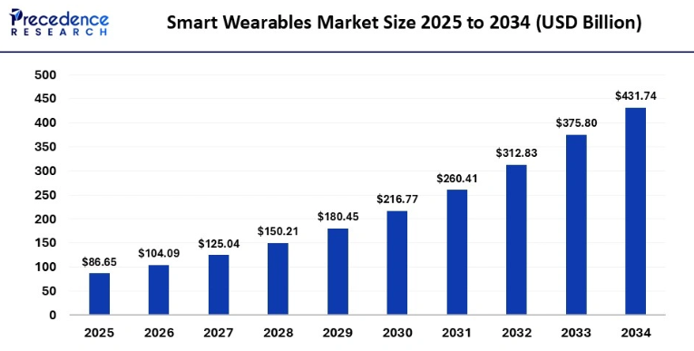
Fig 1: Smart Wearable Market
Source: (Precedence Research, 2025)
Demographic Segmentation
Demographically, the focus market will be 18-45-year-old middle and high-income individuals as this age group has the highest level of fitness technology and high-quality clothing. It is found that more than 63% of adults in developed markets wear them in their daily lives, indicating high penetration among the working age groups. Also, younger professionals and those who are interested in fitness are more ready to spend money on new health solutions (Coherent Market Insights, 2026). The balance of gender is equal with both men and women becoming more and more active in terms of fitness tracking and wellness activities. The consumers with high income are also the most significant because wearable devices and smart apparel are also the products that demand discretionary income.
Psychographic Segmentation
Psychographically, target segment comprises of health-conscious, performance-oriented and tech-savvy people who value self-optimisation and data-driven lifestyles. Active use of health-tracking functions (heart rate and sleep monitoring) is actively used by more than 90% of wearable users, and it means that an enormous majority of wearable users are psychologically inclined towards wellness and self-performance improvement (Deloitte et al., 2026). These consumers value innovation, convenience and personalised insights, which can be aligned to the tendencies of preventative healthcare and digital fitness ecosystem. Furthermore, over 64% of the global users have wearable devices and integrate them into their daily lives, which proves the fact that the behavioural patterns are closely related to the identity, lifestyle, and long-term health goals (World Economic Forum et al., 2026).
Behavioural Segmentation
The behavioural market is characterised by frequent use, high brand involvement, and high dependency on fitness technology ecosystems. In 2025, the global wearable shipments were above 611 million units, meaning that wearables were adopted and repeat usage behaviour existed. Moreover, the product involvement and habitual use are high with more than 92% of smartwatch users tracking their health and fitness everyday (Future Market Insights et al., 2026). This segment is characterized by consumers who are active in pursuit of performance improvement, prevention of injuries and optimisation of recovery. They also have higher chances of adopting integrated platforms, like fitness applications and smart apparel, showing loyalty to brands that deliver value and personalised experiences continuously.

2.2 Detailed explanation of your chosen target audience
The Nike SmartFit Recovery Wear target market consists of digitally inclined urbanised fitness conscious consumers between the age of 20-40 years of age with medium to high disposable income and with high health optimisation oriented consumers. These are typically young professionals, semi-professional athletes and lifestyle fitness clients that are passionate users of smart devices and applications to monitor performance. This is the age group that makes up around 70% of all wearable users in the world since they are the most effective users of fitness technology and data-driven solutions (Grand View Research et al., 2026). Efficiency, personalisation and measurable outcomes are values that they embrace particularly in recovery, injury prevention and performance enhancement. Psycho-graphically, they are driven by self-improvement and competitive success and behaviourally by the fact that they are high participators in the fitness ecosystems making them highly responsive to integrated smart apparel innovations (Apple et al., 2025).

2.3 Way brand will differentiate itself from competitors in the market
The SmartFit™ product distinguishes itself as a product that combines more sophisticated biometric sensors into a performance garment itself, eliminating the need for a traditional wearable like a smartwatch to enjoy the benefits of SmartFit. Compared to other competitors, such as Fitbit or Apple, who can track muscles and their recovery with the use of external devices, Nike integrates technology into clothes to do it more precisely (IndustryARC, 2026). Also, it works synergistically with Nike Training Club app to provide a complete fitness ecosystem with personalised insights and recommendations. The brand also stands out with its high equity in sports performance, international credibility, and sustainability with recycled materials. With its emphasis on recovery and injury prevention, which is a niche that has not been fully developed yet, Nike would stand out in the sportswear and wearable technology markets.

2.4 Positioning of the brand extension
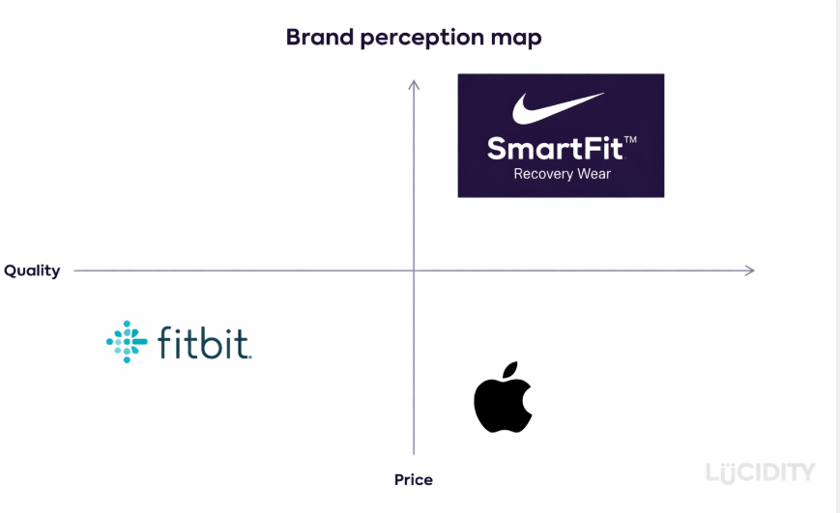
Fig 2: Positioning Map
Source: (Self-Created)

3.0 Element 3: Marketing Mix (4Ps or 7Ps)

3.1 Way each element of the marketing mix will be applied and how it aligns with and supports the overall brand extension strategy
Product
Nike SmartFit™ Recovery Wear is a highly strategic development of the traditional sports wardrobe into a smart device, integrating both biometric sensors and artificial intelligence, as well as real-time feedback. The wearable technology sector expanding by 14.6% CAGR to $231 billion by 2032, which is an indicator of the innovation of Nike SmartFit ™ Recovery Wear in AI-enhanced, health-oriented smart apparel (McKinsey et al., 2026). The functionality of the product to track fatigue in muscles, variability of heart rate and patterns of recovery is in line with the rising consumer trend towards preventative health care and performance optimisation. In comparison to traditional wearable, by incorporating sensors into clothing, the precision and comfort are increased, and the user experience becomes better (The Business Research Company, 2025).
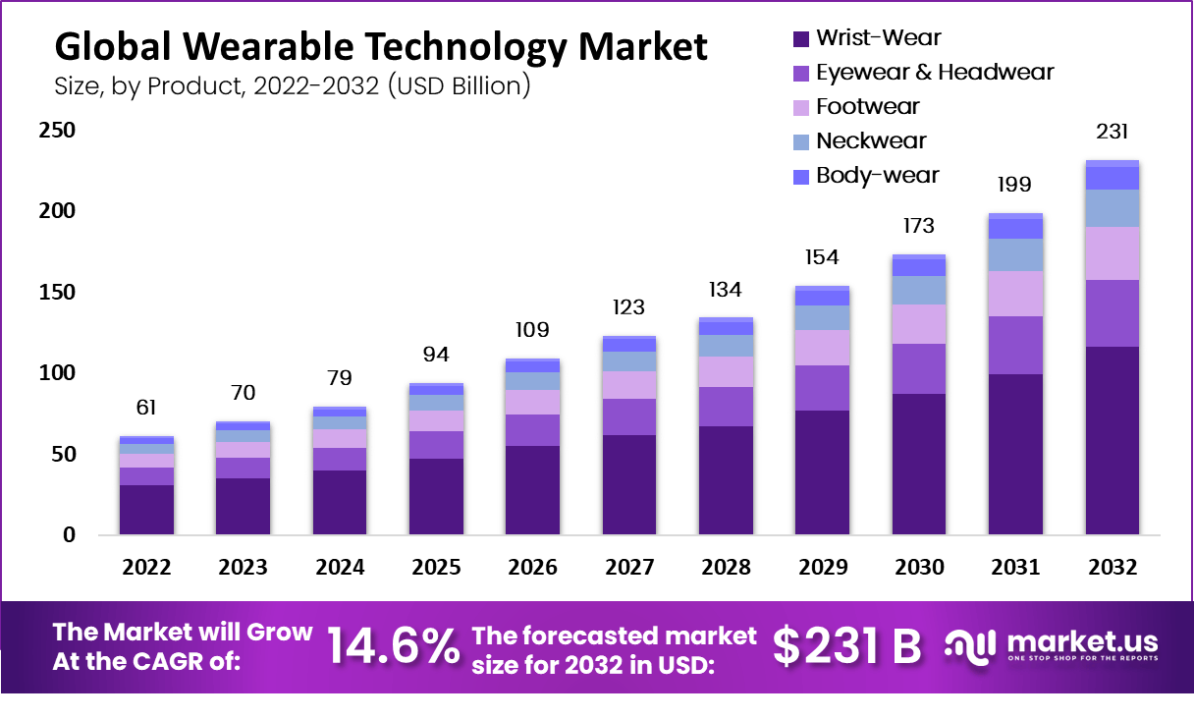
Fig 3: Global Wearable Market
Source: (Market.us, 2025)
Price
Nike SmartFit ™ pricing strategy is strategically set at a high price point because of its technological advancement, creativity, and a good brand equity. Consumers in developed markets are more ready to spend on high value wearable products in 2026 and especially those providing personalised insights and AI-led suggestions (Nike, 2025). Nevertheless, the international inflation and the increasing cost of living has also turned consumers into a more discerning bunch that demands brands to explain their high price with real value and pay-offs over the long term. Nike responds by focusing on the capability of the product to decrease the risk of injury, improve recovery and improve athletic performance-quantifiable benefits to users. Moreover, high prices support exclusivity and fit the positioning of Nike in the high-end market (Technavio, 2026).
Place
The distribution model of SmartFit ™ by Nike consists of an advanced omnichannel strategy that incorporates both physical stores and online spaces, as well as international supply chains. As North America comprises about 37.7% of the global wearable technology market by 2026, it is considered a main distribution center, with high consumer demand and well-developed retail systems. At the same time, other emerging markets like India and China are growing fast because of the penetration of smartphones, growth of disposable incomes and the growth of digital ecosystems (Nike, 2026a). Nike takes advantage of these trends by selling the product via its official Web site, mobile apps, flagship outlets, and other retail partners. The combination of online and offline channels is convenient, accessible, and provides a customer with a smooth journey.
Promotion
The digital engagement, influence marketing, and experience campaign are the primary elements of the Nike promotion of SmartFit ™ because consumer interaction in the wearable technology industry is dynamic. Worldwide, wearable device shipments should be above 600 million units by 2027, as the use of digital ecosystems in consumer behaviour formation continues to gain increased significance (Nike, 2026b). With its robust brand name and association with top players, Nike uses aspirational and credible messages. With the help of social media channels, notification apps, and personal marketing campaigns, it is possible to communicate with everyone individually, making it more relevant and engaging. Moreover, experiential marketing campaigns, including in-store demonstrations and live performance tracking enable consumers to connect with the product directly and increase the perceived value (Statista, 2026b).
People
The element of the People is essential to the provision of the SmartFit ™ value proposition which includes the employees, the brand ambassadors and the customers. The use of professional athletes and fitness influencers by Nike also builds brand credibility since consumers tend to use expert opinions when embracing new technologies (PwC et al., 2026). On the internal level, smart apparel development will demand multidisciplinary skills, such as engineers, data scientists, and product designers, as the fashion industry and technological industry become more and more intertwined. With the ongoing development of the wearable technology market, human capital is becoming a major source of innovation and competitive edge. Also, feedback and data sharing by customers help to create values and lead to constant improvement of the product. Nike builds customer relationships and promotes long-term engagement by promoting a community-based strategy, which is an essential part of its digital offerings, and solidifies its brand as a customer-focused and innovation-driven brand.
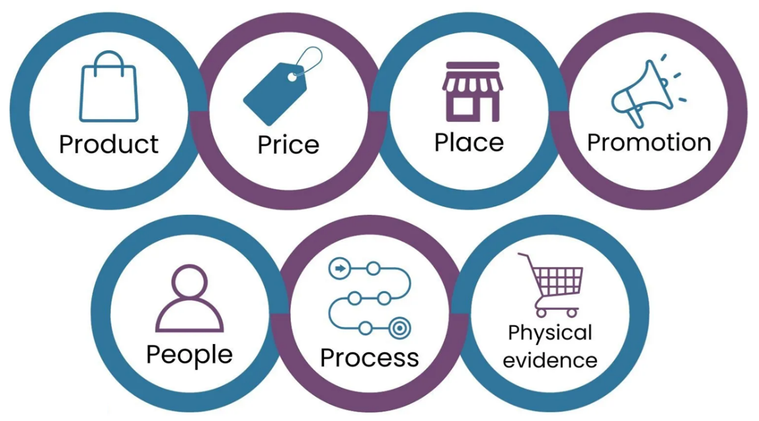
Fig 4: 7Ps of Marketing
Source: (Oxford College of Marketing, 2020)
Process
The operations behind the Nike SmartFit™ are aimed at providing a streamlined and unified user experience, in terms of product development and after-sales interaction. The use of advanced manufacturing methods guarantees the accurate incorporation of sensors into clothing, and AI-based algorithms process user data to give actionable information (Research and Markets, 2026). The wearable tech sector is experiencing a fast change in the precision of sensors and machine learning to perform more complex and accurate tracking of performance. The Nike processes do not stop at the point of sale but provide continuous updates via its app ecosystem, so that the users get a continuous value. Also, the digital integration and efficient supply chain management will allow the scalability and adaptability to market changes (Statista, 2026a).
Physical Evidence
Physical evidence is vital in enhancing the credibility and perceived value of Nike SmartFit™, especially in a market where people use both tangible and intangible aspects of the product to measure quality. The design of the product, with the use of high-quality materials and the noticeable elements of technology, conveys the message of innovation and long-lasting (Research Nester, 2025). Packaging and in-store display also boosts brand perception by drawing attention to the advanced features of the product and premium positioning.
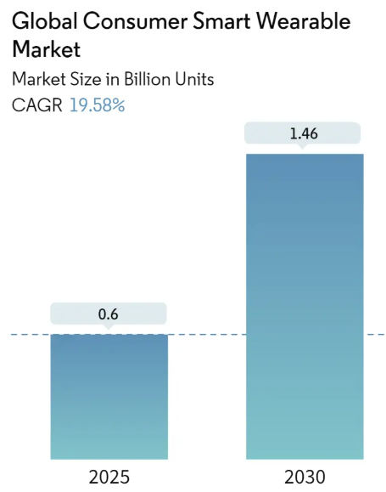
Fig 5: Consumer Smart Wearable Market
Source: (Mordor Intelligence, 2025)
Also, digital interfaces, like the Nike Training Club app, can be viewed as an intangible performance evidence, which gives its users real-time data and customised insights. Smart wearable devices increasing to 0.6 billion in 2025, and 1.46 billion in 2030 (CAGR 19.58%), underscoring the need to have a robust physical and digital evidence in consumer trust-building. Providing high-quality and consistent physical evidence, Nike boosts consumer trust and helps to promote positioning as a smart fitness innovation leader (Scoop Market, 2026).

4.0 Element 4: Reflection

4.1 Reflection on my experience developing the brand extension
The process of creating the concept of Nike SmartFit™ Recovery Wear was very interesting and thought-provoking and demanded the combination of theory and practice. I needed to critically evaluate the market trends especially the fast development of wearable technology and the desire of consumers to use market-driven fitness products and synchronise them with the brand name of Nike. This exercise helped me to become a better strategist because I needed to make sure that the suggested extension was innovative and aligned with the core values of Nike.

4.2 Reflection on the experience preparing and delivering the poster presentation
Writing and presenting the poster presentation, I was able to train my skills in conveying complex concepts in a clear, concise and visually appealing way. The ability to translate detailed strategic analysis into a structured and visual appealing format was a challenge in itself because it had to prioritise on key information without reducing it to a shallow level. My communication and presentation skills were enhanced as I gained confidence in explaining concepts and answering questions during the presentation.

4.3 Key skills, knowledge, and insights you have gained throughout this process
During this project, I acquired various positive competencies, such as strategic thinking, market analysis, and imagination to solve problems. I learnt more about segmentation, targeting, positioning and the marketing mix strategies and I also learnt how new technologies affect consumer behaviour. Also, I improved my research abilities through the analysis of the existing industry data and trends to aid the decision making process. Among the lessons I have learned is the fact that innovation should be consistent with brand identity because effective brand extensions should be creative and consistent.

4.4 Way these have contributed to my personal and professional development
This project has really helped a great deal in my personal and professional growth as it has helped me to improve my analytical, communication and strategic planning skills. It has taught me to be more organized in solving problems, a crucial aspect of the life of a business and marketing consultant. On the professional level, the experience has enhanced my skills in assessing market opportunities, creating innovative solutions, and making presentations. At a personal level, it has made me more confident in my ability to cope with complicated assignments and work on my own.

4.5 Way I could further enhance my approach and performance in similar projects in the future
To achieve more in terms of performance, in the future I would like to use more primary research techniques like survey or interviews to learn more about the consumer. This would further support the legitimacy of my analysis and recommendations. Moreover, I will sharpen my data analysis abilities, as I will learn to work with sophisticated tools and methods that will yield more informative data. Another aspect that can be improved is time management since with more refining of ideas and quality of presentation, more time could be devoted to it.

References
Apple Inc. (2025) Apple newsroom: health and wearable innovations. Available at: https://www.apple.com/newsroom/2025/
Business Research Insights (2025) Wearable technology market report 2025–2035. Available at: https://www.businessresearchinsights.com/market-reports/wearable-technology-market-119131
Coherent Market Insights (2026) Wearable technology market size and forecast. Available at: https://www.coherentmarketinsights.com/market-insight/wearable-technology-market-4771
Deloitte (2026) Consumer industry outlook and analysis. Available at: https://www.deloitte.com/global/en/Industries/consumer/analysis.html
Future Market Insights (2026) Hyper-personalized fitness market report. Available at: https://www.futuremarketinsights.com/reports/hyper-personalized-fitness-market
Grand View Research (2026) Wearable technology market size report. Available at: https://www.grandviewresearch.com/industry-analysis/wearable-technology-market
IndustryARC (2026) Wearable technology market research report. Available at: https://www.industryarc.com/Research/Wearable-Technology-Market-Research-504119
Market.us (2025) Wearable technology market size, share and forecast 2023–2032. Available at: https://www.market.us/report/wearable-technology-market/
McKinsey & Company (2026) Consumer packaged goods and retail insights. Available at: https://www.mckinsey.com/industries/consumer-packaged-goods/our-insights
Mordor Intelligence (2025) Global consumer smart wearable market size & share analysis – growth trends and forecasts (2025–2030). Available at: https://www.mordorintelligence.com/industry-reports/global-consumer-smart-wearable-market
Nike (2026b) Nike Training Club app. Available at: https://www.nike.com/ntc-app
Nike (202a6) Nike sustainability strategy. Available at: https://www.nike.com/sustainability
Nike, Inc. (2025) Annual report 2025. Available at: https://investors.nike.com/investors/financials/annual-reports/default.aspx
Oxford College of Marketing (2020) Understanding the 7Ps of the marketing mix. Available at: https://blog.oxfordcollegeofmarketing.com/2020/10/08/understanding-the-7ps-of-the-marketing-mix/
Precedence Research (2025) Smart wearables market size, share and growth forecast 2025–2034. Available at: https://www.precedenceresearch.com/smart-wearables-market
PwC (2026) Global consumer markets insights. Available at: https://www.pwc.com/gx/en/industries/consumer-markets.html
Research and Markets (2026) Wearable technology market report. Available at: https://www.researchandmarkets.com/reports/6226695/wearable-technology-market-report
Research Nester (2025) Wearable technology market forecast report. Available at: https://www.researchnester.com/reports/wearable-technology-market/4840
Scoop Market (2026) Wearable technology statistics and trends. Available at: https://scoop.market.us/wearable-technology-statistics/
Statista (2026a) Wearable technology market size worldwide. Available at: https://www.statista.com/statistics/671341/global-wearable-technology-market-size/
Statista (2026b) Wearable technology industry overview. Available at: https://www.statista.com/topics/3126/wearable-technology/
Technavio (2026) Fitness app market industry analysis. Available at: https://www.technavio.com/report/fitness-app-market-industry-analysis
The Business Research Company (2025) Wearable technology global market report. Available at: https://www.thebusinessresearchcompany.com/report/wearable-technology-global-market-report
World Economic Forum (2026) Health and healthcare insights. Available at: https://www.weforum.org/topics/health-and-healthcare/

