
University Of Wales
Trinity Saint David

Module: LCBB6000 – Dissertation
Title: Research proposal: Exploring the Role of Visual Merchandising in Shaping Consumer Purchase Decisions: A Case of UK Clothing and Jewellery Retail Markets

Student: IonicaToader
Student ID: 2127850
Tutor: Dr. Seyed Navid Nasirpourosgoei

Table of Contents

Background and Problem Statement 4
Research Objectives and Questions 4
Literature Review 5
Methodology 6
Gantt chart 8
Potential Implications 8
Conclusion 9
Reference list 10

Background and Problem Statement

In the contemporary era, retail stores have adopted visual merchandising as a way of influencing brand identity, enhancing customer engagement and increasing sales performance. Visual merchandising is defined as the use of visual elements such as product display, lightning, store layout and product placement to enhance customer appeal and therefore, foster purchase intentions (Saeed, 2015, p.442). In the highly competitive UK retail landscape, specifically within the clothing and jewellery sectors, visual merchandising has become a key aspect in driving customer intentions. Clothing and jewellery stores utilise visual merchandising to attract customers, highlight products and promotions and enhancing shopping experiences for customers. Research has shown that customers’ purchasing decisions are, in most instances, influenced by their senses, including touch, feel, see, smell and hearing (Nobbs, 2015, p.17). In the case of visual merchandising, the sense that is primarily utilised is the sense of sight, where the retailer, even without talking to the customer, engages them as they enter a store.
Even so, despite visual merchandising having great significance on consumer purchasing behaviour, there is limited understanding of the elements used to effectively drive consumer decisions within the UK’s clothing and jewellery sector. Clothing and jewellery customers’ preferences vary widely and are influenced by product type, individual expectations and shopping context (Park et al., 2015, p.94). These customers are attracted to what they see immediately when they walk into a retail store, and their purchasing decisions start taking shape at that particular moment. This research will, therefore delve into understanding the elements of visual merchandising, specifically window displays, store layout, lighting and product placement.
This study will analyse the usefulness and the impact of visual merchandising techniques on customer behaviour in the UK clothing and jewellery market. The likely findings of this research are knowledge on whether visual merchandising is crucial in influencing the consumers’ purchases. The research will also suggest findings that could help refine merchandising tactics employed by clothing and jewellery retailers based in the UK. This study will afford suggestions on these aspects of visual merchandising and advise the UK retail firms on how they can implement these aspects as part of their marketing mix.

Research Objectives and Questions

The following research objectives and questions have been defined and developed in order to achieve the overall research objective.
- To analyse the key elements of visual merchandising, specifically window displays, store layout, lighting, and product placement and their influence on consumer purchasing decisions.
- To examine consumer perceptions of visual merchandising strategies and identify the factors most effective in driving purchasing behaviour.
- To examine optimising visual merchandising techniques to enhance consumer engagement and boost sales.

The research questions for this study will be;
- What are key elements of visual merchandising, specifically window displays, store layout, lighting and product placement, and how do they influence consumer purchasing decisions?
- What are consumer perceptions of visual merchandising, and which are the most effective factors in driving purchasing behaviour?
- What are the optimising visual merchandising techniques to enhance consumer engagement and ultimately boost sales?

Literature Review
Visual merchandising is an integral element of retail marketing that focuses on attracting customer attention, which leads to an enhanced shopping experience and boosts sales. It is founded on sensory marketing principles, which indicate that visual appeal is influential in shaping customer perceptions and emotions (Bell, 2022, p.24). Elements such as window displays, lighting, colour schemes, store layout, product placement and signage are incorporated strategically to create a cohesive store environment. This communicates to the customers the brand identity, allowing them to feel comfortable and relaxed, hence enhancing their shopping experience. In the clothing and jewellery market, visual merchandising is a key competitive differentiator as this sector heavily relies on aesthetics to appeal to its customers (Park et al., 2015, p.92). These stores are aware of the importance of placing the most aesthetically pleasing merchandise on their display and curating a beautiful space that attracts their customers as soon as they walk in.
There are numerous benefits of incorporating visual merchandising elements for the clothing and jewellery sector. One of these benefits is capturing consumer interest even before they enter the store. Studies have indicated that an engaging and thematic window display captures the customer’s attention, even in the instance where they had not planned to do any fashion and jewellery shopping (Edirisinghe et al., 2020, p.482; Bell, 2022, p.65). For instance, a jewellery store that has incorporated a minimalist spotlighted window display, which focuses its attention on one specific product, conveys sophistication. This will appeal to high-end customers who value sophistication and, at the same time, simplicity. On the other hand, a clothing store that displays vibrant and in-season fashion on its windows attracts a diverse customer base. Ebster (2011, p.31), posited that window displays positively correlate with increased store visits, as they provide a preview of the brand’s offerings.
Moreover, store layout and lighting, as other elements of visual merchandising, impacts customer purchasing decisions. Proper arrangement of aisles, product sections and displays within the store are crucial in impacting ease of navigation, enhancing shopper comfort and promoting product exposure. In the clothing sector, open layouts are associated with increased browsing, which leads to longer dwell times, providing the customer the freedom to explore (Mondol et al., 2021, p.388). The provision of comfortable seats and a well-equipped changing room allows the customer to spend quality time browsing the products of their choice, making the experience a memorable one. In jewellery retail, the layout is characterised by a more structured path, providing the customers with guidance on high-value displays which indicate and promote exclusivity (Pai and Mayya, 2021, p.15). Well-lit stores enhance customer satisfaction by offering product visibility, reducing the customer’s struggle in finding a product of their choice.
Despite the availability of research on visual merchandising, few studies focus specifically on the UK clothing and jewellery sectors in tandem, making it difficult to directly compare the unique impacts of visual merchandising across these markets. Additionally, limited research examines the nuanced consumer expectations and preferences between these two sectors within a single geographic context. By addressing this gap, this study aims to offer a sector-specific analysis that can guide UK retailers in developing tailored visual merchandising strategies that maximise consumer engagement and sales potential.

Methodology

This research will therefore incorporate a quantitative research method because the main purpose is to assess the level of impact of the various aspects of visual merchandising on the consumers’ buying behaviour in the clothing and jewellery sub-sectors of the UK. Quantitative research should be ideal for this study since it focuses on getting block figures of data that can be tested statistically regarding the extent and kind of influence that visual merchandising has on consumers’ choices (Bloomfield and Fisher 2019, p. 28). Further, this approach makes it easier to adopt data collection tools such as questionnaires to establish the consumer perception or behaviour relating to certain merchandising aspects.
Questionnaires will be directly applied to consumers in the UK market as a method of getting primary data. The questionnaire will include closed questions to assess consumer reactions to main visual merchandising aspects such as window displays, space and light configuration, and product disposition in clothing and jewellers’ stores. Questions on consumer perception and intention questions will be presented in a Likert scale which will facilitate comparison of the results and the use of statistical tests (Bloomfield and Fisher 2019, p.29). The total number of participants will be 200 consumers, an equal division between the two sectors. All the stores chosen for this study must be located either in large or medium market towns across the United Kingdom. These numbers are satisfactory to give statistically representative results and enable sector comparisons at the same time. Consumer participants will be chosen randomly from populated commercial hubs to include different consumer categories.
Descriptive and inferential statistical tools will be used to analyse the collected survey data by identifying trends and relationships that exist between the visual merchandising factors and the behaviour of the target consumers (Bauer et al., 2021, p.107). The quantitative data will be analysed descriptively to provide an overview of consumer’s perceptions of visual merchandising tactics. After that, inferential statistics, including correlation and regression analysis, will be used to quantify the relationship between merchandising factors and the extent of purchase intention. Differences will be highlighted using comparison cross-sectional studies to examine the extent of consumer response disparities between the clothing and jewel sectors to provide a more nuanced investigation of merchandising effects within each sector.

Gantt chart
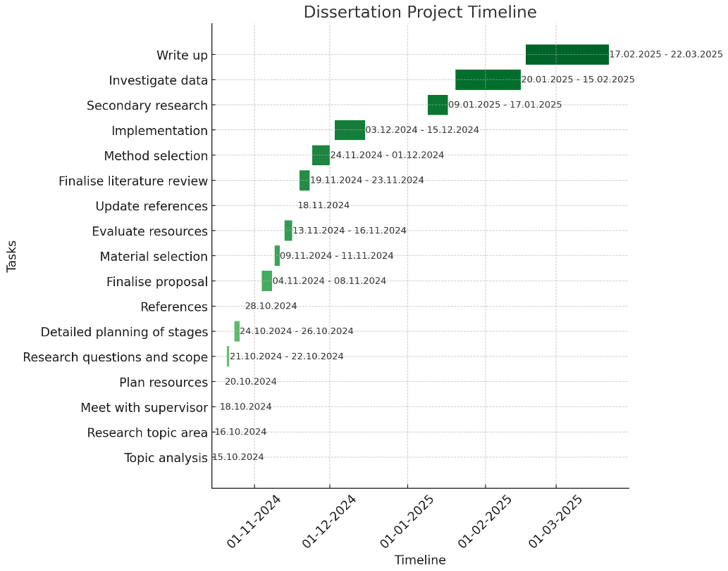

Potential Implications

The research outcomes of this investigation are expected to enable UK retailers enhance their Visual Merchandising approaches in order to encourage customers’ interactions and ultimately improve their sales. As this work is concerned with the state of view and belief systems of consumers as buyers and sellers of apparels and accessories, it is believed that this study will add theoretical and practical value to the ongoing and future merchandising efforts of retail industry.

Conclusion

The above was a proposal for the framework of a study that is set to establish the effects of visual merchandising on the customer purchase intentions in the clothing and jewellery subsectors of the United Kingdom. The research outcomes of this investigation are expected to enable UK retailers to enhance their Visual Merchandising approaches to encourage customers’ interactions and ultimately improve their sales. As this work is concerned with the state of view and belief systems of consumers as buyers and sellers of apparel and accessories, it is believed that this study will add theoretical and practical value to the ongoing and future merchandising efforts of the retail industry.

Reference list
- Bauer, G.R., Churchill, S.M., Mahendran, M., Walwyn, C., Lizotte, D. and Villa-Rueda, A.A., 2021. Intersectionality in quantitative research: A systematic review of its emergence and applications of theory and methods. SSM-population health, 14, p.107.
- Bell, J.A., (2022). Silent selling: best practices and effective strategies in visual merchandising. Bloomsbury Publishing USA.
- Bloomfield, J. and Fisher, M.J., 2019. Quantitative research design. Journal of the Australasian Rehabilitation Nurses Association, 22(2), pp.27-30.
- Ebster, C., (2011). Store design and visual merchandising: Creating store space that encourages buying. Business Expert Press.
- Edirisinghe, D., Nazarian, A., Foroudi, P. and Lindridge, A., (2020). Establishing the psychological relationship between female customers and retailers: A study of the small-to medium-scale clothing retail industry. Qualitative Market Research: An International Journal, 23(3), pp.471-501.
- Mondol, E.P., Salman, N.A., Rahid, A.O. and Karim, A.M., (2021). The effects of visual merchandising on consumer’s willingness to purchase in the fashion retail stores. International Journal of Academic Research in Business and Social Sciences, 11(7), pp.386-401.
- Nobbs, K., Foong, K.M. and Baker, J., (2015). An exploration of fashion visual merchandising and its role as a brand positioning device. Journal of Global Fashion Marketing, 6(1), pp.4-19.
- Pai, S. and Mayya, S., (2021). Effectiveness of Visual Merchandising on Consumer Buying Behaviour: A Study of Reliance Digital, Puttur, DK. International Journal of Case Studies in Business, IT and Education (IJCSBE), 5(2), pp.1-23.
- Park, H.H., Jeon, J.O. and Sullivan, P., (2015). How does visual merchandising in fashion retail stores affect consumers’ brand attitude and purchase intention? The International Review of Retail, Distribution and Consumer Research, 25(1), pp.87-104.
- Saeed, A., (2015). Impact of lighting as a visual merchandising tool on consumer’s purchase behaviour. Pakistan Business Review, 17(2), pp.430-443.

