
Evaluation of Project Management Plan
BMSW5104 MPO
Bernad Mrsic 2133762 | 4/12/24 | Lecturer: Alfred Mensah

Contents
1. Project Outline/Description/Scope 1
2. Stakeholder Analysis 2
3. Work Breakdown Structure (WBS) 5
4. Costs/Resources Use 6
5. Consideration of Resources 10
6. Outline Project Schedule / Gantt Chart 11
7. Risk Assessment 15
8. Project Management Plan 18
Reference list 18
Appendix 19

1. Project Outline/Description/Scope

The project aims to introduce onsite catering services at a large manufacturing company in Southeast London, with the goal of providing convenient and healthy meal options for its approximately 1,000 employees. The absence of onsite catering facilities currently results in congestion in the local area as employees leave the premises during lunch breaks. By offering onsite catering, the company seeks to alleviate this congestion, promote a healthy lifestyle among its staff, reduce absenteeism, and fulfil its corporate social responsibility objectives. Workplace catering is a crucial tool in shaping a company's culture, particularly in today's Working From Home culture. By providing delicious and nutritious meals, workplace catering can foster collaboration, boost productivity, encourage healthy eating habits, value team members' well-being, save time and reduce stress, enhance team member retention, celebrate diversity, support sustainability, and celebrate milestones. By breaking down silos, fostering cross-departmental collaboration, and promoting unity among coworkers, workplace catering can create a more vibrant, productive, and inclusive work environment. By offering nutritious options, catering can encourage healthier eating habits, boosting overall well-being and energy levels. Additionally, catering can save time and reduce stress, making it a unique perk that sets a company apart from competitors. By embracing sustainability practices and celebrating milestones, workplace catering can contribute to a greener corporate culture and ultimately lead to increased employee satisfaction, retention, and overall success.

2. Stakeholder Analysis

Low
High
Interest
Power
Low
High
Mendelow’s Metrix graph design by: © Bernad Mrsic 2024

According to Berkun (2015) stakeholder analysis is crucial for understanding the interests, concerns, and potential impacts of individuals or groups involved in or affected by a project. Here's a stakeholder analysis for the introduction of onsite catering services at the manufacturing company:
1. Senior Management Team:
• Interest: Interested in improving employee satisfaction, productivity, and reducing absenteeism.
• Concern: Cost implications, operational logistics, and ROI.
• Influence: Decision-makers who approve budget allocation and project implementation.
2. Employees (Office Staff and Factory Workers):
• Interest: Convenience, access to healthy meal options, and reduced travel time during lunch breaks.
• Concern: Quality, variety, and affordability of onsite meals.
• Influence: User feedback and adoption of the catering services.
3. Local Community:
• Interest: Reduced congestion during lunch hours, potential economic benefits from increased foot traffic in nearby businesses.
• Concern: Potential noise or environmental impacts from increased activity at the company premises.
• Influence: Community relations, potential regulatory or planning permissions.
4. Catering Service Providers:
• Interest: Business opportunity to provide catering services, potential long-term contracts.
• Concern: Meeting the company's expectations in terms of menu, pricing, and service quality.
• Influence: Ability to deliver on contractual obligations, responsiveness to feedback.
5. HR Department:
• Interest: Enhancing employee welfare, promoting a healthy work environment, and reducing absenteeism.
• Concern: Integration with existing HR policies, employee engagement, and communication strategies.
• Influence: Implementation of employee wellness programs, coordination with staff feedback mechanisms.
6. Finance Department:
• Interest: Cost implications, budget allocation, and ROI assessment.
• Concern: Financial viability, cost-benefit analysis, and potential impact on company finances.
• Influence: Budget allocation decisions, financial analysis, and forecasting.
7. Health and Safety Committee:
• Interest: Ensuring food safety standards, promoting healthy eating habits, and compliance with health regulations.
• Concern: Food hygiene, allergen management, and safety protocols in the catering facilities.
• Influence: Setting health and safety standards, monitoring compliance, and providing recommendations.
8. Environmental Sustainability Team:
• Interest: Minimizing environmental impact, promoting sustainable food sourcing and waste management practices.
• Concern: Waste reduction strategies, energy efficiency in catering operations, and carbon footprint.
• Influence: Advising on sustainable practices, monitoring environmental performance, and recommending improvements.
9. Union Representatives:
• Interest: Ensuring fair treatment of employees, representing worker interests, and negotiating employment terms.
• Concern: Impact on existing employment conditions, such as break times and meal allowances.
• Influence: Negotiating with management on behalf of employees, advocating for employee rights and benefits.
10. Regulatory Authorities:
• Interest: Ensuring compliance with health, safety, and food hygiene regulations.
• Concern: Adherence to legal requirements, licensing, and permits for onsite catering operations.
• Influence: Enforcing regulatory standards, issuing permits, and conducting inspections.
Understanding and addressing the needs and concerns of these stakeholders will be essential for the successful implementation of the onsite catering project. Regular communication, consultation, and collaboration with relevant parties will help mitigate risks and ensure the project's alignment with organizational objectives and stakeholder expectations.

3. Work Breakdown Structure (WBS)

1. Project Initiation
According to Maylor (2010) project Initiation will define project scope, also identify stakeholders then set project objectives and goals after obtain senior management approval.
2. Planning Phase
In this phase we conduct market research, analyse employee preferences and research local suppliers. Assess competitor offerings and try to improve our offerings. We then develop budget and estimate costs for equipment. Next step is to estimate staffing costs and budget for marketing and promotion. Procurement planning and identify and select suppliers, make sure we negotiate contracts. Procure equipment and supplies.
3. Design and Setup
Design catering facilities, plan layout of kitchen and dining area, obtain necessary permits and approvals. Purchase equipment and supplies, order kitchen appliances, purchase utensils and serving ware. Procure food ingredients. Install and setup facilities, install kitchen equipment, set up dining area and test facilities for functionality.
4. Staff Training
Develop training program for staff, create training modules for food safety. Develop customer service training materials while training kitchen staff. Conduct food handling and safety training and provide cooking techniques training. Train service staff, train cashiers and servers on Point-of-Sale Systems. Train staff on menu offerings and ingredients.
5. Launch and Promotion
Develop marketing strategy then plan promotional events. Design marketing collateral (Posters, Flyers, etc.) and implement marketing campaign. Advertise onsite catering services internally, utilize social media and online channels for promotion. Launch catering services, organise grand opening event after which we will monitor feedback and adjust and improve operations accordingly.
6. Operations and Maintenance
Constant monitoring of daily operations, hygiene of food preparation while ensuring good customer service. Keep high cleaning and sanitation standards. Monitor and maintain equipment, schedule regular equipment inspections. Scheduled manufacturer maintenance and repairs and envisage continuous improvement. Gather employee feedback, implement changes to menu or service based on feedback.
7. Evaluation and Reporting
Measure performance metrics and track sales revenue. Monitor customer satisfaction. Assess employee productivity after which we will prepare progress reports. Compile full financial reports for the management. Then we will summarize customer feedback and present findings to senior management. Discuss achievements and challenges and then provide recommendations for future improvements.
This Work Breakdown Structure outlines the various tasks and activities required in our project to successfully implement onsite catering services at the manufacturing company. Each task can be further broken down into smaller subtasks as needed for detailed planning and execution.

4. Costs/Resources Use

When embarking on the ambitious project of constructing an onsite catering kitchen and restaurant to serve approximately 1000 staff, meticulous planning and budget allocation are paramount. A budget of £75,000.00, with a 20% reserve, provides a solid foundation, but it's crucial to allocate resources wisely to ensure a successful outcome.
Firstly, we have consider the costs of construction and renovation. This encompasses materials such as kitchen equipment, furniture, fixtures, and fittings. Additionally, labour costs for skilled tradespeople and contractors must be factored in.
Secondly, operational expenses must be accounted for. This includes the procurement of food supplies, ongoing maintenance of kitchen equipment, and utilities such as electricity, water, and gas.
Furthermore, compliance with health and safety regulations is non-negotiable. Budget for inspections, permits, and necessary safety measures to ensure a hygienic and secure environment for food preparation and service.
Don't overlook the importance of technology in modern catering operations. Investing in point-of-sale systems, inventory management software, and other technological solutions to streamline operations and enhance customer service.
Finally, we have allocate funds for contingency purposes. Unforeseen expenses or delays can arise during the construction and operational phases, so having a reserve ensures that the project can proceed smoothly without compromising quality or timelines.
As we carefully considering these costs and allocating resources accordingly, we have set the stage for a thriving onsite catering kitchen and restaurant that meets the needs of your company's staff while staying within budget constraints. (Roberts, Paul, 2011)
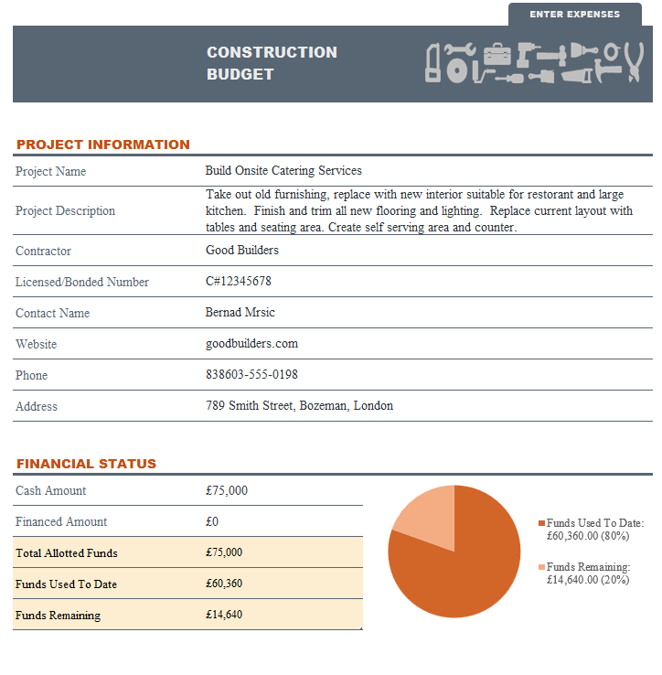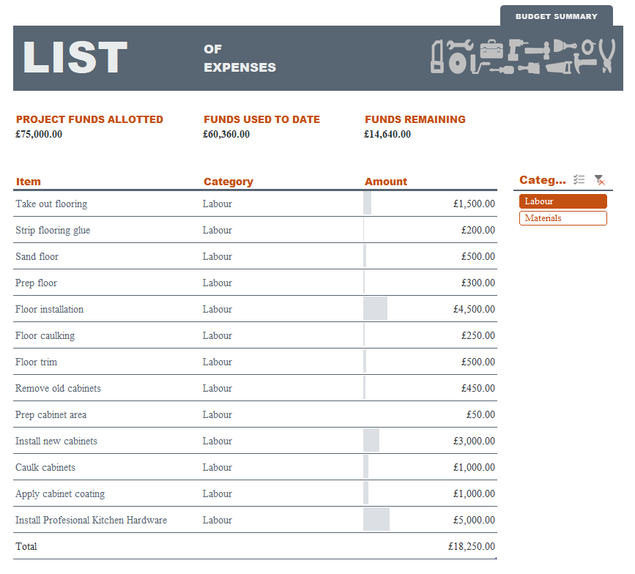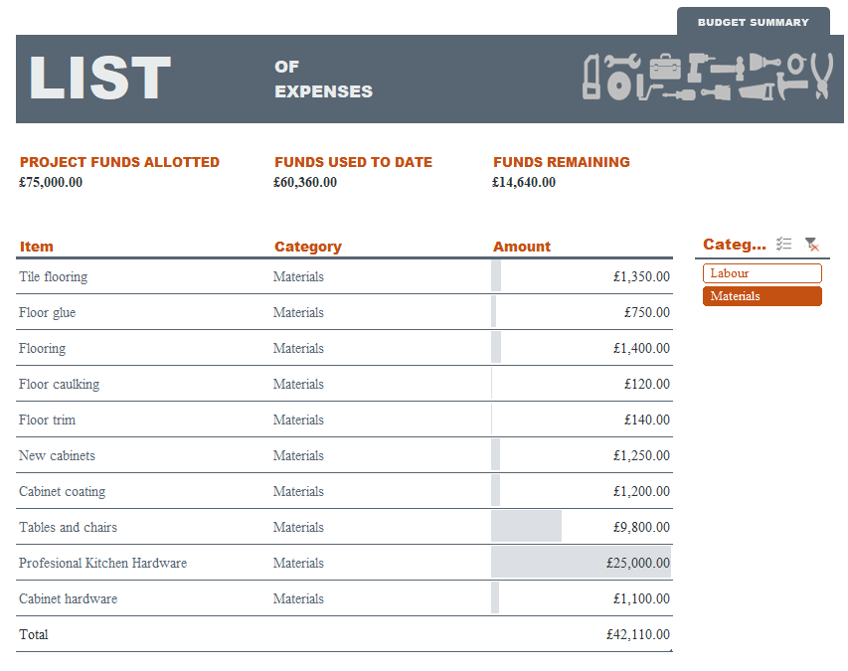

5. Consideration of Resources

When embarking on the creation of an onsite catering kitchen and restaurant for approximately 1000 staff, meticulous consideration of resources becomes paramount for a successful project outcome. The project manager's time must be allocated efficiently, ensuring strategic oversight and effective coordination of all facets. Staff time for training and implementation is a critical investment, guaranteeing seamless integration and proficiency within the new operational framework. Time for stakeholder engagement and communication is indispensable, fostering alignment, addressing concerns, and soliciting valuable input from all involved parties. Moreover, prudent management of financial resources within budget constraints is imperative, necessitating careful planning, cost-control measures, and prioritization of expenditures to achieve optimal results without compromising fiscal integrity. By conscientiously addressing these resource considerations, the endeavour can proceed methodically, enhancing productivity, satisfaction, and overall success for the company and its staff. (Reiss, 2007)
Some of the key points are:
- Project Manager's Time
- Staff Time for Training and Implementation
- Time for Stakeholder Engagement and Communication
- Financial Resources within Budget Constraints

6. Outline Project Schedule / Gantt Chart

I have used a Gantt chart as a visual representation of a project schedule. It is commonly used in project management to illustrate the start and finish dates of the various elements of a project. Gantt charts typically display tasks or activities as horizontal bars along a timeline. The length of each bar corresponds to the duration of the task, and their placement shows when the task is scheduled to start and end.
In this project Gantt charts are useful for:
Project Planning: They help project managers and teams plan out the sequence of tasks and activities required to complete a project.
Scheduling: Gantt charts allow stakeholders to see when tasks are scheduled to begin and end, helping to allocate resources and manage timelines effectively.
Progress Tracking: They provide a visual representation of project progress, showing which tasks are completed, which are in progress, and which are yet to start.
Communication: Gantt charts are a clear and concise way to communicate project timelines and progress to stakeholders, team members, and clients.
Dependency Management: They help identify dependencies between tasks, showing which tasks need to be completed before others can start.
Overall, Gantt charts are valuable tools for modern project managers to plan, execute, and track the progress of projects, ensuring they stay on schedule and within budget, and will be very useful tool in this project.

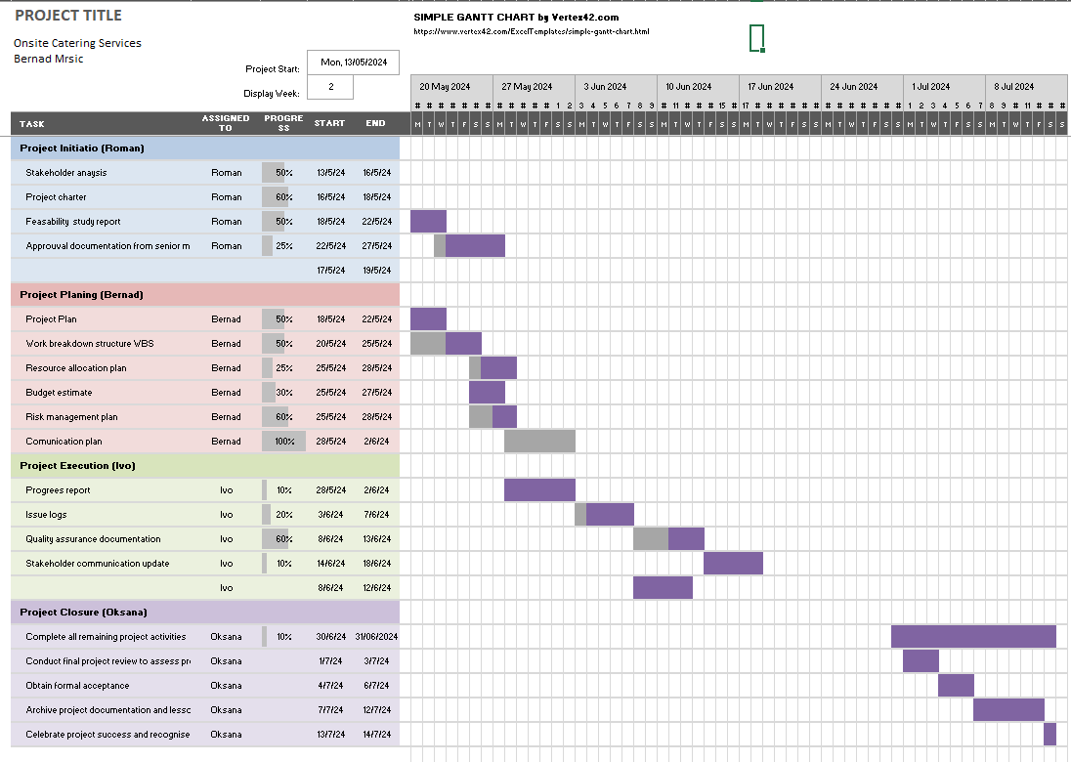
Gantt graph design by: © Bernad Mrsic 2024

| Task | Start Date | End Date |
|---------------------------------------------------|------------|------------|
| Project Initiation | 13-May-24 | 13-May-24 |
| Stakeholder Engagement | 14-May-24 | 20-May-24 |
| Site Assessment | 21-May-24 | 26-May-24 |
| Catering Service Selection | 27-May-24 | 29-May-24 |
| Menu Development | 30-May-24 | 01-Jun-24 |
| Infrastructure Setup | 02-Jun-24 | 05-Jun-24 |
| Staff Training | 06-Jun-24 | 08-Jun-24 |
| Launch and Promotion | 09-Jun-24 | 11-Jun-24 |
| Monitoring and Evaluation | 12-Jun-24 | 13-Jul-24 |
| Project Handover and Closure | 14-Jul-24 | 14-Jul-24 |

A Milestone graph:
Is a visual representation used in project management to track significant events or achievements throughout the duration of a project. It provides a snapshot of key dates and deliverables, allowing project managers and stakeholders to monitor progress and understand the project's timeline at a glance.
Key features of a milestone graph include:
Milestones: These are specific points in time that mark important events, achievements, or completion of major deliverables within the project. Milestones are often represented as nodes or markers on the graph.
Timeline: The timeline axis typically represents time, either in days, weeks, months, or other relevant units depending on the duration and complexity of the project.
Dependencies: Milestones may be linked by dependencies, indicating that the completion of one milestone is contingent upon the completion of another. Dependencies can be represented with arrows or lines connecting the milestones.
Critical Path: In more complex milestone graphs, the critical path, which is the sequence of tasks that determines the shortest duration of the project, may also be highlighted. This helps identify which milestones are crucial for keeping the project on schedule.
Status Tracking: Milestones can be color-coded or annotated to indicate their current status (e.g., completed, in progress, delayed). This helps project managers quickly identify areas of concern or where additional resources may be needed.
Overall, milestone graphs serve as a valuable tool for project managers to communicate progress, identify potential risks or delays, and ensure that the project stays on track to meet its objectives within the specified timeframe.
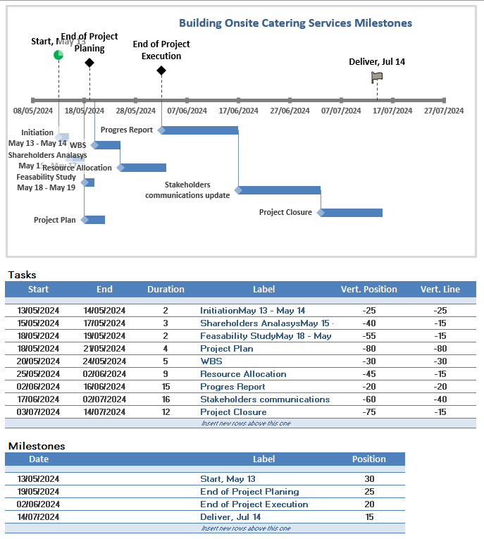
Milestone graph design by: © Bernad Mrsic 2024

7. Risk Assessment

Risk Management Plan for Onsite Catering Implementation Project
Introduction:
The purpose of this risk management plan is to identify, assess, and mitigate potential risks associated with the implementation of onsite catering at our manufacturing organization's site in Southeast London. By proactively managing risks, we aim to ensure the successful planning and execution of the project. (Heagney, 2016)
2. Risk Identification:
2.1. Market Demand:
• Lack of demand for onsite catering services among employees.
• Misalignment between offered food options and employees' preferences.
2.2. Financial:
• Budget overruns due to unforeseen expenses.
• Inaccurate cost estimation leading to financial constraints.
2.3. Operational:
• Insufficient space for catering facilities.
• Disruption to current operations during construction/installation phases.
2.4. Regulatory/Compliance:
• Failure to meet health and safety regulations.
• Non-compliance with food handling standards.
2.5. Supplier/Vendor:
• Reliance on unreliable suppliers.
• Vendor delays in equipment delivery or food sourcing.
3. Risk Assessment:
3.1. Likelihood:
• Low (L): Rarely occurs.
• Medium (M): Could occur.
• High (H): Likely to occur.
3.2. Impact:
• Low (L): Negligible impact on project objectives.
• Medium (M): Moderate impact, manageable with effort.
• High (H): Significant impact, may hinder project success.

Risk Category | Likelihood | Impact | Risk Level
Market Demand | M | M | Medium
Financial | M | H | High
Operational | M | H | High
Regulatory/Compliance | L | H | Medium
Supplier/Vendor | M | M | Medium

4. Risk Mitigation Strategies:
4.1. Market Demand:
• We have conducted surveys or focus groups to understand employee preferences.
• We offer a diverse menu to cater to varying tastes and dietary requirements.
4.2. Financial:
• We have developed a comprehensive budget with a contingency fund for unforeseen expenses.
• We regularly monitor expenses and adjust spending as necessary to stay within budget.
4.3. Operational:
• Conduct a thorough site assessment to ensure adequate space for catering facilities.
• Implement a phased approach to minimize disruption to ongoing operations.
4.4. Regulatory/Compliance:
• Consult with regulatory authorities to ensure compliance with health and safety standards with regular updates.
• Train staff on proper food handling procedures to maintain compliance as required.
4.5. Supplier/Vendor:
• Conduct due diligence when selecting suppliers/vendors, considering reliability and track record, with a possible alternatives.
• Negotiate contracts with clear timelines and penalties for delays.
5. Risk Monitoring and Control:
5.1. Establish regular meetings to review and update the risk register.
5.2. Assign responsibility for monitoring specific risks to team members.
5.3. Implement early warning systems to detect emerging risks.
5.4. Develop contingency plans for high-impact risks to mitigate their effects if they occur.
5.5. Communicate any changes to the risk profile to stakeholders promptly.

6. Conclusion:
By implementing the risk management plan outlined above, we aim to minimize the impact of potential risks and ensure the successful implementation of onsite catering at our manufacturing organization's site. Regular monitoring and proactive mitigation efforts will be crucial in addressing emerging risks and maintaining project success.
Delays or issues with catering service providers could impact project timelines. Failure to comply with health and safety regulations or obtain necessary permits could halt the project. Some employees may prefer leaving the premises for lunch and resist the change. Unforeseen expenses could exceed the allocated reserved budget. Problems with infrastructure setup or equipment could cause delays.

8. Project Management Plan

The project management plan provides a comprehensive overview of the project, including its scope, stakeholders, resources, schedule, and risks. It serves as a guiding document for project execution, ensuring that all aspects are considered and managed effectively to achieve the desired outcomes within the specified constraints. (Wysocki, 2019)

Reference list

Berkun, S. (2015). Making things happen : mastering project management. Sebastopol: O’reilly Media.
Bob. Hughes (ed.) (2012) Project management for IT-related projects [electronic resource]?: textbook for the ISEB Foundation Certificate in IS Project Management . 2nd ed. London?:, BCS.
Buttrick, R. (2009) The project workout?: the ultimate handbook of project and programme management . 4th ed. Harlow, England?:, FT Prentice Hall.
Heagney, J. (2016). Fundamentals of Project Management. 5th ed. New York: Mcgraw-Hill.
Heerkens, Gary. (2001) Project management [electronic resource] . New York, N.Y.?:, McGraw-Hill Trade.
Kingston, I. (2023). Nourishing Company Culture: The Benefits of Workplace Catering. [online] BM | Independently Minded Contract Caterer. Available at: https://www.bmcaterers.co.uk/foodie-blog/nourishing-company-culture-the-benefits-of-workplace-catering/ [Accessed 8 Apr. 2024].
Leach, L.P. (2005) Critical chain project management [electronic resource] . 2nd ed. Boston?:, Artech House.
Maylor, H. (2010). Project Management. Harlow: Financial Times Prentice Hall.
Reiss, G. (2007). Project Management Demystified. Routledge.
Roberts, Paul (2011). Effective Project Management. Kogan Page.
Wysocki, R.K. (2019). Effective Project Management: Traditional, Agile, Extreme. 8th ed. Wiley.

Appendix



