Name: Steffan John Benson
Student P Number: 151818
Assignment Title: Unity Maze Game
Module Title: Indie Games Development
Module Lecturer: Kemi Ademoye
Date: 5/12/2017

Project Brief:
The purpose of the project is to develop a maze game using the Unity game engine and development tool. Players will be tasked with completing an objective while avoiding or defeating obstacles, and will be required to do this for multiple levels.

Table of Contents

Page Number | Section Title
1 | Title
2 | Table of Contents
3 | Design
4 | Implementation
5 | Evaluation
6 | References and Screenshots
7 | Screenshots

Design
Game Description
The purpose of the game is to find the ball object and transport it to the objective. Once the ball reaches the objective, the maze will reset and the task must be completed again. The player will win once the task has been completed 3 times. If the player fails to complete the task within a given time frame, the player will lose and will be sent to the main menu.
Rules and Instructions
Rules
To successfully complete each level, players must complete the following tasks:
- Navigate a randomly generated maze to an end ‘Portal’.
- Transport an object to the end of the maze.
- Complete the above objectives in a given timeframe.
- Stay inside the maze. (Leaving the maze will cause the player to fall infinitely)
Controls
To move their character, the player can use either the arrow keypad or the letter keys W, A, S, D, which correspond to movement forward, left, right and backwards respectively. To run, the left shift key can be pressed. Jumping is controlled by the space bar, however jump height is restricted to prevent players from jumping on top of or out of the maze. In the main menu, the play button can be pressed to start the game. In order to wake the mouse for general use, the ESC key can be pressed and the mouse will then function as normal as well as for looking in the game.
Challenges
The challenges presented to the player include having to navigate a maze with little to no reference as to where the end point is located. As well as having to find the end point, the player must also locate an object and transport it to the end point. Due to the physics of the objects and the maze, the player must be careful to ensure the object moves in the way they want, as the object can easily get stuck in a corner and is difficult to remove once stuck.

Implementation
- FPSMazeGame
This script is used to create each level of the game. Functions in the script are used to generate random start and finish points for the player and the game ball, as well as control the input system for the character. The functions are all controlled by one central method that will check if a maze is needed, then generate a maze if necessary and place the player and the game ball in the maze. The start and finish point are added and the level counter is incremented by 1.
- FPCharacter
This script is used to produce character states for the player animations. Once the character states have been set by the script, they will then be used to logically establish when the character is moving, idle, jumping and reloading, so that the appropriate animations can be applied. For example, the character cannot be in the walking and running states at the same time, so the script will check if the character is walking and if it is the character state walking is set.
- StartGame
This script is used to start the game. When a button is pressed on the main menu scene, the script is called and will activate the FPSMazeGame script, starting the game. The script uses unity’s scene management to load scenes.
- Next Level (Not Completely Finished)
This script is used to detect if the game ball has collided with the finish point. Once the game ball has collided with the finish point, the script will check to see if the tag of the collision is the game ball. If the game ball has collided with the finish point, the maze will be deleted and replaced by a new maze, and the player and game ball will be reset. The script is functional, and will generate a new maze when the finish point is reached. However, the position of the player and the game ball aren’t reset, which allows the player to take the ball from the previous finish point’s location.
- Countdown (Not Functional) [1]
The following script is used for the countdown timer for each level. The script controls the countdown timer, which will be of a pre-set value. Once the timer reaches zero, debug will display a message saying “Time’s Up”, and the game will end. This script is incomplete and has not been implemented completely into the game, and will thus not function as intended. The script also depends on the use of a HUD in order to be implemented properly.

Evaluation
Bugs and Incomplete Sections
The game HUD has not been included as during implementation, the HUD would not render on the correct plane. This causes the HUD to be invisible when the game has begun, effectively making the HUD worthless. The game ball will occasionally spawn on top of a wall. This issue can be resolved by adding a check to the spawning script that would check if the spawn location is within the walls of the maze before allowing it to spawn. The game ball spawning on top of walls is caused mainly by the lack of a random spawn point for the game object, which could be remedied by adding a list of random locations that the game ball can spawn in. The game ball also can get stuck in a corner while being transported around the maze. Although this is not an issue with scripting, it can make the game impossible to complete. This can be fixed by making the physics of the game ball include bouncing, so that the ball can be bounced out of a corner, or change the maze pieces to include rounded corners. The level system functions correctly in progressing the player each time the objective is completed, however this function continues beyond the 3-level constraint that was originally intended.
Strengths and Weaknesses
One of the better designed sections of the game is the implementation of the main menu. The transition from the main menu is simple and is not computationally expensive. The design is appealing to users, and easy to navigate. A major weakness that appeared during implementation was the use of animations. When applying animations to character models, the transitions between walking and sprinting function correctly in that order, but when transitioning back from sprinting to walking the sprinting animation stays on. The game presents a reasonable challenge in the task that must be completed to progress, without being to easy for players to stumble across an exit. The need to find the game ball and transporting it to the finish point means the player must navigate the maze more while transporting an object. Implementing the maze creation was a simple task, and adding the level increments allowed for simple transitions between levels without the need to manually delete and create a new maze. Another weakness demonstrated by this project was the implementation of the HUD. Having practiced implementing HUD on a 2D game, adding an extra dimension presented the problem of ensuring the HUD rested on the required plane of view. This became an issue as scaling and testing a HUD when the incorrect plane is being used will not provide useful feedback to any programmer.
Potential Future Updates
Due to the nature of the objective in the game, which resembles the sport of Golf (Mini-golf), a system to record the number of collisions between the game ball and the player can be implemented to establish a scoring system. This can also lead to a multiplayer format in which players can compete to complete the maze in the shortest time or the least number of collisions. To simplify transporting the game ball, a system to allow the player to pick up the game ball can be implemented. The current system of colliding with the game ball, which resembles kicking the ball, is crude and can often lead to the game ball travelling in the wrong direction. In order to cater to more skilled players of the game, a difficulty setting could be implemented. If a player chooses a higher difficulty, the maze size can be increased to make navigation to the game ball and the finish point more time consuming, or the time limit for the player to complete each level can be reduced to add pressure on the player.

References

[1] | N/A, "C# Countdown Timer - Unity Blog," Unity, 09 03 2012. [Online]. Available: https://answers.unity.com/questions/225213/c-countdown-timer.html. [Accessed 2017 12 10].

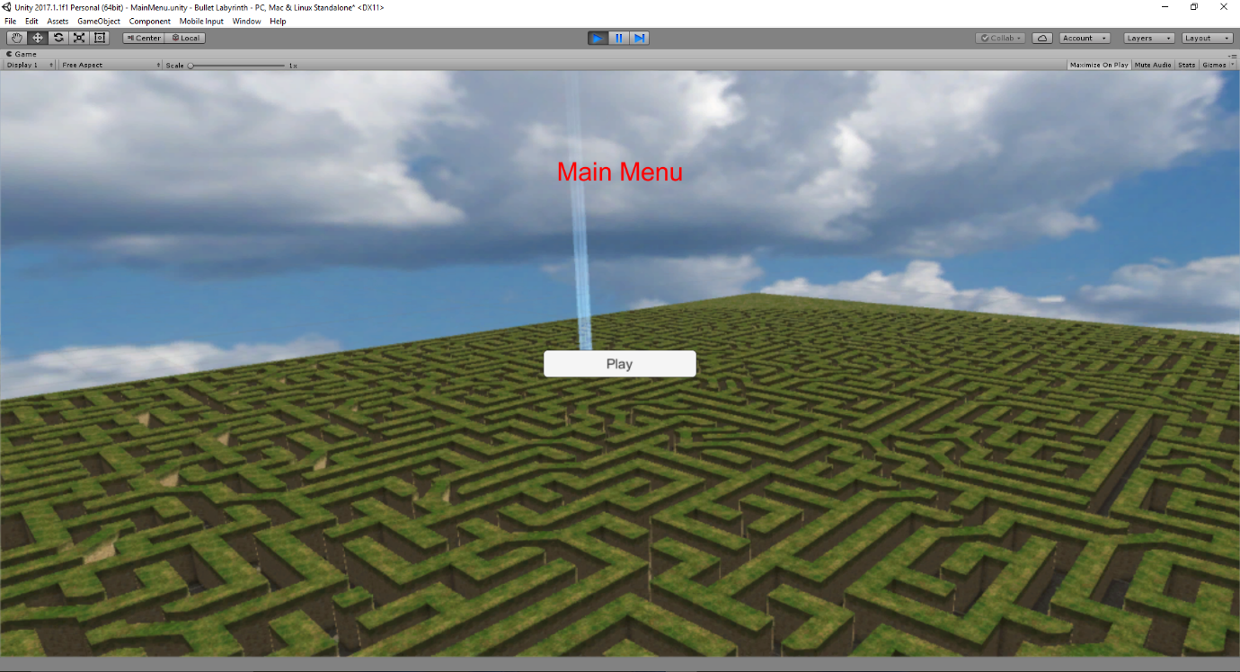
Screenshots
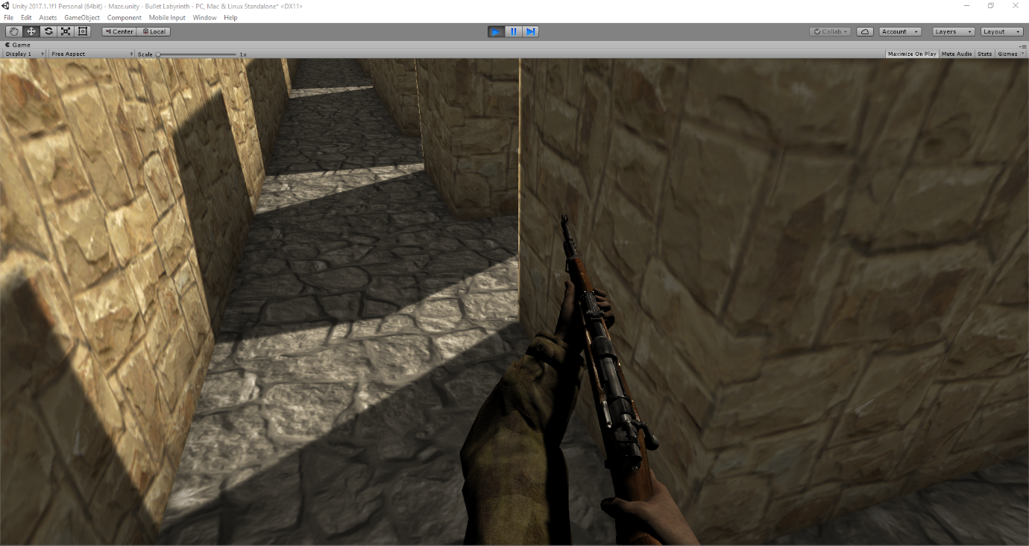
View of main menu, background image displays screenshot of a 50x50 maze generated dynamically.
Screenshot of player view.

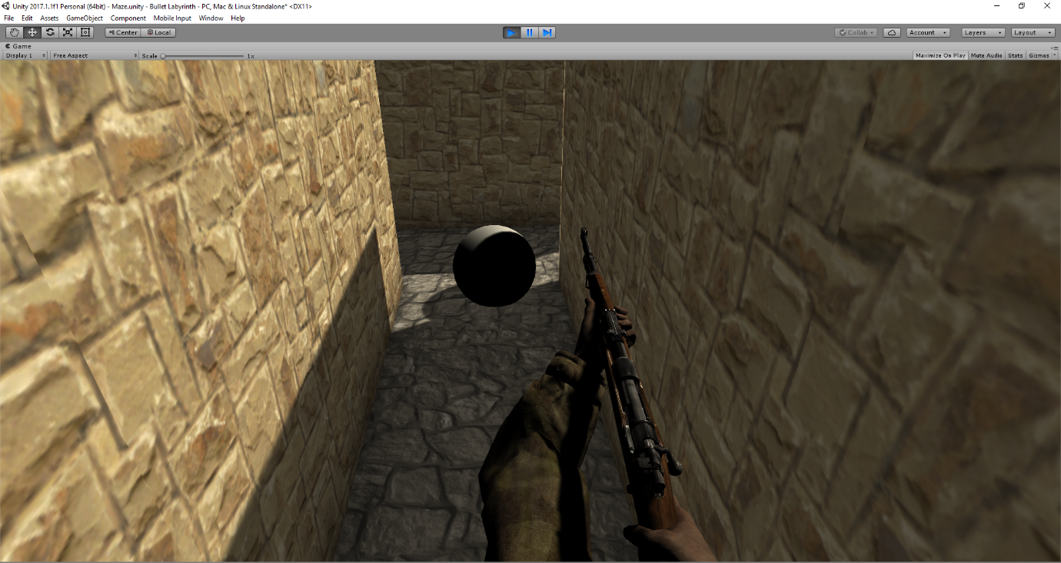
Screenshot of game ball objective in player view.
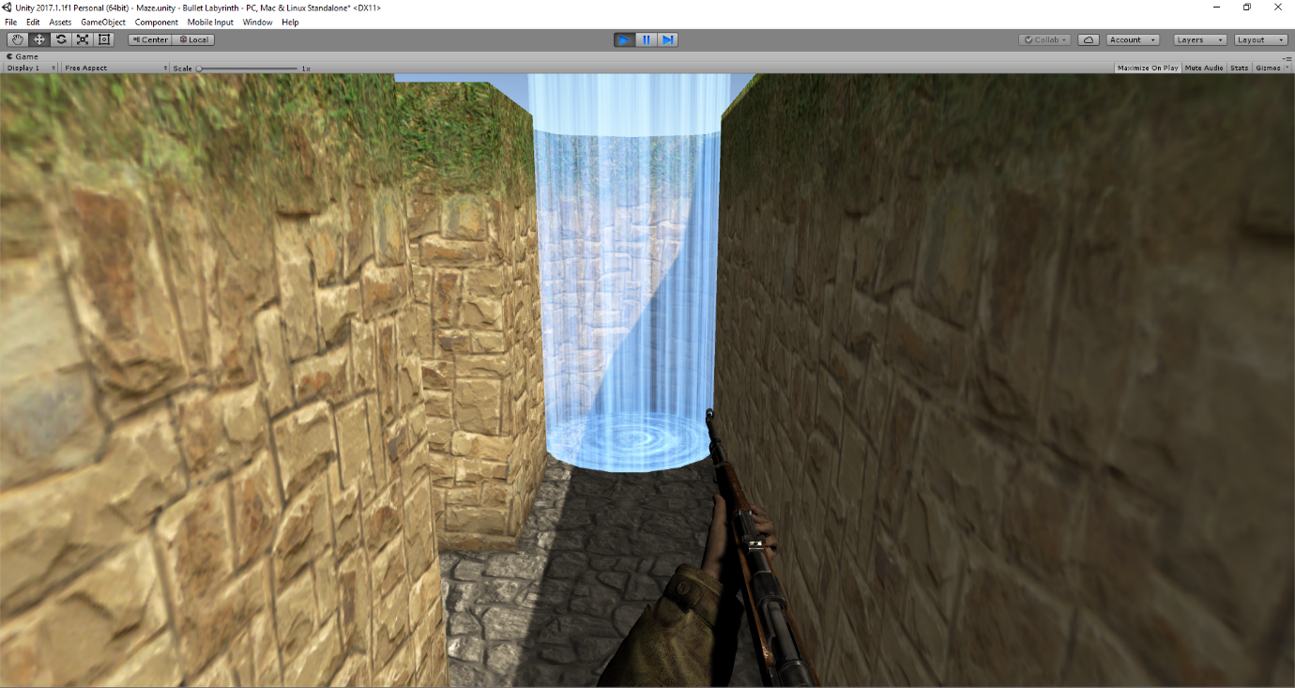
Screenshot of the finish point, where the game ball objective must be transported to.

