

Strategic Planning and Delivery Considerations for UK Winter Sustainability in Hospitality Expo 2024

Module Name
International Meetings Management for the Hotel Industry (BMIH6007)

Lecturer’s Name
Kathryn Flynn

Student’s Name: Md Sohel Khan
Student ID: 2211256

Word Count
2547 words

Declaration
I confirm that I have not used any AI tools in the research and creation of this assignment. I confirm that I have not presented any AI generated materials as my own work. I confirm I have copies of my drafts, notes, and other resources I used, which I may be asked to provide in evidence.

Table of Contents
Introduction 4
The Event Cycle 4
Event Concept 6
Delegate Experience and Itinerary 6
Unique Selling Proposition (USP) 7
Event Features and Practical Benefits 7
Aim and Objectives 8
Overarching Aim 8
SMART Objectives 8
Event Management 9
Skills Required 9
Resources 9
Operational Tasks 9
Marketing 10
Event Management 12
Skills Required 12
Resources 12
Operational Tasks 12
Event Budget 13
Industry Trends/Issues/Impacts 15
Situational and Cultural Considerations 15
SWOT Analysis 16
Strategic Value 16
Reference List 17

Introduction
The "UK Winter Sustainability in Hospitality Expo 2024" is set up to address the winter hospitality sustainability issues. The expo provides hospitality managers with tools and advice to run environmentally responsible winter operations by controlling waste, cutting energy use, and supporting sustainable procurement. The event will take place at the Crystal in London, a landmark certified in BREEAM, renewable energy, rainwater collecting system. This location shows the dedication of the expo to environmentally friendly operations as well as the most cutting-edge hospitality approaches for sustainability. Combining theoretical and practical elements including seminars, exhibits, and panel discussions, "UK Winter Sustainability in Hospitality Expo 2024" helps industry leaders apply sustainable practices appealing to environmentally conscious audiences and so lower environmental impact.

The Event Cycle
Getz's (2012) proposed Event Cycle Model breaks events into four phases: research and concept development, planning and preparation, execution, and evaluation.

Figure 1: The Event Cycle Model/Source: (Getz, 2012)
The EMBOK framework and this approach help to arrange important events as the "UK Winter Sustainability in Hospitality Expo 2024." EMBOK's five domains—administration, design, marketing, operations, and risk management—guarantee the sustainable planning, management, and evaluation of events—that is, the whole structure of EMBOK guarantees guarantees of sustainability (Silvers and O'Toole, 2020).
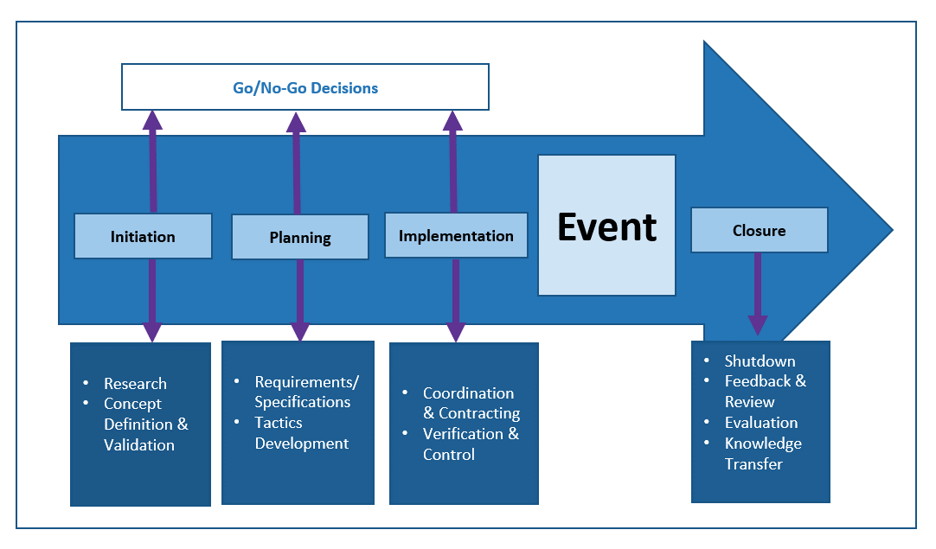
Figure 2: EMBOK Model/Source: (Silvers and O'Toole, 2020)
- Research and Concept Development: This phase of research looks at the aim, target audience, and viability of the event (Getz and Page, 2019). Getz (2007) claims that the formulation of significant event objectives depends on the application of good research. For the "UK Winter Sustainability in Hospitality Expo 2024," this stage looks at winter-specific sustainability challenges in the hotel sector including trash reduction and energy use. The choice of venues that give environmental sustainability top priority—such as London's BREEAM-certified The Crystal—helps to support the expo's goals. Research shows that, as Bardukova (2023) notes, event decisions follow sustainable hospitality sector trends.
- Planning and Preparation: Reducing risks and achieving event goals depend on planning (Getz, 2012). In this regard, the risk and administrative areas of the EMBOK model offer structure. Budgeting, personnel management, and working with environmentally friendly vendors who fit the goals of the event are among administrative chores (Silvers and O'Toole, 2020). Furthermore scheduled are interactive sessions on energy saving and environmentally friendly buying. Singh, Shalender, and Joan Su (2020) agree that by integrating participants, immersive, educational elements improve the effectiveness of events. Risk control also handles weather issues to guarantee that events are robust to unanticipated challenges.
- Implementation: Real-time coordination and event activities characterise the implementation phase (Getz and Page, 2019). The operations component of EMBOK covers transportation as well as on-site sustainable facilities including recycling stations and energy-efficient lighting (Silvers and O'Toole, 2020). Workshops, displays, and keynote speeches from experts in sustainability help to address winter sustainability challenges, therefore improving the attendance experience. According to Jones (2017), environmentally friendly hotel operations help to meet the goals of the event and improve its standing as a leader in this regard.
- Evaluation: The Event Cycle Model ends with analysis and feedback that forms evaluation (Getz and Page, 2019). The knowledge management system of EMBOK helps to document acquired skills so that continuous improvement may be supported (Silvers and O'Toole, 2020). Financial appraisals, waste and energy analyses, and attendance polls help to analyse environmental impact and satisfaction. Getz (2012) claims that this stage is crucial for the validation of sustainability goals including the lower of pollutants and energy consumption. By giving information on participant experiences and operational efficiencies for next planning, the event advances sustainable event management.

Event Concept

Delegate Experience and Itinerary
The expo delegate trip aims to maximise involvement and learning. Starting with keynote talks on winter sustainability from business leaders and panel discussions on energy efficiency, waste management, and sustainable hotel sourcing (Hamilton, 2021), day one opens The "Sustainable Tech Showcase" at the exhibition showcases waste reduction technologies for high-consumption winter operations (Chen, Despeisse, and Johansson, 2020) along with energy-efficient HVAC systems. On Day 2 and 3 are practical workshops like "Sustainable Food Sourcing" and "Energy Efficiency in Winter Operations." These presentations offer chances for experience learning to handle issues related to sustainability particular to winters (Sharma, 2017).
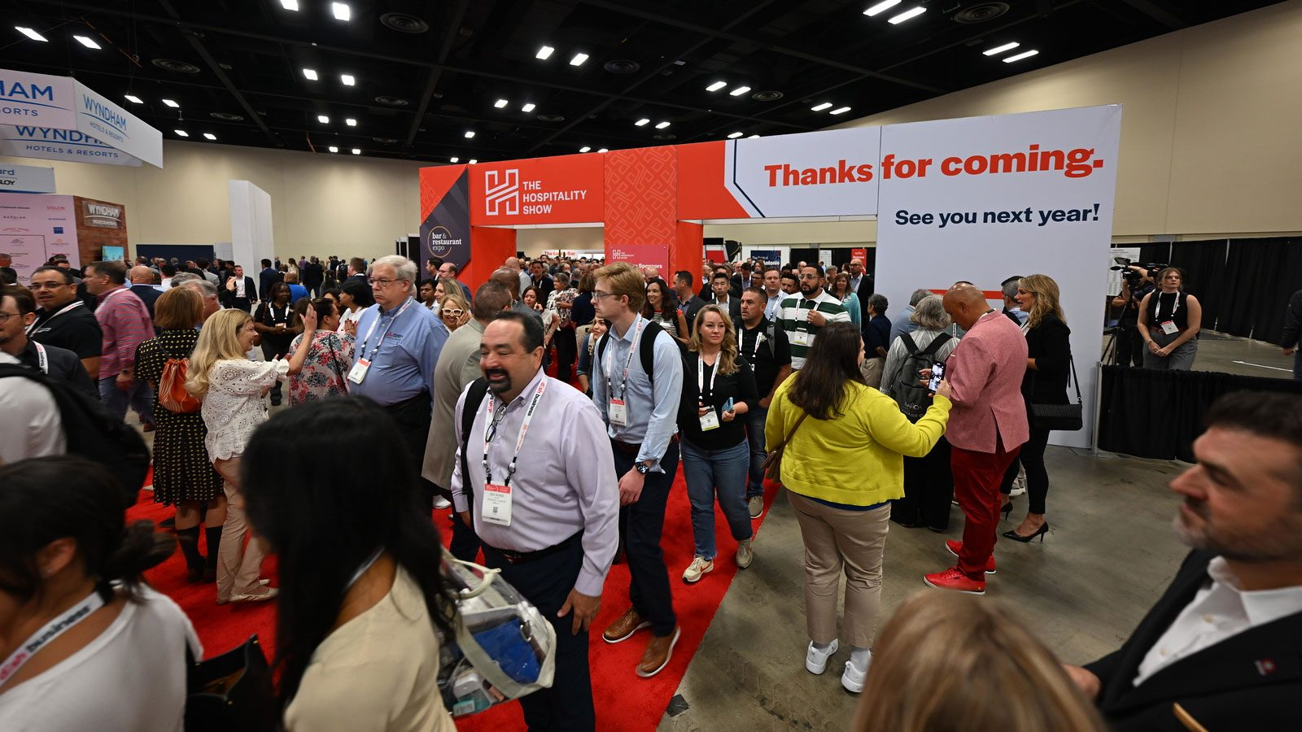
Apart from the scheduled sessions, the event comprises networking hubs enabling significant industry connections. These centres, which use networking theories, offer B2B matchmaking and themed collaborative spaces where delegates may discuss partnerships and best practices with sustainability experts and technology providers (Fox et al., 2014). These meetings go beyond networking to build professional ties and promote sustainability teamwork.

Unique Selling Proposition (USP)

Event Features and Practical Benefits
Vendors show delegates renewable energy technology and biodegradable packaging in the "Sustainable Tech Showcase" and "Sustainable Food Pavilion," Through food sourcing and energy management seminars and exhibits, attendees get useful guidance for their businesses (Bladen et al., 2022). Panel talks on industry concerns and regulatory trends that highlight future sustainability expectations and compliance underline the practical, solution-driven orientation of the event (Sartono et al., 2024).

Aim and Objectives

Overarching Aim
The "UK Winter Sustainability in Hospitality Expo 2024" supports the application of sustainable strategies in the winter hotel sector. Through encouraging cooperation, creativity, and knowledge-sharing, this event gives hospitality experts the tools they need to handle environmental issues particular to winter. These include waste, increased energy needs, and winter's need for sustainable resource procurement and waste (Han, 2021). As per Çakmak and Yilmaz, (2018), the winter sustainability expo gives practical solutions top priority in reducing environmental effects and supporting corporate leaders in putting environmentally friendly ideas into use.

SMART Objectives

Event Management

Skills Required
Effective management of a major event requires a range of abilities. The event highlights ecologically friendly approaches, thereby making sustainability management absolutely essential (Çakmak and Yilmaz, 2018). Those that give sustainability top priority might ethically source materials and reduce waste. From vendor management to delegate services, skills for event coordination help departments to collaborate (Getz and Page, 2019). The smooth flow of difficult events across several sessions depends on good organisation (Brown, Power, and Conchie, 2021). Logistic preparation guarantees both effective setup and takedown. Operational efficiency calls for control of the venue, guest lodging, transportation, and technology support. Positive interactions with sponsors, exhibitors, and local businesses guarantees financial stability and long-term collaborations ( Allen et al., 2022).

Resources
The success of the expo depends also on the usage of environmentally friendly materials. Important staff members include event planners, sustainability experts, and technological support (Getz and Page, 2019). While sustainability consultants may offer direction on ecologically friendly food and trash management, technical support ensures the use of energy-efficient audiovisual equipment. To lower food miles and support zero-waste (Oreskovic and Gupta, 2022), the catering staff will present locally grown organic cuisine. Electric shuttles will also be used to send delegates to and from the site, therefore lowering carbon emissions and supporting environmentally friendly transportation. Using recyclable and biodegradable promotional materials and displays will help to highlight the event's environmental friendliness (Balden et al., 2022).

Operational Tasks
Carefully planned event logistics guarantee sustainability. Recycling stations, biodegradable utensils, and less single-use products all help to promote sustainable waste management (Jones, 2017). LinkedIn and Twitter promotions, email campaigns to hotel managers about winter sustainability issues (Getz and Page, 2019), and ads in sustainability-minded periodicals like Green Hotelier help to target the intended audience: Promos and branded goods improve awareness and help to match sponsorships to environmental goals of companies (Cook et al., 2023).
Technical staff will run audiovisual systems using energy-efficient lighting and sound equipment to help to reduce the environmental impact. To protect attendees from the possible risks of the crowd, the event's health and safety system follows Health and Safety Executive (HSE) standards. The event follows the policies for population control, first aid, and disaster readiness described in HSG 195. While Allen et al. (2022) argue that well defined policies create visitor confidence and event enjoyment, Clarke and Chen (2021) underline that thorough health and safety preparation protects attendants and increases the credibility of events.

Marketing
The 7S model guides this marketing effort since it stresses the sustainability of the event and targets the suitable audience.
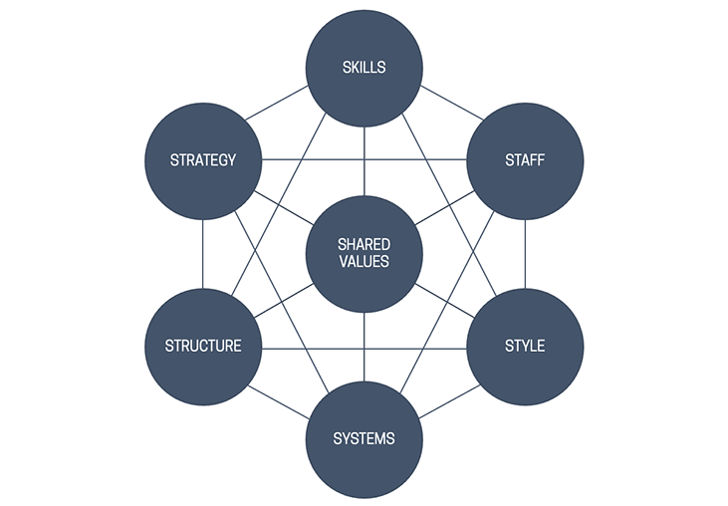
Figure 3: 7S Model of Marketing/ Source: (Cornwell, 2020)
Table 1: Marketing Plan of the Event/Source: (Author)
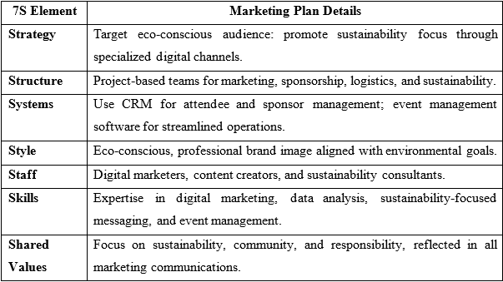
Although the marketing plan for this sustainability-oriented event is well-organised, it might find it challenging to attract and reach the target demographic. Eco-conscious branding is crucial since studies show that specialised customers who give sustainability first priority favour environmentally friendly events (Han et al., 2021). According to Brown, Power, and Conchie (2021), targeted digital marketing could raise audience involvement on sustainability-oriented sites and LinkedIn. Research shows that individuals who deviate from sustainability-specific media could be missed by specialised channels, hence this strategy might limit awareness ( Allen et al., 2022).
To properly run environmentally friendly events, one must have flexible roles with well defined parameters. Project-based teams organised and separated thus can offer effective coordination (Cornwell, 2020). Still, experiential marketing could improve the plan as, especially in sustainable businesses, live event experiences have been demonstrated to raise participant involvement and loyalty (Oreskowicz and Gupta, 2022). Finally, Brown, Power, and Conchie (2021) suggest that although digital advertising alone might not be enough, corporeal advertisements can improve credibility and reach a diverse audience. Despite its support of sustainable ideas, diversified marketing could increase the attractiveness of the plan.

Event Management

Skills Required
A good, sustainable event calls for the abilities in sustainability, event planning, and logistics (Bladen et al., 2022). The effective use of event resources, the lowering of waste, and the application of ecologically friendly methods depend on sustainability management skills—which are very essential for A sustainability specialist will assess every choice, including food and material procurement, to minimise the environmental effect. Complex, multi-day plans involving vendor management, transportation, and technical setup—which include resource excess—need event coordinating and logistical capabilities (Brown, Power and Conchie, 2021). Environmentalists who support the event's eco-friendly focus and financial viability help to assist green technology companies. As such, skills in stakeholder interaction are absolutely vital (Allen et al., 2022).

Resources

Operational Tasks
Working on operations ensures that all elements of the event follow sustainable event guidelines (Getz, 2012). Recycling stations, biodegradable tools, and a cut in single-use item usage will help to promote waste management (Jones, 2017). Targeted email advertising (Cornwell, 2020) will help hotel experts to promote the winter sustainability aspect of the event. To drive attendance, LinkedIn and Twitter will post updates, speaker quotes, and interactive debates. Targeting eco-aware professionals through industry-specific platforms like Green Hotelier is beneficial, according to Fox et al. (2014), via focused marketing.
The financial and reputation success of an event depends on the policies followed by sponsors (Cornwell, 2020). Events sponsorship packages centre on sustainable goods like environmentally friendly items and renewable energy. Digital and venue exposure are part of sponsorship possibilities, which match sponsor visibility with the environmental goals of the event and provide focused marketing chances for companies with like aims (Balden et al., 2022). This strategy protects funds and forms alliances with environmentally friendly companies.

Event Budget
Table 2: Event Budget/Source: (Author)
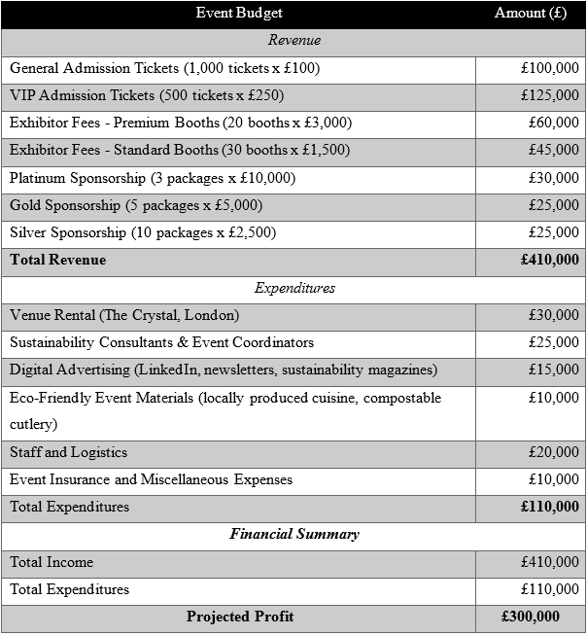

The event's budget relies on ticket sales, exhibitor fees, and sponsorships. In line with Brown, Power, and Conchie (2021), VIP tickets are £250 while regular admission is £100, therefore accommodating a range of attendance preferences. Conventional booths cost £1,500; premium booths are £3,000 for companies with environmental concerns. Platinum, gold, and silver sponsorship packages, which span £2,500 to £10,000 and offer a varied range of online and on-site visibility, draw eco-friendly hotels and renewable energy companies (Allen et al., 2022). Among the major outlays are venue leasing, staffing, advertising, and sustainability. Held at the Crystal in London, BREEAM-certified and in line with environmental goals (CIBSE, 2024), the £30,000 event will The costs are £25,000 for coordinators and sustainability experts and £15,000 for focused digital campaigns. Compostable cutlery and locally grown food (Oreskovic and Gupta, 2022) help to show the event's sustainability. Green sponsors are given marketing tailored to fit the goals of the event in terms of sustainability. According to Cornwell (2020), public subsidies and environmental money can help lower costs and forward the green goals of the event, which are vital for financial and environmental sustainability.

Industry Trends/Issues/Impacts
The hotel sector has given sustainability top priority recently by stressing techniques that reduce the environmental impact during peak seasons, such winter (Çakmak and Yilmaz, 2018). Eco-aware consumers and legislators are giving waste minimising, sustainable food procurement top priority as well as energy-efficient infrastructure (Han and Hyun, 2018). According to Moreno-Gené et al. (2020), winter-specific problems including heating needs and holiday rubbish generation inspire the industry to create sustainable solutions to seasonal environmental problems.
Targeted insights and solutions to lower winter energy use and waste from the "UK Winter Sustainability in Hospitality Expo 2024's ideas support these trends Through workshops on sustainable waste management and energy-efficient heating, the event offers industry professionals answers to these problems. Font and Lynes (2018) found that by appealing to the eco-friendly attitudes of modern consumers, seasonal sustainability hotel events help companies in adjusting to environmental criteria and improving their brand reputation.
Given its winter-specific sustainability, the event is relevant in the modern hotel sector, where stakeholders are urged more and more to follow sustainable practices. As customers grow more ecologically sensitive, this event presents companies with a timely chance to learn about sustainable solutions that satisfy operational needs and tourist expectations (Balden et al., 2022). By tackling present industry challenges at the "UK Winter Sustainability in Hospitality Expo 2024" (Oreskovic and Gupta, 2022), the hotel sector is ready to satisfy the needs of sustainable tourism and thereby reaffirm its environmental responsibilities.

Situational and Cultural Considerations
Organising the "UK Winter Sustainability in Hospitality Expo 2024," it is imperative to take cultural and situational factors—especially in view of its worldwide audience—into account. Hospitality has to be responsive to the values, customs, and sustainability expectations of many civilisations (Parent and Ruetsch, 2020). In European and North American marketplaces, eco-friendly habits are encouraged; nevertheless, other areas could give economic efficiency top priority above environmental issues (Font and Lynes, 2018). Through cultural sensitivity, the expo can educate attendees on a range of viewpoints and present material in line with different sustainability concepts, therefore engaging foreign audiences (Bladen et al., 2022). This shows to attendees that their cultural viewpoints are valued and raises the worldwide attraction of the event (Han and Hyun, 2018).

SWOT Analysis
A SWOT analysis of the event highlights situational factors relevant to its strategic planning.
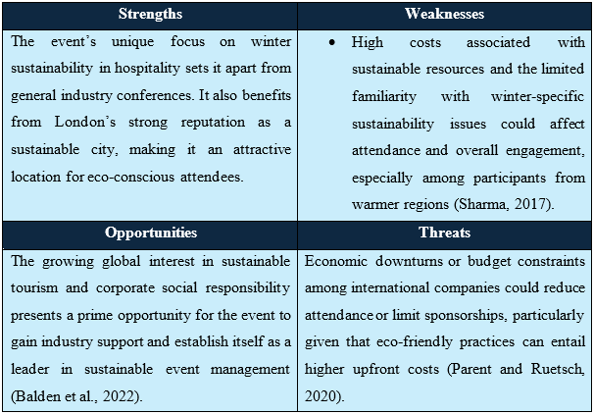

Strategic Value
Improved knowledge of these situational and cultural elements improves the involvement of stakeholders and the event planning. Risk management uses SWOT analysis to pinpoint financial issues and suggest alliances with sponsors focused on sustainability to help pay for expenses (Allen et al., 2022). Cultural sensitivity drives the inclusive and globally relevant event since it raises stakeholder involvement (Quinn et al., 2021). Incorporating a range of sustainable points of view will help the event to promote long-term regional ties and significant conversations (Bladen et al., 2022). Adoption of sustainable practices depends on this as well as hotel industry cooperation (Oreskovic and Gupta, 2022). Situational and cultural elements support the event's strategic fit with worldwide hospitality trends even further, therefore enhancing its attractiveness and support of global winter sustainability concepts.

Conclusion

Reference List
Allen, J., Harris, R. and Jago, L. (2022). Festival & special event management. John Wiley & Sons.
Bardukova, L. (2023). Navigating the Hospitality Horizon: Current Trends and Strategies for Customer Attraction and Retention in the Hotel Industry. Economics and computer science, 2, pp.88-103.
Bladen, C., Kennell, J., Abson, E. and Wilde, N. (2022). Events management: An introduction. Routledge.
Brown, O., Power, N. and Conchie, S.M. (2021). Communication and coordination across event phases: A multi‐team system emergency response. Journal of Occupational and Organizational Psychology, 94(3), pp.591-615.
Çakmak, F. and Yilmaz, Ö. (2018). Winter tourism in terms of economic sustainability of tourism. Hitit University Journal of Social Sciences Institute, 11, pp.267-286.
Chen, X., Despeisse, M. and Johansson, B. (2020). Environmental sustainability of digitalization in manufacturing: A review. Sustainability, 12(24), p.1-31.
CIBSE (2024). CIBSE Case Study: The First LEED Platinum & BREEAM Outstanding Building | CIBSE. [online] www.cibse.org. Available at: https://www.cibse.org/knowledge-research/knowledge-portal/cibse-case-study-the-first-leed-platinum-breeam-outstanding-building [Accessed 9 Oct. 2024].
Cook, D., Biscaia, R., Papadas, K., Simkin, L. and Carter, L. (2023). The creation of shared value in the major sport event ecosystem: understanding the role of sponsors and hosts. European Sport Management Quarterly, 23(3), pp.811-832.
Cornwell, T.B. (2020). Sponsorship in marketing: Effective partnerships in sports, arts and events. Routledge.
Font, X. and Lynes, J. (2018). Corporate social responsibility in tourism and hospitality. Journal of Sustainable Tourism, 26(7), pp.1027-1042.
Fox, D. et al. (2014) Doing events research: from theory to practice. Routledge: Oxford.
Getz, D. (2012). Event studies: Discourses and future directions. Event management, 16(2), pp.171-187.
Getz, D. and Page, S.J. (2019). Event studies: Theory, research and policy for planned events. Routledge.
Hamilton, J.M. (2021). The Ideal Tourist: Power, Identity, and Environmental Privilege in Tourism Marketing (Doctoral dissertation, University of Minnesota).
Han, H. (2021). Consumer behavior and environmental sustainability in tourism and hospitality: A review of theories, concepts, and latest research. Sustainable Consumer Behaviour and the Environment, pp.1-22.
Jones, M. (2017). Sustainable event management: A practical guide. Routledge.
Jones, M. (2017). Sustainable event management: A practical guide. Routledge.
Moreno-Gené, J., Daries, N., Cristóbal-Fransi, E. and Sánchez-Pulido, L. (2020). Snow tourism and economic sustainability: The financial situation of ski resorts in Spain. Applied Economics, 52(52), pp.5726-5744.
O’Toole, W. (2011) Events feasibility and development: from strategy to operations. Elsevier: Oxford
Oreskovic, L. and Gupta, R. (2022). Enabling Sustainable Lifestyles in New Urban Areas: Evaluation of an Eco-Development Case Study in the UK. Sustainability, 14(7), p.1-18.
Parent, M.M. and Ruetsch, A. (2020). Managing major sports events: Theory and practice. Routledge.
Quinn, B., Colombo, A., Lindström, K., McGillivray, D. and Smith, A. (2021). Festivals, public space and cultural inclusion: public policy insights. Journal of Sustainable Tourism, 29(11-12), pp.1875-1893.
Sartono, Y., Astuti, E.S., Wilopo, W. and Noerman, T. (2024). Enhancing Sustainability in Solution Projects through Social CRM: An Expansion of the Self-Efficacy Value Adoption Model. Sustainability, 16(19), p.8353.
Sharma, A.J. (2017). Enhancing Sustainability through Experiential Learning in Management Education. In Management Education for Global Leadership (pp. 256-274). IGI Global.
Silvers, J.R. and O'Toole, W. (2020). Risk management for events. Routledge.
Singh, N., Shalender, K. and Joan Su, C.H. (2020). Developing impacts and indicators for sustainable event management using a triple bottom line approach: A study of auto expo. Event Management, 24(1), pp.1-16.

