Name: Noah Cooper

Student Number: 2501949

WORKSHEET 1 – TESTING (Using Variables)

- Original code:
[Copy and paste your original code from Moodle into this box. Do not change it.]
#define _CRT_SECURE_NO_WARNINGS
#include <stdio.h>
#include <math.h>
#include <ctype.h>
#include <stdlib.h>
#include <string.h>
#include <time.h>
#include <Windows.h>

void main()
{
char surname[12], nin[9];
int age=111;
float hpw=1111;

printf("what is your surname? ");
scanf("%s", &surname);

while (strlen(surname) >= 13 || strlen(surname) <= 3)
{
printf("Sorry out of range");
printf("what is your surname? ");
scanf("%s", &surname);
}

printf("what is your national insurence number? ");
scanf("%s", &nin);
while (strlen(nin) <= 8)
{
printf("Sorry out of range");
printf("what is your national insurence number? ");
scanf("%s", &nin);
}

printf("how old are you? ");
scanf("%d", &age);
while (age < 16 || age >120)
{
printf("Sorry out of range");
printf("how old are you? ");
scanf("%d", &age);
}

printf("how many hours do you work per week? ");
scanf("%f", &hpw);
while (hpw < 1 || hpw>60)
{
printf("Sorry out of range");
printf("how many hours do you work per week? ");
scanf("%f", &hpw);

}

printf("The data is \n%s", surname);
printf("\n%s", nin);
printf("\n%d", age);
printf("\n%f", hpw);
}

- Code Testing

For each test below, run your code and enter the values provided. Present a screenshot of the programme running. Did the programme behave correctly or did it do something unexpected, and if so, why?

Surname:
- Enter JONES

- Leave blank

- Enter A

- Enter 123

National Insurance Number:
- Enter PE534121B

- Leave blank

- Enter AB11223344556677 (ie too long for National Insurance number format)

Age
- Enter 34

- Enter 150

- Enter -4

- Enter a letter

Number of working hours per week:
- Enter 37.5

- Enter 105

- Enter 0

- Enter –2

Fill in a box for each test above. You should present 15 separate boxes, 1 for each test. (Note: the two boxes are provided as a template)

Test: i
Surname i. Enter JONES

Screenshot(s) of output:
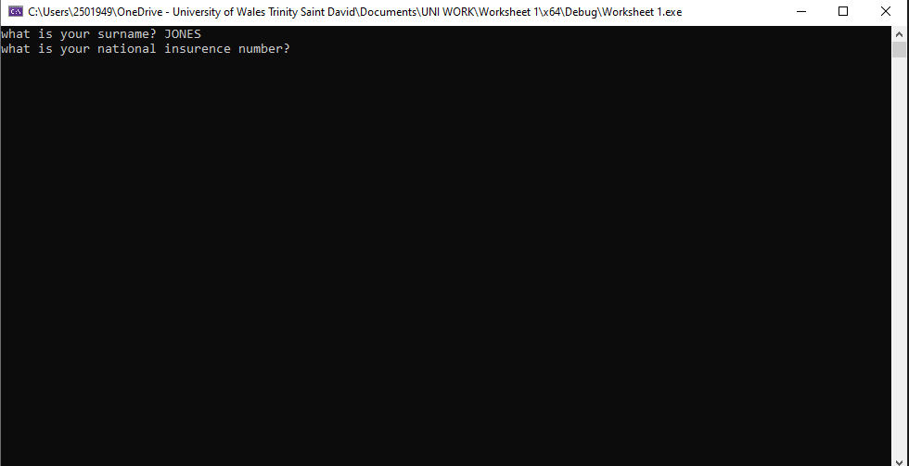
Result: Did the programme behave as expected ie syntactically and logically correct?
YES/NO (delete as appropriate)
If NO, what went wrong?
If YES, comment on what happened

It worked well

Test: ii
Surname ii Leave blank

Screenshot(s) of output:
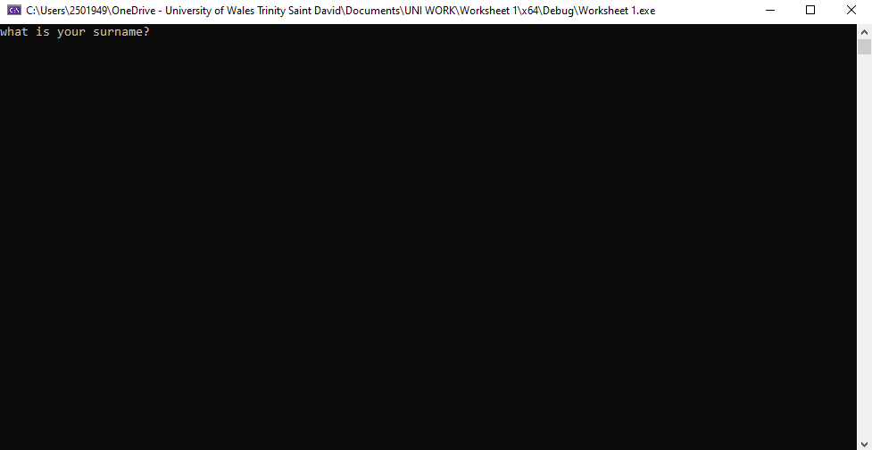
Result: Did the programme behave as expected ie syntactically and logically correct?
YES/NO (delete as appropriate)
If NO, what went wrong?
If YES, comment on what happened

It does work but wish it also had a message with it, however it won't let the code continue Until it the user has typed something in

Test: A
iii
Screenshot(s) of output:
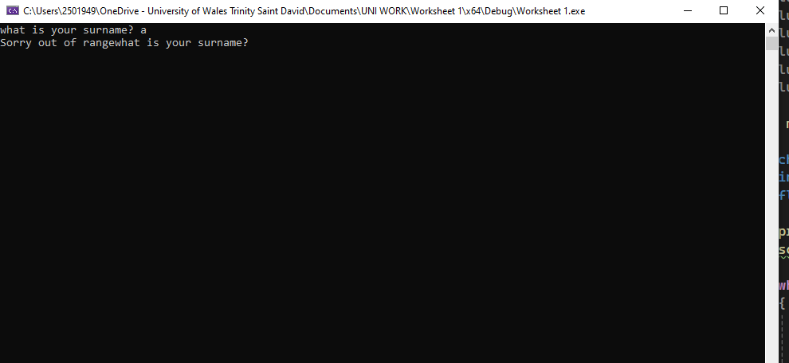
Result: Did the programme behave as expected ie syntactically and logically correct?
YES/NO (delete as appropriate)
If NO, what went wrong?
If YES, comment on what happened

Yes, it worked well

Test: 123
iv
Screenshot(s) of output:
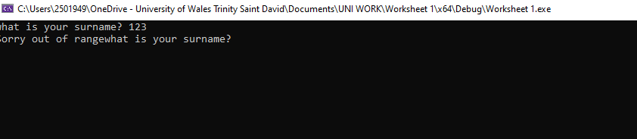
Result: Did the programme behave as expected ie syntactically and logically correct?
YES/NO (delete as appropriate)
If NO, what went wrong?
If YES, comment on what happened

It had worked

Test: PE534121B
i
Screenshot(s) of output:
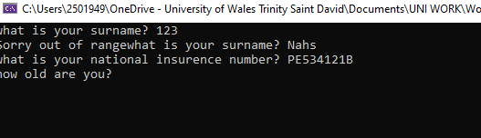
Result: Did the programme behave as expected ie syntactically and logically correct?
YES/NO (delete as appropriate)
If NO, what went wrong?
If YES, comment on what happened

It worked well

Test: nothing entered
ii
Screenshot(s) of output:
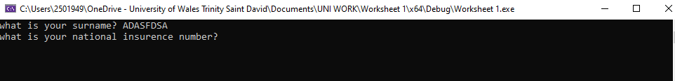
Result: Did the programme behave as expected ie syntactically and logically correct?
YES/NO (delete as appropriate)
If NO, what went wrong?
If YES, comment on what happened

The code did stop but wish it had a message; however it won't let the code continue Until it the user has typed something in

Test: AB11223344556677
iii
Screenshot(s) of output:
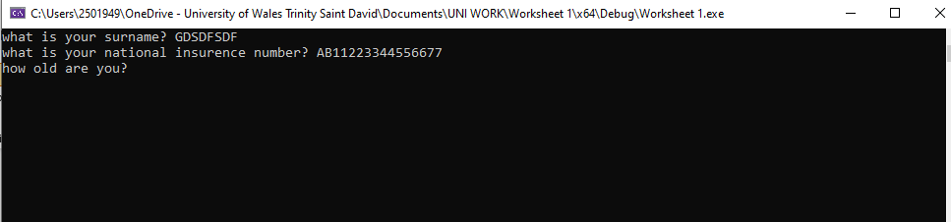
Result: Did the programme behave as expected ie syntactically and logically correct?
YES/NO (delete as appropriate)
If NO, what went wrong?
If YES, comment on what happened

It did not catch that which means it didn't work as planned

Test: 34
iv
Screenshot(s) of output:
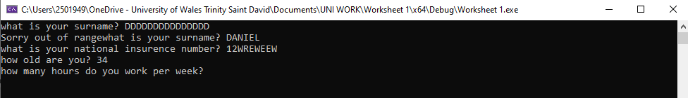
Result: Did the programme behave as expected ie syntactically and logically correct?
YES/NO (delete as appropriate)
If NO, what went wrong?
If YES, comment on what happened

Yes, it has worked as planned

Test: 150
i
Screenshot(s) of output:
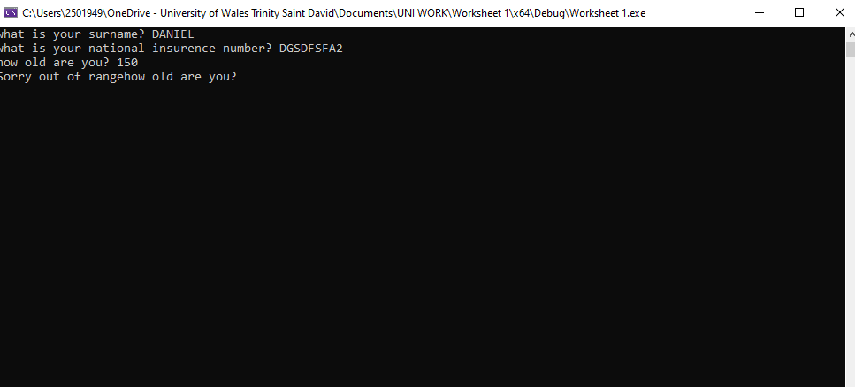
Result: Did the programme behave as expected ie syntactically and logically correct?
YES/NO (delete as appropriate)
If NO, what went wrong?
If YES, comment on what happened

It has worked as planned

Test: -4
ii
Screenshot(s) of output:
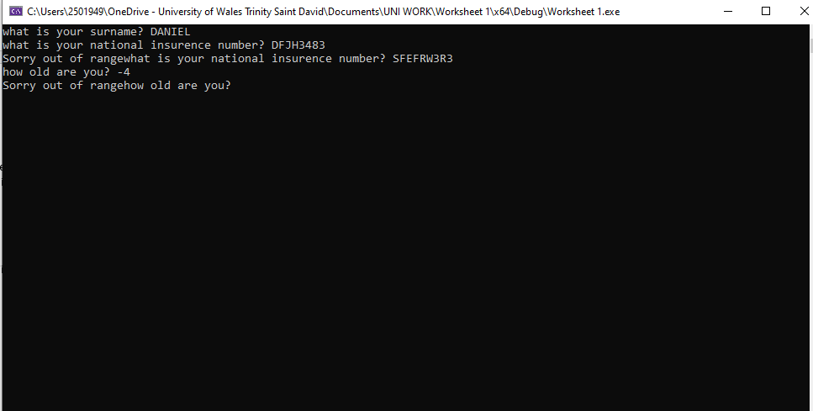
Result: Did the programme behave as expected ie syntactically and logically correct?
YES/NO (delete as appropriate)
If NO, what went wrong?
If YES, comment on what happened

It has worked well as planned

Test: a
iii
Screenshot(s) of output:
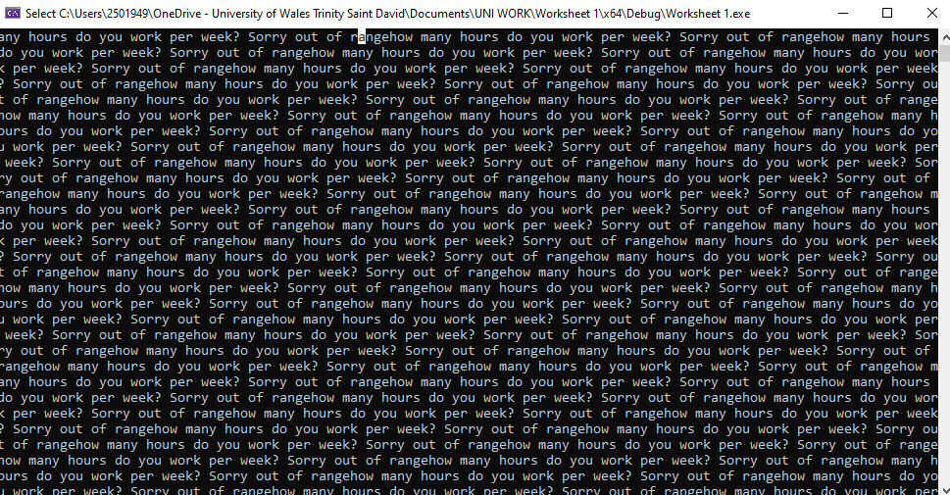
Result: Did the programme behave as expected ie syntactically and logically correct?
YES/NO (delete as appropriate)
If NO, what went wrong?
If YES, comment on what happened

It catches it but had it repeated over and over and over...

Test: 37.5
i
Screenshot(s) of output:
Result: Did the programme behave as expected ie syntactically and logically correct?
YES/NO (delete as appropriate)
If NO, what went wrong?
If YES, comment on what happened

It has worked, but would be better if I had rounded it to .00

Test: 105
ii
Screenshot(s) of output:
Result: Did the programme behave as expected ie syntactically and logically correct?
YES/NO (delete as appropriate)
If NO, what went wrong?
If YES, comment on what happened

It has worked as intended

Test: 0
iii
Screenshot(s) of output:
Result: Did the programme behave as expected ie syntactically and logically correct?
YES/NO (delete as appropriate)
If NO, what went wrong?
If YES, comment on what happened

It has worked as intended

Test: -2
iv
Screenshot(s) of output:
Result: Did the programme behave as expected ie syntactically and logically correct?
YES/NO (delete as appropriate)
If NO, what went wrong?
If YES, comment on what happened

Has worked as intended

- Consider the results of the above tests and revisit your code in order to solve the problems. (Note: you may not be able to solve all of them, but solve as many as you can.)

Paste your revised code here:

[Copy and paste your revised code here – note, do not use a screenshot]
#define _CRT_SECURE_NO_WARNINGS
#include <stdio.h>
#include <math.h>
#include <stdlib.h>
#include <string.h>
#include <ctype.h>

int main()
{
char surname[12], nin[9];
int age = 0;
float hpw = 0.0;
int validate;

printf("what is your surname? ");
scanf("%s", surname);

while (strlen(surname) >= 13 || strlen(surname) <= 3)
{
printf("Sorry out of range\n");
printf("what is your surname? ");
scanf("%s", surname);
}
printf("what is your national insurence number? ");
scanf("%s", nin);

while (strlen(nin) <= 7 || strlen(nin) >= 9)
{
printf("Sorry out of range\n");

printf("what is your national insurance number? ");
scanf("%s", nin);
}

while (1)
{
printf("how old are you? ");
validate = scanf("%d", &age);

if (validate != 1)
{
printf("Invalid input, please enter digits only.\n");
while (getchar() != '\n');
}
else
{
if (age >= 16 && age <= 120)
{
break;
}
else
{
printf("Sorry out of range\n");
}
}
}

while (1)
{
printf("How many hours do you work per week? ");
validate = scanf("%f", &hpw);

if (validate != 1)
{
printf("Invalid input, please enter a number.\n");
while (getchar() != '\n');
}
else
{
if (hpw >= 1 && hpw <= 60) {
break;
}
else
{
printf("Sorry out of range\n");
}
}
}

printf("The data is \n%s", surname);
printf("\n%s", nin);
printf("\n%d", age);
printf("\n%f", hpw);
return 0;
}

Name:_Noah Cooper

Student Number:
2501949

WORKSHEET 2 – TESTING (Tiles)

- Original code:

#define _CRT_SECURE_NO_WARNINGS #include <stdio.h> #include <math.h> #include <ctype.h> #include <stdlib.h> #include <string.h> #include <time.h> #include <Windows.h>
void main() { float wallX, wallY, tileacross, tileupwards, total;
printf("choose the width Meaurement of wall");
scanf("%f", &wallX);
while (wallX > 200 || wallX < 40) //who even wants 2 tiles?
{
printf("Incorrect Data");
printf("choose the width Meaurement of wall");
scanf("%f", &wallX);
}
printf("choose the width Meaurement of wall");
scanf("%f", &wallY);
while (wallY > 200 || wallY < 40) //who even wants 2 tiles?
{
printf("Incorrect Data");
printf("choose the width Meaurement of wall");
scanf("%f", &wallY);
}
tileacross = wallX / 20;
tileacross = ceil(tileacross); //rounds up
tileupwards = wallY / 20;
tileupwards = ceil(tileacross); //rounds up
total = tileacross * tileupwards; //the ammount of tiles
printf("The minimum ammount of tiles would be %f", total);

- Code Testing

For each test below (i – vii), run your code and enter the values provided. Provide a screenshot of the of what happened when the programme ran. Did the programme behave correctly or did it do something unexpected, and if so, why?

Input:

- Enter dimensions: Width 40 Length 45
- Enter dimensions: Width 100000 Length 200000
- Enter dimensions: Width -16 Length -20

Logic:
- Enter dimensions: Width 80 Length 80. The result should be 16 tiles
- Enter dimensions: Width 40 Length 45. The result should be 6 tiles
- Enter dimensions: Width 85 Length 90. The result should be 25 tiles.
- Enter dimensions: Width 15 Length 15. The result should be 1 tile.

Note: If you decide to extend your program to allow a tile to be cut such that 2 pieces can be used from the same tile, your results may differ from the above. In this case, explain your logic as part of your answer)

Fill in a box for each test above. You should present 7 separate boxes, 1 for each test. (Note: the first box is provided as a template)

Test i:
Input - Enter dimensions: width 40 length 45

Screenshot(s) of output:
Result: Did the programme behave as expected ie syntactically and logically correct?
YES/NO (delete as appropriate)
If NO, what went wrong?

If YES, comment on what happened

Yes it took the 2 numbers and made the correct calculations

Test: Enter dimensions: Width 100000 Length 200000

ii
Screenshot(s) of output:
Result: Did the programme behave as expected ie syntactically and logically correct?
YES/NO (delete as appropriate)
If NO, what went wrong?

If YES, comment on what happened

It had what it was supposed to do by stopping the program to add sensible measurements only

Test: Enter dimensions: Width -16 Length -20

iii

Screenshot(s) of output:
Result: Did the programme behave as expected ie syntactically and logically correct?
YES/NO (delete as appropriate)
If NO, what went wrong?

If YES, comment on what happened

It had what it was supposed to do by stopping the program to add sensible measurements only

Test: Enter dimensions: Width 80 Length 80. The result should be 16 tiles

iv
Screenshot(s) of output:
Result: Did the programme behave as expected ie syntactically and logically correct?
YES/NO (delete as appropriate)
If NO, what went wrong?

If YES, comment on what happened
It produced the right amount of tiles!

Test: Enter dimensions: Width 40 Length 45. The result should be 6 tiles

V
Screenshot(s) of output:
Result: Did the programme behave as expected ie syntactically and logically correct?
YES/NO (delete as appropriate)
If NO, what went wrong?

If YES, comment on what happened
It wasn’t correct, I think I may have messed up the division in the code

Test: Enter dimensions: Width 85 Length 90. The result should be 25 tiles.

vi
Screenshot(s) of output:
Result: Did the programme behave as expected ie syntactically and logically correct?
YES/NO (delete as appropriate)
If NO, what went wrong?

If YES, comment on what happened
The code worked perfectly well here, just want the code to be a single number and not 25.000000

Test: Enter dimensions: Width 15 Length 15. The result should be 1 tile.

vii
Screenshot(s) of output:
IF I USED 40 WHICH IS THE LOWEST I HAVE ON HERE TYPED
Result: Did the programme behave as expected ie syntactically and logically correct?
YES/NO (delete as appropriate)
If NO, what went wrong?

If YES, comment on what happened

This did not work since the lowest the tile can go is 40 not 15 for me, however the code put out 4.000000 when i did the lowest values 40x40

- Consider the results of the above tests and revisit your code in order to solve any problems discovered at the testing phase. (Note: you may not be able to solve all of them, but solve as many as you can.)

Paste your revised code here:
[Copy and paste your revised code here – note, do not use a screenshot]
#define _CRT_SECURE_NO_WARNINGS #include <stdio.h> #include <math.h> #include <stdlib.h> #include <string.h>
void main() { int tileacross, tileupwards, total; float wallX, wallY;
printf("choose the width Meaurement of wall");
scanf("%f", &wallX);
while (wallX > 200 || wallX < 15) //who even wants 2 tiles?
{
printf("Incorrect Data");
printf("choose the width Meaurement of wall");
scanf("%f", &wallX);
}
printf("choose the width Meaurement of wall");
scanf("%f", &wallY);
while (wallY > 200 || wallY < 15) //who even wants 2 tiles?
{
printf("Incorrect Data");
printf("choose the width Meaurement of wall");
scanf("%f", &wallY);
}
tileacross = ceil(wallX / 20.0);
tileupwards = ceil(wallY / 20.0);
total = tileacross * tileupwards;
printf("The minimum ammount of tiles would be %d", total);
}

