Robotic Puzzle Cube Solver

Ruaidhri Cook

BSc Software Engineering

Dr Nik Whitehead

Word Count: 4028

Table of Contents
Table of Figures 3
Introduction 4
Background Literature 4
What Is a puzzle cube? 4
Rotation Notation 4
Puzzle Cube Mathematics & Algorithms 5
Physical & Mathematical boundaries 5
Group Theory 6
Algorithms 7
Puzzle Cube Competition & Regulation 8
Aims and Objectives 8
Aim 8
Objectives 8
Research Methodology 9
Development Methodology 10
Risks 10
Analysis and Deliverables 11
Data & Analysis 11
Deliverables 11
Physical Resources 12
Hardware 12
Software 12
Virtual & physical information sources 12
Human Resources 12
Timeline 13
References 14
Bibliography 15

Table of Figures
Figure 1 5
Figure 2 7

Introduction
This project is the engineering and programming of a robotic machine that will solve a 3x3 puzzle cube, commonly known by the brand name ‘Rubik’s Cube’, without the assistance or input of a user. The robot will be constructed using LEGO MINDSTORMS components. The program will use complex mathematical algorithms to solve the puzzle cube based upon the data received by a sensor.
The project will explore the physical and computational boundaries associated with the solving of a puzzle cube with methods of solving the puzzle cube being analysed and scrutinised to produce a program that that is most efficient with computational power.

Background Literature

What Is a puzzle cube?
The concept of a Puzzle Cube manifests itself in the form of a 3D mechanical Cube, the most common form of this cube is the 3x3 version. The cube consists of 6 coloured faces which are made up of 9 different tiles which are all the same colour if the puzzle cube is in its solved state and jumbled in an incoherent order in its unsolved state.[1][2] The cube itself is made up from 27 smaller cubes, often referred to as cubies. These cubies can come in three different types, these are: Edge cubies (two visible tiles), corner cubies (three visible tiles) and center cubies (one visible tile found in the middle of each face).[1][3]

Rotation Notation
To solve the cube many people will use a standard notation to refer to certain moves. A basic puzzle cube move can be defined as a full 90 or 180 degree turn clockwise or anticlockwise of nine cubies on either of the 3 axis. This means that there is a total of eighteen unique moves, however additional moves can also be made which are either variants of the basic eighteen moves or moves that manipulate the cube itself rather than the cubies to allow for easier or more efficient ways to solve the cube. Although there are multiple moves the basic notation used to solve a cube only consists of nine base letters which can suffixed with either the digit ‘2’ to indicate the two rotations clockwise or an apostrophe to indicate an anti-clockwise rotation. [4]
The nine base letters used for notation are as follows:
L – Clockwise turn of the face to the left
R – Clockwise turn of the face to the right
U – Clockwise turn of the face on the top
D – Clockwise turn of the face on the bottom
F – Clockwise turn of the face at the front
B – Clockwise turn of the face at the back
M – Clockwise turn of the vertical middle layer at the front
E – Clockwise turn of the horizontal middle layer at the front
S – Clockwise turn of the vertical middle layer at the side
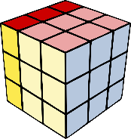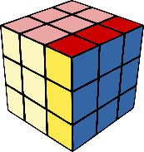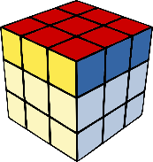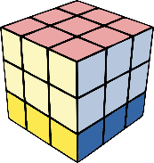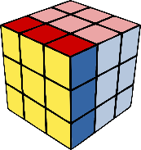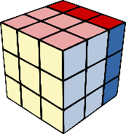
Left - L Right - R Top - U Bottom - D Front - F Back - B
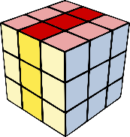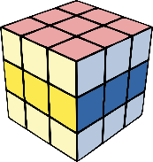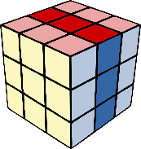
Vertical Middle - M Horizontal Middle – E Vertical Middle (Side) – S
Although it is not essential to the solving of a puzzle cube, basic notation for rotations of the whole cube also exist as a utility to make the solving of the puzzle cube more efficient. Much like the other basic moves these too can be suffixed with the digit ‘2’ or an apostrophe.
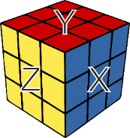
The notation for these basic utility moves are as follows:
X – Clockwise rotation of the whole cube on the x axis (Right Face)
Y – Clockwise rotation of the whole cube on the y axis (Top face)
Z - Clockwise rotation of the whole cube on the y axis (Front face)
When rotating the cube itself the X rotation must be clockwise or anti-clockwise in relation to the right-hand face. The Y rotation also must be clockwise or anti-clockwise in relation to the top face. The Z rotation must be clockwise or anti-clockwise in relation to the front face. [4]

Puzzle Cube Mathematics & Algorithms

Physical & Mathematical boundaries
To puzzle cube has physical and mathematical boundaries which limit the ways it can be solved, with the physical boundaries being intrinsically linked to the mathematical ones. On a 3x3 cube there is a total of 8 corner cubies which could be arranged in 8 different ways each of which could be arranged in 3 different orientations, this means there are 3⁸ possibilities for the orientation of the corner pieces. There is also 12 of the edge cubies, which could arrangeable in 12 different ways, each of these could also be arranged in 2 different orientations, meaning side cubies can have 2¹² orientation arrangements. However, it is important to remember that puzzle cube as physical boundaries regarding how each cubie can be manipulated, for this reason ⅔ of the possible arrangements for corner cubies are invalid and are not possible without deconstruction of the puzzle itself, which would of course be an illegal move when solving the puzzle. In addition to this “only ½ of the permutations have the same edge-flipping orientation as the original cube, and only ½ of these have the correct cubie-rearrangement parity” [2][5]. For this reason, a puzzle cube is limited to 43,252,003,274,489,856,000 valid arrangements (see Fig.1 below)
$\frac{(8! · 3^{8} · 12! · 2^{12})}{(3 · 2 · 2) }=4.3252 · {10}^{19}$ Figure 1

Group Theory
Group theory is a branch of algebra that is often described as the theory of symmetry and can be used as an analysis tool for objects with symmetry, which is why it can be used to analyse a puzzle cube and work out how to solve one.[6]

Definition & theorem of groups
The groups used in group theory are a set of objects with the binary operator ‘*’ on any objects that satisfy the following four axioms:
- Closure - The operation * is closed, so for any group elements h and g in G, h∗ g is also in G.
- Associativity - The operation * is associative, so for any elements f, g, and h, (f ∗ g) ∗ h = f ∗ (g ∗ h).
- Identity - There is an identity element e ∈ G such that e ∗ g = g ∗ e = g.
- Inverse - Every element in G has an inverse g−1 relative to the operation * such that g ∗ g−1 = g−1 ∗ g = e.
Groups also have some basic theorems that can be used to understand how groups work, the basic theorems are as follows:
• The identity element, e, is unique.
• If a ∗ b = e, then a = b−1
• If a ∗ x = b ∗ x, then a = b
• The inverse of (ab) is b−1a−1
• (a−1)−1 = e
[2][7][8]

Puzzle cube moves as elements of a group
The puzzle cube is made up of 54 faces, thus a Puzzle Cube group would have to be a subgroup a of a permutation group of 54 elements.[9]

Puzzle cube move permutations
The permutation of the cube can be described as rearrangements of the cubies on the puzzle cube. When referring to puzzle cube permutations sometimes canonical cycle notation may be used, this illustrates group theory through numbers, an example of this could be:
(1)(423)
In this example the element ‘1’ would stay in it’s place whilst the elements ‘4’, ’2’ and ‘3’ are cycled, so ‘4’ could go to ‘2’, ‘2’ could go to ‘3’, and ‘3’ could go to ‘4’. (423) $→$ (342).
This example uses one 1-cycle and one 3-cycle, for this reason after just 3 steps the each number will return to the original position. With other examples there may be more steps to return to the original position, for example:
(1 2 3)(4 5 6 7)
In this example there is one 3-cycle and one 4-cycle, this means that the first set needs 3 steps for each number to reach the original position however the second set needs 4 steps, this means that the lowest number of cycles needed to return the numbers to their original, other than zero moves, is 12 as it is the lowest number that is a multiple of both 4 and 3. [2][10]

Algorithms
Distance | Number of positions
0 | 1
1 | 18
2 | 243
3 | 3,240
4 | 43,239
5 | 574,908
6 | 7,618,438
7 | 100,803,036
8 | 1,332,343,288
9 | 17,596,479,795
10 | 232,248,063,316
11 | 3,063,288,809,012
12 | 40,374,425,656,248
13 | 531,653,418,284,628
14 | 6,989,320,578,825,358
15 | 91,365,146,187,124,313
16 | ~1,100,000,000,000,000,000
17 | ~12,000,000,000,000,000,000
18 | ~29,000,000,000,000,000,000
19 | ~1,500,000,000,000,000,000
20 | ~490,000,000

God’s Number
‘God’s Number’ refers to the minimum number of moves required to solve any puzzle cube. The first algorithm to be created to solve the puzzle cube was Thislethwaite’s algorithm in July of 1981, this algorithm allowed for the puzzle cube to be solved in a maximum of 52 moves, this algorithm was then improved upon through optimisation of Kociemba's Algorithm until it was mathematically determined that 20 is the maximum number of rotations needed to solve any cube, with 20 being the optimal amount of turns to solve ~490,000,000 of the puzzle cube combinations.[11][12]
Figure 2

Thislethwaite’s Algorithm
Following on from group theory an algorithm to solve puzzle cubes was created called Thistlethwaite’s Algorithm. This algorithm works by switching from group to group, with only the moves allowed for the cube being those specified by the current group.
The groups that are used for this algorithm are as follows:
“Group 0 = <L, R, F, B, U, D>. This group contains all the positions possible on a puzzle cube.
Group 1 = <L, R, F, B, U2 ,D2>. This group contains all positions that can be reached (from the solved state) with quarter turns of the left, right, front and back sides of the puzzle cube, but only double turns of the up and down sides.
Group 2 = <L, R, F2, B2, U2, D2>. In this group, the positions are restricted to ones that can be reached with only double turns of the front, back, up and down faces and quarter turns of the left and right faces.
Group 3 = <L2, R2, F2, B2, U2, D2>. Positions in this group can be solved using only double turns on all sides.
Group 4 = {I}. The final group contains only one position, the solved state of the cube.”
This algorithm is specifically for use with computers as it would be too difficult to memorise for a human, however this means it allows for a fast way to solve the puzzle cube.
[13][5][14]

Kociemba's Algorithm
This algorithm, otherwise known as ‘God’s algorithm’, requires two phases in order to solve the puzzle cube, the first of these increases the count of moves that are allowed to achieve the Group 1 state (<U D R2 F2 L2 B2>), once it has found the minimum moves required to achieve this it continues to find more move solutions in order to find a range of the lowest number of moves needed and a much larger number of moves needed.
In the second phase of this algorithm the permutations on any edges and corners are restored. However, because group 1 is a sizeable subset an estimate must be made on how many moves are required to complete phase 2. This is done by looking at combinations of moves for phase 1 and phase 2, for example the lowest moves to achieve phase 1 may be 4, however if it is followed by 17 moves to achieve phase 2 this is less effective than one of the high move solutions for phase 1 such as 8 being paired with a 12 move solution to achieve phase 2 .[15]
The algorithm was created to find the shortest method to unscramble/solve the puzzle cube. This algorithm relies on group theory and a virtual tree structure containing all the possible combinations of a scrambled puzzle cube. It works by working through the tree by going from node to node with the root of the tree being the solved puzzle cube. The algorithm traverses the tree from the root to find the node that corresponds with the current state of the cube, from this the path taken is analysed and reverse engineered to work out how to undo the scrambling and thus solve the puzzle cube.[16][17]

Puzzle Cube Competition & Regulation
The number of moves that are required to solve a puzzle cube is heavily dependant on how jumbled it is in it’s unsolved state. The puzzle cube takes a different number of moves to solve depending on it’s arrangement, for this reason in official puzzle cube competition there is strict guidelines that dictate to what extent the puzzle is ‘scrambled’ for it to be a valid unsolved cube, these guidelines are given by the WCA (World cube Organisation).[18]

Aims and Objectives

Aim
The aim of the project is to produce a robot that can solve a puzzle cube to the same standard set by both other robots that are built to solve a puzzle cube and humans that solve puzzle cubes in competitions.

Objectives
- Create an algorithm that can calculate the moves needed to solve a puzzle cube.
- Optimise the algorithm so that it is efficient.
- Create a robot capable of physically executing all the possible moves required to solve a puzzle cube.
- Optimise the robot so that it can execute the moves as quick as possible within the physical boundaries.

Research Methodology
This project will carry out research first by identifying the key areas of knowledge that would be required to design the software and the hardware. This research would consist of finding information about LEGO MINDSTORMS robotics and what mechanisms would need to be implemented to create a robot with the functions needed for the project, moreover further research would be done when creating the robot prototype, this would be done to optimise and improve the design if necessary. In addition to the research about LEGO MINDSTORMS there would also be extensive research into the mathematics that is required to solve a puzzle cube and how that would translate into runnable code. Other research that would be done is into the statistics of how many turns it takes to solve the puzzle cube and how long it takes, this will allow for the project to have a benchmark that shows whether it is efficient or not.
The chosen approach for the bulk of the research will be in stages. These stages are as follows:
- Preliminary research – This will most be the identification of background information on what methods for creating the project are most effective, such as research on programming languages, methods of solving the puzzle cube and what engineering ’tricks’ can be used to make the robot. This information can come from forums and non-academic web sources that use a trust based system to identify ‘good’ information.
- Initial research – This is to give a thorough idea of how to design both the LEGO MINDSTORMS robot and the algorithm required to solve the puzzle cube. This information will be found through books, articles and websites from reliable sources.
- Primary research – This research will come directly from analysing the results from surveys that were made with specific intentions to extract useful information from people and experts knowledgeable about robotics, algorithms, puzzle cubes, programming and mathematics.
- Research evaluation - At this stage information that has been can also be scrutinised and evaluated to make sure it is applicable to the project and it’s aims to narrow down the scope of any additional information.
- Cohesive research – At this stage further information will be found on how to develop the previous research into actual code compatible with the LEGO MINDSTORMS robot, this stage will look more closely at the fusing the pre-existing knowledge and aims for the project with the research and knowledge of how to solve a puzzle cube.
- Benchmark research – This will be the research stage where specific information is identified that can be useful when testing the speeds and efficiency of the algorithm in comparison with other robots and human beings.
- Additional research – This will be at the stage in development where prototypes are being created and will be more ‘on-the-go’ research to find any additional information that can help with the project that had not be identified as an area of interest before.
This staged approach is useful as it is more time efficient than doing all the research in one go, rather the information needed to progress the project is found as and when it is required, this means the project will not stagnate at certain points because research areas will not be exhausted and over-researched when other tasks can be done. The biggest problem thrown up by research is its ability to over face the researcher, therefore by fragmenting the research, it will make it easier to extract the needed information for the current point in the timescale.
Although this project is specific to solving a puzzle cube, the algorithm that will be created will rely on mathematical theory which will have many useful applications other than to solve a puzzle cube, this means it could be generalized and adapted to solve different problems that rely or utilize the same mathematical theory.[16]

Development Methodology
The chosen development methodology for this project will be Agile development for the software, with the principles for agile development also being used for the physical part of the project as well.
This is the chosen methodology because it allows for the creation of the software to be broken up into small modules that can be tested in a test harness, this allows for the software to be built up and stops stagnation if a certain part of the software is proving difficult to make. This means that further research can be done in any areas that need improvement whilst other modules of code are being created. This will not only make it easier to identify if the project is on target in terms of the timescale but also make it time efficient because the project would not come to a halt if one module needs further research to complete.
Although it is in the agile style the project will also have optimisation stages, this means that there shall always be a working deliverable however this could mean the project is less optimised or efficient than existing puzzle cube solvers if the final post-alpha version cannot be produced.
This Agile methodology will also apply to the physical part of the project, meaning the mechanisms needed to manipulate the puzzle cube and move it will be created in different parts. With this said the physical part will be less modular as there are some parts to it that would rely on other modules being functional. [19]

Risks
One of the potential risks that would apply to the project is that the physical part of the robot may be too difficult to engineer with the current resources. This would mean additional Lego parts may need to be purchased which would increase the cost of the project.
Another risk that would need to be considered is the computational power required to solve the cube, this is because the LEGO MINDSTORMS CPU that would be used to execute the code is not as powerful as the machines initially used to try and test the code. For this reason, it would be essential to make sure the code is properly optimised.
There is also the risk of timing, this is because the project must be completed within a set timeframe which means time will have to be allocated to each task generously as the length of time taken to complete tasks can easily be misjudged.
This project would not be subject to any ethical risks or concerns because it does not alter the environment or create any tools that can be used maliciously or have a negative effect when used.

Analysis and Deliverables

Data & Analysis
One of the forms of data that would be collected is the total moves the robot made to solve the puzzle, this dataset would then be used to find the mode, median and the average of the data. Other data that would be looked at it the total computational time needed for the program to solve the puzzle through it’s algorithms, which would also be analysed in a similar fashion to the moves data. The other type of data that would be analysed is the would be the total time taken for the robot to physically solve the puzzle cube, something which would also be recorded and analysed using mode, median and average.
In addition, the analysed data could be compared to the data produced by different iterations of the programs. This data could also be compared with the data of other programs designed to solve a Puzzle cube and compared with the data recorded by the WCA (World Cube Association) in their human puzzle cube solving competitions.

Deliverables
The project will consist of 2 deliverables, these would be the physical robot itself and the program used to solve the mathematics of the puzzle cube and control the robot’s components to solve the physical cube.
The minimum success criteria for the project would be a program that could solve a puzzle cube in a test harness, this would show the theory and algorithms needed for the project are working and would be able to be used to solve a puzzle cube.

Physical Resources
To create this project, I will need several physical resources. The following are the resources that will be instrumental in the creation of the project

Hardware
- LEGO MINDSTORMS set – This will be needed as it will include the sensor, the motor and the robot CPU all of which are essential for the physical aspect of the project.
- Additional LEGO parts – These are a resource that may be needed if there are not sufficient LEGO pieces included in the LEGO MINSTORMS set to create the chassis and the fully functioning robot.

Software
- An integrated development environment (IDE) – This software will be needed to write the code, some IDE’s such as Visual Studio also give syntax highlighting which would assist with the writing of the code, it would also give detailed information on the execution times for each process used in the code.
- A virtual LEGO builder- This software will be needed to design the robot.

Virtual & physical information sources
- Journals – It is essential there is access to journals, so all the relevant information required to create the project can be found.
- Puzzle Cube Data – This will be needed because it is essential there is data that can be used to compare with the data collected for the project, this is because it shows whether the robot & software are effective.

Human Resources
For the project it would be useful to utilise humans. The project may require people to fill out information for surveys in order better the project, the people chosen for these surveys would have to be knowledgeable about the subject matter, this means collecting information from programmers, mathematicians and any people enthusiastic and/or knowledgeable about puzzle cubes. The people used for surveys can be both people surveyed in person or people who take an online survey; for those taking online surveys they would have to be distributed among reliable people, such as those that are active and knowledgeable from puzzle cube forums, however it would also be important to scrutinise data from these sources to maintain accuracy.
Human resources may also be needed when testing out the robot and when collecting data for it, this is because it would be difficult to initiate the program whilst also timing how long it takes for the robot to complete the task at hand.

Timeline
This gantt chart shows each step of the project and the timeframe for each task, this includes some tasks that will be performed at the same time.
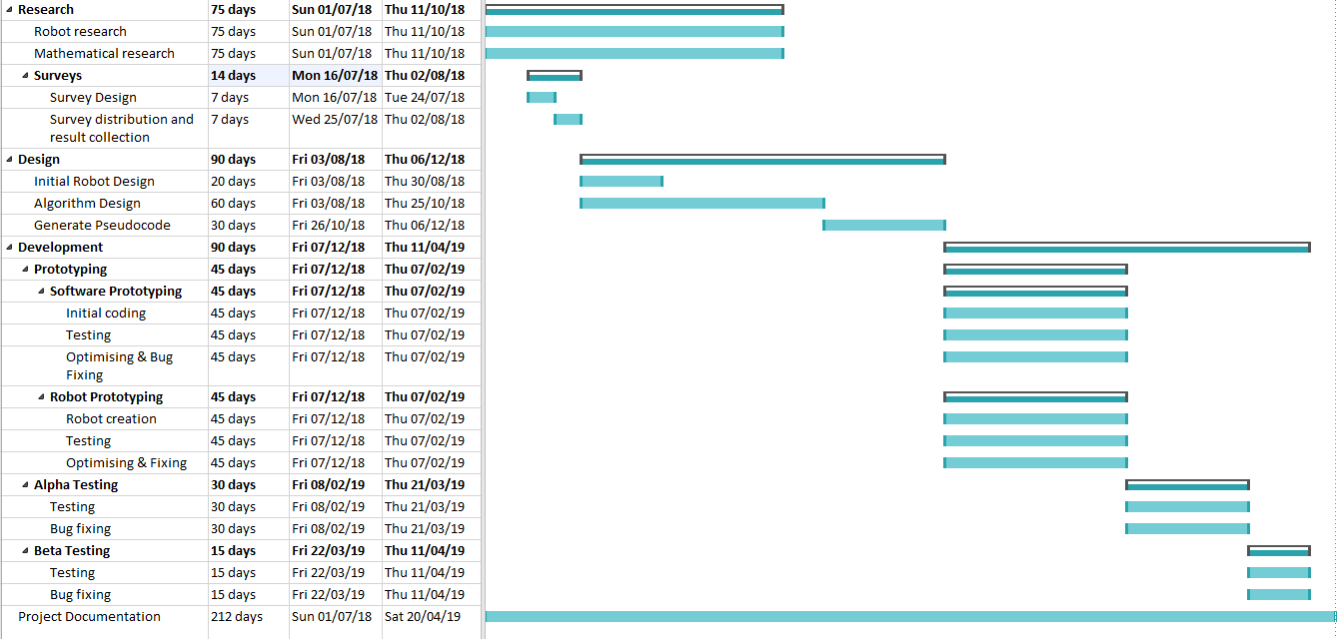
The research section will need Human resources to collect survey information, and the physical & virtual information sources to collect other relevant information for research.
The design section will require the virtual LEGO building software to design the robot.
The development section will require the IDE software to write the code and to analyse problems in the code, so they can be fixed.

References
[1] J. Chen, “Solving Rubik’s Cube Using SAT Solvers,” arXiv:1105.1436, 2011.
[2] M. Travis, “The Mathematics of the Rubik’s Cube,” Math.Uchicago.Edu, pp. 1–20, 2009.
[3] S. Bonzio, A. Loi, and L. Peruzzi, “On the nxnxn Rubik’s Cube,” pp. 1–18, 2017.
[4] Ruwix.com, “Rubik’s Cube Notation.” [Online]. Available: https://ruwix.com/the-rubiks-cube/notation/. [Accessed: 13-Apr-2018].
[5] D. . De Moloy, “SOLVING RUBIK ’ S CUBE,” no. September, 2015.
[6] University of Connecticut, “Why is group theory important?” [Online]. Available: http://www.math.uconn.edu/~kconrad/math216/whygroups.html.
[7] “Donald L. Kreher,” 2012.
[8] M. Staff, “Group theory 101: How to play a Rubik’s Cube like a piano.” [Online]. Available: https://youtu.be/FW2Hvs5WaRY. [Accessed: 15-Apr-2018].
[9] J. Chen, “Group Theory and the Rubik ’ s Cube,” Mathuchicagoedu, vol. 4301, no. July, pp. 1–7, 2009.
[10] T. Davis, “Group Theory via Rubik’s Cube,” pp. 1–59, 2006.
[11] T. Rockicki, H. Kociemba, M. Davidson, and J. Dethridge, “God’s Number is 20.” [Online]. Available: http://cube20.org/.
[12] T. Rokicki, “Twenty-two moves suffice for Rubik’s cube®,” Math. Intell., vol. 32, no. 1, pp. 33–40, 2010.
[13] Z. Wang and Y. Wang, “Rubik ’ s Cube Solver,” pp. 1–177, 2013.
[14] Jaap, “Thistlethwaite’s 52-move algorithm.” [Online]. Available: https://www.jaapsch.net/puzzles/thistle.htm. [Accessed: 23-Apr-2018].
[15] Ruwix, “Herbert Kociemba’s Optimal Cube Solver.” [Online]. Available: https://ruwix.com/the-rubiks-cube/herbert-kociemba-optimal-cube-solver-cube-explorer/. [Accessed: 20-Apr-2018].
[16] Brigham Young University, “Step-by-Step Guide & Research Rescue: Basic Research Strategy.” [Online]. Available: http://guides.lib.byu.edu/stepbystep. [Accessed: 23-Apr-2018].
[17] D. Truesdell, C. Holsey, and T. Verbano, “Rubik ’ s Cube Solving Robot.”
[18] W. C. A. Regulations, “WCA Regulations and Guidelines WCA Regulations Committee,” pp. 1–21, 2018.
[19] IT Knowledge Portal, “Software Development Methodologies.” [Online]. Available: http://www.itinfo.am/eng/software-development-methodologies/. [Accessed: 20-Apr-2018].

Bibliography

[1] | C. Durnford, “How To Solve The Rubik's Cube,” Rubik's Brand Ltd, [Online]. Available: https://uk.rubiks.com/blog/how-to-solve-the-rubiks-cube. [Accessed 15 4 2018].
[2] | THINK MATHS, “RUBIK'S CUBE SOLVING INSTRUCTIONS,” [Online]. Available: RUBIK'S CUBE SOLVING INSTRUCTIONS. [Accessed 20 April 2018].
[3] | M. Hutchings, “The Mathematics of Rubik’s Cube,” [Online]. Available: https://math.berkeley.edu/~hutching/rubik.pdf. [Accessed 18 April 2018].
[4] | L. Hardesty, “The math of the Rubik’s cube,” [Online]. Available: http://news.mit.edu/2011/rubiks-cube-0629. [Accessed 20 April 2018].
[5] | T. McNeil, “Rubik’s Cube’s Math Secret,” TuftsNow, [Online]. Available: http://now.tufts.edu/articles/rubik%E2%80%99s-cube%E2%80%99s-math-secret. [Accessed 12 April 2018].

