

School of Applied Computing

Student Name: | Peter Davies |  | Student P number: | P079868
Programme: | BSc Web Development
Module: | Project Management | Lecturer: |  | Sue Maw
Assignment Title: | Managing an IT Project
Hand Out Date: | 01/10/17 |  | Submission deadline: | 27/04/18



Disclosure: | I declare that this assignment is all my own work and that I have acknowledged all materials used from the published or unpublished works of other people. All references have been duly cited.
Student’s Signature: |  | Date: | 24/04/18

Abstract

Contents

- Introduction……………………………………………….………………….………………….……………………1

- Updated Project Initiation Document………………….………………….………………….………….2

- Demonstration Screenshots………………….………………….………………….………………………..5

- Risk Management………………….………………….………………….………………….………………….13

  - Risks Identified ………………….………………….………………….………………….……………….13
  - Risk Evaluation Matrix………………….………………….………………….…………………..……16
  - Risk Assessment Table………………….………………….………………….………………………..16
  - Risk Exposure Calculations………………….………………….………………….………………….18

- Code of Practice………………….………………….………………….………………….…………………….19

  - Sustainability Issues………………….………………….………………….………………….………..19

    - First, Second & Third Order Sustainability Issues………………………………19

  - Ethical & Legal Issues………………….………………….………………….………………….…..…23

    - British Computer Society Code of Conduct………………….……………….….23
    - IEEE Code of Conduct………………….………………….……………………………….25

- Quality Assurance Issues………………….………………….………………….………………….………27

- References………………….………………….………………….………………….…………………………..29

- Bibliography………………….………………….………………….………………….………………………..30

Introduction

The following report follows on from an initial Project Initiation Document and in-class demonstration of a designed, built and tested database system for local charity football club, Mumbles Rangers FC.

The report firstly shows screenshots of the updated PID, and PowerPoint slides produced for the project. The risk of the project is then analysed, followed by sustainability issues recognised and ethical and legal issues in relation to the BCS and IEEE code of conduct. Quality assurance is then discussed, and finally references and a bibliography cite all work referenced and researched.

Updated Project Plan

Original Task Sheet

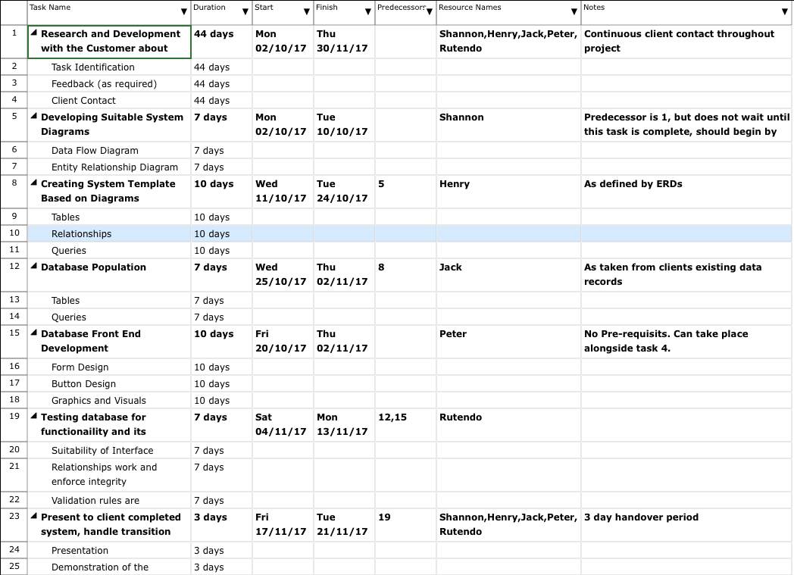

Original Gantt

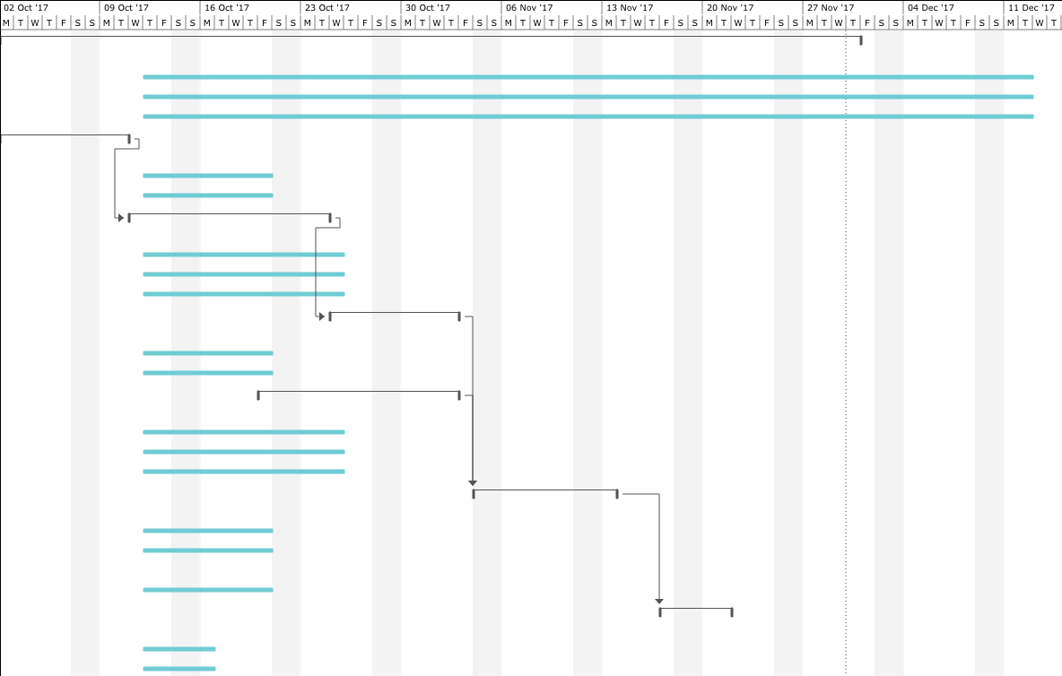

Updated Task Sheet

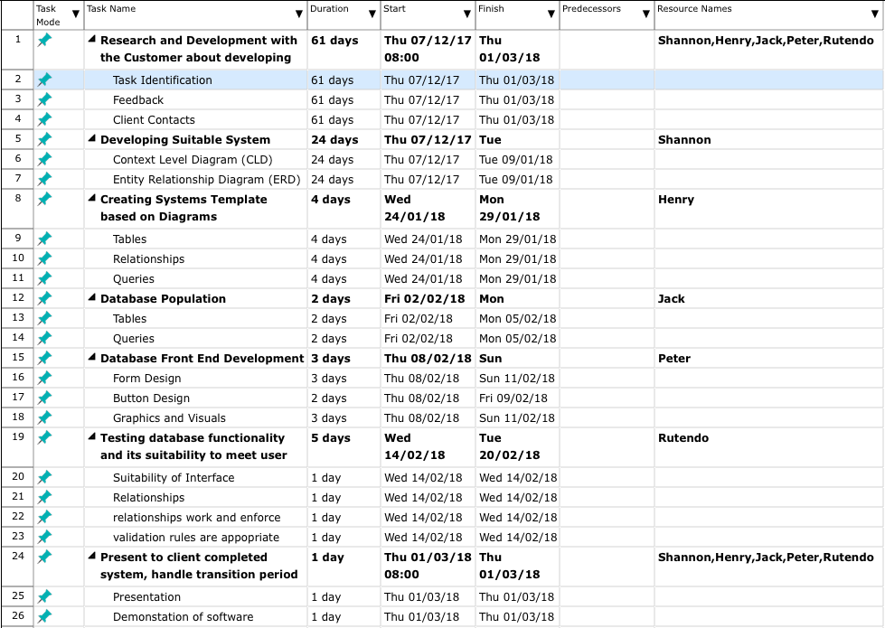

Updated Gantt

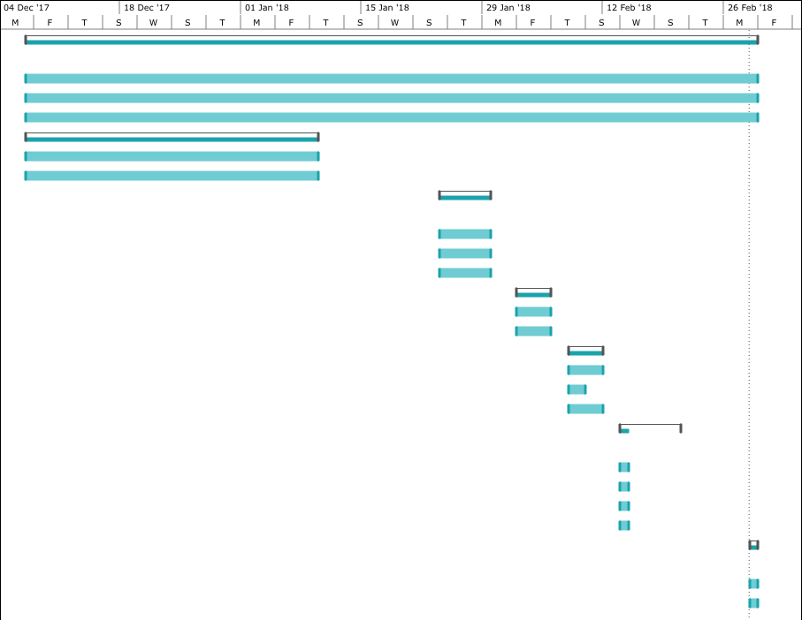
Comparison of the two project plans, shows that, as a team, our original estimated durations were inconsistent with actual task durations. In some cases, the tasks exceeded the time schedule placed, for example; Research & Development was given a total duration time of 44 days, in practice, this task ran over by 17 days, totalling 61 days.

While two predicted time durations ran over (Research & Development and Developing Diagrams), the remaining tasks identified and given durations were delivered in less time than proposed. As identified in the presentation, the given time durations for each task were lenient, these tasks can and should be completed before schedule.

Overall the project was running consistently three months behind schedule. The anticipated completion date was 21/11/17, however, the project was completed 01/03/18. This was due to a number of factors, which have been identified in the risk analysis of this report.

Demonstration Screenshots

In the following screenshots, the demonstration produced in Microsoft PowerPoint [1] is shown which was used to discuss the finished database for Mumbles Rangers [2]. The presentation discusses the different tasks in detail, and their proposed time scales compared with their actual task time scale. It concludes with a review of the overall project planning process.

Front Page

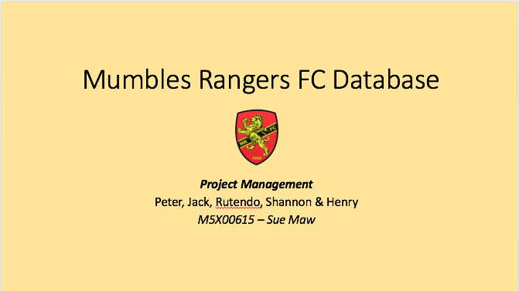

Project Planning & Database Diagrams

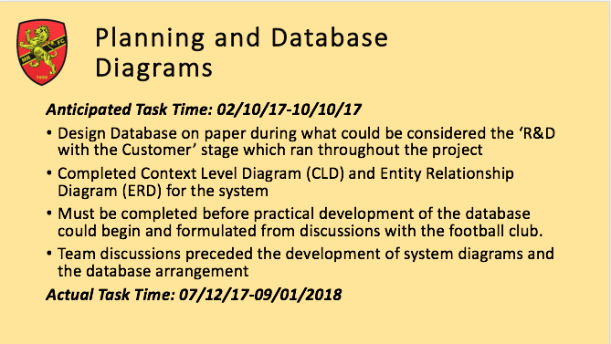

Context & Entity Relationship Diagrams

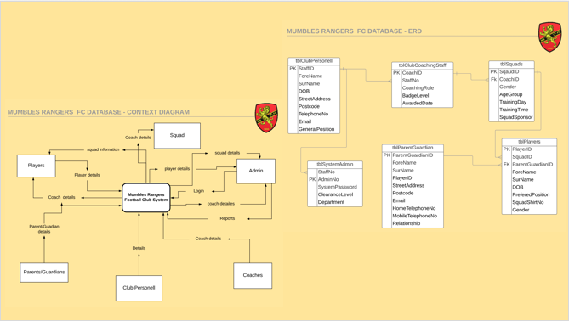

Creating Database Structure

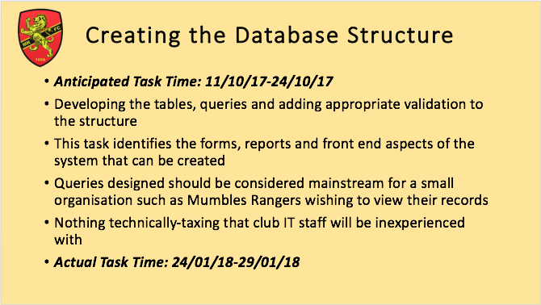

Database Structure Screengrabs

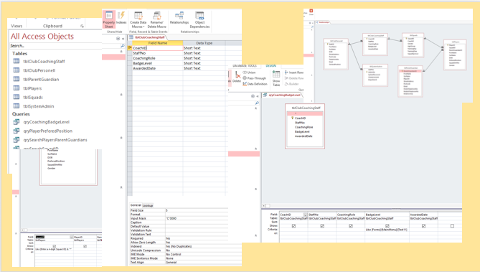

Adding Test Data

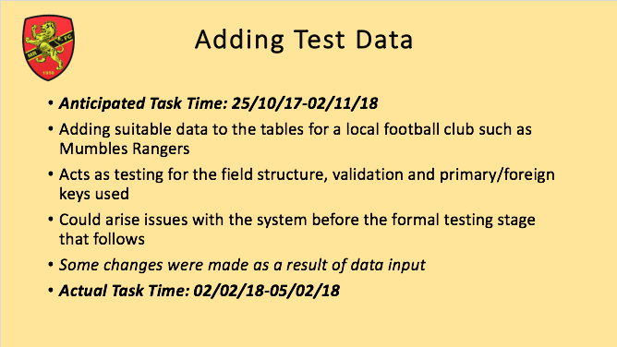

Test Data Screengrabs

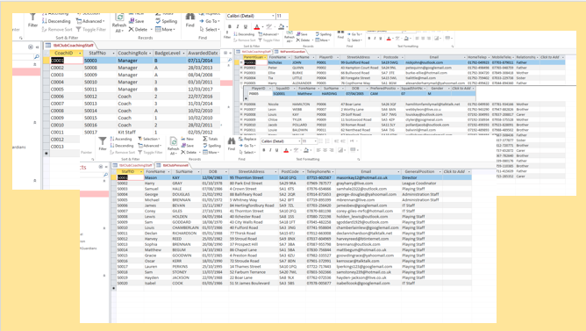

Developing Front End Interface

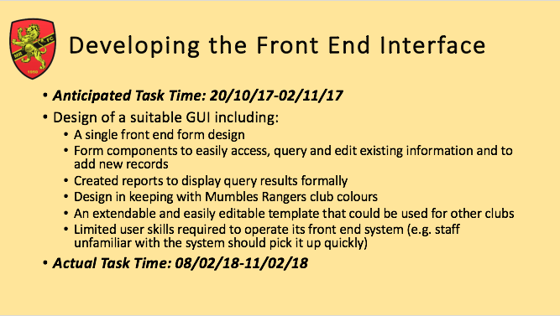

Front End GUI Screengrabs

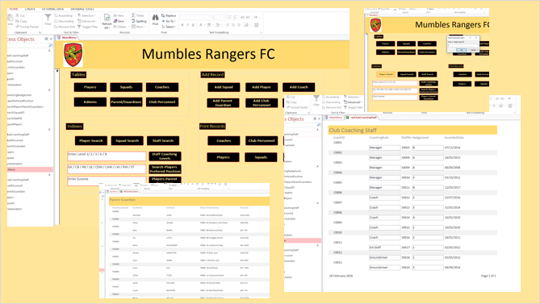

Database Testing

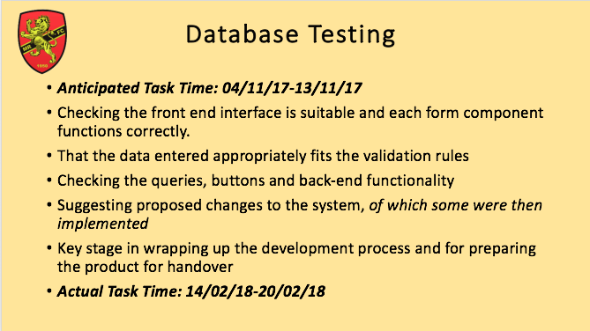

Database Testing Screengrabs

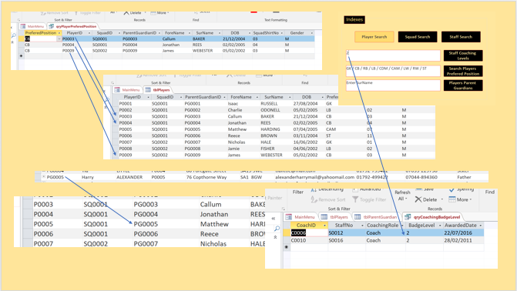

Database Testing Table

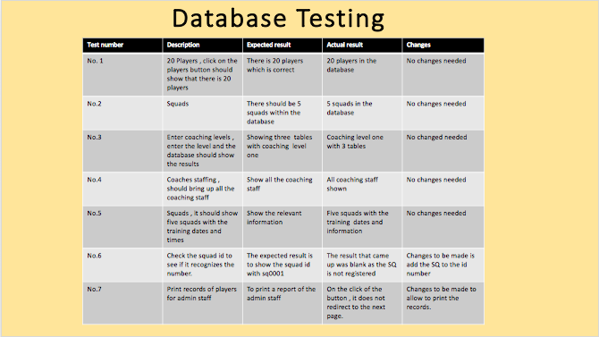

Project Risk

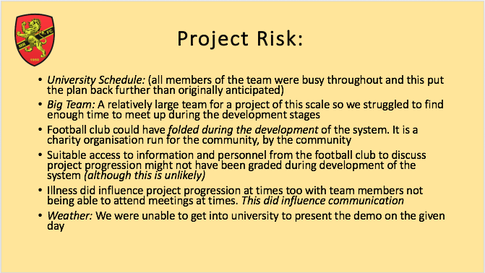

Project Plan – Post Development

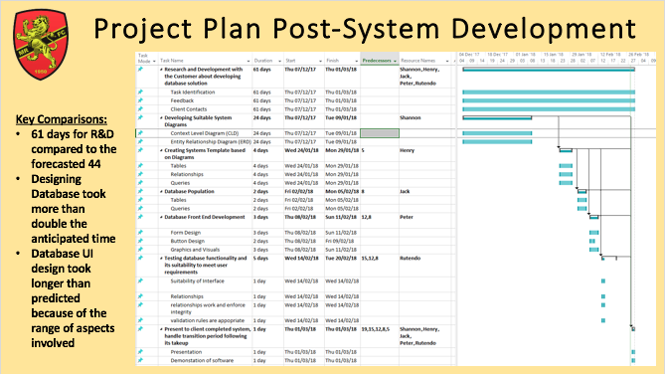

Project Plan Review

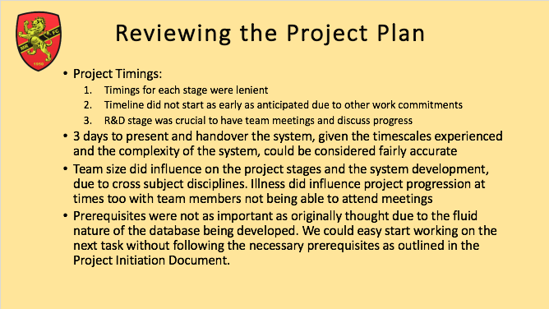

Risk Management

Risk management is paramount as potential problems can occur in any project [3]. Risk is future uncertain events with a probability of occurrence and a potential for loss [4][5]. Risk in project management, by definition, is the extent of consequence and probability of not achieving a distinct goal for the project [6]. It is the uncertainty of outcome, which could be a positive opportunity or a negative threat to a project. Risk is to be assessed with a permutation of likelihood of something happening and the impact that said something has, if it happens [7].

Risk management is the task of identifying and assessing these risks and acting on them [7], it comprises firstly, of the understanding of risks, and consequently analysing these risks to in turn address the risks to ensure that the project reaches its given objectives [8].

4.1 Risks Identified

Risk Management for the Mumbles Rangers Database project firstly, involves the identification of risks which are related to the project objectives outlined in the project plan. To do this, a list of possible project risks is provided for use in assessing the factors which may have an effect in the following areas;

- Cost
- Schedule
- Staffing Team
- Organisational (Organisation DB is for)

The list will also identify the probability level of risk for each identified project risk on a scale of low – high. Where;

- Low – Very unlikely that said risk will occur.
- Moderate – Up to a 25% chance that said risk will occur.
- Significant – Between a 25% – 75% that said risk will occur.
- High – Over 75% chance of risk occurring.

A description of risk level is also provided for each risk identified.

Cost Risks

- Cost of acquisition of hardware or software resources needed to implement project.

LOW | MODERATE | SIGNIFICANT | HIGH

- Low risk as all software and hardware is provided by University.

- Cost of Labour to produce database.

LOW | MODERATE | SIGNIFICANT | HIGH

- No labour costs as database is being developed free of charge as part of an assignment in the Project Management module.
- Risk that chosen software cannot handle size of project proposed.

LOW | MODERATE | SIGNIFICANT | HIGH

- Given the size of the Mumbles Rangers football club there is a moderate possibility that Microsoft Access [9] may not be sufficient to handle the data requirements of the football club. If this is the case, specialist software may be required with a specialist team to develop it, i.e. Microsoft SQL Server [10].

Schedule Risks

- Project schedule will exceed deadline.

LOW | MODERATE | SIGNIFICANT | HIGH

- Significant risk that project will exceed deadline. Optimistic dates set out in the project plan.

- Requirements of system may change over course of project.

LOW | MODERATE | SIGNIFICANT | HIGH

- Given the nature of the subject matter, once the system is designed it is capable of being modified or even applied to different football clubs with no major change required.

- Risk that requirements are poorly communicated.

LOW | MODERATE | SIGNIFICANT | HIGH

- Mumbles Rangers is run by volunteers, many of which may have no experience in computerised systems and may not be able to communicate requirements effectively.

- Large team size may hinder meetings due to too many commitments from team members elsewhere in academic and personal life.

LOW | MODERATE | SIGNIFICANT | HIGH

- 5 different team members with different responsibilities and different University timetables will provide a high risk that meetings will not be able to take place.

- Discussing ideas and problems with project authority (Part-Time, UWTSD Staff Member, Sue Maw).

LOW | MODERATE | SIGNIFICANT | HIGH

- As main project authority, discussions with Sue Maw may need to take place, as she is part time, face to face meetings may prove difficult, however, emails are answered making this a low risk.

- Access to members of Mumbles Rangers staff limited.

LOW | MODERATE | SIGNIFICANT | HIGH

- Discussing each stage of the project with members of staff at Mumbles Rangers presents a moderate risk as staff members are all volunteers, with very few able to answer questions the team may have.

- Illness effecting team members attendance to meetings and ability to complete tasks on time.

LOW | MODERATE | SIGNIFICANT | HIGH

- The probability of illness amongst staff members is significant due to UK Winter. Flu virus reports at their highest level since 2010/11 [11].

- Other module assignments using up team members resources, hindering attendance to meetings and pushing deadlines for tasks back.

LOW | MODERATE | SIGNIFICANT | HIGH

- High chance that build-up of assignments over the period laid out in the project plan will force this project to slow and deadlines to be pushed back.

- Winter time in UK – probability of travel disruption due to weather.

LOW | MODERATE | SIGNIFICANT | HIGH

- Although the UK is experiencing a bitter winter, the main cause of travel disruption, snow, is unlikely in South Wales.

Organisational Risks

- Mumbles Rangers charity organisation may cease to exist due to lack of donations and or volunteers.

LOW | MODERATE | SIGNIFICANT | HIGH

- Mumbles Rangers football club has been around since 1950, therefore the probability of the club closing after 68 years is unlikely.

4.2 Risk Evaluation Matrix

A risk evaluation matrix shows the level of risk by studying the category of likelihood or probability compared with the consequence severity, it aids project managers in their risk assessment of a project by visualising risks, their probability and outcome severity [12] [13].

The identified risks and their probability can now be drawn up in a risk evaluation matrix. As a key, risks will be identified in the matrix as follows;

- Cost Risks – C1, C2, C3.
- Schedule Risks – S1, S2, S3 etc.
- Organisational Risks – O1.

 |  | SEVERITY
 |  | LOW | MODERATE | SIGNIFICANT | HIGH
PROBABILITY | LOW | S2, S5, S9, O1 | C2 |  | C1
PROBABILITY | MODERATE | S3 | S6 |  | C3
PROBABILITY | SIGNIFICANT | S1 |  | S7
PROBABILITY | HIGH | S4 |  |  | S8

In the risk evaluation matrix shown, it can be seen that the majority of risks are low to moderate, however, three risks identified are over the ‘tolerance line’. To further evaluate the risks, a risk assessment table is produced to show methods which will help manage risk.

4.3 Risk Assessment Table

RISK | PROBABILITY | SEVERITY | MANAGEMENT METHOD
C1 | LOW | HIGH | Confirm with UWTSD that all hardware and software facilities will be available to all team members for use on this project.
C2 | LOW | MODERATE | Ensure each team member understands this is a not for profit project and there will be no payment for services provided.
C2 | MODERATE | HIGH | Conduct correct research into both MR and Microsoft access to confirm that software is suitable for such an organisation, before project commences.
S1 | SIGNIFICANT | LOW | Ensure that project is completed on time, however, as it is a voluntary project MR do understand that team have other commitments and no financial loss will incur if project is not delivered on time. Initial project deadline is not life or death.
S2 | LOW | LOW | Ensure a contract is laid out specifying each requirement and correct requirement analysis is drawn up with both parties agreeing what system should and shouldn’t do before project commences.
S3 | MODERATE | LOW | Talk through system with MR staff members and ensure they understand systems features and its limitations to avoid any requirement disappointments.
S4 | HIGH | LOW | Ensure communication between all members is upheld at all times. Any changes to plan or schedule must be communicated.
S5 | LOW | LOW | Learn days of which Sue Maw works, and be aware of her email address.
S6 | MODERATE | MODERATE | Ensure there is a dedicated club contact with appropriate means of getting in touch, email, phone etc.
S7 | SIGNIFICANT | SIGNIFICANT | Have systems in place to allow other members to pick up jobs if team member is unwell.
S8 | HIGH | HIGH | Project manager must ensure that all team members are on course for deadlines in all subjects and if needed pass on time management techniques to minimise risk.
S9 | LOW | LOW | Ensure team knows protocal should any meetings or deadlines be affected by weather.
O1 | LOW | LOW | Keep in contact with hierarchy at MR to ensure continued existence of club

4.4 Risk Exposure Calculations

Risk exposure calculations aid in the risk management process by allowing project managers to calculate how much they stand to lose financially due to risk events identified [14]. An organisation can then choose whether or not to expose their company to these financial risks, where generally the rule is “only take on avoidable risk if the expected return is positive” [15]
As the Mumbles Rangers Database Project is a not for profit project with no payment, costs or budget involved, however, should there be a cost involved for future projects the following formula will be used.
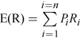

Fig 1. Risk Exposure Formula [15]

Fig 1 illustrates the formula which can be used to calculate the risk exposure of a given risk, where;

- E(R) = Expected Return
- P_{i} = Probability of Occurance
- R_{i} = Value of Damage

Code of Practice

5.1 Sustainability Issues

Global warming and climate change is one of the biggest issues facing the world today, with expert scientists from the World Economic Forum [16] stating that climate change is the biggest risk to humanity, both in sociological and economic aspects [17][18].

With NASA Climate Change Department stating that temperatures in January 2018 were the fifth warmest on record, since 1880 [19], and with the UK temperature being warmer than the North Pole in February [20], [21] it is clear to see that humans are having a great impact on the environment, with business being a major contributor to global warming.

It is said that the IT industry globally accounts for just 2% of the carbon emissions, however,
The Carbon Trust Office reports that office equipment, i.e. Computers and other associated hardware, are the fastest growing consumer of electricity in the business world, accounting for 15% of total electricity used. This figure is said to rise to 30% by the year 2020 [22], [23]. Furthermore, the UK Government has pledged to reduce Co2 by 80% by 2050 [23], further reinforcing the issue of compiling with Green IT standards.

IT also greatly helps to reduce carbon emissions; by providing technological solutions to optimise resources and, in turn, save energy [24]. A good example of this is logistics, by using IT systems to analyse and consolidate shipments, a company in Chicago IL decreased their shipping mileage from 1,029,873 miles to 322,241 miles with a reduction in Co2 of 68% [25]. Evidence like this proves how useful good analysis of sustainability issues and use of IT can greatly improve a business’s carbon footprint, but furthermore reducing costs and improving a business’s image [22].

With the aforementioned figures in mind, every project in IT, including Mumbles Rangers Database, needs to consider its environmental impact. To do this, an analysis of first, second & third order sustainability issues will be completed for the project.

5.1.1 First, Second & Third Order Sustainability Issues

To identify some of the sustainability issues associated with the Mumbles Rangers project, a table format used in G. Lami et al. paper on ‘A Methodology to Derive Sustainability Indicators for Software Development Projects’ [26], is borrowed.

This table is displayed on the following page.

SUCCESS FACTOR |  | DIRECT EFFECTS
 |  | Power Waste | Effort/Time Waste | Material Waste Production | Paper Waste | Fuel Waste
People & Actions | Developers | Personal Laptops. | Building System. |  | Printed assignment brief. Verbally or electronically communicate. | Travel to University for lectures & meetings. Travel to FC for meetings with MR staff.
People & Actions | Users |  | Training on new system. |  | Previous admin using paper system. | Video Conferencing& Travel to meetings.
People & Actions | Top Management |  | Explaining new system. |  |  | Introducing system to other football clubs in the area.
People & Actions | Project Team |  | Team members skill/knowledge in database construction. |  |  | Team members travelling to meetings/university.
Project Content | Project Scope, Goals, Objectives |  |  | No environmentally dangerous materials.
Project Content | Resources |  | One team member expert in MS Access.
Project Content | Technology |  | Building System. | University supplied software (MS Access) | Dematerialisation. | Video Conferencing.
Development Processes | Requirements Determination | Meetings done over winter – more power for lighting etc. | Designing and discussing system requirements. |  | Moving from paper system.
Development Processes | Project Management |  | Setting up meetings. |  | Sketching & jotting ideas down. | Car travel, bike travel, train & bus.
Development Processes | User Training |  | Setting up training sessions. |  | Trainees taking notes. | Car travel, bike travel, train & bus.
Institutional Context | Organisational Properties | Issues integrating current paper system. | Lack of clear instruction. |  |  | Travel for meetings.
Institutional Context | Environmental Conditions | Deadline cuts. |  | Improve Recycling | FC will still use paper.

The Green Drivers table helps to recognise the 1st, 2nd & 3rd order sustainability impacts for the project.

First Order

1st order impacts are those that are of direct result of the project’s existence.

- More power will be used in the office & home with implementation of the new IT system.

- Over the years, more IT equipment will be required to continually use the system, meaning more e-Waste.

- Less staff will be required to book keep and run the football club meaning some jobs may be lost at the club.

Second Order

2nd order impacts are the results of the IT system reducing other impacts.

- Staff will now be able to work from home, meaning less travel to and from the office to complete administration tasks.

- Staff will also all be able to see data updated through system to there will be less travel to and from meetings at the office.

- Teams will be better organised, optimising team selection through the system which in turn allows team members and parents to decide whether they should travel to games, home & away. This will reduce unnecessary travel.

- Office waste will be greatly reduced with less paper and associated office equipment required to carry out admin tasks.

- Logistically less equipment for the office will need to be delivered or collected from high street shops meaning less travel for staff or companies involved in supplying football club.

- Newsletter will now be automatically e-mailed rather than printed on paper, saving more office supplies such as paper, ink, letters, stamps, and the cost of delivery including the fuel used to deliver said letters.

Third Order

3rd order impacts are those which are long term, or socioeconomic.

- Mumbles Rangers may have a need for more power to their club house due to extra computers being used, this would mean more pylons, or diffing up of their home ground, Underhill Park [27].
- Increased connectivity may also be required; masts providing mobile coverage and mobile Wi-Fi, more telephone cables required to carry internet, or underground cables to supply connectivity to club. These additions will affect aesthetics and environment of the club.

- Increased connectivity could also prove stressful to volunteer club staff, the new system may mean that all volunteers will be contactable and responsible for club matters at all times, which could prove overwhelming, in turn, encouraging people to relinquish their duties and even discouraging future volunteers which may adversely affect the future of MR.

- On the other hand, the introduction of the new technology and the implementation of the new system may increase productivity and make the day to day running of the club easier for volunteers, which will encourage people to join the club. With the football club thriving, the wellbeing of the community will also improve.

5.2 Ethical & Legal Issues

All projects undertaken have a duty to comply to ethical and legal standards laid out in each field of business. IT is no different, with two major organisations covering code of conduct standards for ethical and legal issues for information technology and engineering. These organisations are; The British Computer Society – The Chartered Institute for IT [28] and IEEE or Institute of Electrical and Electronics Engineers [29].

The BCS code of conduct lays out professional standards required from BCS members [30], as UWTSD’s School of Applied Computing [31] courses are accredited by the BCS, this code of conduct directly applies to students studying and completing assignments for the University.

Projects of any size should pay attention to ethical and legal issues, as there are many areas of which the line can be crossed. With pressure on companies to complete projects, or just bring projects in on time and budget, compromises in ethics and legal practices are sometimes taken, which can have disastrous effects for the project and the organisations [32]. A recent notable example of ethics and laws being ignored to achieve projects aim is that of Cambridge Analytica [33]. The company is accused of harvesting over 50 million US voter’s data from Facebook, without permission, in order to influence the US Presidential outcome [34], [35], this is not only a serious ethical issue but in the eyes of democracy, a legal one too.

Even for the small project tasked for Mumbles Rangers, these codes of ethics and legal standards still apply. These issues are identified and compared against that of the BCS and IEEE to ensure compliance in every area.

5.2.1 BCS Code of Conduct

Public Interest

- Have a due regard for public health, privacy, security and wellbeing of others and the environment.

- Have due regard for the legitimate rights of Third Parties.

- The project team have a duty of care to provide a service to MR which is secure. As a team, exposure to personal data will be unavoidable, and therefore the team must adhere to part a. of the code of conduct. If the team were unethical, personal data could be sold or misused. Or even used to manipulate people.

- Conduct your professional activities without discrimination on the grounds of sex, sexual orientation, marital status, nationality, colour, race, ethnic origin, religion, age or disability, or of any other condition or requirement.

- If the team were to be discriminatory in any of the above areas they could refuse to work on the project or refuse to work with members of MR staff. The team assembled by project manager, Henry Cobbold, comprises of members from different ethnic backgrounds, races and religious beliefs, this will ensure a view from each background is considered.

- Promote equal access to the benefits of IT and seek to promote the inclusion of all sectors in society wherever the opportunity arises.

- The team could design a system which is difficult to use, and one not fit for purpose. As a volunteer organisation it is important that the system can be used by all and training is provided to users.

Professional Competence & integrity

- Only undertake to do work or provide a service that is within your professional competence.

- If MR were paying for this system, a project team could lie about their skills and abilities to produce a working system for the charity. This could mean MR paying for a system that doesn’t work or one they never receive. Thankfully, the project team all hail from a school of computing with enough expertise to complete the project, and no money is being exchanged, just the goal of achieving good grades.

- Ensure that you have the knowledge and understanding of Legislation, and that you comply with such Legislation, in carrying out your professional responsibilities.

- Sensitive personal data could be misused. Addresses could be passed on to cold callers or even thieves. Project authority, Sue Maw, has taught of legislation surrounding data.

- Avoid injuring others, their property, reputation, or employment by false or malicious or negligent action or inaction.

- System could financially destroy the charity should money be changing hands. Which in turn would see the club cease to exist.

Duty to Relevant Authority

- Accept professional responsibility for your work and for the work of colleagues who are defined in a given context as working under your supervision.

- System could be produced, with no aftercare or training provided. The team has a responsibility to provide a working system, and provide training to volunteer staff at MR.

- NOT misrepresent or withhold information on the performance of products, systems or services (unless lawfully bound by a duty of confidentiality not to disclose such information)

- As with many software projects, the organisation who has commissioned the work often has no knowledge of the workings of the technology, or how it is developed. The team could use this to their advantage by lying to charity about completion dates, products performance or requirements. Honest communication between team members and MR staff is required.

Duty to the Profession

- Accept your personal duty to uphold the reputation of the profession and not take any action which could bring the profession into disrepute.

- If project failed, or any of the above points were to happen during the course of the project, Mumbles Rangers and the community would hold a very poor view of IT professionals across the board. As professionals, the team are bound to uphold the reputation of IT professionals.

5.2.2 IEEE Code of Conduct

- Be respectful of others

- We will be respectful of others, including IEEE members and IEEE employees, and will act in a professional manner while participating in IEEE activities.

- The team could walk away from the project after accepting responsibility, they could also lie to MR about progress, features or completion date.

- We will be respectful of the privacy of others and the protection of their personal information and data.

- Covered by IEEE & BCS. Team could use personal data for malicious activities, or even sell sensitive data to malicious parties or companies.

- Comply with applicable laws in all countries where IEEE does business and with the IEEE policies and procedures

  - Rejecting bribery in all forms.

- Team could accept bribes from other companies to allow them to view the software being developed for MR. Bribes could also be taken for data procurement.

- Not misusing or infringing the intellectual property of others.

- Data remains the intellectual property of MR. Team could misuse the trust instilled. MS Access license belongs to UWTSD, team could pass this license off as their own. Once system is designed, a new license for MR must be attained.

Legal Issues

Consent

Everyone associated with the club will have information held in the system. The GDPR states “Where processing is based on consent, the controller shall be able to demonstrate that the data subject has consented to processing of his or her personal data.” [36] this implies that MR should seek consent from parties whose data will be held on their system, and, seek permission for this data to be accessible to select volunteers from the club. The GDPR also gives guidelines to persons being able to withdraw their consent at any time [36], the club should also seek to offer this option to avoid legal complications.

Quality Assurance Issues

Quality assurance is an approach to avoid mistakes or defect in products and avoiding complications whilst delivering services to customers. It is a process of finding out if a product or service meets its stipulated requirements [37]. The International Organisation for Standardisation [38] defines it as “part of quality management focused on providing confidence that quality requirements will be fulfilled” (ISO 9000) [39].

In terms of software quality, which will be where the issues lie for the Mumbles Rangers project, ISO 25010 [40] applies, where functionality, reliability, usability, efficiency, maintainability and portability all apply.

Functionality

Does the system satisfy users needs?

Referring to objectives laid out in the PID document, objective (a) specifies that the system must allow user to “Easily Add/Remove/Amend Records”. The system designed fulfils this objective. The system was also required to incorporate standard data queries, these were implemented and integrated into an easy-to-use front-end design.

Testing was carried out by team member Rutendo Gore, which was demonstrated in the in-class demo, to ensure that the system met these objectives. These objectives fall under the ‘specific’ category when referring to the ‘SMART’ criteria.

Reliability

Can the software maintain its level of performance?

Reliability is key with a system which will hold sensitive data. Again, MS Access provides a stable and reliable platform of which to build the database. A maximum database size of 2GB is permitted [41], which is more than enough to satisfy MR’s needs, in addition updates are available through Microsoft on a regular basis.

Usability

How easy is it to use?

The chosen platform, Microsoft Access provides a user-friendly platform of which a wealth of support and tutorials are available online. The front-end design also offers an intuitive navigation system of which users will find easy to navigate, especially when referring to the systems main objectives of adding/amending and deleting records.

Maintainability

Maintenance of the software and changes made when needed.

Very little maintenance would be required of such a small system. However, the maintenance required would be that of staff wishing to update or delete records in the system. This is covered by the easy-to-use front end and simplicity of MS Access.

Portability

The system produced is portable and will be implemented onto many different computers to allow staff to work from anywhere. However, MS Access is currently only available on the Windows operating system, so cross compatibility with staff using OSX system could be an issue.

There are many local, volunteer run football clubs all over the UK, of which, many would find benefits in implementing a computerised system for their club. With little modification, this system could be used by any other football club, or any other sports club with a need for such system.

References

[1] “MS PowerPoint.” [Online]. Available: https://products.office.com/en-GB/business/get-office-365-for-your-business-with-latest-2016-apps?&wt.srch=1&wt.mc_id=AID623586_SEM_9diVI5oZ&lnkd=Google_O365SMB_App. [Accessed: 27-Mar-2018].
[2] M. Rangers, “Homepage | Mumbles Rangers FC.” [Online]. Available: https://www.clubwebsite.co.uk/mumblesrangers/Home. [Accessed: 07-Nov-2017].
[3] “Software Development Risk Assessment.”
[4] V. Gandhi, V. Ahuja, V. Anand, and V. Yadav, “Risk management is an important aspect of software project management: a communication,” Discov. Eng., vol. 2, 2013.
[5] “Types of Risks in Software Projects — Software Testing Help.” [Online]. Available: http://www.softwaretestinghelp.com/types-of-risks-in-software-projects/. [Accessed: 27-Mar-2018].
[6] H. KERZNER, PROJECT MANAGEMENT A Systems Approach to Planning, Scheduling, and Controlling. 2003.
[7] HM Treasury, The Orange Book Management of Risk -Principles and Concepts. 2004.
[8] “About Risk Management.” [Online]. Available: https://www.theirm.org/the-risk-profession/risk-management.aspx. [Accessed: 27-Mar-2018].
[9] “Microsoft Access | Database Software &amp; Applications | Try or Buy.” [Online]. Available: https://products.office.com/en-gb/access. [Accessed: 09-Nov-2017].
[10] “SQL Server 2017 on Windows and Linux | Microsoft.” [Online]. Available: https://www.microsoft.com/en-gb/sql-server/sql-server-2017. [Accessed: 27-Mar-2018].
[11] “Flu outbreak: UK deaths triple with GPs seeing major rise in patients | Society | The Guardian.” [Online]. Available: https://www.theguardian.com/society/2018/jan/18/flu-outbreak-gps-under-huge-pressure-as-deaths-soar-to-120. [Accessed: 27-Mar-2018].
[12] L. Anthony TonyCox, “What’s Wrong with Risk Matrices?,” Risk Anal., vol. 28, no. 2, pp. 497–512, Apr. 2008.
[13] “What is a Risk Assessment Matrix? - Definition from Safeopedia.” [Online]. Available: https://www.safeopedia.com/definition/730/risk-assessment-matrix. [Accessed: 27-Mar-2018].
[14] “How to Calculate Risk Exposure | Sapling.com.” [Online]. Available: https://www.sapling.com/6535496/calculate-risk-exposure. [Accessed: 27-Mar-2018].
[15] “Understanding and managing risk: Stage 2: Measure and estimate risk exposures - OpenLearn - Open University - BB841_1.” [Online]. Available: http://www.open.edu/openlearn/money-management/management/understanding-and-managing-risk/content-section-2.2.2#. [Accessed: 27-Mar-2018].
[16] “The World Economic Forum.” [Online]. Available: https://www.weforum.org/. [Accessed: 28-Mar-2018].
[17] L. Elliot, “Climate change disaster is biggest threat to global economy in 2016, say experts | Business | The Guardian,” The Guardian , 2016. [Online]. Available: https://www.theguardian.com/business/2016/jan/14/climate-change-disaster-is-biggest-threat-to-global-economy-in-2016-say-experts. [Accessed: 28-Mar-2018].
[18] B. Kahn, “Climate Change Is the World’s Biggest Risk, in 3 Charts | Climate Central,” Climate Central , 2017. [Online]. Available: http://www.climatecentral.org/news/climate-change-worlds-biggest-risk-charts-21050. [Accessed: 28-Mar-2018].
[19] “Climate Change: Vital Signs of the Planet: January 2018 was fifth warmest January on record,” NASA’s Goddard Institute for Space Studies, 2018. [Online]. Available: https://climate.nasa.gov/news/2683/january-2018-was-fifth-warmest-january-on-record/. [Accessed: 28-Mar-2018].
[20] S. Winter, “UK to be OFFICIALLY declared COLDER than the North Pole - SHOCK winter temperatures hit | Weather | News | Express.co.uk,” The Express, 2018. [Online]. Available: https://www.express.co.uk/news/weather/923102/UK-colder-than-North-Pole-official-snow-cold-weather-forecast. [Accessed: 28-Mar-2018].
[21] A. Doyle, “‘Wacky’ weather makes Arctic warmer than parts of Europe,” Reuters, 2018. [Online]. Available: https://uk.reuters.com/article/us-europe-weather/wacky-weather-makes-arctic-warmer-than-parts-of-europe-idUKKCN1GA2AD. [Accessed: 28-Mar-2018].
[22] Green IT for Dummies. .
[23] Green IT. .
[24] A. Sobotta Thomas, I. Sobotta Nicolajesn, and J. Gtze, Greening IT, 1st ed. 2010.
[25] J. Liccardi, “Reducing Your Company’s Carbon Footprint through Transportation - Supply Chain Coach.” [Online]. Available: http://supplychaincoach.com/reducing-your-companys-carbon-footprint-through-transportation/. [Accessed: 28-Mar-2018].
[26] G. Lami, F. Fabbrini, and M. Fusani, “A methodology to derive sustainability indicators for software development projects,” Proc. 2013 Int. Conf. Softw. Syst. Process - ICSSP 2013, p. 70, 2013.
[27] “Swansea - Underhill Park.” [Online]. Available: https://www.swansea.gov.uk/underhillpark. [Accessed: 29-Mar-2018].
[28] “BCS - The Chartered Institute for IT.” [Online]. Available: http://www.bcs.org/. [Accessed: 28-Mar-2018].
[29] “IEEE - History of IEEE.” [Online]. Available: https://www.ieee.org/about/ieee_history.html. [Accessed: 28-Mar-2018].
[30] “Code of conduct | Membership | BCS - The Chartered Institute for IT.” [Online]. Available: http://www.bcs.org/category/6030. [Accessed: 28-Mar-2018].
[31] “UWTSD : School of Applied Computing - Home.” [Online]. Available: https://www.facebook.com/UWTSDComputing/. [Accessed: 09-Nov-2017].
[32] A. Catambay, “Ethical Issues in Project Management (&amp; How to Deal with Them) - Clarizen,” Clarizen, 2017. [Online]. Available: https://www.clarizen.com/ethical-issues-project-management-deal/. [Accessed: 28-Mar-2018].
[33] “Cambridge Analytica – Data drives all that we do.” [Online]. Available: https://cambridgeanalytica.org/. [Accessed: 28-Mar-2018].
[34] G. Lee, “Q&amp;A on Cambridge Analytica: The allegations so far, explained – Channel 4 News,” Channel 4 News, 2018. [Online]. Available: https://www.channel4.com/news/factcheck/cambridge-analytica-the-allegations-so-far. [Accessed: 28-Mar-2018].
[35] P. Greenfield, “The Cambridge Analytica files: the story so far | News | The Guardian,” The Guardian , 2018. [Online]. Available: https://www.theguardian.com/news/2018/mar/26/the-cambridge-analytica-files-the-story-so-far. [Accessed: 28-Mar-2018].
[36] “Art. 7 GDPR – Conditions for consent | General Data Protection Regulation (GDPR).” [Online]. Available: https://gdpr-info.eu/art-7-gdpr/. [Accessed: 30-Mar-2018].
[37] M. Rouse, “What is quality assurance (QA)? - Definition from WhatIs.com.” [Online]. Available: http://searchsoftwarequality.techtarget.com/definition/quality-assurance. [Accessed: 28-Mar-2018].
[38] “ISO - International Organization for Standardization.” [Online]. Available: https://www.iso.org/home.html. [Accessed: 28-Mar-2018].
[39] “ISO 9000:2015 - Quality management systems -- Fundamentals and vocabulary.” [Online]. Available: https://www.iso.org/standard/45481.html. [Accessed: 28-Mar-2018].
[40] “ISO/IEC 25010:2011 - Systems and software engineering -- Systems and software Quality Requirements and Evaluation (SQuaRE) -- System and software quality models.” [Online]. Available: https://www.iso.org/standard/35733.html. [Accessed: 28-Mar-2018].
[41] “Access 2016 specifications - Access.” [Online]. Available: https://support.office.com/en-ie/article/access-2016-specifications-0cf3c66f-9cf2-4e32-9568-98c1025bb47c. [Accessed: 30-Mar-2018].

Bibliography
D. Geradin and M. Kuschewsky, “Competition Law and Personal Data: Preliminary Thoughts on a Complex Issue,” SSRN Electron. J., 2013.
A. D. Vanberg, A. D. Vanberg, and M. B. Ünver, “The right to data portability in the GDPR and EU competition law: odd couple or dynamic duo?,” Eur. J. Law Technol., vol. 8, no. 1, Mar. 2017.
“GDPR: Ready for the EU’s New Data Privacy Law? What You Need to Know | Knobbe Martens Intellectual Property Law.” [Online]. Available: https://www.knobbe.com/news/2018/01/gdpr-ready-eu’s-new-data-privacy-law-what-you-need-know. [Accessed: 30-Mar-2018].
“Intellectual property and data protection in the UK | nibusinessinfo.co.uk.” [Online]. Available: https://www.nibusinessinfo.co.uk/content/intellectual-property-and-data-protection-uk. [Accessed: 30-Mar-2018].
“GDPR: Ready for the EU’s New Data Privacy Law? What You Need to Know | Knobbe Martens Intellectual Property Law,” 2018. [Online]. Available: https://www.knobbe.com/news/2018/01/gdpr-ready-eu’s-new-data-privacy-law-what-you-need-know. [Accessed: 30-Mar-2018].
“Home Page of EU GDPR.” [Online]. Available: https://www.eugdpr.org/. [Accessed: 30-Mar-2018].
“Green IT: Why Mid-size Companies Are Investing Now INFO-TECH RESEARCH GROUP GREEN IT: WHy MId-SIzE COMPANIES ARE INvESTING NOW.”
“Software Development Risk Assessment.”
“PROJECT MANGEMENT PLAN EXAMPLES Prepare Project Support Plans and Documentation - Project Risk Assessment Examples Example 54.”
“Types of Risks in Software Projects — Software Testing Help.” [Online]. Available: http://www.softwaretestinghelp.com/types-of-risks-in-software-projects/. [Accessed: 27-Mar-2018].

