Veronika Marinova
M5X01923
Foreign Languages and Cultural Awareness
Dale Clarke

M5X01923 - Foreign Languages and Cultural Awareness

In this assignment, I’ll be talking about the different cultures around the world and how they prefer to spend their holidays abroad.

Table of Contents

Introduction ……………………………………………………………………….. 3
South Koreans ………………………………………………………………….... 3
Japanese …………………………………………………………………………. 5
Italians …………………………………………………………………………….. 5
French …………………………………………………………………………….. 6
Americans ………………………………………………………………………... 7
South Africa ……………………………………………………………………… 8
Conclusion ……………………………………………………………………….. 9
References ……………………………………………………………………... 10

Introduction

Tourism doesn’t stop rising. According to research done in 2018, there were a record 1.4 billion tourists all over the world. And also according to the World Tourism Organization (UNTWO), tourism in 2018 has increased with 6 % compared to the previous year. Of course, that doesn’t mean that every tourist that year has travelled only on holiday. Some of them have travelled more than once. (Blackall, 2019) One of the reasons for the booming tourism industry is mainly because of the growing middle class in several countries around the world – mainly Indian and China – which means that more and more people have the option to travel to different countries around the world. (Palmer, 2019) Another reason for the unexpected booming, is that a growing new generation, known as “millennials”, travel a lot more, than previous generations. (Palmer, 2019) More and more people nowadays use technology, such as smartphones, tablets and laptops, in order to book trips easier, do research on a specific area, before booking or decide which hotel best suits their needs. (Palmer, 2019)

South Koreans
Unlike most other tourists, when Koreans plan trips, they tend to never use the popular search engine Google. They mostly prefer to use a popular website, which resembles more of a cross between the search engine Yahoo and the forum website Reddit, called NAVER portal. The portal itself has many options, but among the most used are the NAVER Café and NAVER Blog. South Koreans use the NAVER portal in order to find different places to stay (i.e. hotels), places where you can eat (i.e. restaurants, cafés) or what to do (i.e. theme parks, tourist attractions, museums, cinemas). The platform also includes shopping places, different stores you can visit and even go to interesting off-beat cafés. (Sukonek, 2018) The most interesting and important option of the NAVER website is being able to view and read travel stories from other South Korean travel bloggers. They also offer ideas about how you can spend a vacation at certain places to make your stay more enjoyable and unforgettable. They offer suggestions about what to try during your trip. They also offer tips and interesting facts for you to know and be aware of, regardless of which country or city you visit around the world. South Koreans are fond of using the NAVER blogs in order to be on track with the latest hot-spots around the world and in their homeland. (Sukonek, 2018) It is recommended that, if you notice a sudden increase of South Korean tourists in your area, it’s best that you decide to trust this platform, if you want to increase the activity of Korean visitors to your business. (Sukonek, 2018) Another very popular platform that South Koreans use for abroad travels is Kakao Story, which resembles a Korean version of the largely known American social networking website, Instagram, which is known to host some of the Internet’s biggest ‘influencers’. Kakao Story happens to work in a similar fashion, except it’s more focused on Korean ‘influencers’. Like NAVER, Kakao Story offers viewers to watch or read stories of popular native ‘influencers’, listen to their advice and recommendations about different destination all over the planet. (Sukonek, 2018) Another very popular Korean platform, but this time resembling Facebook Messenger, rather than Instagram, is Kakao Talk. It is known as the most widely used application for communication in South Korea. It is used almost by every company in the country as a form of communication between sellers and customers. It can also be used as a way to communicate with Korean tourists, whenever they visit an area close to you. (Sukonek, 2018) Attracting Korean visitors may not seem like an easy task at first. It is vital for hospitality businesses such as hotels, cafés, resorts and restaurants to use tools such as NAVER, Twitter, Facebook, Instagram, Kakao Story and Kakao Talk, in order to attract guests from far away Asian countries such as South Korea. Having good command of the Korean language can be just as big of an advantage as being present in many natively used applications. It will not only be easier for the natives to be in contact with your business, but also you have a bigger chance for the same guests to consider paying a visit more than once, which can become possible thanks to the options you offer viewers online. (Sukonek, 2018)


I Modern Day Korean Family – Source: 9korea.com

Japanese
The Japanese are not only famous for their love for Photography wherever they go, but they’re also famous for being among some of the most well-dressed, polite and tidy tourists globally. (Demetriou, 2017) Most Japanese prefer to travel in groups, but for the last couple of years, there has been an increase of individual travellers as well. They prefer visiting romantic type of destinations, such as Barcelona’s architecture, Paris’ poetry, cuisine and fashion, Liverpool, due to it being home to one of the best European bands of all times, The Beatles. Or visit Hawaii, because of its similarity to an ocean paradise. (Demetriou, 2017)
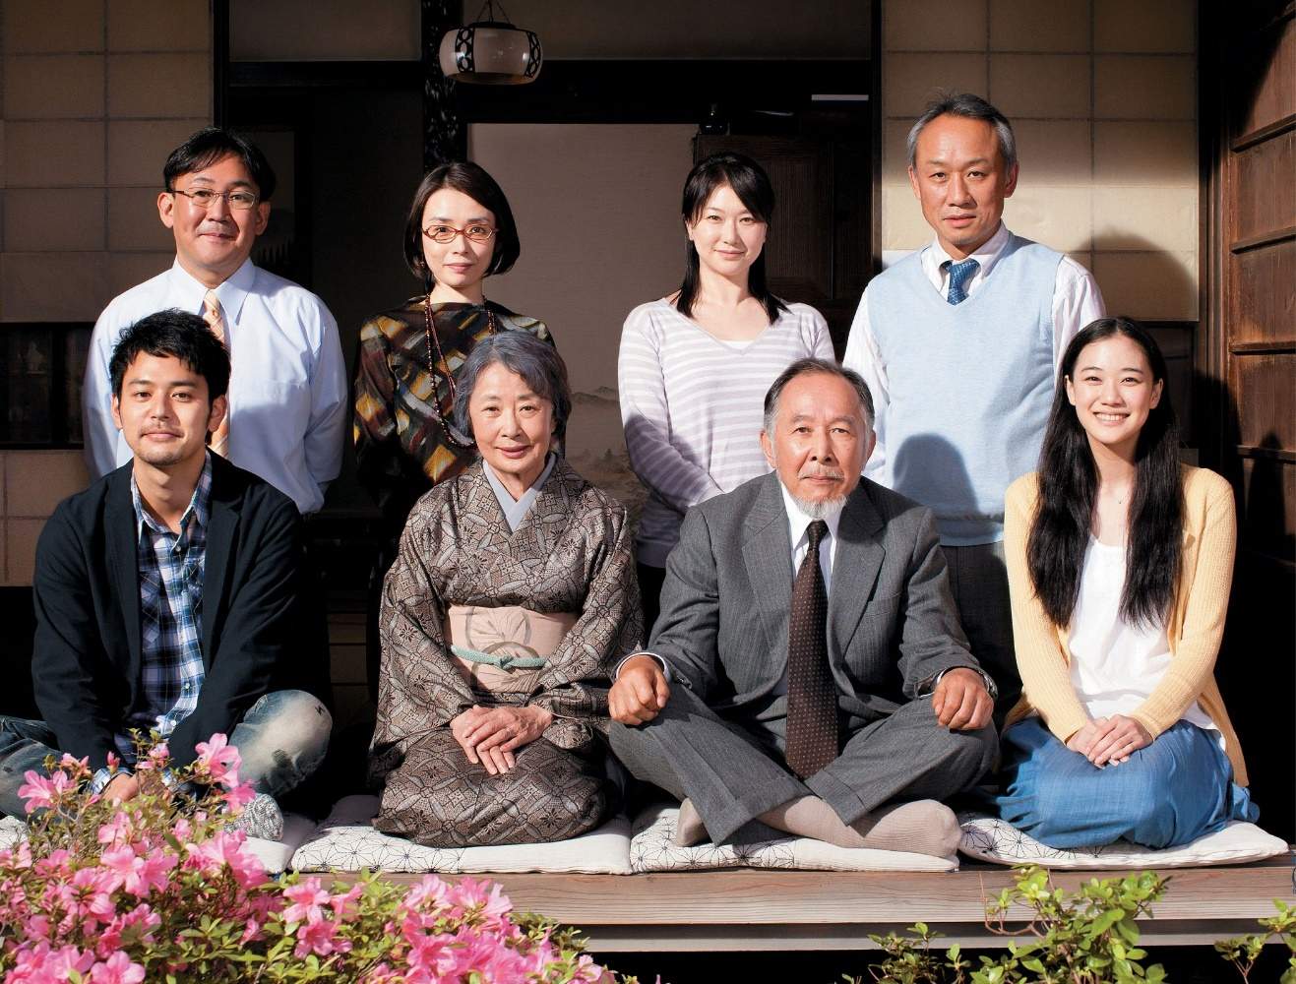
II Japanese Family Photo - Source: blogspot.com

Italians
During the summer, Italians prefer to travel to places that have a seaside, climbing mountains or visit a destination that has a colder climate. Nordic countries or the United Kingdom may seem like places that are more suitable to the Italian taste. During winter though, they prefer going to countries with much warmer climate, such as nations, located in the southern parts of Asia. (Marshall, 2018) Whenever they visit a city, Italians are more interested in visiting popular tourist attractions, go shopping at the most populated streets or try delicious native cuisine. A lot of Italians prefer family picnics in the parks. Whenever they’re at the beach, they prefer to sunbath or lay down on the deckchairs. Italians are very fond of museums, more than any other place they visit in the city. (Marshall, 2018) Like the Japanese, Italians love to travel in groups. Italians are not among the nations that usually prefer to plan their trips in advance, or get up early in the morning. Most of them prefer to start their day with an espresso and then pack their bags and go sightseeing. Most Italian tourists behave the same way as they do back in their own countries, but when visiting other cultures, they try speak foreign languages as best as could. Due to arriving from a country that’s famous for its cuisine worldwide, Italians show excitement to try different meals, whenever they’re far from their home or hotel. (Marshall, 2018) Due to being smart dresses, Italians prefer to wear outfits that match with either the location they’re visiting or the activity they’re doing. (Marshall, 2018)

III Italian Family eating pasta - Source: lovetoknow.com

French
Among the French’s most favourite activities is camping. Whenever they visit a country they mostly prefer to go camping in the wilderness of the country. French tourists also prefer to travel to destinations that are pretty close to their home country. This is why the highest number of French tourists are detected mostly in Europe. Due to its approximation to France, the United Kingdom has one of the biggest number of French tourists on the continent. Being a citizen to country, that offers some of the best cuisine in the world, being rivalled only to Italy, French visitors are very fond of visiting places within the area that offer only the finest meals, you can try anywhere. This is why so many books and chefs claim that one of the main reasons why French decide to visit a place, has to do with gastronomy. (Howard, 2018)

IV French family taking a photo – Source: 123rf.com

Americans
American travellers are among the pickiest tourists. Americans prefer to visit the most popular places, rather than exploring far away and less known territories. If one place becomes highly popular worldwide, there’s definitely going to be an influx of American tourists there in the near future. Americans seek only the most popular cities or destinations on the planet. This type of behaviour is due to the fact, that Americans have less vacation time throughout the year, unlike Europeans, which is why whenever they go somewhere, they only tend to visit places that are among the top five or top ten most visited at all. Locals tend to call Americans ‘list-tickers’, because of this behaviour. (Peck, 2018) American tourists tend to be polite and knowledge seekers. Whenever they visit a certain place, their main priority is to learn as much as they can about the history of the attraction. Americans are also among the nations who complain a lot about the places and activities their doing. Due to their high expectations, Americans always find a detail to complain about. This type of behaviour is noticed mainly whenever they visit a restaurant or café, always expecting service, which is comparable to the price they pay for it. (Peck, 2018) Most Americans prefer to dress casually, i.e. sneakers, jeans, T-shirts. Regardless of where they travel, Americans would pick clothing that matches the location they’re visiting and also be as safe to wear as possible. Safety is of big concern to citizens of the United States. (Peck, 2018)

V American family celebrating Thanksgiving – Source: bitcoin.com

South Africa
South Africans prefer to travel during peak and low seasons. Most of them prefer faraway destinations. (GetawayMagazine, 2019) Among the most popular destinations for South Africans are the United States, United Kingdom, Italy, Thailand and France. Most South Africans prefer to spend their holidays, travelling with either friends or family. (GetawayMagazine, 2019) A majority of South Africans travel at least once a year, but the number of people who prefer to on holiday twice or more is just as much. (GetawayMagazine, 2019) Most South Africans prefer to go on vacations using travel agencies, due to the fact that it seems much safer to them. They also seek to visit new places, rather than returning to old ones. (GetawayMagazine, 2019) One of the most popular means of transport for South Africans is renting cars, followed by using public transport, when going on vacation. Unlike other nations listed up to here, most citizens from this highly advanced African country prefer to plan their vacation in advance, rather go with the flow. Furthermore, the citizens of this southern nation are quite fond of sightseeing, trying out local cuisine and most importantly to feel relaxed while travelling far away. (GetawayMagazine, 2019)

VI South African family at the beach – Source: sapeople.com

Conclusion
In conclusion, citizens from each nation have their own ways of spending a vacation. That’s why it’s important for us to be informed of the different ways in which travellers prefer to spend their time, in order for the hospitality industry to offer experiences that can suit their needs.

References
American Family Image. (n.d.). Retrieved from https://news.bitcoin.com/how-to-explain-bitcoin-to-your-family-this-thanksgiving/
Blackall, M. (2019, July 01). Global tourism hits record highs - but who goes where on holiday? Retrieved from The Guardian: https://www.theguardian.com/news/2019/jul/01/global-tourism-hits-record-highs-but-who-goes-where-on-holiday
Demetriou, D. (2017, January 18). What the Japanese are really like on holiday. Retrieved from The Telegraph: https://www.telegraph.co.uk/travel/comment/japanese-tourists-stereotypes-and-the-truth/
French Family Image. (n.d.). Retrieved from https://www.123rf.com/photo_51524593_happy-family-of-three-standing-in-front-of-the-eiffel-tower-and-enjoying-their-vacation-in-paris-fra.html
GetawayMagazine. (2019, June 11). How South Africans like to spend their holidays. Retrieved from Getaway: https://www.getaway.co.za/travel-news/how-south-africans-like-to-spend-their-holidays/
Howard, H. (2018, September 05). Where do the French Go on Holiday in France? Retrieved from Culture Trip: https://theculturetrip.com/europe/france/articles/where-do-the-french-go-on-holiday-in-france/
Italian Family Image. (n.d.). Retrieved from https://family.lovetoknow.com/about-family-values/italian-family-life
Japanese Family Image. (n.d.). Retrieved from https://syntaxis-syntax.blogspot.com/2014/07/japanese-family.html
Marshall, L. (2018, September 14). Sorting fact from fiction: What Italians are really like on holiday. Retrieved from The Telegraph: https://www.telegraph.co.uk/travel/destinations/europe/italy/articles/italians-on-holiday-stereotypes-and-the-truth/
Modern Day Korean Family Image. (n.d.). Retrieved from https://www.9korea.com/photos/the-people-of-south-korea/modern-korean-family/
Palmer, B. (2019, September 02). 4 Reasons Why Global Tourism is Skyrocketing. Retrieved from PCMA: https://www.pcma.org/4-reasons-global-tourism-is-skyrocketing/
Peck, S. (2018, July 04). The truth about how Americans travel. Retrieved from The Telegraph: https://www.telegraph.co.uk/travel/destinations/north-america/united-states/articles/what-american-tourists-are-really-like/
Peregrine, A. (2018, October 01). Sorting fact from fiction: What the French are really like on holiday. Retrieved from The Telegraph: https://www.telegraph.co.uk/travel/destinations/europe/france/articles/the-french-on-holiday-stereotypes-and-the-truth/
South African Family Image. (n.d.). Retrieved from https://www.sapeople.com/2017/09/28/planning-holiday-please-whole-family/
Sukonek, P. (2018, October 19). How South Koreans Plan Trips - and Why You Should Care. Retrieved from Tribe Global: https://www.tribeglobal.net/Blog/How-South-Koreans-Plan-Trips-and-Why-You-Should-Care

