

CertHE in Business Skills

Student Name: Cucu Sebastian-George
Student Number:2430674
Course Name: Digital Skills LCLM4002
Lecturer Name: Nishi Ramsurrun
Session: February 2025 Term

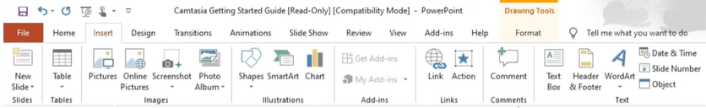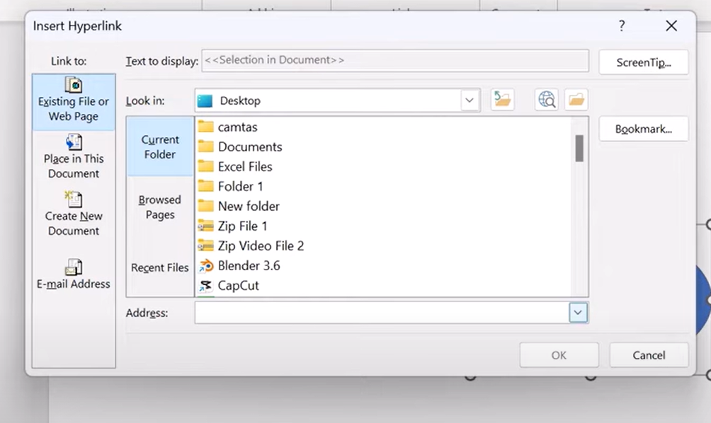
Second step , click on existing file or web page and insert your link at Address
First step is to select insert tab and then click on link icon
How to insert a hyperlink in Powerpoint
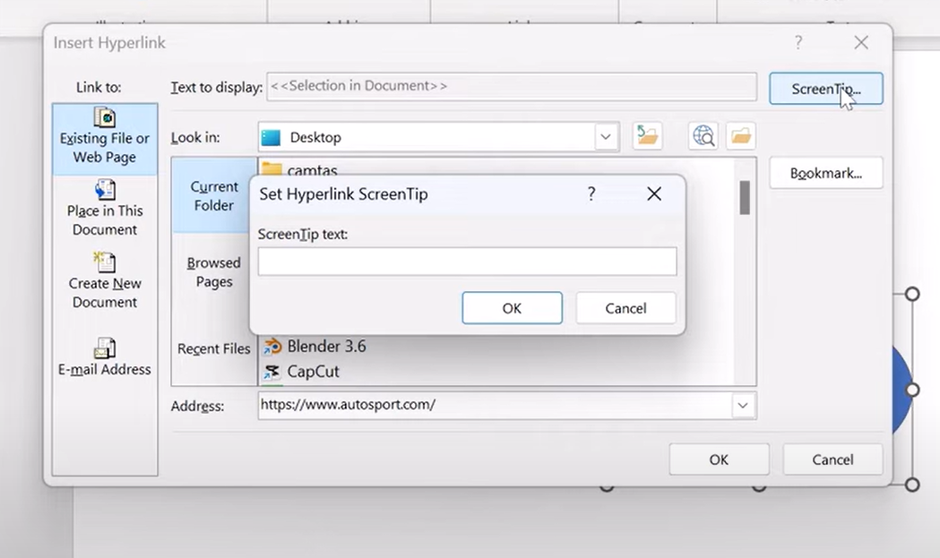
After all of this has been set you just need to click ok and that’s it
If you want a Screen Tip just click on ScreenTip and type in the box what do you want to appear instead of your link

