University of Wales Trinity St David
School of Engineering

Conrod Dynamic Forces Report

Corey Davies
(1702838)

Motorsport Engineering HND/BSC

3/12/2017

Analytical Methods & Study Skills
(M4X02193)
Contents

List of Figures…………………………………………………………………………………………………………………………………………………….3

Introduction……………………………………………………………………………………………………………………………………………………….4

Research/Literature review………………………………………………………………………………………………………………………………..4

Methodology…………………………………………………………………………………………………………………………………………….…......5

Analysis………………………………………………………………………………………………………………………………………………….….........7

Conclusion…………………………………………………………………………………………………………………………………………………….…..8

Recommendations for further study………………………………………………………………………………………………………..…….….8

References…………………………………………………………………………………………………………………………………………………….…..8

List of Figures
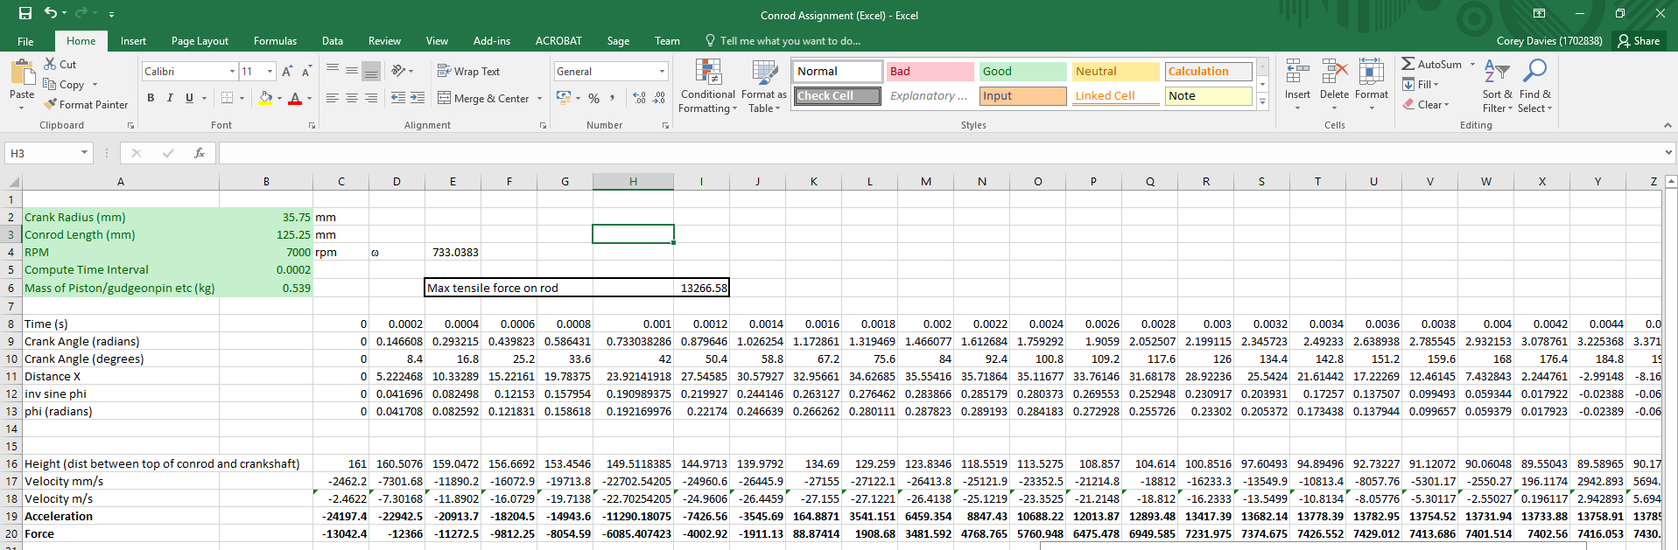

Figure 1

Figure 1.1

Figure 1.2

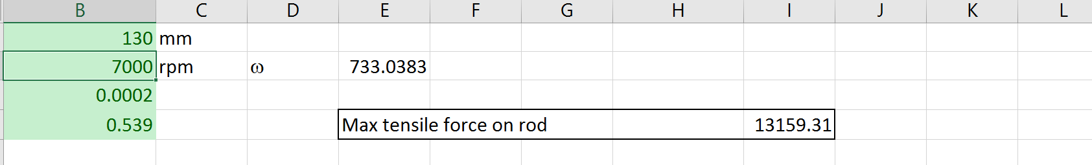
Figure 1.3
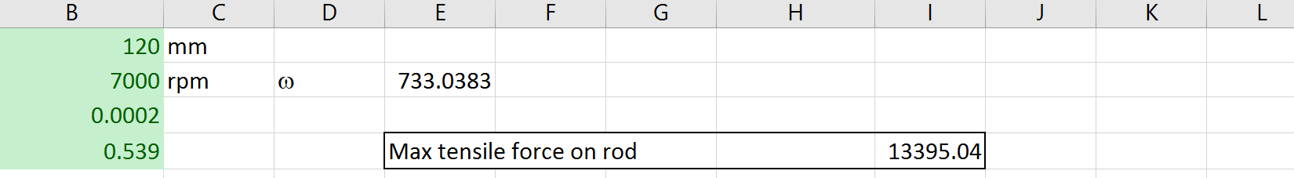

Figure 1.4

Introduction
In this report I was tasked with researching a chosen piston engine to analyse and report the forces that the conrod or rather the connecting rod undergoes, inside a vehicle engine. The engine I have chosen for this task is a 1jz engine manufactured by Toyota. The 1jz engine used an inline 6 with a 2.5litre cubic capacity producing 280bhp at 6200rpm and 363nm at 4800rpm.
What I hope to gain from completing this task is a further understanding on how the forces of the conrod or connecting rod is affected by the following values:
- Crank Radius
- Conrod Length
- RPM
- Mass of Piston/Piston Pin

Research
By researching into the subject and into my chosen piston engine I was able find the values required to analyse the forces on the conrod. From the research I also found some information relating to the history and performance of the 1jz engine and its successor the 2jz.
1Jz
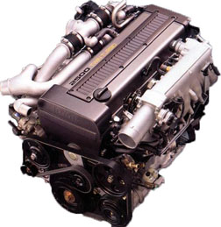
The 1Jz Engine was introduced in the early 90s to be used in the Toyota Supra, Chaser, Cresta, Soarer and Mark II Toyota models. The engine layout was transversely mounted because of its six piston in design. The 1Jz displaced 2491cc with 86mm bore x 71.5mm stroke. The engine was made with a cast iron block housing with aluminium alloy pistons that had an 8.5:1 compression ratio. An aluminium alloy head was used with a pented roof combustion chambers and direct fire ignition for increased combustion efficiency. Pent roof was used because of its greater volumetric efficiency and reduced emissions. The 1Jz was belt driven with dual cams and four valves per cylinder and high cc injectors to pump the necessary fuel to the engine. 1Jz were produced until 1996 and were equipped with parallel mounted twin CT12A Turbochargers, which breathed through a front mount intercooler. The engine produced 280bhp at 6200 RPM and 363nm of torque at 4800 RPM. (As Referenced By Http: 1).
In 1996 1Jz had a major overhaul. Both camshafts were featuring Toyota’s Variable Valve Timing (VVT-i). The water jackets were modified for improved cooling. The twin CT12A were replaced by a single CT15B unit, to suit the new turbocharger the head and exhaust manifold was revamped. These improvements did not improve the 1Jz power output as the 1Jz was already running 280bhp and was the limit according to Japanese Automobile manufacturers. How ether torque was increased from 363nm to 379nm at 2400 RPM. The production of the 1Jz seized in 2007. (As Referenced By Http: 6).
Engine Data
Crank Radius – 35.75mm (As Referenced By Http: 4)
Conrod Length – 125.25mm (As Referenced By Http: 4)
Mass of piston/Piston pin – Piston 407g/Piston pin 132g (As Referenced My Http: 5)
Maximum RPM – 7,000/7,500 (As Referenced By Http: 1)

Then came the 2Jz engine which was again transversely mounted with 6 pistons and much larger than the 1Jz, instead of a 2.5 litre engine the 2Jz had a 3.0 litre capacity and produced 220bhp at 5,600 RPM and 294nm of torque at 3,600 RPM. Although the engine was modified for exporting with larger injectors, intercoolers and better more improved turbochargers and is considered the better of the Jz engines. (As Referenced By Http: 2 and 3)
Engine Data
Crank Radius – 43mm (As Referenced By Http: 4)
Conrod Length – 142mm (As Referenced By Http: 4)
Mass of piston/Piston pin – Piston 407g/Piston pin 132g (As Referenced My Http: 5)
Maximum RPM - 6,800/7,200 (As Referenced By Http: 3)

Methodology
The methods used to properly analyse the forces on the conrod was Excel. How I undertook the analysis was first finding the appropriate information on my chosen piston engine. E.g. The Crank Radius, Conrod Length, Maximum RPM and the Mass of the Piston/Piston Pin. By using a pre-developed Excel program provided I then transferred the researched data into the Excel program. Also by using and changing the information on the spreadsheet associated with the Crank Radius, Conrod Length, Maximum RPM and the Mass of the Piston/Piston Pin I was able to analyse how the conrod is affected at e.g. different RPM’s.

1st Graph
The Y axis on the graph represents the height of the conrod and the x axis represent the time in seconds.

2nd Graph
The Y axis on the graph measures the velocity of the conrod in m/s and the x axis represents the time in seconds.

3rd Graph
The y axis on this graph measures the acceleration and force acting on the conrod and the x axis represents the time in seconds.

Analysis
From the researched data and the pre developed excel program provided by inputting the values for the 1Jz engine which produced the results on Figure 1. At 7000 RPM the conrod had a max tensile force on the conrod of 13266.58nm. Throughout the analysis the conrod height reached 161mm which is the conrod length (125.25mm) plus the crank radius (31.75mm) TDC (Top dead centre) and 89.55mm which is the conrod length (125.25mm) minus the crank radius (31.75mm) BDC (Bottom dead centre) giving relative positions of the conrod/piston (Figure 1.1). The velocity that the conrod underwent though the four stroke cycle was 27.2m/s at 7000 RPM (Figure 1.2).

Changing in Conrod Length
By increasing the length of the conrod from 125.25mm to 130mm the maximum tensile force on the conrod decreased see (Figure 1.3) and by decreasing the length of the conrod from 125.25mm to 120mm the maximum tensile force on the conrod increased see (Figure 1.4). Increasing the length of the conrod decreased the tensile force on the conrod because there’s more material to be stretched and by decreasing the length of the conrod it reduced the material therefore increasing the force applied to the conrod. Changing the length of the conrod also increased the height therefore increasing the stroke.
Also by changing the length of the conrod the velocity, force and acceleration changed. The velocity reduced when the conrod length was increased from 125.25mm to 130mm and increased when the conrod length was decreased from 125.25mm to 120mm.
The Acceleration of the conrod decreased when the conrod was increased from 125.25mm to 130mm and increased when the conrod length was reduced from 125.25mm to 120mm. This is correct because when working out the acceleration you use the formula (change in velocity ÷ time) then by reducing the conrod length you’re increasing the acceleration because of the reduced distance travel.
The force acting on the conrod when the conrod is increased from 125.25mm to 130mm decreases because it’s subjected to less force because of the increased material. When the conrod is decreased from 125.25mm to 120mm the force on the conrod is increased because of the reduced material.
RPM
By increasing the RPM of my chosen piston engine from 7000 RPM to 7500 RPM changes the values in the Velocity, Acceleration, Force and also the maximum tensile force on the conrod. By increasing the RPM the Velocity, Acceleration, Force and the maximum tensile force increase when the RPM is increased and decrease when the RPM is decreased.
Mass of piston/piston pin
From increasing the mass of the piston/piston pin only one value changes in the excel program and that is the force acting on the conrod and the maximum tensile force. By increasing the mass from 0.539kg to 1kg the force acting on the conrod increased and by decreasing the mass of the piston/pin the force on the conrod reduces.

Conclusion
From the analysis I conclude that if the conrod was to surpass the maximum tensile strength it would break. And By increasing the length of the conrod the velocity decreases and the acceleration. Also when the conrod is increased in length the force acting on the conrod was reduced because of the increased material. By decreasing the conrod length increased the velocity and acceleration because of the reduced distance travel. The force was increased when decreasing the conrod length because of the reduced material. And by increasing the RPM the Velocity, Acceleration, Force and the maximum tensile force increase when the RPM is increased and decrease when the RPM is decreased.

Recommendations for further study
Recommendation for further study into the subject:
Http: 7, By N.L. Marina, Stress-Strain State of a Connecting-Rod bolt, Online, Available:https://link.springer.com/content/pdf/10.3103/S1068798X15030107.pdf 4/12/2017

References
Http: 1, NA, Toyota 1JZ-GTE/GE/FSE Engine, Online, Available: http://mywikimotors.com/toyota-1jz/ 29/11/2017
Http: 2, By Aaron Bonk, Everything You Need to Know About the Toyota 2JZ-GTE Engine, Online, Available: http://www.superstreetonline.com/how-to/engine/1505-guide-to-understanding-the-toyota-2jz-gte-engine/ 29/11/2017
Http: 3, NA, Toyota 2JZ-GTE/GE/FSE Engine, Online, Available:http://mywikimotors.com/toyota-2jz/ 29/11/2017
Http: 4, By Jeff Lange, Aug 2003 1JZ rod length and rod/stroke ratio, Online, Available:http://www.supraforums.com/forum/showthread.php?307890-1JZ-rod-length-and-rod-stroke-ratio29/11/2017
Http: 5, By Wez, May 2002, Weight of 2JZGTE Engine Parts, Online, Available: http://www.mkivsupra.net/vbb/showthread.php?207379-Weight-of-2JZGTE-Engine-Parts 29/11/2017

Http: 6, By NA, Toyota 1JZ-GTE Engine, Online, Available:http://www.jdmspecengines.com/toyota-engines/jz-series/1jz-gte.html 29/11/2017

