Professional Development

by Elena Pruteanu

Course: Higher Skills Education for the Workplace (2111212)
Professor’s name: Mel Squire
Date of submission: 19th November

Executive summary
This is the reflective paper about the learning outcome that I am learning in these five weeks. In which I learned about the understanding and knowledge and the skills that have been used in achieving the desired goals. The strength and weaknesses that I have and related to the goals that I have in my life. The opportunities and the threats that an organisation had in the achieving of the desired goals. The main task that the tutor has given to me is to complete the level 4 certificate and jump to level 5 at the specific time frame till January 2022. I make my personal professional development to complete the task.

Table of Contents
Executive summary 2
Introduction 4
Week 1 4
Week 2 5
Week 3 6
Week 4 7
SMART GOAL 7
Specific 7
Measurable 7
Attainable 8
Realistic 8
Timely 8
Week 5 10
Reference 12

Introduction
In this reflection paper, I write about the learning and the skills for effective work. What goals I set to achieve in the reference to get the accuracy in the grades and any goals that I am achieving according to the tasks. The SWOT and the SMART analysis are the best things that are used in the reference to get the desired goals. The strength and weaknesses that I got and the opportunities and threats that I gain in performing any task. The special activity that I have to perform is to complete level 4 with a certificate and jump into level 5 within the specific time frame of January 2022.

Week 1
In the week one module I learned the understanding of the knowledge and the skills about working effectively. How does effective work come out? The basic understanding of the efficiency of the work. Also, I have learned to establish the specific goals concerning employment and also to develop the action plan on a personal level. In week 1 I demonstrate the willingness to advance personal and employability by the understanding of the personal areas of strength and development. Make analysis over my career of how to boost up my career and also make sure to be at my desired position that I set within the five years. Career growth depends upon the skills that I have and that I have to polish for future growth. The skills that are related to the professional career have to be in a person and should be too perfect to gain the desired goals. Be realistic about the goals and the knowledge that is needed in professional growth. In week 1 the major element that everyone had to be focused on is self-awareness, in week 1 I learned about the concept of self-awareness and how to develop it, and it is the earliest step in the building of self-awareness that leads towards the learnings (Makarenko, 2018). Firstly, I should know about myself that what are my weakness and the strength that required, make the preferences and the desired goals that needs in the growth of the professional career. Make a crystal-clear concept of the personality perception and what attitude has been used in the professional environment. The behaviour of a person in the working environment and towards the desired goals is the major component and leaves a major impact on the task and the environment of an organisation. It includes all the weaknesses and strengths that a person has and it also impacts the career of an individual. The thoughts and the critical thinking way are the best thing completing the tasks, the way you think more creatively the outcome becomes more effective. The motivation in the development of the career is the most important thing when an employee is motivated towards the goals, then the outcome always becomes 100%. All the factors affected directly over the professional career. In short, week 1 provides the basic concept about self-awareness and what things should be used in the area of self-awareness. It allows you to understand yourself and also gives you the ability to understand the other people at work to collaborate and do the tasks effectively. After self-awareness, the next biggest component is self-assessment. In the self-assessment, it makes a concept to analyse in what area a person is perfect and what skills are the best in a person that can be used in completing the task (Darcy, 2019). A self-assessment required that what task and things that a person should do and that went well and what is the reason behind the accurate result of the task. What mistakes that I made in the past task and need to be improved in the next task for a better outcome.

Week 2
The development of the professional career, as in week 1 I learned about self-awareness and the self-assessment and leading to this in week 2 I learned more deeply about self-awareness. Making the understanding about the self-awareness, by participating more effectively and actively in the different kinds of the personal profiling and the styles of the learnings that are called the psychometric tests and it contains the three major elements that are VARK, Myer Briggs personality profiling and the Honey & Mumford. In this week 2, I learned about the implications of the training and the learnings. Self-awareness is most important to make the foundation in the field of management skills and enhance the leadership quality in a person. It will enhance the quality of the judgment that leads towards the identification of the new opportunities in the development of the professional career of the individual (Zorina, 2018). Many scholarly articles provide the 5 elements of self-awareness that are undertaking the profiling and the psychometric tests, should meditate that enhance the capability of critical thinking, should ask the loyal friend about the issue that always gives positive and the perfect advice. Whenever you start working on a new project, first write down the key plans. And get feedback on a regular basis. The learning style of the VARK stands for the visual, aural, read/write, and kinesthetic strategies of the study. There are four kinds of learners, activist, pragmatist, theorist, and reflectors. They like to deal with the new issues and the new observations, doing so many activities to keep busy in life, and also, they love the challenges to cater, these are the activist learners. In contrast, a pragmatist applies the things that they learn through practice in the situation. It needs logical reasoning in the task and also it wants the hands-on enthusiastic way that implies over the task. The theorist learners give time in the research of the information about the task, they need lots of reading and research, the best part of the theorist is that they think before applying anything over the task. As compared to this the reflectors always think critically and deeply about the learning, they always try and test new things, and also, they are reserved students (Omary, 2019). The concept of the Myer Briggs test of the psychometric contains the extraversion and the sensing then the thinking and judging. These are the four basic criteria that are used in the psychometric test by Myer Briggs.

Week 3
In week 3 I learned deeply about the learning styles, there are three learning styles that I have learned in week 3. Myer Briggs, Honey and Mumford, and the VARK. Also, in week 3 I do learn the SWOT analysis and the SMART analysis. In the SWOT analysis, I learned the strength, weaknesses, opportunities, and threats that the SWOT stands for. It is quick access to take the stock depending upon the situation. The strength of a person includes the thinks that what qualities a person has that others don’t. in what thing I am better than other people. What are the resources at the personal level I can use? How the senior management looks at your strengths. Mine achievements and the values that I use in the field of strength. Having influential people that are in connections. The weaknesses of a person that find out the tasks that usually get avoided by a person, what are the weaknesses that had been observed by the other people, if I am not confident while performing the task I considered as the weakest person, identify the negative habits at work. Having the personality traits that are holding me back is another weakest point. Restrictions over travel to work (Ezeani, 2020). The opportunities that had been analysed in the context of the SWOT third part, that is the industry is growing or not? Or I have the new networking strategies that help and some better advice. What are the trends that are evolving in current situations and what do they provide the advantages to them? What are the new technologies that always help in the task? Need in the industry and the complaints that come from both new and older customers about the company. And creating new opportunities regarding the solution. The threats that I faced while doing the task at work. Any co-worker that is competing at work and in the project. The demands for the things that need to change. The changes in technology always threaten the position. Any of the weaknesses that I have always led towards the threats. By setting the personal goals and the objectives lies in the concept of the SMART that stands for specific, measurable, achievable, realistic, and time-bound. The goals, that are explained and specific, are considered as the clarification about the goals and their work. The goals should be measurable that how successful I am with the completion of the goal. All the goals should be achievable and always help to motivate workers to give their best in the completion of the goals (Rachmajanti, 2019). The goals should be more relevant and must be coinciding with the overall objective of the goal. Time is the major part while performing the goal because of the management of the time, how much time it takes to complete the goal.

Week 4

SMART GOAL
I plan to complete my Level 4 certificate and achieve a MERIT by January 2022 to progress onto BA Level 5.

Specific
The specific goals that had the chance to complete the general goals. As a student I have to set the goals first that answer major six WH questions that are given below:
- Who?
- When?
- Why?
- Which?
- What?
- Where?
Do these questions include that who is involved? When to establish a time frame? Why a specific reason and the purpose or the advantages that are used in accomplishing the goals? Which will identify the constraints and the requirement? What do I have to accomplish? And where is it located? The basic goal is to get the shape but the specific desire goal.

Measurable
This part measures progress by the criteria that are used to attain the goals that have been set in the specific part. When I measure my progress in the light of the completion of level 4 that produces the merit by January 2022 that will lead towards the progress of level 5 of BA. I make a special track and try to focus on the targets that are set according to the dates and days. To determine my progress in the term of level 4 to level 5 in the merit time of January 2022 is to ask some questions that are measurable that how much I have given in a task? How many days are required? And lastly, how would I know about the accomplishment of the task.

Attainable
In this part, I already know and set my desired goals and measure the progress of my task. In the attainable part, I have to identify the most important goals. And now I will find out the ways that are used to make the goals come true. By developing my attitudes, my skills, any capabilities, and the financial capacity of myself that I deliver while performing the task. By seeing the opportunities that make me closer to my desired goals to achieve them. My behaviour matters most in the performance of my desired goal to get an accurate outcome.

Realistic
To be realistic towards my goals is the most important part of smart goals. All the set goals represent the objective that I am willing and able to work on. My goals in the study plan are both realistic and high. Now I can choose one of them and how high my goals are? Each of my set goals has sustainable progress (Soboleva, 2020). The high goals have the most motivation as compared to the low ones. My goal is realistic when I purely believe that I can achieve my goal and accomplish it within time with accuracy in the form of grades in January 2022.

Timely
All my goals are grounded within time. Like I have to complete the level 4 certificate in the January of 2022 to lead towards level 5. When I start studying and when I had to stop studying according to the levels and the modules that I choose in level 4 and it is led towards level 5.
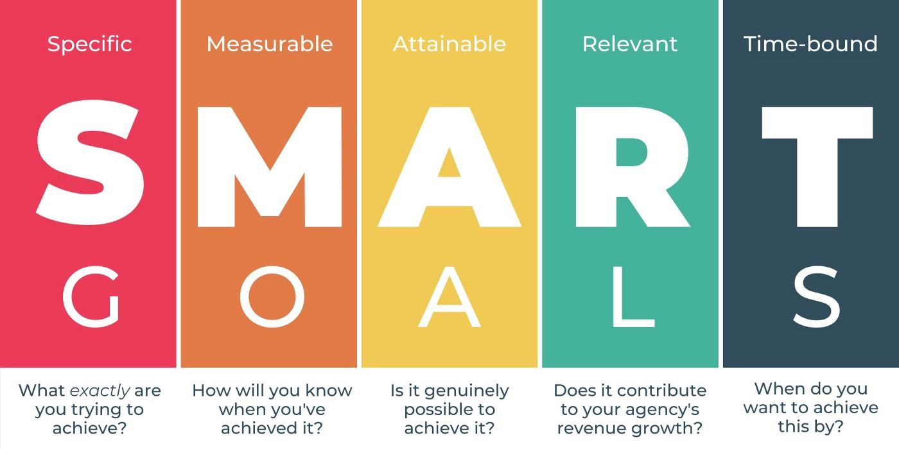
Figure 1-https://medium.com/@sidrahkhurshid.96/how-setting-smart-goals-is-beneficial-for-your-business-9fb2ba0ee117

What do I want to achieve and learn? | What do I have to do for achieving this? | What kind of resources do I need to achieve this? | What will be my success criteria? | Targeted dates
Making a plan that will tackle the issues and the gaps in my learning in level 4 that leads to level 5 in the specific period of January 2022. | SMART goals and complete my level 4 certificate. | Lots of information and research to achieve the desired grades and accuracy in the assignment. | Making a time management timetable to perform the tasks.
By developing the ability to achieve the goals and ensuring the grades. | Best grades by researching more documents and resources. | Modules and lectures. Analysis of the topic. | Improve the methods of planning that affect the grades.

Week 5
In week 5 I learned about problem-solving creatively. In an organisation, there are so many tasks that are performed, and while performing the task there are so many obstacles that come in the way of working. There is an art to dealing with the challenges and the obstacles and it is a part of the working life at any organisation, to overcome the obstacles in the tasks is not an easy job. This is the creativity of how to acknowledge the issue and deal with it. Maintain the balance with the convergent and the divergent thinking that has been done individually and provide the knowledge about each one’s practice when it is needed. If I require something to kick start in my life, I should focus on the creative ideas that are used in solving the problems. When I have the ideas, the issues are always with it. Now it is my responsibility to acknowledge the mistakes that I am doing, and where I went wrong while performing the task (Hirschi, 2018). The basic thing that I have learned in week 5 is to have ample information about the topic and also the research. The more information I have the more I get ideas about the task performance. The research about the topic before starting the task always comes with an accurate outcome. In the research work, I have to use the tactic while using the brain and creativity of my own related to the task. Generating new creative ideas that leave major effects on the task. Always try to implement the perfect resolving solution over the task that resolves it in less time and with accuracy. It is too easy to tempt the solution that had been used before because our mind is fixed to think habitually with the stereotypical ways of thinking for the solution that leads to stop thinking about the new creative ideas. It is beneficial at the point where I am stuck with the issue and it cannot be resolved by the typical old solution then it is the time to rethink new creative ideas that are beneficial for the task. First, I have to choose my goal that either is desired or is a challenge (Afanasyev, 2019). Then select the solution that is most beneficial for its resolution and develop the action plan for the task. Problem-solving is defining the issues that are determining the causes of the issues, identifying and making the priority list of the tasks, and selecting the alternative solutions that are best for the tasks and the problems. It is the selecting and evaluating the alternative ideas.

Reference
Afanasyev, V.V., Ivanova, O.A., Rezakov, R.G., Afanasyev, I.V. and Kunitsyna, S.M., 2019. Organizational environment for the schoolchildrens' professional identities: establishing, modelling, efficiency expectations and long-term development. International journal of civil engineering and technology, 10(2), p.1612.
Darcy, S., Maxwell, H., Grabowski, S. and Onyx, J., 2019. Artistic impact: From casual and serious leisure to professional career development in disability arts. Leisure Sciences, pp.1-20.
Ezeani, A., Odedina, F., Rivers, D., Fatiregun, O. and Akinremi, T., 2020. SWOT analysis of oncology clinical trials in Africa: A town hall report from the Global Congress on Oncology Clinical Trials in Blacks. JCO Global Oncology, 6, pp.966-972.
Hirschi, A., 2018. The fourth industrial revolution: Issues and implications for career research and practice. The career development quarterly, 66(3), pp.192-204.
Makarenko, S., Oliinyk, N. and Kazakova, T., 2018. Improving the method approach to the rating evaluation of employees as professional career development. Baltic Journal of Economic Studies, 4(5), pp.179-187.
Omary, M.B., Shah, Y.M., Schnell, S., Subramanian, S., Swanson, M.S. and O'Riordan, M.X., 2019. Enhancing career development of postdoctoral trainees: act locally and beyond. The Journal of physiology, 597(9), p.2317.
Rachmajanti, S., Sulistyo, G.H. and Suharyadi, A.N., 2019. Developing ELT Teachers Professionally towards Capability Scaffolding Roles: Reflecting on Their Standing SWOT. ICLI 2018, p.351.
Soboleva, E.V. and Karavaev, N.L., 2020. Characteristics of the Project-Based Teamwork in the Case of Developing a Smart Application in a Digital Educational Environment. European Journal of Contemporary Education, 9(2), pp.417-433.
Zorina, E., Kartavtzeva, I., Krusian, I. and Mikhienko, S., 2018. Aspects in formatting professional speech culture for rural career development courses listeners. In Engineering for Rural Development 17. Сер." 17th International Scientific Conference Engineering for Rural Development, Proceedings" (p. 1125).

